Bureau of
Environmental Health,
Community Assessment Program

Massachusetts
Department Of
Public Health

Evaluation of Thyroid Cancer Incidence
in Hanover, MA

December 2007
TABLE OF CONTENTS

I. INTRODUCTION 1
II. COMMUNITY Environmental Concerns 1
III. METHODS 2
IV. RESULTS 5
V. DISCUSSION 10
VI. CONCLUSIONS AND RECOMMENDATIONS 12
VII. REFERENCES 14

Table 1: Diagnoses of Thyroid Cancer in Hanover, 1999-2003
Table 2: Diagnoses of Thyroid Cancer by Census Tract in Hanover, 1999-2003

Figure 1: Location of Census Tracts in the Town of Hanover, MA
Figure 2: Location of Drinking Water Wells for the Town of Hanover, MA

Appendix A: Explanation of a Standardized Incidence Ratio (SIR) And 95% Confidence Interval

Appendix B: Risk Factor Information for Thyroid Cancer

I. INTRODUCTION

In September 2006, a written request to investigate the incidence of thyroid cancer in the town of Hanover was received by the Massachusetts Department of Public Health’s (MDPH) Bureau of Environmental Health (BEH). The request was made by concerned residents of the town. Specific concerns in the residents’ letter focused on a suspected increase in thyroid cancer incidence among individuals residing in Hanover, and whether this may represent an atypical pattern or possibly be related to a common environmental factor. The residents mentioned possible exposure to perchlorate in the town of Hanover as a source of exposure concern. In response to these concerns, the BEH’s Community Assessment Program (CAP) reviewed available thyroid cancer incidence data from the Massachusetts Cancer Registry (MCR) for the town of Hanover as a whole and for each of the two census tracts (CTs) of Hanover (see Figure 1).

II. COMMUNITY Environmental Concerns
In the request letter to the BEH, residents of Hanover expressed concern regarding possible contamination of the drinking water supply by perchlorate. Perchlorate can be found in the environment in one of two forms, either as a solid or dissolved in water. One of the chemical properties of perchlorate is its ability to produce large amounts of heat when it reacts with specific chemicals. This makes it ideal for use in rocket motors, fireworks, gunpowder, and explosives, among other products. Living near a factory where any of these products are made may provide opportunities for exposure among individuals if perchlorate has been released into the air, soil or water surrounding the plant. Perchlorate can potentially reach drinking water supplies if a release occurs near where a city or a town obtains their drinking water or near a private well.

When perchlorate enters the body it is taken up by the thyroid gland, where it can inhibit the uptake of iodine by the thyroid. With smaller amounts of iodine being used by the thyroid there is a potential for lower output of thyroid hormones (a condition called hypothyroidism). The long-term health effects of perchlorate exposure are still uncertain (Baverman et al. 2005; Buffler et al. 2006). However, perchlorate is currently used to control the thyroid dysfunction called thyrotoxicosis which can be induced by the medication amiodarone (a drug used to treat heart arrythmias) (Wolff 1998).

Southern Hanover was home to the National Fireworks Company in the early part of the 20th century (Barker 1995). This facility was located in the southwest corner of Hanover. It is also known that during World War II the fireworks factory was converted to an ammunition factory for the duration of the war.

III. METHODS
To investigate concerns about thyroid cancer in Hanover, the most recent data available from the Massachusetts Cancer Registry (MCR) were reviewed in an effort (1) to confirm cancer diagnoses among Hanover residents that were reported to the BEH, (2) to identify any additional diagnoses, and (3) to determine whether an atypical pattern of thyroid cancer may be occurring in the town as a whole or in any particular geographic area/neighborhood. [Coding for thyroid cancer in this report follows the International Classification of Diseases for Oncology (ICD-O) system (Third Edition)].

The MCR, a division within the MDPH Bureau of Health Information, Statistics, Research and Evaluation, is a population-based surveillance system that has been monitoring cancer incidence in the Commonwealth since 1982. All new diagnoses of cancer among Massachusetts residents are required by law to be reported to the MCR within six months of the date of diagnosis (M.G.L. c.111. s 111b). This information is kept in a confidential database. Data are collected on a daily basis and are reviewed for accuracy and completeness on an annual basis. This process corrects misclassification of data (i.e., city/town misclassification) and deletes duplicate case reports. Once these steps are finished, the data for that year are considered “complete.” Due to the volume of information received by the MCR, the large number of reporting facilities, and the six-month period between diagnosis and required reporting, the most current registry data that are complete will inherently be a minimum of two years prior to the current date. At the time of this analysis, complete data records available from the MCR include diagnoses that occurred from January 1, 1982 to December 31, 2003. Although the MCR data are currently complete through 2003, this is an on-going surveillance system that collects reports on a daily basis. Therefore, it is possible to review case reports for more recent years (i.e., 2004-present), which can provide a qualitative review of cancer patterns in a given area.

It is important to note that although some non-cancerous (i.e., benign) tumors are reported to the MCR (e.g., those diagnosed in the brain and central nervous system), these diagnoses are not included in the data summarized here. Also, only primary site (original location in the body) cancers are included in the MCR. Cancers that occur as the result of a primary site cancer spreading to another location in the body (i.e., metastasis) are not considered separate cancers. Therefore, this analysis includes only diagnoses of invasive (i.e., malignant) primary cancers.

In order to determine whether cancer incidence in a community is occurring at a higher or lower rate than expected, a statistic called the standardized incidence ratio (SIR) is calculated using data from the MCR. More specifically, an SIR is the number of observed cancer diagnoses in a town divided by the number of expected diagnoses based on the population of the town and the state’s cancer rates. An SIR greater than 100 indicates that more cancer diagnoses occurred than expected; an SIR less than 100 means that fewer diagnoses occurred than expected. For example, an SIR of 150 is interpreted as 50 percent more diagnoses than expected; an SIR of 90 indicates 10 percent fewer diagnoses than expected. When an SIR is statistically significant, as indicated by an asterisk symbol (*), there is less than a 5% chance that the observed number of diagnoses is due to chance alone. SIRs and 95% confidence intervals (CIs), statistics used to help interpret the SIR, are not calculated when the observed number of diagnoses is fewer than five. A more detailed explanation of SIRs and 95% CIs is provided in Appendix A.

SIRs for thyroid cancer for the town of Hanover as a whole as well as for each CT within Hanover were calculated for the 5-year time period 1999 – 2003. Because statewide data for the years 2004-present were not considered complete at the time of this analysis, expected numbers of diagnoses and incidence ratios could not be calculated for the most recent time period.

Accurate age group and gender-specific population data are required to calculate SIRs. Therefore, the CT is the smallest geographic area for which cancer rates can be accurately calculated. Specifically, a CT is a smaller statistical subdivision of a county as defined by the U.S. Census Bureau. CTs usually contain between 2,500 and 8,000 persons and are designed to be homogeneous with respect to population characteristics (U.S. DOC 2000). The town of Hanover is divided into two census tracts (CT 5031.01 and CT 5031.02) that separate the town roughly into a northern portion and a southern portion (see Figure 1)

To better characterize the pattern of thyroid cancer incidence in Hanover, case-specific information available from the MCR relating to cancer subtype, date of diagnosis, age at diagnosis, and gender was also reviewed for each individual diagnosed with thyroid cancer in Hanover. This information is discussed in the context of known or established thyroid cancer risk factors and incidence patterns in the general population. In addition, the place of residence at the time of diagnosis for each individual with thyroid cancer was “mapped” using a computerized geographic information system (ESRI 2006). This allowed for a qualitative evaluation of the spatial distribution of the addresses of individuals diagnosed with thyroid cancer and an assessment of any possible geographic concentration of diagnoses in specific neighborhoods in Hanover. For confidentiality reasons, maps of the residences of individuals diagnosed with thyroid cancer cannot be provided in this report. However, a summary of this evaluation with any notable findings is presented in this report.

IV. RESULTS
Table 1 shows the number of thyroid cancer diagnoses in Hanover by gender for the time period 1999 – 2003. In the town as a whole, there were 12 diagnoses of thyroid cancer when approximately seven would have been expected during this time period (SIR=185, 95% CI 96-324). Although more diagnoses were observed than expected, the elevation was not statistically significant meaning that the difference could be due to chance or natural random variation. When the incidence of thyroid cancer was examined by gender, two diagnoses occurred among males when approximately two would have been expected during this time period. Among females, ten diagnoses of thyroid cancer occurred when about five would have been expected (SIR=201, 95% CI 96-370). This elevation among females, for the town of Hanover as a whole, was not statistically significant.

Table 1: Diagnoses of Thyroid Cancer in Hanover, 1999-2003

 | Observed | Expected | SIR | 95% CI
Males | 2 | 1.5 | NC | NC
Females | 10 | 5.0 | 201 | 96-370
Total | 12 | 6.5 | 185 | 96-324

Table 2 shows the number of cancer diagnoses by gender in each census tract (CT) in Hanover during the 1999 – 2003 time period. In CT 5031.02, there was one diagnosis of thyroid cancer when approximately three would have been expected. The one thyroid diagnosis occurred in a female when approximately three females would have been expected to be diagnosed in CT 5031.02. Approximately one male would have been expected to be diagnosed with thyroid cancer in CT 5031.02 during this time period.

In CT 5031.01, 11 individuals were diagnosed with thyroid cancer when approximately three would have been expected overall (SIR=345, 95% CI 172-618). This elevation in thyroid cancer incidence in CT 5031.01 is statistically significant. When examined by gender, two males were diagnosed in this CT when approximately one would have been expected while nine females were diagnosed when approximately two would have been expected (SIR=370, 95 % CI 169-702). Thyroid cancer incidence among females in CT 5031.01 is statistically significantly elevated.

Table 2: Diagnoses of Thyroid Cancer by Census Tract in Hanover, 1999-2003

Census Tract | Total |  |  |  | Males |  |  |  | Females
 | Obs | Exp | SIR | 95% CI | Obs | Exp | SIR | 95% CI | Obs | Exp | SIR | 95% CI
5031.01 | 11 | 3.2 | 345* | 172-618 | 2 | 0.8 | NC | NC-NC | 9 | 2.4 | 370* | 169-702
5031.02 | 1 | 3.3 | NC | NC-NC | 0 | 0.7 | NC | NC-NC | 1 | 2.5 | NC | NC-NC
Town Total | 12 | 6.5 | 185 | 96-324 | 2 | 1.5 | NC | NC-NC | 10 | 5.0 | 201 | 96-370

Since 2003 there have been an additional two diagnoses of thyroid cancer in Hanover reported to the MCR. Both individuals were females. One woman resided in CT 5031.01 and the second resided in CT 5031.02. Because this time period is not considered complete, it is not possible to calculate an expected number of thyroid cancer diagnoses for the years beyond 2003.

Among the six names provided to the CAP, as individuals with thyroid cancer, three could be confirmed in the MCR database. Although we reviewed the MCR data for thyroid cancer diagnoses in Hanover through the present time, it is possible that some residents of this neighborhood with thyroid cancer may not be included in the MCR files. For example, some of these individuals may have been diagnosed prior to 1982 when the MCR began collecting information on individuals in the state diagnosed with cancer. Similarly, some individuals with recent cancer diagnoses may not have been reported to the MCR yet. This would be particularly true for any diagnoses that occurred during 2005 through 2006. It is also possible that some individuals resided at or reported an address other than Hanover at the time of their diagnosis. Finally, it is also possible that some individuals may have actually been diagnosed with non-invasive cancer types (i.e., benign tumors) or other pre-cancerous or non-cancerous conditions. These types of diagnoses are not considered actual cancer diagnoses and for that reason would not be included in the MCR data files.

Gender Distribution
Gender appears to play a role in the development of thyroid cancer as females consistently have a higher incidence of this cancer type than males (Ron and Schneider 2006). The majority of thyroid cancer diagnoses in the town of Hanover occurred in females. Among the 15 individuals diagnosed with thyroid cancer in the town of Hanover, from 1999 to the present, there were two males (13%) and 13 females (87%).

Age Distribution
Thyroid cancer has a different age distribution than most cancers. Most cancers occur in older individuals (individuals 65 years of age or older); however, the median age of diagnosis for individuals with thyroid cancer is 46 years (half of the individuals are over 46 and half are under 46) (MCR 2006). In fact, 25% of all thyroid cancers are diagnosed in individuals under the age of 35 (Ron and Schneider 2006). The median age at diagnosis of the 15 individuals diagnosed with thyroid cancer in Hanover was 42 years of age. Thirteen percent (n=2) of the individuals in Hanover were under the age of 35 at the time of their diagnosis.

Thyroid Cancer Subtypes
There are several different types of thyroid cancer. Papillary carcinomas comprise the largest portion of thyroid cancer diagnoses constituting approximately 80% of all thyroid cancers. Follicular carcinoma is the next most common thyroid cancer type with approximately 10% of individuals diagnosed with this subtype. Medullary thyroid cancer is another, less common type of thyroid cancer (ACS 2005). Among the individuals diagnosed with thyroid cancer in Hanover, 80% (n=12) were diagnosed with the papillary subtype of thyroid cancer, while the remaining three individuals were each diagnosed with different forms of thyroid cancer, one being a medullary thyroid cancer and two less common types, Hürthle cell and insular carcinoma.

Geographic Distribution
During the 1999 – 2003 time period, 11 of the 12 (92%) individuals diagnosed with thyroid cancer in Hanover resided in CT 5031.01. Two of the three diagnoses that have been reported for 2004 to the present were among individuals who resided in CT 5031.01.When examined spatially, the distribution of these individuals was spread out fairly evenly over the entire CT, closely following the population density patterns of the census tract.

Previous Diagnoses of Cancer
The only known environmental risk factor for thyroid cancer is external radiation to the head or neck. Exposure to radiation can occur as a result of treatment for another disease or a previous diagnosis of cancer. Of the 14 individuals diagnosed with thyroid cancer in Hanover from 1999 to the present, one had a previous diagnosis of cancer. However, with the information available from the MCR, it is not possible to determine if this individual received radiation treatment for their previous cancer diagnosis.

Residential History
Most cancers have long latency periods or periods of development (i.e., the interval between first exposure to a disease-causing agent and the appearance of symptoms of the disease [Last, 1995]) that can range from 10 to 30 years and in some cases may be more than 40 or 50 years (Bang, 1996; Frumkin, 1995). The length of time in which an individual lived in a specific area may help determine the importance that their place of residence might have had in terms of exposure to a potential environmental source. Therefore, a residential history of each individual diagnosed with thyroid cancer in Hanover from 1999 to the present was constructed.

Residential histories were constructed by examining the Town of Hanover annual street listings. For 12 of the 14 adults, length of residence at the address reported at diagnosis could be determined using the street listings. Length of residence at the address reported at diagnosis ranged from less than one year to greater than 30 years. Eight of the 12 individuals resided at their address of diagnosis for less than 10 years, with four of the eight living for less than four years at their residence of diagnosis. Two individuals lived at their residence of diagnosis for between 10 and 25 years and the remaining two individuals were long-term residents (i.e., 25 or more years) at the address reported at the time of their diagnosis.

Public Drinking Water in Hanover
According to the Consumer Confidence Reports on the town’s public drinking water, produced annually by the Hanover Department of Public Works, the town’s nine drinking water wells are all located in the southeastern section of town. The nearest well to the former fireworks/ammunitions factory site is over two miles away (Figure 2). According to data from the MDEP, 98% of households in Hanover receive water from the public water supply (MDEP 2005).

Between 2004 and 2006, in response to concerns about perchlorate in drinking water supplies, the Massachusetts Department of Environmental Protections (MDEP) initiated a series of investigations and sampling programs to assess levels of perchlorate in towns and cities in the state. Drinking water supplies that had more than 1 μg/L (the analytical Reporting Limit) of perchlorate were investigated further in order to ascertain the source of the perchlorate contamination (MDEP 2006).

In 2004, testing of the town’s nine drinking water wells detected perchlorate in one of the wells. A small amount (~0.3 μg/L) of perchlorate was found. The approximately 0.3 μg/L of perchlorate found in the Hanover drinking water supply well was below the Reporting Limit of 1 μg/L that the MDEP used in 2004 as a measure of a potentially impacted public water supply. This amount is also below the health-based limit of 2 μg/L established by the MDEP (MDEP 2006). Following its protocol, MDEP did not recommend follow-up in Hanover because the level of perchlorate was below the 1 μg/L limit set for retesting. It should be noted that percholorate can be found in private wells that have been “shocked” and/or systematically disinfected by hypochlorite products.

Private Drinking Water Wells in Hanover
As previously stated, in Hanover approximately 98% of town residents receive their drinking water from the public water supply system (MDEP 2006; MDEP 2005). The health agent for the town of Hanover maintains a database of private well locations (Personal communication with J K Joyce, August 27, 2007). MDPH reviewed these locations to determine whether any of the individuals diagnosed with thyroid cancer may have obtained their drinking water from a private well. Twelve of the 14 individuals diagnosed with thyroid cancer in Hanover between 1999 and the present obtain their drinking water from the public water supply system; their residences at diagnosis did not appear on the list of private well locations. Two individuals reside in households that may obtain their drinking water from private wells, although it is possible that these wells are used solely for irrigation purposes.

V. DISCUSSION
This report is descriptive in nature and therefore has certain inherent limitations. The results of a descriptive investigation cannot be used to establish a causal link between a particular risk factor (either environmental or non-environmental) and a disease outcome (Adami and Trichopoulus 2002). Neither can it determine what may have caused cancer or another disease in any one individual. However, the results can be useful in identifying areas where further public health investigations or interventions may be warranted. Despite the limitations of descriptive studies, these types of studies can help to identify patterns of risk factors that may exist, such as behaviors or opportunities for environmental exposures, in a geographic context.

Understanding that cancer is not one disease, but a group of diseases is very important. Research has shown that there are more than 100 different types of cancer, each with different causative (or risk) factors. In addition, cancers of a certain tissue type in one organ may have a number of causes. Cancer may also be caused by several factors acting over time. Tobacco use has been linked to lung, bladder, oral and pancreatic cancers. Other factors related to certain cancers may include lack of crude fiber in the diet, high fat consumption, alcohol abuse, and reproductive history. Family history (or genetics) is an important risk factor for several cancers. In addition, some occupational exposures, such as jobs involving contact with asbestos, have been shown to increase the risk of developing cancer. Environmental contaminants have also been associated with certain types of cancers (Bang 1996; Frumkin 1995).

According to statistics from the American Cancer Society, cancer is the second leading cause of death in Massachusetts and the United States. Not only will one out of three females and one out of two males develop cancer in their lifetime, but cancer will affect three out of every four families. For this reason, cancers often appear to occur in “clusters,” and it is understandable that someone may perceive that there are an unusually high number of cancer diagnoses in their surrounding neighborhoods or towns. Upon closer examination, many of these “clusters” are not unusual increases, as first thought, but are related to such factors as local population density, variations in reporting or chance fluctuations in occurrence. In other instances, the “cluster” in question includes a high concentration of individuals who possess related behaviors or risk factors for cancer. Some, however, are unusual; that is, they represent a true excess of cancer in a workplace, a community, or among a subgroup of people. A suspected cancer cluster is more likely to be a true cluster if it involves a large number of diagnoses of one type of cancer diagnosed in a relatively short time period rather than several different types diagnosed over a long period of time (i.e., 20 years), a rare type of cancer rather than common types, and a large number of diagnoses diagnosed among individuals in age groups not usually affected by that cancer. These types of clusters may warrant further public health investigation.

According to the MDPH report entitled, Cancer Incidence in Massachusetts 1994 – 1998, City and Town Supplement, which covers the five-year period before the 1999 – 2003 time period examined here, thyroid cancer incidence in the town of Hanover was about as expected for both males and females during this earlier five-year time period. There were two diagnoses among males when approximately one would have been expected and two diagnoses among females when approximately three would have been expected.

In the recently released report entitled Cancer Incidence and Mortality in Massachusetts - Statewide Report 1999 – 2003, incidence rates of thyroid cancer in both males and females were reported to have increased significantly statewide from 1999 to 2003 (MCR 2006). In males, the estimated annual percent change in thyroid cancer incidence during the five-year period was 14% while in females it was 13.5%. In its special data report on thyroid cancer (MCR 2006a), the MCR states that the increase in thyroid cancer incidence in Massachusetts mirrors similar changes in the US and points to better tumor detection as an explanation of the increase. According to its data report, thyroid cancer rates have been increasing since 1984, with significant increases since 1997. The introduction of fine needle aspiration biopsy and ultrasound imaging during the 1980s has aided in the earlier detection of small thyroid tumors.

VI. CONCLUSIONS AND RECOMMENDATIONS
For the town of Hanover as a whole, the incidence of thyroid cancer was elevated for the five-year period of 1999-2003, although the elevation was not statistically significant and could be due to chance or natural random variation. When examined by gender and residence at diagnosis, a statistically significant elevation of thyroid cancer was noted among females in one of two Hanover census tracts, CT 5031.01. A review of additional risk factor information for these diagnoses did not indicate an atypical pattern with regard to age at diagnosis, thyroid cancer subtype, spatial pattern of residences at diagnosis, or length of residence in Hanover prior to diagnosis, such that a common factor (either environmental or non-environmental) appears to be related to thyroid cancer incidence in Hanover. For eight of the 12 individuals diagnosed between 1999 and the time of this report and for whom their residential history could be constructed using annual street listings, eight resided at their address of diagnosis for less than 10 years and four of the eight for less than four years; given that most cancers have long periods of development, between 10 and 40 years, their length of residence makes it unlikely that their place of residence played a role in their diagnosis. Also, a recent sampling program of public water supplies across the state by the MDEP showed that perchlorate (a compound of interest to some residents in Hanover) was not detected in eight of the town’s nine drinking water supply wells. In one of Hanover’s public drinking water wells, perchlorate was detected at a concentration below MDEP’s health-based guideline for drinking water and below its trigger concentration that would require additional sampling and analysis.

Due to the statistically significant elevation in one census tract of Hanover, the CAP will continue to monitor the incidence of thyroid cancer in the town of Hanover and its census tracts through the Massachusetts Cancer Registry. Consistent with MDEP recommendations for private well owners, if a private well in Hanover is systematically disinfected or periodically shocked with hypochlorite products, then the MDPH recommends the property owner have its well water tested regularly for perchlorate.

VII. REFERENCES

Adami HO. Trichopoulus D. 2002. Concepts in cancer epidemiology and etiology. In: Adami HO. Hunter D. Trichopoulos D. editors. Textbook of cancer epidemiology. New York: Oxford University Press.

American Cancer Society (ACS) 2005. Detailed Guide: Thyroid Cancer. Available online at www.cancer.org. Accessed October 30, 2006.

Bang KM. 1996. Epidemiology of occupational cancer. J Occup Med. 11(3):467-85.

Barker B. Focus on History. 1995. Available online at http://www.hanover-ma.gov/pdf/forms/historical/Hanover-Focus-On-History.pdf .

Baverman LE. He XM. Pino S. Cross M. Magnani B. Lamm SH. Kruse MB. Engel A. Crump KS. Gibbs JP. 2005. The effect of perchlorate, thiocyanate, and nitrate on thyroid function in workers exposed to perchlorate long-term. Journal of Clinical Endocrinology & Metabolism 90:700-706.

Buffler PA. Kelsh MA. Lau EC. Edinboro CH. Barnard JC. Rutherford GW. Daaboul JJ. Palmer L. Lorey FW. 2006. Thyroid function and perchlorate in drinking water: an evaluation among California newborns, 1998. Environmental Health Perspectives 114: 798-804.

Environmental Systems Research Institute (ESRI). 2006. ArcGIS, Arcview license, ver. 9.2, Redlands, California.

Frumkin H. 1995. Carcinogens. In: Occupational Health, 3rd edition. Levy BS and Wegman DH, editors. Boston: Little Brown and Company.

Last JM. 1995. A Dictionary of Epidemiology. International Epidemiological Association, Inc. New York: Oxford University Press.

Massachuestts Cancer Registry (MCR). 2006. Cancer Incidence in Massachusetts - Statewide Report 1999-2003. Massachusetts Department of Public Health: Boston.

MCR. 2006a. Data Report: Thyroid Cancer in Massachusetts. Massachusetts Department of Public Health: Boston. May 2007. Available at: http://www.mass.gov/Eeohhs2/docs/dph/cancer/thyroid_cancer.pdf.

MCR. 2001. Cancer Incidence and Mortality in Massachusetts 1994 – 1998 City and Town Supplement. Massachusetts Department of Public Health: Boston.

Massachusetts Department of Environmental Protection (MDEP). 2006. The Occurrence and Sources of Perchlorate in Massachusetts: Draft Report. MDEP. Updated April 2006.

MDEP. 2005. Communication from Lydia Thompson to Justin Mierz concerning public water systems in Massachusetts. Boston, Massachusetts.

Personal communication between MDPH Community Assessment Program and JK Joyce, Health Agent, Town of Hanover (August 27, 2007).

Ron E. Schneider AB. 2006. Thyroid Cancer. In: Cancer Epidemiology and Prevention, Third Edition. Schottenfeld D and Fraumeni JF, editors. New York: Oxford University Press.

U.S. Department of Commerce (U.S. DOC). 2000. Census of Population: General Population Characteristics, Massachusetts. U.S. Department of Commerce, Washington, DC: U.S. Government Printing Office.

Wolff J. 1998. Perchlorate and the thyroid gland. Pharmacological Review. 50:89-105.

Figures
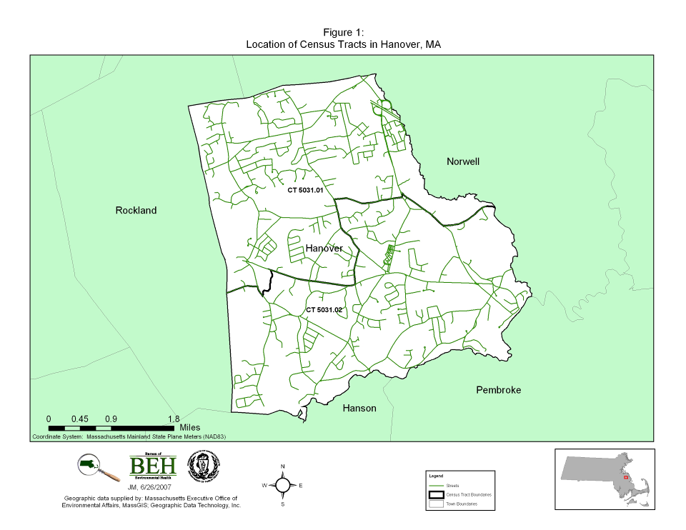
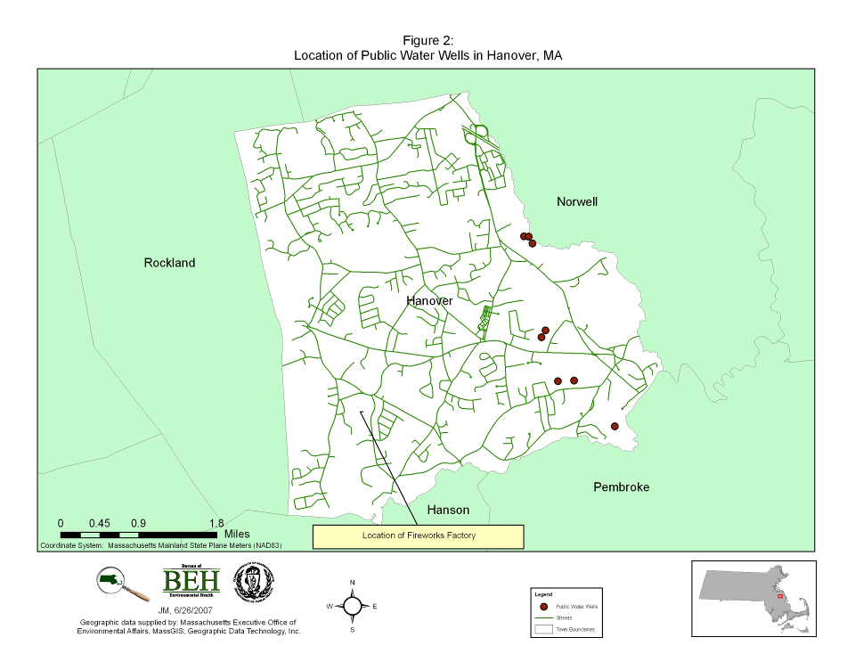

Appendix A:
Explanation of a Standardized Incidence Ratio (SIR)
And 95% Confidence Interval

Explanation of a Standardized Incidence Ratio (SIR)
And 95% Confidence Interval

In order to evaluate cancer incidence a statistic known as a standardized incidence ratio (SIR) was calculated for each cancer type. An SIR is an estimate of the occurrence of cancer in a population relative to what might be expected if the population had the same cancer experience as some larger comparison population designated as “normal” or average. Usually, the state as a whole is selected to be the comparison population. Using the state of Massachusetts as a comparison population provides a stable population base for the calculation of incidence rates. As a result of the instability of incidence rates based on small numbers of cases, SIRs were not calculated when fewer than five cases were observed.

Specifically, an SIR is the ratio of the observed number of cancer cases to the expected number of cases multiplied by 100. An SIR of 100 indicates that the number of cancer cases observed in the population evaluated is equal to the number of cancer cases expected in the comparison or “normal” population. An SIR greater than 100 indicates that more cancer cases occurred than expected and an SIR less than 100 indicates that fewer cancer cases occurred than expected. Accordingly, an SIR of 150 is interpreted as 50% more cases than the expected number; an SIR of 90 indicates 10% fewer cases than expected.

Caution should be exercised, however, when interpreting an SIR. The interpretation of an SIR depends on both the size and the stability of the SIR. Two SIRs can have the same size but not the same stability. For example, an SIR of 150 based on 4 expected cases and 6 observed cases indicates a 50% excess in cancer, but the excess is actually only two cases. Conversely, an SIR of 150 based on 400 expected cases and 600 observed cases represents the same 50% excess in cancer, but because the SIR is based upon a greater number of cases, the estimate is more stable. It is very unlikely that 200 excess cases of cancer would occur by chance alone.

To determine if the observed number of cases is significantly different from the expected number or if the difference may be due solely to chance, a 95% confidence interval (CI) was calculated for each SIR. A 95% CI assesses the magnitude and stability of an SIR. Specifically, a 95% CI is the range of estimated SIR values that has a 95% probability of including the true SIR for the population. If the 95% CI range does not include the value 100, then the study population is significantly different from the comparison or “normal” population. “Significantly different” means there is less than 5% percent chance that the observed difference is the result of random fluctuation in the number of observed cancer cases.

For example, if a confidence interval does not include 100 and the interval is above 100 (e.g., 105-130), then there is statistically significant excess in the number of cancer cases. Similarly, if the confidence interval does not include 100 and the interval is below 100 (e.g., 45-96), then the number of cancer cases is statistically significantly lower than expected. If the confidence interval range includes 100, then the true SIR may be 100, and it cannot be concluded with sufficient confidence that the observed number of cases is not the result of chance and reflects a real cancer increase or decrease. Statistical significance is not assessed when fewer than five cases are observed.

In addition to the range of the estimates contained in the confidence interval, the width of the confidence interval also reflects the stability of the SIR estimate. For example, a narrow confidence interval (e.g., 103--115) allows a fair level of certainty that the calculated SIR is close to the true SIR for the population. A wide interval (e.g., 85--450) leaves considerable doubt about the true SIR, which could be much lower than or much higher than the calculated SIR. This would indicate an unstable statistic.

Appendix B:
Risk Factor Information for Thyroid Cancer
The American Cancer Society estimates that thyroid cancer will affect 30,180 people in the U.S. in 2006, accounting for 2% of all cancers diagnosed in the United States among females and 1% among males (ACS 2006). In Massachusetts, thyroid cancer accounts for approximately 1.6% of all cancers diagnosed among males and females combined (MCR 2005). Females are more likely to develop thyroid cancer than males. The risk of thyroid cancer is highest among individuals between the ages of 20 and 55. A 2% annual increase in the incidence of thyroid cancer in the U.S. is occurring, making thyroid cancer one of the few cancers that has an increasing incidence (ACS 2005). The prognosis for most thyroid cancers is extremely good with a five-year survival rate of approximately 97% (ACS 2005).

There are several different subtypes of thyroid cancer. Eighty percent of thyroid cancers are of the papillary carcinoma subtype. The second most common subtype is follicular carcinoma of the thyroid (10% of thyroid cancers). Other subtypes of thyroid cancer include medullary thyroid carcinoma (3%) and anaplastic carcinoma (2%) (ACS 2005). While thyroid cancer is one of the most common cancers for individuals below 40 years of age, each subtype of thyroid cancer has a different age-specific incidence pattern. Papillary carcinoma has a peak in incidence between 45 and 55 years of age, while follicular carcinomas have a peak in incidence among individuals around the age of 60. Anaplastic carcinomas are rare in individuals under 50, but the incidence increases after 50 years of age (Hall and Adami 2002). Each subtype of thyroid cancer may have different risk factors associated with its development (ACS 2005).

Ionizing radiation is the only established risk factor for thyroid cancer. The earliest indication of radiation exposure causing thyroid cancer occurred in the early part of the 20th century when radiation was used to treat many different diseases of childhood. Numerous epidemiological investigations have looked at several groups of individuals treated with radiation in the early 20th century: children with ringworm of the scalp, infants with enlarged thymus glands, adolescents with enlarged tonsils, children with cancer, young adults with Hodgkin’s disease, patients given whole-body irradiation, and women treated for cervical cancer. These groups all experienced an elevated incidence of thyroid cancer (Hall and Adami 2002). There is also a marked increase in the incidence of thyroid cancer among atomic bomb survivors in Japan. Presently, exposure to ionizing radiation is limited in the United States. Individuals receiving treatment for certain cancers may receive ionizing radiation. Also, certain occupations may expose individuals to ionizing radiation on a regular basis. However, data on the occupational risks of ionizing radiation are inconclusive.

Exposure to ionizing radiation in childhood appears to be more strongly linked with the development of thyroid cancer than exposure in adulthood. For thyroid cancer the latency period (i.e., the time period between exposure to an environmental risk factor and the development of clinically significant disease) is thought to be 10 to 25 years or longer (Upton 1998).

Approximately 3% of individuals diagnosed with thyroid cancer have a family history of the disease. Individuals with a genetic predisposition for thyroid cancer are more likely to develop the medullary thyroid carcinoma subtype (Ron 1996). Familial thyroid cancer is also more aggressive in nature than sporadic (non-familial) thyroid cancer. Individuals with certain inherited medical conditions are also at higher risk of thyroid cancer. Higher rates of thyroid cancer occur among people with conditions such as Gardner syndrome and familial polyposis. These conditions also increase a person’s risk for developing colorectal cancer as well as other types of cancer (ACS 2005).

Few other risk factors for thyroid cancer are known. A diet low in iodine may increase the risk of follicular carcinomas (ACS 2005). However, this is not generally considered a cause of thyroid cancer among individuals in the U.S. as salt in the United States is fortified with iodine.

References

American Cancer Society. 2006. Cancer Facts & Figures 2006. Atlanta: American Cancer Society, Inc.

American Cancer Society. 2005. Detailed Guide: Thyroid Cancer. Available at: http://www.cancer.org. Cited March 30, 2006.

Hall P and Adami H. 2002. Thyroid Cancer. In: Textbook of Cancer Epidemiology. Adami H, Hunter D and Trichopoulus D. Eds. New York: Oxford University Press.

Massachusetts Cancer Registry (MCR). 2005 Cancer Incidence and Mortality in Massachusetts - Statewide Report 1998-2002. Available at: http://www.mass.gov/dph/pubstats.htm November 2005.

Ries LAG, Eisner MP, Kosary CL, Hankey BF, Miller BA, Clegg L, Mariotto A, Feuer EJ, Edwards BK (eds). 2005. SEER Cancer Statistics Review, 1975-2002, National Cancer Institute. Bethesda, MD, http://seer.cancer.gov/csr/1975_2002/, based on November 2004 SEER data submission, posted to the SEER web site 2005.

Ron E. 1996. Thyroid Cancer. In: Cancer Epidemiology and Prevention. Schottenfeld D and Fraumeni JF. Eds. New York: Oxford University Press.

Upton AC. 1998 Ionizing Radiation. In: Occupational and Environmental Medicine. Rom WN, Ed. Philadelphia: Lippincott-Raven.

The data summarized here are drawn from data entered on MCR computer files before June 28, 2007. The numbers presented may differ slightly from those published in previous or future reports, reflecting late reported diagnoses, address corrections, or other changes based on subsequent details from reporting facilities.
Using different population estimates or statistical methodologies, such as grouping ages differently or rounding off numbers at different points during calculations, may produce results slightly different from those published here.

