**EVEREST HOSPITAL, LLC**

**DON APPLICATION #23101112-TO**

**ATTACHMENTS**

**TRANSFER OF OWNERSHIP**

**Vibra Hospital of Western Massachusetts - Central Campus**

**March 18, 2025**

**EVEREST HOSPITAL, LLC**

**DON APPLICATION # 23101112-TO**

TABLE OF CONTENTS

1. Determination of Need Narrative
2. Exhibits to the Determination of Need Narrative
3. Notice of Material Change
4. Notice of Intent
5. Factor 4 – Independent CPA Analysis
6. Certificate of Organization
7. Affidavit of Truthfulness and Compliance
8. Filing Fee

**EXHIBIT 1**

**DETERMINATION OF NEED NARRATIVE**

# 2. Project Description

The Applicant proposes to become the owner of Vibra Hospital of Western Massachusetts – Central Campus, a 47-bed Long Term Acute Care Hospital (“LTCH”) located in Leicester (Rochdale), Massachusetts (the “Hospital”). Pursuant to a Contract of Sale (the “Sales Agreement”) and Operations Transfer Agreement (the “OTA”) each dated May 11, 2023, by and among Applicant and Vibra Hospital of Western Massachusetts, LLC and its parent organization, Vibra Healthcare II, LLC (collectively, “Vibra”), Applicant will acquire the Hospital, including all real property on which the facility is located and personal and intangible property associated with operating the Hospital. As part of the same transaction, Applicant will also acquire The Meadows of Central Massachusetts, a Skilled Nursing Facility located at the same address as the Hospital (the “SNF”).

# 6.5 Explain why you believe this most closely characterizes the Proposed Project

The Applicant has entered into two agreements with Vibra Hospital of Western Massachusetts, LLC, the current licensee of the Hospital and the SNF. The first agreement is the Sales Agreement under which the Applicant will acquire the real property associated with the Hospital. The second agreement is the OTA by which the Hospital operations would transfer to the Applicant after receipt of certain regulatory approvals and simultaneous with closing under the Sales Agreement.

# 6.6 In context of responding to each of the Required Factors 1, 3 and 4, consider how the proposed transaction will affect the manner in which the Applicant serves its existing Patient Panel in the context of value (that is cost and quality), and describe the impact to the Patient Panel in the context of Access, Value (price, cost, outcomes), and Health Disparities.

The Applicant does not anticipate any changes in the Hospital’s services in connect with the proposed transaction, whether in respect to any of the Hospital’s reimbursement rates, care referral patters and access to needed services.

# 13. Factors

F.1.a.i Patient Panel

**Describe your existing Patient Panel, including incidence or prevalence of disease or behavioral risk factors, acuity mix, noted health disparities, geographic breakdown expressed in zip codes or other appropriate measure, demographics including age, gender and sexual identity, race, ethnicity, socioeconomic status and other priority populations relevant to the Applicant's existing patient panel and payer mix.**

The Hospital is an LTCH that is licensed by the Department of Public Health (“DPH”) as a non-acute hospital[1]. As an LTCH, the Hospital provides extended medical and rehabilitative care to inpatients with clinical complex problems such as multiple acute or chronic conditions who require an average length of stay of greater than 25 days.[2] The LTCH does not have an emergency room and patients are typically transferred to an LTCH from the intensive care unit of an acute care hospital. An LTCH patient requires an extended hospital stay with daily physician visits, 24 hour respiratory and nursing care. Medicare sets out specific criteria requiring an LTCH to only admit patients following an acute care hospital stay where (a) the patient’s stay included at least 3 days in an intensive care unit, or (b) the LTCH case receives a principal diagnosis indicating the receipt of mechanical ventilation services for at least 96 hours[3]. Medicare also requires an LTCH to have an average length of stay greater than 25 days.[4] This results in LTCHs caring for a medically complex patients who are functionally compromised, incapable of participating in therapy, and have long lengths of stay. LTCHs also provide cost advantages for the overall care continuum, whereby these medically complex patients can receive the highly specialized and resource intensive care they require in a setting that is equipped to deliver such care.

As set forth on Exhibit A, from January 1, 2020 through December 31, 2024[5], the Patient Panel[6] had an average of approximately 275 patients each year.[7]

The following describes the Patient Panel in more detail:

|  |  |
| --- | --- |
| Gender: | 40.3% of the Patient Panel identified as Female and 59.7% as Male. |
| Age: | 54.5% of the Patient Population is aged 18 to 64 and 45.5% of the Patient Population is age 65+. The Patient Population does not include any patients age 17 or younger. |
| Referral Sources  and Patient Origin: [8] | The Hospital, like the other LTCHs in Massachusetts, serves the entire Commonwealth. As noted above, LTCHs provide care to inpatients who require extended medical and rehabilitative care with clinical complex problems such as multiple acute or chronic conditions who require an average length of stay of greater than 25 days. Patients are typically transferred to an LTCH from the intensive care unit of an acute care hospital. There are no referrals from community-based providers. The medical criteria for admission requires one of the following interventions: ventilator, trach care, chest tubes, frequent suctioning, total parenteral nutrition, telemetry, intravenous (“IV”) drips, IV antibiotics, and complex wounds. The majority of the Hospital’s referral sources are acute care hospitals located in Central and Western Massachusetts, primarily from Worcester and Springfield and the surrounding areas.[9] |
| Payor Mix: | The Hospital primarily serves a large public payor mix. From January 1, 2020 through December 31, 2024 the public payor mix was 75.3% broken down as follows: 47.2% Medicare and Managed Medicare and 28.1% Medicaid and Managed Medicaid. The remaining 24.7% of the payor mix includes commercial pay and other. |
| Length of Stay: | As noted above, the Hospital provides care to inpatients who have medical or respiratory complexities that require daily physician intervention and intensive treatment and require an average length of stay of greater than 25 days. The average length of stay for a patient during this period was 35.35 days. |

## F1.a.ii Need by Patient Panel

**Provide supporting data to demonstrate the need for the Proposed Project. Such data should demonstrate the disease burden, behavioral risk factors, acuity mix, health disparities, or other objective Patient Panel measures as noted in your response to Question F1.a.i that demonstrates the need that the Proposed Project is attempting to address. If an inequity or disparity is not identified as relating to the Proposed Project, provide information justifying the need. In your description of Need, consider the principles underlying Public Health Value (see instructions) and ensure that Need is addressed in that context as well.**

LTCHs serve a crucial role by treating the sickest patients who need extended hospital stay[10]. LTCHs serve a high-acuity patient mix that requires specialized clinical teams and programs for respiratory, infectious disease and other comorbidities.[11] The top five diagnosis from the period of 2020-2024 at the time admission at the Hospital are: respiratory failure, respiratory system diagnosis with ventilator support, aftercare (with complication or comorbidity or a major complication or comorbidity), renal failure and respiratory infections. Exhibit B. These conditions require particularized care and expertise when presented alongside one or more other chronic conditions such as cardiovascular disease, infectious disease, and stroke. This extended stay includes daily physician visits, 24 hour respiratory and nursing care as well as a multidisciplinary team including physical therapy, occupational therapy, speech therapy and respiratory therapy. The Hospital is invaluable to ensuring that the residents of Central and Western Massachusetts have access to long-term hospital services so that the acute care hospitals in the region can appropriately discharge patients in need of prolonged hospital care to the appropriate level and free up acute care beds for more acute care needs. The closure of Vibra Hospital of Western Massachusetts in Springfield on August 17, 2023 along with the closure of a number of regional skilled nursing facilities in recent years[12] has widened the already existing gaps in patients’ access to post-acute services. See Section F1.b.i for the discussion on throughput challenges. The Proposed Project will ensure that the Hospital’s services continue in the community.

The Applicant anticipates maintaining the Hospital’s current accreditation with The Joint Commission (TJC). The Applicant will also evaluate the Hospital’s historical patient panel to determine what, if any, other services or programs should be implemented. The Applicant plans to utilize standard policies and procedures in a systematic way to ensure the Hospital is delivering safe and effective care, one example being procedures for care coordination with the SNF, as described further below.

## F1.a.iii Competition

**Provide evidence that the Proposed Project will compete on the basis of price, total medical expenses, provider costs, and other recognized measures of health care spending. When responding to this question, please consider Factor 4, Financial Feasibility and Reasonableness of Costs.**

The Hospital is a certified Medicare and MassHealth provider that services the entire Commonwealth and as noted above has a large public payer mix (approximately 75.3%). The Applicant anticipates that the Proposed Project will either have a net neutral impact or reduce the Hospital’s total medical expenses (TME). Under the Proposed Project, the Hospital will continue to provide chronic care hospital level services to patients with an average hospital stay greater than 25 days. The Applicant is committed to focusing on providing access to LTCH services to Central and Western Massachusetts and having local leadership on site and involved in the day-to-day operations.

On the clinical side, the Applicant will continue to maximize the LTCH services that it provides to reduce the burden on acute care hospitals by providing a collaborative continuum of care. As noted above, the Hospital shares a campus with the SNF. This allows for clinical coordination so that patients can “step-down” to sub-acute settings when they no longer need hospital level care[13]. Patients with chronic long-term needs will have access to the appropriate setting where the Applicant will continue to implement its best practices to both reduce and prevent hospital readmissions and improve patients’ quality of life. The shared campus also allows for operational efficiencies through the sharing of certain back office services such as housekeeping and dining and allows for consolidated purchasing. Finally, Applicant has identified additional under-utilized services including rehabilitation, dialysis, and telemetry that it will explore expanding to optimize the Hospital’s services.

## F1.b.i Public Health Value /Evidence-Based

**Provide information on the evidence-base for the Proposed Project. That is, how does the Proposed Project address the Need that Applicant has identified.**

The Proposed Project continues to be a resource to alleviate the chronic throughput challenges faced across the Commonwealth[14]. Despite the ending of the COVID-19 Public Health Emergency, the health care system continues to face stressors exacerbated by this “throughput” backlog: As of December 2024, 294 patients across 38 Massachusetts acute care hospitals, comprising 14.7% of all reported patients, awaited discharge to LTCH or IRF settings.[15] Of those patients awaiting discharge to an LTCH or IRF, 23% were waiting for more than thirty (30) days.[16] The majority of the patients awaiting discharge to an LTCH are in the Central Region and can be served by the Hospital.[17] This backlog prevents patients from reaching their appropriate care settings and further burdens providers who must provide care at levels they are not otherwise prepared for. For LTCH patients with comorbidities and medically complex post-acute care needs that require specialized treatment, the impact of this backlog is particularly serious and underscores the importance of LTCHs to the care continuum.[18]

LTCHs are not only an important link in the care continuum, they have positive clinical implications for their patients. Patients benefit from extended acute care for various illnesses including respiratory issues, wounds/wound debridement, gastrointestinal infections, traumatic brain injuries, hemodialysis, long term IV medication and spinal cord injuries, as well as lower readmission rates to already overburdened acute hospitals. Once patients are discharged from LTCHs, evidence shows improved outcomes for those who received ventilator weaning in the LTCH setting.[19] Studies also show that patients with complex medical illnesses which do not require ventilation also benefit from LTCH services.[20]

By continuing to offer LTCH services, the Applicant will ensure that patients with chronic long-term needs have access to the appropriate care setting. In addition, the Applicant will leverage its expertise in long-term care settings to implement effective step-down processes to facilitate patients’ transition to a skilled nursing facility, home health agency, or other post-acute setting, as further described in F1.c below. Finally, Applicant plans to execute a comprehensive quality assurance program as described in F1.b.iv below.

## F1.b.ii Public Health Value /Outcome-Oriented

**Describe the impact of the Proposed Project and how the Applicant will assess such impact. Provide projections demonstrating how the Proposed Project will improve health outcomes, quality of life, or health equity. Only measures that can be tracked and reported over time should be utilized.**

The Applicant anticipates that the Proposed Project will improve health outcomes and quality of life through its standardized clinical practices, disease specific programs and best practices.

*Assessing the Impact of the Proposed Project*

To assess the impact of the Proposed Project, the Applicant developed the following measures discussed below:

1. Patient Satisfaction. The Applicant will review patient satisfaction levels with LTCH services.

Measure: The Hospital’s Exceptional Care program will be provided to all eligible patients. The program focus on the following key areas:

* Delivering exceptional experiences for our patients
* Ensuring safe and quality outcomes
* Engaging our patients and their loved ones in their care plan

Projections: Since the Proposed Project has not occurred, the Applicant will establish a benchmark of 92% for the overall rating of care.

Monitoring: Any category receiving less than national benchmark will be evaluated and policy changes instituted as appropriate. Metrics will be reviewed monthly.

1. Clinical Quality.
   1. Vent Wean Rates. As noted above, one of the top five diagnosis for the Hospital is respiratory illness. This measure evaluates the number of patients that are weaned from ventilators, i.e. decreasing the degree of ventilator support and allowing the patient to assume a greater proportion of their own ventilation.

Measure: The wean rate is determined by the number of patients on a ventilator at admission that are successfully weaned (≥48 hours) at the time of discharge.

Projections: The Hospital has demonstrated a wean rate from ventilators that is higher than the national average. For the reporting period of April 1, 2023 through March 30, 2024, the Hospital reported a wean rate of 67.5% compared to the national average of 52.9%.[21] Since the Proposed Project has not occurred, the Applicant will maintain its wean rate of 67.5% for this measure and reassess as Applicant collects data.

Monitoring: Reviewed monthly

* 1. New or Worsened HAPUs[22]. LTCHs by their nature serve chronic conditions that include complex wounds. For the reporting period of April 1, 2023 through March 30, 2024, the Hospital reported that 9.5% of its patients had any stage of pressure ulcers that were new or worsened, compared to the national average of 2.4%.

Measure: The number of patients with Stage 2-4 pressure ulcers, or unstageable pressure ulcers due to slough/eschar, non-removable dressing/device, or deep tissue injury, that were not present or were at a lesser stage on admission.

Projections: Since the proposed project has not occurred, the Applicant plans to collect and assess the relevant patient data and address areas of need with respect to this measure. Applicant’s provisional projected discharge rates for this measure are as follows: 7.2% at the end of Year 1; 4.9% in Year 2; and 2.5% in Year 3, consistent with the national average. As stated above, Applicant will reassess its projections as it collects data and further familiarizes itself with the patient population.

Monitoring: Reviewed quarterly

F1.b.iii Public Health Value /Health Equity-Focused

**For Proposed Projects addressing health inequities identified within the Applicant's description of the Proposed Project's need base, please justify how the Proposed Project will reduce the health inequity, including the operational components (e.g. culturally competent staffing). For Proposed Projects not specifically addressing a health disparity or inequity, please provide information about specific actions the Applicant is and will take to ensure equal access to the health benefits created by the Proposed Project and how these actions will promote health equity.**

The Applicant complies with all applicable federal and state laws and does not discriminate on the basis of race, color, national origin, age, disability or sex. The Applicant will also continue to serve a high mix of government payors including MassHealth beneficiaries. In addition, the Applicant will continue to the Hospital’s current language access program and have culturally and linguistically appropriate language services by providing aids and translation services to patients so that they can communicate effectively with their providers. The Applicant will also provide written information in alternative formats such as large print, audio, and accessible electronic formats.

The Hospital currently works with a nearby correctional center to provide services to its inmates. Incarcerated individuals are a challenging and often overlooked population that is at elevated risk for chronic conditions including pulmonary disorders, in part due to socioeconomic disadvantages and limited access to medical and social services prior to their incarceration.[23] The Applicant anticipates it will continue this work as well as explore additional opportunities to expand its contributions to reduce health inequity in the local community.  For example, it will use the initial year after the closing of the proposed transaction to form community partnerships and educate itself about the community’s health needs[24] so that it can promote health equity specific to its local area. This could involve participating in health fairs to educate on fall prevention, heart healthy lifestyles, nutrition, exercise, supporting local support groups like the American Heart Association or ALS Association, and partnering with other local providers. Furthermore, because the Hospital is located in an area with limited public transportation access, Applicant plans to further explore and implement transportation services programs for eligible patients and their families with access challenges.

## F1.b.iv Additional Information

**Provide additional information to demonstrate that the Proposed Project will result in improved health outcomes and quality of life of the Applicant's existing Patient Panel, while providing reasonable assurances of health equity.**

After closing of the proposed transaction, the Applicant plans to review the Hospital’s current comprehensive quality assurance program to discuss areas of focus to improve quality and delivery of care for the Patient Panel while continuing to promote health equity. At the Applicant’s suggestion, the Hospital has already started implementing regular staff meetings to address already identified areas for improvement, such as reducing Hospital readmissions, implementing documentation best practices, and increasing patient satisfaction – a practice that the Applicant will continue under the Proposed Project. This emphasis on ongoing training and communication is only one part of the Applicant’s quality assurance program. Under the Applicant, Hospital leadership overseeing the quality assurance program will be involved in the day-to-day operations and will be comprised of individuals from the Applicant’s experienced team who understand the community and the Patient Panel.

During the initial year of the Proposed Project, the Applicant will collect and analyze the Hospital’s historic patient outcomes and operations to identify areas for advancement, then set baselines and establish goals to work towards improvement. Such work may include adding evidenced based service lines/programs as needed to ensure access or updating the facility to address patient satisfaction. Additionally, the Applicant will draw upon its vast long-term care expertise to identify areas for development or improvement in the Hospital’s discharge coordination processes with nursing homes and other relevant post-acute care settings. The intent is to provide the right care at the right cost effective and clinically appropriate setting.

The Applicant will continue to collaborate with other organizations in the state to enhance patient quality and outcomes. This will be accomplished in part by adding new clinical expertise to the medical leadership team at both the Hospital and SNF who will be closely involved in establishing transition policies and protocols between the facilities. Better coordination enables the Hospital to anticipate the care needed upon the patient’s return back to the Hospital and contributes to a smoother transition for the patient.

Historically, the Hospital’s Medicare Care Compare quality scores have been comparable or better than other area LTCHs in several areas including ventilator wean rates, complications, care assessment, readmission rates, and patients’ successful return to the community.[25] The Applicant expects to maintain such quality standards under the Proposed Project. However, the Applicant will continue to explore opportunities to further improve and innovate areas of quality for better outcomes at both the Hospital and the SNF.

## F1.c Continuity and Coordination of Care

**Provide evidence that the Proposed Project will operate efficiently and effectively by furthering and improving continuity and coordination of care for the Applicant's Patient Panel, including, how the Proposed Project will create or ensure appropriate linkages to patients' primary care services.**

The Applicant’s goal is to ensure that patients are discharged to the most appropriate level of care. It will conducts daily evaluations of patient’s clinical and physical capabilities and, in collaboration with the patient, patient’s physician, and family, review discharge goals. As previously mentioned, the Applicant’s case management and clinical personnel will communicate regularly with the SNF to enable cohesive transfer of patients between the facilities as appropriate for each patient’s individual needs. The Applicant will also coordinate home discharges with the patient and their care team to ensure proper durable medical equipment and community support is provided, as needed.

At admission and upon patient request, the Applicant will notify the patient’s primary care provider. The patient’s attending physician at the Hospital will communicate with the patient’s primary care provider throughout the patients’ stay as needed. Upon discharge, the patient discharge information will be provided to the patient’s primary care provider and directed follow-up appointments will be made as directed.

Senior members of the Applicant’s team have deep experience working in post-acute care and will be focusing on the integration of services specifically with area SNF operations. The Applicant is committed to working with Vibra’s Hospital leadership to understand its current operations and systems. By connecting the new and old leadership, the Hospital aims to fortify the institutional knowledge of its personnel with new ideas and expertise, already leading to improved staff coverage and qualifications at both the Hospital and the SNF and ideas for improving care coordination, particularly when addressing the challenges of transitioning patients from an LTCH to a nursing home or vice versa.

Additionally, the Applicant is anticipating having a consulting agreement with another regional LTCH provider with over 20 years of experience who will be able to provide the Applicant with operational support following the closing of the proposed transaction. This includes assistance with admissions, marketing, provider contracting, case management, and revenue cycle. The Applicant is committed to continuing to work towards improvements in staff coverage and customer service. The Applicant plans to connect with other regional providers to establish strong working relationships with the Hospital which will further improve patients’ journey throughout the care continuum.

## F1.d Consultation with Government Agencies

**Provide evidence of consultation, both prior to and after the Filing Date, with all Government Agencies with relevant licensure, certification, or other regulatory oversight of the Applicant or the Proposed Project.**

The Applicant and its representatives have had discussions with the Department of Public Health Determination of Need Program, Division of Health Care Facility Licensure and Certification, the Health Policy Commission, and MassHealth’s Office of Long-term Services and Supports.

## F1.e.i Process for Determining Need/Evidence of Community Engagement

**For assistance in responding to this portion of the Application, Applicant is encouraged to review *Community Engagement Standards for Community Health Planning Guideline*. With respect to the existing Patient Panel, please describe the process through which Applicant determined the need for the Proposed Project.**

In advance of the Proposed Project, the Applicant has slowly begun to interface with the area healthcare systems who comprise the Hospital’s referral sources and community senior centers to inform them of the transition. UMass Memorial Medical Center, Baystate Health System, Cooley Dickinson Hospital and Heywood Hospital are just a few. This outreach consisted of in-person meetings or telephone calls with senior members of the Applicant’s team. This personalized outreach directly engages the Applicant with the community to better understand the needs of the Patient Panel.

In addition, the Applicant made the following public announcements about the Proposed Project:

1. A live zoom presentation regarding the Proposed Project was held on October 29, 2024. The presentation was created by the Applicant’s senior leadership. The notice of the live

presentation was sent and/or provided to Hospital patients, staff and community partners and included a copy of the presentation embedded with the notice. The notice also invited the community to submit written comments/questions in advance of the presentation. On the day of the presentation, the Applicant was on the live zoom for 30 minutes but no one dialed into the presentation. The Applicant also did not receive any written comments or feedback. The presentation reviewed the purpose of the Proposed Project, what it would mean for patients and the community and provided a general overview of the Proposed Project’s process. See Exhibit 11.

1. A Notice of Intent regarding the Proposed Project was published in Worcester Telegram and Gazette on February 14, 2024.

## F1.e.ii Community Engagement

**Please provide evidence of sound Community Engagement and consultation throughout the development of the Proposed Project. A successful Applicant will, at a minimum, describe the process whereby the “Public Health Value” of the Proposed Project was considered, and will describe the Community Engagement process as it occurred and is occurring currently in, at least, the following contexts: Identification of Patient Panel Need; Design/selection of DoN Project in response to “Patient Panel” need; and Linking the Proposed Project to “Public Health Value”.**

To ensure sound community engagement for the Proposed Project, the Applicant took the actions described above. The Applicant has also met with referral sources and community providers individually over the past year. Upon approval of Proposed Project, the Applicant will undertake a more in-depth community-wide engagement campaign, including, but not limited to, issuing press releases to local media outlets to inform the Patient Panel and the local community of the transfer of ownership. The Applicant also plans to hold a grand re-opening event for the community upon the completion of its regulatory filings. The Applicant will also reconstitute the Patient and Family Advisory Council, which has been dormant, to advise on Hospital matters including patient and provider relationships, institutional review boards, quality improvement initiatives, and patient education on safety and quality matters to the extent allowed by state and federal law.

## Factor 2: Health Priorities

**Addresses the impact of the Proposed Project on health more broadly (that is, beyond the Patient Panel) requiring that the Applicant demonstrate that the Proposed Project will meaningfully contribute to the Commonwealth's goals for cost containment, improved public health outcomes, and delivery system transformation.**

F2.a Cost Containment

**Using objective data, please describe, for each new or expanded service, how the Proposed Project will meaningfully contribute to the Commonwealth's goals for cost containment.**

The Applicant plans to work in partnership with its primary referral sources (acute care hospitals) to ensure that patients are receiving care in the appropriate setting on the care continuum. Getting patients with chronic needs who are in need of long-term acute hospital services into the correct setting opens up capacity at the acute care hospitals. These programs along with the Applicant’s quality assurance programs aimed at improving quality of care and health outcomes will contribute to the Patient Panel’s quality of life which in turn will reduce the burden on the acute hospital system and allow for more discharges to the appropriate long-term care setting and/or ultimately, home. Applicant’s plan to improve care coordination at the time of discharge is part of its strategy for reducing preventable and costly hospital readmissions.[26] Hospital physicians, with the Applicant’s encouragement, have already established a renewed focus on addressing preventable readmissions. Collectively, this will all contribute to the Commonwealth’s goals for cost containment.

For example, during the COVID-19 Public Health Emergency, LTCHs have served an important role. When acute care hospitals were overwhelmed during the surges and lacked the capacity to care for patients with higher needs, LTCHs were available to care for long-haul COVID-19 patients that were stable but required a high level of support. The presence of LTCHs in a market enable short-term acute care hospitals to clear beds, often ICU beds, to treat other COVID-19 and non COVID-19 patients. LTCHs are particularly adept and experienced in the treatment of high acuity patients, such as those suffering from COVID-19 and needing placement on a ventilator.

F2.b Public Health Outcomes

**Describe, as relevant, for each new or expanded service, how the Proposed Project will improve public health outcomes.**

As noted above, the Applicant will review the Hospital’s comprehensive quality assurance program to determine what, if any, changes should be implemented. As previously mentioned, the Applicant is planning to bring a renewed focus to its rehabilitation, dialysis, and telemetry services to provide comprehensive care and optimize its resources. Despite its plans for service expansion, the Applicant is committed to maintaining its high standards with respect to its current areas of specialization: The Hospital has demonstrated a wean rate from ventilators that is higher than the national average. The wean rate is determined by the number of patients on a ventilator that are successfully weaned (>48 hours) at the time of discharge. The Hospital’s reported a wean rate of 67.5% compared to the national average of 53%.[27] The Applicant will bring these clinical practices and its expertise to the Proposed Project to improve the public health outcomes for the Patient Panel.

## F2.c Delivery System Transformation

**Because the integration of social services and community-based expertise is central to goal of delivery system transformation, discuss how the needs of their patient panel have been assessed and linkages to social services organizations have been created and how the social determinants of health have been incorporated into care planning.**

The Applicant, who has extensive experience in post-acute care brings decades of case management experience to both the Hospital and the SNF. The close proximity of the SNF offers the Hospital unique insight into the needs and challenges of the subsequent link in the care continuum and enables both facilities to work cohesively to identify post-discharge challenges as soon as the patient is hospitalized. The Hospital holds regular interdisciplinary team meetings to discuss patient discharge needs, which enables case managers to coordinate with providers such as the SNF that will be involved with the patient’s post-discharge care. Such regular communication between the Hospital and the SNF throughout the duration of a patient’s hospitalization will help ensure that the appropriate providers and programs are involved and consulted well ahead of the patient’s discharge.

The Applicant’s interdisciplinary collaborative discharge planning process focuses on the individualized goals and treatment preferences of the patient to ensure an effective transition of the patient from hospital to post-discharge care, and reduce potential factors leading to preventable hospital readmission. This process is established in the Hospital’s policies and procedures and identifies a number of factors that should be considered in the discharge plan including, but not limited to, patient functionality, patient caregiver supports, financial and social support systems, sociocultural and religious practices, emotional and mental status, and social determinants of health (e.g. availability/accessibility to adequate housing and transportation, language barriers). Collaborative communication in discharge planning is a shared responsibility of the interdisciplinary healthcare team, patient, and designated patient support caregiver. The readiness of and social supports available to patient caregivers are also important considerations under the discharge process.

As part of the discharge process to ensure continuity of care related to patient’s needs, the Applicant makes referrals, as applicable, subject to patient choice and consistent with relevant to the discharge plan and patient goals/preferences of treatment, to extended care providers, community-based resources, durable medical equipment, and/or specialized ambulatory services (physical therapy, occupational therapy, home health, hospice, mental health, wound care, dialysis, infusion clinics, skilled nursing facility, etc.). The Applicant recognizes that post-discharge care requires a variety of resources and works with home care agencies and non-providers as appropriate to address client’s other supportive needs (e.g., working with home improvement retailors to install in-home grab bars and other modifiers, provide special equipment).

The Applicant will also assist patients with scheduling post-discharge follow-up appointments with primary care providers and/or specialists as applicable. The Applicant will ensure the transfer of medically necessary information for continuity of care for post-discharge services and/or follow-up needs of patient. The Applicant will also provide relevant training to the patient and designated supportive caregiver as applicable.

**EXHIBIT 2**

**EXHIBITS TO DETERMINATION OF NEED NARRATIVE**

**Exhibit 2A**

1. Patient Volume and Gender

| **Years** | **Female** | **Male** | **Grand Total** |
| --- | --- | --- | --- |
| 2020 | 144 | 194 | **338** |
| 2021 | 131 | 166 | **297** |
| 2022 | 117 | 175 | **292** |
| 2023 | 87 | 157 | **244** |
| 2024 | 77 | 130 | **207** |

1. Age

|  | **2020** | **2021** | **2022** | **2023** | **2024** |
| --- | --- | --- | --- | --- | --- |
| **0 to 17** | <11 | <11 | <11 | <11 | <11 |
| **18 to 64** | 194 | 156 | 160 | 119 | 120 |
| **65+** | 144 | 141 | 132 | 125 | 84 |
| **Grand Total** | **338** | **297** | **292** | **244** | **204** |

1. Patient Origin

| County | 2020 | 2021 | 2022 | 2023 | 2024 |
| --- | --- | --- | --- | --- | --- |
| Worcester, MA | 177 | 145 | 155 | 141 | 90 |
| Hampden, MA | 74 | 52 | 70 | 56 | 63 |
| Middlesex, MA | 44 | 32 | 28 | 19 | 16 |
| Hampshire, MA | 20 | 14 | <11 | <11 | <11 |
| Franklin, MA | <11 | <11 | <11 | <11 | <11 |
| Essex, MA | 11 | 11 | <11 | <11 | <11 |
| Berkshire, MA | <11 | <11 | <11 | <11 | <11 |
| Norfolk, MA | <11 | <11 | <11 | <11 | <11 |
| Suffolk, MA | <11 | <11 | <11 | <11 |  |
| Bristol, MA | <11 | <11 | <11 | <11 | <11 |
| Schenectady, NY | <11 | <11 | <11 |  |  |
| Providence, RI | <11 | <11 | <11 |  |  |
| Washington, RI | <11 | <11 | <11 |  |  |
| Rockingham, NH | <11 | <11 | <11 |  |  |
| Orange, VT | <11 | <11 | <11 |  |  |
| Hartford, CT | <11 | <11 | <11 |  |  |
| Windham, CT | <11 | <11 | <11 |  |  |
| Putnam, NY | <11 | <11 | <11 |  |  |
| Albany, NY | <11 | <11 | <11 |  |  |
| Rensselaer, NY | <11 | <11 | <11 |  |  |
| Dorchester, SC | <11 | <11 | <11 |  |  |
| St. Lucie, FL | <11 | <11 | <11 |  |  |
| Plymouth, MA | <11 | <11 | <11 | <11 | <11 |
| Hillsborough, NH | <11 | <11 | <11 |  |  |
| Saratoga, NY | <11 | <11 | <11 |  |  |
| Barnstable, MA | <11 | <11 | <11 |  | <11 |
| Cheshire, NH | <11 | <11 | <11 |  |  |
| Sullivan, NH | <11 | <11 | <11 |  |  |
| Strafford. NH | <11 | <11 | <11 |  |  |
| York, ME | <11 | <11 | <11 |  |  |
| Windham, VT | <11 | <11 | <11 |  |  |
| Westchester, NY | <11 | <11 | <11 |  |  |
| Lee, FL | <11 | <11 | <11 |  |  |
| Unspecified | <11 | <11 | <11 |  |  |

1. Race and Ethnicity

| **Ethnicity** | **2023** | **2024** |
| --- | --- | --- |
| Mexican/Mexican American | <11 | <11 |
| Puerto Rican | <11 | <11 |
| Cuban | <11 | <11 |
| Another Hispanic, Latino Origin | 25 | 26 |
| Not of Hispanic, Latino Origin | 215 | 172 |
| Patient unable to respond | <11 | <11 |
| Patient declines to respond | <11 | <11 |
| **Grand Total** | **246** | **207** |

| **Ethnicity** | **2023** | **2024** |
| --- | --- | --- |
| White | 196 | 146 |
| Black/African American | 21 | 19 |
| American Indian or Alaska Native | <11 | <11 |
| Asian Indian | <11 | <11 |
| Chinese | <11 | <11 |
| Filipino | <11 | <11 |
| Japanese | <11 | <11 |
| Korean | <11 | <11 |
| Vietnamese | <11 | <11 |
| Other Asian | <11 | <11 |
| Patient unable to respond | <11 | <11 |
| Patient declines to respond | <11 | <11 |
| None of the above | 24 | <11 |
| **Grand Total** | **246** | **173** |

1. Payor Mix

| **Payors** | **2020** | **2021** | **2022** | **2023** | **2024** |
| --- | --- | --- | --- | --- | --- |
| Commercial | 72 | 60 | 56 | 54 | 74 |
| Medicaid | 54 | 46 | 42 | 48 | 38 |
| Medicare | 104 | 101 | 91 | 66 | 58 |
| Managed Medicaid | 57 | 27 | 39 | 26 | 9 |
| Managed Medicare | 42 | 51 | 64 | 48 | 24 |
| Other | 0 | 12 | 0 | 2 | 1 |
| **Grand Total** | **338** | **297** | **292** | **244** | **204** |

1. Length of Stay by Days

|  |  |  |  |  |  |
| --- | --- | --- | --- | --- | --- |
| **2020** | **2021** | **2022** | **2023** | **2024** | **Avg LOS**  **2020-2024** |
| 30.52 | 33.44 | 40.27 | 37.74 | 34.76 | 35.35 |

**Exhibit 2B**

**Top 5 Annual Admit Diagnosis (2020-2024) by DRG**

| **DRG** | **Description** | | **2020** | **2021** | **2022** | **2023** | **2024** |
| --- | --- | --- | --- | --- | --- | --- | --- |
| 189 | Pulmonary edema & respiratory failure | | 138 | 104 | 122 | 92 | 75 |
| 208 | Respiratory system diagnosis w ventilator support, < 96 hours | | 100 | 111 | 75 | 13 | 50 |
| 207 | Respiratory system diagnosis w ventilator support,  ≥ 96 hours | | <11 | <11 |  | 47 | 11 |
| 539 | Osteomyelitis w MCC | | <11 |  |  |  | <11 |
| 682 | Renal failure w MCC | | <11 |  |  |  | <11 |
| 871 | Septicemia w/o MV 96+ hours w MCC | |  | <11 | <11 |  |  |
| 872 | Septicemia w/o MV 96+ hours w/o MCC | |  |  | <11 |  |  |
| 949 | Aftercare w CC/MCC | |  | 17 | 11 | 11 | <11 |
| 177 | Respiratory infections and inflammation | |  |  |  | <11 |  |
|  | | **Total** | **258** | **241** | **220** | **171** | **151** |

**EXHIBIT 3**

**NOTICE OF INTENT**



**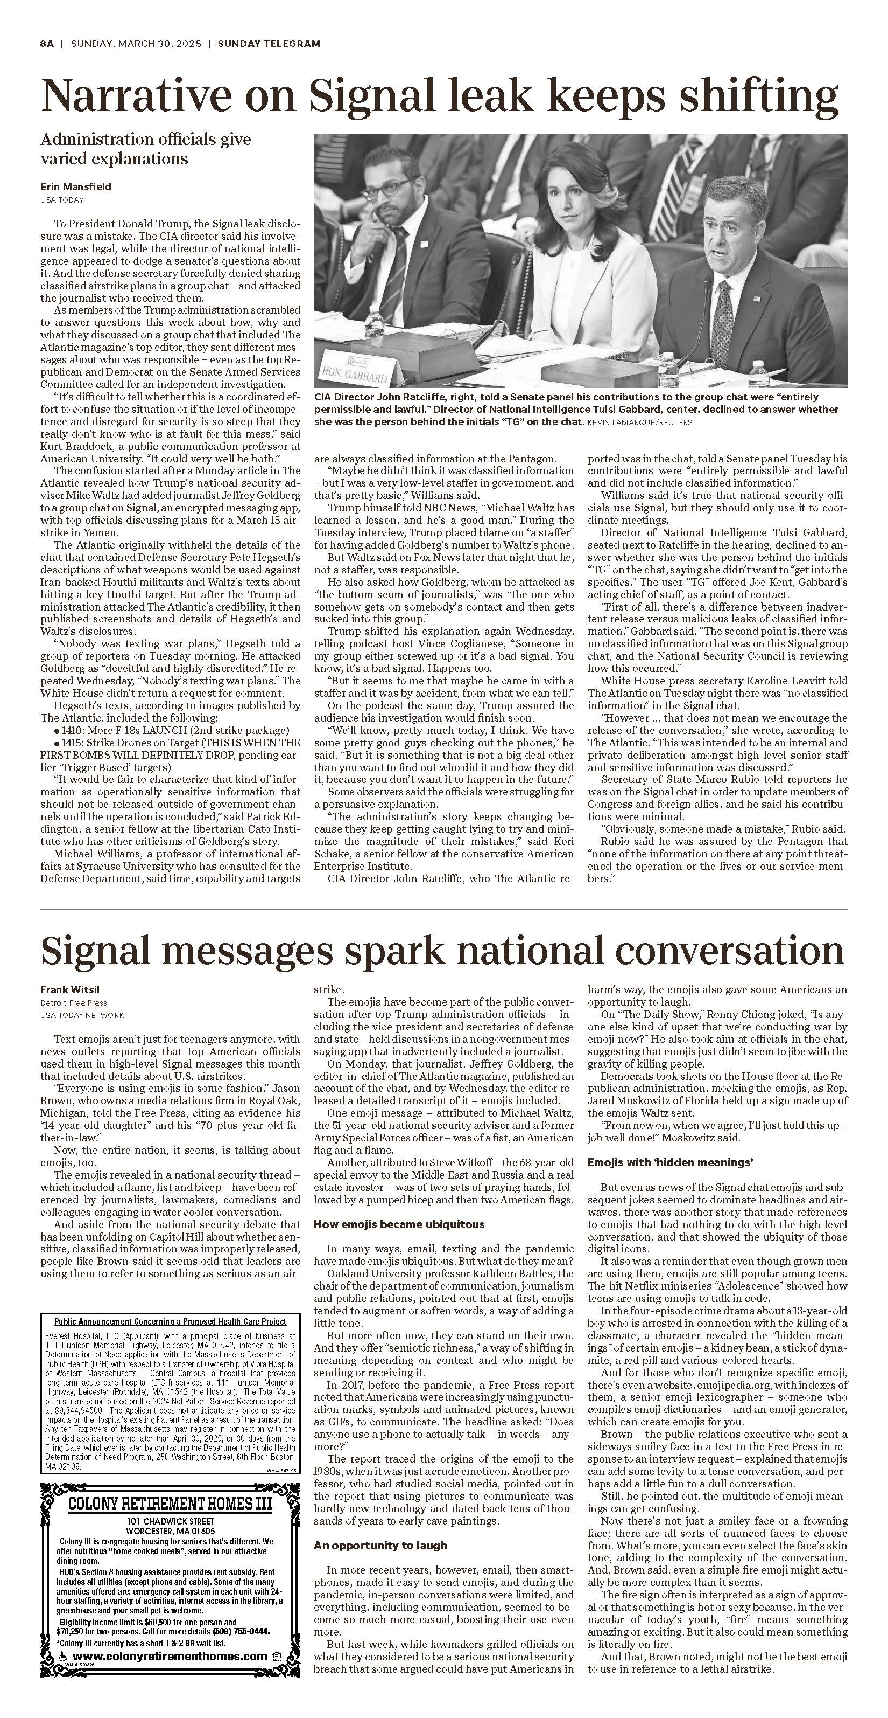  
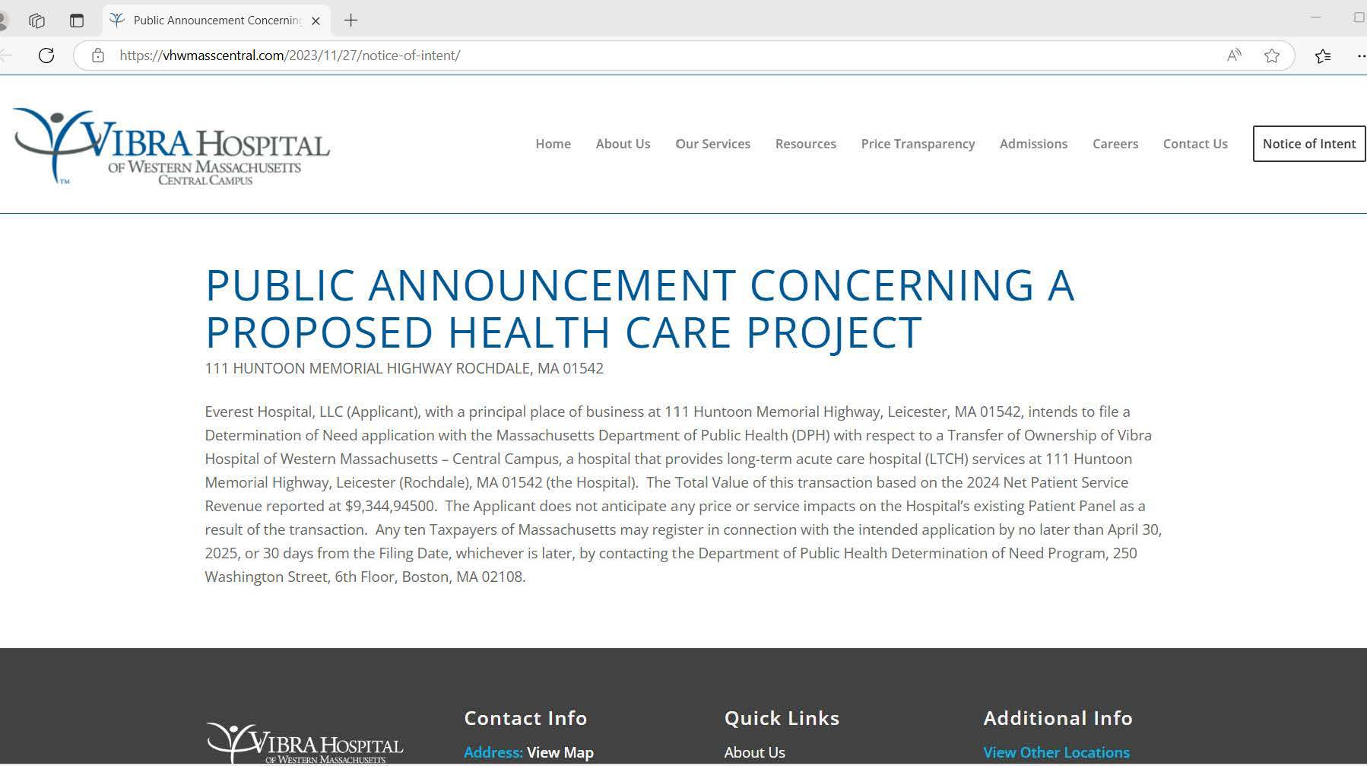**

**EXHIBIT 5**

**FACTOR 4 – INDEPENDENT CPA ANALYSIS**

**[To be Submitted Separately]**

**EXHIBIT 6**

**CERTIFICATE OF ORGANIZATION**

**Certificate of Organization available at**

<https://corp.sec.state.ma.us/CorpWeb/CorpSearch/CorpSummary.aspx?sysvalue=pzcYC5_gp64Q1p1lWL.vNzvEMut0QNQoAc8ycwcq_2E->

**EXHIBIT 7**

**AFFIDAVIT OF TRUTHFULNESS AND COMPLIANCE**

 Version: 7-6-17

**Massachusetts Department of Public Health**

**Determination of Need**

**Affidavit of Truthfulness and Compliance**

**with Law and Disclosure Form 100.405 (B)**

**Instructions**: Complete Information below. When complete check the box "This document is ready to print:". This will date stamp and lock the form. Print Form. Each person must sign and date the form. When all signatures have been collected, scan the document and e-mail to: [dph.don@state.ma.us](mailto:dph.don@state.ma.us) Include all attachments as requested.

Application Number: 23101112-TO

Original Application Date: [blank]

Applicant Name: Everest Hospital, LLC

Application Type: Transfer of Ownership

Applicant's Business Type: LLC

Is the Applicant the sole member or sole shareholder of the Health Facility(ies) that are the subject of this Application? Yes

The undersigned certifies under the pains and penalties of perjury:

1. The Applicant is the sole corporate member or sole shareholder of the Health Facility(ies) that are the subject of this Application;
2. I have ~~read~~ [been informed of the content of] 105 CMR 100.000, the Massachusetts Determination of Need Regulation;
3. I understand and agree to the expected and appropriate conduct of the Applicant pursuant to 105 CMR 100.800;
4. I have ~~read~~ [been informed of the content of] this application for Determination of Need including all exhibits and attachments, and certify that all of the information contained herein is accurate and true;
5. I have submitted the correct Filing Fee and understand it is nonrefundable pursuant to 105 CMR 100.405(B);
6. I have submitted the required copies of this application to the Determination of Need Program, and, as applicable, to all Parties of Record and other parties as required pursuant to 105 CMR 100.405(B);
7. I have caused, as required, notices of intent to be published and duplicate copies to be submitted to all Parties of Record, and all carriers or third-party administrators, public and commercial, for the payment of health care services with which the Applicant contracts, and with Medicare and Medicaid, as required by 105 CMR 100.40S(C), et seq.;
8. I have caused proper notification and submissions to the Secretary of Environmental Affairs pursuant to 105 CMR 100.405(E) and 301 CMR 11.00;
9. If subject to M.G.L c. 6D, § 13 and 958 CMR 7 .00, I have submitted such Notice of Material Change to the HPC – in accordance with 105 CMR 100.40S(G);
10. Pursuant to 105 CMR 100.210(A)(3), I certify that both the Applicant and the Proposed Project are in material and substantial compliance and good standing with relevant federal, state, and local laws and regulations, as well as with all previously issued Notices of Determination of Need and the terms and Conditions attached therein;
11. I have ~~read~~ [been informed of/that] and understand the limitations on solicitation of funding from the general public prior to receiving a Notice of Determination of Need as established in 105 CMR 100.415;
12. I understand that, if Approved, the Applicant, as Holder of the DoN, shall become obligated to all Standard Conditions pursuant to 105 CMR 100310, as well as any applicable Other Conditions as outlined within 105 CMR 100.000 or that otherwise become a part of the final Action pursuant to 105 CMR 100.360;
13. Pursuant to 105 CMR 100.705(A), I ~~certify~~ [been informed of/that] that the Applicant has Sufficient Interest in the Site or facility; and
14. Pursuant to 105 CMR 100.70S(A), I ~~certify~~ [been informed of/that] that the Proposed Project is authorized under applicable zoning by-laws or ordinances, whether or not a special permit is required; or,
    1. If the Proposed Project is not authorized under applicable zoning by-laws or ordinances, a variance has been received to permit such Proposed Project; or,
    2. The Proposed Project is exempt from zoning by-laws or ordinances.

|  |
| --- |
| **LLC**  All parties must sign. Add additional names as needed.  Yedidya Yosef Danziger <Signature on File> 3/13/25  Name: Signature: Date: |

**This document is ready to print:** [unchecked] **Date/time Stamp:** [blank]

**EXHIBIT 8**

**AFFILIATED PARTIES FORM**

**[To be Submitted Separately]**

**EXHIBIT 9**

**CHANGE IN SERVICE FORM**

**[To be Submitted Separately]**

**EXHIBIT 10**

**FILING FEE**

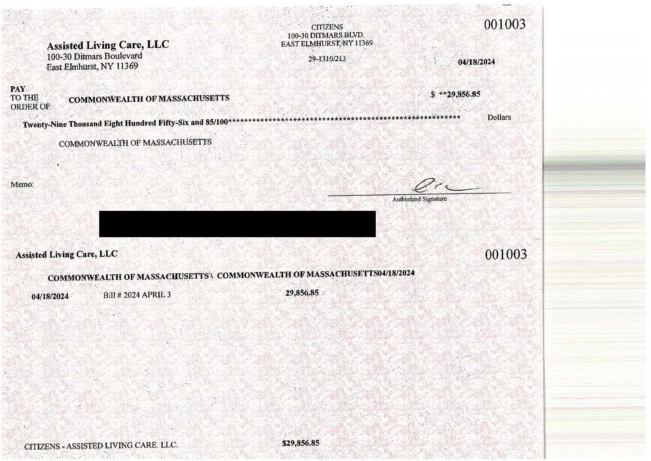

**EXHIBIT 11**

**COMMUNITY ENGAGEMENT PRESENTATION SLIDES**

**[To be Submitted Separately]**

4023\0001\2192818.v1

1. 105 CMR 130.375.
2. 105 CMR 130.020 defines Chronic Care Service as “A service, other than a rehabilitation, psychiatric, substance use disorder, intermediate care facility, or skilled nursing facility service, that has an average length of inpatient stay greater than 25 days and that meets the long-term care hospital patient level criteria issued by the Federal Centers for Medicare and Medicaid Services.”
3. MedPac, [“Long-term Care Hospital Payment Systems”](https://www.medpac.gov/wp-content/uploads/2024/10/MedPAC_Payment_Basics_24_LTCH_FINAL_SEC-2.pdf) (Revised Oct. 2024), at: <https://www.medpac.gov/wp-content/uploads/2024/10/MedPAC_Payment_Basics_24_LTCH_FINAL_SEC-2.pdf>
4. *Id.*
5. CMS put in place certain flexibilities during the COVID-19 Public Health Emergency to reduce administrative burdens and ease throughput (“Covid Waivers”). Covid Waivers were in place for LTCHs from January 2020 (retroactive) through May 2023 (extending through the hospital’s fiscal year Dec. 2023), which allowed them to forgo the Medicare LTCH admission criteria describe in the Application. See, <https://www.cms.gov/files/document/long-term-care-facilities-cms-flexibilities-fight-covid-19.pdf>. Pre-COVID, Vibra’s unique patients in CY 2018 were 361 and CY 2019 were 362.
6. During this period Vibra transitioned electronic medical records (EMR) systems and is unable to provide race/ethnicity data from 2020-2022, which was not collected in the EMR system used during this period.
7. The Applicant is a newly-formed entity, created for the purposes of this proposed transaction, and therefore does not have its own Patient Panel.
8. The majority of the Patient Panel data presented in this Application was collected at discharge; however the patient referrals and zip codes were only available at the time of admission. Because of this, the Hospital is unable to provide patient referral and origin zip codes at discharge but could provide the data recorded at admission. Therefore, the Patient Panel totals for this category do not match with the other categories.
9. Referrals came from UMass University and UMass Memorial Medical Center, Saint Vincent Hospital, Baystate Medical Center, Leominster Hospital, Mercy Medical Center, Brigham and Women’s Hospital, Beverly Hospital, Holyoke Medical Center, Heywood Hospital, Cooley Dickinson Hospital, among several others.
10. See [AHA Fact Sheet: Long-term Care Hospitals](https://www.aha.org/system/files/media/file/2019/04/fact-sheet-ltch-0319.pdf) at: <https://www.aha.org/system/files/media/file/2019/04/fact-sheet-ltch-0319.pdf> (March 2019).
11. *Id.*
12. Closures include the 2023 closures of Willimansett Center East and West, Governor’s Center and Chapin Center; the 2024 closure of Pioneer Valley Health and Rehabilitation Center; and the pending closure of Highview of Northampton.
13. For example, the SNF under current ownership is exploring participating in MassHealth’s program for Specialized Ventilator-Dependent Services. The Applicant has been in communication with leadership at MassHealth’s Office of Long-term Services and Supports and desires to continue exploring if this program is an option for the SNF because it will further enhance the continuum of care and allow the Hospital to discharge patients to a lower acuity setting which will positively impact the Hospital’s TME.
14. The [Massachusetts Health & Hospital Association (MHA)](https://www.mhalink.org/throughputreports/) has documented the monthly throughput challenges since March 2022. See: <https://www.mhalink.org/throughputreports/>. See also, [*A Clogged System: Keeping Patients Moving Through their Care Journey*,](https://mhalink.informz.net/mhalink/data/images/ACloggedSystemMHAReport.pdf) Mass. Health & Hosp. Assn (June 2023), <https://mhalink.informz.net/mhalink/data/images/ACloggedSystemMHAReport.pdf> (showing that as of June 2023, roughly 15% of acute care beds were “tied up” with patients awaiting discharge to post-acute care facilities).
15. [*Throughput Survey Report*,](https://mhalink.informz.net/mhalink/data/images/December%202024%20Throughput%20Survey%20Report%20Draft%20v2.pdf) Mass. Health & Hosp. Assn (Dec. 2024), <https://mhalink.informz.net/mhalink/data/images/December%202024%20Throughput%20Survey%20Report%20Draft%20v2.pdf> .
16. *Id.*
17. *Id.*
18. The backlog facing patients that are transferring to post-acute facilities remains an issue, most recently highlighted by the planned closure of New England Sinai Hospital in Stoughton. (“‘The planned closure of New England Sinai adds yet another layer of fragility to our state’s healthcare system,’ said MHA Vice President of Clinical Affairs Patricia Noga, R.N. ‘We know it is already a massive challenge for patients to find post-acute care services and for hospitals to discharge individuals to the next level of care.’” *Monday Report, New England Sinai Closure Adds to SE Mass. Capacity Problem*, Mass. Health & Hosp. Assn, Electronic mail, Dec. 11, 2023.).
19. See e.g., A. Jubran, B. J.B. Grant, L. A. Duffner et al., *Long-term Outcome after Prolonged Mechanical Ventilation*, 199 Am J. Respiratory & Crit. Care Med. 1508 (June 15, 2019), <https://www.ncbi.nlm.nih.gov/pmc/articles/PMC6580672/pdf/rccm.201806-1131OC.pdf>.
20. See L. Koenig et al., *The Role of Long-term Acute Care Hospitals in Treating the Critically Ill and Medically Complex An Analysis of Nonventilator Patients*, 53 Med. Care 582 (July 2015), <https://journals.lww.com/lww-medicalcare/Fulltext/2015/07000/The_Role_of_Long_term_Acute_Care_Hospitals_in.5.aspx>.
21. [*Vibra Hospital of Western Mass – Central Campus*,](https://www.medicare.gov/care-compare/details/long-term-care/222046?city=Rochdale&state=MA&zipcode=01542) Medicare.gov, <https://www.medicare.gov/care-compare/details/long-term-care/222046?city=Rochdale&state=MA&zipcode=01542> (last updated Dec. 18, 2024).
22. HAPU is a hospital-acquired pressure ulcer. Medicare collects outcome measures from all LTCHs on HAPUs.
23. E.M. Viglianti, et al., *Mass Incarceration and Pulmonary Health: Guidance for Clinicians*, 15 Annals Am. Thoracic Soc’y 409 (2018).
24. Neither for profit nor non-acute hospitals are required to perform a Community Health Needs Assessment (CHNA).
25. *Supra* note 21.
26. A.J. Weiss, et al., [*Overview of Clinical Conditions With Frequent and Costly Hospital Readmissions by Payer, 2018*](https://hcup-us.ahrq.gov/reports/statbriefs/sb278-Conditions-Frequent-Readmissions-By-Payer-2018.jsp#:~:text=The%20average%20readmission%20cost%20was,%2416%2C400%20for%20privately%20insured%20stays), AHRQ Statistical Brief, July 2021, <https://hcup-us.ahrq.gov/reports/statbriefs/sb278-Conditions-Frequent-Readmissions-By-Payer-2018.jsp#:~:text=The%20average%20readmission%20cost%20was,%2416%2C400%20for%20privately%20insured%20stays> .
27. *Supra* note 21.