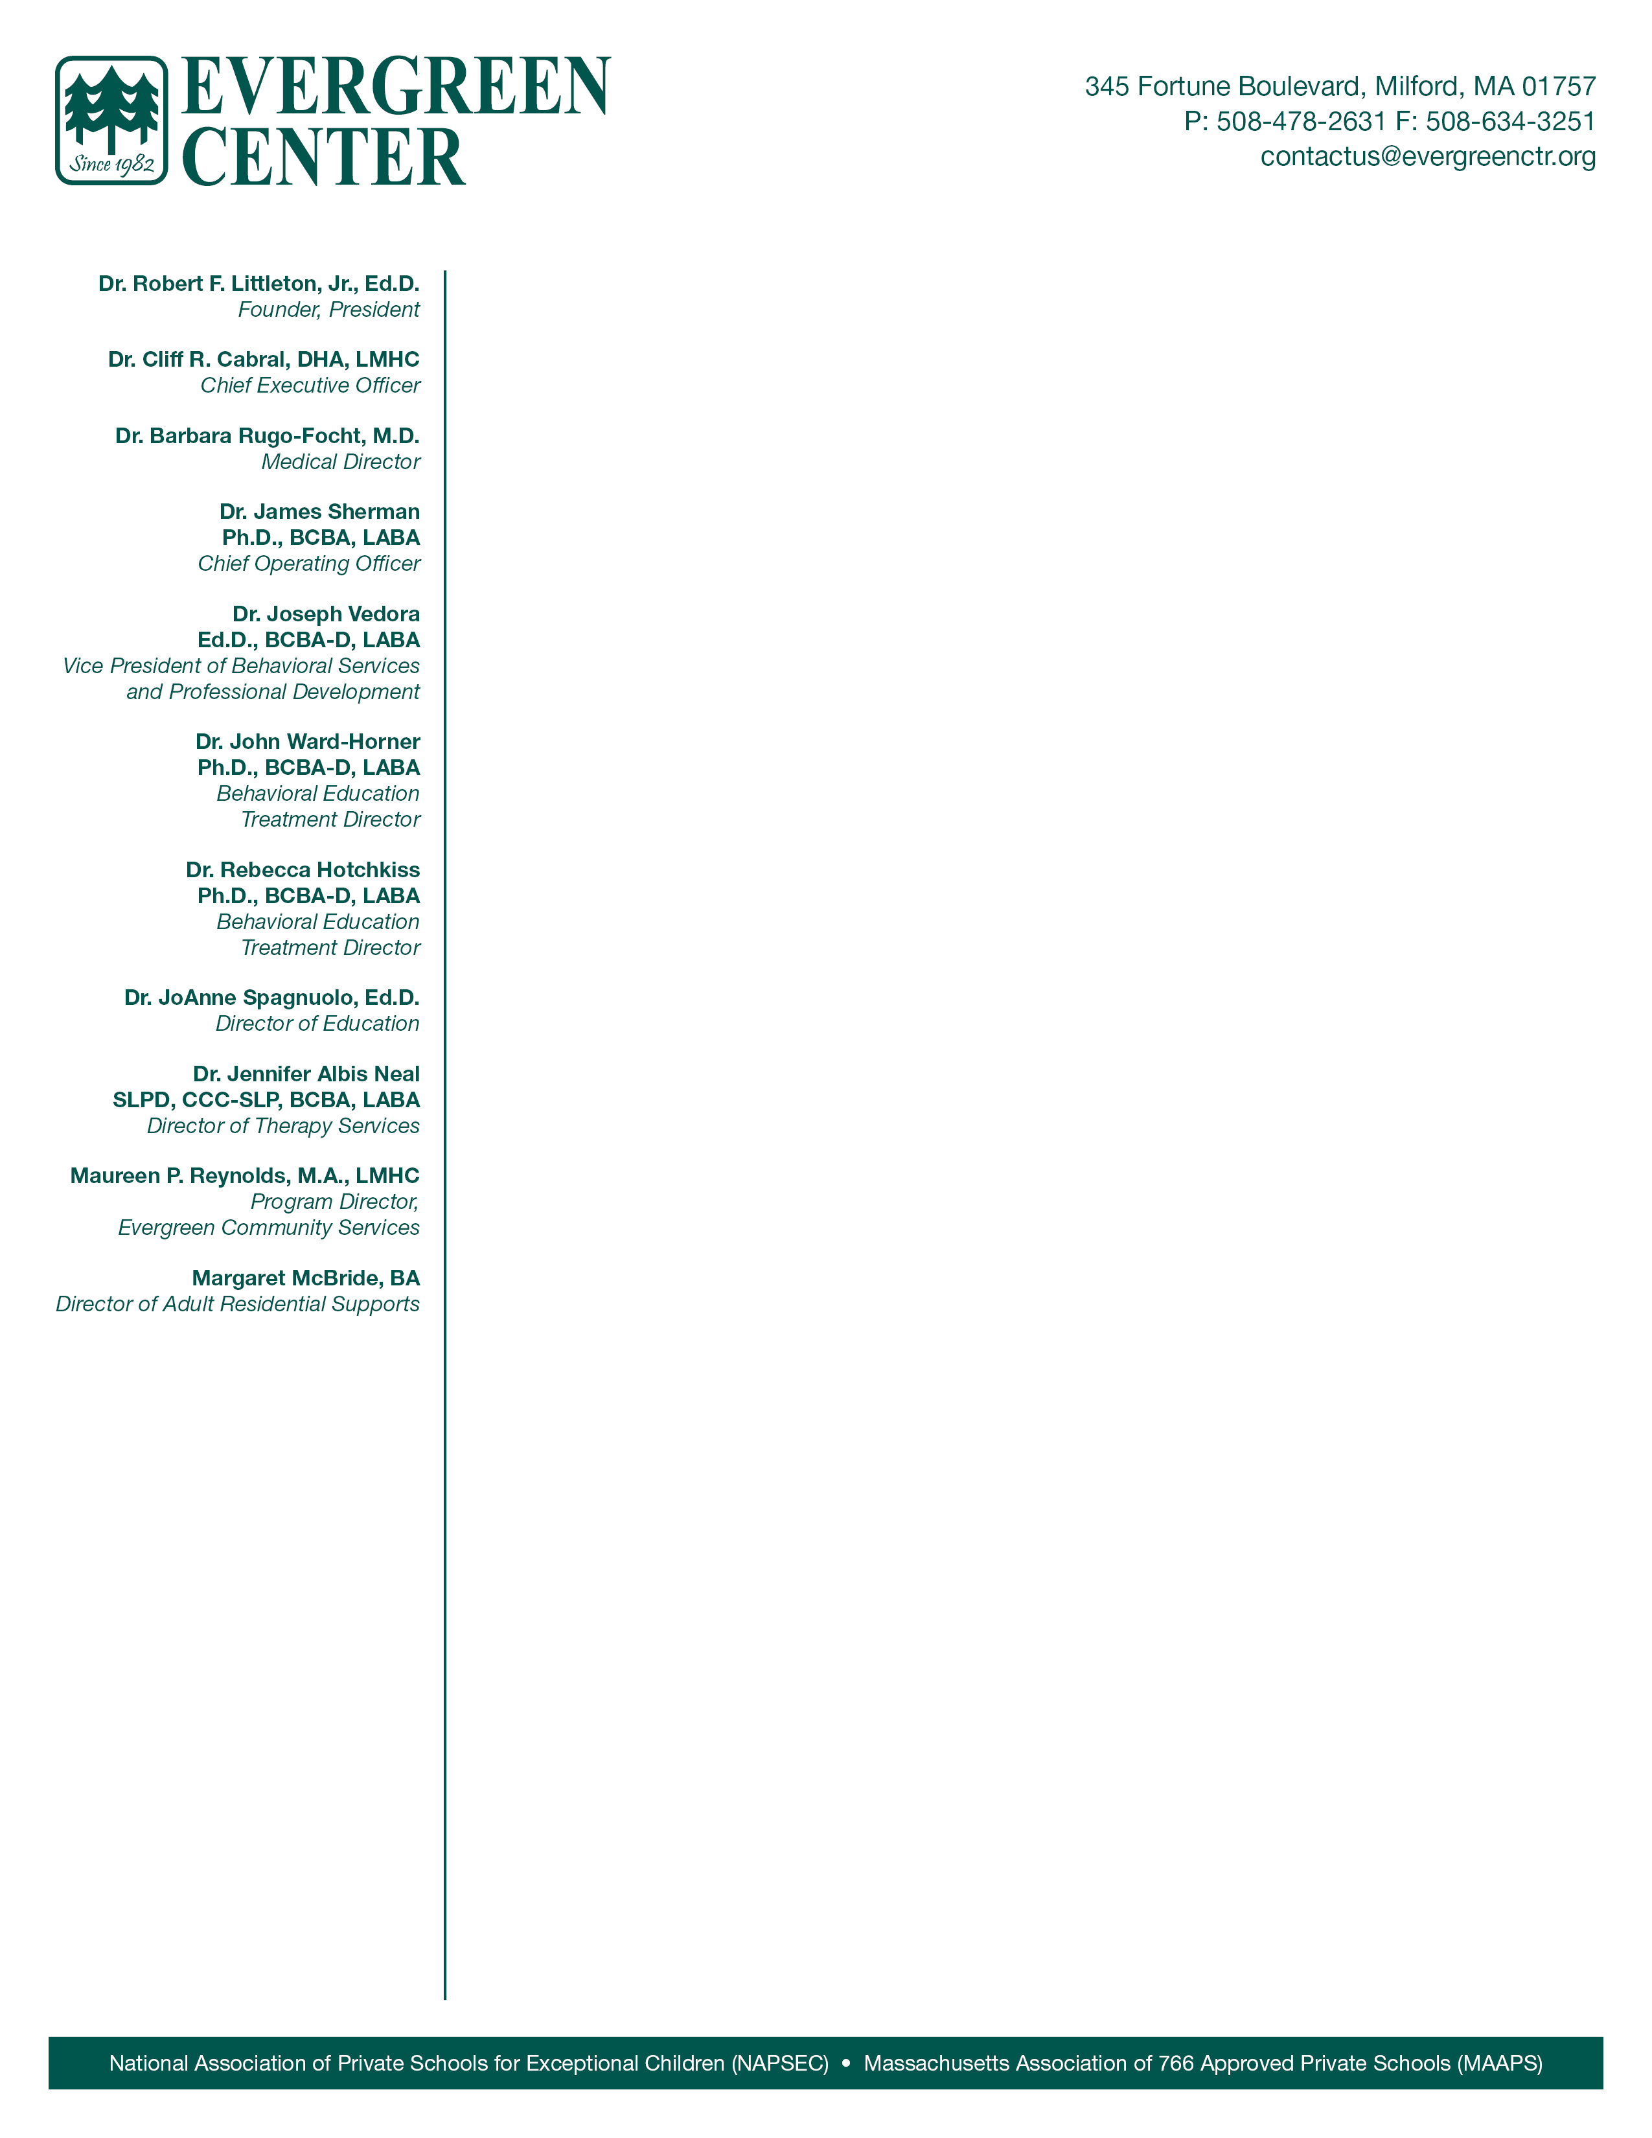
bbbb

PROGRAM RECONSTRUCTION NOTIFICATION LETTER TO PURCHASERS

September 24, 2025
To: Special Education Director
cc: Jannelle Roberts, M.Ed., Director, DESE
Jacquiline Brown, Director of SPED Pricing and Financial Audit, OSD
Janine Brown-Smith, Esq.

Dear Colleagues and Partners,
Since 1982, the Evergreen Center has served as a cornerstone resource for the Commonwealth, providing residential special education services that prevent costly out of state placements while helping students remain connected to their communities. Our comprehensive continuum of care serves students with complex developmental disabilities coupled with significant medical, therapeutic, and behavioral needs that extend beyond traditional educational settings.
We are writing to notify you of our intent to pursue the Program Reconstruction process in conjunction with the Department of Elementary and Secondary Education's Mid-Cycle Review of the Evergreen Center. This decision reflects our commitment to meeting the evolving and increasingly complex needs of all students entrusted to our care.
Over recent years, we have observed unprecedented increases in student acuity and clinical complexity. We routinely receive referrals for students who exhibit extremely disruptive and physically aggressive conduct, engage in property destruction, as well as intensive self-injurious actions. The frequency of students presenting with these elevated care needs continues to rise, necessitating strategic enhancements to our programming, staffing, and infrastructure.
The Evergreen Center has not restructured its rates to capture cost increases associated with dramatic shifts in both the clinical and economic landscape since 2017. We face significant workforce challenges competing for qualified staff with public schools, nursing homes, home healthcare, and a variety of other industries. Salary inequities have created recruitment and retention difficulties that threaten the continuity of care essential for our students' progress, while evolving regulatory requirements continue to impose additional costs not reflected in current tuition rates. The proposed reconstruction addresses these challenges through strategic enhancements to our educational programming, workforce development, vocational services, therapeutic supports, and technology infrastructure.
Through Program Reconstruction, we aim to better support students with increasingly complex needs. Workforce development efforts will focus on retention strategies as well as improving clinical supports during critical times. We also seek to expand vocational programming by building community partnerships that support employment readiness and to address the growing need for greater therapeutic services capacity in OT, PT, and speech and language therapy.
In order to meet these needs, we anticipate new authorized tuition prices of $344,404.91 for the Basic Skills Program and $379,302.81 for the Intensive (Behavior Development) Program. We are seeking these changes effective July 1st, 2026. These adjustments will enable us to maintain the specialized staffing, programming, and infrastructure necessary to serve our shared students with increasingly complex needs.
During our 42 years of operation, the Evergreen Center has remained steadfast in our commitment to providing effective, specialized care that enables students with severe special needs to thrive while staying connected to their families and communities. We recognize the financial pressures facing school districts and remain committed to maximizing the value of all resources invested in our students' futures. The proposed enhancements represent careful analysis of student needs, regulatory requirements, and evidence based practices designed to have the greatest impact on student outcomes while maintaining fiscal responsibility.
We will be submitting our detailed reconstruction proposal to DESE in the coming months. We welcome the opportunity to discuss these proposals at your convenience. As always, please feel free to contact us at ccabral@evergreenctr.org for further discussion.
Thank you for your ongoing support of the students and families we serve together.
Respectfully Submitted,


Dr. Cliff R. Cabral, DHA, LMHC
Chief Executive Officer
Evergreen Center

