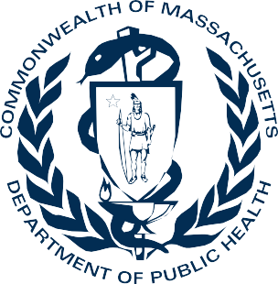
DPH Office of Problem Gambling Services
Evidence-Based and Comprehensive Problem Gambling Treatment Services

Problem Gambling Treatment: A Strategic Approach
Since 2016, the Massachusetts Department of Public Health (DPH), Office of Problem Gambling Services (OPGS) has taken a comprehensive and strategic approach to the development of problem gambling treatment services in the Commonwealth. The development of clinical services are guided by the principles of data, availability, accessibility, capacity, and effectiveness in order to optimize services and ensure health and wellness for all.

Additionally, OPGS prioritizes Gambling Disorder as defined by the DSM-5 Diagnostic Criteria, in recognition of clinical practices. This definition is essential in the development of clinical treatment options. The DSM-5 diagnostic criteria are used by clinicians to report disorders to insurers for reimbursement, and to public health authorities for causes of illness and death. Lastly, the DSM-5 diagnostic criteria are used to determine risk factors, causes, clinical practice guidelines, and clinical treatment.

Problem Gambling Treatment: Promoting Equity
Problem gambling is governed by a complex set of interrelating factors, causes, and determinants ranging from biology and family history to social norms and existing statutes. Research indicates that gambling is interrelated with various health issues and disproportionately impacts individuals with mental health disorders, substance misuse disorders, and communities of color (Alegría, Petry, Hasin, Liu, Grant, & Blanco, 2009). Historically, community-level experiences of gambling and communities of color are often not the focus of problem gambling research, services, and efforts (Ortiz, Cain, Formica, Bishop, Hernanez, & Lama, 2021). In order to address historical disparities, OPGS conducts meaningful community engagement and surveillance, implements a variety of programs and services to individuals and families throughout MA to prevent and mitigate gambling-related harms, provides workforce support and leadership development to enhance capacity within priority populations, leads public awareness campaigns to increase

education and awareness of gambling, and provides robust technical assistance and evaluation across all problem gambling programs and services within the prevention and treatment areas.

Problem Gambling Treatment in the Commonwealth

Helpline Services
Direct Services
Public
Awareness
Behavior Health Workforce
Development
Technical
Assistance and Evaluation

Helpline Services
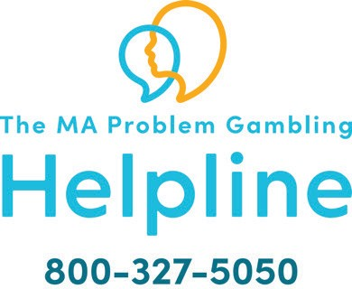
The Massachusetts Problem Gambling Helpline is the primary safety net of the Commonwealth to ensure individuals seeking information and support for problem gambling are provided evidence-based
services and support.

In 2020, the Problem Gambling Helpline was integrated within the Substance Use Helpline with the goal of enhancing caller experience, maximizing cost effectiveness, and expanding reach.

Some of the key highlights are the following:
- Providing 24/7 bilingual services (English/Spanish) and capacity for additional languages
- Screening an estimated 15,000-20,000 annual Substance Use Helpline callers for problem gambling. The largest expansion of problem gambling screening in the country!
- Conducting direct transfers to referral treatment sources that will improve access and engagement of treatment
- Providing follow-up services from Helpline clinicians to callers
- Robust quality assurance protocols to ensure efficiency and effectiveness

Direct Services and Community Support
The Department of Public Health contracts 22 outpatient problem gambling treatment locations across the commonwealth for individuals and families. Problem gambling treatment services include the following:
Problem gambling
assessment
Individual
and/or family counseling
In-home therapy
Educational groups
Case
management
Recovery coaching

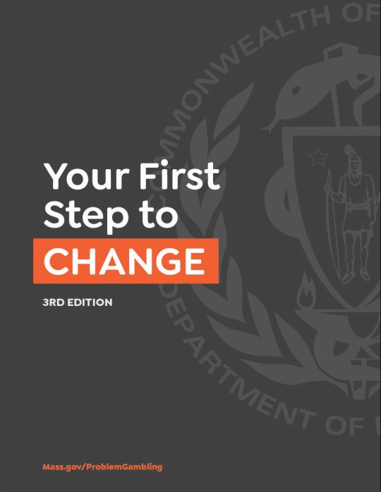
First Step to Change, 3rd Edition
First Step to Change is an evidence-based
self-assessment and brief intervention workbook for individuals thinking about changing their gambling behavior. It helps identify problems and determine helpful strategies to guide them through the process of change.

The toolkits help people:
- Gain information about addiction-related problems
- Evaluate their own addiction-related behavior.
- Develop change strategies, should they decide that change is the best course

MASS Men
- The MassMen Project promotes wellness and empowers working-age men across Massachusetts to take action to feel better emotionally, physically, and spiritually.
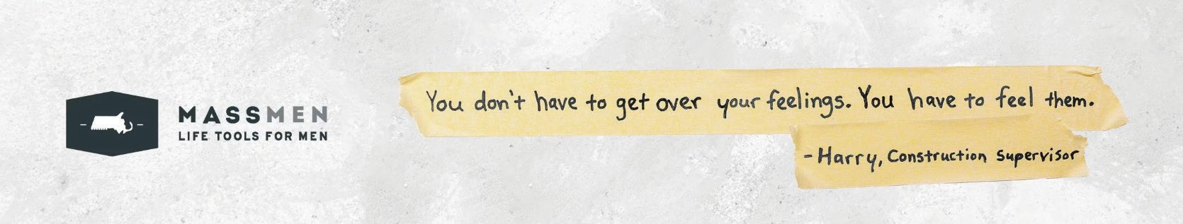
- The MassMen website offers an online free and anonymous screening tool for mental health disorders, including problem gambling. The screening tool provides individuals the opportunity to self-identify signs and symptoms, educate themselves on mental health topics, and connect with local resources in order to seek treatment.

Public Awareness and Resources
OPGS leads a comprehensive communications strategy centered on our platform: Let’s Get Real About Gambling. Campaigns under this platform aim to increase education and awareness of the risks associated with gambling, especially for priority populations. All of OPGS’ public awareness campaigns center on promoting education, resources, helpline and treatment services, as well as the promotion of recovery.
OPGS adapts multiple promotion strategies, which include the use of billboards, digital bulletins, gas stations, social media channels such YouTube, Facebook, Instagram and other platforms in order to reach a wide audience. To date, OPGS’ public awareness
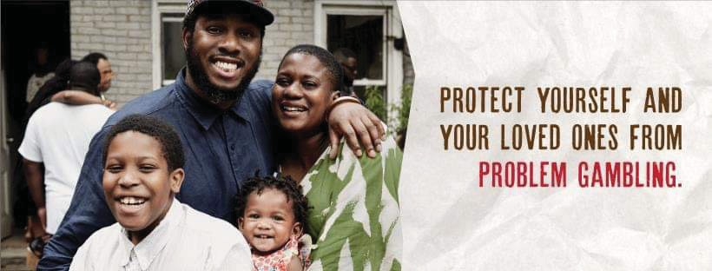
campaigns have included General Audiences, Youth and Parents, Older Adults, Men of Color, and other priority populations that have resulted in over 100 million impressions! Be on the lookout for new campaigns in the future.

Massachusetts Problem Gambling Clearinghouse
The Clearinghouse offers numerous health education materials related to problem gambling in various formats and languages free of charge.

Behavioral Health Workforce Development
The Department of Public Health funds an array of evidence-based training opportunities at no cost to providers in the behavioral workforce aimed to build capacity of identify, assess, and treat problem gambling.

Practice Guidelines for Treating Gambling-Related Problems
- Practice guidelines were designed for treatment professionals who want to learn more about evidence-based treatment approaches for clients experience gambling-related problems.

Project Build Up
- Project Build Up (PBU) is a Grant and Community Support Initiative funded by the Massachusetts Department of Public Health’s (MDPH) Office of Problem Gambling Services (OPGS) and administered by Health Resources in Action (HRiA) to strengthen the capacity of outpatient substance use or gambling treatment agencies to provide or promote problem gambling treatment services. Project Build Up (PBU) is focused on helping agencies create culturally responsive practices that address health and racial equity to support communities that are disproportionately impacted by problem gambling.

Technical Assistance and Evaluation
OPGS is committed to leading with data and building capacity across problem gambling programs and services. Our evaluation framework measures the progress of programming while informing continuous quality improvement. Our technical assistance center build treatment capacity of problem gambling and related issues.

Massachusetts Technical Assistance Center for Problem Gambling Treatment (M-TAC)
M-TAC provides a range of services that build the capacity of outpatient treatment programs to address problem gambling and co-occurring substance use and mental health disorders.

For more information: mass.gov/opgs

Citation:
1. Alegria AA, Petry NM, Hasin DS, Liu SM, Grant BF, Blanco C. Disordered gambling among racial and ethnic groups in the US: results from the national epidemiologic survey on alcohol and related conditions. CNS Spectr. 2009 Mar;14(3):132-42. doi: 10.1017/s1092852900020113. PMID: 19407710; PMCID: PMC2737691.
https://pubmed.ncbi.nlm.nih.gov/19407710/

2. Ortiz, V., Cain, R., Formica, S.W. et al. Our Voices Matter: Using Lived Experience
to Promote Equity in Problem Gambling Prevention. Curr Addict Rep 8, 255–262 (2021). https://doi.org/10.1007/s40429-021-00369-5.

