EVV Provider Identification Packet Checklist for ASAP Contracted Providers

This is a checklist for ASAP Contracted Provider Organizations to use when completing the EVV Provider Identification Packet. This checklist is for reference only and does not need to be submitted with the EVV Provider Identification Packet.

Provider Organizations Using the MyTimesheet State-Sponsored EVV System
☐ Complete and return the MyTimesheet Provider Identification Excel Spreadsheet. Instructions can be found on page 7. The MyTimesheet Provider Identification Excel Spreadsheet must be returned via the Massachusetts Managed File Transfer. Please follow the directions on page 3 for using this site.

Provider Organizations Using an Alt-EVV (Alternate EVV) System
☐ Complete and return the MA EVV Data Aggregator Provider Identification Excel Spreadsheet. Instructions can be found on page 9.
☐ Complete and return the Alternate Electronic Visit Verification System Attestation of Compliance Form on page 15. Instructions can be found on page 14. If necessary, this form can be submitted separately from the other forms in the Provider Identification Packet. The MyTimesheet Provider Identification Excel Spreadsheet must be returned via the Massachusetts Managed File Transfer. Please follow the directions on page 3 for using this site.

Electronic Visit Verification (EVV) Provider Identification Packet

EVV Introduction

The 21st Century Cures Act (the Cures Act) is a federal mandate requiring states to implement EVV for Personal Care Services (PCS) by January 1, 2021 and Home Health Care Services (HHCS) by January 1, 2023. Massachusetts is implementing EVV using an “Open” or “Hybrid” model approach. This means that Provider Organizations may use either the state-sponsored EVV system or their own EVV system. Providers choosing to use their own EVV system must upload their EVV data to the State’s MA EVV Data Aggregator and attest to meeting CMS and the Commonwealth’s standards for EVV systems.
- MyTimesheet is the state-sponsored EVV system.
- Alt-EVV (Alternate EVV) is the provider’s EVV system. Providers who use their own EVV system are referred to as Alt-EVV Providers.
The Executive Office of Health and Human Service (EOHSS) will be implementing EVV in programs that provide certain home and community-based services. For ASAP provider organizations, EVV will be required for providers that offer personal care services, homemaking and companion services.
The referenced data to be submitted is required for the purpose of conducting EVV. EOHHS has executed a data sharing agreement (DUA) with the Executive Office of Elder Affairs (EOEA) and Optum Government Solutions (Optum), EOHHS’s third-party administrator (TPA) for MassHealth and EVV. Pursuant to that DUA, the disclosure of data pertaining to EVV Data is permitted and protected under applicable state and federal laws and regulations.

Provider Identification Packet Purpose

The Provider Identification Packet is intended to provide EOHHS with the information necessary to confirm that providers are using EVV and record the means by which providers will submit EVV data. In addition, the Provider Information Packet collects information about future EVV users at your organization. Optum, the State’s contractor that configures the Data Aggregator and MyTimesheet systems, will use the information that you provide about users to help your organization begin the process of using either the Data Aggregator or MyTimesheet.
Please note: Provider Organizations will need to resubmit a completed Provider Identification Packet to EOHHS if any of the following occurs:
- Change in type of EVV compliance (i.e., Alt-EVV to MyTimesheet or MyTimesheet to Alt-EVV)
- Change of Alt-EVV vendor
- A merger or acquisition
- A change to the provider’s FEIN
- A change to the provider’s Key EVV Contact

Submitting the Provider Identification Packet Instructions

Returning the Packet
You must return your completed Provider Identification Packet via the Commonwealth of Massachusetts' Managed File Transfer website. (Figure 1).
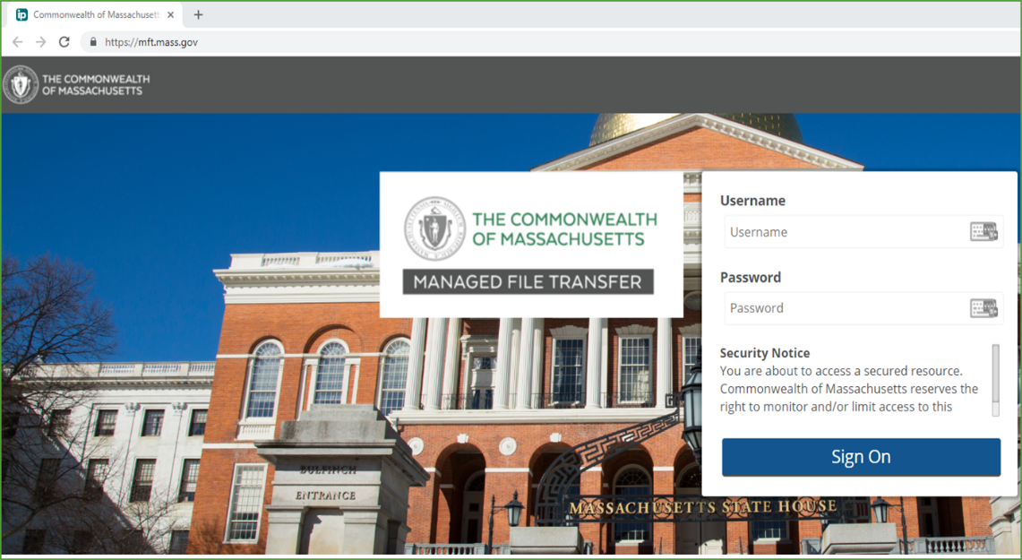
Figure 1: The Commonwealth of Massachusetts Managed File Transfer Website
The instructions below describe how to access, login, and upload the forms to the Managed File Transfer website.

New User Set-Up for Managed File Transfer Website

- The Massachusetts Managed File Transfer site will send each ASAP Contracted Provider Organization an email. The email will be from mft@mass.gov. (If your organization did not receive these emails or if you have questions regarding the new user set-up, please contact EVVfeedback@State.MA.US.)

- The first email (similar to the sample email shown in Figure 2), “New User Account for Commonwealth of Massachusetts,” will include your username and a link. (Figure 3). You will need to click this link to continue with the set-up process.
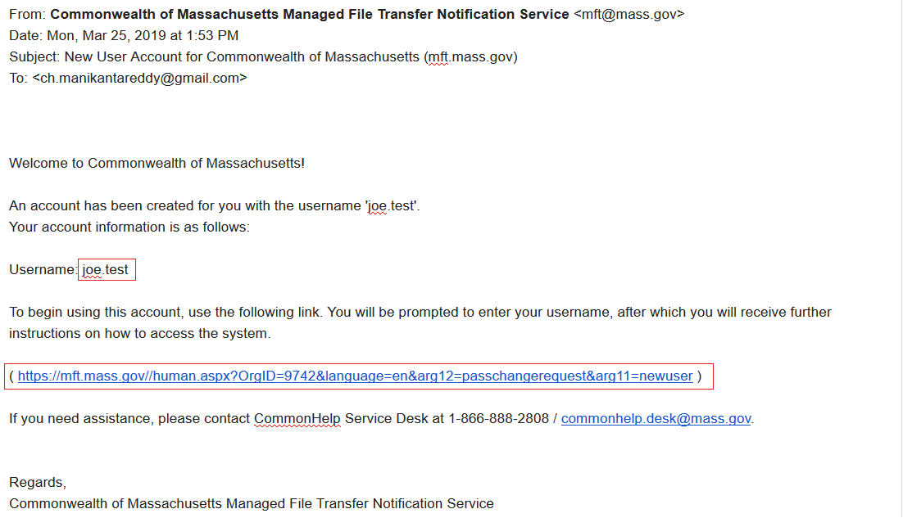
Figure 2: Sample Email #1 - New User Account
- After you click the link, you will see a screen similar to the one in Figure 3. Enter your username from the prior screen and select Request Password.
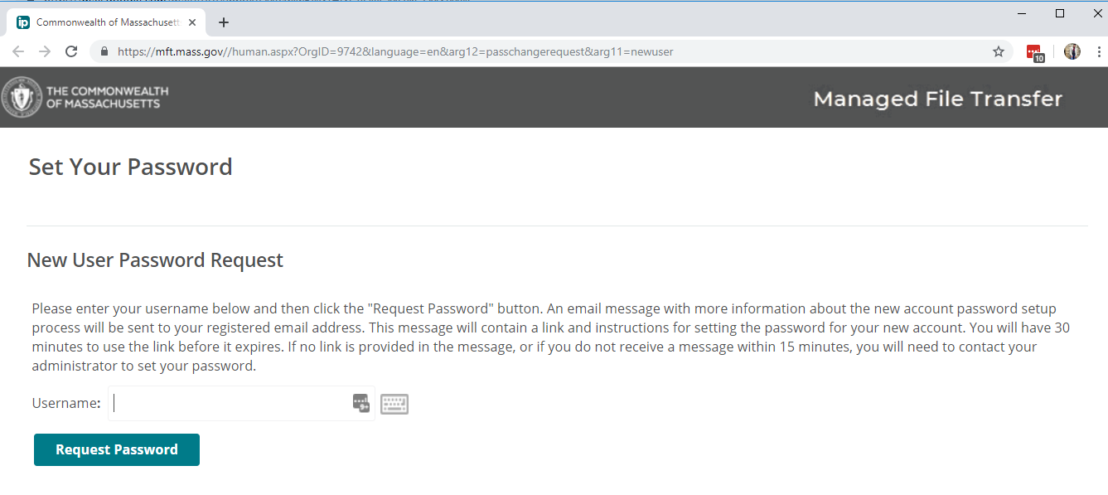
Figure 3: Follow a link in Email #1 to Set Your Password
- After selecting Request Password, you will receive a second email. The second email (similar to sample email shown in Figure 4), “New User Password Request Confirmation,” will include the link to setup your password for the Managed File Transfer website.
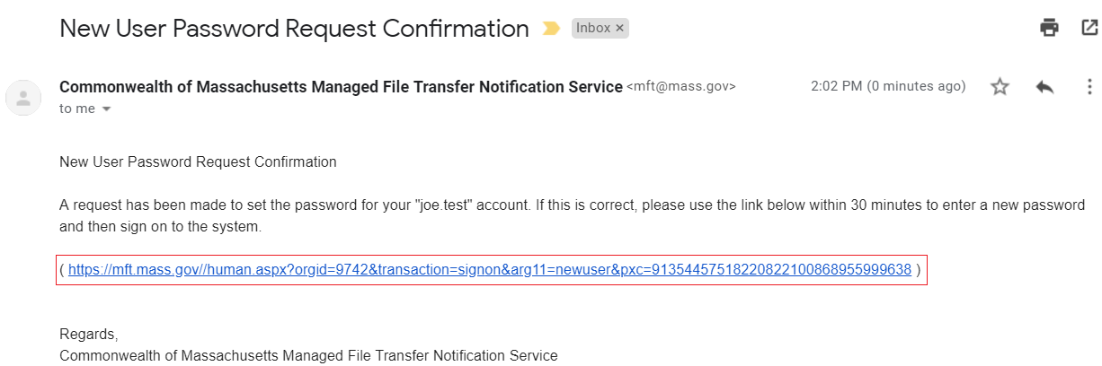
Figure 4: Sample Email #2 - New User Password Request Confirmation
- Click the link and set-up your password.

Uploading the Provider Identification Packet

- Once the new user setup is complete, navigate to https://mft.mass.gov/

- Enter your username and password and click “sign on.”

- On the “home” page click “upload” (Figure 5).

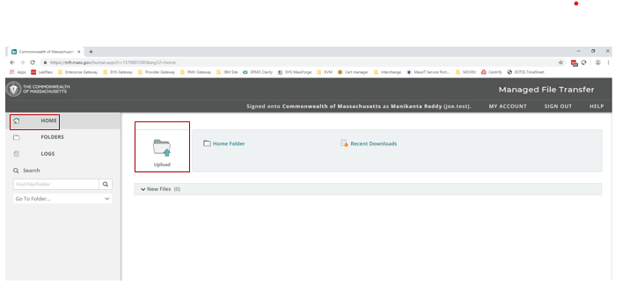
Figure 5: Click "upload" on the "home" page
- Drag and drop your files or click “browse” to select the file to upload (Figure 6).
All provider organizations need to upload the Provider Information Excel Spreadsheet. Alt-EVV Provider Organizations also need to upload the Alternate Electronic Visit Verification System Attestation of Compliance Form.
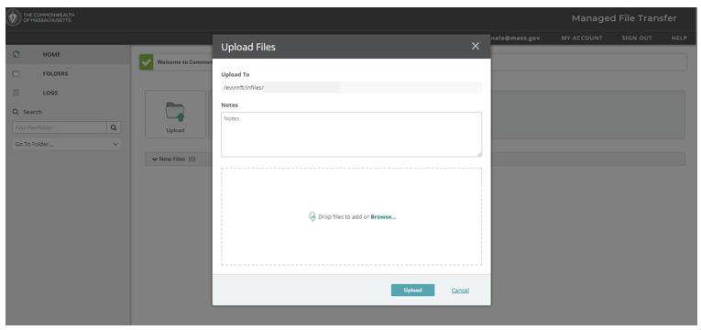
Figure 6: Drag files or click "browse" to upload

- Once the file is selected, click “upload” (Figure 7). The green check mark next to the file name indicates a successful upload (Figure 8).
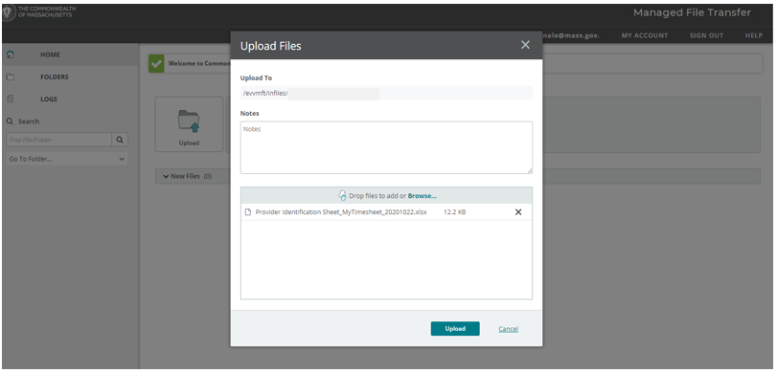
Figure 7: After selecting the file click "upload"

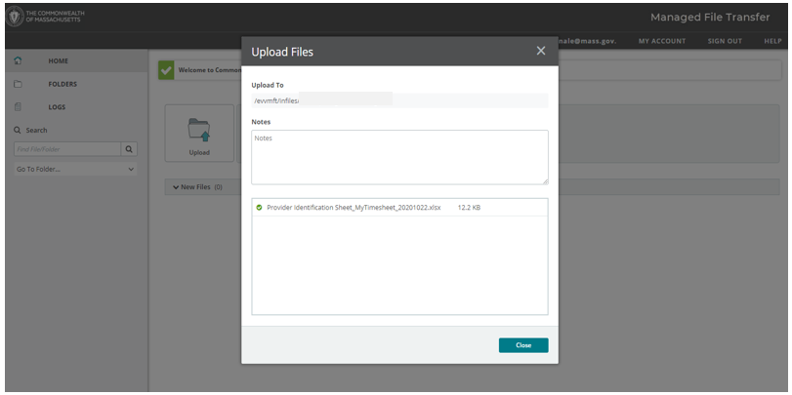
Figure 8: The green check mark next to the file name indicates the upload was successful.

MA EVV MyTimesheet Identification Excel Spreadsheet Instructions

Note: The MyTimesheet Provider Identification Excel Spreadsheet is required only for Provider Organizations using the MyTimesheet system. If you are using an Alt-EVV system, please proceed to the next form.
The Excel Spreadsheet has three sections:
  - Section 1: Provider Organization Demographic Information
    - Enter provider organization name, provider address, provider FEIN, lead ASAP, and type of EVV System starting in row 6, column A of the Excel Spreadsheet.

  - Section 2: Key EVV Contact Information
    - Provider Organizations are required to identify a Key EVV Contact. The Key EVV Contact should be an employee of the Provider Organization who will serve as the primary point of contact for EOHHS and Optum when communicating with your Provider Organization regarding EVV.
    - Enter the name, title, email address, and telephone number for the identified Key EVV Contact starting in row 6, column F of the Excel Spreadsheet.

  - Section 3: EVV Primary User Information
    - Provider Organizations using MyTimesheet are required to identify an employee who can serve as the “Primary User” for the Organization. The EVV Primary User is responsible for creating new users and deactivating old users in the MyTimesheet system.
    - The EVV Primary User can be the same person as the Key EVV Contact; however, both areas of the spreadsheet need to be completed.
    - The EVV Primary User is not limited to creating and deactivating users. If this individual has other EVV responsibilities, the Primary User is assigned an additional EVV role. The available additional roles are described below:
      - The Scheduler role is assigned to individuals whose responsibilities include scheduling appointments, editing appointments, communicating with workers, and running reports.
      - The Supervisor role is assigned to individuals whose responsibilities include approving exceptions to regular processes. For example, confirming visits that were not captured in EVV, managing visits that were occurred without an appointment in the EVV system (i.e., free-floating visits), and bulk cancelling appointments
      - The Super User role is assigned to individuals whose responsibilities are a combination of the responsibilities in the Scheduler and the Supervisor roles.
  - Enter the name, email address, telephone number, and EVV role for the identified Primary User starting in row 6, column K of the Excel Spreadsheet.
  - If you would like multiple people to share the responsibilities of the Primary User for your Provider Organization, you can designate an additional user to this role. If applicable, please provide details for your Organization’s second Primary User starting in row 6, column K of the Excel Spreadsheet.
  - The Primary User(s) identified in the Excel Sheet will be provided credentials to the MyTimesheet system and the ability to complete the user management activities described above.
  - If the person that you have designated as the Primary User is no longer assigned this role, it is the responsibility of your Provider Organization to communicate this to Optum. The Provider Organization must reach out to MA EVV Customer Helpdesk at 1-844-368-5184 between 8:00 am and 6:00 pm EST to get the “EVV New Primary User/Upload User Registration and Deactivation Form”. Providers will use this form to either (1) identify a new Primary User or (2) change their Primary User. Providers need to email the complete form to the MA EVV Helpdesk at maevvsupport@optum.com.
The Excel Sheet should be returned following the “Submitting the Provider Identification Packet Instructions” found on page 3 of this packet.
Once a Provider Organization accurately completes and submits the Excel Spreadsheet, the Provider Identification Packet is complete. EOHHS will process your Provider Identification Packet within 3 business days of receiving it. If the document is incomplete or inaccurate, EOHHS will email your organization with next steps. If the document is complete, EOHHS will notify Optum.
The testing and training timeline for MyTimesheet is currently not finalized. After submitting a complete Provider Identification Packet, and once the MyTimesheet timeline is finalized, the Primary User(s) will receive several emails from Optum with instructions on how to access and login to the MyTimesheet system, as well as how to register for required training.

MA EVV Data Aggregator Identification Excel Spreadsheet Instructions

Note: The MA EVV Data Aggregator Provider Identification Excel Spreadsheet is required only for Provider Organizations using the MA EVV Data Aggregator system. If you are using the MyTimesheet system, please refer to the instructions on the previous page.
The Excel Spreadsheet has three sections:
  - Section 1: Provider Organization Demographic Information
    - Enter provider organization name, provider address, provider FEIN, lead ASAP, and type of EVV System starting in row 6, column A of the Excel Spreadsheet.
    - Enter the Type of Data Upload in row 6, column F of the Excel Spreadsheet.
      - There are two ways in which Alt-EVV providers can send EVV data to the MA EVV Data Aggregator. Detailed information about both of these options can be found in the Data Aggregator Technical Specifications and User Guide on the Massachusetts EVV website on mass.gov under “Provider Resources.”
        - Manual File Upload – In this case, the Alt-EVV Provider compiles EVV visit records a CSV file and submits the records manually to the MA EVV Data Aggregator through a web page.
        - Automated Application Programming Interface (API) Upload – In this case, the Alt-EVV Provider submits EVV visit records in a file using an automated API process.
      - Both methods require successful completion of a testing process prior to sending “live” EVV visit data to the MA EVV Data Aggregator system. Providers must email their success notification email to the MA EVV System Helpdesk to confirm their testing is complete.
      - Provider Organizations that select automated API upload will need to also complete testing for the manual data upload process. This is to ensure that if the API process fails, the Provider still can upload EVV visit data to the MA EVV Data Aggregator.

  - Section 2: Key EVV Contact Information
    - Provider Organizations are required to identify a Key EVV Contact. The Key EVV Contact should be an employee of the Provider Organization who will serve as the
primary point of contact for EOHHS and Optum when communicating with your Provider Organization regarding EVV.
    - Enter the name, title, email address, and telephone number for the identified Key EVV Contact starting in row 6, column G of the Excel Spreadsheet.

  - Section 3: MA EVV Data Aggregator File Upload User or MA EVV Data Aggregator API Upload User
    - Provider Organizations using an Alt-EVV system must designate at least one employee to be the MA EVV Data Aggregator File Upload User or MA EVV Data Aggregator API Upload User. The user role depends on the primary method that the Alt-EVV Provider intends to use to upload EVV data.
    - Alt-EVV Providers choosing to manually upload EVV data to the MA EVV Data Aggregator will use the MA EVV Data Aggregator File Upload User. This user role is assigned to the individual who will be uploading the files, receiving email notification once the system completes file processing and downloading the error files. Detailed information about the error files can be found in the Data Aggregator Technical Specifications and User Guide on the Massachusetts EVV website on mass.gov under “Provider Resources.”
    - Alt-EVV Providers choosing to automate their upload of EVV data using an API will use the MA EVV Data Aggregator API Upload User. This user role is assigned to the individual who will be coordinating the API effort and receiving error files.
  - Enter the name, email address, telephone number, and EVV role for the identified MA EVV Data Aggregator File Upload User or MA EVV Data Aggregator API Upload User starting in row 6, column L of the Excel Spreadsheet.
  - The Key EVV Contact can also be the MA EVV Data Aggregator File Upload User or MA EVV Data Aggregator API Upload User; however, both areas of the spreadsheet need to be completed
  - If you would like multiple people to share the responsibilities of the Upload User for your Provider Organization, you can designate an additional user to this role. If applicable, please provide details for your Organization’s second Upload User starting in row 6, column P of the Excel Spreadsheet.
  - The Upload User(s) identified in the Excel Sheet will be provided credentials to access the MA EVV Data Aggregator system. The Upload User(s) will upload EVV files on behalf of your Provider Organization.
- If the person that you have designated as the Upload User is no longer assigned this role, it is the responsibility of your Provider Organization to communicate this to Optum. The Provider Organization must reach out to MA EVV Customer Helpdesk at 1-844-368-5184 between 8:00 am and 6:00 pm EST to get the “EVV New Primary User/Upload User Registration and Deactivation Form”. Providers will use this form to either (1) identify a new Primary User or (2) change their Primary User. Providers need to email the complete form to the MA EVV Helpdesk at maevvsupport@optum.com. Even if the individual assigned this role leaves the Provider Organization, the Provider Organization is still obligated to submit EVV files into the MA EVV Data Aggregator on at least a monthly basis.
  - All Alt-EVV providers must complete a testing process before they are given access to the Alt-EVV production environment.
The Excel Spreadsheet should be returned following the “Submitting the Provider Identification Packet Instructions” found on page 3 of this packet. Continue to page 14 of this packet to review instructions on completing and submitting the Alternate Electronic Visit Verification System Attestation of Compliance Form.

MA EVV Data Aggregator System Generated Email Communications for Required Testing and Training

Provider Organizations that select the manual file upload option will receive three system generated emails. These emails will be sent to the individual(s) listed as the Upload User(s) in the Provider Identification Spreadsheet.
- The first email will include your MA EVV Data Aggregator username and a link to setup your password. It will have the subject line, “MA EVV Data Aggregator Test Portal – Password Setup”. The email will be from maevvsupport@optum.com.

- The second email will outline instructions for the MA EVV Data Aggregator manual upload testing process. It will have the subject line, “Welcome to the MA EVV Data Aggregator System – Manual File Upload”. The email will be from maevvsupport@optum.com.

- The third email will include a link to create an account for Optum’s Learning Management System (LMS). The LMS is where you will register for the required Data Aggregator training and access relevant training materials. This email will have the subject line, “State Government Solutions Invite”. It will be from clientlearning@optum.com. Training registration and learning materials will only be available on the LMS site.

Provider Organizations that select the automated API upload option will receive four system generated emails. These emails will be sent to the individual(s) listed as the Upload User(s) in the Provider Identification Spreadsheet.

- The first email will include your MA EVV Data Aggregator username and a link to setup your password. It will have the subject line, “MA EVV Data Aggregator Test Portal – Password Setup”. It will be from maevvsupport@optum.com.

- The second email will outline instructions for the MA EVV Data Aggregator API upload testing process. It will have the subject line, “Welcome to the MA EVV Data Aggregator System – Application Programming Interface (API) Upload”. It will be from maevvsupport@optum.com.

- The third email will outline instructions for the MA EVV Data Aggregator manual upload testing process. It will have the subject line, “Welcome to the MA EVV Data Aggregator System – Manual File Upload”. It will be from maevvsupport@optum.com. (Provider organizations that select to send EVV data to the MA EVV Data Aggregator using an automated API upload also need to complete testing for the manual data upload process. This is to ensure that if the API process fails, you still can upload EVV visit data to the MA EVV Data Aggregator.)

- The fourth email will include a link to create an account for Optum’s Learning Management System (LMS). The LMS is where you will register for the required Data Aggregator training and access relevant training materials. This email will have the subject line, “State Government Solutions Invite”. It will be from clientlearning@optum.com. Training registration and learning materials will only be available on the LMS site.
Please note that Provider Organizations need to complete and pass the testing process before sending “real” EVV data to the MA EVV Data Aggregator. Providers are also required to have at least one staff person attend MA EVV Data Aggregator Training. This is a condition for receiving access to the production environment.

Alternate Electronic Visit Verification System Attestation of Compliance Form Instructions

Note: This form is required for all Alt-EVV Provider Organizations.
A completed Alternate Electronic Visit Verification System Attestation of Compliance Form known as the “EVV Attestation Form” is required for every provider using an alternate EVV system in accordance with the instructions below:
- If your Provider Organization has multiple locations, the following rules apply:

  - If a provider agency has multiple locations under the same FEIN but all locations are using the same EVV system: only one Attestation Form is required;
  - If a provider agency has multiple locations under the same FEIN and locations are using different EVV systems: one Attestation Form is required per EVV system;
  - If a provider agency has multiple locations under different FEINs: one Attestation Form is required per FEIN (regardless of the number of EVV systems being used).

- The EVV Attestation Form should be completed by someone with the authority to bind the provider organization into an agreement.

- If necessary, completed EVV Attestation Forms can be submitted separately from the other forms in the Provider Identification Packet.
The EVV Attestation Form should be returned following the “Submitting the Provider Identification Packet Instructions” found on page 3 of this packet.
Once a Provider Organization accurately completes and submits the EVV Attestation Form and the Excel Sheet, the Provider Identification Packet for Provider Organizations using the MA EVV Data Aggregator is complete. EOHHS will process your Provider Identification Packet within 3 business days of receiving it. If the document is incomplete or inaccurate, EOHHS will email your organization with next steps. If the document is complete, EOHHS will notify Optum. Within 5 business days of submitting a complete Provider Identification Packet, the Upload Users(s) will receive several emails from Optum with instructions on how to access and login to the test environment for the MA EVV Data Aggregator, as well as how to register for the required training.

Alternate Electronic Visit Verification System Attestation of Compliance Form

I represent _____[PROVIDER/ORGANIZATION NAME]____, and I have the authority to sign this Alternate Electronic Visit Verification (EVV) System Attestation of Compliance Form on behalf of this provider organization.

I acknowledge that my organization is a provider of personal care services and designated by the Executive Office of Health and Human Services (EOHHS) or any of its agencies or as required to use EVV. I acknowledge that EVV is required in the provision of personal care services as required by Section 12006 of the 21st Century Cures Act as codified at 42 USC 1396b(l), or by EOHHS or its agent or any EOHHS agency, or both. I acknowledge that EOHHS offers the option to use the state-sponsored EVV system (known as MyTimesheet) or a provider organization-procured EVV system (known for the purposes of this Alternate EVV System Attestation of Compliance Form as an alternate EVV system).

My provider organization will be using an alternate EVV system. I attest that my organization’s alternate EVV system complies with the following (please initial next to each requirement):
______ The requirements of 42 USC 1396b(l) where applicable, specifically, that the organization’s EVV system is “a system under which visits conducted as part of such services are electronically verified with respect to—
- the type of service performed;
- the individual receiving the service;
- the date of the service;
- the location of service delivery;
- the individual providing the service; and
- the time the service begins and ends.”

______ All EVV data is stored, maintained, and shared in accordance with the requirements of HIPAA privacy and security law (as defined in section 3009 of the Public Health Service Act).

______ All requirements related to EVV and EVV data detailed in my contract with EOHHS, any
EOHHS agency, an EOHHS contracted Integrated Care Plan, or my Aging Service Access Point (ASAP), or the Notice of Intent with the Executive Office of Elder Affairs (EOEA), as applicable.

______ Any additional requirements imposed by EOHHS or its agent related to use of the alternate EVV system, including, but not limited to, the collection, aggregation, submission, review, or auditing of identified data elements.
I sign under the pains and penalties of perjury that the information in this Alternate EVV System Attestation of Compliance Form is true and accurate.

________________________ ________________________
PRINT NAME SIGNATURE

________________________ ________________________
TITLE DATE

_________________________________________ ________________________
PROVIDER/ORGANIZATION NAME PROVIDER FEIN

The Cures Act is not limited to services explicitly titled ‘Personal Care’ but to services that meet the regulatory definition of PCS or HHCS. The Executive Office of Health and Human Service (EOHHS) reviewed the definitions of our services and identified those that meet CMS’ definition for EVV.
The MA EVV Data Aggregator is the website where Provider Organizations using their own alternate EVV system will upload their EVV data.
Type of EVV system refers to the Provider Organization’s decision to use either MyTimesheet or an Alt-EVV system.
Type of EVV system refers to the Provider Organization’s decision to use either MyTimesheet or an Alt-EVV system.

