Electronic Visit Verification (EVV) in Massachusetts: Stakeholder Dialogue Session #1

Tri-Valley, Inc. – Dudley, MA, April 24, 2019

Slide 1:

Today’s Agenda
- EVV Overview & EVV Stakeholder Engagement
- Data File for Alt-EVV Data Aggregator
- Future Dialogue Sessions

Slide 2:

21st Century Cures Act mandates EVV use
- Electronic Visit Verification (EVV) refers to the technology a worker uses during a home visit to capture information about the services provided
- The 21st Century Cures Act (federal law) requires EVV for the following Medicaid services:
  - Personal care by 1/1/2020
  - Home health by 1/1/2023
- EVV is required for Medicaid services but EOHHS will be requiring it for EOEA Non-Medicaid services as well

Slide 3:

EVV Requirements

To meet federal requirements, EVV systems must verify:
- Type of service performed;
- Individual receiving the service;
- Date of the service;
- Location of service delivery;
- Individual providing the service; and
- Time the service begins and ends

Slide 4:

Massachusetts’ goals for EVV implementation

Quality: Promote quality outcomes by ensuring appropriate service delivery
Efficiency: Reduce administrative burden of paper timesheets
Program Integrity: Reduce billing errors and unauthorized spending

Slide 5:

Terms Addressed in Today’s Session

Alternate EVV or Alt. EVV: Refers to EVV systems used by provider agencies that are NOT the MyTimesheet EVV System. These are “Alternative” EVV systems.
Data Aggregator: System that combines or “aggregates” EVV data from provider agencies. Provider agencies using Alt. EVV systems will send their EVV data to Optum’s data aggregator. MyTimesheet data will also flow into the data aggregator.
MyTimesheet: Optum’s EVV system that can be used by provider agencies to collect EVV data.
Optum: Vendor that EOHHS selected to provide the MyTimesheet & Data Aggregator EVV Systems.

Slide 6:

EOHHS Deploying a Hybrid EVV model for ASAP Contracted Providers

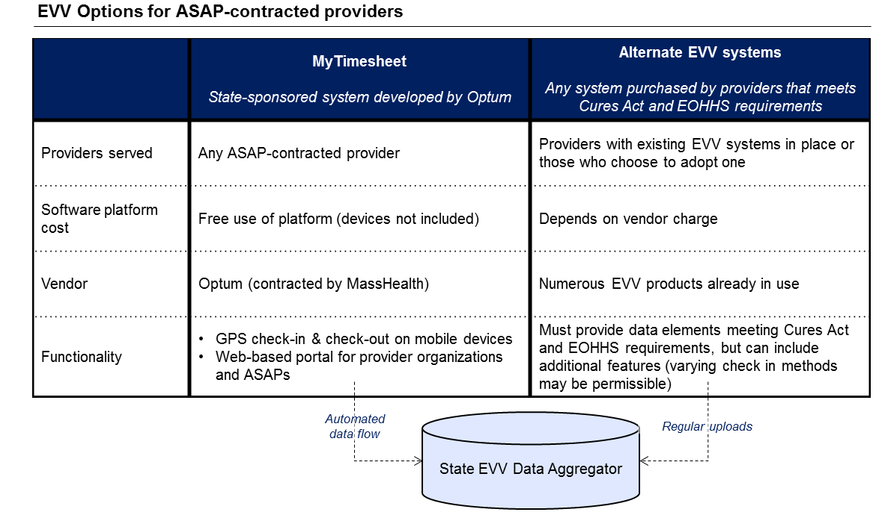

Slide 7:

EVV Estimated Timeline
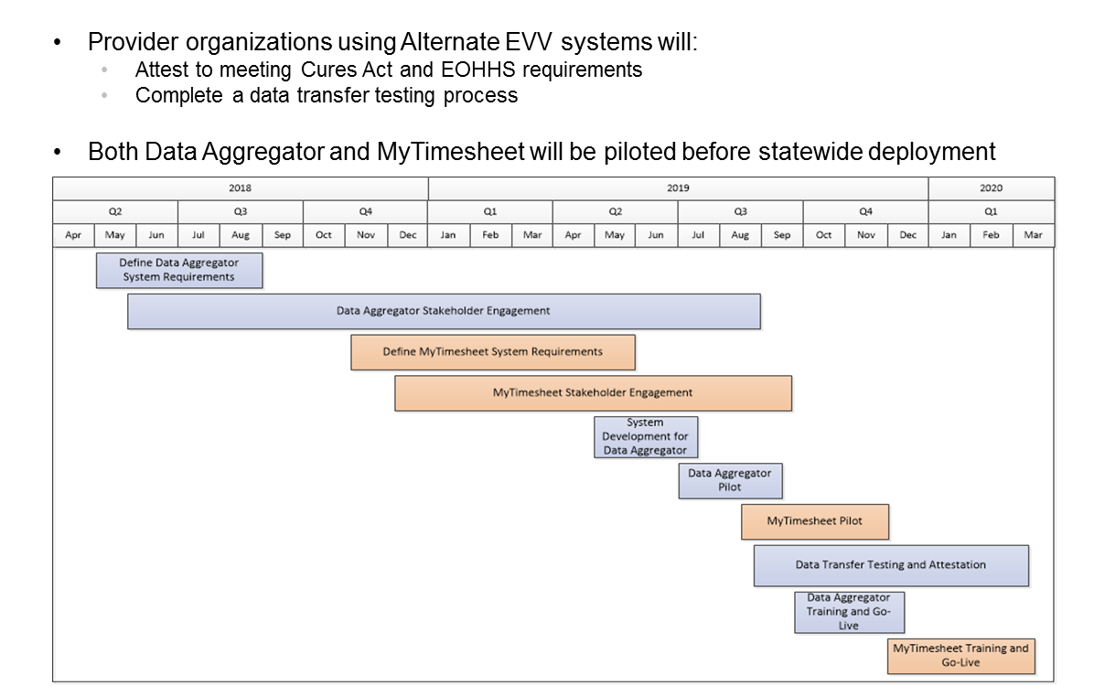

Slide 8:

EOHHS EVV Stakeholder Engagement (to date)

16 Public Listening Sessions in 2017

11 stakeholder workgroup sessions in 2017

9 Meetings with ASAPs & Providers in early to mid-2018

Home Care Alliance EVV Expo in August 2018

Presentation on EVV to ASAP/AAA Executive Directors in June 2017 and October 2018

Presentation at Home Care Quarterly Meeting in May 2017, August 2017, and November 2018

EVV Meeting with ASAP Contract Managers in December 2018

Alternate EVV Implementation Listening Session in February 2019

Slide 9:

EVV Stakeholder Dialogue Sessions

EOHHS anticipates holding seven EVV stakeholder dialogue sessions across the state, starting in April 2019. Sessions will take place every 3-4 weeks at ASAPs in varying locations across the Commonwealth.

EOHHS and Optum will address different areas of the EVV system in depth at each session.

Goals of the dialogue sessions:

Enable provider agencies to provide feedback and recommendations on EVV requirements at a detailed level before the products are finalized;

Reinforce timelines and general requirements for EVV; and

Offer provider agencies opportunities to interact with the EOHHS and Optum EVV teams.

Slide 10:

Today’s Session

Topic

Data File Requirements - Data File from Provider Agencies Using Alternate EVV Systems to the Optum Data Aggregator

The handout presented has been compiled during our business requirements sessions with Optum

Related topics such as data file name and format, source, point of destination, frequency, and timing will be addressed in future sessions

Questions to Keep in Mind:

Do the data fields presented make sense to you?

Are there data fields presented that you find questionable, unnecessary, or onerous?

Are there any other field requirements that are missing that we should be capturing?

Slide 11:

EVV Stakeholder Dialogue Schedule
- Elder Service of Merrimack Valley, Lawrence, MA, May 8, 2019 2-4pm
- South Shore Elder Services, Braintree, MA, May 21, 2019 10am-12pm
- Elders Services of Berkshire County, Pittsfield, MA, June 7, 2019 10am-12pm
- Springwell, Waltham, MA, June 24, 2019 10am-12pm
- LifePath, Greenfield, MA, July 16, 2019 2-4pm
- Elder Service of the Cape Cod, South Dennis, MA, August 14, 2019 11am-1pm

Slide 12:

Thank You!
Information about EOHHS’ EVV Implementation can be found at:

https://www.mass.gov/guides/mytimesheet-electronic-visit-verification-system

Feedback/questions related to EVV can be submitted to EOHHS by emailing:

EVVfeedback@State.MA.US

