Electronic Visit Verification (EVV) in Massachusetts: Stakeholder Dialogue Session #2

Elder Service of Merrimack Valley – Lawrence, MA, May 8, 2019

Slide 2:

Today’s Agenda
- EVV Overview & EVV Stakeholder Engagement
- Transmission of Data File for Alt-EVV Data Aggregator
- Additional Clarification Questions for Providers
- Future Dialogue Sessions

Slide 3:

21st Century Cures Act mandates EVV use
- Electronic Visit Verification (EVV) refers to the technology a worker uses during a home visit to capture information about the services provided
- The 21st Century Cures Act (federal law) requires EVV for the following Medicaid services:
  - Personal care by 1/1/2020
  - Home health by 1/1/2023
- EVV is required for Medicaid services but EOEA will be requiring it for EOEA Non-Medicaid services as well

Slide 4:

EVV Requirements

To meet federal requirements, EVV systems must verify:
- Type of service performed;
- Individual receiving the service;
- Date of the service;
- Location of service delivery;
- Individual providing the service; and
- Time the service begins and ends

Slides 5 & 6:

Terms Addressed in Today’s Session

- Alternate EVV or Alt. EVV – Refers to EVV systems used by provider agencies that are NOT the MyTimesheet EVV System. These are “Alternative” EVV systems.

- API (Application Programming Interface) – One of two ways that data for alt-EVV systems can be submitted to the state EVV data aggregator. API is an automated process. Data submitted via API will need to be formatted with a JSON payload per the data layout described in the Alternate EVV Data Aggregation Technical Specification Document.

- Csv (Comma-separated value) file – Format for one of two ways that data for alt-EVV systems can be submitted to the state EVV data aggregator.

- Data Aggregator – System that combines or “aggregates” EVV data from provider agencies. Provider agencies using Alt. EVV systems will send their EVV data to Optum’s data aggregator. MyTimesheet data will also flow into the data aggregator.

- Data File – File containing all the visit records being submitted to the Optum EVV Data Aggregator.
- Data Record – One row of the Data file. Typically, one row represents one visit; however, if there are multiple services in a single visit, each row represents a different service.
- Data Upload – Manual process for uploading the .csv file to the Optum EVV Data Aggregator.
- MyTimesheet – Optum’s EVV system that can be used by provider agencies to collect EVV data
- Optum – Vendor that EOHHS selected to provide the MyTimesheet & Data Aggregator EVV Systems.

Slide 7:

EVV Estimated Timeline
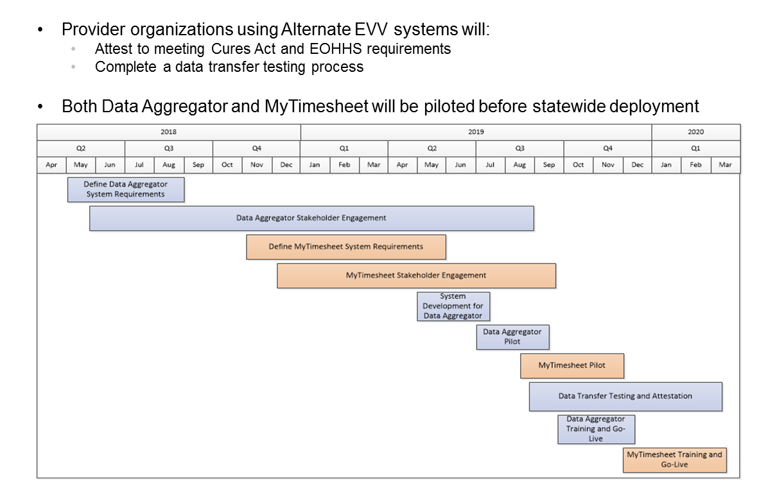

Slide 8:

EOHHS EVV Stakeholder Engagement (to date)

16 Public Listening Sessions in 2017

11 stakeholder workgroup sessions in 2017

9 Meetings with ASAPs & Providers in early to mid-2018

Home Care Alliance EVV Expo in August 2018

Presentation on EVV to ASAP/AAA Executive Directors in October 2018

Presentation at Home Care Quarterly Meeting in May 2017, August 2017, and November 2018

EVV Meeting with ASAP Contract Managers in December 2018

Alternate EVV Implementation Listening Session in February 2019

EVV Regional Provider Dialogue Session #1 – Tri-Valley, 4/24/19

Slide 9:

Today’s Session Discussion Topics

Transmission of Data File – Provider Agencies Using Alternate EVV Systems to the Optum Data Aggregator

Methods for sending visit data and upload process

Visit data validation and errors

Modified and voided visits

Testing/Process for submitting the data file

Questions to Keep in Mind

Does the process(es) for sending the data file make sense to you?

Does the data file validation and error criteria seem reasonable or are there elements that you would like to see differently?

What concerns do you have if any regarding the testing process?

Slide 10:

Additional Clarification Questions for Providers Using Alternate EVV Systems
- Does your EVV system include features for billing, claims, scheduling, or payroll?
  - If so, what did the EVV system replace when it went live and how has this process been?
  - If your EVV system does not encompass these features, how does your alt-EVV system interact with systems for scheduling, claims, billing, and payroll?
- Do consumers “sign” the “timesheet” once the services are completed during each visit? If so, how does this work and have you had any issues with this process?
- Do workers capture or confirm services or tasks that are provided during their visit?

Slide 11:

EVV Stakeholder Dialogue Schedule
- South Shore Elder Services, Braintree, MA, May 21, 2019 10am-12pm
- Elders Services of Berkshire County, Pittsfield, MA, June 7, 2019 10am-12pm
- Springwell, Waltham, MA, June 24, 2019 10am-12pm
- LifePath, Greenfield, MA, July 16, 2019 2-4pm
- Elder Service of the Cape Cod, South Dennis, MA, August 14, 2019 11am-1pm

Slide 12:

Thank You!
Information about EOHHS’ EVV Implementation can be found at:

https://www.mass.gov/guides/mytimesheet-electronic-visit-verification-system

Feedback/questions related to EVV can be submitted to EOHHS by emailing:

EVVfeedback@State.MA.US

