Electronic Visit Verification (EVV) in Massachusetts: Stakeholder Dialogue Session #3

South Shore Elder Services – Braintree, MA, May 21, 2019

Slide 2:

Today’s Agenda
- EVV Overview & EVV Stakeholder Engagement
  - https://www.mass.gov/info-details/electronic-visit-verification
- Topics for Review
  - High Level Process Workflow
  - Scheduling Policies
- Future Dialogue Sessions

Slide 3:

21st Century Cures Act mandates EVV use
- Electronic Visit Verification (EVV) refers to the technology a worker uses during a home visit to capture information about the services provided
- The 21st Century Cures Act (federal law) requires EVV for the following Medicaid services:
  - Personal care by 1/1/2020
  - Home health by 1/1/2023
- EVV is required for Medicaid services but EOEA will be requiring it for EOEA Non-Medicaid services as well

Slide 4:

EVV Requirements

To meet federal requirements, EVV systems must verify:
- Type of service performed;
- Individual receiving the service;
- Date of the service;
- Location of service delivery;
- Individual providing the service; and
- Time the service begins and ends

Slide 5:

Massachusetts’ goals for EVV implementation

- Effective Compliance: Provide an EVV system that complies with federal Medicaid requirements, minimizes burden on users, and does not disrupt the provision of services
- Efficiency: Reduce administrative burden of paper timesheets
- Program Integrity: Reduce billing errors and unauthorized spending

Slide 6:

Terms Used in Today’s Session

- Alternate EVV or Alt. EVV – Refers to EVV systems used by provider agencies that are NOT the MyTimesheet EVV System. These are “Alternative” EVV systems.

- Data Aggregator – System that combines or “aggregates” EVV data from provider agencies. Provider agencies using Alt. EVV systems will send their EVV data to Optum’s data aggregator. MyTimesheet data will also flow into the data aggregator.

- MyTimesheet – Optum’s EVV system that can be used by provider agencies to collect EVV data.
- Optum – Vendor that EOHHS selected to provide the MyTimesheet & Data Aggregator EVV Systems.

Slide 7:

EVV Estimated Timeline
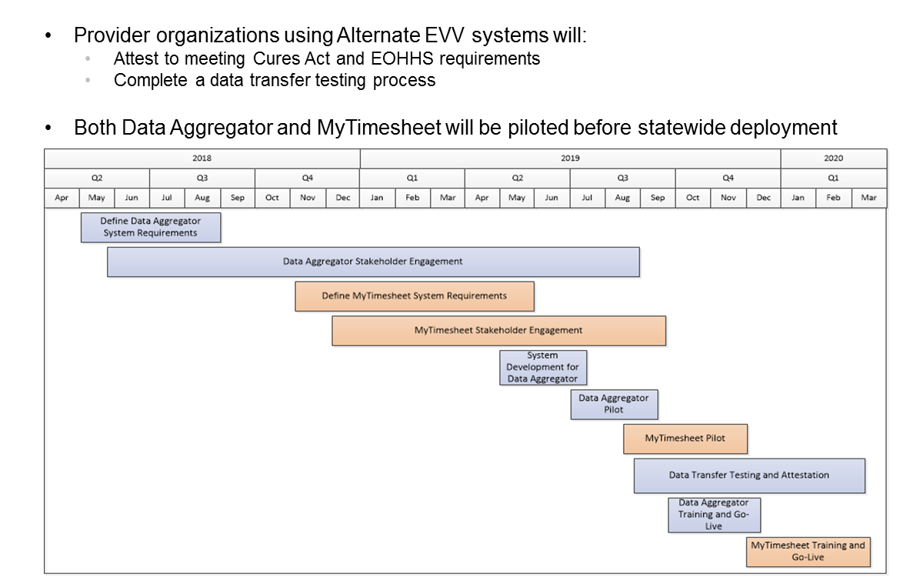

Slide 8:

EOHHS EVV Stakeholder Engagement (to date)

16 Public Listening Sessions in 2017

11 stakeholder workgroup sessions in 2017

9 Meetings with ASAPs & Providers in early to mid-2018

Home Care Alliance EVV Expo in August 2018

Presentation on EVV to ASAP/AAA Executive Directors in October 2018

Presentation at Home Care Quarterly Meeting in May 2017, August 2017, and November 2018

EVV Meeting with ASAP Contract Managers in December 2018

Alternate EVV Implementation Listening Session in February 2019

2 EVV Regional Provider Dialogue Session in April and May 2019

Slide 9:

Objective of Dialogue Sessions

Obtain feedback from provider agencies on different aspects of EVV

Ensure that EOHHS and Optum are on the right track before system is developed and plans are finalized

Make system or policy changes based on additional review from feedback

Hear from providers across the Commonwealth and engage as partners

Engage with all stakeholders across the Commonwealth, not just those who are located in Metro-Boston

Facilitate relationships between EOHHS, Optum, EOEA and provider agencies

Address a broad range of topics

Not all stakeholders will be able to attend all sessions but format should allow all stakeholders to attend at least one session

Supplement with other modes of education and input

Slide 10:

Topics Addressed and Highlights of Past Dialogue Sessions

April 24 Session – Alt. EVV Data File
- Most of the requested data fields seemed reasonable
- Need to review Non-Electronic Visit reasons
- Need to review capture of care program
- Need to consider capturing home health data

May 8 Session – Alt. EVV Data File Submission
- Alt-EVV vendors need time to develop data file and meet standards
- Need to consider how EVV relates to Provider Direct
- Need to clarify how providers should handle visits where multiple services are delivered
- Presentations from sessions posted at https://www.mass.gov/info-details/electronic-visit-verification

Slide 11:

Today’s Topics
- High-Level Overview of MyTimesheet
- Workflow Review – Process that outlines a consumer being referred for services, the provider accepting of the referral, service provision and the provider being paid by an ASAP
- Scheduling policies, procedures, and considerations

Slide 12:

EVV Process Overview – My Timesheet

Slide 13:

High Level Workflow

Slide 14:

Scheduling Policies
- We are looking for feedback from all provider agencies (both MyTimesheet and Alt-EVV users)
- We want to know how you address certain scheduling situations
- If you have an idea of how a current process could be improved, we want to hear it
- If we haven’t addressed an area of scheduling that you think is important to review, please let us know

Slide 15:

Scheduling Policies

Scheduling and Authorizations

Do you remove/cancel future appointments when a member’s authorization has ended? If so, how does that process work? If not, has that created issues?

Does your system apply restrictions on scheduling based on the service authorization? For example, will your EVV system prevent you from scheduling a visit if the member has reached the maximum number of authorized service units?

Urgent/Emergency Appointments

Are there situations where a worker performs a visit prior to scheduling and/or authorization? If so, how frequent are such visits and how are they handled?

How do you handle/schedule urgent appointments?

How do you schedule visits without authorizations?

Would it be problematic if emergency visits were required to be scheduled before the worker could perform the visit?

Slide 16:

Scheduling Policies

Exceptions to Schedule

When a worker is checking in, what do you consider to be "late” (e.g.10 minutes after scheduled time, 15 minutes, etc.)?

When a worker is checking out, what do you consider to be “early” (e.g.10 minutes before scheduled time, 15 minutes, etc.)?

What if a worker provides a different service than the one that was scheduled?

Capturing Information

What is your current process for electronically capturing when a worker works with multiple consumers at the same time?

Do workers capture or confirm services, ADLs, IADLs, or tasks that are provided during their visit? Are captured or confirmed items per EOEA regulations and terminology?

Other

What are your most common reasons for reschedule requests from consumers?

Do consumers “sign” the “timesheet” once the services are completed during each visit? If so, how does this work and have you had any issues with this process?

Slide 17:

EVV Stakeholder Dialogue Schedule
- Elders Services of Berkshire County, Pittsfield, MA, June 7, 2019 10am-12pm
- Springwell, Waltham, MA, June 24, 2019 10am-12pm
- LifePath, Greenfield, MA, July 16, 2019 2-4pm
- Elder Service of the Cape Cod, South Dennis, MA, August 14, 2019 11am-1pm

Slide 18:

Thank You!

Information about EOHHS’ EVV Implementation can be found at:

https://www.mass.gov/guides/mytimesheet-electronic-visit-verification-system

Feedback/questions related to EVV can be submitted to EOHHS by emailing:

EVVfeedback@State.MA.US

