Electronic Visit Verification (EVV) in Massachusetts: Stakeholder Dialogue Session #4

Elder Services of Berkshire County – Pittsfield, MA, June 7, 2019

Slide 2:

Today’s Agenda
- EVV Overview & EVV Stakeholder Engagement
  - https://www.mass.gov/info-details/electronic-visit-verification
- Topics for Review
  - Topic 1: Data Field for Alt-EVV Data Aggregator
  - Topic 2: Transmission of Data File for Alt-EVV Data Aggregator
- Dialogue Sessions

Slide 3:

21st Century Cures Act mandates EVV use
- Electronic Visit Verification (EVV) refers to the technology a worker uses during a home visit to capture information about the services provided
- The 21st Century Cures Act (federal law) requires EVV for the following Medicaid services:
  - Personal care by 1/1/2020
  - Home health by 1/1/2023
- EVV is required for Medicaid services but EOEA will be requiring it for EOEA Non-Medicaid services as well

Slide 4:

EVV Requirements

To meet federal requirements, EVV systems must verify:
- Type of service performed;
- Individual receiving the service;
- Date of the service;
- Location of service delivery;
- Individual providing the service; and
- Time the service begins and ends

Slide 5:

Massachusetts’ goals for EVV implementation

- Effective Compliance: Provide an EVV system that complies with federal Medicaid requirements, minimizes burden on users, and does not disrupt the provision of services
- Efficiency: Reduce administrative burden of paper timesheets
- Program Integrity: Reduce billing errors and unauthorized spending

Slides 6 & 7:

Terms Used in Today’s Session

- Alternate EVV or Alt. EVV – Refers to EVV systems used by provider agencies that are NOT the MyTimesheet EVV System. These are “Alternative” EVV systems.

- API (Application Programming Interface) – One of two ways that data for alt-EVV systems can be submitted to the state EVV data aggregator. API is an automated process. Data submitted via API will need to be formatted with a JSON payload per the data layout described in the Alternate EVV Data Aggregation Technical Specification Document.

- Csv (comma-separated value) file – Format for one of two ways that data for alt-EVV systems can be submitted to the state EVV data aggregator.

- Data Aggregator – System that combines or “aggregates” EVV data from provider agencies. Provider agencies using Alt. EVV systems will send their EVV data to Optum’s data aggregator. MyTimesheet data will also flow into the data aggregator.

- Data File – File containing all the visit records being submitted to the Optum EVV Data Aggregator.

- Data Record – One row of the Data file. Typically, one row represents one visit; however, if there are multiple services in a single visit, each row represents a different service.

- Data Upload – Manual process for uploading the .csv file to the Optum EVV Data Aggregator.

- MyTimesheet – Optum’s EVV system that can be used by provider agencies to collect EVV data.
- Optum – Vendor that EOHHS selected to provide the MyTimesheet & Data Aggregator EVV Systems. Slide 8:

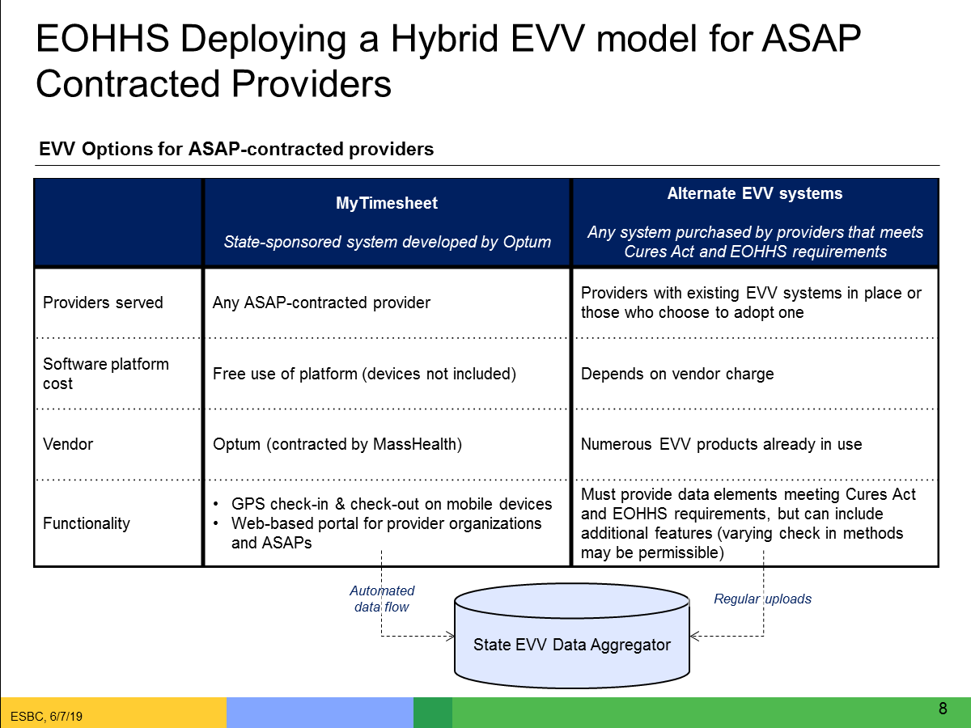

Slide 9:

EVV Estimated Timeline
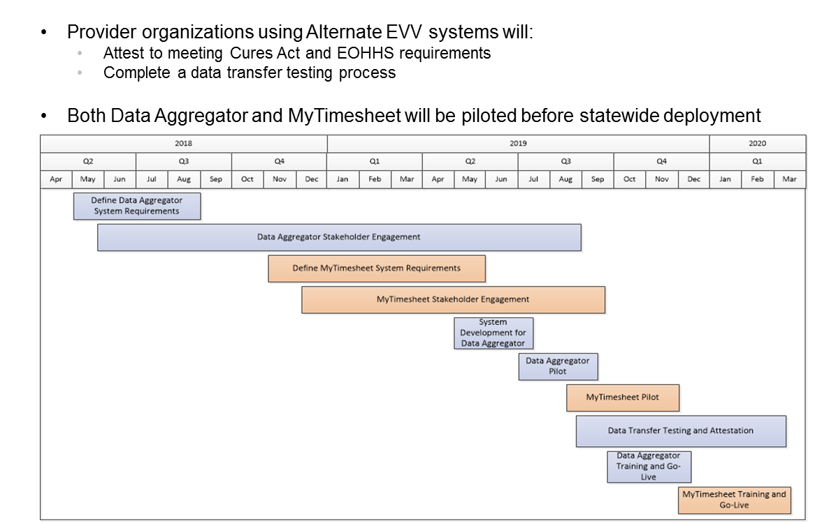

Slide 10:

EOHHS EVV Stakeholder Engagement (to date)

16 Public Listening Sessions in 2017

11 stakeholder workgroup sessions in 2017

9 Meetings with ASAPs & Providers in early to mid-2018

Home Care Alliance EVV Expo in August 2018

Presentation on EVV to ASAP/AAA Executive Directors in October 2018

Presentation at Home Care Quarterly Meeting in May 2017, August 2017, and November 2018

EVV Meeting with ASAP Contract Managers in December 2018

Alternate EVV Implementation Listening Session in February 2019

3 EVV Regional Provider Dialogue Session in April and May 2019

Slide 11:

Objective of Dialogue Sessions

Obtain feedback from provider agencies on different aspects of EVV

Ensure that EOHHS and Optum are on the right track before system is developed and plans are finalized

Make system or policy changes based on additional review from feedback

Hear from providers across the Commonwealth and engage as partners

Engage with all stakeholders across the Commonwealth, not just those who are located in Metro-Boston

Facilitate relationships between EOHHS, Optum, EOEA and provider agencies

Address a broad range of topics

Not all stakeholders will be able to attend all sessions but format should allow all stakeholders to attend at least one session

Supplement with other modes of education and input

Slide 12:

Topics Addressed and Highlights of Past Dialogue Sessions

April 24 Session – Alt. EVV Data File
- Most of the requested data fields seemed reasonable
- Need to review Non-Electronic Visit reasons
- Need to review capture of care program
- Need to consider capturing home health data

May 8 Session – Alt. EVV Data File Submission
- Alt-EVV vendors need time to develop data file and meet standards
- Need to consider how EVV relates to Provider Direct
- Need to clarify how providers should handle visits where multiple services are delivered

May 21 Session – Process Workflow and Scheduling Policies
- Need to clarify how schedules should be imported/exported into and out of MyTimesheet
- Need to consider and review consumer education
- Need to establish policy for clustered sites
- Presentations from sessions posted at https://www.mass.gov/info-details/electronic-visit-verification

Slide 13:

Today’s Session Discussion Topics
- Data File Requirements - Data File from Provider Agencies Using Alternate EVV Systems to the Optum Data Aggregator
  - The handout presented has been compiled during our business requirements sessions with Optum
  - Related topics such as data file name and format, source, point of destination, frequency, and timing will be addressed in future sessions
- Transmission of Data File – Provider Agencies Using Alternate EVV Systems to the Optum Data Aggregator
  - Methods for sending visit data and upload process
  - Visit data validation and errors
  - Modified and voided visits
  - Testing/Process for submitting the data file

- Questions to Keep in Mind:
  - Do the data fields presented make sense to you?
  - Are there data fields presented that you find questionable, unnecessary, or onerous?
  - Are there any other field requirements that are missing that we should be capturing?

Slide 14:

EVV Stakeholder Dialogue Schedule
- Tri-Valley, Inc., Dudley, MA, April 24, 2019 9:30-11am
- Elder Service of Merrimack Valley, Lawrence, MA, May 8, 2019 2-4pm
- South Shore Elder Services, Braintree, MA, May 21, 2019 10am-12pm
- Elders Services of Berkshire County, Pittsfield, MA, June 7, 2019 10am-12pm
- Springwell, Waltham, MA, June 24, 2019 10am-12pm
- LifePath, Greenfield, MA, July 16, 2019 2-4pm
- Elder Service of the Cape Cod, South Dennis, MA, August 14, 2019 11am-1pm

Slide 15:

Thank You!

Information about EOHHS’ EVV Implementation can be found at:

https://www.mass.gov/guides/mytimesheet-electronic-visit-verification-system

Feedback/questions related to EVV can be submitted to EOHHS by emailing:

EVVfeedback@State.MA.US

