Electronic Visit Verification (EVV) in Massachusetts: Stakeholder Dialogue Session #6

Lifepath – Greenfield, MA, July 16, 2019

Slide 2:

Today’s Agenda
- EVV Overview & EVV Stakeholder Engagement
  - https://www.mass.gov/info-details/electronic-visit-verification
- My Timesheet Topics for Review
  - High Level Process Workflow
  - Cures Act Compliance
  - Reporting Functionalities
- Future Dialogue Sessions

Slide 3:

Terms Used in Today’s Session
- Alternate EVV or Alt. EVV – Refers to EVV systems used by provider agencies that are NOT the MyTimesheet EVV System. These are “Alternative” EVV systems.

- Data Aggregator – System that combines or “aggregates” EVV data from provider agencies. Provider agencies using Alt. EVV systems will send their EVV data to Optum’s data aggregator. MyTimesheet data will also flow into the data aggregator.

- MyTimesheet – Optum’s EVV system that can be used by provider agencies to collect EVV data.
- Optum – Vendor that EOHHS selected to provide the MyTimesheet & Data Aggregator EVV Systems.

Slide 4:

Objective of Dialogue Sessions

Obtain feedback from provider agencies on different aspects of EVV

Ensure that EOHHS and Optum are on the right track before system is developed and plans are finalized

Make system or policy changes based on additional review from feedback

Hear from providers across the Commonwealth and engage as partners

Engage with all stakeholders across the Commonwealth, not just those who are located in Metro-Boston

Facilitate relationships between EOHHS, Optum, EOEA and provider agencies

Address a broad range of topics

Not all stakeholders will be able to attend all sessions but format should allow all stakeholders to attend at least one session

Supplement with other modes of education and input

Slide 5:

21st Century Cures Act mandates EVV use
- Electronic Visit Verification (EVV) refers to the technology a worker uses during a home visit to capture information about the services provided
- The 21st Century Cures Act (federal law) requires EVV for the following Medicaid services:
  - Personal care by 1/1/2020
  - Home health by 1/1/2023
- EVV is required for Medicaid services but EOEA will be requiring it for EOEA Non-Medicaid services as well
- EVV use is not required for organizations that provide only companion services and/or only adult day services

Slide 6:

Massachusetts’ goals for EVV implementation

- Effective Compliance: Provide an EVV system that complies with federal Medicaid requirements, minimizes burden on users, and does not disrupt the provision of services
- Efficiency: Reduce administrative burden of paper timesheets
- Program Integrity: Reduce billing errors and unauthorized spending

Slide 7:

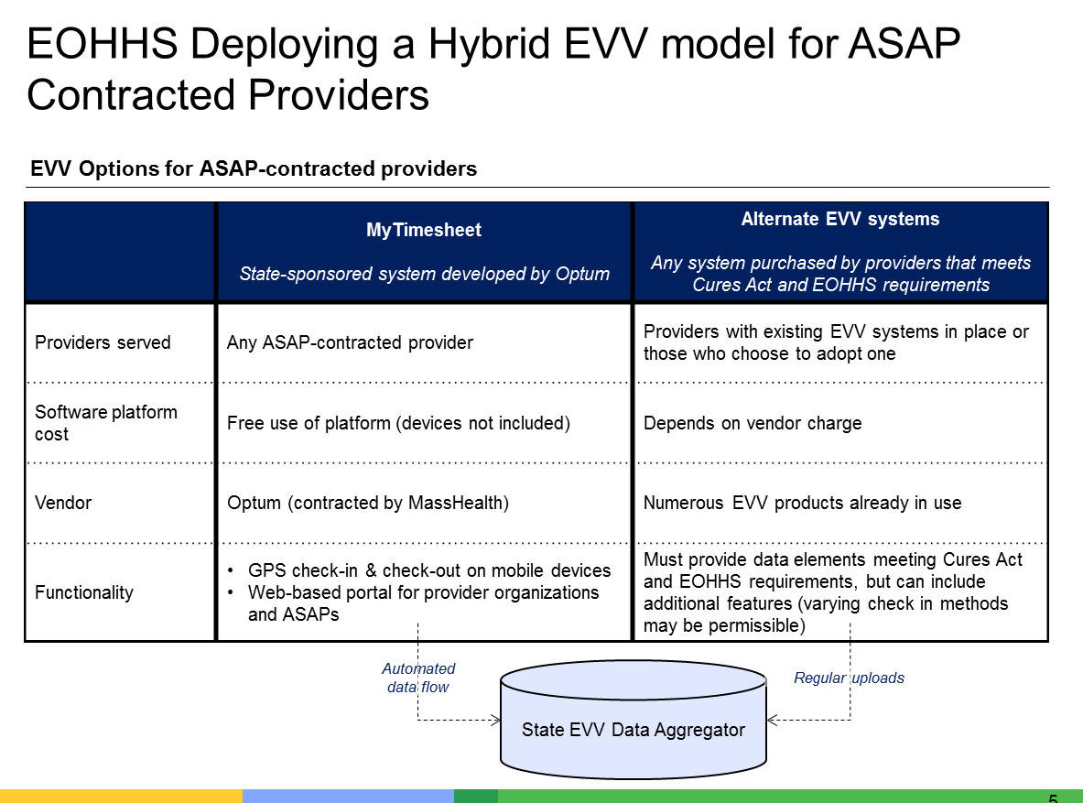

Slide 8:

EVV Estimated Timeline
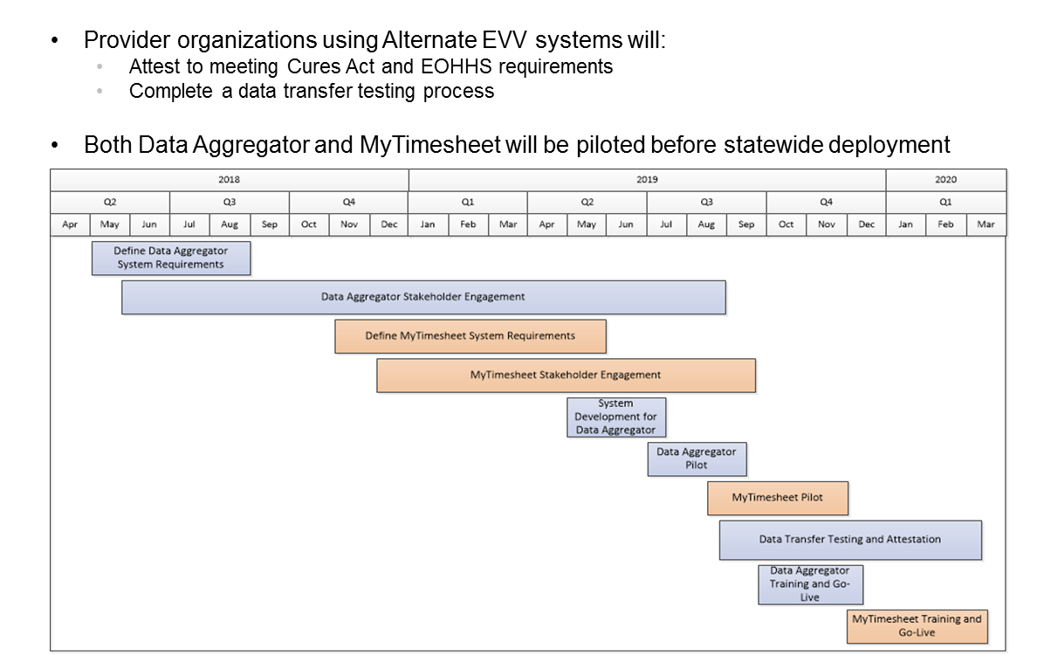

Slide 9:

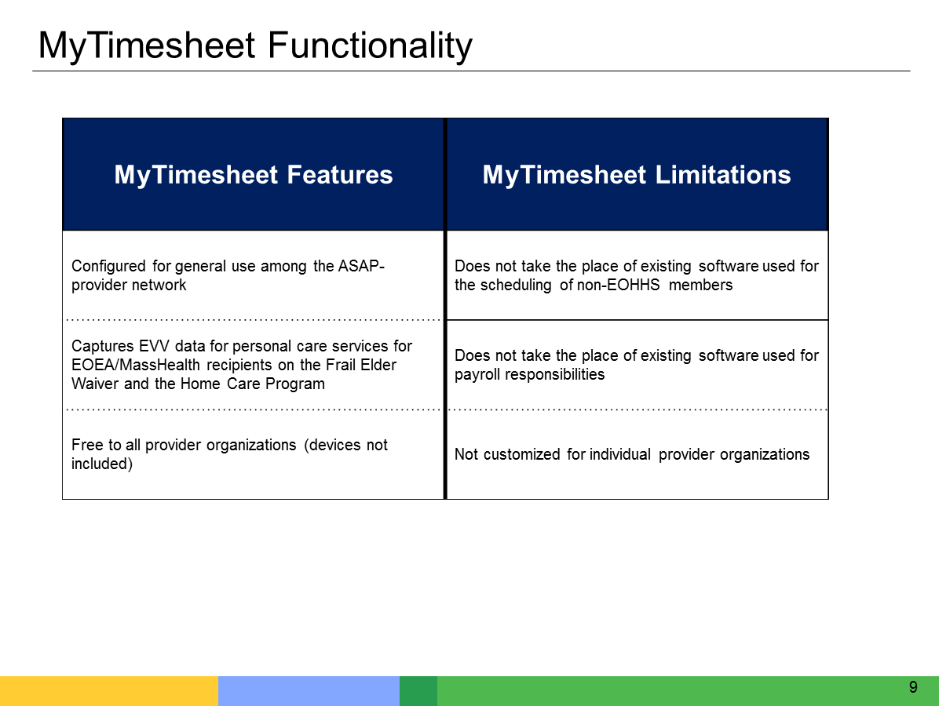

Slide 10:

EVV Overview – MyTimesheet

Slide 11:
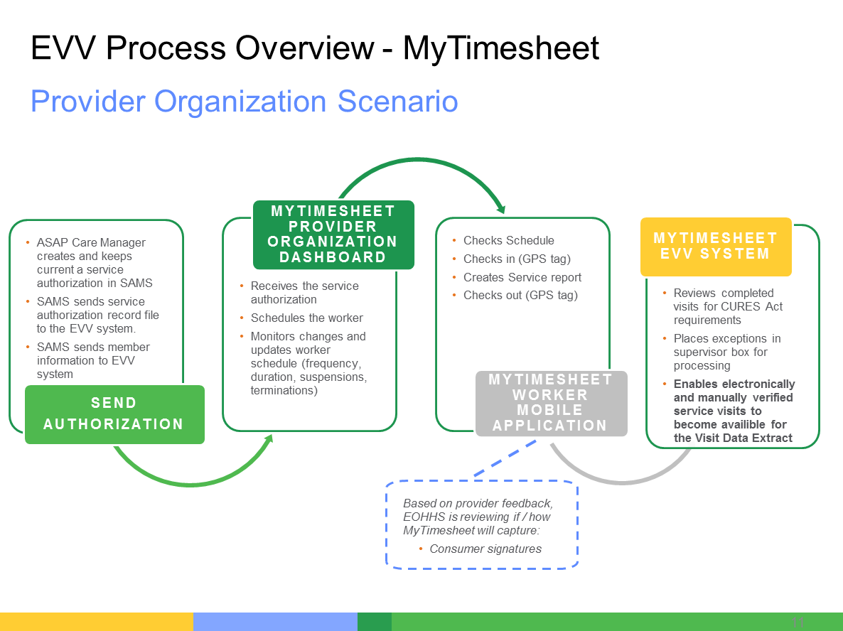

Slide 12:

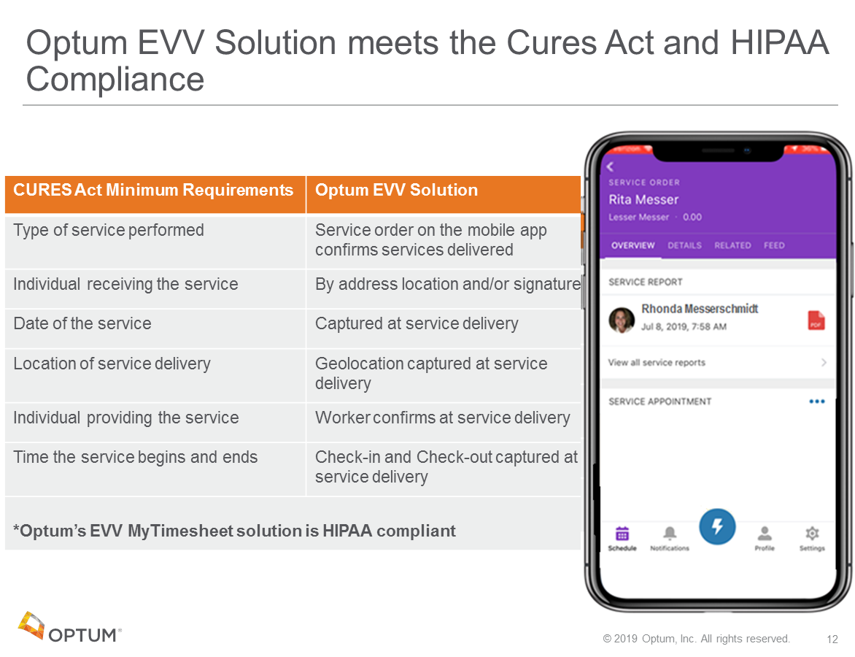

Slide 13:
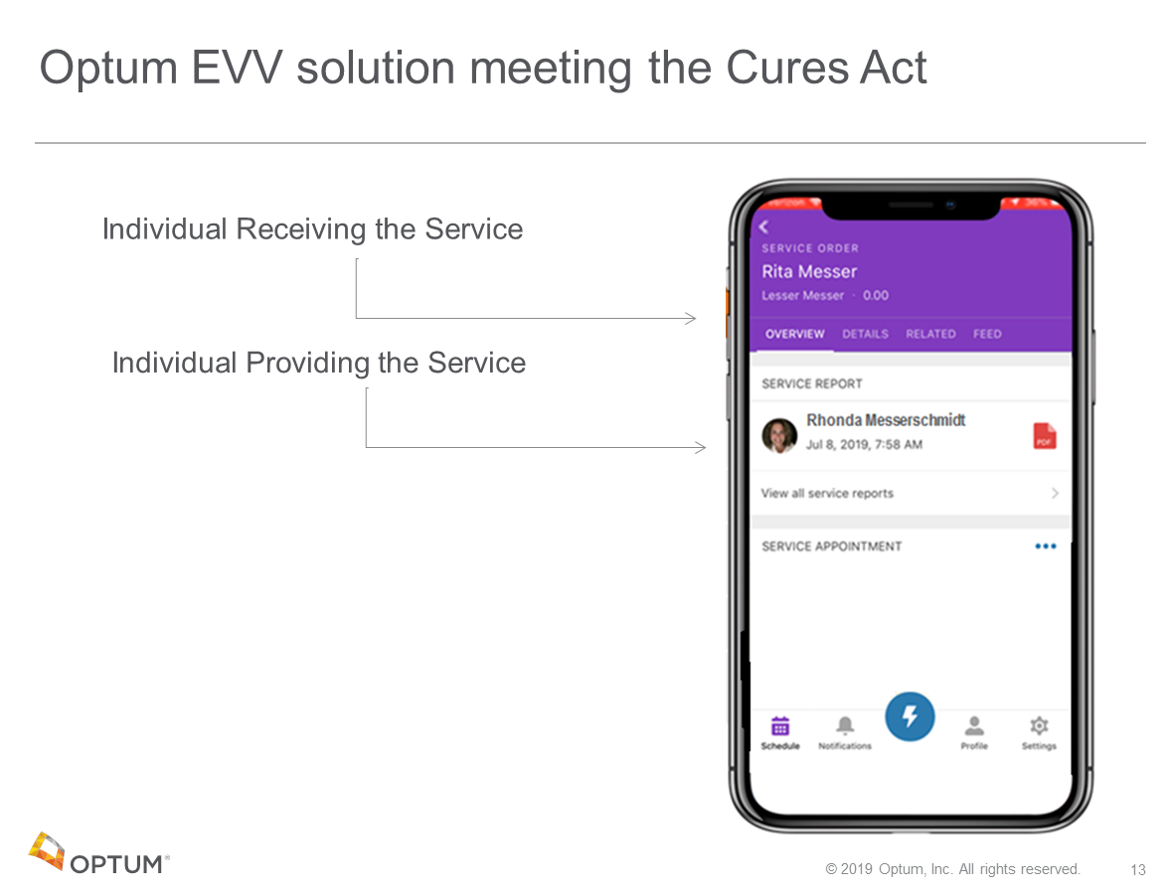

Slide 14:
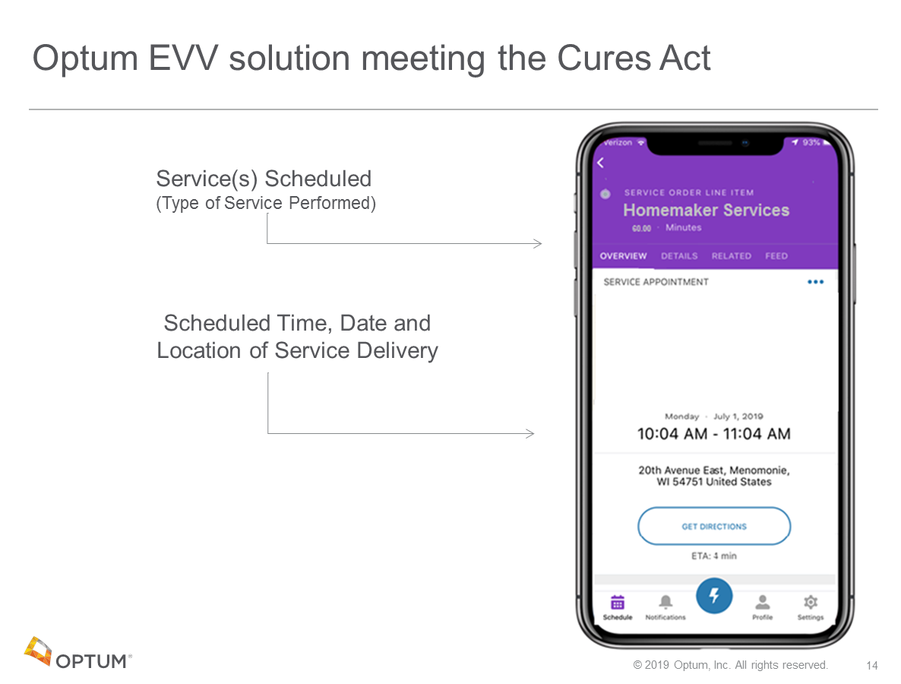

Slide 15:
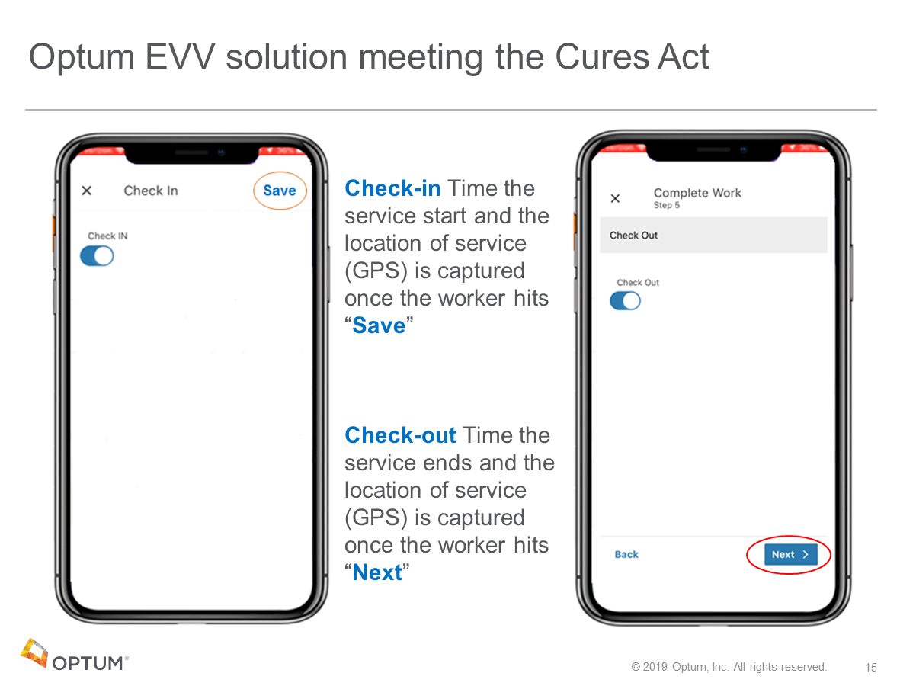

Slide 16:

EVV Overview – Reporting

Slide 17:

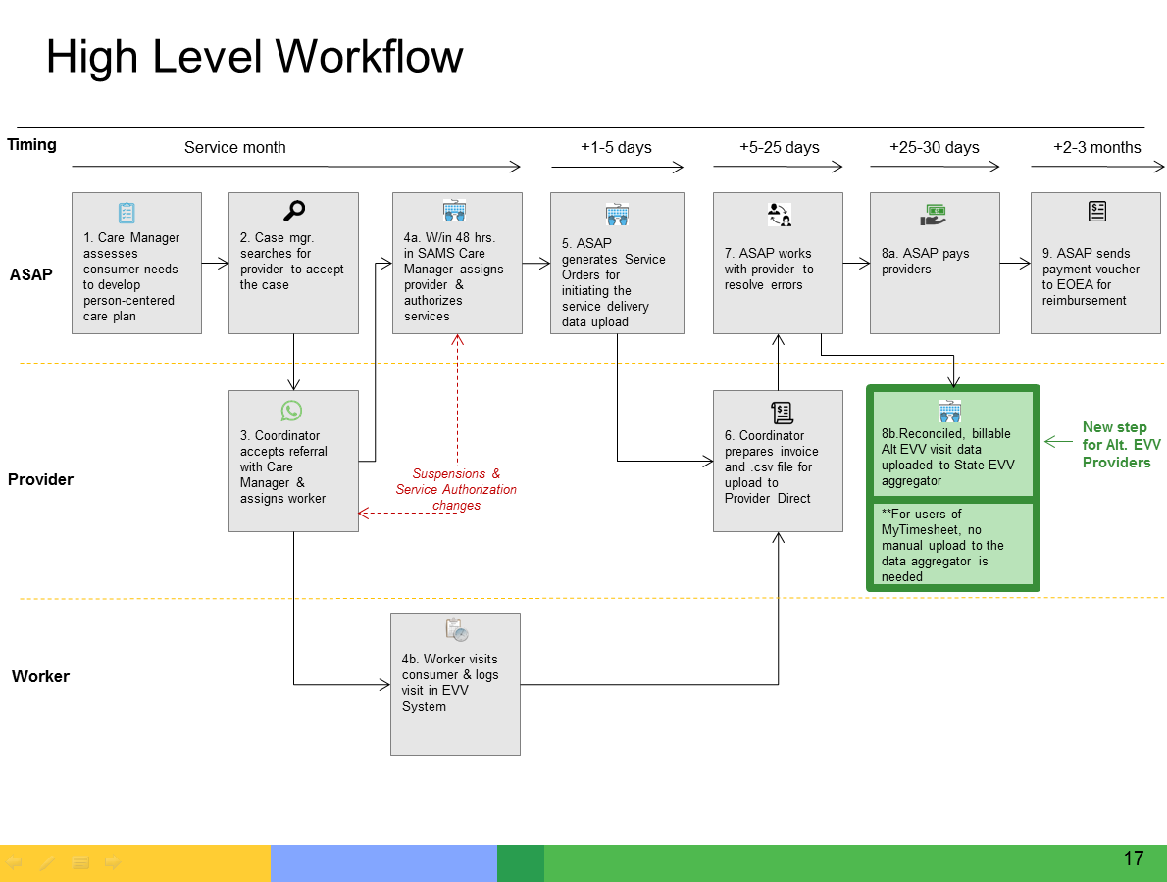

Slide 18:
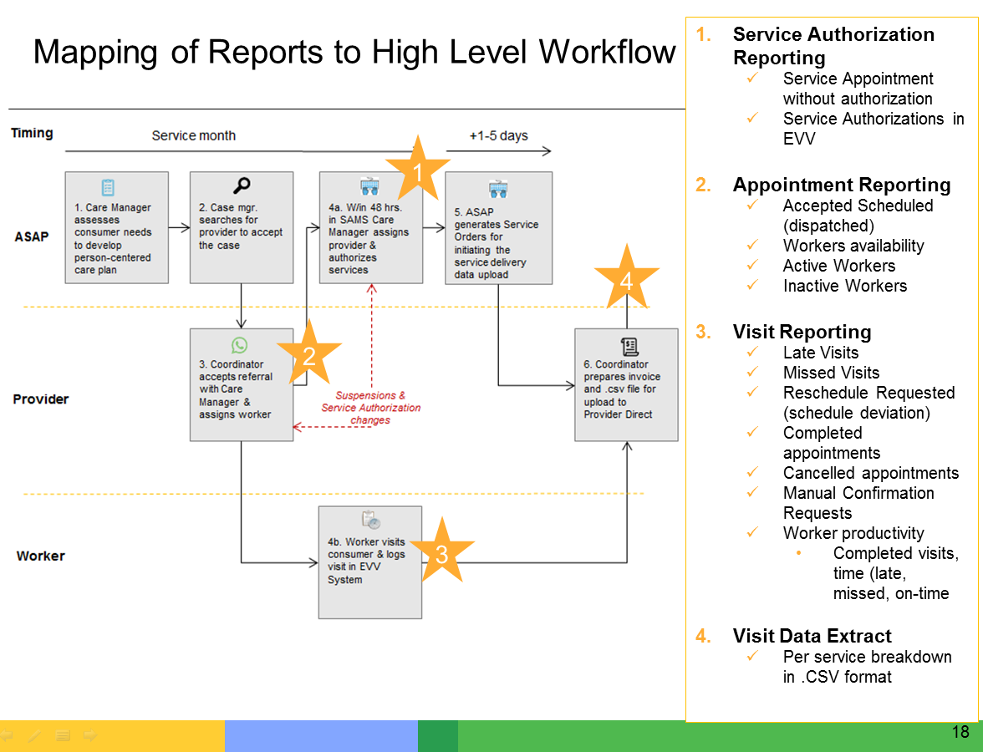

Slide 19:
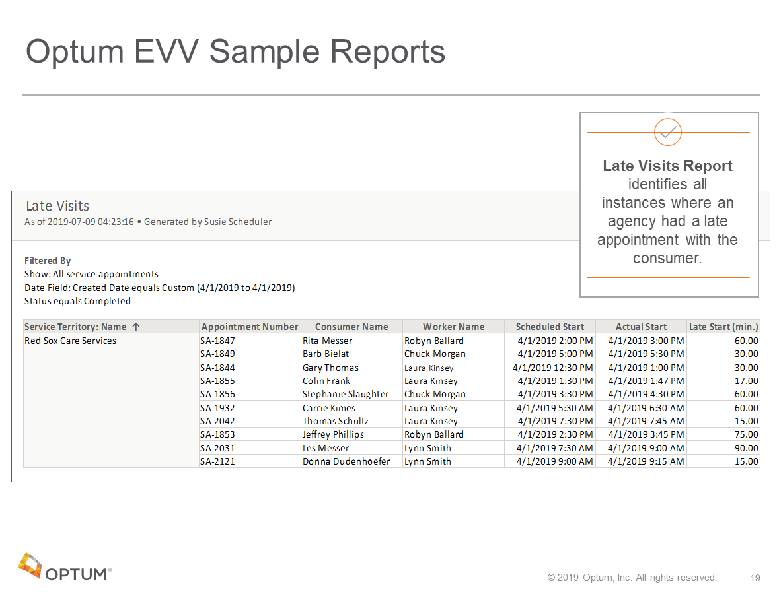

Slide 20:
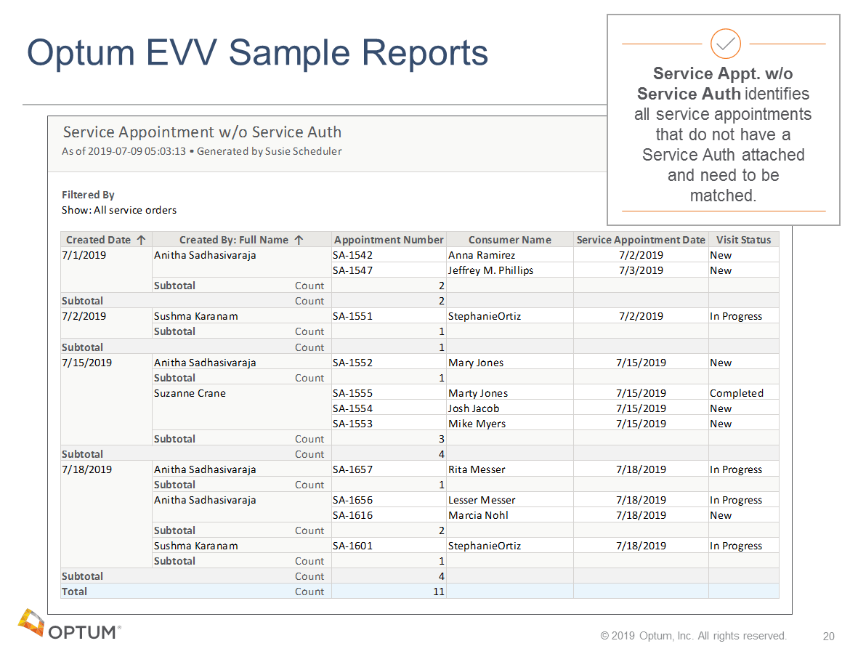

Slide 21:
