# Slide 1

Electronic Visit Verification (EVV) in Massachusetts

Stakeholder Dialogue Session #8

Mystic Valley Elder Services, Malden, MA

December 6, 2019

# Slide 2

## Agenda

* EVV Overview and EVV Stakeholder Engagement
* Areas for Disucssion
* MyTimesheet Topics for Review
  + The MyTimesheet Scheduling Console
* Next Steps

# Slide 3

## Terms Used in Today’s Session

* Alternate EVV or Alt. EVV – Refers to EVV systems used by provider agencies that are NOT using the MyTimesheet EVV System. These are “Alternate” EVV systems.
* Data Aggregator – System that combines or “aggregates” EVV data from provider agencies. Provider agencies using Alt. EVV systems will send their EVV data to Optum’s data aggregator. MyTimesheet data will also flow into the data aggregator.
* Electronic Visit Verification (EVV) - refers to the technology a worker uses during a home visit to capture information about the services provided
* MyTimesheet – Optum’s EVV system that can be used by provider agencies to collect EVV data
* Optum – Vendor that EOHHS selected to provide the MyTimesheet & Data Aggregator EVV Systems.

# Slide 4

## 21st Century Cures Act Mandates EVV Use

* Massachusetts is implementing EVV as mandated by the 21st Century Cures Act (federal law) for the following Medicaid Services:
  + Personal care by January 1, 2020
  + Home health by January 1, 2023
* Massachusetts submitted a Good Faith Effort Application to CMS on November 15, 2019, which would provide the state with an additional year to comply with EVV requirements
* EOEA is electing to require EVV for some non-Medicaid services (Home Care Program) as well to simplify data collection on the worker level
* EVV use is not required for organizations that provide only companion services and/or only adult day services

# Slide 5

## Massachusetts’ goals for EVV implementation

* Effective Compliance: Provide an EVV system that complies with federal Medicaid requirements, minimizes burden on users, and does not disrupt the provision of services
* Efficiency: Reduce administrative burden of paper timesheets
* Program Integrity: Reduce billing errors and unauthorized spending

# Slide 6

## EOHHS is Deploying a Hybrid EVV model for ASAP Contracted Providers

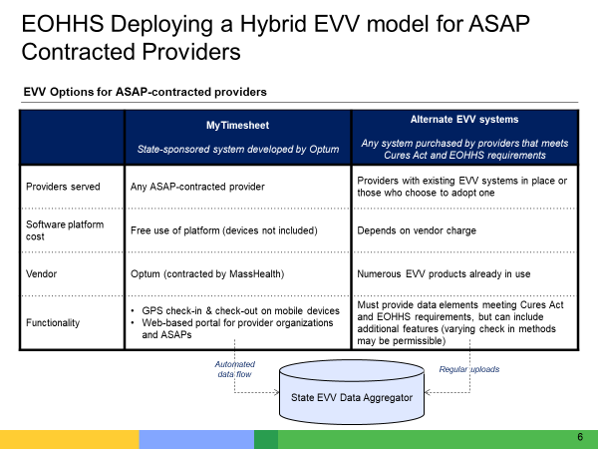

A visual depiction of the EVV options for ASAP-contracted providers

Image summary:

* MyTimesheet is the state-sponsored EVV system that is being developed by Optum.
* Providers can also elect to use their own EVV system, known as “Alt-EVV”. Optum is developing a Data Aggregator that will serve as a warehouse for Alt-EVV data. If a provider elects to use their own EVV system, the provider will need go through a phase of testing with Optum to ensure that their data can feed into the Data Aggregator and do so correctly.

# Slide 7

## MyTimesheet Functionality

* MyTimesheet is configured for general use among the ASAP-provider network
* MyTimesheet captures EVV data for personal care services for EOEA/MassHealth recipients on the Frail Elder Waiver and the Home Care Program
* MyTimesheet is free to all provider organizations (devices are not included)
* MyTimesheet does not take the place of existing software used for the scheduling of non-EOHHS members
* MyTimesheet does not take the place of existing software for payroll responsibilities
* MyTimesheet is not customized for individual provider organizations

# Slide 8

## Estimated EVV Implementation Timeline for the ASAP Network

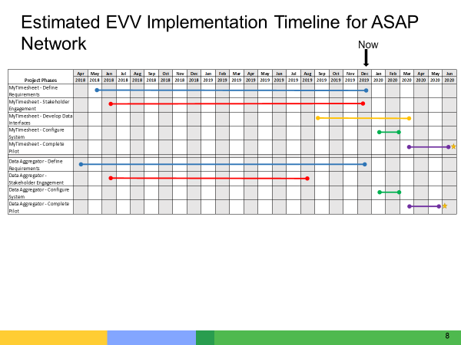

A visual representation of the EVV implementation timeline for the ASAP network. All dates are tentative.

Image summary:

* EOHHS is continues with the requirements gathering for MyTimesheet and the Data Aggregator, which is expected to conclude in January of 2020.
* EOHHS is working with Optum to develop the data interfaces that are necessary to feed MyTimesheet with service authorization information from SAMS.
* Optum will begin system configuration in January 2020.
* There will be a pilot of both MyTimesheet and the Data Aggregator between March and June 2020.
* Both systems will Go Live in June of 2020.

# Slide 9

## Objective of Dialogue Sessions

* Obtain feedback from provider agencies on different aspects of EVV
  + Ensure that EOHHS and Optum are on the right track before system is developed and plans are finalized
  + Identify any possible system or policy changes based on feedback
  + Engage with all stakeholders across the Commonwealth, not just those who are located in the Metro-Boston area
  + Facilitate relationships between EOHHS, Optum, EOEA and provider agencies
* Clarify programs that require EVV
  + Frail Elder Waiver, Home Care Program, Senior Care Options (SCO), One Care
* Address a broad range of topics
  + Each session has addressed a different topic related to the two EVV options (MyTimesheet and Alt-EVV)
  + Supplement with other modes of education and input including stakeholder surveys and MassHealth webpage updates

# Slide 10

## Topics Addressed at Past Dialogue Sessions

* April 24, 2019: The Alt-EVV Data File
* May 8, 2019: Alt-EVV Data File Submission
* May 21, 2019: Process Workflow and Scheduling Policies
* June 7, 2019: Alt-EVV Data File Submission
* June 24, 2019: Process Workflow and Scheduling Policies
* July 16, 2019: Compliance with Cures Act and Reporting
* August 14, 2019: Compliance with Cures Act and Reporting

# Slide 12

## Next Agenda Item

We are moving onto the Discussion Topics

# Slide 13

## Discussion: Billing Extract Report

The Billing Extract Report is a report that will support providers who elect to use MyTimesheet in entering data into Provider Direct. This report will not replace current Provider Direct processes. The report will include:

* Provider organization name and EIN
* Associated ASAP
* Consumer name and ID(s)
* Worker name and ID
* Service address
* Service description
* Service date
* Service start and end time
* Actual service duration and rounded service duration

What other data is important to include in a Billing Extract Report?

# Slide 13

## Discussion: Current Practices

For All Provider Organizations

* Does your organization provide email addresses for your workers?
* If you are a provider organization with multiple locations, how do you handle scheduling across multiple offices? How does your scheduling system accommodate this practice?
* For example, do you have schedulers covering specific offices or service locations?
* How is coverage handled (i.e. if a scheduler is covering for another office or a worker is covering a case temporarily at another location)?

For Alt-EVV Users

* How do you have your workers check in and check out for multiple services in a visit?
* If you have your workers check in and out only once when you have multiple services provided in a single visit, how does your organization handle billing those services?

# Slide 12

## Next Agenda Item

We are moving onto the MyTimesheet Scheduling Console

# Slide 13

Scheduling Console Overview

MyTimesheet

Rhonda Messerschmidt

# Slide 14

## Overview of the MyTimesheet Scheduling Data Flow

* The flow chart below illustrates how data flows from EOEA and EOHHS to Optum for scheduling in the MyTimesheet EVV system
* EOHHS and Optum will have an automatic data transfer process in place that sends the Service Authorization data from SAMs to MyTimesheet.

# Slide 15

## Scheduler Responsibilities in MyTimesheet

A Scheduler at a Provider Organization may use MyTimesheet to complete the following activities:

* Complete intake review of the service authorizations
* Schedule appointments
* Review and respond to worker notifications related to scheduling
* Resolve scheduling issues
* Run scheduling reports

First, we will talk about completing an intake review of the service authorizations.

# Slide 16

## Intake Review of Service Authorizations

* MyTimesheet offers Provider Organizations the ability to view the service authorizations that are transferred from SAMS to MyTimesheet during the automatic data transfer process.
* The service authorization data will be used to generate the MyTimesheet Service Plan for the consumer.
* Once the MyTimesheet Service Plan is created, the consumer’s schedule can be set up in the MyTimesheet system.

# Slide 17

## Scheduler Responsibilities in MyTimesheet

A Scheduler at a Provider Organization may use MyTimesheet to complete the following activities:

* Complete intake review of the service authorizations
* Schedule appointments
* Review and respond to worker notifications related to scheduling
* Resolve scheduling issues
* Run scheduling reports

Next, we will talk about how to schedule appointments.

# Slide 18

## Scheduling Appointments

* Once MyTimesheet has the service authorization information from the data transfer, the Scheduler can create the appointments in MyTimesheet.
* Scheduling appointments is done in MyTimesheet by creating what is called a “Service Plan”.
* A Service Plan is information about a specific service being delivered, the time frames, and frequency. It is based on the service authorization.
* Much of the information needed to complete the Service Plan will be automatically populated by the service authorization. Some data may be populated by the scheduler, depending on the business practice of the provider organization and the level of detail provided in the service authorization.

# Slide 21

## Scheduling Appointments

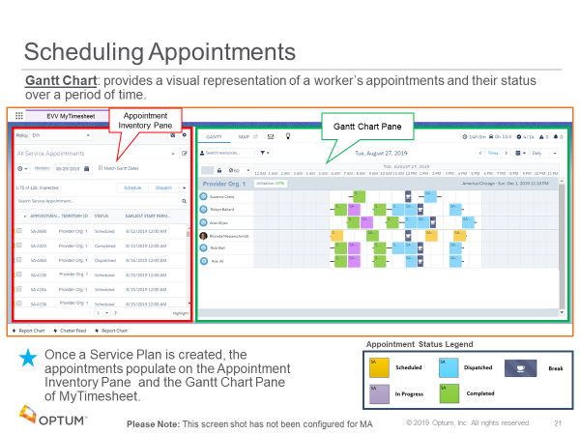

Image description:

This image shows that when a MyTimesheet Service Plan is created, the appointments populate on the Appointment Inventory Pane and the Gantt Chart Pane of MyTimesheet.

* The Gantt Chart provides a visual representation of a worker’s appointments and their status over a period of time.
* The Gantt Chart is color coded so that a scheduler can distinguish between when a service is scheduled, when it has been dispatched, when it is progress, and when it is complete.

# Slide 22

## The Appointment Inventory Pane

The Appointment Inventory Pane contains all of the service appointments in a list format. These appointments were created from Service Plans with information from the Service Authorizations

You can use the appointment inventory pane to:

* View the list of appointments that need to be scheduled
* View the list of appointments that have been scheduled that are ready to be dispatched
* View the status for any listed service appointments
* Choose the criteria that you want applied to appointments in order for them to be listed
* Set the date range for the appointments you want included in the list

# Slide 23

## The Gantt Chart Pane

The Gantt Chart Pane contains a view of all appointments that have been scheduled, dispatched, in-progress or completed.

Actions you can take using the Gantt chart pane include:

* View the current status and details of in-progress appointments
* Identify scheduling conflicts
* Move appointments from one worker to another worker
* Schedule and dispatch appointments
* Change appointment status
* Flag appointments
* Reschedule appointments

# Slide 24

## Scheduling Appointments

To Schedule Appointments:

* Select the appointments that need to be scheduled from the Appointment Inventory Pane.
* Appointments that need to be scheduled they are identified with the Status “None”.
* Click the radio button to the left to select the appointments you want to schedule and then select “Schedule.”
* The system will recommend a worker to deliver the service, in the timeframe and frequency needed by the consumer or the scheduler can pick a worker based on their availability.

# Slide 25

## Dispatching Appointments

Dispatch is an action taken by a Scheduler that pushes the scheduled appointment to the worker’s mobile app.

To Dispatch Appointments:

* Select the appointments that need to be dispatched from the Appointment Inventory Pane.
* They are identified with the Status of “Schedule”.
* Click the radio button to the left to select the appointments you want to dispatch and then select “Dispatch.”
* The status will change from scheduled to dispatched.
* The system will push that appointment to the worker’s mobile app.

# Slide 26

## Scheduler Responsibilities in MyTimesheet

A Scheduler at a Provider Organization may use MyTimesheet to complete the following activities:

* Complete intake review of the service authorizations
* Schedule appointments
* Review and respond to worker notifications related to scheduling
* Resolve scheduling issues
* Run scheduling reports

Now we will talk about how to review and respond to worker notifications related to scheduling

# Slide 27

## Worker Notifications Related to Scheduling

* The Scheduler can receive notifications on the scheduling console from the Workers out in the field.
* These notifications are sent from the Mobile App through a chatter message.
* The Scheduler clicks on a notification to open it. This enables the Scheduler to respond to the Worker and communicate in real-time.

# Slide 28

## Resolving Scheduling Issues

In lieu of the of the Chatter functionality the worker can call the scheduler with the Service appointment number (for example, SA-1790) and the Scheduler can search for that Service Appointment in the search box to update the details based on their conversation.

# Slide 29

## Scheduler Responsibilities in MyTimesheet

A Scheduler at a Provider Organization may use MyTimesheet to complete the following activities:

* Complete intake review of the service authorizations
* Schedule appointments
* Review and respond to worker notifications related to scheduling
* Resolve scheduling issues
* Run scheduling reports

Now we will talk about how to resolve scheduling issues.

# Slide 30

## Resolving Scheduling Issues

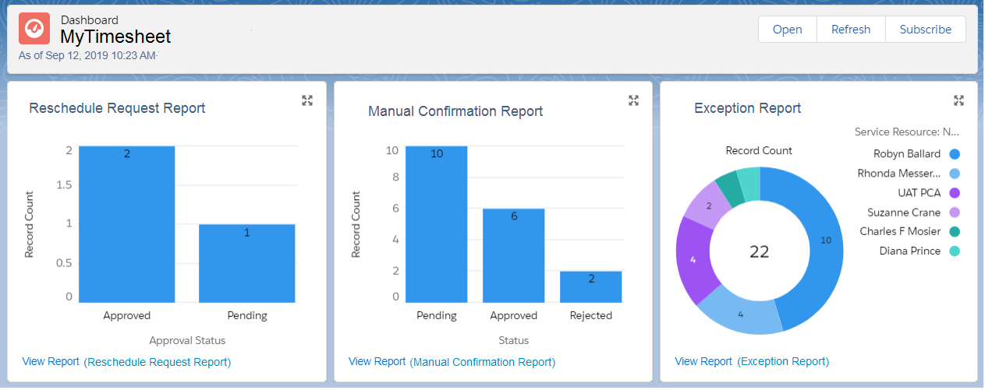

Image description:

This image represents what a supervisor would see on their dashboard. This dashboard is where exceptions are handled and where operations can be monitored (for example, see a record of manual confirmations).

# Slide 31

## Resolving Scheduling Issues

If a worker forgot to check in or check out, this requires a manual confirmation for the appointment. The Supervisor (or other provider organization designee) would confirm the reason for the missing check in/check out and then update MyTimesheet with the details as indicated to the right.

Once the research has been completed on this manual confirmation request the user is ready to approve or reject

# Slide 31

## Scheduler Responsibilities in MyTimesheet

A Scheduler at a Provider Organization may use MyTimesheet to complete the following activities:

* Complete intake review of the service authorizations
* Schedule appointments
* Review and respond to worker notifications related to scheduling
* Resolve scheduling issues
* Run scheduling reports

Finally, we will talk about running scheduling reports.

# Slide 33

## Running Scheduling Reports

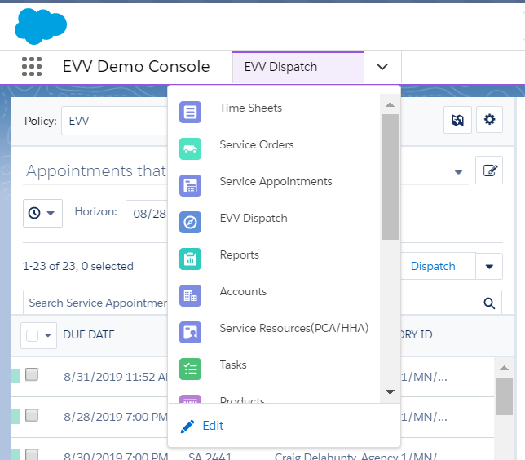

Image description: A supervisor can go into the report library, click on the down arrow, as indicated in the picture, and open the menu of options. The worker will then select Reports.

# Slide 34

## Running Scheduling Reports

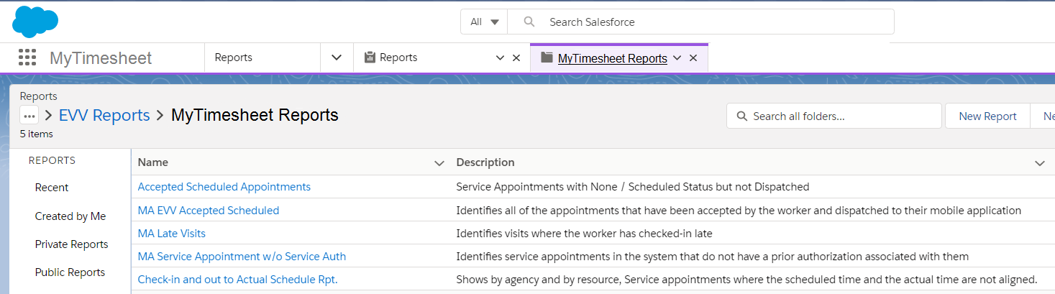

Image description: In the report library for MyTimesheet, click on the report you’d like to run. For every report, there is a description of what that report contains. The report parameters are pre-set; however, they can be modified with the right set of user permissions.

# Slide 35

## Running Scheduling Reports



Image description: This is a sample check in/check out report that shows variance in time recorded by the system versus scheduled time. Any report can be exported into Excel.

# Slide 36

A break to review any questions from the audience.

# Slide 37

## Next Agenda Item

We are moving onto Next Steps

# Slide 38

## Next Steps

* EOHHS is hosting two provider demos of the Optum CORE product, which will be customized into MyTimesheet. The demos will be in mid-December.
* You can visit the Massachusetts EVV webpage for the most up to date information and provider communication: <https://www.mass.gov/info-details/electronic-visit-verification-evv>
* Contact the Massachusetts EVV email address with questions at [EVVFeedback@MassMail.State.MA.US](mailto:EVVFeedback@MassMail.State.MA.US)