EXAMPLE

STANDARD OPERATING PROCEDURE

Sample Collection Techniques for Bacterial Samples in Surface Waters

January 14, 2020

Table of Contents

1.0 SCOPE AND APPLICATION 3
2.0 SAFETY CONSIDERATIONS 3
3.0 WATER SAMPLE COLLECTION, PRESERVATION AND HANDLING 4
3.1 Sample Bottles 4
3.2 Step-by-Step Directions 4
3.3 Sample Preservation & Transport 5
3.4 Documentation 6
3.5 Standard QC Samples (Duplicates, Splits, and Field Blanks) 6
4.0 SAMPLING EQUIPMENT 6
5.0 PREVENTATIVE MAINTENANCE 6
6.0 CORRECTIVE ACTIONS 6
7.0 ATTACHMENTS 6

1.0 SCOPE AND APPLICATION
The purpose of this document is to provide guidance on field sample collection procedures for bacterial samples in ambient surface water samples. The use of good field sampling procedures helps to ensure that data collected meet the quality assurance requirements of the General Quality Assurance Project Plan (QAPP) for precision, accuracy, representativeness, and completeness. A primary goal in field sampling is to ensure that the sample collected reflects ambient conditions at the time of sampling. The integrity of the sample and its associated quality control is dependent on following standardized sample collection, preservation, storage, and transport protocols. The collection of incongruous materials (sediment, surface scum, plant fragments, etc.) and improper sampling techniques introduces error into the analysis and affects data usability.

2.0 SAFETY CONSIDERATIONS
Safety for staff and volunteers is top priority. Do not put yourself in harm’s way to complete sampling. Review the following:

- FIRST AID KITS should be taken on all sampling trips; inspect and re-stock as needed before going on-site.

- EQUIPMENT: Check sampling equipment and protective gear for defects, holes, or wear and tear before use.

- SITE ACCESS: Investigate the accessibility of sampling sites, as well as streamflow and water depth characteristics at sampling locations, before sampling. If site access is hazardous, sampling should be postponed or an alternative site found.

- ROADS and BRIDGES: Many sites are on bridges and busy roadways. Warn approaching traffic of your presence by paring on the same side that you’re working on (if possible); place orange cones by the vehicle if parked near the lane of travel.

- SAMPLING TEAMS: Always sample in teams of two or more, unless otherwise approved by the monitoring coordinator. At least one person per sampling crew should be trained in Adult CPR/first aid. Make sure that someone (in addition to your sampling team) knows where you will be going and when you expect to be back.

- CLOTHING & PERSONAL SAFETY: Dress for anticipated conditions but be prepared for “worst case.” Items to consider include extra clothing, sunshade, sunscreen, orange safety vests, hats, insect repellent, insulated boots and gloves, safety glasses, waterproof boots for highest anticipated depths (chest waders or hip waders).

- GLOVES: Elbow-length rubber gloves are recommended for work directly in potentially-contaminated waters (e.g. sampling).

- TICKS: Check for ticks on yourself and your clothing, particularly after walking through grassy or brushy areas.

- FOOD AND DRINKS: Never have food or drinks near samples and never use sample coolers to store food and drinks. Schedule lunch/dinner/snack at a non-sampling time. Always wash hands thoroughly before and after handling samples and food.

- PACE: Work at a reasonable pace to ensure personal safety (and data quality). Rushed sampling will usually lead to poor results.

- PFDs: For sampling from boats, a personal flotation device (PFD) is required for each occupant. It is highly recommended that PFDs are worn at all times.

3.0 WATER SAMPLE COLLECTION, PRESERVATION AND HANDLING
ORGANIZATION/PROJECT
Site ID ______________________
Analysis ____________________
Date ________________________
Time _______________________
Sampler’s Initials______________

3.1 Sample Bottles

Bacterial grab samples are collected in a sterile, 120-mL containers (or 290-mL for collecting samples for splitting). Containers can be requested to have sodium thiosulfate tablet included for dechlorination, if ambient water at sampling locations possibly contains residual chlorine. When in doubt, request that sodium thiosulfate be included in the sample bottles.

Labels (example above) with site ID, date, and analysis filled out should be placed on the dry sample bottles before going into the field; time and sampler’s initials will be filled out in the field. It is the responsibility of the sampling team to check the bottle labels and site IDs for each site to ensure that the right bottles are used.

3.2 Step-by-Step Directions
STEP | DESCRIPTION
BEFORE SAMPLING
1 | REVIEW APPROVED SAP as needed for site locations, driving directions, analytes, sampling apparatus, etc.…
2 | ASSEMBLE EQUIPMENT as specified in SAP.  Equipment generally includes: clipboard, field forms, permanent pen/marker, Chain of Custody forms, pre-labeled sample bottles, cooler with ice and temperature blank, sterile water (if needed for QC), sampling pole, sampling basket, gloves, sampling site directions, personal gear.
ON LOCATION
3 | FIELD SHEET  Fill out the fieldsheet. Note any unusual conditions.
4 | SITE ACCESS (RIVER/STREAM)  Scan the site for best wade-in access that will provide least disturbance of substrate and provide for a representative sample. DO NOT wade if conditions are unsafe. Where wading into the flow is not possible and no alternative access is available, samples may be taken using a pole. Be sure that a sample taken from the bank is in the flow and representative of the larger area. If a safe, representative location cannot be found, do not take sample.
4a | WADE-IN GRAB SAMPLING (RIVER/STREAM)  - Use of clean gloves for bacterial sampling is recommended to protect the integrity of the sample.  - Wade in carefully, moving upstream until you get to the main flow of the stream. Sample from midstream if the stream is small. If the stream is larger, go only as far out from shore as is safe, as close to the current as possible.  - Establish a solid footing before sampling.  - Stand facing upstream (the water moving towards you) and allow any disturbed sediments to be carried downstream before sampling.  - Always collect the sample upstream of where you’re standing.  - Keep sampling container closed until you are ready to take the sample.  - DO NOT RINSE INSIDE OF BOTTLES.  - Open the bottle (careful not to contaminate the lid) and hold the bottle near its base.  - With the bottle facing slightly upward and with its mouth toward the current, scoop through the water moving upstream to collect sample.  - Make sure the bottle is filled to just over the 100-mL line, leaving airspace for mixing. Do not overfill.  - Re-cap.
5 | TAKE ANY DUPLICATE SAMPLES  Using exactly the same procedure as for the original sample, take the duplicate sample as soon as possible after the original sample.
6 | FIELD BLANK SAMPLES - Except for the type of water in them, the field blank and all samples should be handled, preserved and transported the same way.  Pour sterile water directly from the bottle of sterile water into each sample bottle at the site. Fill to just over the 100-ml line. Cap bottle.
7 | SPLIT SAMPLING - For split samples, take the sample as described above, using a larger volume (e.g. 290-mL) sterile bottle. For field splits, cap the original sample, mix well, and pour immediately into the two smaller sterile sample bottles to just above the 100-mL line and cap immediately.
8 | POLE SAMPLING – to collect samples where the site is too deep or too cannot be accessed without disturbing sediment:  - Rinse the pole with ambient water three times without bottles.  - Fit the bottle into the clamp. DO NOT rinse the sterile bottle.  - Uncap the bottle (taking care not to contaminate the cap).  - With the bottle facing slightly upward with its mouth toward the current, scoop through the water moving upstream to collect sample.  - Make sure the bottle is filled to just over the 100-mL line, leaving airspace for mixing. If thiosulfate is included, do not overfill.  - Re-cap the bottle and remove from the bottle from the clamp.
9 | SHALLOW DEPTH RIVER SAMPLING (where very shallow water depth precludes the manual filling of sample bottles without sediment disturbance). Proceed as follows:  - Scan the site for a “flowing” pool or deeper section where a representative sample can be taken.  - If an area is found, uncap the bottle, place cap in new plastic baggie, and gently insert the bottle into the water (rather than scooping through the water as described above). Observe whether sediment is disturbed while sampling and whether the sample contains debris from the surface. When filled to 100-mL line, recap, and wade out.  - Document situation on fieldsheet. For example, note on fieldsheet if sample contains predominately water off the surface due to shallow water depth.  - If the entire area is too shallow, reconsider the need to sample the station.
10 | LAKE AND BEACH SAMPLING using a sampling pole (see equipment description below):  - Wade approximately knee to waist deep into the lake at a location that reflects the water quality within the recreational zone (e.g. designated swimming area). Minimize the suspension of bottom sediments to the extent possible when wading into the lake.  - Take the sample following the sampling directions for either wade-in sampling or pole sampling (above).
11 | SAMPLE TRANSPORT  - Place samples (on ice in cooler (4° C, dark) immediately.  - Transport to lab within 6 hours of sampling (counting from the first sample of a trip). During transport, keep coolers containing samples in sight at all times or locked in the car if stops are made. Do not leave samples unattended at any time, unless they are locked in a vehicle.  - Transfer custody at lab using chain-of-custody form and get copy of completed form. Check cooler temperature and record on COC.
12 | PRECAUTIONS  It is important to document the samplers’ expert opinion on the chain of custody when a site is suspected of having a high bacteria concentration. Informing the bacteria analyst when the site is suspect provides information on how the sample should be treated during analysis.  Resample if the sampler over-fills the container or contact had been made to sample. Always take an extra sterile bacteria sample bottle for use in cases where a bacteria sample bottle has been wasted, and re-sampling is needed.  If water depth is less than appx. 18 inches do not take samples using pole sampler. Find a spot for taking wade-in grab samples.
AFTER SAMPLING
13 | CLEAN/DECONTAMINATE EQUIPMENT. Any collection devices should be washed thoroughly after each daily use with phosphate free LIQUI-NOX™ and rinsed three times with tap water. Coolers should be rinsed with tap water and left open to dry.

3.3 Sample Preservation & Transport
All samples must be transported in an insulated cooler filled with ice to ~ 4°C. Cooler temperatures should be checked on arrival the laboratory using a “temperature blank” (i.e. bottle of tap water, of similar size to the samples, put in the cooler at the same time as the first sample, from which transport temperature can be read). Bacterial samples must be delivered to the laboratory within 6 hours of sampling and analyzed within 8 hours of sampling.

3.4 Documentation
Project fieldsheet and Chain of Custody should be filled out completely in waterproof ink. All corrections should be crossed out once and the sampler’s initials written next to the error. Any deviations from the SOP should be noted on the fieldsheet.

3.5 Standard QC Samples (Duplicates, Splits, and Field Blanks)
It is the monitoring coordinator’s responsibility to review the approved QAPP and SAP for QC sample types and numbers and to provide the correct number of sample bottles for QC for each sampling run.

4.0 SAMPLING EQUIPMENT
Field sampling teams should be provided with enough new, sterile sample containers to collect the project’s samples and associated quality control samples. Other equipment needed, including insulated coolers filled with ice, personal protective equipment, appropriate collection apparatus, chain of custody form, and field sheet should be provided. (See Appendix 1 for example list of equipment.)

The sampling locations dictate the equipment that may be required. In general, sampling stations should be selected to facilitate the taking of wade-in manual grab samples (wading in and filling sample bottles by hand). Where wade-in sample collection is not possible, samples can be collected from the shore or bank (as long as the water collected is representative of the flowing river/stream) with an extension pole sampler pole used to avoid shore effects (see Appendix 2 for construction of a sampling pole).

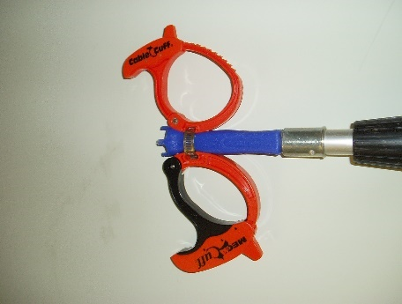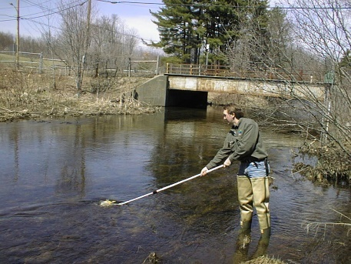

Cross-contamination between stations is minimized by rinsing the sampling pole three times (without bottles) with station water prior to use, and the fact that the bottle openings are well above the top of the basket.

5.0 PREVENTATIVE MAINTENANCE
A copy of the project SAP and SOPs should be distributed to each sampling team for review during training, before participating in sampling. The SAP provides details including site location, site background, chain of custody procedures, required sample volumes, shipping requirements, equipment required, and labeling procedures.

6.0 CORRECTIVE ACTIONS
When problems arise during sampling, such as unanticipated site conditions or new information that affects the sampling:
- Document the problem and any actions taken to solve the problem on the chain of custody and field sheet.
- Bring any problem to the attention of the project leader/ monitoring coordinator for follow up.
- Do not assume somebody else is taking care of the problem.

7.0 ATTACHMENTS
Example Survey Checklists
Mass DEP-DWM Sample Collection Rod Construction
age |  | of

ATTACHMENT 1: Example Survey Checklist

BASIC SURVEY CHECKLIST

- Field sheets
- Chain of Custody forms
- Clipboard, ink field pens and extra fine point Sharpies
- Labeled sample bottles (for each crew and from each lab), including QC samples and an “extra” bottle bag/crew
- Sterile water for blanks
- Coolers w/ ice (including temperature blank)
- First aid kit
- Personal protective equipment (e.g., waterproof boots, raingear, PFDs, sunglasses, hat, warm clothing, traffic safety vest, and other items as needed that are not already in field kit)
- Personal tools and materials (e.g., Swiss army knife, Leatherman, bug net hat, field notebook, etc...)
- Sample collection pole
- Traffic safety cone (min. one in each vehicle)
- Survey-specific items (e.g. measuring tape, max. depth device, machete, etc. as needed)

ATTACHMENT 2: Sample Collection Rod Construction
age |  | of

MassDEP-DWM Sample Collection Rod
SOP CN 001.3 Last Updated: December 2007

The water levels in rivers are constantly changing. A weekend of heavy rains can turn your ankle-deep stream into a chest-deep torrent. This can be a problem when charged with repeated safe collection of water samples at specific locations. In addition to avoiding unsafe conditions, there is always the need to collect representative samples, which may not be accessible from shore or by wading in. One solution is to recruit volunteers with long legs and arms. Another solution is to attach your sample jars to the end of a long pole.

DWM has come up with a design that may help with your sampling efforts. It involves attaching a 4” clamp onto a telescoping aluminum pole (see figure 1). All parts are available at most well-stocked hardware stores, or home centers. The telescoping pole (usually used to wash windows, or paint roller extension) will cost ~$10.00. The clamp (used by carpenters) will cost ~$5.00. You will also need two nuts, bolts, steel washers, and neoprene washers (see figure 2). You’ll also need a drill, screwdriver, pliers, friction tape and waterproof glue.

Parts to Purchase
Aluminum Extension Pole $10.00
Carpenter’s Bar Clamp $ 5.00
2 nuts, 2 bolts, 2 steel washers,
and 2 neoprene washers $ 2.00
Friction Tape $ 2.00
Waterproof Glue $ 1.00
TOTAL………… $20.00

Tools to Use
Drill
Screwdriver
Pliers

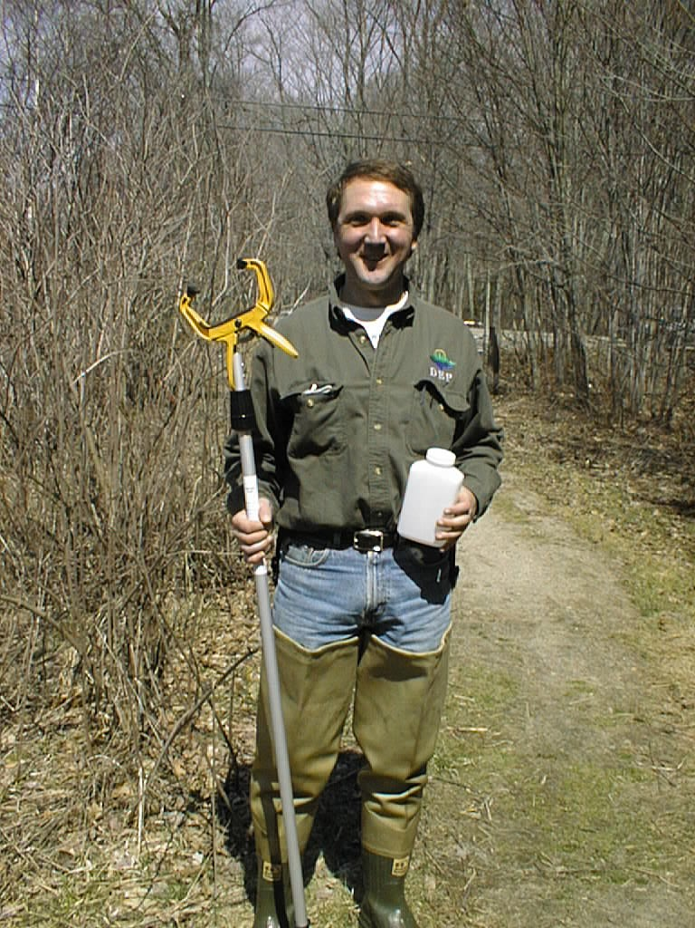
Figure 1

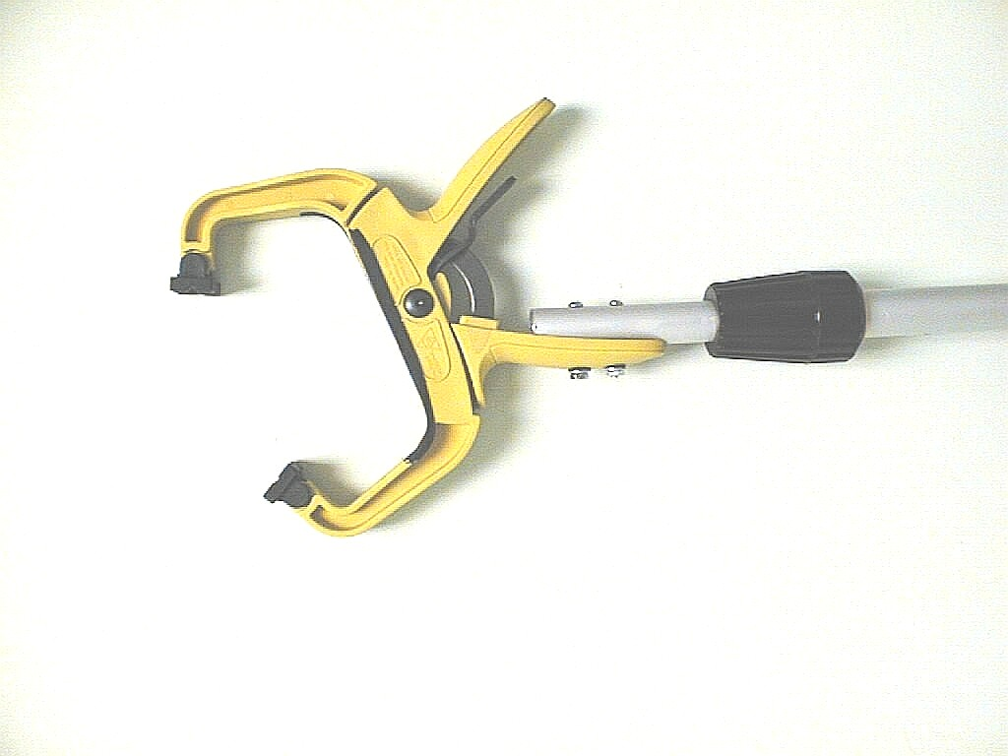
Friction
Tape
Release
Lever
Figure 2

The telescoping pole we selected is aluminum, because it is lightweight and rust-free. It extends from 4’ to 8’. The clamp we selected is a 4” bar clamp, as it holds 90% of our bottles. You may wish to bring the bottles you use to the store with you and find out which clamp size is right for you.

To construct the sampling pole, start by removing the threaded end from the pole (most extension poles have a threaded end to attach a window brush or squeegee). Most threaded ends are pop-riveted on, and you can drill them out. Next, match up the clamp handle to the hole made by drilling out the rivet. Be sure to use the handle that does NOT have the release lever. You will want access to the lever when the clamp is closed. Mark the location of the existing hole, and the location of the second hole. Drill the second hole through the pole, and two corresponding holes in the clamp handle. Attach the clamp handle with the two bolts, washers and nuts. It’s a good idea to use neoprene washers so the plastic clamp handle won’t crack due to over tightening. If you’re not using lock washers, put a drop of glue on the end of each nut. Next, add some friction tape (bicycle handle bar tape) to the inside of the clamp’s jaws. This will prevent the bottle from slipping out of the clamp.

A new design for 2007 using two ratchet clamps is shown below (Figure 3). Because they are adjustable, these clamps allow sampling with a variety of bottle sizes.
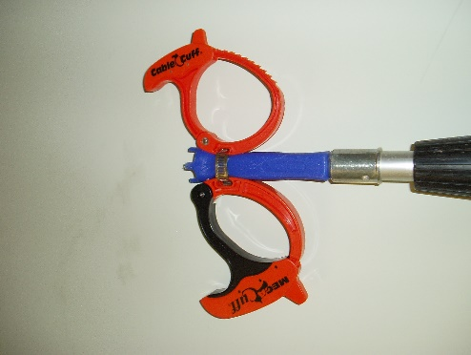

To use the collection rod, first rinse the clamp end of the rod in the stream you wish to sample. This will reduce the possibility of contamination from the previous station (or contamination from the trunk of your car!). Then, place a bottle in the clamp and squeeze the clamp closed. Remove the cap from the bottle. Rotate the rod until the bottle is upside down (or 45° angle for bacterial sample bottles with thiosulfate). Immerse the bottle to the desired depth and then rotate the rod to fill the bottle (see figure 3). Once the bottle is full, remove it from the water, cap it and remove it from the clamp.

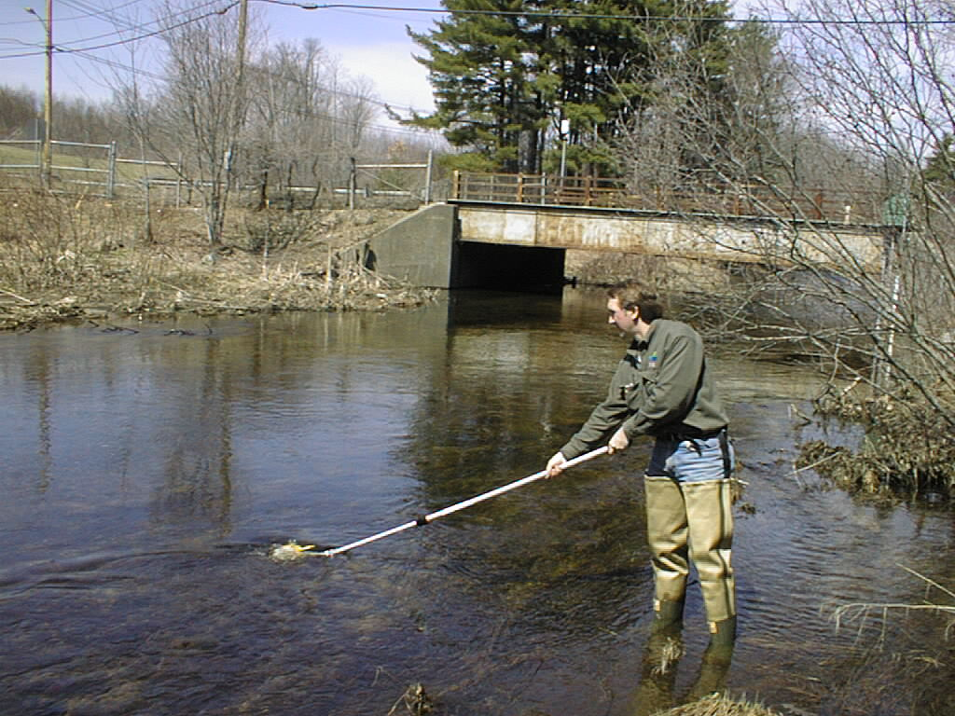
Figure 3

Do not extend the pole too far when sampling high velocity streams. You’d be surprised at how much force there can be on the pole. To avoid damaging (bending) the pole, it is recommended that you leave at least 1 foot un-extended. You can mark this limit on the pole with a permanent marker.

When you have finished collecting your water samples at your first station, and have moved on to your next station, don’t forget to rinse the rod BEFORE you attach your next bottle. Place the clamp end of the rod in the stream you now wish to sample and swirl it in the water. This will reduce any possibility of contamination from your previous station (or contamination from the trunk of your car!). It’s a good idea to put a small label on the rod to remind you to rinse the rod at each station prior to use. You can write this in permanent marker on the shaft of the pole. Also, since the pole is made of aluminum, be extra careful around power lines.

