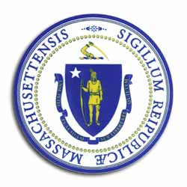
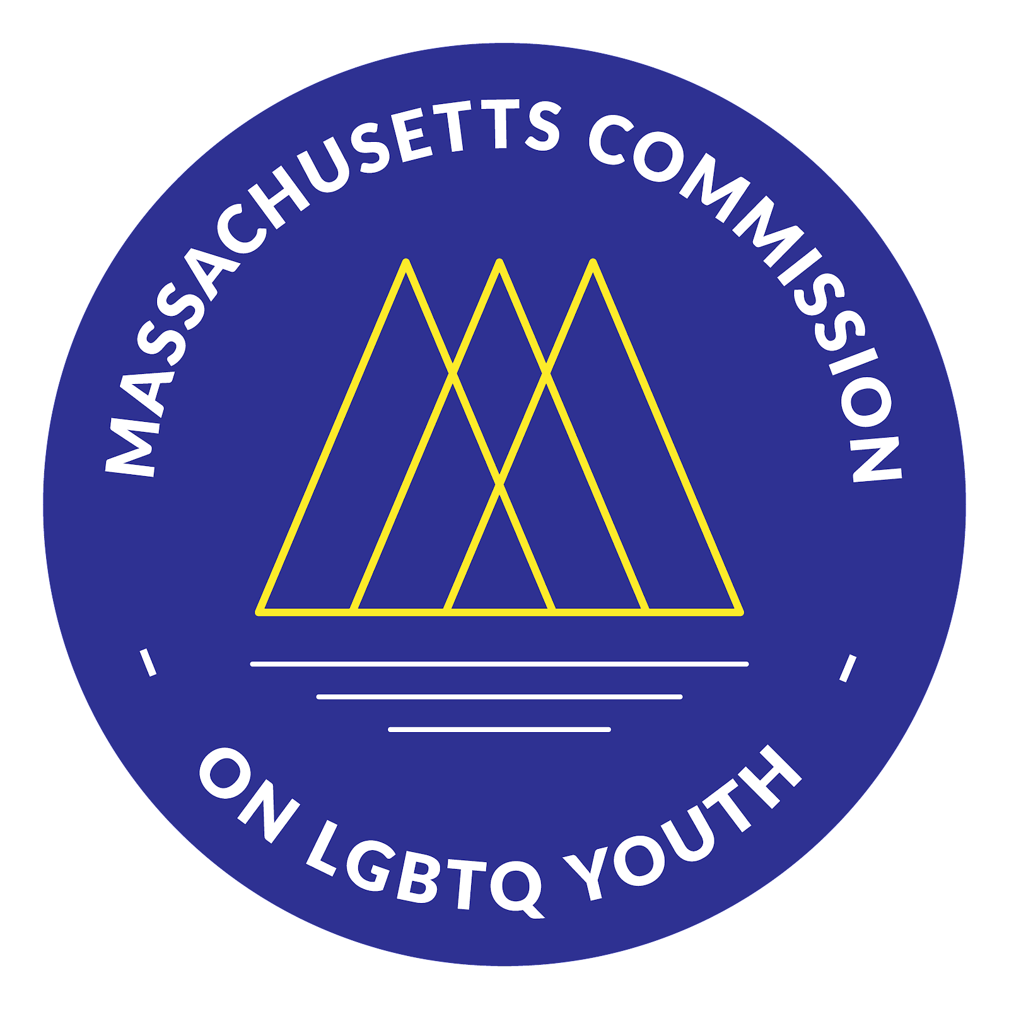
Massachusetts Commission

on LGBTQ Youth

“Working for a Commonwealth where all youth thrive”

AGENDA
Executive Committee Meeting
Monday, September 26, 2022 @ 5:00 pm
https://www.mass.gov/orgs/massachusetts-commission-on-lgbtq-youth

Pursuant to Chapter 20 of the Acts of 2021, this meeting will be conducted via remote participation.
https://us02web.zoom.us/meeting/register/tZ0vduuqqzwtGN2CZ-GwASOwJsmW4De9Nqos

5:00 - 5:10 pm: Welcome and Approval of Minutes Craig
- Land Acknowledgement
- Public Comment
- Approval of the Minutes (August)

5:10 - 5:30 pm: Reflections on the Gayla

5:30 - 5:50 p.m.: Black & Pink Update Craig

5:50 - 6:10 pm Committees Next Steps Brainstorm
- Team & Committee Activities List
- Membership (Lead: Chris)
- Safe Schools (Leads: Ashley Waterberg)
- Racial Justice Committee (Lead: Fahmina)
- Legislative Team (Lead: Braxton)

6:10-6:25 pm Membership & Officer Slate for 2023

6:25-6:30 pm: Closing & Next Steps

All meetings, with the exception of Special Meetings for Executive Session, are open to the public.
The items listed are those reasonably anticipated by the Chair to be discussed at the meeting. Not all items may in fact be discussed and other items not listed may also be brought up for discussion to the extent permitted by law. Meetings may be recorded for live stream and/or future posting to our website.

