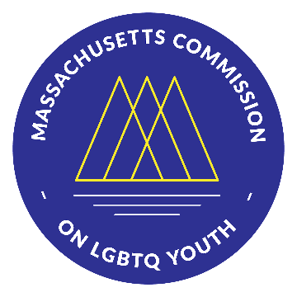 | Massachusetts Commission on LGBTQ Youth  “Working for a Commonwealth where all youth thrive”
https://www.mass.gov/orgs/massachusetts-commission-on-lgbtq-youth

AGENDA
Executive Committee Meeting
Monday, August 22, 2022, @ 5:00 pm
Pursuant to Chapter 20 of the Acts of 2021, this meeting will be conducted via remote participation.

Register here to receive a personal link to join the Zoom meeting or to automatically join if the meeting has begun: https://us02web.zooming .us/meeting/register/tZYkc-uupzktHdH3p8k6H6HhOUTM_D3Ax_QU

-----------------------------------------------------------------------------------------------------

- WELCOME: 5:00 pm
  - Land Acknowledgement Craig
  - Check-In Shaplaie
  - Remarks from the Public & Commission Membership
  - Approval of meeting minutes Craig
    - 7/27/22 Executive Committee Meeting VOTE

- REPORTS: 5:30 pm
    - Executive Director Shaplaie
    - Overview of 2022 GSA Leadership Summit 2022 Kimm, Ev, Jeff

- BUSINESS ITEMS: 6:00 pm
    - 30th Anniversary Gayla Event Shaplaie & Molly
    - Reflections on 30th Anniversary Video
    - Feedback from one on one’s with Craig Craig
    - New member recruitment Molly & Chris
    - Other Items

- ADJOURNMENT 7:00 pm

All meetings, with the exception of Special Meetings for Executive Session, are open to the public.
The items listed are those reasonably anticipated by the Chair to be discussed at the meeting. Not all items may in fact be discussed and other items not listed may also be brought up for discussion to the extent permitted by law. Meetings may be recorded for live stream and/or future posting to our website.

