INDOOR AIR QUALITY ASSESSMENT
Odor Investigation

Executive Office of Elder Affairs
One Ashburton Place, 5th floor
Boston, MA

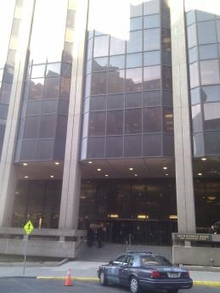

Prepared by:
Massachusetts Department of Public Health
Bureau of Environmental Health
Indoor Air Quality Program
December 2016

Background
Building: | Executive Office of Elder Affairs
Address: | One Ashburton Place, 5th floor
Assessment Requested by: | Rosalba Schino, CFO, Executive Office of Elder Affairs
Reason for Request: | Water damage/mold concerns
Date of Assessment: | December 5, 2016
Massachusetts Department of Public Health/Bureau of Environmental Health (MDPH/BEH) Staff Conducting Assessment: | Ruth Alfasso, Environmental Engineer, indoor air quality (IAQ) Program
Building Description: | One Ashburton Place, also known as the McCormack Building, is a large state office building built in the 1970s.
Windows: | Not openable

Methods
Please refer to the IAQ Manual for methods, sampling procedures, and interpretation of results (MDPH, 2015).

Results/Discussion

Microbial/Moisture Concerns
The reason for the requested visit was to investigate the site of a spill or leak in the staff lunchroom. Several weeks previous to the visit, there had been reports of a spill or leak behind the refrigerator in the staff lounge (Picture 1). An odor was reported and there were concerns that mold had colonized the area behind the refrigerator.
The refrigerator was pulled away from the wall and the wall behind it was examined (Picture 2). The wall, including the space underneath the coving, was dry. There were no musty or moldy odors. It was reported that an odor had persisted until thorough cleaning of the area had been conducted. Note that the floor in this room is tile, which is not prone to growing mold, although dirt or debris on the tile floor can become colonized. Some sticky material was seen on the floor underneath where the fridge had been; this material should be cleaned.
Note that the flooring in this room is original to the building and is in somewhat poor condition (Picture 3) and is scheduled to be replaced. In general, areas with water and food use, such as lunchrooms, should have non-porous flooring.
Water streaks were observed on part of the wall behind the fridge, which should be cleaned. It was also reported that some water-stained tiles had been removed since the leak. Although the area above the ceiling tile system in this building contains a large open space and no porous materials that might collect water or grow mold, stained ceiling tiles should be removed whenever a leak occurs in part to enable faster detection of any new leaks. The US Environmental Protection Agency (US EPA) and the American Conference of Governmental Industrial Hygienists (ACGIH) recommends that porous materials (e.g., wallboard, carpeting) be dried with fans and heating within 24 to 48 hours of becoming wet (US EPA, 2008; ACGIH, 1989). If porous materials are not dried within this time frame, mold growth may occur.
The refrigerator was clean inside as well. Refrigerators should be cleaned out regularly to prevent odors.

Conclusions/Recommendations
Since no odors, moist materials or mold-colonized materials were found, the current situation appears to be resolved. Based on observations at the time of assessment, the following is recommended:
- Clean the sticky material from the floor underneath the fridge.
- Wash off the wall behind the fridge to remove water stains.
- If leaks reoccur, ensure that all moistened materials are dried or removed within 24-28 hours, per EPA recommendations (US EPA, 2008; ACGIH, 1989)
- Continue to keep the refrigerator and other food storage and preparation areas clean to prevent odors and pests.
- If floor tiles are to be removed and replaced, ensure that good work practices are followed to prevent dusts and odors from impacting occupied areas. The guidance “Methods Used to Reduce/Prevent Exposure to Construction/Renovation Generated Pollutants in Occupied Buildings” is attached as Appendix A for reference and can also be accessed at: http://www.mass.gov/eohhs/gov/departments/dph/programs/environmental-health/exposure-topics/iaq/pollution/renovate/constructionrenovation-pollutants-prevention.html.
- Refer to resource manual and other related IAQ documents located on the MDPH’s website for further building-wide evaluations and advice on maintaining public buildings. These documents are available at: http://mass.gov/dph/iaq.

References
ACGIH. 1989. Guidelines for the Assessment of Bioaerosols in the Indoor Environment. American Conference of Governmental Industrial Hygienists, Cincinnati, OH.
MDPH. 2015. Massachusetts Department of Public Health. Indoor Air Quality Manual: Chapters I-III. Available at: http://www.mass.gov/eohhs/gov/departments/dph/programs/environmental-health/exposure-topics/iaq/iaq-manual/.
US EPA. 2008. Mold Remediation in Schools and Commercial Buildings. US Environmental Protection Agency, Office of Air and Radiation, Indoor Environments Division, Washington, D.C. EPA 402-K-01-001. http://www.epa.gov/mold/mold-remediation-schools-and-commercial-buildings-guide.
Picture 1
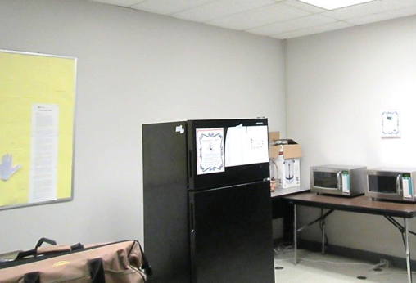
Staff lunchroom with refrigerator pulled away from the wall
Picture 2
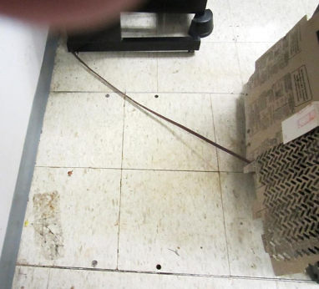
Area behind refrigerator, note darkened sticky patch
Picture 3
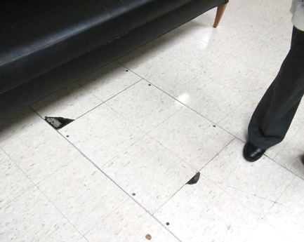
Poor condition of floor tiles

