INDOOR AIR QUALITY ASSESSMENT

Executive Office of Elder Affairs
One Ashburton Place, 5th floor
Boston, MA

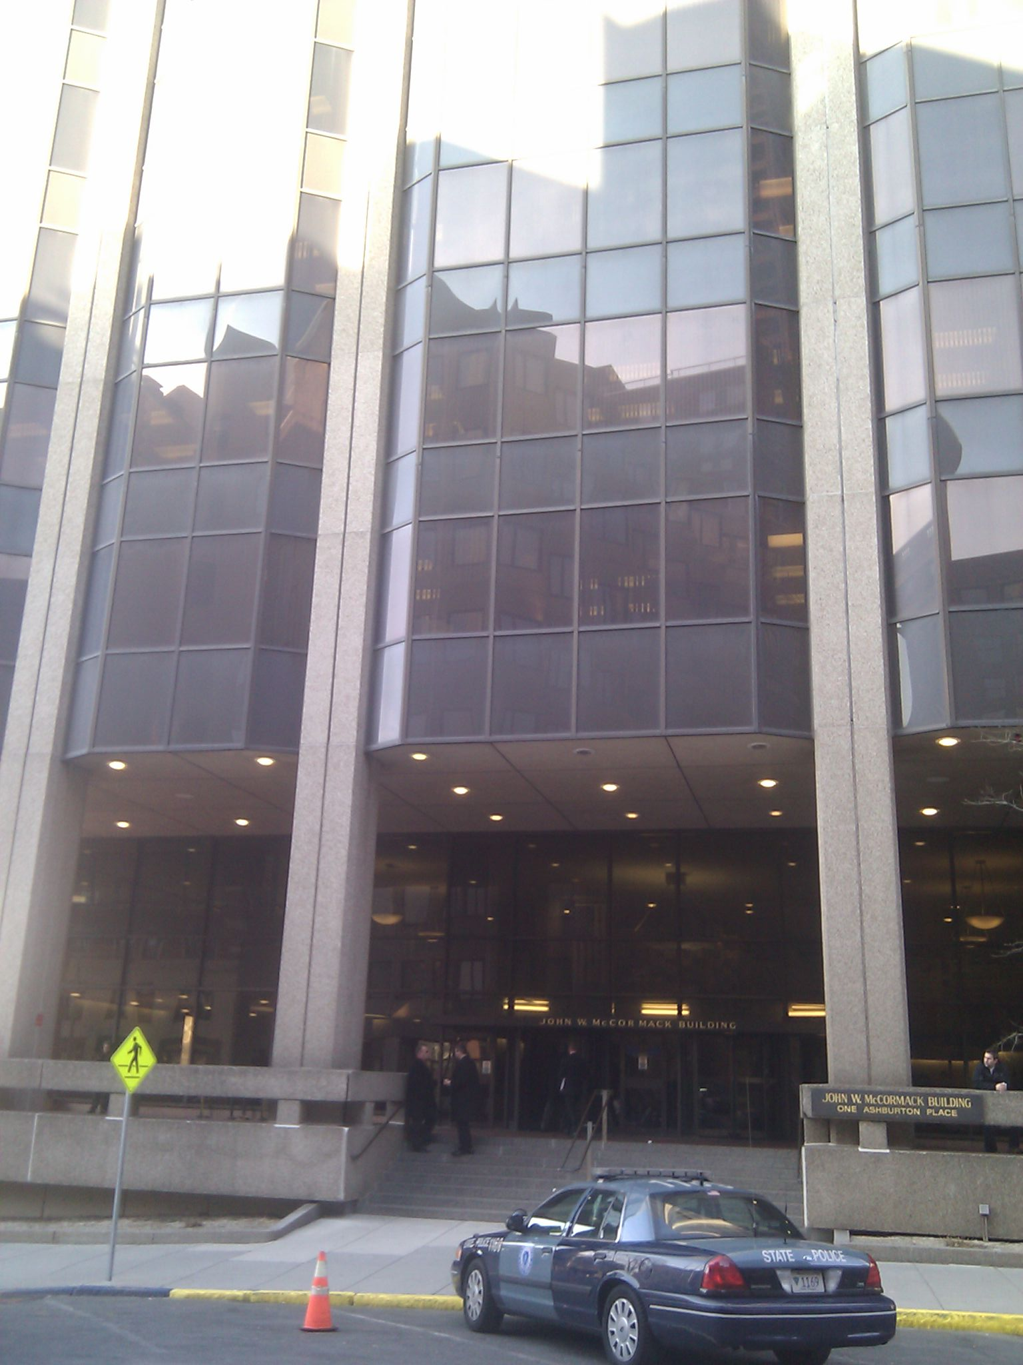

Prepared by:
Massachusetts Department of Public Health
Bureau of Environmental Health
Indoor Air Quality Program
November 2017

Background
Building: | Executive Office of Elder Affairs
Address: | One Ashburton Place, 5th floor
Assessment Requested by: | Parrish Rossi, DCAMM
Reason for Request: | Water damage/mold concerns
Date of Assessment: | October 23, 2017
Massachusetts Department of Public Health/Bureau of Environmental Health (MDPH/BEH) Staff Conducting Assessment: | Ruth Alfasso, Environmental Engineer, indoor air quality (IAQ) Program
Building Description: | One Ashburton Place, also known as the McCormack Building, is a large state office building built in the 1970s.
Windows: | Not openable

Methods
Please refer to the IAQ Manual for methods, sampling procedures, and interpretation of results (MDPH, 2015). Note that only two offices and one open/cubicle area were tested during this visit.

IAQ Testing Results
The following is a summary of indoor air testing results (Table 1).
- Carbon dioxide levels were below 800 parts per million (ppm) in all areas surveyed, indicating adequate air exchange.
- Temperature was within the recommended range of 70°F to 78°F in the areas tested.
- Relative humidity was within the recommended range of 40 to 60% in the areas tested.
- Carbon monoxide levels were non-detectable (ND) in all areas tested.
- Fine particulate matter (PM2.5) concentrations measured were below the National Ambient Air Quality (NAAQS) limit of 35 μg/m³ in all areas tested.

Ventilation
A heating, ventilating and air conditioning (HVAC) system has several functions. First it provides heating and, if equipped, cooling. Second, it is a source of fresh air. Finally, an HVAC system will dilute and remove normally-occurring indoor environmental pollutants by not only introducing fresh air, but by filtering the airstream and ejecting stale air to the outdoors via exhaust ventilation. Even if an HVAC system is operating as designed, point sources of respiratory irritation may exist and cause symptoms in sensitive individuals.
Fresh air is supplied by induction units located along the outer edges of the building (Picture 1). Return air is drawn through grates or around light fixtures using ducted returns. As shown in Picture 1, some induction units had items on top of them, which can obstruct the flow of fresh air. In addition, some of the items on/near the vents of the induction units can be a source of dusts, odors and, in the case of plants, pollen and other potential allergens. Induction unit vents should be kept free of items and kept clean.
It is important to note that relative humidity levels in the building would be expected to be lower during the winter months due to atmospheric conditions and heating. Low relative humidity can lead to common symptoms such as: dry skin, lips, and scalp; dry/scratchy throats and noses (nose bleeds); exacerbation of asthma, eczema, or allergies; dry/irritated eyes; and irritation of respiratory tract.

Microbial/Moisture Concerns
Signs of water infiltration were noted in office 5030 including water-damaged ceiling tiles (Picture 2), an area of bubbling paint and efflorescence (Picture 3), and water stains on paper on the windowsill. The ceiling tile was removed and the area above it was examined. Above the ceiling tile system in this area is an open volume of space crossed by metal bracing and other materials that are not supportive of mold growth. No moldy odors or mold staining was observed on any of the materials above the ceiling tile system. Note that efflorescence like that shown in Picture 3 is the result of water moving through a material such as brick and plaster. Dissolved minerals from the material precipitate out on a surface when the water evaporates. While this is an indication that there is a periodic water leak in this area, it is not microbial growth. A water-damaged ceiling tile was also observed in adjacent room 5031. Water-damaged tiles and other signs of water damage indicate that there are periodic leaks from the building envelope in this area.
Plants were also noted in office 5030 (Picture 1). Plants can be a source of mold, pollen and other allergens and should be well-maintained and not placed on porous materials or in the airstream of ventilation equipment.

Other IAQ Evaluations
Exposure to low levels of total volatile organic compounds (TVOCs) may produce eye, nose, throat, and/or respiratory irritation in some sensitive individuals. Dry erase materials were observed in the offices examined. Other sources of TVOCs in offices can include hand sanitizers, cleaners and fragranced products such as air fresheners. Use of such product should be minimized.
Ventilation equipment should be kept free of items to prevent restriction of airflow. Induction units need to be cleaned periodically to remove dust and debris that can be a source of irritation when ventilation is operating.
The offices assessed were carpeted. Carpets should be vacuumed regularly with a high efficiency particulate arrestance (HEPA) filter equipped vacuum cleaner and cleaned annually (or semi-annually in soiled/high traffic areas) in accordance with Institute of Inspection, Cleaning and Restoration Certification (IICRC) recommendations, (IICRC, 2012).

Conclusions/Recommendations
Based on observations at the time of assessment, the following is recommended:
- If leaks reoccur, ensure that all moistened materials are dried or removed within 24-28 hours, per EPA recommendations (US EPA, 2008; ACGIH, 1989).
- Do not store any items on ventilation equipment or underneath areas where water has been known to leak.
- Have induction units cleaned of dust and debris periodically.
- Reduce use of products containing VOCs including eliminating air freshening products.
- Clean carpeting in accordance with IICRC recommendations (IICRC, 2012).
- Refer to resource manual and other related IAQ documents located on the MDPH’s website for further building-wide evaluations and advice on maintaining public buildings. These documents are available at: http://mass.gov/dph/iaq.

References
ACGIH. 1989. Guidelines for the Assessment of Bioaerosols in the Indoor Environment. American Conference of Governmental Industrial Hygienists, Cincinnati, OH.
IICRC. 2012. Institute of Inspection, Cleaning and Restoration Certification. Carpet Cleaning: FAQ. Retrieved from http://www.iicrc.org/consumers/care/carpet-cleaning.
MDPH. 2015. Massachusetts Department of Public Health. Indoor Air Quality Manual: Chapters I-III. Available at: http://www.mass.gov/eohhs/gov/departments/dph/programs/environmental-health/exposure-topics/iaq/iaq-manual/.
US EPA. 2008. Mold Remediation in Schools and Commercial Buildings. US Environmental Protection Agency, Office of Air and Radiation, Indoor Environments Division, Washington, D.C. EPA 402-K-01-001. http://www.epa.gov/mold/mold-remediation-schools-and-commercial-buildings-guide.
Picture 1
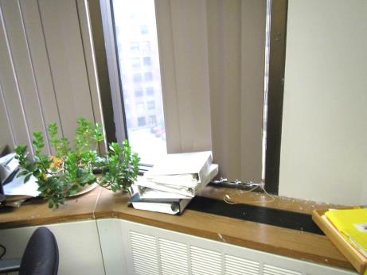
Induction unit with items and plants on top
Picture 2
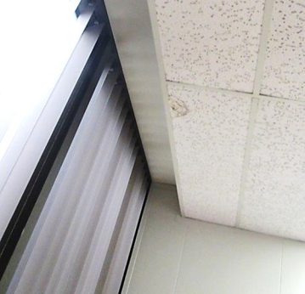
Water-damaged ceiling tile
Picture 3
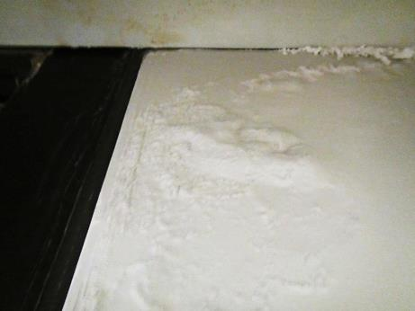
Bubbled paint and efflorescence (arrow)

Location | Carbon  Dioxide  (ppm) | Carbon Monoxide  (ppm) | Temp  (°F) | Relative  Humidity  (%) | PM2.5  (µg/m³) | Occupants  in Room | Windows  Openable | Ventilation |  | Remarks
 |  |  |  |  |  |  |  | Supply | Exhaust
5118 cubicle | 519 | ND | 71 | 52 | 1 | 0 | N | Y | Y | Outside of office 5031
5031 office | 749 | ND | 71 | 53 | 1 | 1 | N | Y | Y | Small water-damaged ceiling tile
5030 office | 503 | ND | 71 | 53 | 1 | 0 | N | Y | Y | Water-damaged ceiling tile, bubbled paint, efflorescence, items on induction unit, plants, dry erase materials

