INDOOR AIR QUALITY ASSESSMENT

Executive Office of Energy and Environmental Affairs
100 Cambridge Street
9th floor
Boston, MA

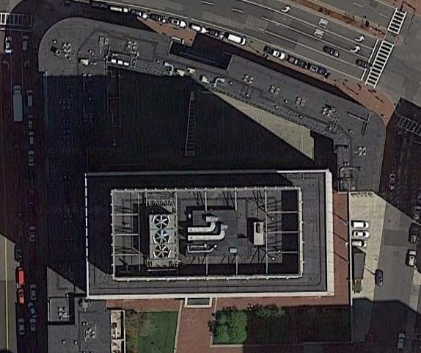

Prepared by:
Massachusetts Department of Public Health
Bureau of Environmental Health
Indoor Air Quality Program
September 2019

Background
Building: | Executive Office of Energy and Environmental Affairs (EEA)
Address: | 100 Cambridge Street, 9th floor, Boston, MA
Assessment Requested by: | Brandon Perotto, Deputy Director of Facilities, EEA
Reason for Request: | Concerns regarding IAQ and respiratory symptoms in a small area
Date of Assessment: | September 20, 2019
Massachusetts Department of Public Health/Bureau of Environmental Health (MDPH/BEH) Staff Conducting Assessment: | Ruth Alfasso, Environmental Engineer/Inspector, IAQ Program
Building Description: | The area assessed is on the 9th floor of the Saltonstall Building, a 1960s era high-rise building in downtown Boston.
Windows: | Not openable

Methods
Please refer to the IAQ Manual for methods, sampling procedures, and interpretation of results (MDPH, 2015).

IAQ Testing Results
The following is a summary of indoor air testing results (Table 1). Only a small number of rooms were assessed during this visit, including the room of concern and several adjacent areas.
- Carbon dioxide levels were below 800 parts per million (ppm) in all areas assessed, indicating adequate fresh air in the space.
- Temperature was within the recommended range of 70°F to 78°F in all areas assessed.
- Relative humidity was within the recommended range of 40% to 60% in all areas assessed.
- Carbon monoxide levels were non-detectable in all indoor areas assessed.
- Fine particulate matter (PM2.5) concentrations measured were below the National Ambient Air Quality Standard (NAAQS) level of 35 μg/m³ in all areas assessed.

In addition to all these results being within the BEH/IAQ guidance levels, there was no obvious difference in readings between the office of concern (9-14A) and other areas tested.

Ventilation
A heating, ventilating, and air conditioning (HVAC) system has several functions. First, it provides heating and, if equipped, cooling. Second, it is a source of fresh air. Finally, an HVAC system will dilute and remove normally occurring indoor environmental pollutants by not only introducing fresh air, but also filtering the airstream and ejecting stale air to the outdoors via exhaust ventilation. Even if an HVAC system is operating as designed, point sources of respiratory irritation may exist and affect symptoms in sensitive individuals. The following analysis examines and identifies components of the HVAC system and likely sources of respiratory irritant/allergen exposure due to water damage, aerosolized dust, and/or chemicals found in the indoor environment.
Fresh air is provided by air handling units (AHUs). Air from the AHUs is filtered, heated/cooled, and delivered to rooms via ducted supply vents (Pictures 1 and 2). Air is returned/exhausted through vents located around lights, mostly in hallways. It is recommended that HVAC systems be re-balanced every five years to ensure adequate air systems function (SMACNA, 1994).
An occupant expressed concerns regarding drafts/air blowing directly on them from vents, believing this contributed to symptoms experienced in the building. If the system can be balanced for appropriate air distribution, the location of vents or of occupants can be adjusted to prevent drafts.

Microbial/Moisture Concerns
Plants were observed in one area (Picture 3; Table 1). Plants can be a source of pollen and mold, which can be respiratory irritants to some individuals. Plants should be properly maintained and equipped with drip pans to prevent water damage to porous materials. Plants should also be located away from air diffusers to prevent the aerosolization of dirt, pollen, and mold. No plants were observed in the office of concern.
No water-damaged materials, water stains, or musty odors were observed in any of the areas examined including the office of concern. No leaks have been reported in this area of the building.

Other IAQ Evaluations
Exposure to low levels of total volatile organic compounds (TVOCs) may produce eye, nose, throat, and/or respiratory irritation in some sensitive individuals. To determine if VOCs were present, BEH/IAQ staff examined rooms for products containing VOCs. BEH/IAQ staff noted hand sanitizers, cleaners, and dry erase materials in use within the building (Table 1). All of these products have the potential to be irritants to the eyes, nose, throat, and respiratory system of sensitive individuals.
The offices were mostly carpeted. Carpets should be cleaned annually (or semi-annually in soiled/high traffic areas) in accordance with Institute of Inspection, Cleaning and Restoration Certification (IICRC) recommendations, (IICRC, 2012). It was reported that carpeting in the area of concern had been cleaned prior to the assessment.
Personal fans were observed in a number of areas. Fan blades to some of these units had settled dust, which can be reaerosolized when the fan is activated. Some supply vents were also dusty (Table 1).

Conclusions/Recommendations
Based on observations at the time of assessment, no specific sources of respiratory irritation were noted that could account for symptoms experienced. The following is recommended to maintain/improve IAQ in general in this area of the building:
- Operate supply and exhaust ventilation continuously in all areas during occupied periods.
- To improve comfort, redirect airflow away from occupants if feasible or reconfigure workspace/move building occupant to reduce discomfort due to airflow.
- Have the HVAC system balanced every 5 years in accordance with SMACNA recommendations (SMACNA, 1994).
- For buildings in New England, periods of low relative humidity during the winter are often unavoidable. Therefore, scrupulous cleaning practices should be adopted to minimize common indoor air contaminants whose irritant effects can be enhanced when the relative humidity is low. To control for dusts, a high efficiency particulate arrestance (HEPA) filter equipped vacuum cleaner in conjunction with wet wiping of all surfaces is recommended. Avoid the use of feather dusters. Drinking water during the day can help ease some symptoms associated with a dry environment (throat and sinus irritations).
- Keep indoor plants in good condition, avoid overwatering, and avoid placing them on porous items such as carpets or paper. Also, keep plants out of the air stream of supply vents.
- Reduce use of products containing VOCs including eliminating air freshening products.
- Change filters on AHUs on a regular schedule at least twice a year.
- Clean carpeting in accordance with IICRC recommendations (IICRC, 2012).
- Clean the blades of personal fans, supply, and exhaust vents periodically to avoid aerosolizing dusts.
- If occupant concerns persist after changing offices, feel free to contact the BEH/IAQ program for additional assistance.
- Refer to resource manual and other related IAQ documents located on the MDPH’s website for further building-wide evaluations and advice on maintaining public buildings. These documents are available at: http://mass.gov/dph/iaq.

References
IICRC. 2012. Institute of Inspection, Cleaning and Restoration Certification. Carpet Cleaning: FAQ.
MDPH. 2015. Massachusetts Department of Public Health. Indoor Air Quality Manual: Chapters I-III. Available at: http://www.mass.gov/eohhs/gov/departments/dph/programs/environmental-health/exposure-topics/iaq/iaq-manual/.
SMACNA. 1994. HVAC Systems Commissioning Manual. 1st ed. Sheet Metal and Air Conditioning Contractors’ National Association, Inc., Chantilly, VA.
Picture 1
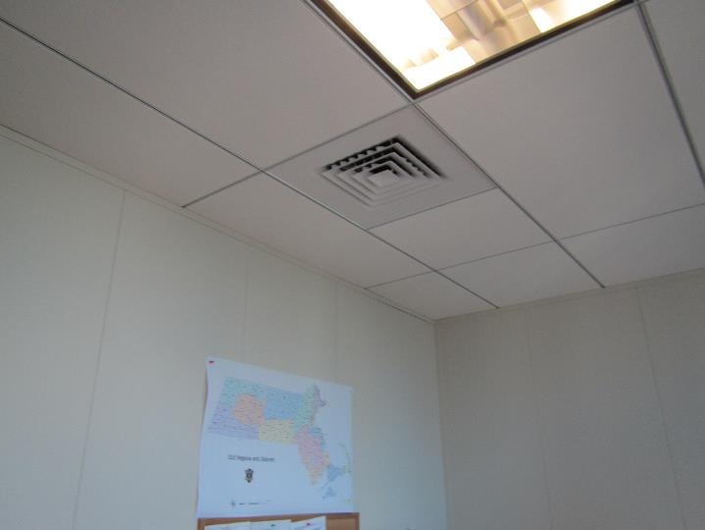
Supply vent
Picture 2
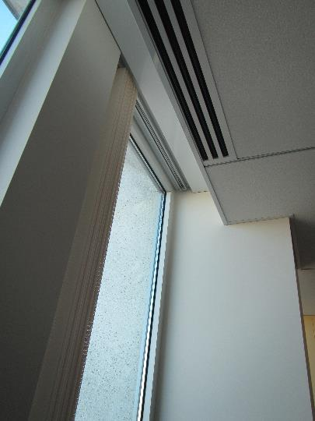
Supply vent next to window
Picture 3
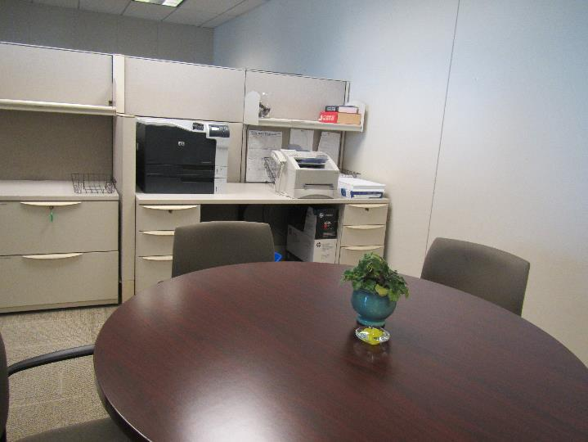
Plant in an open area/conference room

Location | Carbon  Dioxide  (ppm) | Carbon Monoxide  (ppm) | Temp  (°F) | Relative  Humidity  (%) | PM2.5  (µg/m³) | Occupants  in Room | Windows  Openable | Ventilation |  | Remarks
 |  |  |  |  |  |  |  | Supply | Exhaust
9-14A | 623 | ND | 70 | 42 | 1 | 0 | N | Y |  | DEM (new board), salt lamp, PF
9-09A | 629 | ND | 70 | 42 | 2 | 2 | N | Y |  | Drilling into wall to hang dry erase board
Perotto cube | 586 | ND | 70 | 41 | 3 | 0 | N | Y | Y | DEM
Open area with table | 599 | ND | 70 | 41 | 3 | 0 | N | Y | Y | Plants
Cube area | 559 | ND | 70 | 41 | 1 | 0 | N | Y | Y
9-15B | 594 | ND | 70 | 41 | 3 | 0 | N | Y |  | DEM
9-16A | 673 | ND | 70 | 43 | 2 | 2 | N | Y |  | Dried plants/flowers, hand sanitizer, DEM
9-17A | 621 | ND | 71 | 42 | 2 | 0 | N | Y |  | Cleaning product, DEM

