Background/Introduction

INDOOR AIR QUALITY ASSESSMENT

Executive Office of Health and Human Services
600 Washington Street, 5th and 6th Floors
Boston, Massachusetts

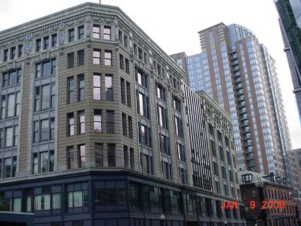

Prepared by:
Massachusetts Department of Public Health
Bureau of Environmental Health
Indoor Air Quality Program
April 2008

In response to a request from Rosemary Sammarco, Director of Leasing, Executive Office of Health and Human Services (EOHHS), the Massachusetts Department of Public Health (MDPH), Bureau of Environmental Health (BEH) conducted an evaluation of the indoor air quality on the 5th and 6th floors at 600 Washington Street, Boston, Massachusetts. On January 3, 2008, Michael Feeney, Director of BEH’s Indoor Air Quality (IAQ) Program, conducted the evaluation. Mr. Feeney was accompanied by Sharon Lee and James Tobin, Indoor Air Quality Inspectors in BEH’s IAQ Program. The assessment was conducted to evaluate the potential for indoor air quality related problems on the 5th and 6th floors, which contain the Office of MassHealth as well as EOHHS IT Services. The building was retrofitted into office space with the installation of an HVAC system, suspended ceiling and space that part of an addition in the front of the building. With the exception of windows in the addition (Picture 1), windows in the EOHHS space do not open.

Methods
Air tests for carbon monoxide, carbon dioxide, temperature and relative humidity were conducted with the TSI, Q-Trak, IAQ Monitor, Model 8551. Air tests for airborne particle matter with a diameter less than 2.5 micrometers were taken with the TSI, DUSTTRAK™ Aerosol Monitor Model 8520. Screening for total volatile organic compounds (TVOCs) was conducted using a Thermo Environmental Instruments Inc., Model 580 Series Photo Ionization Detector (PID) and an Hnu, Model 102 Snap-on PID. BEH staff also performed visual inspection of building materials for water damage and/or microbial growth.

Results
The EOHHS headquarters has an employee population of approximately 500 and is visited daily by various members of the public as well as state and federal agencies. The tests were taken during normal operations and results appear in Table 1.

Discussion
Ventilation
It can be seen from Table 1 that carbon dioxide levels were above 800 parts per million (ppm) in 78 out of 158 areas surveyed, which is generally indicative of inadequate air exchange in approximately half of the areas tested in the building. It is important to note that the outdoor temperature on the day of the assessment ranged from 13º F to 14º F (Weather Underground, 2008). During cold weather temperature extremes, fresh air provided to the heating, ventilating and air-conditioning (HVAC) system is often limited to prevent heating coils from freezing and subsequently bursting.
Air-handling units (AHUs) on each floor provide fresh air to the building. AHUs are located in a mechanical room (AHU room) (Picture 2), drawing air from outdoors through a series of vents located along the exterior wall of the building (Picture 3). Fresh air in occupied spaces is supplied by ceiling-mounted fresh air diffusers connected to AHUs via ductwork. Air is exhausted from the occupied space through ceiling mounted return vents connected to ductwork. The return vent ductwork terminates in the AHU rooms (Picture 3). The return air vent on each AHU is open to the room as the entire room was designed to serve as a return duct. In this configuration, the AHU becomes depressurized and draws air from the return air ducts and in turn, the occupied spaces.
To maximize air exchange, the MDPH recommends that both supply and exhaust ventilation operate continuously during periods of occupancy. In order to have proper ventilation with a mechanical supply and exhaust system, the systems must be balanced to provide an adequate amount of fresh air to the interior of a room, while removing stale air from the room. It is recommended that HVAC systems be re-balanced every five years (SMACNA, 1994). The date of the last balancing was not available at the time of the assessment.
The Massachusetts Building Code requires that each area have a minimum ventilation rate of 20 cubic feet per minute (cfm) per occupant of fresh outside air or openable windows (SBBRS, 1997; BOCA, 1993). The ventilation must be on at all times that the room is occupied. Providing adequate fresh air ventilation with open windows and maintaining the temperature in the comfort range during the cold weather season is impractical. Mechanical ventilation is usually required to provide adequate fresh air ventilation.
Carbon dioxide is not a problem in and of itself. It is used as an indicator of the adequacy of the fresh air ventilation. As carbon dioxide levels rise, it indicates that the ventilating system is malfunctioning or the design occupancy of the room is being exceeded. When this happens a buildup of common indoor air pollutants can occur, leading to discomfort or health complaints. The Occupational Safety and Health Administration (OSHA) standard for carbon dioxide is 5,000 parts per million parts of air (ppm). Workers may be exposed to this level for 40 hours/week, based on a time-weighted average (OSHA, 1997).
The MDPH uses a guideline of 800 ppm for publicly occupied buildings. A guideline of 600 ppm or less is preferred in schools due to the fact that the majority of occupants are young and considered to be a more sensitive population in the evaluation of environmental health status. Inadequate ventilation and/or elevated temperatures are major causes of complaints such as respiratory, eye, nose and throat irritation, lethargy and headaches. For more information concerning carbon dioxide, please see Appendix A.
Temperature readings in occupied areas were in a range of 70º F to 78º F, which were within the MDPH recommended comfort range for the day of the assessment. The MDPH recommends that indoor air temperatures be maintained in a range of 70º F to 78º F in order to provide for the comfort of building occupants. In many cases concerning indoor air quality, fluctuations of temperature in occupied spaces are typically experienced, even in a building with an adequate fresh air supply.
A lack of temperature control was expressed in numerous areas of the building. Windows in the original section of the building were the original wood frame and significant drafts of cold air were noted around these frames (called air infiltration). Cold air infiltration through window systems can make temperature control in rooms difficult to maintain. Along the exterior walls beneath the windows of the office floors were large heating registers (Picture 4). In order for the window drafts to be tempered, the heating registers would warm the air directing the drafts upwards. For this system to work, the heat registers must be activated and the flow of heater fluid inside the heating coil properly regulated. The heating registers are controlled by dials set in the casing of each unit (Picture 5). BEH found heating registers off or the heating register controls broken (Picture 6) in numerous areas of the building, which would make comfort control in these areas difficult.
Relative humidity measurements ranged from 8 to 16 percent, which were below the MDPH recommended comfort guidelines. The MDPH recommends a comfort range of 40 to 60 percent for indoor air relative humidity. Relative humidity levels in the building would be expected to drop during the winter months due to heating. The sensation of dryness and irritation is common in a low relative humidity environment. Low relative humidity is a very common problem during the heating season in the northeast part of the United States.

Microbial Growth/Moisture Concerns
An area in the rear of 5th floor (5299) was observed to have conditions conducive to mold growth. Above this area is an AHU that is equipped for cooling in hot, humid weather. Of note were the following conditions:
- Insulation for the pipe supplying the cooling coil chilled what appeared to be either mold colonized (Picture 7) or water damaged at minimum.
- The condensation from the AHU is collected in a pump (Picture 8), which then must pump the condensate upwards to a vertical pipe (Picture 9). It is not clear whether this pump had the capacity to pump water to this drain system.
- BEH staff poured 500 mL of water into the condensation pump. The pump did not activate to remove this water.
- A clear plastic hose connecting the pump to the drain system showed signs of biofilm, indicating that the connection has not been changed.
Each of these conditions can lead to reports of odors associated with microbial growth. AHUs need to be cleaned at a minimum twice a year (between the change from heating to cooling and the change from cooling to heating) in order to prevent microbial growth. The 6th floor AHU also contains water damaged insulation (Picture 10). The US Environmental Protection Agency (US EPA) and the American Conference of Governmental Industrial Hygienists (ACGIH) recommend that porous materials be dried with fans and heating within 24 to 48 hours of becoming wet (US EPA, 2001; ACGIH, 1989). If not dried within this time frame, mold growth may occur. Once mold has colonized porous materials, they are difficult to clean and should be removed.
Plants were observed in several areas. Plants, soil and drip pans can serve as sources of moisture, which can initiate mold growth. Thus, plants should be properly maintained. Over-watering of plants should be avoided and drip pans should be inspected periodically for mold growth. Moreover, a few areas had water coolers installed over carpeting. Water spillage or overflow of cooler catch basins can result in the wetting of the carpet, which can lead to mold growth.

Other IAQ Evaluations
Indoor air concentrations can be greatly impacted by the use of products containing volatile organic compounds (VOCs). VOCs are carbon-containing substances that have the ability to evaporate at room temperature. Frequently, exposure to low levels of total VOCs (TVOCs) may produce eye, nose, throat and/or respiratory irritation in some sensitive individuals. For example, chemicals evaporating from a paint can stored at room temperature would most likely contain VOCs. In an effort to identify materials that can potentially increase indoor VOC concentrations, BEH staff examined classrooms for products containing these respiratory irritants.
Several areas contained dry erase boards and dry erase board markers. Materials such as dry erase markers and dry erase board cleaners may contain VOCs, such as methyl isobutyl ketone, n-butyl acetate and butyl-cellusolve (Sanford, 1999), which can be irritating to the eyes, nose and throat. Cleaning products and air fresheners were seen in some areas (Table 1). Like dry erase materials, cleaning products and air fresheners contain VOCs and other chemicals that can be irritating to the eyes, nose and throat of sensitive individuals. In addition, air fresheners do not remove but mask odors that may be present.

Conclusions/Recommendations
In view of the findings at the time of the visit, the following recommendations are made:
- Remove water damage pipe insulation from AHU on the fifth floor AHU shown in Picture 7. Repairs to water damaged insulation should be done in a manner consistent with guidelines set forth in “Mold Remediation in Schools and Commercial Buildings” published by the US Environmental Protection Agency (US EPA, 2001).
- Ensure that the condensation pump for the 5th floor AHU in Picture 8 is properly functioning to drain condensation properly. Ensure that this unit is properly installed and insulated to prevent condensation generation on the pump.
- Change the clear plastic hose connecting the condensation pump to the drain system at least once a year to remove biofilm buildup.
- Consult with a heating contractor to examine and repair any broken thermostats for radiators.
- Remove water damage materials from the mechanical room on the sixth floor.
- Ensure that the HVAC system provide an adequate amount of fresh air. Balancing the HVAC system is important
- Consider balancing mechanical ventilation systems every 5 years, as recommended by ventilation industrial standards (SMACNA, 1994). Balancing the HVAC system is important and will likely bring the majority of carbon dioxide levels with comfort limits.
- Ensure plants have drip pans. Examine drip pans periodically for mold growth and disinfect with an appropriate antimicrobial where necessary.
- Place plastic mats beneath water coolers.

- For buildings in New England, periods of low relative humidity during the winter are often unavoidable. Therefore, scrupulous cleaning practices should be adopted to minimize common indoor air contaminants whose irritant effects can be enhanced when the relative humidity is low. To control for dusts, a high efficiency particulate arrestance (HEPA) filter equipped vacuum cleaner in conjunction with wet wiping of all surfaces is recommended. Drinking water during the day can help ease some symptoms associated with a dry environment (throat and sinus irritations).
- Refer to resource manuals and other related indoor air quality documents for further building-wide evaluations and advice on maintaining public buildings. These materials are located on the MDPH’s website at http://mass.gov/dph/indoor_air.

References
ACGIH. 1989. Guidelines for the Assessment of Bioaerosols in the Indoor Environment. American Conference of Governmental Industrial Hygienists, Cincinnati, OH.
ASHRAE. 1989. Ventilation for Acceptable Indoor Air Quality. American Society of Heating, Refrigeration and Air Conditioning Engineers. ANSI/ASHRAE 62-1989
BOCA. 1993. The BOCA National Mechanical Code-1993. 8th ed. Building Officials & Code Administrators International, Inc., Country Club Hills, IL.
M.G.L. 1986. Stopped motor vehicles; Operation of Engine; Time Limit; Penalty. Massachusetts General Laws. M.G.L. c. 90:16A.
OSHA. 1997. Limits for Air Contaminants. Occupational Safety and Health Administration. Code of Federal Regulations. 29 C.F.R. 1910.1000 Table Z-1-A.
SBBRS. 1997. Mechanical Ventilation. State Board of Building Regulations and Standards. Code of Massachusetts Regulations. 780 CMR 1209.0
SMACNA. 1994. HVAC Systems Commissioning Manual. 1st ed. Sheet Metal and Air Conditioning Contractors’ National Association, Inc., Chantilly, VA.
US EPA. 2001. Mold Remediation in Schools and Commercial Buildings. US Environmental Protection Agency, Office of Air and Radiation, Indoor Environments Division, Washington, DC. EPA 402-K-01-001. March 2001.

Picture 1

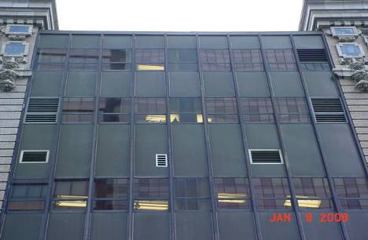

New Addition Windows That Open

Picture 2

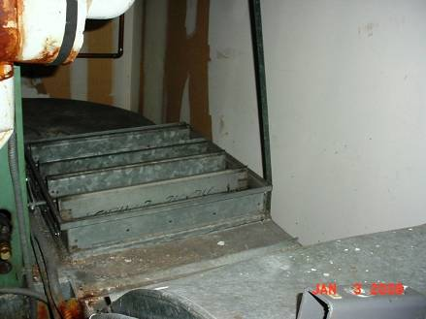

Mechanical Room with AHU, Note Louvered Air Intake Vent

Picture 3

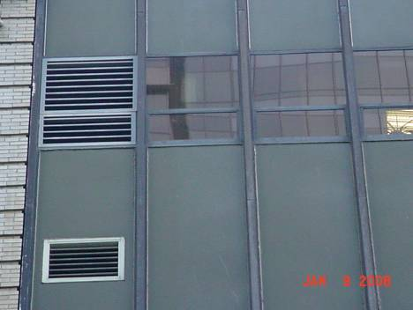

Fresh Air Intake/Exhaust Vents

Picture 4

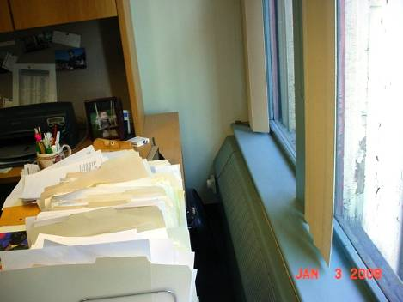

Heating Registers under Windows

Picture 5

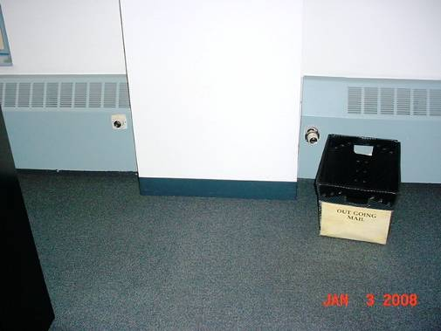

Heating Register Controls

Picture 6

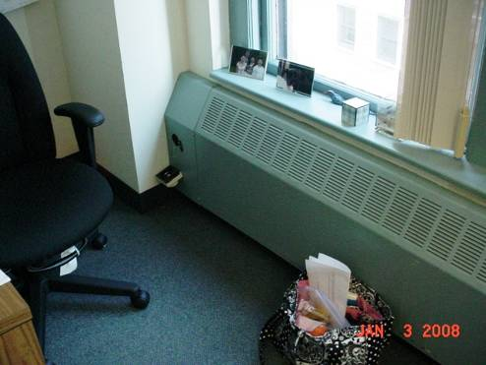

Broken Heating Register Control

Picture 7

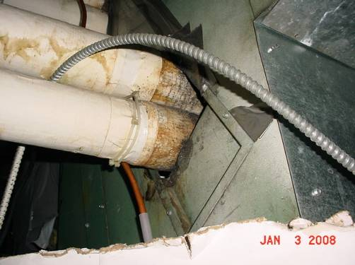

Water Damaged Pipe Insulation That Is Mold Colonized

Picture 8

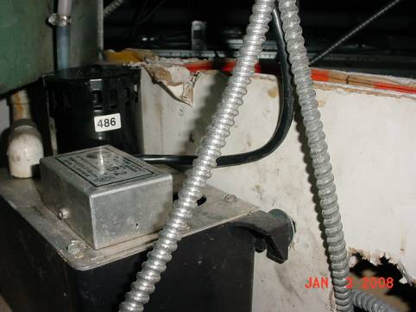

AHU Condensation Pump above Ceiling

Picture 9

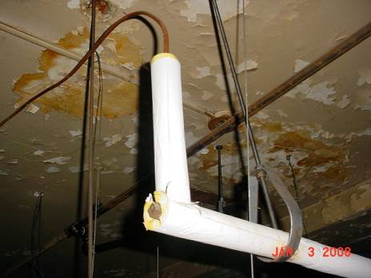

Vehicle Pipe Connected To Condensation Pump by Flexible Hose

Picture 10

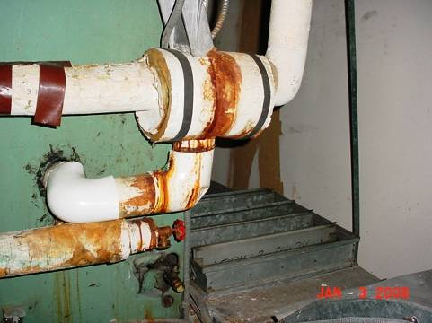

Water Damaged Pipe Insulation in AHU Mechanical Room, Note Location of Air Intake (Arrow)
Location | Occupants  in Room | Carbon  Dioxide  (ppm) | Temp  (°F) | Relative  Humidity  (%) | Carbon Monoxide  (ppm) | TVOCs  (ppm) | Windows  Openable | Ventilation |  | Remarks
 |  |  |  |  |  |  |  | Supply | Exhaust | Remarks
Outside
(background)
5002 | 1 | 802 | 76 | 9 | ND | ND | N | Y | N
5009 | 2 | 852 | 78 | 11 | ND | ND | N | Y | Y | Bubbler on floor; Plant
5010 | 1 | 802 | 77 | 11 | ND | ND | N | Y | N
5015 | 1 | 809 | 78 | 11 | ND | ND | N | Y | Y
5017/5020 | 2 | 891 | 78 | 12 | ND | ND | N | Y | Y | Clutter; Plant; RAD Off
5022/5048 | 3 | 1316 | 77 | 11 | ND | ND | N | Y | Y | Plants
5025 | 2 | 881 | 78 | 10 | ND | ND | N | Y | Y
5028/5027 | 2 | 869 | 78 | 10 | ND | ND | N | Y | Y
5032/5033 | 1 | 819 | 76 | 9 | ND | ND | N | Y | Y
5037/5038 | 2 | 805 | 78 | 10 | ND | ND | N | Y | Y | Items suspended from CT
5041/5042 | 3 | 852 | 76 | 10 | ND | ND | N | Y | Y | PF
5045/5044 | 1 | 843 | 77 | 10 | ND | ND | N | Y | Y | Plants; Clutter; HEPA-AP
5050 | 0 | 810 | 77 | 11 | ND | ND | N | Y | Y | RAD Off
5055 | 0 | 855 | 76 | 11 | ND | ND | N | Y | Y
5060 | 0 | 805 | 77 | 10 | ND | ND | N | Y | Y
5068 | 0 | 859 | 75 | 10 | ND | ND | N | Y | Y
5069 | 0 | 820 | 75 | 11 | ND | ND | N | Y | Y | RAD Off
5071 | 0 | 809 | 76 | 10 | ND | ND | N | Y | Y | Plants; AD; RAD Off
5072 | 1 | 779 | 76 | 8 | ND | ND | N | Y | Y | Plants; RAD Off
5073/5066 | 3 | 807 | 77 | 10 | ND | ND | N | Y | Y | Cooler on carpet
5074/5065 | 1 | 778 | 76 | 10 | ND | ND | N | Y | Y | PF; Plants
5078/5097 | 0 | 785 | 75 | 11 | ND | ND | 4 | Y | Y
5087 | 1 | 822 | 76 | 10 | ND | ND | N | Y | Y
5089/5004 | 1 | 870 | 76 | 10 | ND | ND | N | Y | Y
5102/5101 | 2 | 799 | 75 | 11 | ND | ND | 4 | Y | Y
5106/5113 | 1 | 812 | 76 | 10 | ND | ND | N | Y | Y | Clutter
5108 | 0 | 803 | 76 | 9 | ND | ND | N | Y | Y | Cooler on carpet
5119/5132 | 2 | 825 | 76 | 10 | ND | ND | N | Y | Y
5122/5130 | 3 | 872 | 76 | 10 | ND | ND | N | Y | Y | PF; Plants
5124 | 1 | 817 | 76 | 10 | ND | ND | N | Y | Y
5125 | 1 | 850 | 77 | 10 | ND | ND | N | N | Y | DO; DEM
5126 | 1 | 840 | 77 | 10 | ND | ND | N | N | Y | DO; DEM
5135 | 0 | 769 | 74 | 11 | ND | ND | N | Y | Y | RAD Off
5140/5148 | 1 | 932 | 77 | 11 | ND | ND | N | Y | Y
5142/5147 | 2 | 946 | 77 | 11 | ND | ND | N | Y | Y
5144/5145 | 0 | 899 | 77 | 11 | ND | ND | N | Y | Y
5151/5137 | 2 | 856 | 76 | 12 | ND | ND | N | Y | Y | PF
5155 | 0 | 815 | 75 | 12 | ND | ND | N | Y | Y
5156 | 0 | 822 | 75 | 13 | ND | ND | N | Y | Y
5160 | 0 | 823 | 75 | 12 | ND | ND | N | Y | Y
5161 | 0 | 808 | 75 | 12 | ND | ND | N | Y | Y
5171/5170 | 2 | 915 | 77 | 10 | ND | ND | N | Y | Y
5183/5184 | 1 | 882 | 77 | 10 | ND | ND | N | Y | Y
5189/5191 | 2 | 888 | 74 | 11 | ND | ND | N | Y | Y
5198/5195 | 2 | 895 | 74 | 11 | ND | ND | N | Y | Y
5203/5202 | 1 | 880 | 75 | 10 | ND | ND | N | Y | Y
5205 | 3 | 753 | 74 | 11 | ND | ND | N | Y | Y
5213/5212 | 1 | 867 | 74 | 11 | ND | ND | N | Y | Y
5216 | 0 | 775 | 75 | 11 | ND | ND | N | Y | Y | Plant; DO
5217 | 0 | 789 | 75 | 11 | ND | ND | N | Y | Y | DO; RAD Off
5220 | 0 | 891 | 77 | 10 | ND | ND | N | Y | Y
5223/5002 | 1 | 899 | 76 | 10 | ND | ND | N | Y | Y
5228 | 1 | 898 | 74 | 11 | ND | ND | N | Y | Y
5229/5227 | 2 | 996 | 77 | 10 | ND | ND | N | Y | Y | Toaster oven/ toaster against cube wall
5232/5235 | 2 | 895 | 77 | 10 | ND | ND | N | Y | Y | DEM; Microwave
5238/5242 | 7 | 850 | 74 | 11 | ND | ND | N | Y | Y
5245 | 1 | 851 | 75 | 10 | ND | ND | N | Y | Y
5246 | 4 | 861 | 74 | 12 | ND | ND | N | Y | Y | RAD Off
5248 | 1 | 837 | 74 | 12 | ND | ND | N | Y | Y | RAD On; DO
5250/5249 | 2 | 853 | 74 | 11 | ND | ND | N | Y | Y
5253/5297 | 1 | 894 | 74 | 11 | ND | ND | N | Y | Y
5254/5261 | 3 | 921 | 75 | 11 | ND | ND | N | Y | Y
5259/5256 | 1 | 911 | 75 | 11 | ND | ND | N | Y | Y | Bubbler on carpet
5266/5264 | 3 | 931 | 77 | 10 | ND | ND | N | Y | Y
5269/5262 | 2 | 847 | 77 | 10 | ND | ND | N | Y | Y
5270 | 1 | 857 | 77 | 10 | ND | ND | N | Y | Y
5272 | 6 | 868 | 77 | 10 | ND | ND | N | Y | Y
5275 | 0 | 845 | 77 | 11 | ND | ND | N | Y | Y
5277 | 0 | 826 | 77 | 11 | ND | ND | N | Y | N | WD on CT over space behind cube; Leak down wall
5280/5282 | 2 | 857 | 77 | 10 | ND | ND | N | Y | Y | DEM
5281 | 0 | 831 | 77 | 11 | ND | ND | N | Y | Y
5287/5290 | 2 | 849 | 76 | 10 | ND | ND | N | Y | Y
5295/5294 | 3 | 853 | 75 | 10 | ND | ND | N | Y | Y | Clutter
5299 | 0 | 808 | 74 | 12 | ND | ND | N | Y | Y | AHU Faulty condensation pump; WD Pipe insulation; Poured pint water
5301/5302 | 2 | 844 | 75 | 11 | ND | ND | N | Y | Y | PF
5306/5317 | 2 | 849 | 76 | 11 | ND | ND | N | Y | Y
5309 | 0 | 770 | 75 | 11 | ND | ND | N | Y | Y | Plant; Disinfecting wipes; RAD On
5313 | 0 | 794 | 75 | 11 | ND | ND | N | Y | Y | DEM; Space heater; RAD On
5315/5316 | 2 | 822 | 75 | 11 | ND | ND | N | Y | Y | HEPA-AP; Humidifier
5319/5328 | 1 | 838 | 76 | 11 | ND | ND | N | Y | Y
5329/5321 | 2 | 807 | 76 | 9 | ND | ND | N | Y | Y
5333 | 1 | 720 | 76 | 10 | ND | ND | N | Y | Y | Plant; RAD On
5334/5330 | 3 | 837 | 76 | 10 | ND | ND | N | Y | Y | Plants
5334/5332 | 2 | 855 | 76 | 10 | ND | ND | N | Y | Y | Plants
5337/5292 | 5 | 892 | 76 | 9 | ND | ND | N | Y | Y
5342/5344 | 3 | 795 | 76 | 10 | ND | ND | N | Y | Y | RAD On; Plant; Space heater; Fridge on floor
5347 | 3 | 837 | 77 | 10 | ND | ND | N | Y | Y
5349/5338 | 1 | 834 | 77 | 10 | ND | ND | N | Y | Y | Cooler on carpet
5352/5359 | 6 | 821 | 76 | 10 | ND | ND | N | Y | Y
5354 | 2 | 748 | 75 | 10 | ND | ND | N | Y | Y | RAD Off
5365 | 3 | 820 | 77 | 11 | ND | ND | N | Y | Y
6041 | 1 | 691 | 70 | 15 | ND | ND | N | Y | Y | Plants
6042 | 0 | 634 | 70 | 16 | ND | ND | N | Y | Y
6044 | 1 | 644 | 71 | 15 | ND | ND | N | Y | Y | AP on floor
6045 | 1 | 706 | 70 | 15 | ND | ND | N | Y | Y
6047 | 1 | 782 | 70 | 16 | ND | ND | N | Y | Y
6048 | 0 | 626 | 72 | 13 | ND | ND | N | Y | Y
6049 | 0 | 705 | 71 | 15 | ND | ND | N | Y | Y | Plants
6050/6071 | 2 | 648 | 73 | 13 | ND | ND | N | Y | Y
6051 | 1 | 728 | 72 | 13 | ND | ND | N | Y | Y
6054/6067 | 2 | 689 | 73 | 14 | ND | ND | N | Y | Y
6057 | 3 | 716 | 73 | 13 | ND | ND | N | Y | Y
6058/6063 | 1 | 665 | 73 | 14 | ND | ND | N | Y | Y | DEM
6059 | 1 | 744 | 73 | 14 | ND | ND | N | Y | Y | Plants; Clutter
6072 | 1 | 679 | 73 | 11 | ND | ND | N | Y | Y | Supply vent blocked
6074/6091 | 1 | 626 | 71 | 9 | ND | ND | N | Y | Y | Clutter
6075 | 3 | 682 | 73 | 12 | ND | ND | N | Y | Y
6075/6087 | 2 | 667 | 72 | 9 | ND | ND | N | Y | Y | Clutter; Plants; PF; Microwave & Toaster near paper
6079 | 1 | 626 | 73 | 11 | ND | ND | N | Y | Y | PF; Clutter
6082 | 0 | 732 | 73 | 10 | ND | ND | N | Y | N | Supply vent blocked; DEM; DO; PF
6084 | 0 | 634 | 73 | 9 | ND | ND | N | N | N | PF; DEM
6090/6117 | 2 | 628 | 73 | 8 | ND | ND | N | Y | Y
6093 | 1 | 615 | 72 | 10 | ND | ND | N | Y | Y | Plants
6095 | 0 | 635 | 71 | 9 | ND | ND | N | Y | Y | DO; DEM
6096/6098 | 0 | 605 | 72 | 10 | ND | ND | N | Y | Y
6100 | 0 | 594 | 71 | 9 | ND | ND | N | Y | Y
6101 | 0 | 592 | 71 | 9 | ND | ND | N | N | Y | Copier; Overflowing bubbler catch
6102 | 0 | 574 | 71 | 9 | ND | ND | N | Y | Y | DO
6103 | 1 | 619 | 72 | 10 | ND | ND | N | Y | Y | PF; DO
6106 | 0 | 590 | 72 | 10 | ND | ND | N | Y | Y
6107 (storage) | 0 | 617 | 73 | 9 | ND | ND | N | Y | Y | Paper files
6108 | 1 | 638 | 72 | 11 | ND | ND | N | Y | Y | PF
6111 | 1 | 613 | 73 | 10 | ND | ND | N | Y | Y | 3M Cleaner
6114 | `2 | 679 | 73 | 11 | ND | ND | N | Y | Y
6118 | 1 | 664 | 73 | 11 | ND | ND | N | Y | Y
6121 | 1 | 660 | 73 | 8 | ND | ND | N | Y | Y
6125 | 3 | 648 | 73 | 8 | ND | ND | N | Y | Y
6129 | 2 | 667 | 73 | 9 | ND | ND | N | Y | Y
6132 | 4 | 673 | 74 | 9 | ND | ND | N | Y | Y | AP; PF
6137 | 1 | 688 | 73 | 11 | ND | ND | N | Y | Y
6181 | 0 | 632 | 77 | 9 | ND | ND | N | Y | Y | DO; DEM
6182 | 0 | 655 | 77 | 9 | ND | ND | N | Y | Y | PF; DEM; DO
6183 | 0 | 674 | 77 | 10 | ND | ND | N | Y | Y
6184 | 2 | 734 | 77 | 13 | ND | ND | N | Y | N | Plant
6185 | 0 | 678 | 77 | 12 | ND | ND | N | N | Y
6186 | 0 | 684 | 76 | 12 | ND | ND | N | Y | Y | AP; PF; Lysol disinfecting wipes
6187 | 0 | 708 | 76 | 13 | ND | ND | N | Y | Y
6188 | 0 | 708 | 75 | 12 | ND | ND | N | Y | Y | Plant
6189 | 0 | 665 | 75 | 12 | ND | ND | N | Y | N | DEM
6190 | 0 | 704 | 75 | 12 | ND | ND | N | Y | Y | 3M Cleaner; PF
6191 | 1 | 686 | 74 | 13 | ND | ND | N | N | Y
6193 | 0 | 668 | 76 | 12 | ND | ND | N | Y | N | RAD Control broken; DO
6194 | 0 | 697 | 77 | 10 | ND | ND | N | Y | Y | DO; PF
6195 | 3 | 673 | 77 | 10 | ND | ND | N | Y | Y | Plants; space heater; PF
6198 | 0 | 694 | 76 | 12 | ND | ND | N | N | Y
6198/6187 (hallway) | 0 | 792 | 77 | 10 | ND | ND | N | Y | Y | Bubbler-holder full
6200 | 2 | 677 | 74 | 12 | ND | ND | N | Y | Y
6203 | 1 | 688 | 74 | 12 | ND | ND | N | Y | Y
6205/6206 | 2 | 738 | 73 | 12 | ND | ND | N | Y | Y
6207 | 0 | 677 | 74 | 12 | ND | ND | N | Y | Y | Plants; DEM; PF; DO
6209/6210 | 1 | 704 | 74 | 13 | ND | ND | N | Y | Y
6211 | 0 | 700 | 74 | 12 | ND | ND | N | Y | Y | Bubbler on carpet
6213/6215 | 1 | 685 | 74 | 12 | ND | ND | N | Y | Y | Plants
6217/6229 | 0 | 676 | 75 | 10 | ND | ND | N | Y | Y
6218/6222 | 3 | 694 | 76 | 11 | ND | ND | N | Y | Y | Supply vent blocked; HEPA-AP; 1 WD CT
6231/6226 | 2 | 690 | 76 | 11 | ND | ND | N | Y | Y
6234/6235 | 1 | 667 | 77 | 11 | ND | ND | N | Y | Y | HEPA-AP; Humidifier
6236 | 1 | 672 | 77 | 11 | ND | ND | N | Y | Y | DO

