INDOOR AIR QUALITY REASSESSMENT

EOHHS Service Center
38 Industrial Park Road
Plymouth, Massachusetts

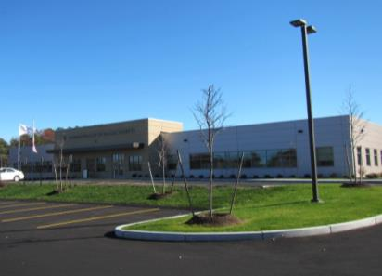

Prepared by:
Massachusetts Department of Public Health
Bureau of Environmental Health
Indoor Air Quality Program
December 2016

Background
Building: | Executive Office of Health and Human Services (EOHHS) Service Center
Address: | 38 Industrial Park Road, Plymouth, MA
Division of Capital Asset Management and Maintenance (DCAMM) Project Manager: | Lars Carlson
Reason for Request: | Post-occupancy assessment
Date of Assessment: | November 18, 2016
Massachusetts Department of Public Health/Bureau of Environmental Health (MDPH/BEH) Staff Conducting Assessment: | Cory Holmes, Environmental Analyst, Indoor Air Quality (IAQ) Program
Building Description: | Single-story newly constructed building that serves as office space for the Department of Developmental Services, Department of Mental Health and the Massachusetts Rehabilitation Commission.
Building Population: | Approximately 100 employees
Windows: | Not openable

Methods
Please refer to the IAQ Manual for methods, sampling procedures, and interpretation of results (MDPH, 2015).

IAQ Testing Results
The following is a summary of indoor air testing results (Table 1).
- Carbon dioxide levels were below 800 parts per million (ppm) in all areas assessed, indicating adequate fresh air in the space.
- Temperature was within or close to the recommended range of 70°F to 78°F in all areas assessed.
- Relative humidity was within or close to the recommended range of 40% to 60% in all areas assessed.
- Carbon monoxide levels were non-detectable in all areas assessed.
- Fine particulate matter (PM2.5) concentrations measured were below the National Ambient Air Quality Standard (NAAQS) level of 35 micrograms per cubic meter (μg/m³) in all areas assessed.

Ventilation
Heating, ventilation and air conditioning (HVAC) is provided by rooftop air-handling units (AHUs, Picture 1). Conditioned air is delivered to occupied areas via louvered supply vents, and stale air is removed via return vents (Picture 2). The HVAC system is controlled by digital thermostats (Picture 3). The BEH recommends that the fan be set to the “on” setting to provide continuous circulation/filtration during occupied hours.

Microbial/Moisture Concerns
No water-damaged materials were observed during the assessment. Plants were observed in several areas (Table 1). Plants can be a source of pollen and mold, which can be respiratory irritants to some individuals. Plants should be properly maintained and equipped with drip pans and should be located away from air diffusers to prevent the aerosolization of dirt, pollen, and mold.

Other IAQ Evaluations
The offices were mostly carpeted. Carpets should be cleaned annually (or semi-annually in soiled/high traffic areas) in accordance with Institute of Inspection, Cleaning and Restoration Certification (IICRC) recommendations, (IICRC, 2012).

Conclusions/Recommendations
Based on observations at the time of assessment, the following is recommended:
- Operate supply and exhaust ventilation continuously in all areas during occupied periods.
- Have the HVAC system balanced every 5 years in accordance with SMACNA recommendations (SMACNA, 1994).
- For buildings in New England, periods of low relative humidity during the winter are often unavoidable. Therefore, scrupulous cleaning practices should be adopted to minimize common indoor air contaminants whose irritant effects can be enhanced when the relative humidity is low. To control for dusts, a high efficiency particulate arrestance (HEPA) filter equipped vacuum cleaner in conjunction with wet wiping of all surfaces is recommended. Avoid the use of feather dusters. Drinking water during the day can help ease some symptoms associated with a dry environment (throat and sinus irritations).
- Keep plants in good condition, avoid overwatering, and remove from the airstream of heating and ventilation equipment.
- Clean carpeting in accordance with IICRC recommendations (IICRC, 2012); annually (or semi-annually in soiled/high traffic areas).
- Refer to resource manual and other related IAQ documents located on the MDPH’s website for further building-wide evaluations and advice on maintaining public buildings. These documents are available at: http://mass.gov/dph/iaq.

References
IICRC. 2012. Institute of Inspection, Cleaning and Restoration Certification. Carpet Cleaning: FAQ. Retrieved from http://www.iicrc.org/consumers/care/carpet-cleaning.
MDPH. 2015. Massachusetts Department of Public Health. Indoor Air Quality Manual: Chapters I-III. Available at: http://www.mass.gov/eohhs/gov/departments/dph/programs/environmental-health/exposure-topics/iaq/iaq-manual/.
SMACNA. 1994. HVAC Systems Commissioning Manual. 1st ed. Sheet Metal and Air Conditioning Contractors’ National Association, Inc., Chantilly, VA.
Picture 1
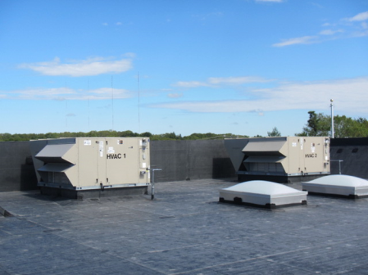
Rooftop air handling units
Picture 2
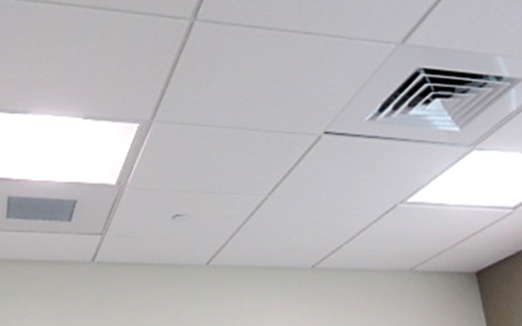
Supply (right) and return (left) vents
Picture 3
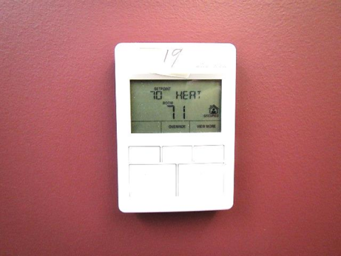
Digital Thermostat

Location | Carbon  Dioxide  (ppm) | Carbon Monoxide  (ppm) | Temp  (°F) | Relative  Humidity  (%) | PM2.5  (µg/m³) | Occupants  in Room | Windows  Openable | Ventilation |  |  | Remarks
 |  |  |  |  |  |  |  | Intake | Exhaust
Background | 396 | ND | 54 | 61 | 4 |  |  |  |  |  | Sunny, clear skies
Lobby | 600 | ND | 71 | 39 | 8 | 2 | N | Y |  | Y
Reception | 599 | ND | 72 | 39 | 2 | 2 | N | Y |  | Y
103 | 526 | ND | 71 | 38 | 3 | 0 | N | Y |  | Y
105 | 528 | ND | 71 | 39 | 4 | 0 | N | Y |  | Y
113 Conference Room | 543 | ND | 72 | 38 | 3 | 0 | N | Y |  | Y
114 | 545 | ND | 71 | 39 | 6 | 0 | N | Y |  | Y
115 | 536 | ND | 71 | 39 | 6 | 0 | N | Y |  | Y
116 | 534 | ND | 70 | 39 | 6 | 0 | N | Y |  | Y
117 | 523 | ND | 71 | 38 | 6 | 0 | N | Y |  | Y
118 | 552 | ND | 71 | 39 | 2 | 0 | N | Y |  | Y
120 | 568 | ND | 70 | 42 | 1 | 1 | N | Y |  | Y | DO
122 | 549 | ND | 70 | 41 | 1 | 0 | N | Y |  | Y | DO
124 | 555 | ND | 69 | 43 | 2 | 0 | N | Y |  | Y | DO
125-130 | 560 | ND | 70 | 42 | 2 | 0 | N | Y |  | Y
131-142 | 563 | ND | 69 | 49 | 2 | 0 | N | Y |  | Y | Plants
134-139 | 567 | ND | 68 | 48 | 2 | 2 | N | Y |  | Y | Plants
143-146 | 580 | ND | 69 | 54 | 2 | 1 | N | Y |  | Y
149 | 571 | ND | 69 | 52 | 2 | 1 | N | Y |  | Y | DO
150 Conference Room | 607 | ND | 69 | 52 | 1 | 0 | N | Y |  | Y | Plants
153 | 469 | ND | 71 | 39 | 10 | 0 | N | Y |  | Y
154 File Room | 476 | ND | 71 | 40 | 2 | 0 | N | Y |  | Y
155 Storage | 484 | ND | 71 | 40 | 6 | 0 | N | Y |  | Y
156 | 552 | ND | 71 | 40 | 12 | 1 | N | Y |  | Y | DO
161 Kitchen | 513 | ND | 71 | 40 | 12 | 0 | N | Y |  | Y | DO
164 Storage | 484 | ND | 73 | 35 | 7 | 0 | N | Y |  | Y
165-168 | 496 | ND | 73 | 36 | 2 | 0 | N | Y |  | Y
170-173 | 522 | ND | 74 | 35 | 8 | 2 | N | Y |  | Y
174-177 | 502 | ND | 74 | 35 | 5 | 1 | N | Y |  | Y
178-181 | 508 | ND | 74 | 35 | 4 | 1 | N | Y |  | Y
182 | 499 | ND | 74 | 35 | 5 | 0 | N | Y |  | Y
184-187 | 507 | ND | 74 | 35 | 7 | 1 | N | Y |  | Y
188-191 | 516 | ND | 74 | 36 | 4 | 1 | N | Y |  | Y
193-194 | 572 | ND | 74 | 36 | 3 | 0 | N | Y |  | Y
195 | 566 | ND | 73 | 38 | 4 | 0 | N | Y |  | Y | DO
196 Records Room | 485 | ND | 73 | 37 | 4 | 0 | N | Y |  | Y | DO
199-202 | 542 | ND | 72 | 38 | 2 | 3 | N | Y |  | Y | DO
203 A & B | 470 | ND | 72 | 38 | 2 | 0 | N | Y |  | Y | DO
204 | 511 | ND | 72 | 38 | 7 | 1 | N | Y |  | Y | DO
206-216 | 588 | ND | 72 | 38 | 3 | 0 | N | Y |  | Y
208-213 | 615 | ND | 72 | 39 | 4 | 4 | N | Y |  | Y
218-220 | 565 | ND | 73 | 38 | 4 | 2 | N | Y |  | Y
221-223 | 568 | ND | 72 | 38 | 2 | 0 | N | Y |  | Y
224 | 612 | ND | 72 | 38 | 2 | 1 | N | Y |  | Y | DO
225 Conference Room | 551 | ND | 73 | 38 | 2 | 0 | N | Y |  | Y | DO
226 | 576 | ND | 73 | 38 | 7 | 1 | N | Y |  | Y | DO
227 | 559 | ND | 73 | 37 | 4 | 1 | N | Y |  | Y | DO

