INDOOR AIR QUALITY
POST-OCCUPANCYASSESSMENT

Executive Office of Health and Human Services
Service Center
49 Nursery Lane
Fitchburg, MA

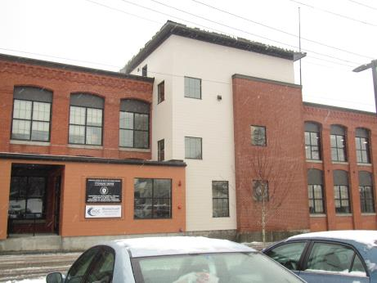

Prepared by:
Massachusetts Department of Public Health
Bureau of Environmental Health
Indoor Air Quality Program
November 2018

Background
Building: | Executive Office of Health and Human Services (EOHHS) Center
Address: | 49 Nursery Lane (Formerly Nockage Street) Fitchburg, MA
Assessment Requested by: | Jamie Blood, Regional Planner/Project Manager, Division of Capital Asset Management and Maintenance (DCAMM)
Reason for Request: | Post-occupancy indoor air quality (IAQ) assessment
Date of Assessment: | November 20, 2018
Massachusetts Department of Public Health/Bureau of Environmental Health (MDPH/BEH) Staff Conducting Assessment: | Ruth Alfasso, Environmental Engineer/Inspector, IAQ Program
Building Description: | Two-story brick building originally constructed around 1900 as a factory. It was completely remodeled prior to occupancy by the EOHHS center.
Building Population: | Approximately 150 employees in Department of Children and Families (DCF), Department of Developmental Services (DDS), Department of Transitional Assistance (DTA), and the Massachusetts Rehabilitation Commission (MRC).Members of the public visit daily.
Windows: | Not openable

Methods
Please refer to the IAQ Manual for methods, sampling procedures, and interpretation of results (MDPH, 2015).

IAQ Testing Results
The following is a summary of indoor air testing results (Table 1).
- Carbon dioxide levels were below the MDPH guideline of 800 parts per million (ppm) in most of the areas assessed, with some levels slightly above, indicating adequate fresh air for most of the space.
- Temperature was within or very close to the recommended range of 70°F to 78°F.
- Relative humidity was below the recommended range of 40% to 60% in all areas assessed the day of the assessment.
- Carbon monoxide levels were non-detectable (ND) in all indoor areas assessed.
- Fine particulate matter (PM2.5) concentrations measured were below the National Ambient Air Quality Standard (NAAQS) level of 35 μg/m³ in all but one area assessed, due to a scented item.

Ventilation
A heating, ventilating, and air conditioning (HVAC) system has several functions. First it provides heating and, if equipped, cooling. Second, it is a source of fresh air. Finally, an HVAC system will dilute and remove normally occurring indoor environmental pollutants not only by introducing fresh air, but also by filtering the airstream and ejecting stale air to the outdoors via exhaust ventilation. Even if an HVAC system is operating as designed, point sources of respiratory irritation may exist and cause symptoms in sensitive individuals. The following analysis examines and identifies components of the HVAC system and likely sources of respiratory irritant/allergen exposure from water damage, aerosolized dust, and/or chemicals found in the indoor environment.
Fresh air is provided by air-handling units (AHUs) located on the roof. Operation of the building’s HVAC system is controlled by an automated computer system. Air from the AHUs is filtered, heated/cooled, and delivered to rooms via ducted supply vents (Picture 1). Air is returned/exhausted through return vents. It is recommended that HVAC systems be re-balanced every five years to ensure adequate air systems function (SMACNA, 1994). It was reported that the system was balanced prior to occupancy. It was reported that exhaust vents in the restrooms and kitchen areas vent directly outside. Direct-vented exhaust is recommended in areas where moisture and odors may be generated.
In a few offices, there was tape over the supply vents (Picture 2). Vents should remain unobstructed for proper airflow once the system has been balanced. If this tape is in response to concerns about drafts, building maintenance staff should be contacted for adjustments of the system. Also note that offices with windows were frequently noticeably cooler than those in the interior during the assessment. Few, if any, thermostats for were found in exterior offices, so the system may not properly account for temperature differences between interior and exterior offices. If occupants express concerns about temperature in the exterior offices, additional thermostats should be located there and the computer system adjusted to supply more heat to those offices.

Microbial/Moisture Concerns
Several water coolers were located in carpeted areas (Picture 3). Spills or leaks from these appliances can moisten the carpet, leading to odors and microbial growth.
Plants were present in some areas (Picture 4; Table 1). Plants can be a source of pollen and mold, which can be respiratory irritants to some individuals. Plants should be properly maintained and equipped with drip pans to prevent water damage to porous materials. Plants should also be located away from air diffusers to prevent the aerosolization of dirt, pollen, and mold.
During the pre-occupancy visit, stained ceiling tiles from a roof leak were noted on the second floor. During the post-occupancy visit, building staff reported that a leak in the same area had occurred since the building was occupied; the roof was since repaired and all the stained tiles were replaced. No water-damaged ceiling tiles or other materials were noted during the post-occupancy visit.
The building has a crawlspace access door in the stairwell that lacked weather-stripping (Picture 5), which can allow odors and pests to migrate into occupied areas. Other doors between occupied and unconditioned spaces, including outdoors, should be rendered tight using weather-stripping, and kept closed.

Other IAQ Evaluations
Exposure to low levels of total volatile organic compounds (TVOCs) may produce eye, nose, throat, and/or respiratory irritation in some sensitive individuals. To determine if VOCs were present, BEH/IAQ staff examined rooms for products containing VOCs. BEH/IAQ staff noted dry erase markers, cleaning products, air freshening products and hand sanitizers in use within the building (Pictures 6 and 7; Table 1). All of these products have the potential to be irritants to the eyes, nose, throat, and respiratory system of sensitive individuals. The scented items in one office may be responsible for the elevated level of PM2.5 found there (Table 1).
Several storage areas had slight odors. In two of these rooms, wooden built-in shelves (Picture 8) had been sealed with a lacquer material that seemed to be the source of the odor. This odor should dissipate as the material finishes off-gassing, but this can be sped up by increasing ventilation when possible. If odors persist, it may help to wash the shelving with a mild detergent and allow to dry fully. Odors in another storage room seemed to be from some of the stored materials. Boxes containing printed materials or plastic items should be kept closed when not in use to minimize off-gassing.
Several office areas had food in them (Table 1). Food should be stored in tightly-sealed containers to prevent odors and pests, particularly since rodents had been observed in the building. Kitchen equipment such as toasters, microwaves, and refrigerators should also be cleaned regularly.
In a few areas, boxes and other items were stored on the floor. Also note that the arrangement of cubicles in one section of the office creates an aisle next to the windows (Picture 9). Areas like this tend to attract clutter and may not be effectively cleaned, which creates harborage for pests. In general, excessive stored materials and accumulated items make it more difficult for custodial staff to clean (Table 1). Items should be stored neatly and moved periodically to allow for wet-wiping and vacuuming of surfaces.
Many offices are carpeted. Carpets should be cleaned annually (or semi-annually in soiled/high traffic areas) in accordance with Institute of Inspection, Cleaning, and Restoration Certification (IICRC) recommendations (IICRC, 2012).

Conclusions/Recommendations
Based on observations at the time of assessment, the following is recommended:
- Operate supply and return ventilation continuously (“fan on”) during occupied periods.
- Remove tape from vents.
- Have the HVAC system balanced every 5 years in accordance with SMACNA recommendations (SMACNA, 1994).
- If temperatures in exterior offices are not comfortable, consider adding thermostats to better represent conditions in those areas.
- For buildings in New England, periods of low relative humidity during the winter are often unavoidable. Therefore, scrupulous cleaning practices should be adopted to minimize common indoor air contaminants whose irritant effects can be enhanced when the relative humidity is low. To control for dusts, a high efficiency particulate arrestance (HEPA) filter equipped vacuum cleaner in conjunction with wet wiping of all surfaces is recommended. Avoid the use of feather dusters. Drinking water during the day can help ease some symptoms associated with a dry environment (throat and sinus irritations).
- Monitor any areas where building envelope leaks have occurred and ensure there is a system for prompt reporting.
- Place refrigerators and water dispensing equipment in areas without carpeting or use a waterproof mat underneath them.
- Keep plants in good condition, avoid overwatering, and avoid placing them on porous items such as carpets or paper.
- Ensure all doors between occupied and unconditioned spaces are sealed with weather-stripping and kept closed.
- Reduce use of cleaning products, sanitizers, and scented products.
- Ventilate storerooms to reduce lacquer odors from shelving; wash shelving if needed.
- Ensure boxes of printed and plastic-containing materials are kept closed when not in use.
- Keep food in tightly sealed containers and keep kitchen equipment clean.
- Store items in an organized manner and off the floor. Move items periodically to allow for cleaning, including vacuuming and wet wiping of surfaces to remove dust. Ensure that areas like that shown in Picture 9 are a regular part of the cleaning program.
- Clean carpeting in accordance with IICRC recommendations (IICRC, 2012).
- Clean supply and exhaust vents, personal fans, and heaters regularly to prevent aerosolization of debris.
- Refer to resource manual and other related IAQ documents located on the MDPH’s website for further building-wide evaluations and advice on maintaining public buildings. These documents are available at: http://mass.gov/dph/iaq.

References
IICRC. 2012. Institute of Inspection, Cleaning and Restoration Certification. Carpet Cleaning: FAQ.
MDPH. 2015. Massachusetts Department of Public Health. Indoor Air Quality Manual: Chapters I-III. Available at: http://www.mass.gov/eohhs/gov/departments/dph/programs/environmental-health/exposure-topics/iaq/iaq-manual/.
SMACNA. 1994. HVAC Systems Commissioning Manual. 1st ed. Sheet Metal and Air Conditioning Contractors’ National Association, Inc., Chantilly, VA.
Picture 1
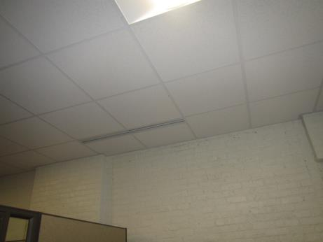
One style of supply vent in the office
Picture 2
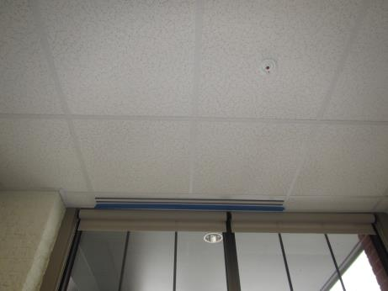
Tape on supply vent
Picture 3
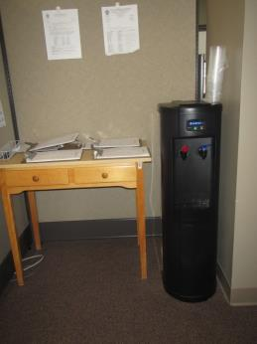
Water cooler on carpet
Picture 4
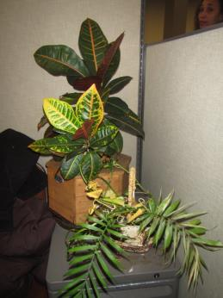
Plants in the office
Picture 5
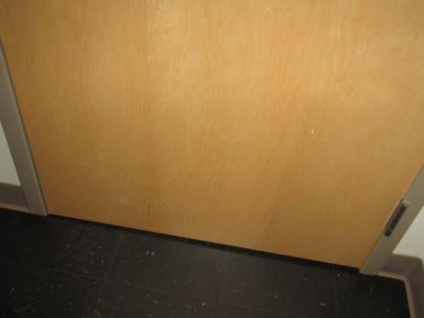
Space under door to crawlspace from stairwell
Picture 6
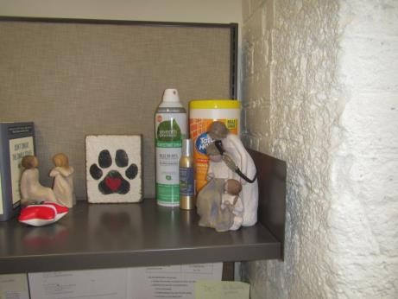
Cleaning products
Picture 7
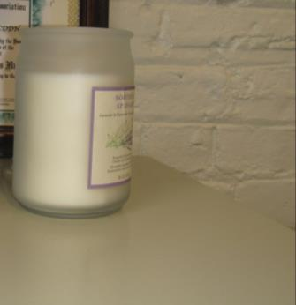
Scented candle
Picture 8
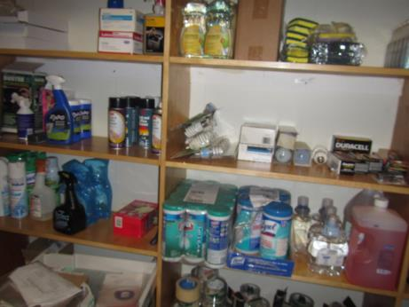
Built-in shelving with lacquer odor and items which can also be sources of odors
Picture 9
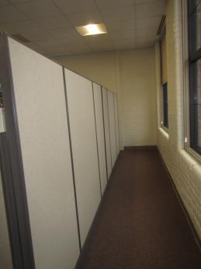
Aisle between cubicle walls and windows

Location | Carbon  Dioxide  (ppm) | Carbon Monoxide  (ppm) | Temp  (°F) | Relative  Humidity  (%) | PM2.5  (µg/m³) | Occupants  in Room | Windows  Openable | Ventilation |  | Remarks
 |  |  |  |  |  |  |  | Supply | Exhaust
Background | 421 | ND | ~32 | 29 | 1 |  |  |  |  | Snow and rain
DTA
Reception | 729 | ND | 72 | 31 | ND | 3 | N | Y | Y | PC
Lobby/waiting | 666 | ND | 71 | 29 | ND | 3 | N | Y | Y
1024-1029 cubes | 861 | ND | 72 | 28 | ND | 1 | N | Y | Y | PF, PC in hallway
1031-1036 cubes | 756 | ND | 73 | 27 | ND | 5 | N | Y | Y | HS, decorative items, plants
1061-1066 cubes | 759 | ND | 74 | 27 | 1 | 3 | N | Y | Y | PF, CP, HS
1067-1072 cubes | 797 | ND | 74 | 26 | 1 | 2 | N | Y | Y | PF, plant
1079-1084 cubes | 731 | ND | 74 | 25 | 3 | 3 | N | Y | Y | HS
1037-1041 cubes | 776 | ND | 73 | 27 | 1 | 4 | N | Y | Y | Plants
1005 | 691 | ND | 71 | 30 | ND | 1 | N | Y | Y
1006 | 615 | ND | 71 | 28 | ND | 0 | N | Y | Y | Training room, NC
1007 cube area | 640 | ND | 72 | 29 | ND | 4 | N | Y | Y | NC
1008 | 637 | ND | 71 | 28 | ND | 1 | N | Y | Y | NC, PC
1009 interview | 618 | ND | 72 | 27 | ND | 0 | N | Y | Y | NC
1010 | 597 | ND | 71 | 26 | ND | 0 | N | Y | Y | NC
1013 | 608 | ND | 71 | 26 | ND | 0 | N | Y | Y | NC
1014 | 711 | ND | 71 | 26 | ND | 0 | N | Y | Y | NC, tape on vent
1015 | 661 | ND | 71 | 27 | 1 | 0 | N | Y | Y | NC, tape on vent
1017 | 691 | ND | 71 | 29 | ND | 0 | N | Y | Y | NC
1018 | 787 | ND | 71 | 27 | ND | 0 | N | Y | Y | NC, boxes on floor
1019 | 812 | ND | 71 | 27 | ND | 0 | N | Y | Y | NC
1020 | 746 | ND | 71 | 28 | 6 | 0 | N | Y | Y | NC, HS
1021 | 658 | ND | 71 | 27 | ND | 0 | N | Y | Y
1022 | 662 | ND | 71 | 27 | ND | 0 | N | Y | Y
1023 kitchen | 755 | ND | 72 | 32 | ND | 2 | N | Y | Y | Plants, fridges, microwave
1042 half-wall | 745 | ND | 73 | 27 | 1 | 1 | N | Y | Y | PC in hallway, DO
1043 half-wall | 747 | ND | 74 | 27 | 1 | 1 | N | Y | Y
1045 conference | 637 | ND | 74 | 25 | 1 | 0 | N | Y | Y
1046 | 810 | ND | 72 | 25 | ND | 0 | N | Y | Y | Feels colder in here, next to window
1048 | 766 | ND | 69 | 36 | 5 | 1 | N | Y | Y
1050 half wall | 727 | ND | 73 | 21 | ND | 0 | N | Y | Y
1051 half-wall | 738 | ND | 73 | 27 | ND | 0 | N | Y | Y
1052 half-wall | 839 | ND | 74 | 26 | 2 | 1 | N | Y | Y
1057 half-wall | 779 | ND | 74 | 26 | 1 | 0 | N | Y | Y
1058 half-wall | 751 | ND | 74 | 26 | 1 | 1 | N | Y | Y
1059 half-wall | 862 | ND | 74 | 26 | 3 | 1 | N | Y | Y
1060 | 736 | ND | 74 | 26 | 1 | 0 | N | Y | Y | HS
1085 | 737 | ND | 71 | 32 | ND | 0 | N | Y | Y
1073 – 1078 cubes | 741 | ND | 74 | 26 | 2 | 3 | N | Y | Y
DMH
Reception | 693 | ND | 71 | 27 | 2 | 1 | N | Y | Y
Lobby Conference for DMH, MRC, DDS | 682 | ND | 71 | 26 | 1 | 0 | N | Y | Y | NC
Waiting area for DMH, MRC, DDS | 642 | ND | 71 | 26 | 1 | 0 | N | Y | Y | NC
1095-1102 cubes | 766 | ND | 72 | 27 | 1 | 0 | N | Y | Y | Plants
1091-1094 cubes | 720 | ND | 73 | 26 | 1 | 0 | N | Y | Y | PC
1103-1106 cubes | 789 | ND | 72 | 26 | 1 | 2 | N | Y | Y | HS, plants
1040 | 632 | ND | 72 | 25 | ND | 0 | N | Y | Y
1088 | 738 | ND | 73 | 26 | 1 | 6 | N | Y | Y | Plant
1089 | 767 | ND | 73 | 26 | 3 | 1 | N | Y | Y | Fridge, items on windowsill, DEM
1108 | 742 | ND | 72 | 26 | 1 | 0 | N | Y | Y | DEM
1109 | 712 | ND | 73 | 25 | ND | 0 | N | Y | Y | DEM, PC, fabric on window
1110 | 708 | ND | 72 | 26 | ND | 0 | N | Y | Y | Scented item, AP, DEM
1111 stationery storage | 604 | ND | 72 | 26 | ND | 0 | N | Y | Y | Odor (coating on built in shelves?), stored items including paper and CP
1112 | 676 | ND | 71 | 26 | ND | 0 | N | Y | Y | Storage, including boxes on floor
1114 | 660 | ND | 72 | 26 | 1 | 0 | N | Y | Y | Shredder and printer
1115 | 551 | ND | 72 | 26 | ND | 0 | N | Y | Y | Rubber odor, stored files in boxes
1116 | 715 | ND | 74 | 25 | 1 | 0 | N | Y | Y | NC, kitchen items
MRC
1142 | 664 | ND | 71 | 26 | 1 | 0 | N | Y | Y | NC
1143 | 600 | ND | 71 | 27 | ND | 0 | N | Y | Y | NC
1146 | 562 | ND | 72 | 25 | ND | 0 | N | Y | Y
1147 | 609 | ND | 70 | 25 | 1 | 0 | N | Y | Y | MT
1148 | 954 | ND | 71 | 28 | 1 | 0 | N | Y | Y | NC
1149 interview | 601 | ND | 71 | 26 | ND | 0 | N | Y | Y | NC
1150 | 548 | ND | 73 | 26 | ND | 0 | N | Y | Y | NC
Security area | 613 | ND | 74 | 26 | 1 | 2 | N | Y | Y | Feels warmer in here, NC, CP, HS
Second Floor – DDS
Second floor women’s restroom |  |  |  |  |  |  | N | Y | Y | Shared with other tenant
Second floor men’s restroom |  |  |  |  |  |  | N | Y | Y | Shared with other tenant
2015-2022 cubes | 691 | ND | 70 | 28 | 2 | 1 | N | Y | Y | Plants
2040-2045 cubes | 702 | ND | 70 | 28 | 2 | 5 | N | Y | Y | Food
2007-2012 cubes | 712 | ND | 70 | 28 | 2 | 3 | N | Y | Y
2037-2040 cubes | 685 | ND | 70 | 27 | 2 | 5 | N | Y | Y | Cloth, items
2032-2034 cubes | 667 | ND | 71 | 26 | 1 | 0 | N | Y | Y
2025-2027 cubes | 680 | ND | 70 | 28 | 1 | 2 | N | Y | Y | Plants
2000 | 732 | ND | 70 | 29 | 36 | 1 | N | Y | Y | Food, salt lamp, plants, scented item
2001 | 759 | ND | 70 | 28 | 3 | 1 | N | Y | Y | DEM, AP, PF, plants
2003 | 701 | ND | 70 | 28 | 1 | 0 | N | Y | Y | Food
2004 | 807 | ND | 70 | 28 | 0 | 2 | N | Y | Y | Salt lamp, scented candle (unlit)
2006 cube | 972 | ND | 71 | 29 | 3 | 1 | N | Y | Y | Water cooler on carpet
2012 | 661 | ND | 70 | 28 | 8 | 0 | N | Y | Y | Copy room, NC
2016 | 829 | ND | 70 | 30 | 1 | Group just left | N | Y | Y
2017 | 689 | ND | 70 | 29 | 1 |  | N | N | N | Storage – shellac or paint odor from shelving, NC
2020 kitchen | 725 | ND | 70 | 30 | 1 | 0 | N | Y | Y | NC, toaster, refrigerator, ducted exhaust reported
2028 | 710 | ND | 70 | 28 | 2 | 1 | N | Y | Y | MT, food
2029 | 714 | ND | 70 | 28 | 1 | 0 | N | Y | Y | DO
2030 | 660 | ND | 70 | 27 | 1 | 0 | N | Y | Y | Heater, decorative items
2031 | 644 | ND | 70 | 26 | 1 | 0 | N | Y | Y
Elevator lobby | 619 | ND | 71 | 27 | 1 | 0 | N | Y | Y | NC and walk off carpets

