INDOOR AIR QUALITYASSESSMENT

Health and Human Services Center
280 Merrimack Street
Lawrence, MA

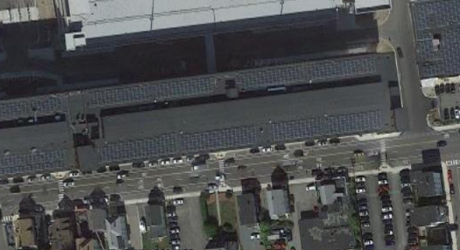

Prepared by:
Massachusetts Department of Public Health
Bureau of Environmental Health
Indoor Air Quality Program
June 2022

BACKGROUND
Building: | Executive Office of Health and Human Services (EOHHS) Center
Address: | 280 Merrimack Street, 3rd Floor Offices, Lawrence, MA
Assessment Requested by: | Pedro Batista, Project Coordinator, EOHHS
Reason for Request: | General indoor air quality (IAQ) issues and rodents
Date of Assessment: | June 8, 2022
Massachusetts Department of Public Health/Bureau of Environmental Health (MDPH/BEH) Staff Conducting Assessment: | Ruth Alfasso, Environmental Engineer/Inspector, IAQ Program
Building Description: | The EOHHS Center is located in a large former mill complex near the Lawrence Commuter Rail station. The EOHHS Center occupies space on the third floor, which was examined during this visit. There are additional EOHHS offices in other areas of the building which were not examined during this assessment. Other residential, retail and office businesses are located in the building.
Building Occupancy: | The EOHHS agencies located in the assessed space include: Mass Rehabilitation Commission (MRC), Department of Children and Families (DCF), Department of Developmental Services (DDS) and Department of Mental Health (DMH). The space contains offices, workstation areas, conference rooms, storage, and accessory uses. The EOHHS center has occupied this building since 2013.
Windows: | Not openable

METHODS
Please refer to the IAQ Manual for methods, sampling procedures, and interpretation of results (MDPH, 2015).

RESULTS AND DISCUSSION
The following is a summary of indoor air testing results (Table 1).
- Carbon dioxide levels were below the MDPH guideline of 800 parts per million (ppm) in all but one area assessed, which was close to 800 ppm, indicating adequate fresh air in the space. Occupancy in the building was somewhat low during the assessment, carbon dioxide levels may be higher with increased occupancy.
- Temperature was within the recommended range of 70°F to 78°F in all areas assessed.
- Relative humidity was within the MDPH recommended range of 40 to 60% in all occupied areas.
- Carbon monoxide was not detected (ND) in the areas assessed.
- Fine particulate matter (PM2.5) concentrations measured were below the National Ambient Air Quality Standard (NAAQS) level of 35 μg/m³ in all areas assessed.

Ventilation
Fresh air is provided by rooftop air-handling units (AHUs). Fresh air is drawn into the AHUs through a bank of filters, heated or cooled, and delivered to occupied areas via ducted supply diffusers (Picture 1). Return air is drawn into ceiling-mounted vents and ducted back to the rooftop AHUs (Picture 2). Open areas and many offices have both supply and return vents, however offices in some areas were found to have only supply vents and no return vents (Table 1). This may limit air circulation in these areas.
In one office, the vent was covered in cardboard (Table 1), which means no fresh air would be delivered to this space. This can also impact the operation of adjacent portions of the system. Vents should not be blocked.
To have proper ventilation with a mechanical supply and exhaust system, the systems must be balanced to provide an adequate amount of fresh air to the interior of a room while removing stale air from the room. It is recommended that heating, ventilation, and air conditioning (HVAC) systems be re-balanced every five years to ensure adequate air systems function (SMACNA, 1994).
AHUs are controlled by thermostats and a centralized control system. It is recommended that there be a means to indicate if the HVAC system is operating in automatic or continuous airflow setting the thermostats do not have the capacity to indicate if the system is set to run to supply continuous fresh air during occupancy.

Microbial/Moisture Concerns
Water-damaged ceiling tiles were noted in several areas (Pictures 3 and 4; Table 1) including the secure-side women’s restroom, a waiting-area conference room, a storeroom, and an office. Based on the location of these tiles, they appear to stem from leaks in the plumbing and/or HVAC system. None of the tiles appeared wet at the time of the visit, nor did any show dark staining that may indicate mold. Water-damaged ceiling tiles should be replaced once the leak has been addressed.
Water dispensers were found in many areas of the office. While waterproof mats were found under some of them, many of these were placed directly on carpet (Picture 5). Spills or leaks from this equipment can moisten carpeting and lead to odors and microbial growth. Small refrigerators were also located in many areas of the building, including common areas and offices. These should also be placed where spills and leaks will not damage carpeting, such as in an uncarpeted area or on a waterproof mat. It is important that refrigerators be kept clean and free from spills (Picture 6) to prevent mold growth, pests, and odors.
Plants were noted in some offices and common areas (Table 1). Plants should be kept in good condition, not overwatered, and placed on washable non-porous drip pans to protect furniture and building materials.

Other Conditions

Rodent Issues
Concerns about rodents were part of the reason for this assessment. No signs of rodents were observed at the time of the visit. It was communicated that the frequency of pest control contractor visits was increased after rodents had been reported approximately a month ago. Pest traps were noted in many areas of the building, which serve as part of the monitoring system for pests. Additional pest sightings or signs of pest activity should be reported to facility management.
In the experience of the IAQ Program, rodents and other pests tend to increase in spaces due to:
- an abundance of unsecured food,
- locations for rodents to hide and nest (harborages),
- occupant traffic/occupancy is reduced for extended periods of time.
IAQ staff noted a number of attractants for rodents, including:
- poorly cleaned microwaves, refrigerators, and toaster ovens in the kitchen and other locations (Table 1; Pictures 6 through 8),
- food stored in non-pest-proof containers or open on tables, cabinets and desks (Table 1; Pictures 9 and 10),
- the likely presence of food stored inside desks in non-airtight containers.
Rodents may hide or nest in stored materials including paper, boxes, fabric furniture and similar locations. Stored items and clutter found in the areas examined (Pictures 11 and 12) can readily serve as rodent harborages. In a few areas, fabric and fabric-covered furniture were found which may also create spaces for rodents to hide (Picture 13). To reduce rodents in a building, harborages should be eliminated.
Rodent infestation can result in symptoms due to materials in their wastes. Mouse urine contains a protein that is a known sensitizer (US EPA, 1992). A sensitizer is a material that can produce symptoms (e.g., running nose or skin rashes) in sensitive individuals after repeated exposure. To eliminate exposure to allergens, rodents must be removed from the building. Please note that removal, even after cleaning, may not provide immediate relief since allergens can exist in the interior for several months after rodents are eliminated (Burge, 1995). Once the infestation is eliminated, a combination of cleaning and increased ventilation and filtration should serve to reduce allergens associated with rodents.

Other issues
During the original pre-occupancy assessment in 2013, areas near the windows were identified as having loose brick and mortar that were creating dust and debris in occupied areas. This is not unexpected considering the age and type of the building. To reduce the impact of dust and debris on occupants, plastic material (Picture 14) was attached to the ceiling in areas where brick dust was an issue. Most of this plastic was found in good condition during the assessment, but the materials have either degraded or been damaged in some areas (Picture 15). This plastic material should be repaired or replaced to prevent brick dust from impacting occupants.
Also identified during the earlier assessment is the configuration of many of the workstation walls near the windows. An aisle exists between the walls and the workstation partitions. Areas behind these workstations can collect debris and items out of sight (Picture 16). Occupants should avoid placing or dropping items into these areas, as they are difficult to access for cleaning. Cleaning of these areas should be conducted on a regular schedule.
Exposure to low levels of total volatile organic compounds (TVOCs) may produce eye, nose, throat, and/or respiratory irritation in some sensitive individuals. BEH/IAQ staff examined areas for products containing VOCs. BEH/IAQ staff noted hand sanitizers, cleaners, and dry erase materials in the office space (Picture 17; Table 1). All of these products have the potential to be irritants to the eyes, nose, throat, and respiratory system of sensitive individuals. Scented products were noted in several areas, including a few offices with strong odors of perfume or air freshener (Table 1). Scented products in particular can be a source of irritation, or a trigger for asthma and migraine headaches. Note that scented products only cover up odors and do not remove the source of the odor.
In one office, a humidifier/essential oil diffuser was operating (Picture 18). No odor was detected from this unit, so it appeared it was being operated without any essential oil. Humidifiers should be kept scrupulously clean to avoid microbial growth.
Some supply and return/exhaust vents were dusty at the time of the visit. Thorough cleaning of ventilation equipment surfaces should be conducted during the year. Personal fans also had settled dust, which can be reaerosolized when the fan is activated.
Most offices were carpeted. Carpets and area rugs should be vacuumed regularly with a high efficiency particulate arrestance (HEPA)-filter-equipped vacuum cleaner and cleaned annually (or semi-annually in soiled/high traffic areas) in accordance with Institute of Inspection, Cleaning and Restoration Certification (IICRC) recommendations, (IICRC, 2012).

CONCLUSIONS AND RECOMMENDATIONS
In view of the findings at the time of the visit, the following recommendations are provided:

Ventilation recommendations
- Ensure the HVAC systems are set to have the fan on continuously during occupancy.
- Avoid covering or blocking vents. Work with facility maintenance staff to resolve issues with drafts or temperature discomfort.
- Consider adding return vents to offices and areas without them.
- Consider adopting a balancing schedule of every 5 years for all mechanical ventilation systems, as recommended by ventilation industrial standards (SMACNA, 1994).
- Change filters for AHUs in accordance with the manufacturer’s instructions or more frequently if needed. This includes filters on return vents.
- For buildings in New England, periods of low relative humidity during the winter are often unavoidable. Therefore, scrupulous cleaning practices should be adopted to minimize common indoor air contaminants whose irritant effects can be enhanced when the relative humidity is low. To control for dusts, a high efficiency particulate arrestance (HEPA) filter equipped vacuum cleaner in conjunction with wet wiping of all surfaces is recommended. Avoid the use of feather dusters. Drinking water during the day can help ease symptoms associated with a dry environment (throat and sinus irritations).

Water damage recommendations
- Replace water-damaged ceiling tiles once leaks have been fixed. Examine the area above the ceiling tiles for additional water damage and clean as needed.
- Maintain indoor plants and avoid overwatering. Ensure that plants are placed in waterproof drip pans that are cleaned frequently to prevent odors.
- Place water dispensers and small refrigerators in areas without carpeting or on a waterproof mat that is cleaned periodically.

Other recommendations
- Reduce storage of items in offices and workstations.
- Do not store boxes on floors.
- Consider reducing the total amount of items stored in the office, including monitoring purchasing of items to ensure there is a place to store them.
- Obtain storage shelves, cabinets, or pest-proof totes that are configured to reduce rodent hiding spaces/harborages.
- Routinely clean the kitchens including refrigerators and food residues from toasters, microwave ovens, coffee makers, or any other appliances used to prepare or heat food.
- Do not store food in or on employee desks, cubicles, or other work surfaces apart from the kitchen, and only in pest-proof air-tight containers made of hard plastic, glass, or metal.
- Consumption of food should occur in the kitchen area to limit the locations of food residues.
- Remove all empty food containers daily. Do not reuse food containers for other uses.
- For additional recommendations, please use methods of integrated pest management IPM in this workplace described in the IPM guide: https://www.mass.gov/doc/ipm-integrated-pest-management-kit-for-building-managers/download
- Repair or replace damaged plastic sheeting near windows to reduce brick dust.
- Avoid storing anything in the aisles between windows and workstations. Ensure these areas are regularly cleaned.
- Reduce or eliminate the use of scented products such as air fresheners and essential oils in the office.
- Ensure humidifiers are kept clean to avoid microbial growth and odors.
- Refer to resource manual and other related IAQ documents located on the MDPH’s website for further building-wide evaluations and advice on maintaining public buildings. These documents are available at: http://mass.gov/dph/iaq.

REFERENCES
Burge, H.A. 1995. Bioaerosols. Lewis Publishing Company, Boca Raton, FL.
IICRC. 2012. Carpet Cleaning FAQ 4 Institute of Inspection, Cleaning and Restoration Certification. Institute of Inspection Cleaning and Restoration, Vancouver, WA.
MDPH. 2015. Massachusetts Department of Public Health. Indoor Air Quality Manual: Chapters I-III. Available at: https://www.mass.gov/lists/indoor-air-quality-manual-and-appendices
SMACNA. 1994. HVAC Systems Commissioning Manual. 1st ed. Sheet Metal and Air Conditioning Contractors’ National Association, Inc., Chantilly, VA.
US EPA. 1992. Indoor Biological Pollutants. US Environmental Protection Agency, Environmental Criteria and Assessment Office, Office of Health and Environmental Assessment, research Triangle Park, NC. EPA 600/8-91/202. January 1992.

Picture 1
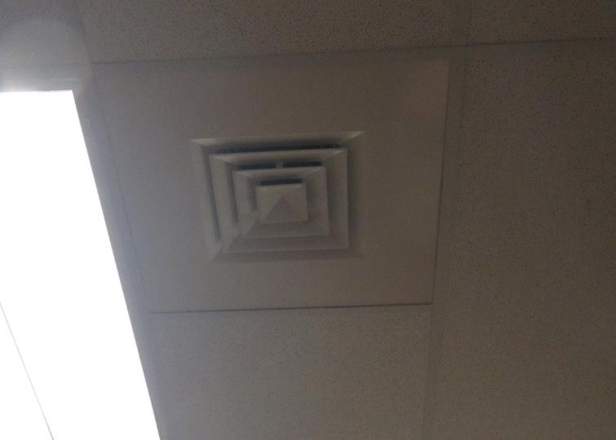
Typical supply vent
Picture 2
Return vent in a hallway area
Picture 3
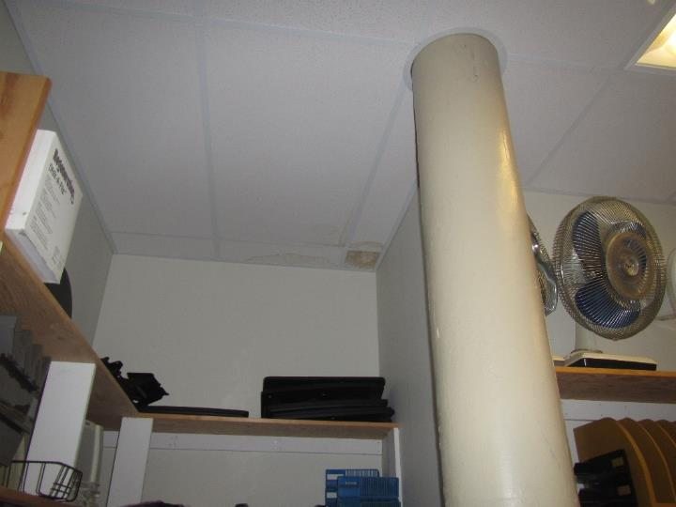
Water-damaged ceiling tiles in a storage room
Picture 4
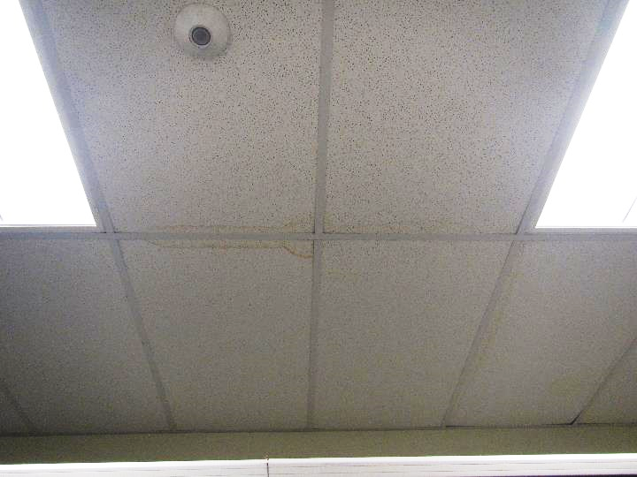
Water-damaged ceiling tiles in the women’s restroom
Picture 5
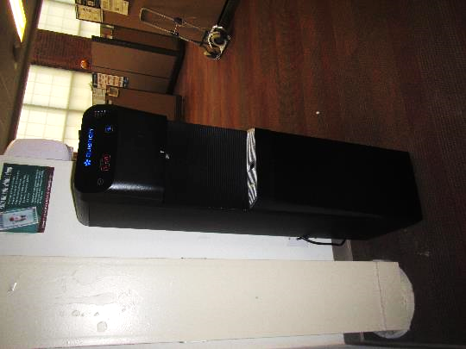
Water dispenser on carpet
Picture 6
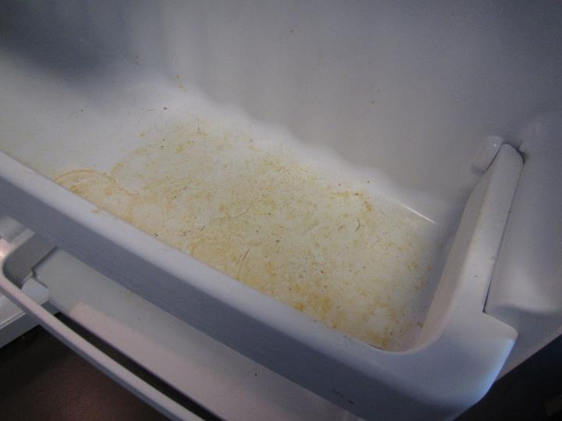
Evidence of spill in refrigerator
Picture 7
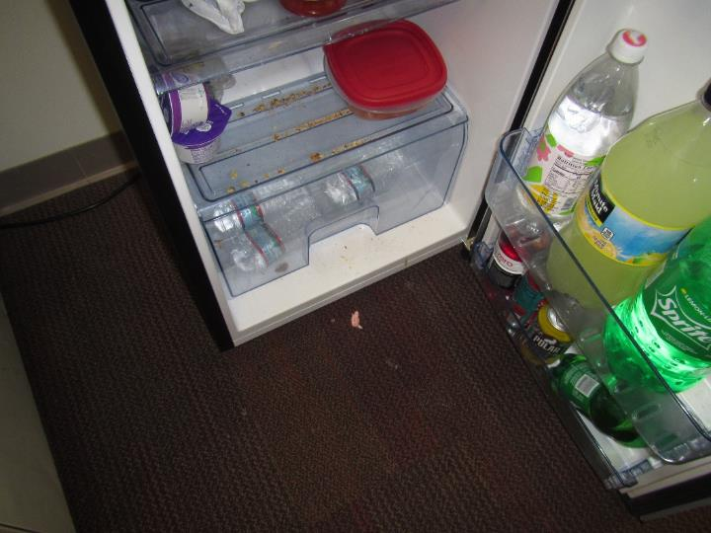
Refrigerator in need of cleaning
Picture 8
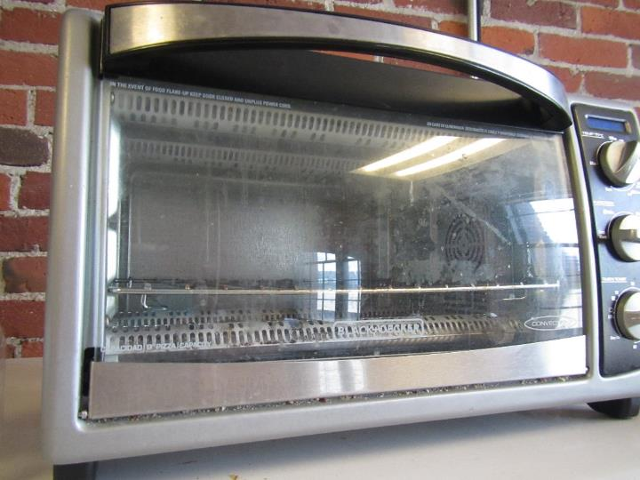
Toaster oven in need of cleaning
Picture 9
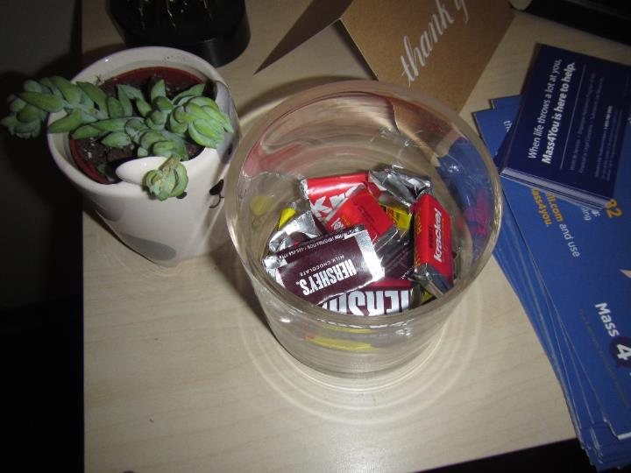
Food stored out on a table
Picture 10
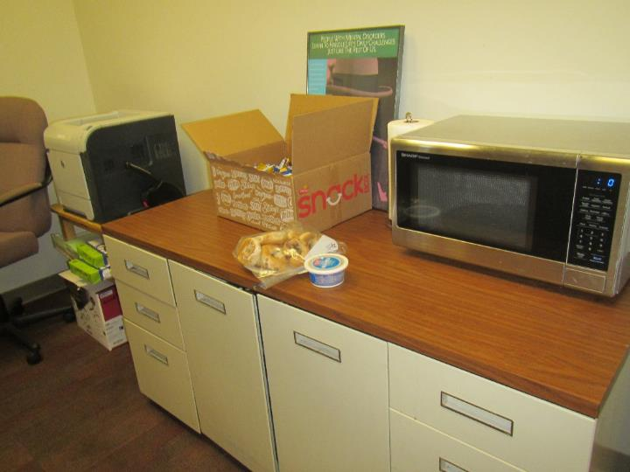
Food and a microwave in an area not in the kitchen
Picture 11
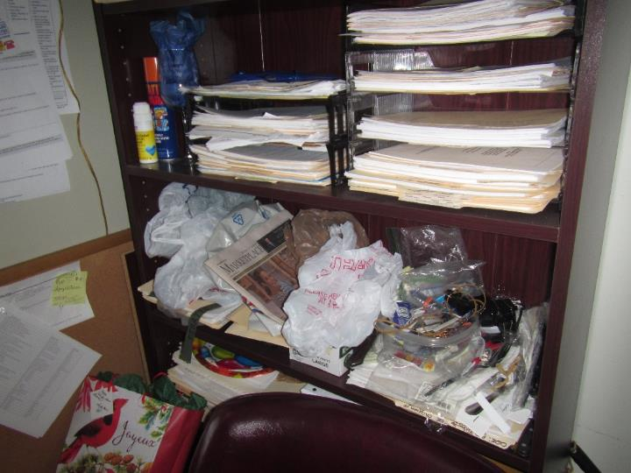
Clutter in an office
Picture 12
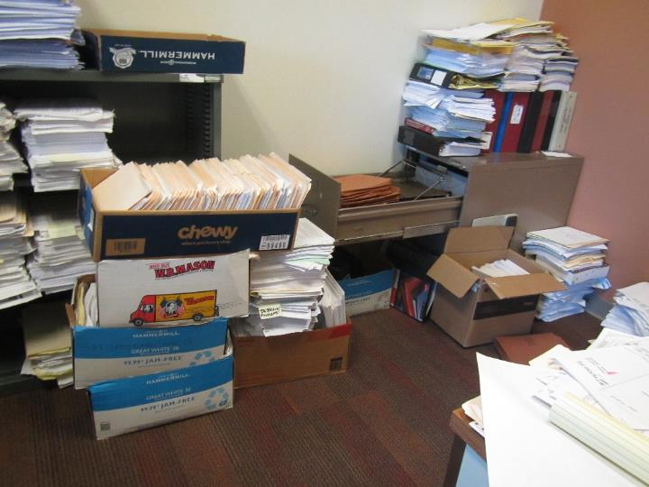
Paper and boxes on the floor
Picture 13
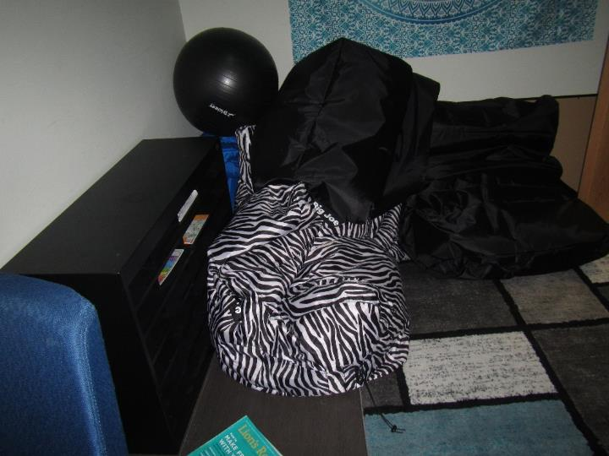
Bean-bag chairs in the Recharge Room
Picture 14
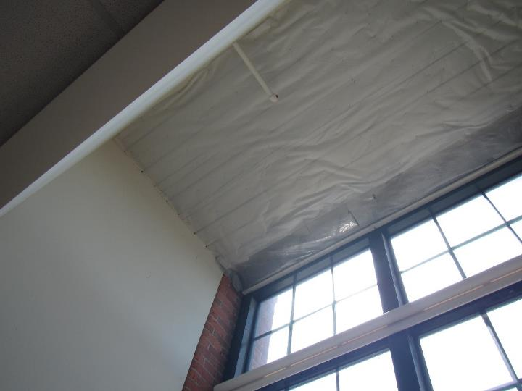
Intact plastic in window area
Picture 15
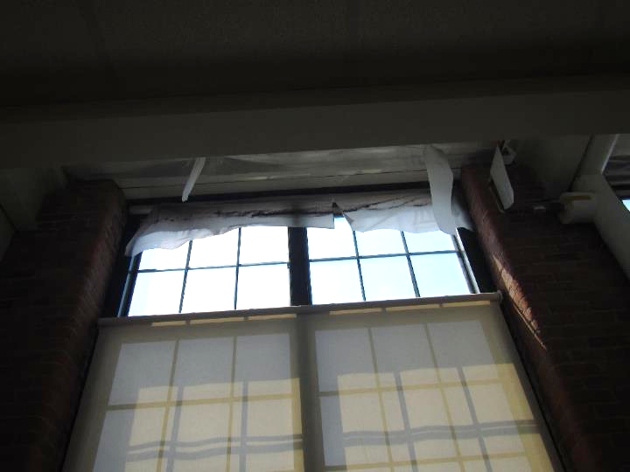
Damaged plastic in window area
Picture 16
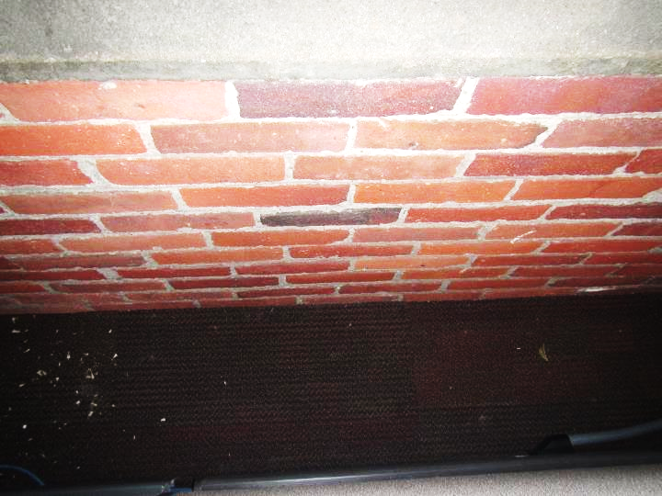
Aisle between wall and workstation partition with debris on carpet
Picture 17
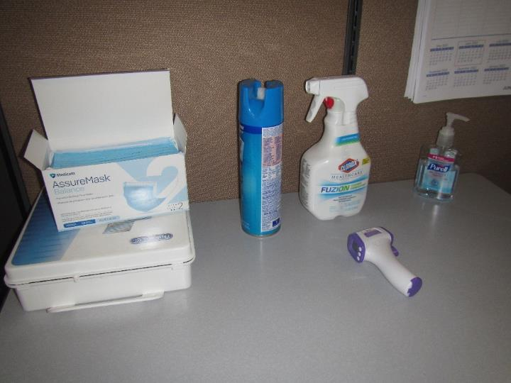
Cleaning/sanitizing products
Picture 18
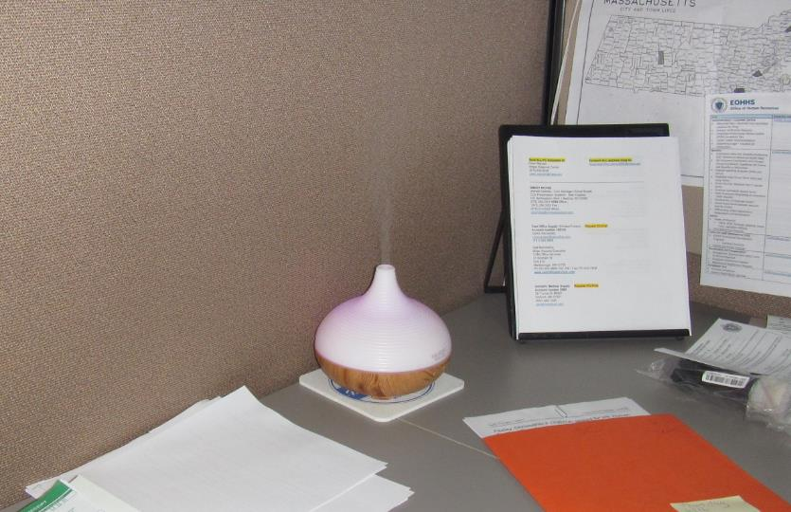
Humidifier/essential oil diffuser
Location | Carbon  Dioxide  (ppm) | Carbon Monoxide  (ppm) | Temp  (°F) | Relative  Humidity  (%) | PM2.5  (µg/m³) | Occupants  in Room | Windows  Openable | Ventilation |  | Remarks
 |  |  |  |  |  |  |  | Supply | Exhaust
Background | 405 | 1 – 1.5 | 73 | 67 | 1 |  |  |  |  | Humid, construction of garage nearby
MRC
Area Outside 2150 | 573 | ND | 74 | 51 | ND | 0 | N | Y | Y | Food, small appliances
2132 | 590 | ND | 73 |  | ND | 0 | N | Y | Y | HS
2130 | 568 | ND | 73 | 52 | ND | 0 | N | Y | Y | Cube area
2116 | 542 | ND | 73 | 52 | ND | 0 | N | Y | Y | Cube area
2114 | 553 | ND | 73 | 51 | 1 | 0 | N | Y | Y | Office
Conference | 539 | ND | 73 | 51 | ND | 0 | N | Y | Y
Reception area (inside) | 539 | ND | 73 | 53 | ND | 1 | N | Y | Y
DDS
2120 | 557 | ND | 73 | 53 | 1 | 1 | N | Y | Y
2121 | 565 | ND | 73 | 53 | ND | 1 | N | Y | Y | HS, CP in area outside
2122 | 580 | ND | 73 | 53 | ND | 0 | N | Y | Y | ½ wall office
2123 | 599 | ND | 73 | 53 | ND | 0 | N | Y | Y | ½ wall office, plants, diffuser/humidifier, PF, food
2147 | 596 | ND | 73 | 53 | ND | 1 | N | Y | Y | Cube area
2142 | 589 | ND | 73 | 53 | ND | 2 | N | Y | Y
2166 | 611 | ND | 74 | 52 | 1 | 0 | N | Y | Y | Office, plants
2168 | 579 | ND | 74 | 52 | 1 | 0 | N | Y | Y | Office
2124 | 534 | ND | 74 | 52 | 1 | 2 | N | Y | Y | Office, items/clutter
2172 | 552 | ND | 73 | 51 | 1 | 0 | N | Y | Y | Office
2174 | 562 | ND | 73 | 52 | ND | 0 | N | Y | Y | Office
2105 | 558 | ND | 72 | 51 | 1 | 0 | N | Y | Y | Office
2104 | 599 | ND | 73 | 52 | ND | 0 | N | Y | Y | Office, microwave, food
2103 | 629 | ND | 73 | 50 | ND | 0 | N | Y | Y | Office, very strong odor of air freshener or perfume
2102 | 524 | ND | 72 | 49 | 4 | 0 | N | Y | Y
2106 (recharge room) | 543 | ND | 72 | 52 | 1 | 0 | N | Y |  | Fabric furniture, beanbag chairs
Women’s restroom |  |  |  |  |  |  | N | Y | Y | Supply vent dusty, 3 WD CT
Men’s restroom |  |  |  |  |  |  | N | Y | Y | No WD CT
2433 DCF storage |  |  |  |  |  |  | N | Y | Y | NC, cabinets
DMH
2225 | 583 | ND | 72 | 54 | ND | 0 | N | Y | Y | WD CT, 2 PF
2226 | 586 | ND | 72 | 54 | ND | 1 | N | Y | Y | Food, PF
2227 | 598 | ND | 72 | 54 | ND | 0 | N | Y | Y
2231 | 575 | ND | 73 | 53 | ND | 0 | N | Y | Y | PF, coffee/tea setup
2232 | 589 | ND | 73 | 53 | 1 | 0 | N | Y | Y | Cube area, debris on floor
2235 | 627 | ND | 73 | 53 | 1 | 0 | N | Y | Y | Printer
2222 | 577 | ND | 73 | 53 | 1 | 1 | N | Y | Y | Plant
2219 | 568 | ND | 73 | 53 | ND | 0 | N | Y | Y
2218 | 576 | ND | 73 | 54 | ND | 1 | N | Y | Y | Cube area, items/clutter
2217 | 581 | ND | 73 | 53 | ND | 0 | N | Y | Y | WD CT in hallway
2212 | 587 | ND | 74 | 53 | ND | 0 | N | Y | Y
2213 | 584 | ND | 73 | 53 | ND | 0 | N | Y | Y
2215 | 588 | ND | 74 | 53 | ND | 1 | N | Y | Y
2211 conference | 588 | ND | 74 | 53 | ND | 0 | N | Y | Y
2200 | 591 | ND | 73 | 53 | ND | 0 | N | Y | Y | Coffee, sugar, debris behind cube wall
2202 | 587 | ND | 74 | 52 | ND | 1 | N | Y | Y
2209 | 616 | ND | 74 | 52 | 1 | 1 | N | Y | Y | HS, markers
2206 | 592 | ND | 74 | 52 | ND | 0 | N | Y | Y
2355 | 572 | ND | 71 | 57 | ND | 1 | N | Y | Y
2352 | 584 | ND | 71 | 56 | 1 | 0 | N | Y | Y
2353 | 581 | ND | 71 | 54 | ND | 0 | N | Y | Y | Ceiling plastic damaged, dried plants
2351 | 584 | ND | 71 | 56 | 1 | 0 | N | Y | Y | DEM
2354 | 562 | ND | 71 | 58 | ND | 1 | N | Y | Y
2347 | 566 | ND | 71 | 58 | ND | 0 | N | Y | Y
2345 | 571 | ND | 71 | 57 | 1 | 0 | N | Y | Y | Plant
2356 | 576 | ND | 71 | 57 | 1 | 1 | N | Y | Y
2326 | 581 | ND | 71 | 56 | 1 | 0 | N | Y | Y | Plants, DEM
2321 | 585 | ND | 73 | 55 | 1 | 0 | N | Y | Y
Kitchen | 574 | ND | 75 | 50 | ND |  |  |  |  | Toaster ovens, some with crumbs, microwaves, 3 refrigerators, one mostly empty but dirty with spill, and one defunct/not used, plant
DCF
DCF legal conference | 560 | ND | 75 | 51 | ND | 0 | N | Y | N
2411 | 560 | ND | 73 | 55 | ND | 0 | N | Y | Y
2419 | 600 | ND | 74 | 54 | ND | 0 | N | Y | Y
2414 | 597 | ND | 74 | 52 | ND | 1 | N | Y | Y
2412 | 644 | ND | 74 | 51 | 1 | 1 | N | Y | N | Paper/clutter
2410 | 618 | ND | 73 | 50 | ND | 0 | N | Y | N
2408 | 554 | ND | 74 | 50 | ND | 0 | N | Y | N
2405 | 579 | ND | 73 | 55 | ND | 2 | N | Y | N | PF on
2403 | 806 | ND | 73 | 55 | ND | 2 | N | Y | N | PF
2404 | 581 | ND | 72 | 55 | ND | 0 | N | Y | Y | Mini fridge
2402 | 557 | ND | 72 | 52 | ND | 0 | N | Y | N | Mini fridge
2401 | 529 | ND | 71 | 59 | ND | 0 | N | Y | N | Ceiling plastic damaged
2322 | 587 | ND | 73 | 55 | 1 | 0 | N | Y | N
2300 | 578 | ND | 73 | 53 | ND | 2 | N | Y | N | PF, perfume odor, plant
2301 | 592 | ND | 73 | 53 | 1 | 0 | N | Y | N | DEM
2302 | 575 | ND | 73 | 54 | 1 | 0 | N | Y | N | DEM
2303 | 574 | ND | 72 | 54 | ND | 0 | N | Y | N
2304 | 576 | ND | 72 | 55 | ND | 0 | N | Y | N | Area rug on carpet, PF
2305 | 571 | ND | 72 | 55 | ND | 0 | N | Y | N | Vent covered with cardboard
2306 | 574 | ND | 71 | 55 | ND | 0 | N | Y | N | Pillows, food, plant
Public side
2007 interview | 533 | ND | 73 | 49 | ND | 0 | N | Y | N
2009 interview | 559 | ND | 73 | 49 | ND | 0 | N | Y | N | NC
2006 interview | 649 | ND | 73 | 52 | ND | 1 | N | Y | N | NC
2003 | 610 | ND | 73 | 50 | ND | 0 | N | Y | N | NC
2004 conference | 639 | ND | 73 | 52 | ND | 0 | N | Y | N | WD CT (2)
2002 large conference | 622 | ND | 73 | 53 | ND | 0 | N | Y | Y
Waiting room | 716 | ND | 73 | 53 | ND | 0 | N | Y | Y

