ODOR ASSESSMENT
Follow-up report

Executive Office of Health and Human Services
600 Washington Street
Boston, MA

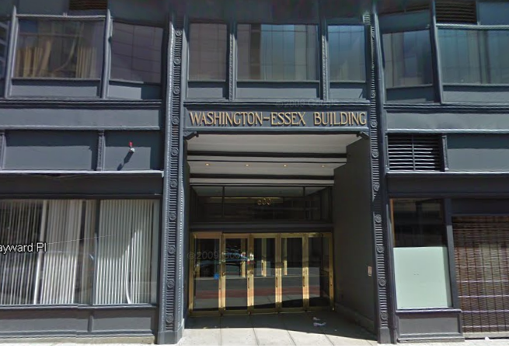

Prepared by:
Massachusetts Department of Public Health
Bureau of Environmental Health
Indoor Air Quality Program
January 2019

Background
Building: | Executive Office of Health and Human Services (EOHHS) office
Address: | 600 Washington Street,  Boston
Assessment Requested by: | Deb Coleman, Facilities Director  Executive Office of Health and Human Services
Reason for Request: | Odors and health concerns following an oil spill
Date of Assessment: | January 15, 2019
Massachusetts Department of Public Health/Bureau of Environmental Health (MDPH/BEH) Staff Conducting Assessment: | Ruth Alfasso, Environmental Engineer, Indoor Air Quality (IAQ) Program
Building Description: | The offices are in a seven-story, brick-faced building. The building underwent interior renovations in 2011. It has a flat roof with a black rubber membrane.
Windows: | Not openable

Background
During the day on Sunday November 25, 2018, there was a report of a discharge of No. 2 fuel oil in the basement of 600 Washington Street which houses EOHHS offices. The fire department was on scene and cleanup, including removal of oil from the street and below ground was initiated. The fire department, in coordination with the building operations staff and EOHHS facilities staff cleared the building and environs in terms of general safety.
EOHHS facilities staff then contacted the Boston Public Health Commission (BPHC) for assistance regarding the safe occupancy of the building. BPHC cleared the building for occupancy, however, occupants in many areas reported oil odor.
As a follow up to the BPHC assessment, the BEH IAQ program was requested to assess the building and measure for TVOCs in occupied areas throughout the building. The BEH/IAQ program took measurements on November 26, 2018 on all floors of the building and the basement. At that time, the BEH IAQ program recommended verbally a few mitigation measures including:
- Operate supply and exhaust ventilation continuously in all areas during occupied periods to ensure a supply of fresh air and exhaust to dilute and remove odors. Consider extended time of operation for the ventilation system to ensure that stagnant air with oily odors does not build up overnight.
- Use a fan as indicated during the visit to eject odors from the basement.
- Consider increasing cleaning in occupied areas, including cleaning carpeting, as oil odor may linger in materials such as upholstery, carpeting, and dust.

On January 15, 2019, the BEH/IAQ program returned to perform follow-up testing and assessment to determine if oil odors and related total volatile organic compounds (TVOCs) remained in the building.

Methods
Please refer to the IAQ Manual for methods, sampling procedures, and interpretation of results (MDPH, 2015).

IAQ Testing Results
The following is a summary of indoor air testing results (Table 1).
- Total Volatile Organic Compounds (TVOC) levels were below the detection limit of the instrument (non detect or ND) areas assessed. Light oil odors were noted in the stairwell on the Hayward Place side of the building along with cigarette smoke odors, but none in occupied areas.

Results/Discussion
No. 2 fuel oil is composed of a variety of compounds, many of which are volatile. The odors of the combined products in oil create a penetrating, distinct “oily” odor. This odor and the associated TVOCs can result in irritation to mucous membranes and other short-term symptoms in sensitive individuals.
The oil was spilled in the basement of the building. Based on testing and assessment on November 26, 2018, it was determined that the stairwell on the Hayward Place side of the building was providing a conduit for oily odors/fumes to travel from the basement to the rest of the building. Because of the stack effect, where heated air rises, odors associated with the basement can be pulled up the stairwell and enter occupied areas. The higher levels of TVOCs measured and odors detected on the 7th floor during the November 26, 2018 visit resulted from this process. Building staff reported that, as recommended by the BEH/IAQ program, a fan was used to eject odor-laden air from the basement directly outside, to prevent migration to occupied areas upstairs.
During the follow-up visit on January 15, 2019, no oily odors were detected in any occupied space and levels of TVOC were ND. The only oily odors detected were in the stairwell of the building. On lower floors of the stairwell, an odor of cigarette smoke was also detected, which is likely from illicit smoking activities. Cigarette smoke can contain TVOCs as well as soot, carbon monoxide and other pollutants. Dust, debris and peeling paint were also observed in stairwells. Cleaning the stairwells thoroughly and preventing illicit smoking will likely reduce odors from this area. The subbasement was also examined, a location where significant oily odors and TVOCs had been observed on the November 26, 2018 visit. This area was no longer a source of measurable TVOCs.

Conclusions/Recommendations
Based on observations at the time of assessment, the following is recommended:
- Have the stairwells cleaned to remove dust, dirt and debris that may be an ongoing source of oil odor. If needed, ventilate the stairwell periodically using a fan in a window.
- Take measures to prevent smoking in the stairwells and elsewhere in the building.
- Ensure building ventilation is operating during occupied hours to provide an ongoing source of fresh air and exhaust.
- Refer to resource manual and other related IAQ documents located on the MDPH’s website for further building-wide evaluations and advice on maintaining public buildings. These documents are available at: http://mass.gov/dph/iaq.
References
MDPH. 2015. Massachusetts Department of Public Health. Indoor Air Quality Manual: Chapters I-III. Available at: http://www.mass.gov/eohhs/gov/departments/dph/programs/environmental-health/exposure-topics/iaq/iaq-manual/.

Location | TVOC (ppm) | Comments
Background (outside) | ND
7248 | ND | No oil odor
7230 | ND | No oil odor
7223 | ND | No oil odor
7th floor elevator lobby | ND | No oil odor
7285 | ND | No oil odor
7268 | ND | No oil odor
7th floor training room | ND | No oil odor
Hayward Place side stairwell
7th floor | ND | Light oil odor
6th floor | ND | Light oil odor
5th floor | ND | Light oil odor
4th floor | ND | Light oil odor and light cigarette odor
2nd floor | ND | Light oil odor and light cigarette odor
1st floor | ND | Light oil odor and light cigarette odor
subbasement | ND | Cleaner odor
Near oil tanks in subbasement | ND | Oil/equipment odor

ppm = parts per million | ND = non-detect

