INDOOR AIR QUALITY ASSESSMENT

Executive Office of Health and Human Services
One Ashburton Place, 11th Floor
Boston, Massachusetts



Prepared by:
Massachusetts Department of Public Health
Bureau of Environmental Health
Indoor Air Quality Program
April 2011

Background/Introduction
In response to a request from John Bruce, Human Resources Liaison, Executive Office of Health and Human Services (EOHHS), the Massachusetts Department of Public Health (MDPH), Bureau of Environmental Health (BEH), conducted an indoor air quality (IAQ) assessment at the EOHHS office located on the 11th floor of One Ashburton Place, Boston, Massachusetts. On April 13, 2011, a visit to conduct the IAQ assessment was made by Mike Feeney, Director, of BEH’s IAQ Program. Mr. Feeney was accompanied by Cory Holmes, Environmental Analyst/Regional Inspector in BEH’s IAQ Program. The assessment was prompted by occupant reports of respiratory issues in the building.
The EOHHS office occupies roughly three-quarters of the 11th floor of One Ashburton Place, which was built in 1975. The space consists of open work areas with cubicles, private offices and conference/meeting rooms. The office has no openable windows.

Methods
Air tests for carbon dioxide, carbon monoxide, temperature and relative humidity were taken with the TSI, Q-Trak, IAQ Monitor 7565. Air tests for airborne particle matter with a diameter less than 2.5 micrometers were taken with the TSI, DUSTTRAK™ Aerosol Monitor Model 8520. BEH staff also performed visual inspection of building materials for water damage and/or microbial growth.

Results
The tests were taken during normal operations. Test results appear in Table 1 and are listed by room name or numerical designation posted in work areas throughout the space.

Discussion

Ventilation
It can be seen from Table 1 that carbon dioxide levels were below 800 parts per million (ppm) in all of the 61 areas surveyed indicating optimal air exchange at the time of testing (Table 1). Fresh air is provided by air handling units (AHU) via ducted vents around light fixtures. Return air is drawn back into ducted vents around light fixtures, which is returned to the AHUs. Air circulation in perimeter offices is provided by wall-mounted induction units (Picture 1).
The Massachusetts Building Code requires a minimum ventilation rate of 20 cubic feet per minute (cfm) per occupant of fresh outside air or have openable windows in each room (SBBRS, 1997; BOCA, 1993). The ventilation must be on at all times that the room is occupied. Providing adequate fresh air ventilation with open windows and maintaining the temperature in the comfort range during the cold weather season is impractical. Mechanical ventilation is usually required to provide adequate fresh air ventilation.
Carbon dioxide is not a problem in and of itself. It is used as an indicator of the adequacy of the fresh air ventilation. As carbon dioxide levels rise, it indicates that the ventilating system is malfunctioning or the design occupancy of the room is being exceeded. When this happens, a buildup of common indoor air pollutants can occur, leading to discomfort or health complaints. The Occupational Safety and Health Administration (OSHA) standard for carbon dioxide is 5,000 parts per million parts of air (ppm). Workers may be exposed to this level for 40 hours/week, based on a time-weighted average (OSHA, 1997).
The MDPH uses a guideline of 800 ppm for publicly occupied buildings. A guideline of 600 ppm or less is preferred in schools due to the fact that the majority of occupants are young and considered to be a more sensitive population in the evaluation of environmental health status. Inadequate ventilation and/or elevated temperatures are major causes of complaints such as respiratory, eye, nose and throat irritation, lethargy and headaches. For more information concerning carbon dioxide, please see Appendix A.
Temperatures ranged from 71°F to 76°F (Table 1), which were within the MDPH recommended comfort range in all areas surveyed during the assessment. The MDPH recommends that indoor air temperatures be maintained in a range of 70 º F to 78 º F in order to provide for the comfort of building occupants. Thermal comfort complaints were expressed by occupants in a few areas (Table 1). In many cases concerning indoor air quality, fluctuations of temperature in occupied spaces are typically experienced, even in a building with an adequate fresh air supply.
Relative humidity measurements ranged from 27 to 36 percent, which were below the MDPH recommended comfort range the day of the assessment (Table 1). The MDPH recommends a comfort range of 40 to 60 percent for indoor air relative humidity. Relative humidity levels in the building would be expected to drop during the winter months due to heating. The sensation of dryness and irritation is common in a low relative humidity environment. Low relative humidity is a very common problem during the heating season in the northeast part of the United States.

Microbial/Moisture Concerns
In order for building materials to support mold growth, a source of water exposure is necessary. Identification and elimination of the source of water moistening building materials is necessary to control mold growth. Occupants in several exterior offices (11041, 11084, and 11101) indicated that windows had water leaks during heavy northeastern wind/weather patterns. Each of these offices had water-damaged ceiling tiles, peeling/bubbling paint and efflorescence on plasterboard (Pictures 2 and 3) all of which indicate water penetration. Efflorescence is a characteristic sign of water damage but it is not mold growth. As moisture penetrates and works its way through mortar, brick or plaster, water-soluble compounds dissolve, creating a solution. As the solution moves to the surface of the material, the water evaporates, leaving behind white, powdery mineral deposits. Water-damaged ceiling tiles can provide a source of mold and should be replaced after a water leak is discovered and repaired. These windows should be monitored and occupants should report leaks to the building’s maintenance liaison/department for further evaluation/repair as necessary.

Other Indoor Air Evaluations
Indoor air quality can be negatively influenced by the presence of respiratory irritants, such as products of combustion. The process of combustion produces a number of pollutants. Common combustion emissions include carbon monoxide, carbon dioxide, water vapor, and smoke (fine airborne particle material). Of these materials, exposure to carbon monoxide and particulate matter with a diameter of 2.5 micrometers (μm) or less (PM2.5) can produce immediate, acute health effects upon exposure. To determine whether combustion products were present in the indoor environment, BEH staff obtained measurements for carbon monoxide and PM2.5.

Carbon Monoxide
Carbon monoxide is a by-product of incomplete combustion of organic matter (e.g., gasoline, wood and tobacco). Exposure to carbon monoxide can produce immediate and acute health affects. Several air quality standards have been established to address carbon monoxide and prevent symptoms from exposure to these substances. The MDPH established a corrective action level concerning carbon monoxide in ice skating rinks that use fossil-fueled ice resurfacing equipment. If an operator of an indoor ice rink measures a carbon monoxide level over 30 ppm, taken 20 minutes after resurfacing within a rink, that operator must take actions to reduce carbon monoxide levels (MDPH, 1997).
The American Society of Heating Refrigeration and Air-Conditioning Engineers (ASHRAE) has adopted the National Ambient Air Quality Standards (NAAQS) as one set of criteria for assessing indoor air quality and monitoring of fresh air introduced by HVAC systems (ASHRAE, 1989). The NAAQS are standards established by the US EPA to protect the public health from six criteria pollutants, including carbon monoxide and particulate matter (US EPA, 2006). As recommended by ASHRAE, pollutant levels of fresh air introduced to a building should not exceed the NAAQS levels (ASHRAE, 1989). The NAAQS were adopted by reference in the Building Officials & Code Administrators (BOCA) National Mechanical Code of 1993 (BOCA, 1993), which is now an HVAC standard included in the Massachusetts State Building Code (SBBRS, 1997). According to the NAAQS, carbon monoxide levels in outdoor air should not exceed 9 ppm in an eight-hour average (US EPA, 2006).
Carbon monoxide should not be present in a typical, indoor environment. If it is present, indoor carbon monoxide levels should be less than or equal to outdoor levels. The day of the assessment, outdoor carbon monoxide concentrations were non-detect (ND) (Table 1). No measureable levels of carbon monoxide were detected in the building at the time of the assessment (Table 1).

Particulate Matter
The US EPA has established NAAQS limits for exposure to particulate matter. Particulate matter is airborne solids that can be irritating to the eyes, nose and throat. The NAAQS originally established exposure limits to particulate matter with a diameter of 10 μm or less (PM10). According to the NAAQS, PM10 levels should not exceed 150 micrograms per cubic meter (μg/m³) in a 24-hour average (US EPA, 2006). These standards were adopted by both ASHRAE and BOCA. Since the issuance of the ASHRAE standard and BOCA Code, US EPA established a more protective standard for fine airborne particles. This more stringent PM2.5 standard requires outdoor air particle levels be maintained below 35 μg/m³ over a 24-hour average (US EPA, 2006). Although both the ASHRAE standard and BOCA Code adopted the PM10 standard for evaluating air quality, MDPH uses the more protective PM2.5 standard for evaluating airborne particulate matter concentrations in the indoor environment.
Outdoor PM2.5 was measured at 12 μg/m³ on the day of the assessment (Table 1). PM2.5 levels measured indoors ranged from 1 to 6 μg/m³ (Table 1), which were below the NAAQS PM2.5 level of 35 μg/m³. Frequently, indoor air levels of particulates (including PM2.5) can be at higher levels than those measured outdoors. A number of mechanical devices and/or activities that occur in buildings can generate particulate during normal operations. Sources of indoor airborne particulates may include but are not limited to particles generated during the operation of fan belts in the HVAC system, use of stoves and/or microwave ovens in kitchen areas; use of photocopiers, fax machines and computer printing devices; operation of an ordinary vacuum cleaner and heavy foot traffic indoors.

Other Conditions
Other conditions that can affect indoor environmental conditions were observed during the assessment. Occupants reported rodent sightings and other signs of infestation in the EOHHS floor space, including on the day of the assessment. Numerous “sticky” traps and boxes of rodent bait were observed on the 11th floor (Pictures 4 and 5). There appear to be two pathways for rodents to enter the EOHHS offices: the induction units that line the perimeter of the 11th floor, and spaces in the ceiling tile system. Offices/meeting spaces have induction units that supply airflow and heat at the base of exterior windows (Picture 1). The induction units are connected in series to ducts that are contained in an open chase that runs along the exterior wall below windows (Picture 6). If any penetrations exist in the floor decking of a size of ¼ inch or greater (MDFA, 1996), mice can readily enter this space. Building maintenance staff have reportedly placed bait traps in the induction unit chase on previous occasions (Pictures 5 and 7). The use of bait traps in induction units and sticky traps in office space will tend to attract rodents into the occupied space. Rodenticides are formulated to attract and induce rodents to eat the bait, which is why such devices should not be located in occupied areas. In addition, BEH staff found the bait traps in an office with the induction unit cover ajar, which gave rodent easy access into the occupied space from the chase. All induction unit covers should be secured to prevent rodent access.
In addition, some areas had ceiling tiles that either had holes in them or were ajar. Any space in the ceiling decking and suspended ceiling system can also allow for rodents to enter occupied space through opening ¼ inch or greater. Once inside the EOHHS offices, cardboard boxes, books, files and documents such as those stored in the IT network room, can provide harborages for rodents.
Rodent infestation can result in indoor air quality impacts and related symptoms due to materials in their wastes. Mouse urine contains a protein that is a known sensitizer (US EPA, 1992). A three-step approach is necessary to eliminate rodent infestation:
- removal of the rodents;
- cleaning of waste products from the interior of the building; and
- reduction/elimination of pathways/food sources that are attracting rodents.
To eliminate exposure to allergens, rodents must be removed from the building. Please note that removal, even after cleaning, may not provide immediate relief since allergens can exist in the interior for several months after rodents are eliminated (Burge, 1995).
Of particular note was the vacuum cleaner found in the EOHHS offices (Picture 8). This type of vacuum cleaner is not equipped with a high efficiency particulate arrestance (HEPA) filter, and would likely aerosolize respirable dust if used. If the vacuum cleaner is used prior to the beginning of the workday, rodent droppings can be aerosolized and cause symptoms in sensitive individuals. The Institute of Inspection, Cleaning and Restoration Certification (IICRC), recommends that carpeting be cleaned annually (or semi-annually in soiled high traffic areas) (IICRC, 2005). EOHHS representatives did not know if a regular carpet cleaning program was in place.
Finally, in several areas, items were observed on windowsills, tabletops, counters, bookcases and desks (Picture 9). The large number of items stored provides a source for dusts to accumulate. These items (e.g., papers, folders, boxes) make it difficult for maintenance staff to clean. Items should be relocated and/or be cleaned periodically to avoid excessive dust build up. Particular attention should be made to flat surfaces throughout the space (Picture 10).

Conclusions/Recommendations
In view of the findings at the time of the visit, the following recommendations are made:
- Relocate all bait and sticky traps into unoccupied spaces in the building’s core.
- Seal all holes in the floor and ceiling decking with rodent-proof, fire-rated expandable foam to eliminate rodent access.
- Ensure that all induction unit covers are in place.
- Replace/properly seal all holes in the suspended ceiling system.
- Due to the reported prevalence of rodent infestation in the building, consider contacting a licensed pest control firm to design and implement an integrated pest management (IPM) plan. At a minimum:
  - Keep list/inventory of location of all rodent bait/sticky traps, monitor on a regular basis and replace as needed to prevent odors from rodent die off.
  - Reduce the amount of stored materials (e.g., boxes) to reduce rodent harborages.
  - Clean any visible rodent feces throughout the building, particularly in the kitchen areas (e.g., cabinets and behind/around cooking equipment). Disinfect surfaces and rinse with clean water.
  - Ensure food products are stored in containers with tight-fitting lids.
- Discontinue the use of the current vacuum cleaner and upgrade to a high efficiency particulate arrestance (HEPA) filter equipped vacuum cleaner.
- Clean carpeting annually or semi-annually in soiled high traffic areas as per the recommendations of the Institute of Inspection, Cleaning and Restoration Certification (IICRC). Copies of the IICRC fact sheet can be downloaded at: http://www.cleancareseminars.com/carpet_cleaning_faq4.htm (IICRC, 2005)
- Investigate and make repairs to windows/exterior flashing/caulking along exterior offices (11041, 11084, and 11101). In the interim, efflorescence, loose paint and plaster debris should be scraped and cleaned using a vacuum with a brush attachment. Once repairs to windows are completed, water-damaged plasterboard and walls should be prepped and refinished.
- Do not store porous items (cardboard, paper, etc.) in areas of known leaks to prevent water damage/mold growth.
- Replace water-damaged ceiling tiles. Examine the area above and around these areas for mold growth. Disinfect areas of water leaks with an appropriate antimicrobial as needed.
- Relocate or consider reducing the amount of materials stored in cubicles, offices and common areas to allow for more thorough cleaning. Clean items regularly with a wet cloth or sponge to prevent excessive dust build-up. Explore the options of additional storage space, cabinets and/or off-site storage options. Particular attention should be made to the IT network room.
- Refer to resource manual and other related indoor air quality documents located on the MDPH’s website for further building-wide evaluations and advice on maintaining public buildings. These documents are available at: http://mass.gov/dph/iaq.

References
ASHRAE. 1989. Ventilation for Acceptable Indoor Air Quality. American Society of Heating, Refrigeration and Air Conditioning Engineers. ANSI/ASHRAE 62-1989.
BOCA. 1993. The BOCA National Mechanical Code/1993. 8th ed. Building Officials and Code Administrators International, Inc., Country Club Hill, IL.
Burge, H.A. 1995. Bioaerosols. Lewis Publishing Company, Boca Raton, FL.
IICRC. 2005. Carpet Cleaning FAQ 4 Institute of Inspection, Cleaning and Restoration Certification. Institute of Inspection Cleaning and Restoration, Vancouver, WA.
MDPH. 1997. Requirements to Maintain Air Quality in Indoor Skating Rinks (State Sanitary Code, Chapter XI). 105 CMR 675.000. Massachusetts Department of Public Health, Boston, MA.
MDFA. 1996. Integrated Pest Management Kit for Building Managers. Massachusetts Department of Food and Agriculture, Pesticide Bureau, Boston, MA.
OSHA. 1997. Limits for Air Contaminants. Occupational Safety and Health Administration. Code of Federal Regulations. 29 C.F.R 1910.1000 Table Z-1-A.
SBBRS. 1997. Mechanical Ventilation. State Board of Building Regulations and Standards. Code of Massachusetts Regulations. 780 CMR 1209.0
US EPA. 1992. Indoor Biological Pollutants. US Environmental Protection Agency, Environmental Criteria and Assessment Office, Office of Health and Environmental Assessment, research Triangle Park, NC. EPA 600/8-91/202. January 1992.
US EPA. 2006. National Ambient Air Quality Standards (NAAQS). US Environmental Protection Agency, Office of Air Quality Planning and Standards, Washington, DC. http://www.epa.gov/air/criteria.html.
Picture 1

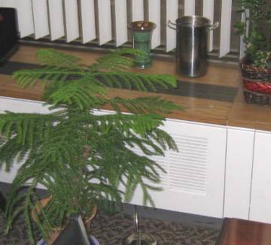

Wall-Mounted Induction Units in Perimeter Offices

Picture 2

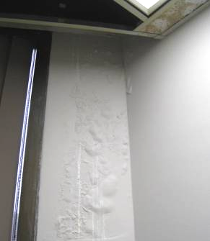

Water-Damaged Ceiling Tiles, Plasterboard, Peeling/Bubbling Paint and
Efflorescence in Exterior Office

Picture 3

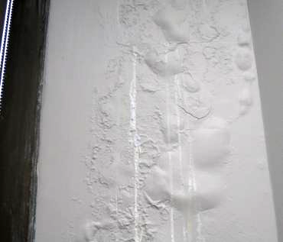

Close-Up of Water-Damaged Plasterboard, Peeling/Bubbling Paint and
Efflorescence in Exterior Office

Picture 4

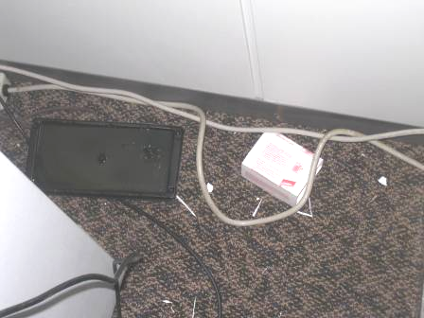

“Sticky” Type Rodent Traps

Picture 5

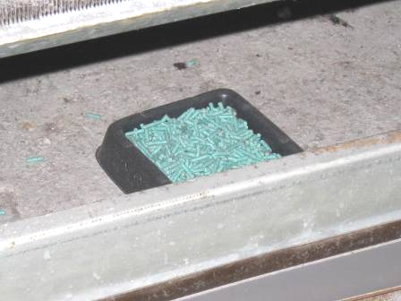

Rodent Bait inside Air Handling Chamber of Induction Unit

Picture 6

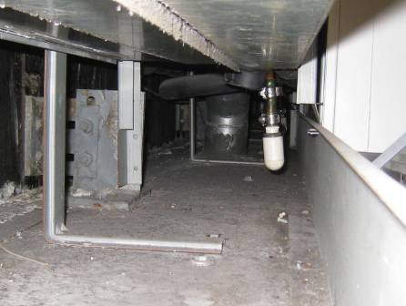

Induction Unit Pipe Chase

Picture 7

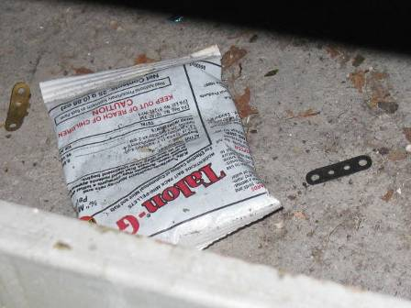

Package of Bait Trap Found in Induction Unit Chase

Picture 8

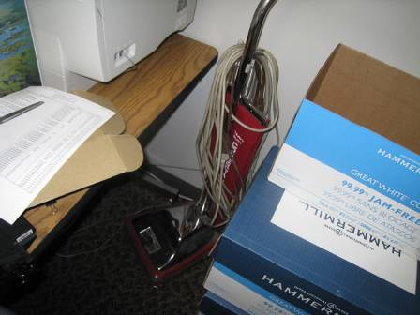

Bag-Type Vacuum Cleaner Observed in the Kitchen

Picture 9

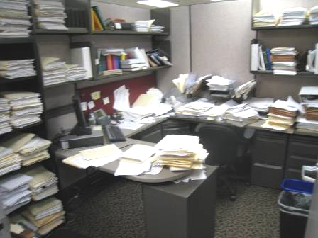

Accumulated Items in Office

Picture 10

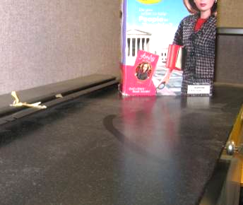

Dust Accumulation on Flat Surfaces

Picture 11

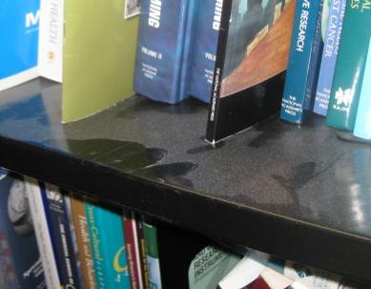

Dust Accumulation on Flat Surfaces
Location | Carbon  Dioxide  (ppm) | Carbon Monoxide  (ppm) | Temp  (°F) | Relative  Humidity  (%) | PM2.5 (ug/m3) | Occupants  in Room | Windows  Openable | Ventilation |  | Remarks
Outside  (Background) | 342 | ND | 43 | 100 | 12 |  |  |  |  | Moderate to heavy rain, winds ESE 14 mph, gusts up to 21 mph
11003 | 543 | ND | 73 | 32 | 4 | 1 | N | Y | Y | Cold complaints
11005 | 537 | ND | 74 | 32 | 3 | 1 | N | Y | Y
11006 | 550 | ND | 74 | 32 | 3 | 1 | N | Y | Y | DO
11008 | 500 | ND | 73 | 32 | 3 | 0 | N | Y | Y | DO
11009 | 456 | ND | 73 | 31 | 3 | 0 | N | Y | Y | DO
11010 | 506 | ND | 71 | 32 | 4 | 0 | N | Y | Y | DO
11011 | 492 | ND | 73 | 32 | 4 | 0 | N | Y | Y | DO, plants
11012 | 480 | ND | 72 | 33 | 3 | 0 | N | Y | Y | DO, plants
11014 | 494 | ND | 73 | 33 | 4 | 0 | N | Y | Y | DO
11015 | 457 | ND | 73 | 33 | 3 | 0 | N | Y | Y | DO
11016 | 462 | ND | 73 | 33 | 3 | 0 | N | Y | Y | Plants, DO
11017 | 486 | ND | 71 | 33 | 3 | 0 | N | Y | Y | DO
11018 | 490 | ND | 72 | 34 | 3 | 2 | N | Y | Y | DO
11020 | 500 | ND | 72 | 36 | 4 | 0 | N | Y | Y
11021 | 506 | ND | 73 | 33 | 3 | 1 | N | Y | Y | DO
11024 | 518 | ND | 73 | 32 | 4 | 0 | N | Y | Y | DO
11025 | 504 | ND | 73 | 32 | 4 | 0 | N | Y | Y | Plants, DO
11027 | 494 | ND | 73 | 32 | 6 | 0 | N | Y | Y
11029 | 529 | ND | 75 | 29 | 2 | 1 | N | Y | Y
11032 | 538 | ND | 73 | 32 | 4 | 1 | N | Y | Y | DO
11034 | 628 | ND | 74 | 31 | 3 | 0 | N | Y | Y | DO
11034 | 505 | ND | 73 | 32 | 3 | 1 | N | Y | Y | DO
11036 | 575 | ND | 74 | 30 | 3 | 1 | N | Y | Y | DO
11037 | 599 | ND | 74 | 31 | 3 | 0 | N | Y | Y | DO
11037-A | 604 | ND | 74 | 30 | 3 | 1 | N | Y | Y | DO
11038 | 584 | ND | 74 | 30 | 3 | 0 | N | Y | Y
11040 | 564 | ND | 73 | 31 | 3 | 1 | N | Y | Y
11041 | 576 | ND | 74 | 32 | 3 | 1 | N | Y | Y | WD CT, MT, WD walls peeling paint, efflorescence, low/dry moisture test
11043 | 497 | ND | 73 | 33 | 4 | 0 | N | Y | Y | WD CT (sprinkler)
11043 | 499 | ND | 75 | 29 | 2 | 0 | N | Y | Y
11044 | 516 | ND | 76 | 29 | 2 | 0 | N | Y | Y
11045 | 504 | ND | 75 | 29 | 2 | 0 | N | Y | Y | Plant
11048 | 503 | ND | 76 | 27 | 2 | 0 | N | Y | Y | DO
11049 | 510 | ND | 74 | 32 | 5 | 0 | N | Y | Y
11052 | 529 | ND | 73 | 32 | 6 | 0 | N | Y | Y | DO, personal fan
11056 | 551 | ND | 73 | 32 | 3 | 1 | N | Y | Y
11056/11088 | 547 | ND | 74 | 31 | 5 | 3 | N | Y | Y | 1 WD CT corner
11057/11059 | 550 | ND | 73 | 32 | 4 | 2 | N | Y | Y
11061/11063 | 538 | ND | 73 | 32 | 3 | 2 | N | Y | Y | Dust accumulation on flat surfaces
11064 | 591 | ND | 74 | 32 | 2 | 2 | N | Y | Y
11068 | 558 | ND | 74 | 31 | 1 | 0 | N | Y | Y
11073-A | 571 | ND | 75 | 31 | 1 | 1 | N | Y | Y
11074 | 614 | ND | 75 | 31 | 2 | 1 | N | Y | Y | DO
11075 | 593 | ND | 75 | 30 | 1 | 0 | N | Y | Y | Plants
11080 | 560 | ND | 74 | 31 | 3 | 0 | N | Y | Y
11083 | 605 | ND | 74 | 31 | 3 | 0 | N | Y | Y | DO
11084 | 562 | ND | 74 | 30 | 3 | 1 | N | Y | Y | DO, WD CT, peeling paint on plaster board walls-dry/low moisture measurement
11093/11095 | 578 | ND | 74 | 31 | 3 | 0 | N | Y | Y | DO
11094/11060 | 553 | ND | 74 | 31 | 4 | 3 | N | Y | Y
11097/11099 | 643 | ND | 74 | 32 | 3 | 2 | N | Y | Y | DO
11101 | 530 | ND | 73 | 32 | 3 | 1 | N | Y | Y | WD/peeling paint
11102 | 529 | ND | 74 | 32 | 3 | 1 | N | Y | Y
11103 | 557 | ND | 73 | 32 | 3 | 1 | N | Y | Y
11104 | 511 | ND | 73 | 32 | 3 | 1 | N | Y | Y
11106/11107 | 544 | ND | 73 | 32 | 4 | 0 | N | Y | Y | Damaged CTs
11112/11113 | 512 | ND | 73 | 32 | 6 | 0 | N | Y | Y
11114/11115 | 527 | ND | 73 | 32 | 5 | 0 | N | Y | Y
11121 | 493 | ND | 72 | 33 | 3 | 1 | N | Y | Y
Office behind Connie’s Desk | 550 | ND | 73 | 33 | 4 | 1 | N | Y | Y | DO
Photocopier Area | 492 | ND | 73 | 33 | 3 | 0 | N | Y | Y | 2 WD CT, 2 photocopiers, DO
Reception | 508 | ND | 73 | 32 | 3 | 1 | N | Y | Y

