INDOOR AIR QUALITY ASSESSMENT
MOLD INVESTIGATION

Executive Office of Health and Human Services
600 Washington Street
Boston, Massachusetts

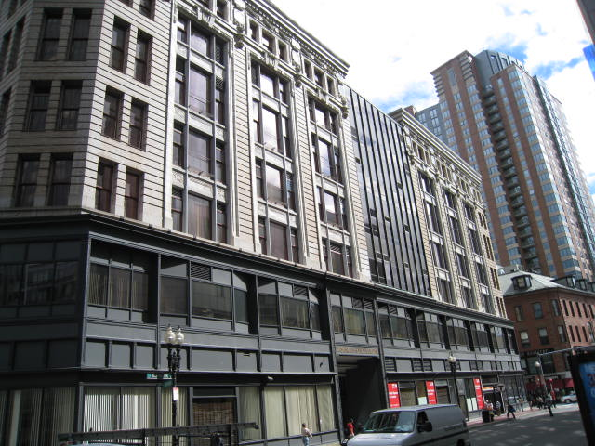

Prepared by:
Massachusetts Department of Public Health
Bureau of Environmental Health
Indoor Air Quality Program
February 2011

Background/Introduction
At the request of Doug Shatkin, Human Resources Director for the Massachusetts Executive Office of Health and Human Services’ (EOHHS) Department of Children and Families (DCF), the Massachusetts Department of Public Health (MDPH), Bureau of Environmental Health (BEH) provided assistance and consultation regarding indoor air quality concerns at the EOHHS office located at 600 Washington Street, Boston, Massachusetts. On September 10, 2010, a visit was made to this building by Mike Feeney, Director, of BEH’s Indoor Air Quality (IAQ) Program. Concerns about mold exposure related to water-damaged ceiling tiles during and after driving rainstorms prompted the request.
The building was constructed originally in a U-shape design. The building was renovated in the 1970s to fill in the open space, which is behind a metal/glass exterior on the front of the building (Picture 1). The area with the water penetration is directly below the metal/glass exterior wall. The building was retrofitted into office space with the installation of an HVAC system above the suspended ceiling. With the exception of the rear of the building, windows in the EOHHS space do not open.

Methods
MDPH staff performed a visual inspection of building materials for water damage and/or microbial growth in the ceiling plenum above the water stained tiles.

Results and Discussion
Ceiling tiles on the second floor beneath the metal/glass exterior wall were examined and found water stained without visible mold growth. Insulation on pipes servicing the air handling units (AHUs) however were found to be mold-contaminated (Picture 2). The source of moisture wetting ceiling tiles is likely penetration beneath a small ledge located above the second floor office (Picture 3). Rainwater impinging on the metal/glass exterior wall runs down this surface, impacts a stone ledge, and then rolls off the ledge onto a metal-on-stone seam (Picture 3). Over time this action may have eroded sealant. Without intact sealant, water can then enter the ceiling plenum causing moistened ceiling tiles. In hot, humid weather, moist air can also enter the ceiling plenum to cause condensation on cold surfaces, such as chilled water pipes and insulation.
The US Environmental Protection Agency (US EPA) and the American Conference of Governmental Industrial Hygienists (ACGIH) recommend that porous materials (e.g., carpeting, gypsum drywall) be dried with fans and heating within 24 to 48 hours of becoming wet (US EPA, 2001; ACGIH, 1989). If not dried within this time frame, mold growth may occur. Once mold has colonized porous materials, they are difficult to clean and should be removed/discarded.

Conclusions/Recommendations
In view of the findings at the time of the visit, the following recommendations are made. These recommendations were communicated at the time of the assessment and are reiterated below:
- Examine the exterior wall assembly above the second floor offices with water damaged ceiling tiles and repair damaged caulking/sealant. Any re-caulking work should be done when the building is not occupied and measures need to be taken to reduce/minimize building occupant exposure to caulking odors.
- Remove water damage insulation in the ceiling above the areas with water damaged ceiling tiles. Reinsulated the chilled water pipes with insulation of an appropriate R rating. Ensure the installation is done in a manner to prevent condensation generation between the pipe and the insulation.
- Replace ceiling tiles as needed.
- Establish communications between all parties involved with remediation efforts to prevent potential IAQ problems. Develop a forum for occupants to express concerns about remediation efforts as well as a program to resolve IAQ issues.
- Develop a notification system for building occupants to report remediation/construction/renovation related odors and /or dust problems to the building administrator. Have these concerns relayed to the contractor in a manner that allows for a timely remediation of the problem.
- When possible, schedule projects which produce large amounts of dusts, odors and emissions during unoccupied periods or periods of low occupancy.
- If possible, relocate susceptible persons and those with pre-existing medical conditions (e.g., hypersensitivity, asthma) away from the general areas of remediation until completion.
- Implement prudent housekeeping and work site practices to minimize exposure to spores. This may include construction barriers, sealing off areas, and temporarily relocating furniture and supplies. To control for dusts, a high efficiency particulate air filter (HEPA) equipped vacuum cleaner is recommended. Non-porous materials should be disinfected with an appropriate antimicrobial agent. Non-porous surfaces should also be cleaned with soap and water after disinfection.

References
ACGIH. 1989. Guidelines for the Assessment of Bioaerosols in the Indoor Environment. American Conference of Governmental Industrial Hygienists, Cincinnati, OH.
US EPA. 2001. Mold Remediation in Schools and Commercial Buildings. US Environmental Protection Agency, Office of Air and Radiation, Indoor Environments Division, Washington, D.C. EPA 402-K-01-001. March 2001.

Picture 1

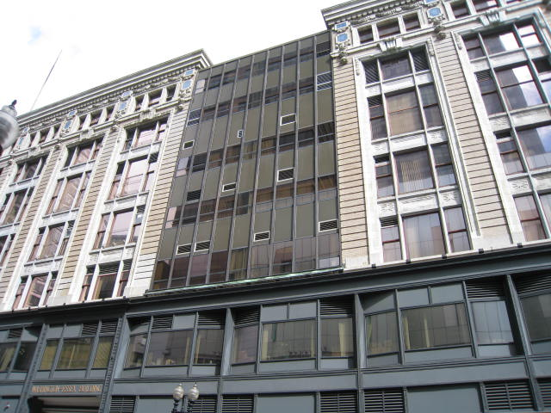

Exterior Metal/Glass Wall Installed above 2nd Floor Offices
Experiencing Water-Damaged Ceiling Tiles

Picture 2

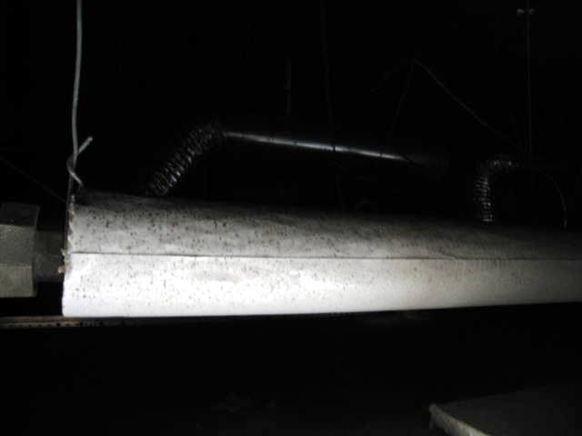

Mold-Contaminated Pipe Insulation above 2nd Floor Ceiling Tiles

Picture 3

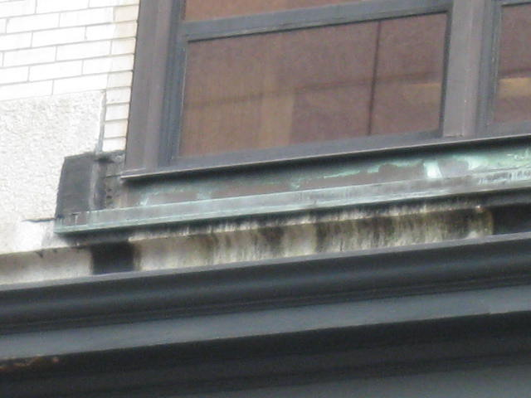

Stone Ledge above 2nd Floor Offices, Note Heavy Water Markings
below Metal-on-Stone Seam

