INDOOR AIR QUALITY ASSESSMENT

Executive Office of Health & Human Services
Service Center
49 Nursery Lane
Fitchburg, Massachusetts

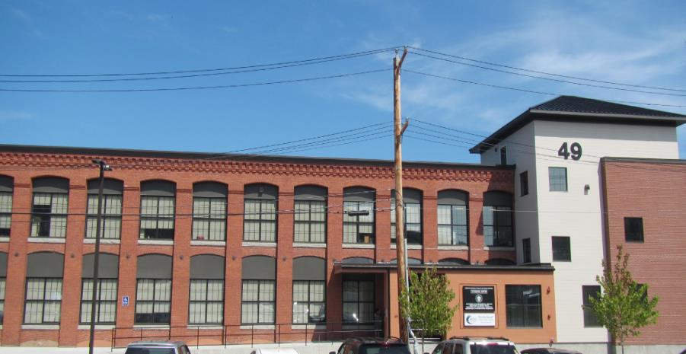

Prepared by:
Massachusetts Department of Public Health
Bureau of Environmental Health
Indoor Air Quality Program
September 2019

Background

Building: | Executive Office of Health & Human Services (EOHHS) Service Center
Address: | 49 Nursery Lane Fitchburg, MA
Project Manager: | John O’Donnell, Director of Engineering and Facility Management, Department of Mental Health (DMH)
Reason for Request: | General Indoor Air Quality (IAQ) concerns
Date of Assessment: | August 1, 2019
Massachusetts Department of Public Health/Bureau of Environmental Health (MDPH/BEH) Staff Conducting Assessment: | Mike Feeney, Director, IAQ Program  Jason Dustin, Environmental Analyst/Inspector, IAQ Program
Building Description: | The EOHHS Center space is located in a large, two-story brick former mill building. The space is composed of private offices, open work areas, and conference rooms. Most areas have carpet tiles or vinyl flooring.
Windows: | Most windows are not openable.

Methods
Please refer to the IAQ Manual for methods, sampling procedures, and interpretation of results (MDPH, 2015).

Results and Discussion
The following is a summary of indoor air testing results (Table 1).
- Carbon dioxide levels were below the MDPH guideline of 800 parts per million (ppm) in all but one area assessed.
- Temperature was within or very close to the MDPH recommended range of 70°F to 78°F but cold temperature complaints in winter and summer have been reported.
- Relative humidity was within the MDPH recommended range of 40% to 60% in all areas. However, extremely low humidity is typical during the heating season in the Northeast and can contribute to eye and respiratory irritation.
- Carbon monoxide levels were non-detectable (ND) in all indoor areas assessed.
- Fine particulate matter (PM2.5) concentrations measured were below the National Ambient Air Quality Standard (NAAQS) level of 35 micrograms per cubic meter (μg/m³) in all occupied areas.

Ventilation
A heating, ventilating, and air conditioning (HVAC) system has several functions. First it provides heating and, if equipped, cooling. Second, it is a source of fresh air. Finally, an HVAC system will dilute and remove normally occurring indoor environmental pollutants by not only introducing fresh air, but by filtering the airstream and ejecting stale air to the outdoors via exhaust ventilation. Even if an HVAC system is operating as designed, point sources of respiratory irritation may exist and cause symptoms in sensitive individuals.
The HVAC system in the EOHHS space consists of large rooftop air handling units (AHUs) that draw in fresh air from intakes on the roof and supply fresh air to supply ducts (Pictures 1 and 2). Return air is brought back to the AHUs through ceiling-mounted return vents (Picture 3).
BEH IAQ staff noted that some HVAC controls appeared to be set to “Fan Auto” instead of the recommended “Fan On” setting. This setting will turn off the supply of fresh air/exhaust ventilation when the thermostat temperature is reached, which can lead to the buildup of commonly found indoor air pollutants. To maximize air exchange, the MDPH recommends that both supply and exhaust ventilation operate continuously during periods of occupancy. In order to have proper ventilation with a mechanical supply and exhaust system, the systems must be balanced to provide an adequate amount of fresh air to the interior of a room while removing stale air from the room. It is recommended that HVAC systems be re-balanced every five years to ensure adequate air systems function (SMACNA, 1994).
The kitchen on the first floor did not appear to have a dedicated local exhaust vent to eject moisture and food odors directly outdoors. As a result, open cubicle areas in some areas were noted to have a burnt food odor dispersed throughout those areas. This condition may increase irritant effects of particulates/odors and also affect occupant comfort and perception of IAQ.

Microbial/Moisture Concerns
BEH IAQ staff noted some water-damaged ceiling tiles on the first floor (Picture 4). This leak was reported to be active and is located at the intersection of the first floor addition and the second floor wall. Building management was reported to be aware of the issue and is actively undertaking repairs to address the leak. Porous building materials (e.g., carpeting, gypsum wallboard, ceiling tiles) that are not dried within 24 to 48 hours of being wet may support mold growth and should be discarded if water-damaged. BEH IAQ staff did not observe any visual signs of mold growth or any musty odors during the assessment.
Plants were noted in some occupied areas (Table 1). Plants can be a source of odors, pollen and mold. Plants should be kept in good condition, not overwatered, and not placed on porous materials.

Other Issues
Hand sanitizers, scented cleaning products, and air fresheners were noted in some areas of the office space. These products can cause irritation of the eyes, nose, and respiratory system of some people.
Most flooring is covered with carpet. The Institute of Inspection, Cleaning and Restoration Certification (IICRC), recommends that carpeting be cleaned annually (or semi-annually in soiled high traffic areas) (IICRC, 2012). Daily vacuuming with a high efficiency particulate arrestance (HEPA)-filtered vacuum is also recommended.
Some occupants reported complaints regarding cold temperatures in the winter as well as during summer months. One area on the first floor adjacent to a concrete block wall corner was of particular concern to occupants (Picture 5). This area appeared to be an addition to the original building and likely does not have adequate insulation. DMH facilities staff reported that they will investigate methods of adding supplemental heating to this area for winter months. Other occupants reported being cold due to being directly in the air stream of supply air diffusers. This situation can overcool an occupant as well as contribute to eye irritation due to the cold, dry air stream with air conditioning. Occupants further reported that the HVAC contractors have been trying to adjust the controls to provide for more comfort in the space. Due to the construction of the former mill building, this task has been difficult.

Conclusions/Recommendations
Based on the observations made during the visit, the following is recommended:
- Operate the HVAC system to provide for continuous fresh air ventilation during occupied hours. Inspect all thermostats/HVAC controls to ensure that they are set for “fan on” instead of the “fan auto” setting.
- Continue efforts to stop the active water leak at the intersection of the first floor DMH roof and second floor wall.
- Monitor any areas of suspected water infiltration and ensure porous building materials are dried within 24-48 hours. Discard any water-damaged porous materials (e.g., ceiling tiles) that have not been properly dried. Refrain from storing porous items in areas of known water infiltration.
- Continue troubleshooting the HVAC controls to adjust temperature settings during summer and winter so that the majority of occupants are comfortable. Add plastic deflectors on supply air diffusers where occupants are located directly in the air stream path.
- Continue to explore supplemental heating options in the DMH corner where most winter temperature complaints have originated.
- Consider installing local exhaust ventilation in the kitchen areas to remove excess humidity, odors, heat, and particulates.
- Continue to change filters for HVAC equipment 2-4 times a year. Use pleated filters of minimum efficiency rating value (MERV) 8 (or higher), which are adequate in filtering out pollen and mold spores (ASHRAE, 2012), if these can be used with current equipment.
- Consider adopting a balancing schedule of every 5 years for all mechanical ventilation systems, as recommended by ventilation industrial standards (SMACNA, 1994).
- Properly maintain plants, including drip pans, to prevent water damage to porous materials. Plants should also be located away from air diffusers to prevent the aerosolization of dirt, pollen, and mold.
- Reduce or eliminate the use of scented cleaners, hand sanitizers, and personal air fresheners.
- Clean carpeting at least once per year according to IICRC recommendations (IICRC 2012). Regularly vacuum carpeting with a HEPA-filtered vacuum cleaner even after construction is completed.
- Refer to resource manuals and other related IAQ documents for further building-wide evaluations and advice on maintaining public buildings. Copies of these materials are located on the MDPH’s website: http://mass.gov/dph/iaq.

References
ASHRAE. 2012. American Society of Heating, Refrigeration and Air Conditioning Engineers (ASHRAE) Standard 52.2-2012 -- Method of Testing General Ventilation Air-Cleaning Devices for Removal Efficiency by Particle Size (ANSI Approved).
IICRC. 2012. Institute of Inspection Cleaning and Restoration Certification. Institute of Inspection, Cleaning and Restoration Certification. Carpet Cleaning: FAQ. Retrieved from https://www.iicrc.org/general/custom.asp?page=SANSIIICRCS100.
MDPH. 2015. Massachusetts Department of Public Health. “Indoor Air Quality Manual: Chapters I-III”. Available at: http://www.mass.gov/eohhs/gov/departments/dph/programs/environmental-health/exposure-topics/iaq/iaq-manual/.
SMACNA. 1994. HVAC Systems Commissioning Manual. 1st ed. Sheet Metal and Air Conditioning Contractors’ National Association, Inc., Chantilly, VA.
Picture 1
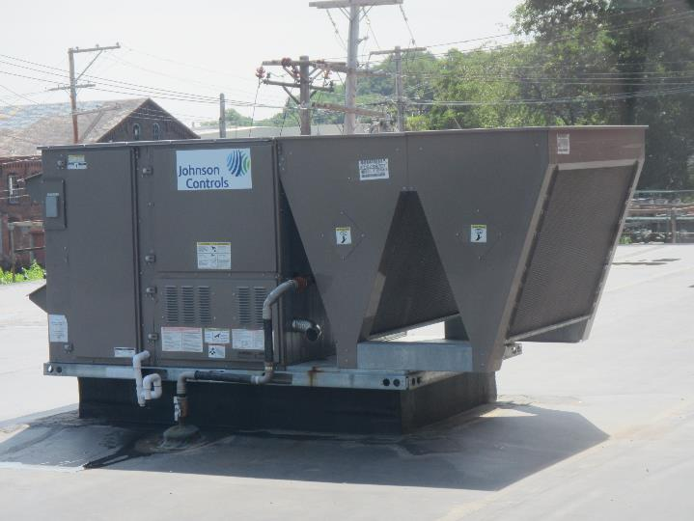
Roof-mounted AHU
Picture 2
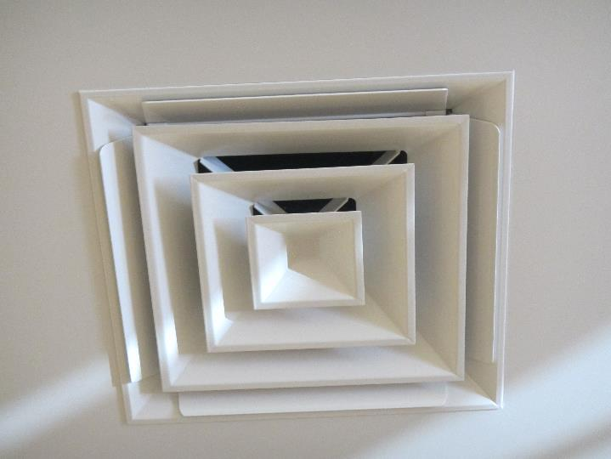
Ceiling-mounted supply air duct
Picture 3
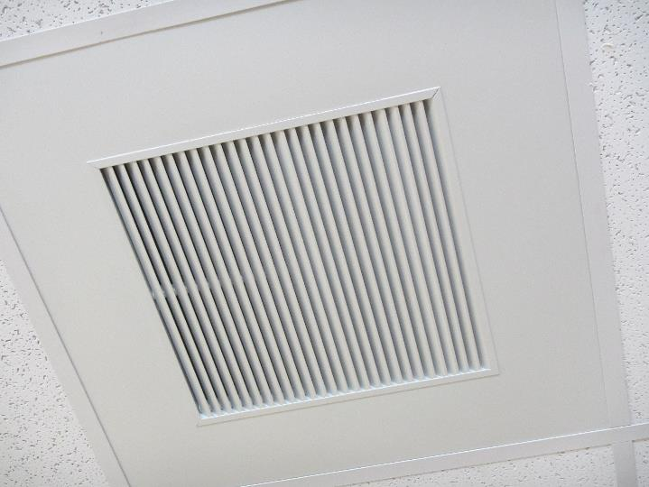
Ceiling-mounted return duct
Picture 4
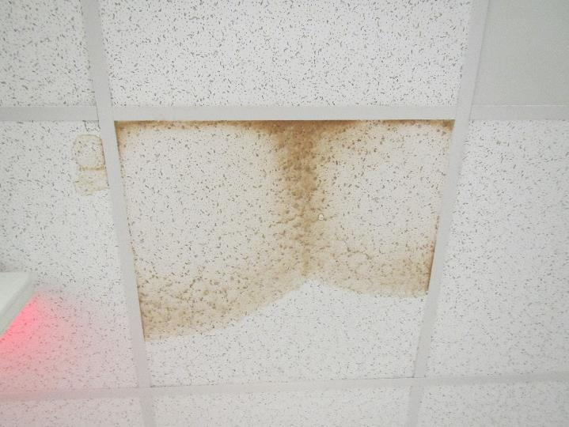
Water-damaged ceiling tiles above DMH space on first floor
Picture 5
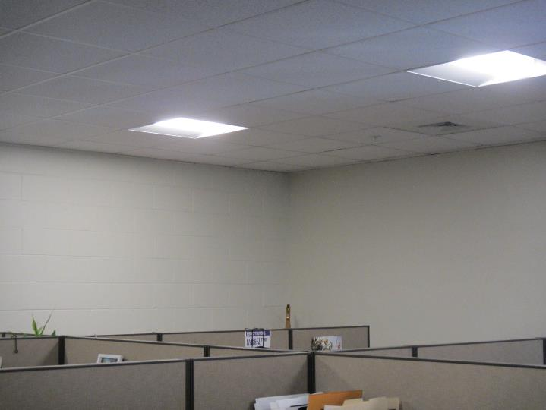
Concrete cinderblock corner with frequent cold complaints

Location | Carbon  Dioxide  (ppm) | Carbon Monoxide  (ppm) | Temp  (°F) | Relative  Humidity  (%) | PM2.5  (µg/m³) | Occupants  in Room | Windows  Openable | Ventilation |  | Remarks
 |  |  |  |  |  |  |  | Supply | Exhaust
Background (outside) | 289 | ND | 80 | 51 | 14 | - | - | - | - | Partly cloudy, light wind
First floor
1103 –OC | 523 | ND | 72 | 58 | 8 | 0 | N | Y | Y | Carpet tile, PF
1106 –OC | 533 | ND | 71 | 59 | 8 | 1 | N | Y | Y | Cinderblock walls, corner cold complaints, HS, CP
1102 –OC | 541 | ND | 72 | 59 | 9 | 1 | N | Y | Y | Near printer
1099 –OC | 533 | ND | 72 | 59 | 9 | 1 | N | Y | Y
1108 | 531 | ND | 71 | 60 | 9 | 0 | N | Y | Y | DEM
1109 | 563 | ND | 71 | 60 | 9 | 0 | N | Y | Y | PF, CPs, DEM, HS
1093 –OC | 581 | ND | 71 | 58 | 9 | 2 | N | Y | Y | WD CTs x 2, active leak, CPs
1091 –OC | 591 | ND | 70 | 57 | 9 | 1 | N | Y | Y
1089 | 601 | ND | 71 | 59 | 10 | 0 | N | Y | Y | AI
1088 | 632 | ND | 71 | 54 | 10 | 3 | N | Y | Y
1087 | 588 | ND | 71 | 55 | 9 | 0 | N | Y | Y | Plant outside door
1114 | 574 | ND | 70 | 57 | 10 | 0 | N | Y | Y | DEM
1120 –OC | 503 | ND | 70 | 55 | 10 | 0 | N | Y | Y | AI, HS
1117 | 501 | ND | 70 | 55 | 10 | 1 | N | Y | Y
1118 | 488 | ND | 69 | 51 | 11 | 0 | N | Y | Y | CP, plant
1119 | 498 | ND | 70 | 52 | 11 | 0 | N | Y | Y | HS, AI, personal heater
1123 | 471 | ND | 69 | 57 | 12 | 0 | N | Y | Y
1129 –OC | 465 | ND | 69 | 53 | 11 | 0 | N | Y | Y
1131 –OC | 458 | ND | 69 | 51 | 11 | 0 | N | Y | Y | Plants
1134 –OC | 463 | ND | 69 | 53 | 12 | 0 | N | Y | Y
1156 –OC | 512 | ND | 69 | 53 | 13 | 0 | N | Y | Y | AI, HS
Inner reception DMH | 723 | ND | 69 | 57 | 12 | 2 | N | Y | Y | CPs
Inner reception DDS | 789 | ND | 70 | 57 | 12 | 3 | N | Y | Y | HS
1086 | 704 | ND | 69 | 56 | 12 | 0 | N | Y | Y
1116 kitchen | 657 | ND | 70 | 57 | 14 | 3 | N | Y | Y | Laminate floor
1086B | 756 | ND | 70 | 55 | 12 | 0 | N | Y | Y
1079 | 711 | ND | 70 | 57 | 14 | 1 | N | Y | Y | HS
1082 | 772 | ND | 71 | 57 | 15 | 0 | N | Y | Y
1085 | 726 | ND | 71 | 57 | 12 | 0 | N | Y | Y | AI
1060 –HW | 748 | ND | 71 | 57 | 13 | 0 | N | Y | Y | HS, fragrances
1078 –OC | 736 | ND | 72 | 57 | 13 | 0 | N | Y | Y
1076 –OC | 784 | ND | 72 | 57 | 14 | 1 | N | Y | Y
1059 –HW | 741 | ND | 72 | 57 | 14 | 0 | N | N | Y
1058 –HW | 798 | ND | 73 | 57 | 13 | 1 | N | Y | Y
1067 | 736 | ND | 73 | 56 | 14 | 0 | N | Y | Y
1069 | 750 | ND | 73 | 56 | 14 | 1 | N | Y | Y
1057 | 731 | ND | 73 | 55 | 15 | 0 | N | Y | Y
1052 | 708 | ND | 73 | 55 | 14 | 0 | N | Y | Y
1066 | 693 | ND | 73 | 55 | 14 | 0 | N | Y | Y | HS
1064 | 692 | ND | 73 | 55 | 13 | 1 | N | Y | Y | AI
1051 –HW | 711 | ND | 73 | 54 | 15 | 0 | N | Y | Y
1050 –HW | 681 | ND | 73 | 54 | 14 | 0 | N | Y | Y
1049 | 653 | ND | 73 | 54 | 14 | 0 | N | Y | Y
1047 | 672 | ND | 74 | 54 | 14 | 1 | N | Y | Y | HS
1046 | 603 | ND | 73 | 53 | 14 | 0 | N | Y | Y
1045 | 641 | ND | 73 | 53 | 14 | 0 | N | Y | Y | Conference, DEM
1043 –HW | 618 | ND | 73 | 54 | 15 | 0 | N | Y | Y
1042 –OC | 630 | ND | 73 | 54 | 14 | 1 | N | Y | Y
1037 –OC | 628 | ND | 73 | 54 | 13 | 0 | N | Y | Y
1038 –OC | 648 | ND | 73 | 55 | 14 | 1 | N | Y | Y | Burnt food odor
1031 –OC | 637 | ND | 73 | 54 | 15 | 1 | N | Y | Y | Burnt food odor
1034 –OC | 648 | ND | 73 | 54 | 14 | 0 | N | Y | Y | Burnt food odor
1029 –OC | 631 | ND | 73 | 54 | 15 | 0 | N | Y | Y
1026 –OC | 628 | ND | 73 | 54 | 15 | 0 | N | Y | Y
1023 Kitchen | 738 | ND | 74 | 56 | 18 | 5 | N | Y | Y
1145 | 687 | ND | 73 | 49 | 13 | 1 | N | Y | Y | Laminate flooring
1146 | 673 | ND | 73 | 49 | 12 | 0 | N | Y | Y | Laminate flooring
1147 | 678 | ND | 73 | 49 | 12 | 0 | N | Y | Y | Laminate flooring
Second Floor
2032 | 732 | ND | 72 | 45 | 7 | 0 | Y | Y | Y | Plant
2134 | 696 | ND | 72 | 45 | 8 | 0 | Y | Y | Y
2038 | 670 | ND | 72 | 45 | 7 | 0 | Y | Y | Y
2029 | 718 | ND | 72 | 45 | 9 | 0 | Y | Y | Y
2031 | 694 | ND | 71 | 45 | 8 | 0 | N | Y | Y
2044 | 679 | ND | 72 | 45 | 8 | 0 | Y | Y | Y
2046 | 677 | ND | 72 | 45 | 8 | 1 | Y | Y | Y
2047 | 662 | ND | 73 | 45 | 8 | 0 | Y | Y | Y | Plant
2049 | 686 | ND | 73 | 45 | 8 | 0 | Y | Y | Y
2043 | 683 | ND | 73 | 45 | 8 | 0 | Y | Y | Y
2025 | 668 | ND | 73 | 44 | 8 | 1 | Y | Y | Y
2027 | 668 | ND | 73 | 44 | 8 | 0 | Y | Y | Y
2022 | 695 | ND | 73 | 44 | 8 | 1 | Y | Y | Y
2024 | 698 | ND | 73 | 44 | 8 | 1 | Y | Y | Y | Plants
2018 | 697 | ND | 73 | 44 | 8 | 2 | N | Y | Y
2019 | 678 | ND | 72 | 44 | 8 | 0 | N | Y | Y
2010 | 700 | ND | 72 | 45 | 9 | 1 | Y | Y | Y | Plants
2007 | 696 | ND | 72 | 45 | 9 | 0 | Y | Y | Y
2008 | 683 | ND | 72 | 45 | 11 | 1 | Y | Y | Y | Plants
2004 | 692 | ND | 73 | 45 | 11 | 1 | Y | Y | Y | Plants
2003 | 693 | ND | 72 | 45 | 12 | 0 | Y | Y | Y
2002 | 682 | ND | 72 | 44 | 10 | 0 | Y | Y | Y
2001 | 662 | ND | 73 | 43 | 9 | 0 | Y | Y | Y | Plants
2000 | 672 | ND | 72 | 43 | 9 | 1 | Y | Y | Y | Plants
2020 | 1120 | ND | 72 | 47 | 9 | 6 | N | Y | Y
2016 | 679 | ND | 72 | 44 | 9 | 0 | N | Y | Y

