**INDOOR AIR QUALITY ASSESSMENT**

**Executive Office of Labor and Workforce Development**

**One Winter Street 4th floor**

**Boston, Massachusetts**

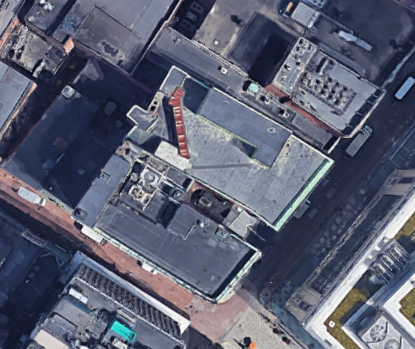

Prepared by:

Massachusetts Department of Public Health

Bureau of Climate and Environmental Health

Indoor Air Quality Program

July 2024

# BACKGROUND

|  |  |
| --- | --- |
| Building: | Executive Office of Labor and Workforce Development (EOL) |
| Address: | One Winter Street, 4th floor, Boston |
| Assessment Requested by: | John D. Thomas, Director of Facilities,  Executive Office of Labor and Workforce Development |
| Reason for Request: | Post-occupancy indoor air quality (IAQ) assessment |
| Date of Assessment: | July 9, 2024 |
| Massachusetts Department of Public Health/Bureau of Environmental Health (MDPH/BEH) Staff Conducting Assessment: | Ruth Alfasso, Environmental  Engineer/Inspector, IAQ Program |
| Building Description: | One Winter Street is a 10-floor office building in Downtown Crossing, Boston. The lowest level of the building is retail and restaurant space. |
| Windows: | Windows are not openable |

# METHODS

Please refer to the IAQ Manual for methods, sampling procedures, and interpretation of results (MDPH, 2015).

Note that this building has been visited by the IAQ program in the past. Reports for other areas of the building can be found at <https://www.mass.gov/info-details/indoor-air-quality-reports-cities-and-towns-b#boston->.

# RESULTS AND DISCUSSION

The following is a summary of indoor air testing results (Table 1).

* ***Carbon dioxide*** measurements were below the MDPH guideline of 800 parts per million (ppm) in all areas tested.
* ***Temperature*** was within the recommended range of 70°F to 78°F in all areas.
* ***Relative humidity*** was slightly above the recommended range of 40% to 60% in many areas, which is reflective of hot, humid outdoor conditions.
* ***Carbon monoxide*** levels were non-detectable (ND) in all areas tested.
* ***Fine particulate matter (PM2.5)*** concentrations were below the National Ambient Air Quality Standard (NAAQS) level of 35 μg/m3 in all areas tested.
* ***Total Volatile Organic Compounds***were ND in all areas tested.

## Ventilation

A heating, ventilating, and air conditioning (HVAC) system has several functions. First, it provides heating and, if equipped, cooling. Second, it is a source of fresh air. Finally, an HVAC system will dilute and remove normally occurring indoor environmental pollutants by not only introducing fresh air, but also filtering the airstream and ejecting stale air to the outdoors via exhaust ventilation. Even if an HVAC system is operating as designed, point sources of respiratory irritation may exist and affect symptoms in sensitive individuals.

Fresh air is provided by air handling units (AHUs) on the roof. Air from the AHUs is filtered, heated/cooled, and delivered to rooms via ducted supply vents (Picture 1). Air is drawn through exhaust grills into the ceiling plenum and returned to the AHUs (Picture 1).

The ventilation system should be on and operating to supply fresh air continuously during occupied periods. Without adequate fresh air supply and removal of stale air, common indoor air pollutants can build up and cause irritation.

HVAC functions are computer controlled at a central location. Temperature sensors are present in occupied areas (Picture 2), but they have no user-adjustable features. It is recommended that the system should be set so the fan is on continuously during occupied periods to supply continuous fresh air. Thermostat settings should include setbacks for times when the space is unoccupied.

It is recommended that HVAC systems be re-balanced every five years to ensure adequate air systems function (SMACNA, 1994). It is not known if the systems were balanced recently.

Sunlight was noted streaming in from windows in a few areas (Table 1). This can lead to temperature complaints and concerns about glare. Adjustable blinds are present which can be used to block sunlight and reduce comfort impacts and should be used as needed.

## Microbial/Moisture Concerns

Plants were noted in a few areas (Table 1), including some that were placed on porous materials. Plants should be well maintained and placed on waterproof drip pans to contain any spills and protect building materials. Porous materials can grow mold, particularly if wetted repeatedly.

Water dispensers were observed on carpet in several areas (Picture 3). Spills or leaks from these appliances can damage carpeting and lead to microbial growth and odors. Refrigerators in break rooms and other areas should be cleaned regularly (Picture 4 shows a sign indicating weekly cleaning) to prevent odors caused by spills and spoiled food. Food preparation equipment such as microwaves and toasters should also be cleaned regularly. All food should be stored in pest-proof containers.

During the pre-occupancy assessment, a shower was noted in the men’s restroom. This shower is not used by EOL staff. Facility maintenance staff report that water is poured into this drain periodically to prevent the drain trap from drying out.

In a few rooms, the ceiling tiles were slightly sagging or bowed in the ceiling tile grid (Picture 1). This is often a sign that ceiling tiles have been exposed to high humidity for a long period of time. If occupants report uncomfortable humidity, or if signs of condensation, such as droplets of water on supply vents occur, HVAC settings should be adjusted. Helpful adjustments to reduce humidity include temporarily reducing the amount of fresh air into the system during very humid weather, or increasing the setpoint temperature a few degrees, which will reduce relative humidity.

## Other IAQ Concerns

Testing was conducted for total volatile organic compounds (TVOCs). All measurements were non-detect (ND). An examination was conducted for products that may be a source of VOCs in indoor air. Products such as dry erase markers and hand sanitizers were noted (Table 1). VOCs from these products can build up and lead to irritation of the mucous membranes or irritating odors.

As mentioned above, most areas of this office are carpeted. Carpets should be cleaned regularly in accordance with Institute of Inspection, Cleaning and Restoration Certification (IICRC) recommendations (IICRC, 2012).

# CONCLUSIONS/RECOMMENDATIONS

The following are recommendations made to maintain IAQ:

## Ventilation recommendations

1. If the HVAC system in the EOL space has not been balanced as a part of the renovations, consider balancing the system.
2. Operate supply and exhaust ventilation in all areas during occupied periods.
3. Work with facility staff to address temperature/comfort issues if they occur, and make appropriate adjustments to the thermostat settings.
4. Ensure filters are replaced on HVAC units at least twice a year. Use filters with a minimum efficiency rating value (MERV) of 8 or better.
5. Use adjustable blinds to control heating and glare due to sunlight.
6. It is recommended that HVAC systems be re-balanced every five years to ensure adequate air systems function (SMACNA, 1994).

## Water damage recommendations

1. Maintain indoor plants and place them on waterproof drip pans that are cleaned periodically.
2. Consider moving water dispensers to areas without carpeting or use a waterproof mat underneath.
3. Keep refrigerators and other food-preparation appliances clean.
4. If uncomfortable humidity or condensation occurs, adjust the HVAC system to reduce humidity during periods of high outdoor humidity.
5. For buildings in New England, periods of low relative humidity during the winter are often unavoidable. Therefore, scrupulous cleaning practices should be adopted to minimize common indoor air contaminants whose irritant effects can be enhanced when the relative humidity is low. To control dust, a high efficiency particulate arrestance (HEPA) filter equipped vacuum cleaner in conjunction with wet wiping of all surfaces is recommended. Avoid the use of feather dusters. Drinking water during the day can help ease some symptoms associated with a dry environment (throat and sinus irritations).

## Other recommendations

1. Use VOC-containing products in areas with good ventilation and keep tightly closed when not in use. Avoid products with strong scents and avoid mixing incompatible products.
2. Clean carpeting in accordance with IICRC recommendations (IICRC, 2012).
3. Refer to resource manual and other related IAQ documents located on the MDPH’s website for further building-wide evaluations and advice on maintaining public buildings. These documents are available at: <http://mass.gov/dph/iaq>.

# REFERENCES

IICRC. 2012. Institute of Inspection, Cleaning and Restoration Certification. Carpet Cleaning: FAQ.

MDPH. 2015. Massachusetts Department of Public Health. Indoor Air Quality Manual: Chapters I-III. Available at: <https://www.mass.gov/lists/indoor-air-quality-manual-and-appendices>.

SMACNA. 1994. HVAC Systems Commissioning Manual. 1st ed. Sheet Metal and Air Conditioning Contractors’ National Association, Inc., Chantilly, VA.

**Picture 1**

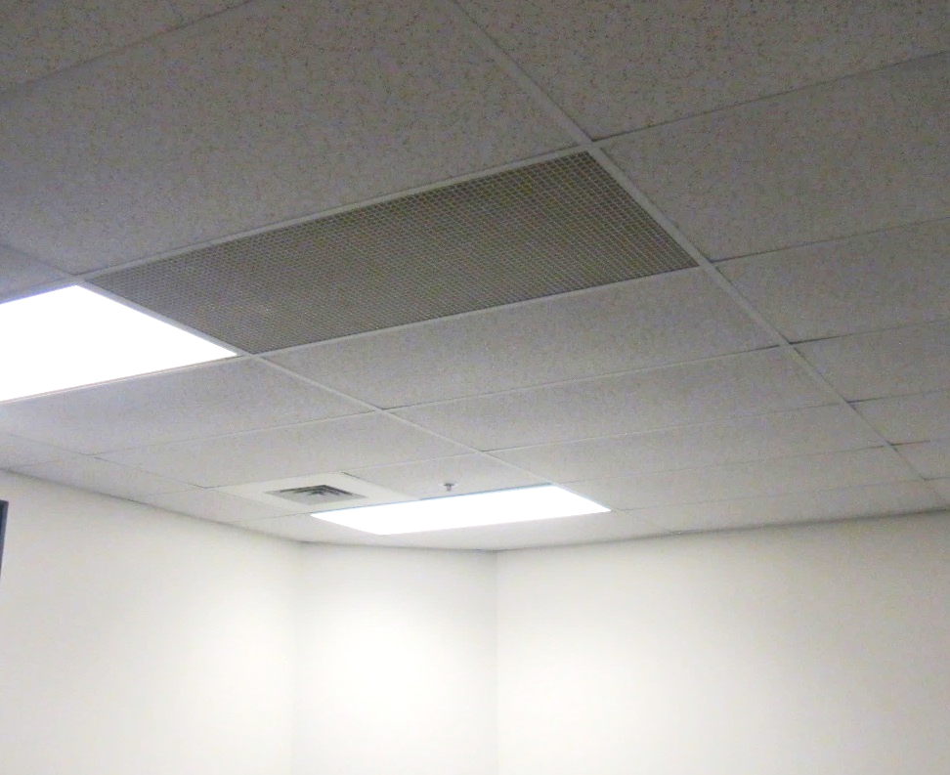

**Supply vent (rear corner) and return vent, note slightly bowed ceiling tiles**

**Picture 2**

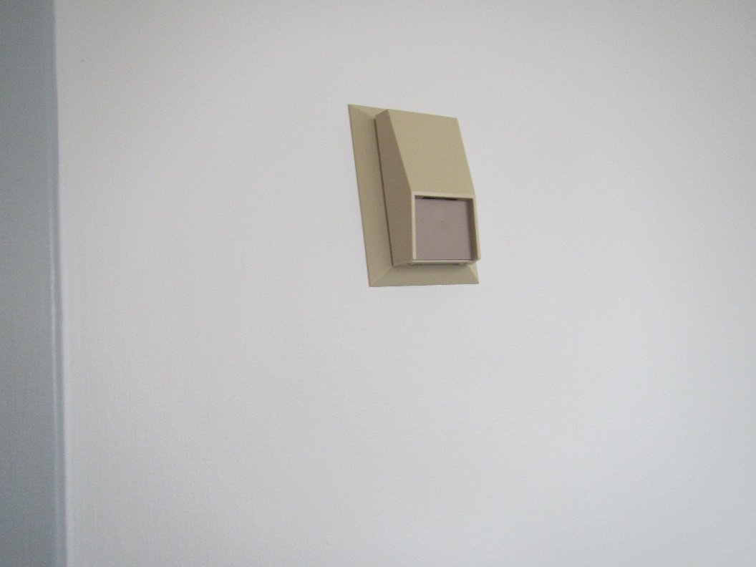

**Thermostat sensor with no user-accessible settings**

**Picture 3**

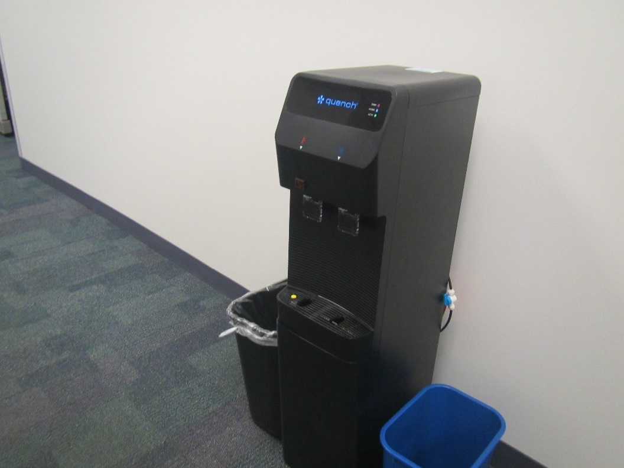

**Water dispenser on carpet**

**Picture 4**

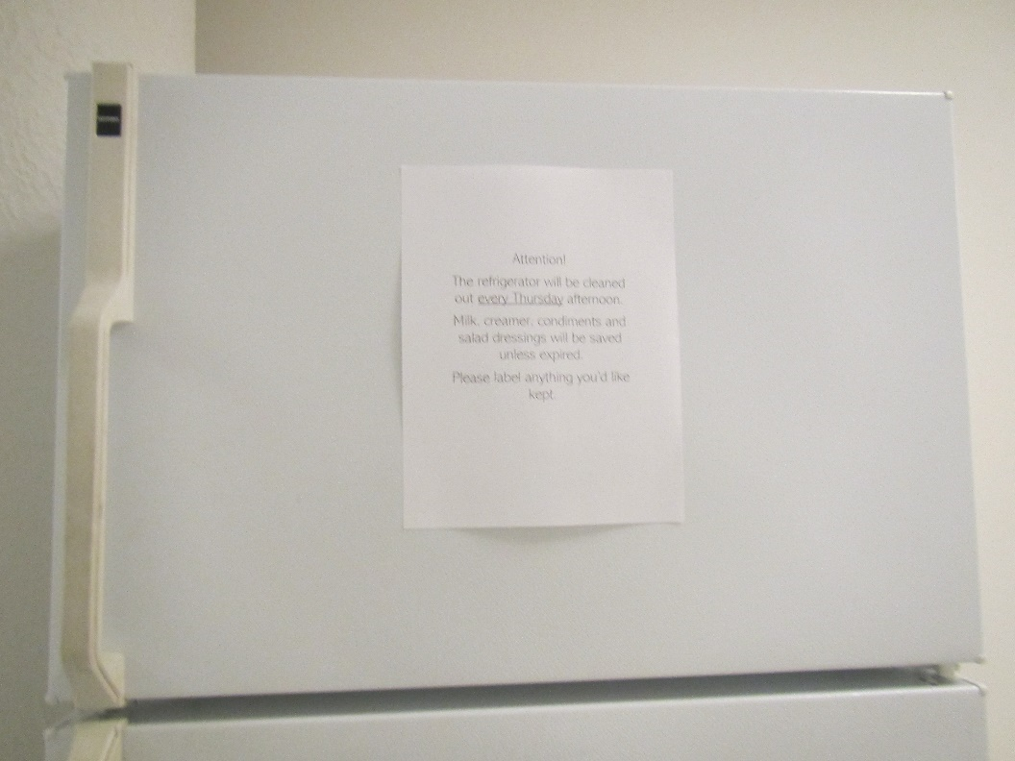

**Sign on refrigerator indicating weekly cleaning**

| **Location** | **Carbon**  **Dioxide**  **(ppm)** | **Carbon Monoxide**  **(ppm)** | **Temp**  **(°F)** | **Relative**  **Humidity**  **(%)** | **PM2.5**  **(µg/m3)** | **TVOC**  **(ppm)** | **Occupants**  **in Room** | **Windows**  **Openable** | **Ventilation** | | **Remarks** |
| --- | --- | --- | --- | --- | --- | --- | --- | --- | --- | --- | --- |
| **Supply** | **Exhaust** |
| Background | 345 | ND | 84 | 63 | 20 | ND |  |  |  |  | Warm and humid, measurement taken at street level |
| 4106 conference room | 558 | ND | 77 | 55 | 4 | ND | 0 | N | Y | Y |  |
| 4107 | 596 | ND | 75 | 60 | 6 | ND | 0 | N | Y | Y |  |
| Amoakuh office | 655 | ND | 75 | 59 | 5 | ND | 1 just left | N | Y | N |  |
| Wishart office | 650 | ND | 75 | 59 | 5 | ND | 1 | N | Y | N |  |
| 4110 | 636 | ND | 75 | 59 | 7 | ND | 0 | N | Y | N |  |
| 4111 | 630 | ND | 75 | 59 | 7 | ND | 0 | N | Y | Y |  |
| 4112 | 584 | ND | 74 | 59 | 6 | ND | 0 | N | Y | Y | Sunlight |
| 4113 | 573 | ND | 75 | 60 | 8 | ND | 0 | N | Y | Y | Ajar tile |
| 4114 | 601 | ND | 75 | 60 | 8 | ND | 1 | N | Y | Y | Sunlight |
| 4116 | 627 | ND | 75 | 59 | 7 | ND | 0 | N | Y | Y |  |
| Cube area near 4116 | 610 | ND | 75 | 59 | 6 | ND | 0 | N | Y | Y |  |
| 4116 conference room | 540 | ND | 71 | 64 | 9 | ND | 0 | N | Y | Y | NC |
| 4120 | 620 | ND | 74 | 61 | 5 | ND | 1 | N | Y | Y | Computer training room, slightly bowed ceiling tiles |
| Refrigerator room | 641 | ND | 74 | 61 | 5 | ND | 0 | N | Y | Y | NC |
| 4123 kitchen area | 633 | ND | 74 | 61 | 9 | ND | 0 | N | Y | N | Kitchen area, microwaves, food |
| Cubes near kitchen | 638 | ND | 73 | 62 | 5 | ND | 2 | N | Y | Y | Dry erase markers |
| Cubes near 4132 | 617 | ND | 72 | 61 | 3 | ND | 1 | N | Y | Y |  |
| 4132 | 593 | ND | 73 | 61 | 4 | ND | 1 | N | Y | Y | Food and items |
| Cubes | 588 | ND | 72 | 62 | 3 | ND | 1 | N | Y | Y |  |
| Cube conference area | 572 | ND | 72 | 62 | 6 | ND | 0 | N | Y | Y | Water cooler on carpet |
| Cubes | 594 | ND | 72 | 64 | 5 | ND | 5 | N | Y | Y |  |
| Cube alley area | 604 | ND | 71 | 65 | 4 | ND | 4 | N | Y | Y | Fan, plant, items |
| 4139 | 565 | ND | 70 | 65 | 6 | ND | 0 | N | Y | N |  |
| 4148 | 540 | ND | 73 | 62 | 5 | ND | 0 | N | Y | Y | NC |