WATER DAMAGE ASSESSMENT

Executive Office of Public Safety
One Ashburton Place, 21st floor
Boston, MA

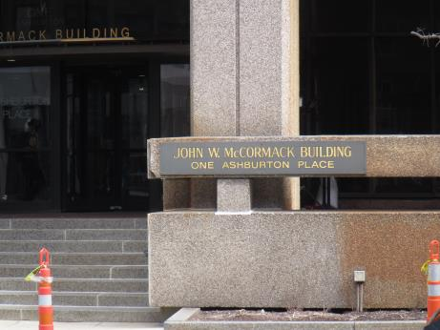

Prepared by:
Massachusetts Department of Public Health
Bureau of Environmental Health
Indoor Air Quality Program
August 2021

Background
Building: | Executive Office of Public Safety (EOPS), south wall offices
Address: | One Ashburton Place, 21st floor
Assessment Requested by: | Christine A. Escott, Facility Manager, Division of Capital Asset Management & Maintenance, Office of Facilities Management & Maintenance
Reason for Request: | Water damage concerns
Date of Assessment: | July 22, 2021
Massachusetts Department of Public Health/Bureau of Environmental Health (MDPH/BEH) Staff Conducting Assessment: | Michael Feeney, Director, Indoor Air Quality (IAQ) Program
Building Description: | One Ashburton Place, also known as The McCormack Building, is a large state office building constructed in the 1970s.
Windows: | Not openable

Methods
To determine the extent and likelihood of future water damage to building components, several parameters were measured. Moisture content of cement flooring beneath carpet tile and furniture was measured using a moisture meter. To determine if a location inside a building may be prone to moistening from condensation during weather extremes, air testing of temperature and relative humidity was done with a TSI Q-Trak set to calculate dew point. Surface temperature testing of building surfaces and equipment was performed using a laser thermometer. Surface temperature of floors was measured in each corner, center of the area, and any area demonstrating possible moisture damage/staining. In addition, building components directly in the airflow from the heating, ventilating, and air conditioning (HVAC) system, visibly wet, or showing rust or water staining were measured for surface temperature.
For additional information on sampling procedures, methods and interpretation of results, please refer to the IAQ Manual (MDPH, 2015).
This building has been visited previously by the IAQ program. Reports from those visits are available on the MDPH website at: https://www.mass.gov/info-details/indoor-air-quality-reports-cities-and-towns-b or on request.

IAQ Testing Results
The following is a summary of testing results (Table 1):
- Temperature was within the MDPH recommended range of 70°F to 78°F in areas tested.
- Relative Humidity was within the MDPH recommended range of 40 to 60% in the areas tested.
- Carpet tiles, floors, suspended ceilings, windows and adjacent structures containing HVAC equipment were examined and tested for moisture along the south/southwest section of the 21st floor. Cement and carpet tile in some areas were shown to be wet.

Ventilation
A HVAC system has several functions. First it provides heating and, if equipped, cooling. Second, it is a source of fresh air. Finally, an HVAC system will dilute and remove normally-occurring indoor environmental pollutants by not only introducing fresh air, but by filtering the airstream and ejecting stale air to the outdoors via exhaust ventilation. Even if an HVAC system is operating as designed, point sources of respiratory irritation may exist and cause symptoms in sensitive individuals.
Fresh air is supplied by induction units located along the outer edges of the building under windows (Picture 1), and supply vents located in the ceiling. Return air is drawn through ceiling-mounted grates. Since the offices in question were unoccupied at the time of the visit, no air testing for carbon dioxide and other parameters was conducted.

Microbial/Moisture Concerns
During a heavy rainstorm, a roof leak resulted in water entering offices along the west wall on the 21st floor, resulting in wetting of ceiling tiles, carpet tiles and materials on the floor. As reported by both office and facilities staff, efforts to dry building components began within 24 hours after the water leak began. As described by facilities staff, remediation methods were consistent with US EPA water damage restoration guidelines. In general, the US Environmental Protection Agency (US EPA) and the American Conference of Governmental Industrial Hygienists (ACGIH) recommends that porous materials (e.g., gypsum wallboard, ceiling tiles, carpeting) be dried with fans and heating within 24 to 48 hours of becoming wet (US EPA, 2008; ACGIH, 1989). If porous materials are not dried within this time frame, mold growth may occur.
At the time of assessment, no areas examined had any observable standing water or musty odors. No signs of water damage were found on furniture in the affected offices. The floor covering in the affected offices is carpet tile, which is a waterproof material with carpet loop pile on one side. Each carpet tile is installed with adhesive in a manner similar to floor tile.
To determine if water had travelled beneath carpet tile, moisture sampling was conducted in several locations in each of the offices affected by the water leak, as well as a location in the center of the office not impacted by the leak, as a control measurement. Sampling indicated that increased levels of moisture existed in the cement floor beneath carpet tile of water-impacted offices when compared to the control location. IAQ staff was able to lift carpet tile by hand from the floor that was adjacent to the exterior wall below the leak in the SW office (Picture 2), indicating the water had penetrated between the cement floor/carpet tile seam to affect the adhesive (Picture 3).
Based on this finding, IAQ staff recommended that carpet tile in each office be checked. It is important to note that neither carpet tile nor the cement floor had musty/mold odors once the carpet tile was removed.
Cabinets containing the induction units along the exterior walls were also examined. IAQ staff could not examine the entire cabinet to ascertain conditions, however, it is important to note that all areas examined were free of musty or other water-damage-related odors. No floor had a surface temperature below the dew point, indicating that the offices are not subject to possible moistening by condensation during hot, humid weather.

Conclusions/Recommendations
Based on observations at the time of assessment, the following is recommended:
- Continue with efforts to repair roof leaks.
- Examine carpet tile along walls in leak-affected offices to ascertain if tile can be readily removed by hand. If tiles can be removed, consider leaving cement floor bare for several days to allow for drying. Reinstall carpet tile in a manner consistent with manufacturer’s recommendations.
- Until leaks have been permanently repaired, avoid storage of materials that can support mold growth, particularly cardboard and paper, on the floor or windowsills in these locations. In addition, consider temporally elevating hardwood furniture on waterproof pads (or similar materials).
- Examine the interior of induction unit cabinets beneath windowsills for water damage and clean as needed.
- Continue to operate supply and exhaust ventilation continuously in all areas during occupied periods. Ensure all HVAC equipment is cleaned/maintained in accordance with manufacturer’s instructions.
- Regularly clean induction units to reduce accumulated debris.
- Replace water-damaged ceiling tiles.
- Refer to resource manual and other related IAQ documents located on the MDPH’s website for further building-wide evaluations and advice on maintaining public buildings. These documents are available at: http://mass.gov/dph/iaq.

References
ACGIH. 1989. Guidelines for the Assessment of Bioaerosols in the Indoor Environment. American Conference of Governmental Industrial Hygienists, Cincinnati, OH.
MDPH. 2015. Massachusetts Department of Public Health. Indoor Air Quality Manual: Chapters I-III. Available at: Indoor air quality - manual and appendices | Mass.gov.
US EPA. 2008. “Mold Remediation in Schools and Commercial Buildings”. Office of Air and Radiation, Indoor Environments Division, Washington, DC. EPA 402-K-01-001. September 2008. Available at: http://www.epa.gov/mold/mold-remediation-schools-and-commercial-buildings-guide.

Picture 1
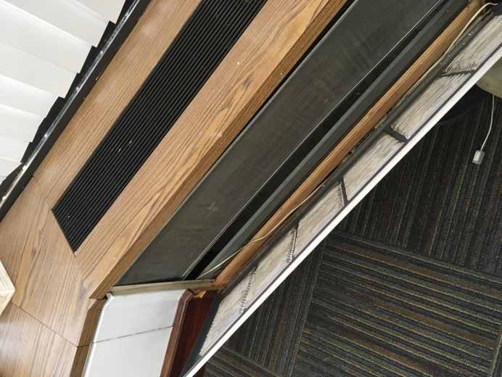
Induction unit within a cabinet beneath windowsill
Picture 2
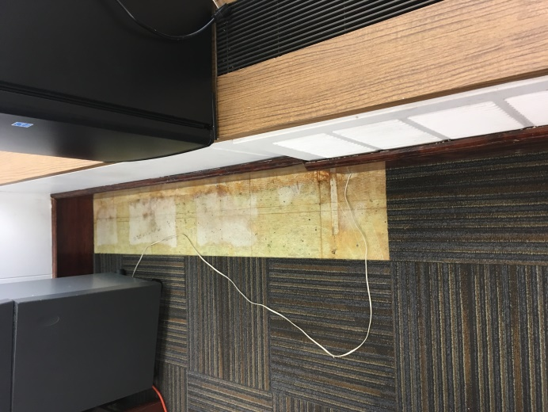
Carpet tile removed by hand, note location next to induction unit cabinet
Picture 3
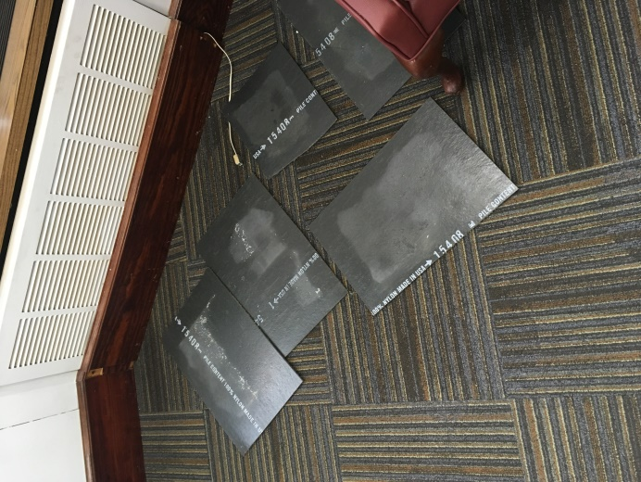
Carpet tile removed from floor, note moisture on tile surface

Location | Air Temp  (ºF) | Relative Humidity  (%) | Dew Point  (ºF) | Floor Temp  (ºF) | Water Damaged/Missing Ceiling Tiles  (#) | Moisture in carpet tile/ cement  (%) | Ventilation |  |  | Air to Floor Temp  Difference  (ºF) | Comments
 |  |  |  |  |  |  | Windows openable | Supply | Exhaust
Background (outdoors) | 79 | 45 | 56 | 64
SW corner office | 72 | 48 | 52 | 65 | 2/3 | 32-48 | N | Y | Y | 7
S office | 72 | 47 | 51 | 64 | 2 | 8-33 | N | Y | Y | 8
S office | 71 | 48 | 51 | 64 | 1 | 26-41 | N | Y | Y | 7
SE corner office | 72 | 50 | 52 | 64 |  | 26-40 | N | Y | Y | 8
Central cubicle near entrance | 72 | 48 | 51 | 64 |  | 22-25 | N | Y | Y | 8

