WATER DAMAGE ASSESSMENT

Executive Office of Technology Services and Security
One Ashburton Place, 8th floor
Boston, MA

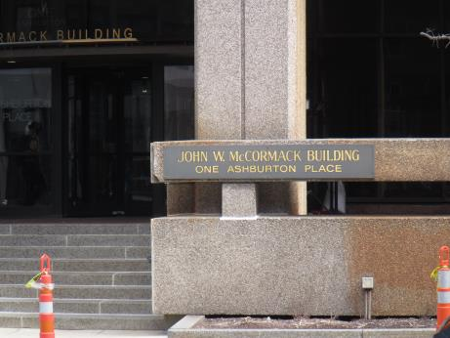

Prepared by:
Massachusetts Department of Public Health
Bureau of Environmental Health
Indoor Air Quality Program
August 2021

Background
Building: | Executive Office of Technology Services and Security offices
Address: | One Ashburton Place, 8th floor
Assessment Requested by: | Christine A. Escott, Facility Manager, Division of Capital Asset Management & Maintenance, Office of Facilities Management & Maintenance, One Ashburton Place, Room 107, Boston, MA 02108
Reason for Request: | Water damage concerns
Date of Assessment: | August 6, 2021
Massachusetts Department of Public Health/Bureau of Environmental Health (MDPH/BEH) Staff Conducting Assessment: | Ruth Alfasso, Environmental Engineer, IAQ Program
Building Description: | One Ashburton Place, also known as The McCormack Building, is a large state office building constructed in the 1970s.
Windows: | Not openable

Methods
Please refer to the IAQ Manual for methods, sampling procedures, and interpretation of results (MDPH, 2015). The moisture content of building materials was tested using a moisture meter, and visual observations were made of water damage and related conditions.
This building has been visited previously by the IAQ program. Reports from those visits are available on the MDPH website at: https://www.mass.gov/info-details/indoor-air-quality-reports-cities-and-towns-b or on request.

IAQ Testing Results
The following is a summary of testing results (Table 1):
- Wallboard adjacent to windows was wet in most of the offices/areas examined.

Ventilation
A heating, ventilating, and air conditioning (HVAC) system has several functions. First it provides heating and, if equipped, cooling. Second, it is a source of fresh air. Finally, an HVAC system will dilute and remove normally-occurring indoor environmental pollutants by not only introducing fresh air, but by filtering the airstream and ejecting stale air to the outdoors via exhaust ventilation. Even if an HVAC system is operating as designed, point sources of respiratory irritation may exist and cause symptoms in sensitive individuals.
Fresh air is supplied by induction units located along the outer edges of the building under the windows (Picture 1), and supply vents located in the ceiling. Return air is drawn through ceiling-mounted grates. Since the offices in question were unoccupied at the time of the visit, no air testing for carbon dioxide and other parameters was conducted.

Microbial/Moisture Concerns
The reason for this assessment is water damage that has been occurring during rain events. Heavy wind-driven rain can infiltrate through gaps around windows and moisten building materials adjacent to and below the windows (Picture 2). The walls in most of the offices examined were shown, via moisture meter readings, to be wet. In some cases, the walls showed signs of previously being wet (e.g., wrinkled paint, Picture 3) but were measured to be dry. Water-damaged ceiling tiles were observed adjacent to windows in many offices as well (Table 1; Picture 4). Water-damaged ceiling tiles should be replaced when discovered.
While materials were wet at the time of the visit, and have probably been repeatedly exposed to moisture, no mold colonization or moldy odors were observed in any of the areas examined. Walls in this building appear to be mostly composed of plaster, which is an inorganic material that is itself resistant to being colonized by mold. Dust or debris on the wall, or materials hanging on or adjacent to the walls, however, can become mold colonized. A wall hanging found on one of the water-damaged walls in the 815 suite is an example of a material that could become moldy if exposed to moisture (Picture 5).
In one office, a piece of vinyl had been attached over the water-damaged wall, to reduce the unsightly appearance and prevent further damage to the wall (Picture 6). The use of this material may create conditions where the plaster wall does not dry. However, the use of this covering can prevent the plaster material that is flaking from the wall from becoming airborne or falling into the induction unit vents (Picture 7).
Plants were noted in a few areas, including on ventilation equipment (Picture 1). Plants can be a source of pollen and mold, which can be respiratory irritants to some individuals. Plants should be properly maintained and equipped with drip pans and should be located away from induction units to prevent the aerosolization of dirt, pollen, and mold.

Conclusions/Recommendations
Based on observations at the time of assessment, the following is recommended:
- Continue with plans to repair the building envelope.
- Operate supply and exhaust ventilation continuously in all areas during occupied periods. Ensure all HVAC equipment is cleaned/maintained in accordance with manufacturer’s instructions.
- Regularly clean induction unit fins to reduce accumulated debris.
- Avoid storage of anything on windowsills and other areas which have been subject to water infiltration. Remove any wall-hangings, posters, whiteboards or other materials from any potentially-impacted walls.
- Continue to monitor for leaks during and after rain events and use fans to dry materials when they become wet.
- Replace water-damaged ceiling tiles.
- Keep plants in good condition, avoid overwatering, and remove from the airstream of heating and ventilation equipment. Consider reducing the number of plants in this area.
- When building envelope repairs are completed, consider a thorough cleaning and refinishing of areas affected by leaks, including: replacement of all water-damaged ceiling tiles, scraping/replacing of damaged paint and plaster, cleaning induction unit cabinets, and deep cleaning carpeting.
- Refer to resource manual and other related IAQ documents located on the MDPH’s website for further building-wide evaluations and advice on maintaining public buildings. These documents are available at: http://mass.gov/dph/iaq.

References
MDPH. 2015. Massachusetts Department of Public Health. Indoor Air Quality Manual: Chapters I-III. Available at: https://www.mass.gov/lists/indoor-air-quality-manual-and-appendices .

Picture 1
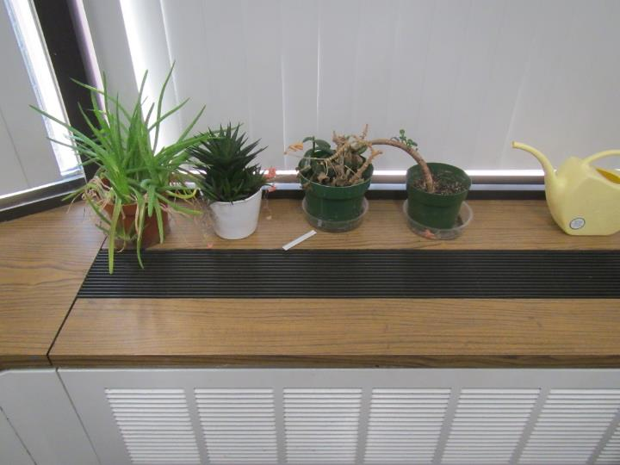
Typical induction unit against the windows, note plants on unit
Picture 2
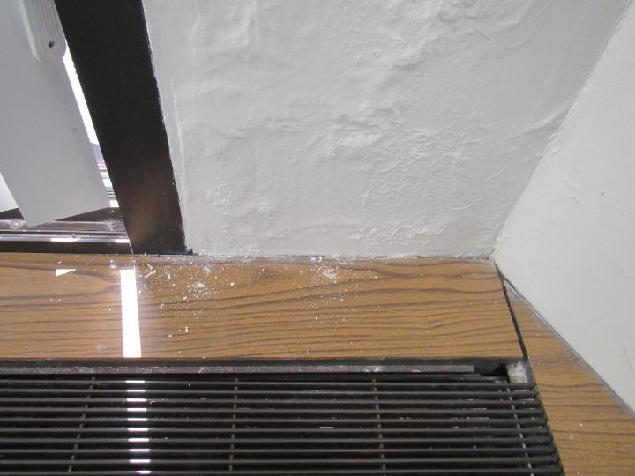
Water-damaged wall plaster, wall was measured as wet
Picture 3
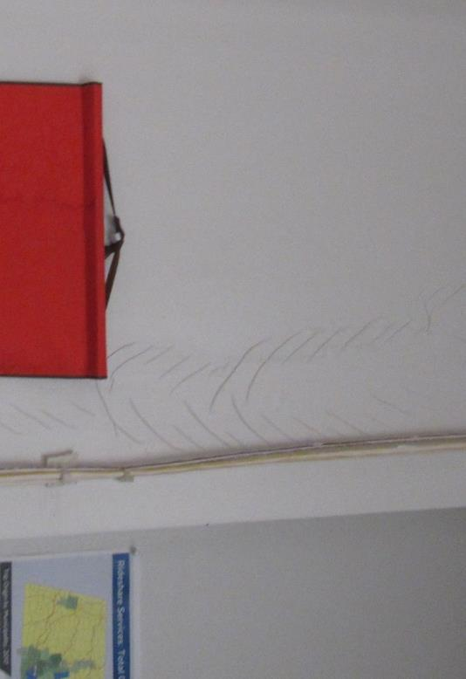
Wrinkled paint on water-damaged wall
Picture 4
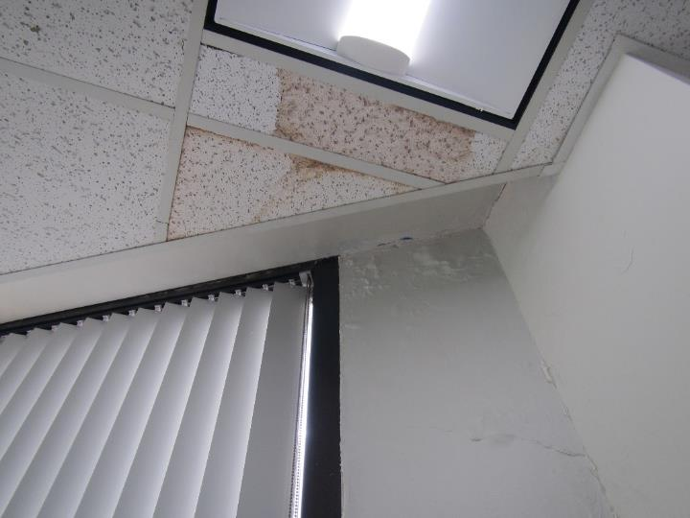
Water-damaged ceiling tiles
Picture 5
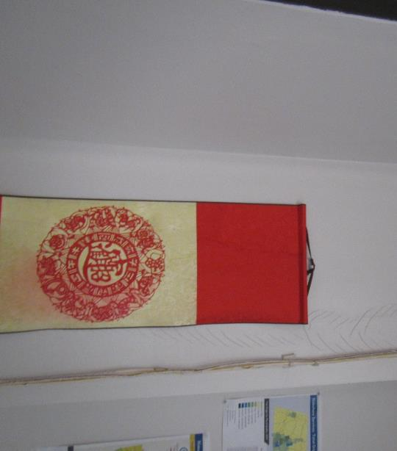
Cloth wall hanging on water-damaged wall
Picture 6
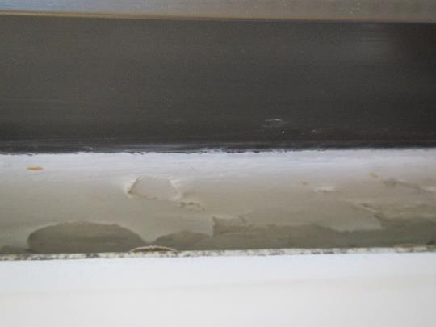
Sheet of vinyl over water-damaged plaster wall
Picture 7
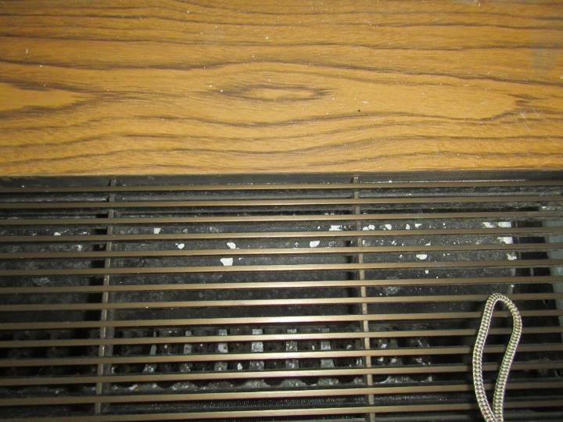
Flakes of plaster in induction unit vent

Location | Remarks
CR-06 | Wall adjacent to window is wet, paint/plaster bubbling, water-damaged ceiling tiles next to window, plaster flakes in vent of induction unit
O-20 | Plaster flakes in vent, vinyl sheet fastened over wall next to windows, wall is wet underneath vinyl and bubbled/flaking, water-damaged ceiling tiles next to window
O-19 | Wall is dry, no water-damaged ceiling tiles, mousetrap on windowsill
O-23 | Water-damaged wall (plaster bubbling) and water-damaged ceiling tiles
Suite 815 right side | Water-damaged wall (wrinkled paint) with wall hanging over it, wall dry, water-damaged ceiling tile
Suite 815 left side | Wall adjacent to window is wet, plants on induction unit

