Massachusetts HIV Epidemiologic Profile
Statewide Report – Data as of 1/1/2023, Accessible MS Word Version, optimized for screen reader use
Please note that while the content of this report is the same as the pdf version, the format and pagination have been modified significantly to optimize use with screen readers to ensure access for blind or visually impaired audiences.
Suggested citation:
Massachusetts Department of Public Health, Bureau of Infectious Disease and Laboratory Sciences. Massachusetts HIV Epidemiologic Profile, Statewide Report – Data as of 1/1/2023 https://www.mass.gov/lists/hivaids-epidemiologic-profiles Published November 2023. Accessed [date].
Bureau of Infectious Disease and Laboratory Sciences
Massachusetts Department of Public Health
Jamaica Plain Campus/State Public Health Laboratory
305 South Street
Jamaica Plain, MA 02130
Questions about this report
Tel: (617) 983-6560
To reach the Reporting and Partner Services Line
Tel: (617) 983-6999
To speak to the on-call epidemiologist
Tel: (617) 983-6800
Questions about infectious disease reporting
Tel: (617) 983-6801
Requests for additional data
https://www.mass.gov/lists/infectious-disease-data-reports-and-requests
Slide sets for HIV Epidemiologic Profile Reports
https://www.mass.gov/lists/hivaids-epidemiologic-profiles

Contents
LIST OF COMMONLY USED ACRONYMS 3
EXECUTIVE SUMMARY 4
EPIDEMIC AT A GLANCE 9
TRENDS IN HIV INFECTION DIAGNOSES OVER TIME 11
RECENT HIV INFECTION DIAGNOSES 16
PERSONS LIVING WITH HIV INFECTION 21
MORTALITY AMONG INDIVIDUALS WITH HIV 26
TRENDS IN DEATHS AMONG INDIVIDUALS WITH HIV 30
GEOGRAPHIC DISTRIBUTION OF HIV INFECTION 33
HIV CARE CONTINUUM 38
SOCIAL VULNERABILITY INDEX 42
TECHNICAL NOTES 43

LIST OF COMMONLY USED ACRONYMS

AFAB | Assigned Female at Birth
AI/AN | American Indian/Alaska Native
AIDS | Acquired Immunodeficiency Syndrome
AMAB | Assigned Male at Birth
API | Asian/Pacific Islander
BIDLS | Bureau of Infectious Disease and Laboratory Sciences
HIV | Human Immunodeficiency Virus
HSR | Health Service Region
HTSX | Heterosexual Sex
IDU | Injection Drug Use
MDPH | Massachusetts Department of Public Health
MSM | Male-to-Male Sex, Men Who Have Sex with Men
N | Number
N/A | Not Applicable
NH | Non-Hispanic
NIR | No Identified Risk
PLWH | Persons (or Individuals) Living with HIV Infection
Pres. HTSX | Presumed Heterosexual Sex
PR/USD | Puerto Rico/United States Dependency
PWID | Persons Who Inject Drugs

EXECUTIVE SUMMARY
Impact of COVID-19 on HIV Surveillance Data
The coronavirus disease 2019 (COVID-19) pandemic had a large impact on the screening, treatment, and surveillance of other infectious diseases in 2020 and 2021. Nationally, the Centers for Disease Control and Prevention (CDC) observed significant declines in HIV testing (and diagnoses) during the COVID-19 pandemic that are likely attributed to interruptions in the availability of clinical services, patient hesitancy in accessing face-to-face clinical services, and shortages in HIV testing reagents/materials. At time of publication, the full effect of the COVID-19 pandemic on case detection and reporting and efforts to control the spread of infectious disease in the Commonwealth has yet to be determined. As such, please interpret 2020 and 2021 HIV surveillance data presented in this report with caution.
Epidemic at a Glance
- The number of persons living with HIV infection (PLWH) in Massachusetts increased by 13% from 20,737 in 2012 to 23,393 in 2021.
- After decreasing from 711 diagnoses in 2012 to approximately 640 diagnoses per year from 2014 to 2018 (five-year average = 638), the number of new HIV infection diagnoses declined to a ten-year low of 537 in 2019. In 2020, the number of new HIV infection diagnoses further declined to 436 and then remained at this lower level in 2021, when there were 446 diagnoses. However, caution should be used in the interpretation of this decline and following stabilization due to the impact of COVID-19 on access to HIV testing and care services, and case surveillance activities.
- The number of deaths due to any cause among individuals reported with HIV infection increased by 23% from 280 in 2012 to 345 in 2021.
- Although there have been reductions in new cases, vulnerable populations remain disproportionately impacted:
  - Men who have sex with men (MSM) continued to represent the largest proportion of new HIV infection diagnoses (39% overall and 54% among individuals assigned male at birth [AMAB] in 2019–2021, as of 1/1/2023).
  - Individuals with IDU exposure mode accounted for 35% of deaths among individuals with HIV in 2021 but only 15% of all PLWH.
Trends in HIV Infection Diagnoses Over Time
- The number of individuals diagnosed with HIV infection has decreased over the past decade in Massachusetts, but disparities persist by sex at birth, exposure mode, race/ethnicity, place of birth, and age.
- Male-to-male sex (MSM) remained the predominant exposure mode from 2012 to 2021.
- After declining by 37% from 2012 (N=49) to 2014 (N=31), the number of reported cases with injection drug use (IDU) as the primary exposure mode peaked at 116 in 2017 and decreased to 58 in 2019. The increase in 2017 was primarily due to an outbreak among persons who inject drugs (PWID) in the northeast part of the state between 2016 and 2018. Following a focused public health response, the number of HIV infection diagnoses attributed to IDU in the northeast has decreased. However, in early 2019, a new cluster of HIV infection was identified in Boston among PWID who were experiencing or had experienced recent homelessness, and the total statewide number of reported cases with IDU as the primary exposure increased to 80 in 2021. As of December 31, 2022, a total of 188 cases diagnosed since November 2018 have been investigated and identified as part of the Boston cluster. As it is an active cluster of concern, additional cases will continue to be investigated and added. Emerging trends among those newly diagnosed in the Boston cluster (N=65 cases diagnosed in 2021) include an increase in polysubstance and methamphetamine use.
- The distributions of individuals diagnosed with HIV infection by sex assigned at birth, current gender, place of birth, and race/ethnicity remained relatively stable from 2012 to 2021.
- From 2012 to 2021, the proportion of individuals diagnosed with HIV infection at age 30–39 years increased from 25% to 35%.
Recent HIV Infection Diagnoses
- Those with no identified risk (NIR), as defined by the CDC, comprised the second largest exposure mode group reported to the MDPH, accounting for 25% of recent HIV infection diagnoses and consisting predominantly of individuals AMAB (66%), individuals born outside the US (63%), and black (non-Hispanic) individuals (53%). Beginning in 2019, all new diagnoses of HIV infection were assigned to field epidemiologists for partner services, education, and linkage to HIV care. Please note that although field epidemiologists offer additional support in the collection of risk information as part of this process, some of the information doesn’t meet the CDC-defined exposure mode categories. For example, risks occurring outside the US, such as transfusion/transplant risk (blood product), are not assigned as a primary exposure mode because it is not possible to verify the information internationally. The Massachusetts Department of Public Health will collect and maintain expanded risk information for local analyses and future use in case the CDC-defined exposure mode categories are updated.
- One in five (20%) individuals AFAB and diagnosed with HIV infection from 2019 to 2021 reported IDU as their primary exposure mode, compared to one in seven (14%) individuals AMAB.
- Black (non-Hispanic) and Hispanic/Latinx individuals were diagnosed with HIV infection during 2019–2021 at rates eight and four times that of white (non-Hispanic) individuals, respectively.
- During 2019 to 2021, 41% (N=580) of all individuals diagnosed with HIV infection were born outside the US. This proportion varied by race/ethnicity: 72% of Asian/Pacific Islander individuals diagnosed with HIV infection were born outside the US, compared to 59% of black (non-Hispanic) and 53% of Hispanic/Latinx individuals. An additional 11% of Hispanic/Latinx individuals diagnosed with HIV infection during this time period were born in Puerto Rico. Twelve percent of white (non-Hispanic) individuals were born outside the US or in Puerto Rico.
Persons Living with HIV Infection (PLWH)
- Challenges to achieving health equity in the prevention and care of HIV infection remain:
  - Racial/ethnic disparities persist among PLWH, and marked differences exist by exposure mode, current gender, place of birth, and geographic region of residence in the state.
  - MSM was the most frequently reported exposure mode, accounting for 40% of PLWH overall and 56% of individuals AMAB living with HIV infection.
  - While 12% of all Massachusetts residents live in the Boston HSR, it is the current residence of 27% of PLWH.
Mortality Among Individuals Reported with HIV
- Disparities in mortality among individuals reported with HIV paralleled those in diagnosis rates by sex assigned at birth, race/ethnicity, and place of birth, but not exposure mode. Individuals with IDU exposure mode were over-represented among HIV-positive individuals who died. The leading causes of death among individuals reported with HIV infection with IDU and IDU/MSM exposure mode who died in 2020 (with a known cause) were external causes of injuries and poisonings (which includes opioid overdoses) which accounted for 33% (N=37/112) of deaths, COVID-19 which accounted for 13% (N=15/112) of deaths, HIV which accounted for 11% (N=12/112) of deaths, cancer which accounted for 9% (N=10/112) of deaths, and chronic liver disease and cirrhosis which accounted for 8% (9/112) of deaths (cause of death was not yet available for 2021 deaths as of 1/1/2023).
- The average age at death among individuals reported with HIV increased by 5.8 years, from 52.7 years in 2012 to 58.5 years in 2021. For comparison, the average age at death of the general Massachusetts population remained between 75.1 and 76.8 from 2012 to 2021.
- Survival of individuals diagnosed with AIDS has increased over time. In the earliest cohort of AIDS diagnoses (1987–1991), estimated survival at five years after AIDS diagnosis was 18%, compared to 86% in the most recent cohort (2017–2021).
Trends in Deaths Among Individuals Reported with HIV
- The proportion of deaths among individuals reported with HIV infection attributed to HIV-related causes decreased from 36% (N=100/280) in 2012 to 13% (N=46/345) in 2021. The leading non HIV-related causes of death among individuals reported with HIV infection who died in 2020 (with a known cause) were external causes of injuries and poisonings (which includes opioid overdoses) which accounted for 22% (N=65/294) of deaths, COVID-19 which accounted for 13% (N=37/294) of deaths, cancer which accounted for 12% (N=34/294) of deaths, and heart disease which accounted for 8% (N=24/294) of deaths (cause of death was not yet available for 2021 deaths as of 1/1/2023).
Geographic Distribution of HIV Infection
- The cities and towns with the highest average annual rate of HIV infection diagnosis during 2019 to 2021 included Everett (20.4 per 100,000), Brockton (18.9), Boston (17.0), Lawrence (15.7), and Malden (14.6). Boston had the highest number of new HIV infection diagnoses from 2019–2021 (N=344), followed by Worcester (N=82).
- Suffolk County was selected as one of 48 counties nationally that is prioritized for funding in the U.S. Health and Human Services’ initiative “Ending the HIV Epidemic (EHE): A Plan for America”. Suffolk County had the highest average age-adjusted rate of HIV infection diagnosis during 2019 to 2021 among all Massachusetts counties at 14.7 per 100,000.
The Massachusetts HIV Care Continuum
- Among 408 individuals newly diagnosed with HIV infection in 2020 (and alive in Massachusetts through 2021), 81% overall were virally suppressed, with 87% of those linked to care, and 91% of those retained in care reaching viral suppression. Viral suppression was lowest among individuals with injection drug use exposure mode (59%, compared to 79% to 89% among other exposure modes).
- Among 22,221 persons living with HIV infection at the end of 2021 (and diagnosed through 2020), 66% overall were virally suppressed, with 92% of those engaged in care and 95% of those retained in care reaching viral suppression.

EPIDEMIC AT A GLANCE
The number of persons living with HIV infection (PLWH) in Massachusetts increased by 13% from 20,737 in 2012 to 23,393 in 2021. After decreasing from 711 diagnoses in 2012 to approximately 640 diagnoses per year from 2014 to 2018 (five-year average = 638), the number of new HIV infection diagnoses declined to a ten-year low of 537 in 2019. In 2020, the number of new HIV infection diagnoses further declined to 436 and then remained at this lower level in 2021, when there were 446 diagnoses. However, caution should be used in the interpretation of this decline and following stabilization due to the impact of COVID-19 on access to HIV testing and care services, and case surveillance activities. The number of deaths due to any cause among individuals reported with HIV infection increased by 23% from 280 in 2012 to 345 in 2021.
FIGURE 1: History of the HIV epidemic, Massachusetts 2012–2021
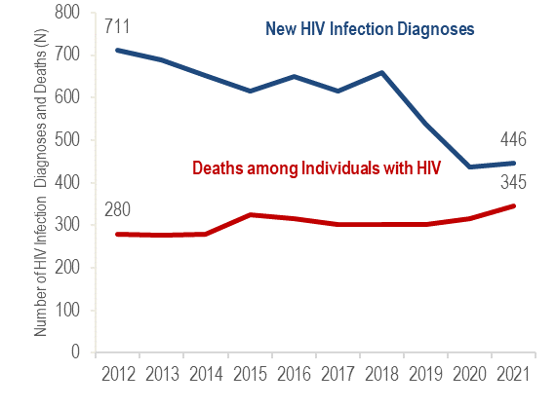
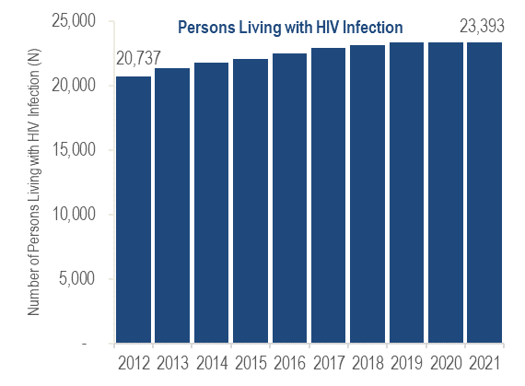
EPIDEMIC AT A GLANCE
N = 446 New HIV diagnoses in MA in 2021
N = 23,393 Persons living with HIV infection in MA as of 12/31/2021
N = 345 Deaths among individuals reported with HIV in MA in 2021
Men who have sex with men (MSM) continued to represent the largest proportion of new HIV infection diagnoses: 39% of all new HIV infection diagnoses in 2019–2021, and 54% among individuals assigned male at birth (AMAB).
During 2019–2021, the HIV infection diagnosis rates among black (non-Hispanic) and Hispanic/Latinx individuals were eight and four times that of white (non-Hispanic) individuals, respectively.
Individuals with injection drug use (IDU) exposure mode accounted for 35% of deaths among individuals reported with HIV in 2021 but only 15% of all PLWH.

TRENDS IN HIV INFECTION DIAGNOSES OVER TIME
FIGURE 2: Trends in HIV infection diagnoses, Massachusetts 2012 – 2021
HIV Infection Diagnoses | 2012 | 2021
Total | 711 | 446
Sex Assigned at Birth
Assigned Male Sex | 518 | 311
Assigned Female Sex | 193 | 135
Race/Ethnicity
White NH | 260 | 158
Black NH | 221 | 150
Hispanic/Latinx | 193 | 119
API | 25 | 13
Other/Unknown | 12 | 6
Age Group (Years)
0-12 | 2 | 1
13-19 | 24 | 7
20-29 | 175 | 95
30-39 | 175 | 154
40-49 | 183 | 96
50-59 | 108 | 58
60-69 | 35 | 32
70+ | 9 | 3
Exposure Mode
MSM | 318 | 163
IDU | 49 | 80
MSM/IDU | 22 | 12
HTSX | 78 | 32
Other | 3 | 1
Pres. HTSX | 98 | 47
NIR | 143 | 111
Place of Birth
US | 393 | 255
PR/USD | 57 | 10
Non-US | 261 | 181
Health Service Region
Boston | 196 | 129
Central | 52 | 43
Metro West | 101 | 79
Northeast | 148 | 88
Southeast | 103 | 62
Western | 94 | 35
Prisoner | 17 | 9
Other/Unknown | 0 | 1

Overall
From 2012 to 2021, the number of new HIV infection diagnoses decreased by 37%. Distributions by sex assigned at birth, place of birth, and race/ethnicity remained relatively stable, while distributions by age at diagnosis and exposure mode shifted.
By Sex Assigned at Birth
HIV infection diagnoses decreased among individuals AMAB (by 40%, from 518 to 311) and AFAB (by 30%, from 193 to 135).
By Race/Ethnicity
HIV infection diagnoses decreased among white (non-Hispanic) individuals (by 39%, from 260 to 158), Hispanic/Latinx individuals (by 38%, from 193 to 119), black (non-Hispanic) individuals (by 32%, from 221 to 150), and Asian/Pacific Islander individuals (from 25 to 13).
By Age at HIV Infection Diagnosis
HIV infection diagnoses decreased among 0–12 year-olds (from two to one), 13–19 year-olds (by 71%, from 24 to seven), 20–29 year-olds (by 46%, from 175 to 95), 30–39 year-olds (by 12%, from 175 to 154), 40–49 year-olds (by 48%, from 183 to 96), 50–59 year-olds (by 46%, from 108 to 58), 60–69 year-olds (by 9%, from 35 to 32), and 70+ year-olds (from nine to three). The proportion of HIV infection diagnoses among 30–39 year-olds increased from 25% to 35%, while it decreased from 25% to 21% among 20–29 year-olds and from 26% to 22% among 40–49 year-olds.
By Exposure Mode
HIV infection diagnoses decreased among individuals with heterosexual sex (by 59%, from 78 to 32), presumed heterosexual sex (by 52%, from 98 to 47), male-to-male sex (MSM) (by 49%, from 318 to 163), MSM/injection drug use (IDU) (by 45%, from 22 to 12), no identified risk (by 22%, from 143 to 111), and “other” exposure modes (from three to one). All diagnoses in the other category were related to perinatal exposures, with no confirmed clotting factor, transfusion, or transplant-related exposures in the ten-year time period. After declining by 37% from 2012 (N=49) to 2014 (N=31), the number of reported cases with injection drug use (IDU) as the primary exposure mode peaked at 116 in 2017, decreased to 58 in 2019, and then increased to 80 in 2021. This was primarily due to an outbreak of HIV among PWID in the northeast part of the state between 2016 and 2018, followed by an intensive and focused public health response, and then a new cluster of HIV infection identified in 2019 among PWID in Boston. The proportion of HIV infection diagnosed among individuals with IDU exposure mode decreased from a peak of 19% in 2017 to 11% in 2019, and then increased to 18% in 2021.
FIGURE 3: Trends in HIV infection diagnoses by sex assigned at birth, Massachusetts 2012 – 2021
Assigned Male Sex at Birth:
HIV Infection Diagnoses | 2012 | 2021
Total | 518 | 311
Race/Ethnicity
White NH | 227 | 123
Black NH | 114 | 76
Hispanic/Latinx | 147 | 94
API | 20 | 13
Other/Unknown | 10 | 5
Age Group (Years)
0-12 | 1 | 0
13-19 | 15 | 5
20-29 | 146 | 81
30-39 | 115 | 110
40-49 | 136 | 60
50-59 | 79 | 37
60-69 | 23 | 16
70+ | 3 | 2
Exposure Mode
MSM | 318 | 163
IDU | 26 | 53
MSM/IDU | 22 | 12
HTSX | 34 | 10
Other | 2 | 0
NIR | 116 | 73
Place of Birth
US | 317 | 197
PR/USD | 41 | 5
Non-US | 160 | 109

Assigned Female Sex at Birth:
HIV Infection Diagnoses | 2012 | 2021
Total | 193 | 135
Race/Ethnicity
White NH | 33 | 35
Black NH | 107 | 74
Hispanic/Latinx | 46 | 25
API | 5 | 0
Other/Unknown | 2 | 1
Age Group (Years)
0-12 | 1 | 1
13-19 | 9 | 2
20-29 | 29 | 14
30-39 | 60 | 44
40-49 | 47 | 36
50-59 | 29 | 21
60-69 | 12 | 16
70+ | 6 | 1
Exposure Mode
IDU | 23 | 27
HTSX | 44 | 22
Other | 1 | 1
Pres. HTSX | 98 | 47
NIR | 27 | 38
Place of Birth
US | 76 | 58
PR/USD | 16 | 5
Non-US | 101 | 72

Race/Ethnicity by Sex Assigned at Birth
From 2012 to 2021, the number of HIV infection diagnoses decreased 46% among white (non-Hispanic) individuals assigned male at birth (AMAB), 36% among Hispanic/Latinx individuals AMAB, and 33% among black (non-Hispanic) individuals AMAB. Among individuals assigned female at birth (AFAB), the number of diagnoses increased slightly by 6% among white (non-Hispanic) individuals AFAB, and decreased 46% among Hispanic/Latina individuals AFAB, and 31% among black (non-Hispanic) individuals AFAB.
Exposure Mode by Sex Assigned at Birth
The number of HIV infection diagnoses decreased among all exposure modes for individuals AMAB except for injection drug use (IDU), which doubled. The number of diagnoses increased 41% among individuals AFAB with no identified risk for exposure mode and by 17% among those with IDU exposure mode. The number of HIV infection diagnoses decreased among individuals AFAB with presumed heterosexual and heterosexual exposure modes (by 52% and 50%, respectively).
Place of Birth by Sex Assigned at Birth
From 2012 to 2021, the number of HIV infection diagnoses among individuals AMAB and AFAB decreased for all categories of birthplace.

RECENT HIV INFECTION DIAGNOSES
Who is most at risk for HIV infection? Recent HIV infection diagnoses are the best available indicator for who is most at risk for HIV infection. Monitoring new diagnoses helps us to determine who is affected and inform effective prevention activities.
FIGURE 4. Percentage of individuals diagnosed with HIV infection by current gender, age, race/ethnicity, and exposure mode, Massachusetts 2019 – 2021 (N=1,419)
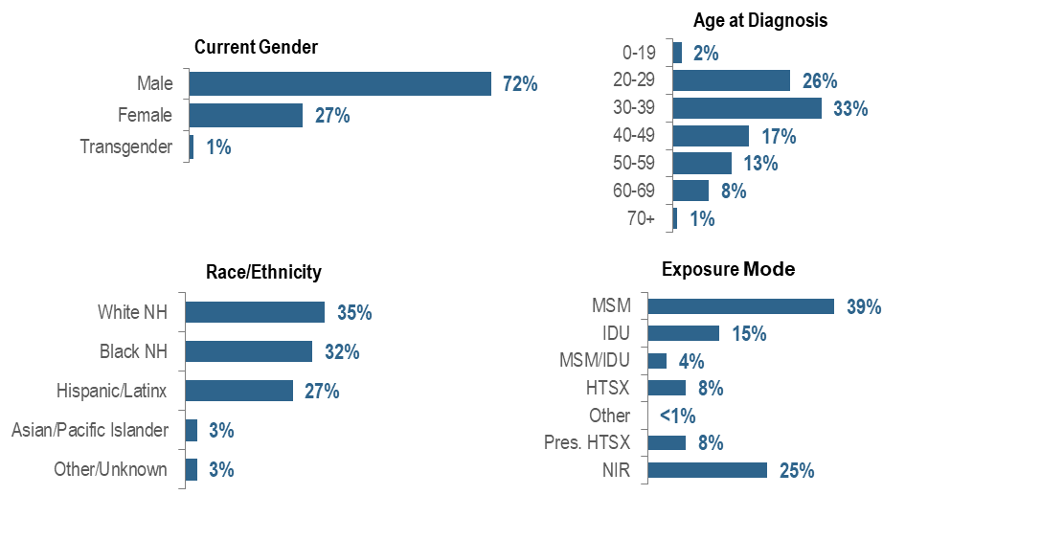
The number of individuals diagnosed with HIV infection has decreased over the past decade in Massachusetts, but disparities persist by current gender, age, race/ethnicity, and exposure mode. Individuals newly diagnosed with HIV infection in Massachusetts during 2019–2021 were predominantly male (72%), young (26% 20–29 year-olds and 33% 30–39 year-olds), white (non-Hispanic) (35%), with an exposure mode of MSM (39%). While MSM was the leading exposure mode, a large percentage of new HIV infection diagnoses had no identified risk (25%).
FIGURE 5. Percentage of individuals diagnosed with HIV infection by race/ethnicity and place of birth, Massachusetts 2019 – 2021
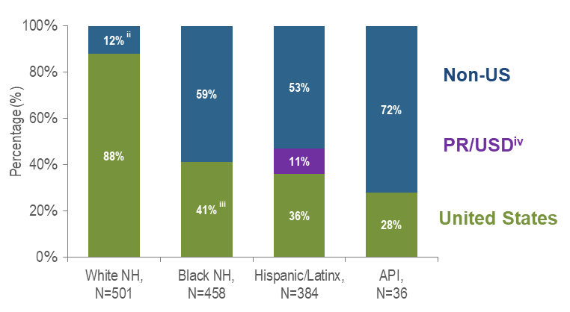

Figure 5 Notes: ^{ii} Non-US born and Puerto Rico/USD categories are combined for white non-Hispanic individuals due to small numbers to adhere to cell suppression rules.
^{iii} US born and Puerto Rico/USD categories are combined for black non-Hispanic individuals due to small numbers to adhere to cell suppression rules
^{iv} All individuals diagnosed with HIV infection from 2019–2021 who were born in a US dependency (USD) were born in Puerto Rico (PR)

Seventy-two percent of Asian/Pacific Islander individuals diagnosed with HIV infection during 2019–2021 were born outside the US, compared to 59% of black (non-Hispanic) and 53% of Hispanic/Latinx individuals. Twelve percent of white (non-Hispanic) individuals were born outside the US or in Puerto Rico.

FIGURE 6. Percentage of individuals diagnosed with HIV infection by race/ethnicity, age, exposure mode, and place of birth by sex assigned at birth, Massachusetts 2019 – 2021
(AMAB, N=1,022; AFAB, N=397;)
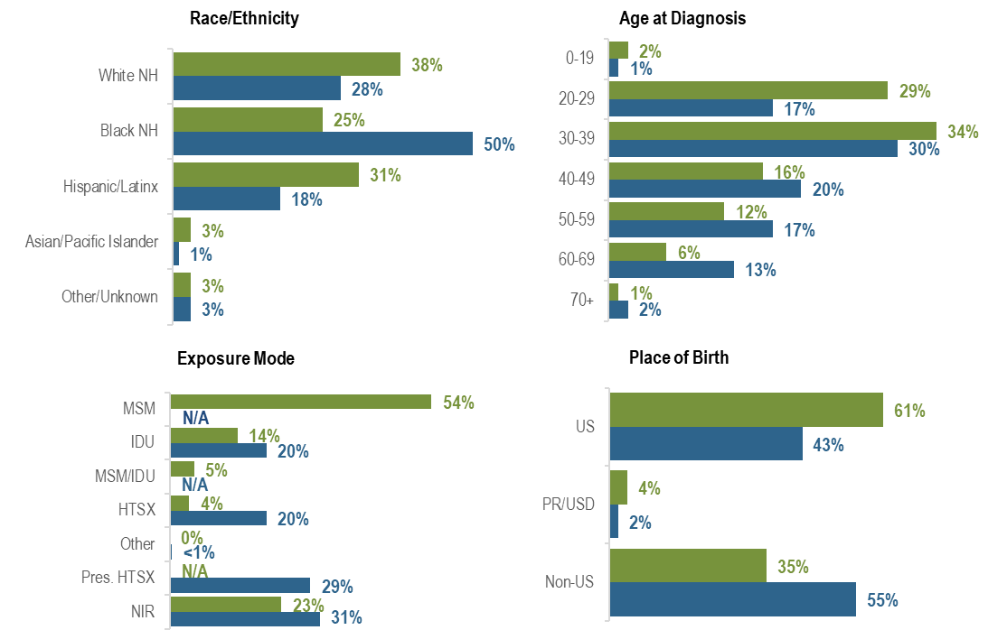
The distributions of new HIV infection diagnoses by race/ethnicity, age, exposure mode, and place of birth varied by sex assigned at birth: the largest proportion of individuals assigned male at birth (AMAB) was white (non-Hispanic) (38%), while the largest proportion of individuals assigned female at birth (AFAB) was black (non-Hispanic) (50%). A larger proportion of individuals AMAB (29%) than AFAB (17%) was diagnosed between the ages of 20 and 29 years. MSM was the predominant exposure mode among individuals AMAB (54%), while the largest proportion of individuals AFAB was reported with NIR (31%). A larger proportion of individuals AFAB (55%) than AMAB (35%) was born outside the US.

FIGURE 7. Percentage of individuals diagnosed with HIV infection by exposure mode and race/ethnicity, Massachusetts 2019 – 2021
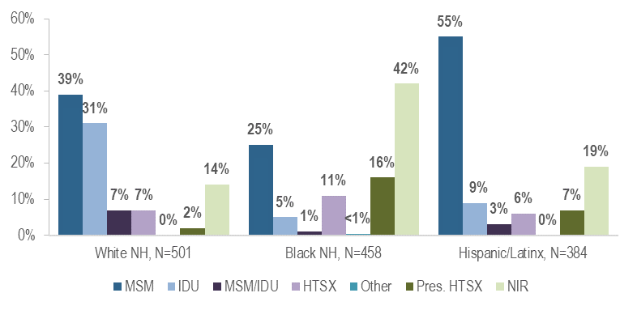
While the predominant exposure mode among white (non-Hispanic) and Hispanic/Latinx individuals recently diagnosed with HIV infection was MSM (39% and 55%, respectively), the largest proportion of black (non-Hispanic) individuals was assigned no identified risk for exposure mode (42%).

HIV does not affect all Massachusetts residents equally. One way to understand which populations are experiencing differential impacts is to compare rates of HIV diagnosis per 100,000 population.
FIGURE 8. Average annual age-adjusted HIV diagnosis rates per 100,000 population by sex assigned at birth and race/ethnicity, Massachusetts 2019 – 2021 (N=1,419)
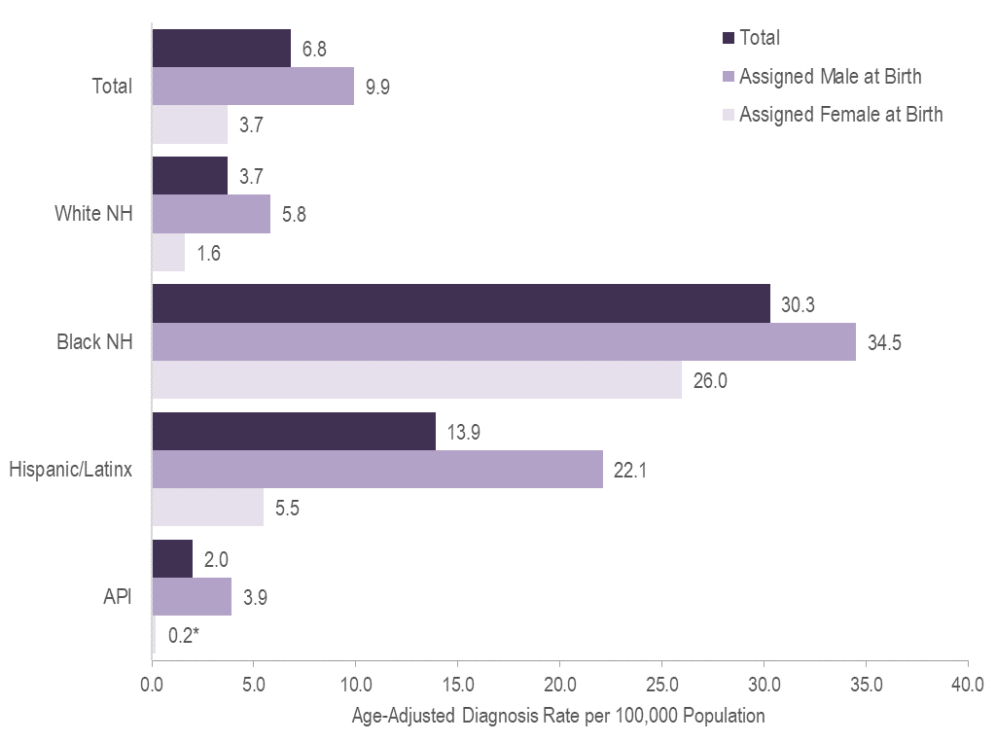
Figure 8 Note: *Rates based on numerators <12 are marked with an asterisk (*) and should be interpreted with caution.
In 2019 – 2021, the average annual age-adjusted HIV diagnosis rate per 100,000 population of individuals assigned male at birth (AMAB) was three times that of individuals assigned female at birth (AFAB). There were large disparities in average annual age-adjusted HIV diagnosis rates for 2019 to 2021 by race/ethnicity. Compared to the rate among white (non-Hispanic) individuals, the rate among:
- black (non-Hispanic) individuals was eight times greater, and
- Hispanic/Latinx individuals was four times greater.
With respect to differences based on race/ethnicity and sex assigned at birth, the average annual age-adjusted HIV diagnosis rate for 2019 to 2021 among:
- black (non-Hispanic) individuals assigned male at birth (AMAB), was six times that of white (non-Hispanic) individuals AMAB,
- Hispanic/Latinx individuals AMAB was four times that of white (non-Hispanic) individuals AMAB,
- black (non-Hispanic) individuals assigned female at birth (AFAB) was 16 times that of white (non-Hispanic) individuals AFAB, and
- Hispanic/Latinx individuals AFAB was three times that of white (non-Hispanic) individuals AFAB.

PERSONS LIVING WITH HIV INFECTION
Who is currently living with HIV infection? The number of persons living with HIV infection (PLWH) reflects the impact of HIV in Massachusetts.
FIGURE 9. Percentage of PLWH by current gender, age, race/ethnicity, and exposure mode, Massachusetts 2021 (N=23,393)
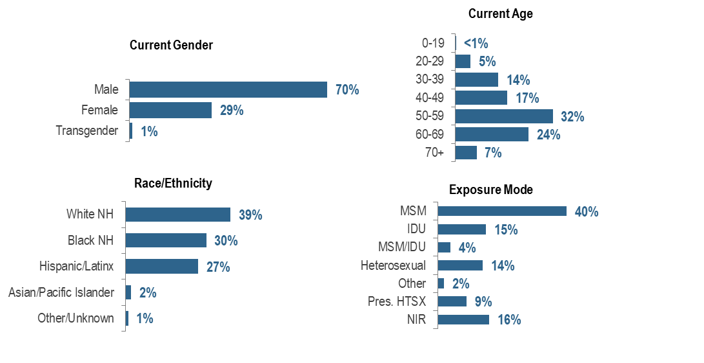
Racial/ethnic disparities persist among PLWH, and marked differences exist by current gender, age, and exposure mode. PLWH in Massachusetts are predominantly male (70%), older (32% among 50–59 year-olds), and white non-Hispanic (39%). Male-to-male sex was the most frequently reported exposure mode, at 40%.

FIGURE 10. Percentage of PLWH by race/ethnicity and place of birth, Massachusetts 2021
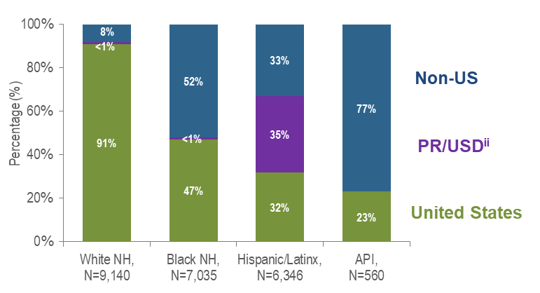

Figure 10 Note: ^{ii} 98% of PLWH on 12/31/2021 who were born in a US dependency were born in Puerto Rico

A total of 77% of Asian/Pacific Islander PLWH in Massachusetts in 2021 were born outside the US, compared to 52% of black (non-Hispanic), 33% of Hispanic/Latinx, and 8% of white (non-Hispanic) PLWH.

FIGURE 11. Percentage of persons living with HIV infection (PLWH) by race/ethnicity, age, exposure mode, and place of birth by sex assigned at birth, Massachusetts 2021
(Assigned Male at Birth, N=16,622; Assigned Female at Birth, N=6,771)
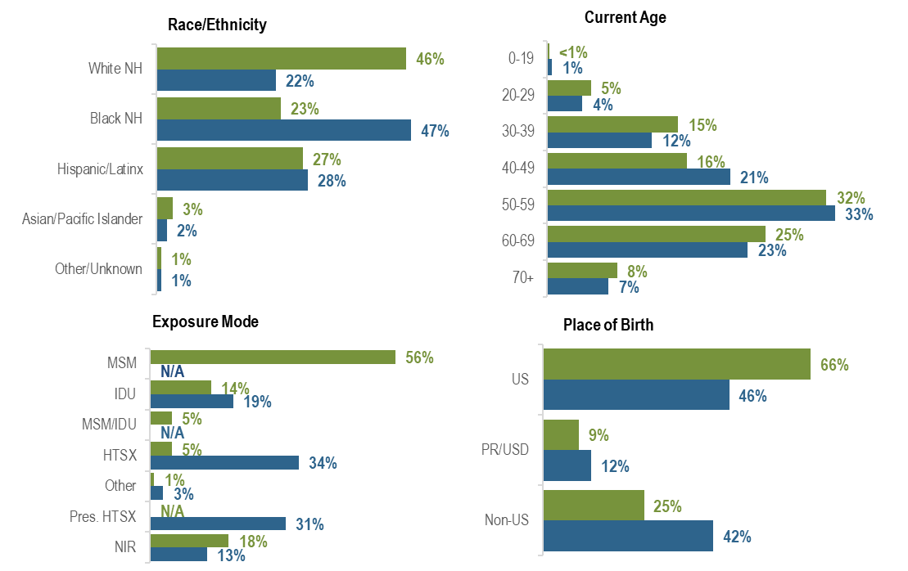
The distributions of PLWH by race/ethnicity, exposure mode, and place of birth varied by sex assigned at birth: the largest proportion of individuals assigned male at birth (AMAB) living with HIV infection was white (non-Hispanic) (46%), while the largest proportion of individuals assigned female at birth (AFAB) was black (non-Hispanic) (47%). MSM (56%) was the predominant exposure mode among individuals AMAB compared to heterosexual sex (34%) and presumed heterosexual sex (31%) among individuals AFAB. A larger proportion of individuals AFAB (42%) than AMAB (25%) was born outside the US.

FIGURE 12. Percentage of PLWH by exposure mode and race/ethnicity, Massachusetts 2021
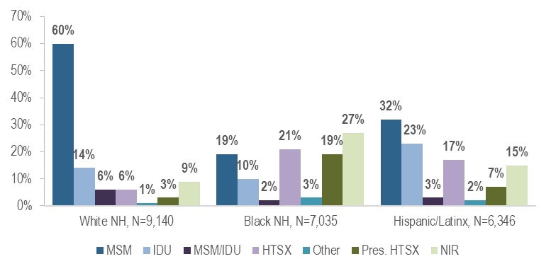
The predominant exposure mode among white (non-Hispanic) PLWH was MSM (60%). Among black (non-Hispanic) PLWH, the largest proportion was reported with no identified risk (27%), followed by heterosexual sex (21%), presumed heterosexual sex (19%), and MSM (19%). Among Hispanic/Latinx PLWH, the largest proportion was MSM (32%), followed by IDU (23%).
FIGURE 13. Age-adjusted HIV prevalence rates per 100,000 population by sex assigned at birth and race/ethnicity, Massachusetts 2021 (N=23,393)
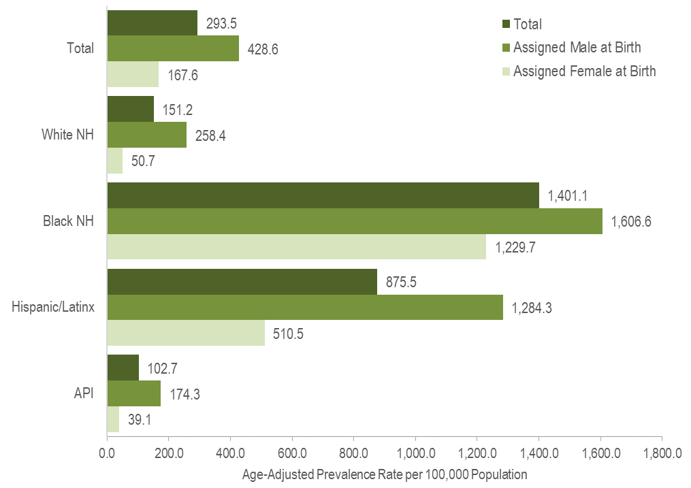
In 2021, the age-adjusted HIV prevalence rate per 100,000 population of individuals assigned male at birth (AMAB) was three times that of individuals assigned female at birth (AFAB). There were large disparities in age-adjusted prevalence rates by race/ethnicity. Compared to the rate among white (non-Hispanic) individuals, the rate among:
- black (non-Hispanic) individuals was nine times greater, and
- Hispanic/Latinx individuals was six times greater.
With respect to differences based on race/ethnicity and sex assigned at birth, the age-adjusted HIV prevalence rate among:
- black (non-Hispanic) individuals AFAB was 24 times that of white (non-Hispanic) individuals AFAB,
- Hispanic/Latinx individuals AFAB was 10 times that of white (non-Hispanic) individuals AFAB,
- black (non-Hispanic) individuals AMAB was six times that of white (non-Hispanic) individuals AMAB, and
- Hispanic/Latinx individuals AMAB was five times that of white (non-Hispanic) individuals AMAB.

MORTALITY AMONG INDIVIDUALS WITH HIV
Who is dying with HIV and how has this changed over time?
In 2021, 13% (N=46/345) of deaths among individuals reported with HIV infection were attributed to HIV-related causes (generally, opportunistic illnesses, for a full list of stage-3 defining opportunistic illnesses, see: https://www.cdc.gov/mmwr/preview/mmwrhtml/rr6303a1.htm#Appendix). Forty-one percent (N=19/46) of HIV-related deaths were among white (non-Hispanic) individuals, 35% (N=16/46) were among black (non-Hispanic) individuals, and 24% (N=11/46) were among Hispanic/Latinx individuals. Hispanic/Latinx and black (non-Hispanic) Massachusetts residents died from HIV-related causes at younger ages (average ages of death were 51.0 and 56.3 years, respectively) compared to white non-Hispanic residents (average age of death was 58.1 years).
FIGURE 14. Average annual age-adjusted death rates among individuals reported with HIV per 100,000 population by sex assigned at birth and race/ethnicity, Massachusetts 2019–2021 (Total number of deaths among individuals reported with HIV from 2019–2021=962)
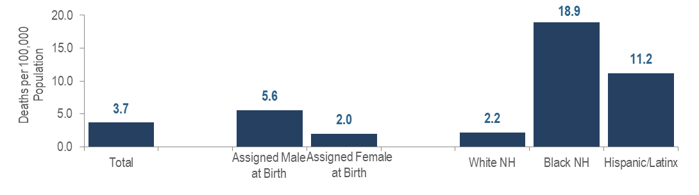Age-Adjusted Rates
In 2019 – 2021, the average annual age-adjusted death rate per 100,000 population for individuals assigned male at birth reported with HIV was three times that for individuals assigned female at birth. There were also large disparities in death rates by race/ethnicity: the rates among black (non-Hispanic) individuals and Hispanic/Latinx individuals were nine and five times that of white (non-Hispanic) individuals, respectively.

Age at Death
The average age at death among individuals reported with HIV increased by 5.8 years, from 52.7 years in 2012 to 58.5 years in 2021. For comparison, the average age at death of the general Massachusetts population remained between 75.1 and 76.8 from 2012 to 2021.
FIGURE 15. Deaths among individuals reported with HIV by exposure mode, Massachusetts 2021 (N=345)
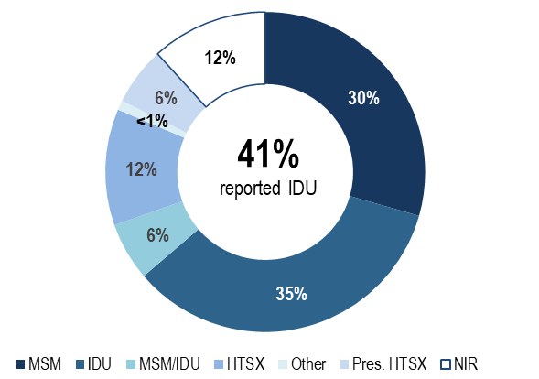
Exposure Mode
- Individuals with IDU exposure mode accounted for the largest proportion of deaths among individuals reported with HIV. In 2021, 35% of deaths among individuals with HIV were reported with an exposure mode of IDU and an additional 6% were reported with an exposure mode of MSM/IDU, compared to 18% and 3%, respectively, of 2021 HIV infection diagnoses. The leading causes of death among individuals reported with HIV infection with IDU and IDU/MSM exposure mode who died in 2020 (with a known cause) were external causes of injuries and poisonings (which includes opioid overdoses) which accounted for 33% (N=37/112) of deaths, COVID-19 which accounted for 13% (N=15/112) of deaths, HIV which accounted for 11% (N=12/112) of deaths, cancer which accounted for 9% (N=10/112) of deaths, and chronic liver disease and cirrhosis which accounted for 8% (9/112) of deaths (cause of death was not yet available for 2021 deaths as of 1/1/2023).

Survival among individuals diagnosed with AIDS
FIGURE 16. Five-year survival among with individuals with AIDS by year of diagnosis, Massachusetts 1987–2021 (Total number of AIDS diagnoses from 1987–2021, N=24,895)
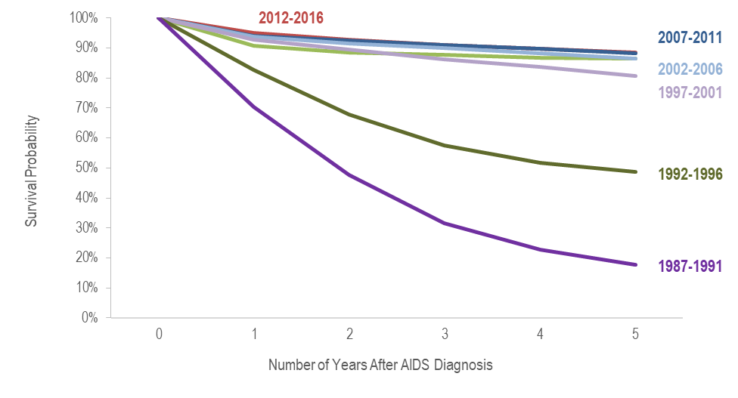
Survival of individuals diagnosed with AIDS has increased over time. In the earliest cohort of AIDS diagnoses (1987–1991), estimated survival at five years after AIDS diagnosis was 18%, compared to 86% in the most recent cohort (2017–2021).
Trends in Age-Adjusted Rates of Death
FIGURE 17. Age-adjusted rate of death per 100,000 population among individuals reported with HIV by sex assigned at birth, Massachusetts 2012–2021 (Total number of deaths among individuals reported with HIV from 2012–2021=3,040)
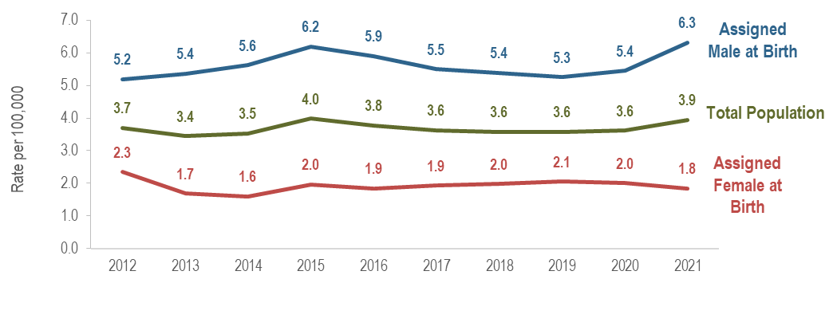
Over the last 10 years of available data, the age-adjusted rate of death per 100,000 population of individuals assigned male at birth (AMAB) reported with HIV has remained two to three times that of individuals assigned female at birth (AFAB). In 2021, the age-adjusted rate of individuals AMAB (6.3 per 100,000) was over three times the rate of individuals AFAB (1.8 per 100,000).

TRENDS IN DEATHS AMONG INDIVIDUALS WITH HIV
The proportion of deaths among individuals reported with HIV infection attributed to HIV-related causes decreased from 36% (N=100/280) in 2012 to 13% (N=46/345) in 2021. The leading non HIV-related causes of death among individuals reported with HIV infection who died in 2020 (with a known cause) were external causes of injuries and poisonings (which includes opioid overdoses) which accounted for 22% (N=65/294) of deaths, COVID-19 which accounted for 13% (N=37/294) of deaths, cancer which accounted for 12% (N=34/294) of deaths, and heart disease which accounted for 8% (N=24/294) of deaths (cause of death was not yet available for 2021 deaths as of 1/1/2023).
FIGURE 18. Trends in all-cause deaths among individuals reported with HIV, Massachusetts 2012–2021
All-Cause Deaths | 2012 | 2021
Total | 280 | 345
Sex Assigned at Birth
Assigned Male Sex | 193 | 261
Assigned Female Sex | 87 | 84
Race/Ethnicity
White NH | 139 | 154
Black NH | 69 | 106
Hispanic/Latinx | 66 | 81
API | 3 | 2
Other/Unknown | 3 | 2
Age Group (Years)
0-12 | 0 | 0
13-19 | 0 | 0
20-29 | 6 | 5
30-39 | 13 | 20
40-49 | 78 | 42
50-59 | 115 | 104
60-69 | 57 | 129
70+ | 11 | 45
Exposure Mode
MSM | 64 | 102
IDU | 125 | 120
MSM/IDU | 16 | 19
HTSX | 29 | 41
Other | 5 | 1
Pres. HTSX | 12 | 20
NIR | 29 | 42
Place of Birth
US | 221 | 262
PR/USD | 33 | 49
Non-US | 26 | 34

Overall
The number of deaths due to any cause among individuals reported with HIV infection increased by 23% from 280 in 2012 to 345 in 2021.
By Sex Assigned at Birth
The annual number of deaths increased by 35% among individuals AMAB and remained relatively stable among individuals AFAB.
By Race/Ethnicity
The annual number of deaths increased by 54% among black (non-Hispanic) individuals, by 23% among Hispanic/Latinx individuals, and by 11% among white (non-Hispanic) individuals.
By Age at Death
There was only one death among the youngest age groups (0–12 and 13–19) over the ten-year period and less than ten per year among the 20–29 year age group (except for 2019 when there were 12). Deaths decreased by 46% among the 40–49 year age group and by 10% among the 50–59 year age group. Deaths increased by 54% among the 30–39 year age group, more than doubled among the 60–69 year age group, and quadrupled among the 70+ year age group.
By Exposure Mode
Deaths increased among individuals with male-to-male sex (59%, from 64 to 102), no identified risk (45%, from 29 to 42), heterosexual (41%, from 29 to 41), and presumed heterosexual (from 12 to 20) exposure modes. Deaths remained relatively stable among individuals with IDU, MSM/IDU, and other exposure modes.
By Place of Birth
Deaths increased among individuals born in Puerto Rico/US dependencies (48%, 33 to 49), outside the US (31%, from 26 to 34), and in the US (19%, from 221 to 262).

FIGURE 19. Trends in causes of death among individuals reported with HIV infection, Massachusetts 2012–2020 (N=2,310)
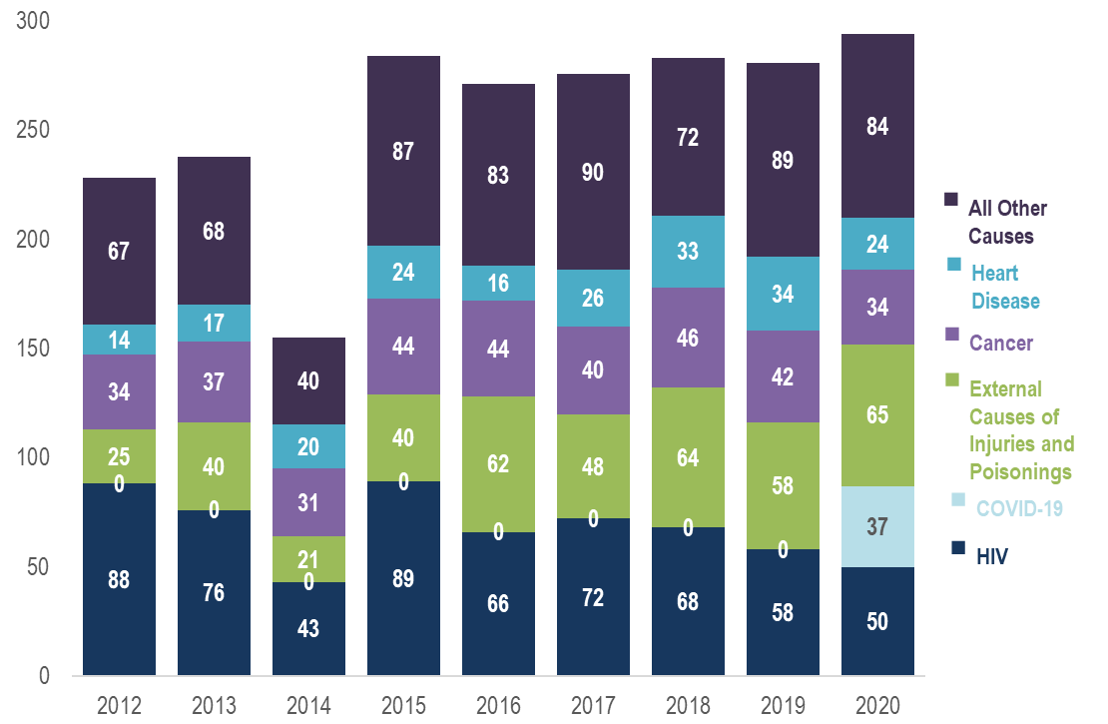
Trends in Causes of Death
In 2020, the leading causes of death among persons reported with HIV infection (with a known cause) were external causes of injuries and poisonings (which includes opioid overdoses) which accounted for 22% (N=65/294) of deaths, followed by HIV which accounted for 17% (N=50/294), and COVID-19, which accounted for 13% (N=37/294) of deaths. By comparison, the leading causes of death in 2020 among the general population of Massachusetts were cancer which accounted for 18% (N=12,381/68,269) of deaths, heart disease which accounted for 17% (N=11,797/68,269), and COVID-19, which accounted for 14% (N=9,455/68,269). While the top two causes of death differed for persons with reported HIV infection and the general population, COVID-19 was the third leading cause in both groups and accounted for a similar percentage of deaths.

GEOGRAPHIC DISTRIBUTION OF HIV INFECTION
What is the geographic distribution of the HIV epidemic in Massachusetts?
FIGURE 20. Percentage distributions of 2019–2021 HIV infection diagnoses (N=1,419) and 2021 persons living with HIV infection (PLWH, N=23,393) by Health Service Region (HSR), Massachusetts
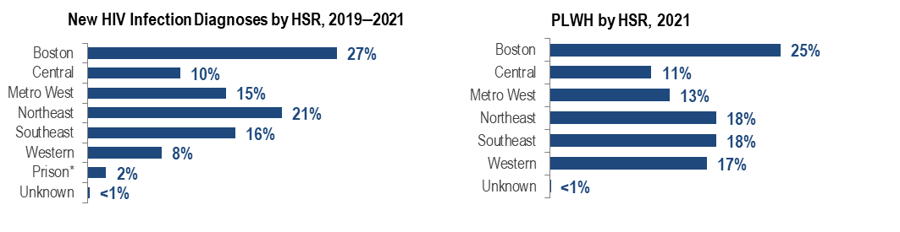
Figure 19 Note: *HSRs are regions defined geographically to facilitate focused health service planning. While prisons are not an HSR, the prison population is presented separately in this analysis because of its unique service planning needs. The prisons category represents persons who were diagnosed with HIV infection while in a correctional facility. As these data do not reflect current incarceration status, the category is not included for persons living with HIV infection.

The highest proportion of new HIV infection diagnoses in 2019 – 2021 was among residents of the Boston HSR (27%), followed by the Northeast HSR (21%), the Southeast HSR (16%), and the Metro West HSR (15%). Similar geographic distributions were observed for persons living with HIV infection (PLWH). The Boston HSR had the highest proportion of PLWH in 2021 (25%), followed by the Northeast and Southeast HSRs (both 18%), and the Western HSR (17%).
FIGURE 21. Percentage distribution of HIV infection diagnoses by Health Service Region (HSR) and exposure mode, Massachusetts 2019–2021 (N=1,419)
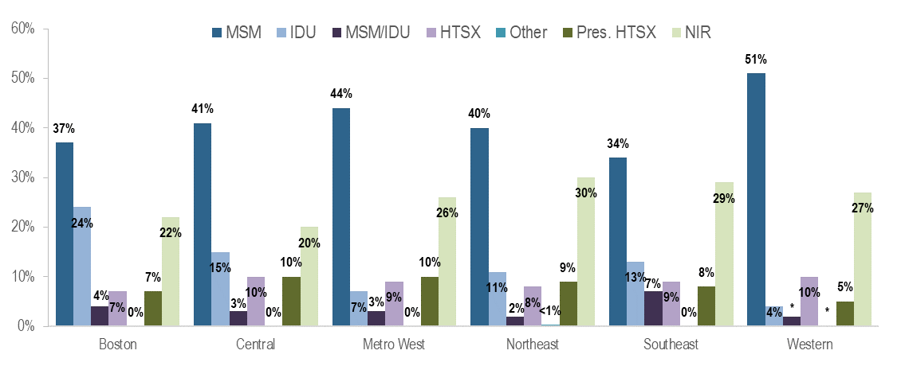
MSM was the most frequently reported exposure mode in all regions of Massachusetts for individuals diagnosed with HIV infection during 2019 to 2021, accounting for 51% of diagnoses in the Western HSR, 44% in the Metro West HSR, 41% in the Central HSRs, 40% in the Northeast HSR, 37% in the Boston HSR, and 34% in the Southeast HSR. The Boston HSR had the highest proportion of individuals with IDU exposure mode at 24%. IDU accounted for 4% to 15% of HIV infection diagnoses in the remaining regions.
FIGURE 22. Percentage distribution of HIV infection diagnoses by Health Service Region (HSR) and race/ethnicity, Massachusetts 2019–2021 (N=1,419)
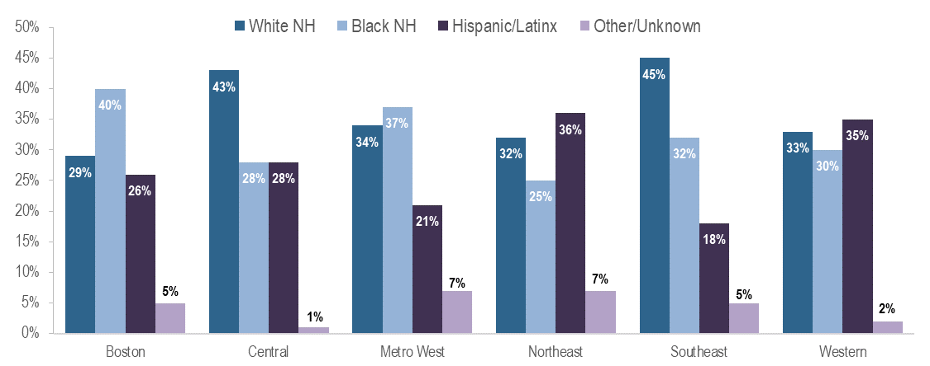
The Southeast HSR had the highest proportion of recent HIV infection diagnoses (2019–2021) among white (non-Hispanic) individuals at 45%, while the Boston HSR had the highest proportion among black non-Hispanic individuals at 40%, and the Northeast and Western HSRs had the highest proportions among Hispanic/Latinx individuals at 36% and 35%, respectively.
FIGURE 23. Average annual age-adjusted rate of HIV infection diagnosis per 100,000 population by county, Massachusetts 2019–2021
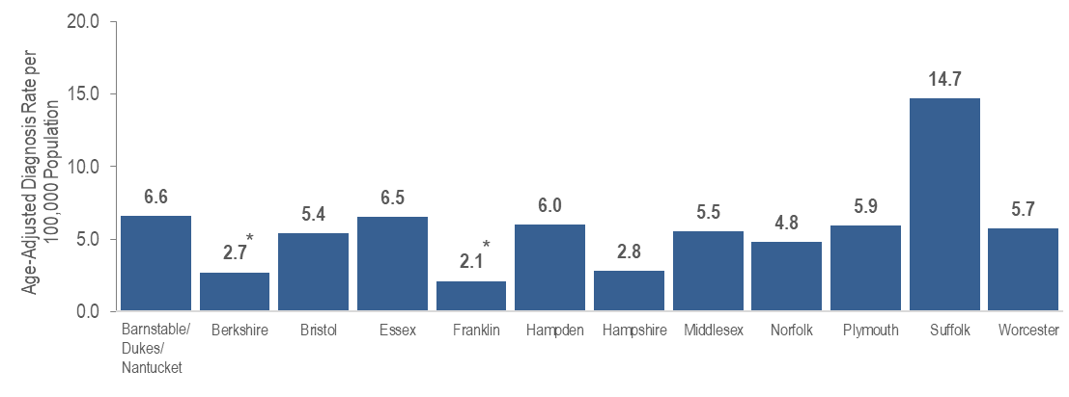
Figure 23 Note: *Rates based on numerators <12 are marked with an asterisk (*) and should be interpreted with caution. Barnstable, Dukes, and Nantucket Counties are combined because of small numbers.
Recently, Suffolk County, in which Boston is the biggest city, was selected as one of 48 counties nationally that is prioritized for funding in the U.S. Department of Health and Human Services’ initiative “Ending the HIV Epidemic (EHE): A Plan for America”. This is a ten-year initiative beginning in 2020 to achieve a 75% reduction in new HIV infections in five years and at least a 90% reduction in ten years. For more information about EHE, see https://www.hrsa.gov/ending-hiv-epidemic and https://jri.org/ending-the-hiv-epidemic-in-Massachusetts#:~:text=EHE%20efforts%20in%20Massachusetts%20aim,new%20HIV%20infections%2C%20and%20end for the Suffolk County EHE Plan. Suffolk County had the highest average age-adjusted rate of HIV infection diagnosis among all Massachusetts counties at 14.7 per 100,000, as well as the highest prevalence rate of persons living with HIV infection in 2021 at 785.8 per 100,000.

FIGURE 24. Average annual rate of HIV infection diagnosis per 100,000 population by city/town, Massachusetts 2019–2021
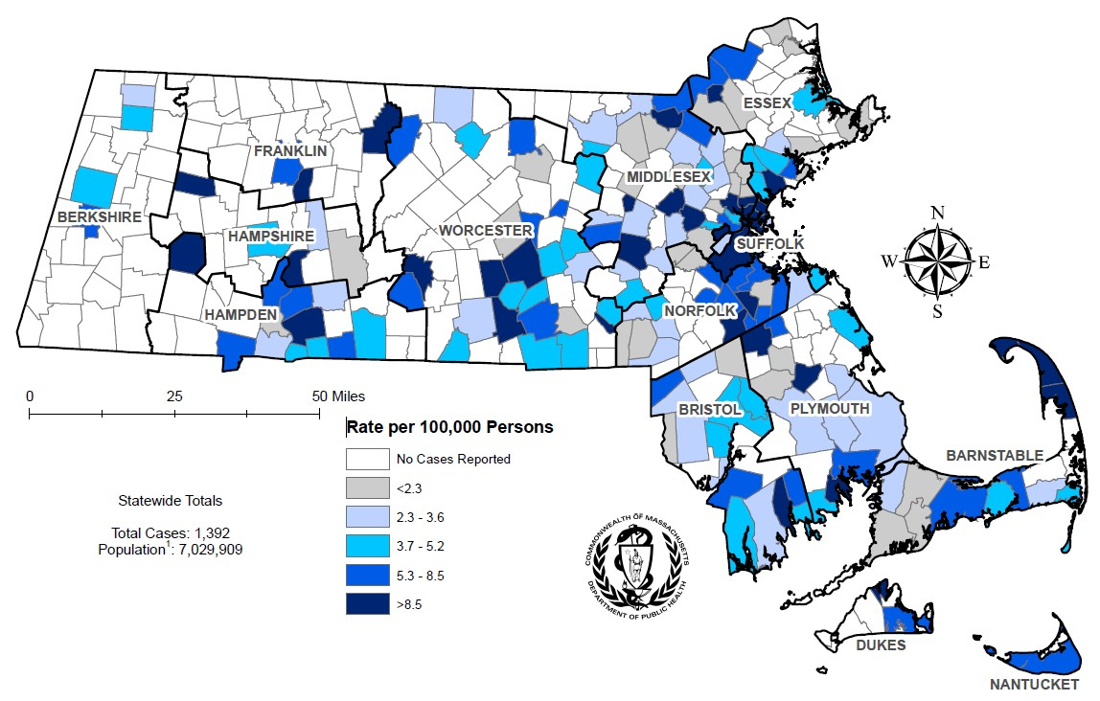
Figure 24 note: Regional HIV data exclude individuals diagnosed in a correctional facility.
The cities and towns with the highest average annual rate of HIV infection diagnosis during 2019 to 2021 included Everett (20.4 per 100,000), Brockton (18.9), Boston (17.0), Lawrence (15.7), and Malden (14.6). Boston had the highest number of new HIV infection diagnoses from 2019–2021 (N=344), followed by Worcester (N=82).
In early 2019, a new cluster of HIV infection was identified in Boston among PWID who are experiencing or have experienced recent homelessness. As of December 31, 2022, a total of 188 cases diagnosed since November 2018 have been investigated and identified as part of the Boston cluster. Emerging trends among those newly diagnosed in the Boston cluster (N=65 cases diagnosed in 2021) include an increase in polysubstance and methamphetamine use.
FIGURE 25. Prevalence rate of persons living with HIV infection (PLWH) per 100,000 population by city/town, Massachusetts 2021
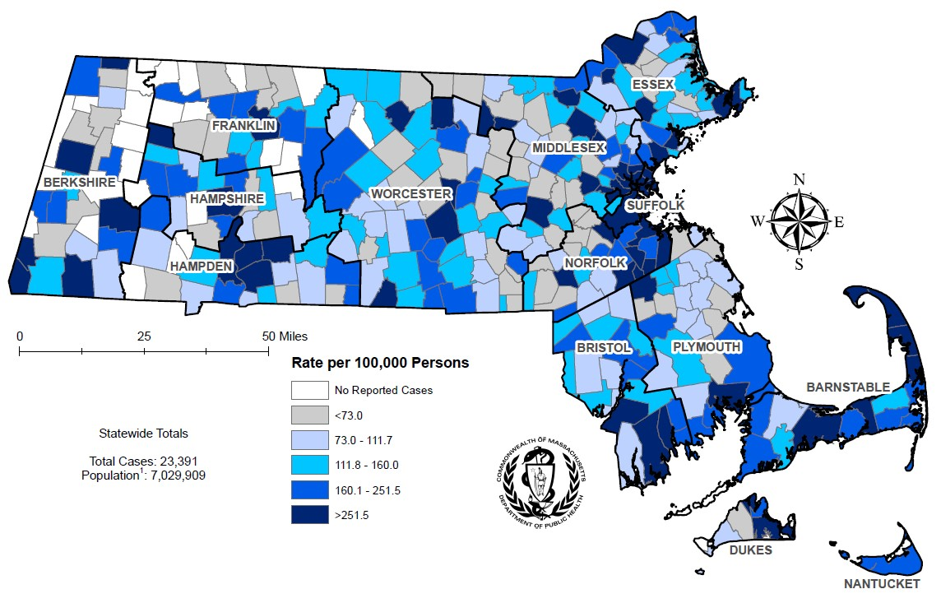
Figure 25 note: Regional HIV data exclude individuals diagnosed in a correctional facility.
The cities and towns in Massachusetts with the highest prevalence rate of PLWH in 2021 included Provincetown (11,439.9 per 100,000), Boston (838.9), Springfield (834.4), Holyoke (781.9), and Chelsea (740.4). Boston and Springfield had the highest numbers of PLWH in 2021, at 5,668 and 1,301, respectively.

HIV CARE CONTINUUM
FIGURE 26. Stages of HIV care among individuals newly diagnosed with HIV infection in Massachusetts, 2020 (N=408)
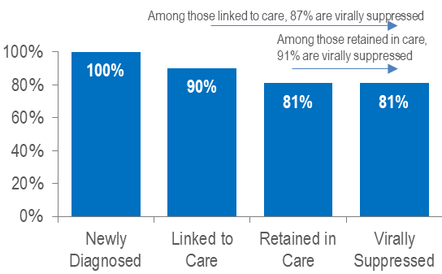

FIGURE 27. Viral load status among individuals newly diagnosed with HIV infection in Massachusetts, 2020 (N=408)
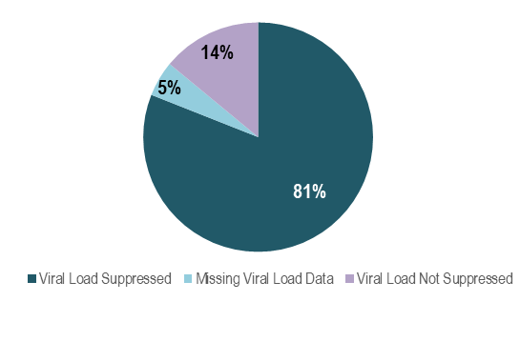
Figure 27 Note: Missing Viral Load Data includes individuals who had not had a lab reported in the past year
Among 408 individuals newly diagnosed with HIV infection in 2020 (and alive in Massachusetts through 2021), 81% were virally suppressed, 14% were not virally suppressed, and 5% did not have a viral load test in the year after diagnosis. Among those newly diagnosed individuals who were linked to care (N=368) and retained in care (N=331), rates of viral suppression were higher at 87% and 91%, respectively. Among individuals diagnosed with HIV infection in 2020, timely linkage to care differed by exposure mode. Viral suppression was lowest among individuals aged under 40 years and with injection drug use exposure mode.
FIGURE 28. Linkage to care among individuals newly diagnosed with HIV infection by sex assigned at birth, race/ethnicity, age, and exposure mode, Massachusetts 2020 (N=408)
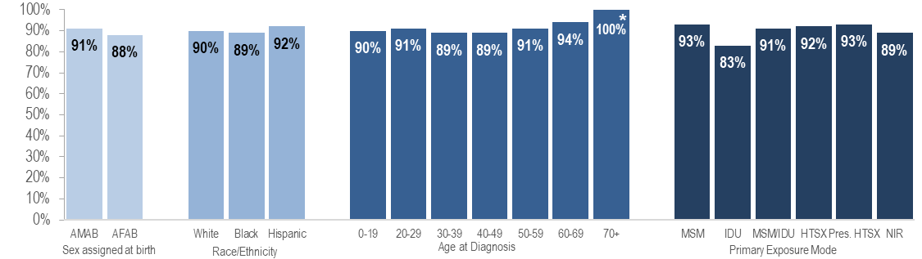
FIGURE 29. Viral suppression among individuals newly diagnosed with HIV infection by sex, race/ethnicity, age, and exposure mode, Massachusetts 2020 (N=408)
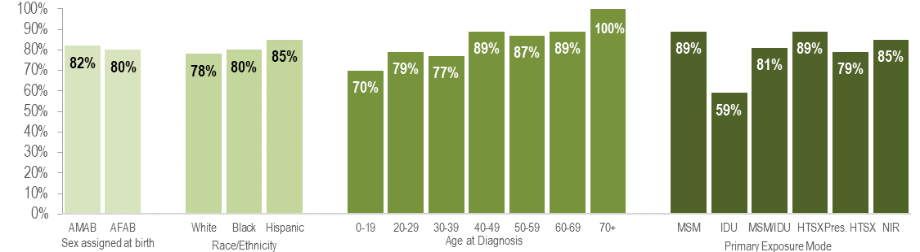
Figure 28 and 29 Note: *Percentages based on numerators <5 are marked with an asterisk (*) and should be interpreted with caution
FIGURE 30. Stages of HIV care among persons living with HIV infection in Massachusetts, 2021 (N=22,221)
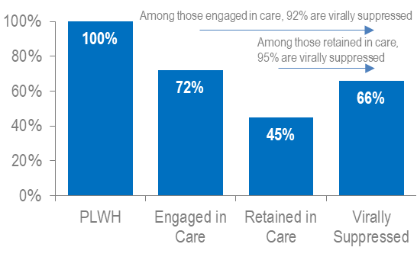
FIGURE 31. Viral load status among persons living with HIV infection in Massachusetts, 2021 (N=22,221)
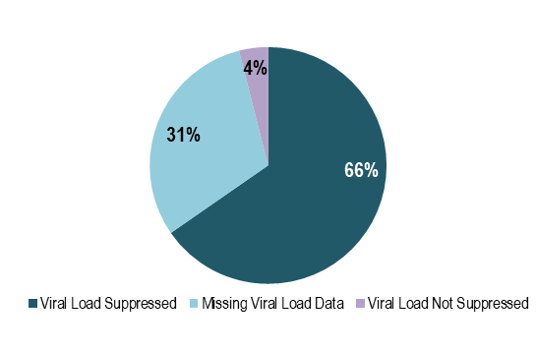
Figure 31 Note: Missing Viral Load Data includes individuals who had not had a lab reported in the past year
Among 22,221 persons living with HIV infection (PLWH) in Massachusetts at the end of 2021 (and diagnosed through 2020), 66% were virally suppressed, 4% were not virally suppressed, and 31% did not have a viral load test in 2021. Rates of care engagement and retention were lower in 2021 (72% and 45%, respectively) and 2020 (69% and 39%, respectively) than in 2019 (75% and 54% respectively), likely due to the effects of the COVID-19 pandemic. However, please note that the total number of PLWH used to calculate these rates includes all individuals who have ever been diagnosed with HIV infection in Massachusetts with no evidence of death or having moved out of the state or country. Quality assurance efforts are currently being conducted to update the number of PLWH used for this analysis. Among those PLWH who were engaged in care (N=15,936) and retained in care (N=10,010), rates of viral suppression were higher at 92% and 95%, respectively. In 2021, engagement in care and viral suppression among PLWH differed by age.
FIGURE 32. Engagement in care among persons living with HIV infection by sex assigned at birth, race/ethnicity, age, and exposure mode, Massachusetts 2020, (N=22,221)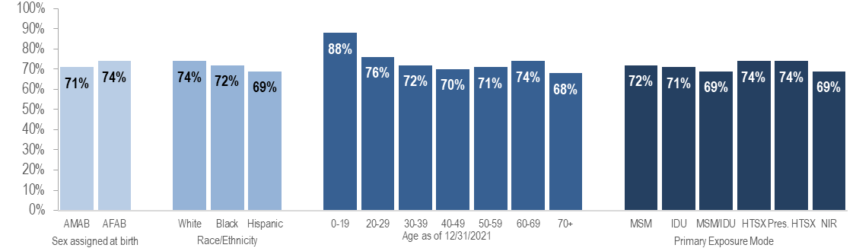
FIGURE 33. Viral suppression among persons living with HIV infection by sex assigned at birth, race/ethnicity, age, and exposure mode, 2021 (N=22,221)
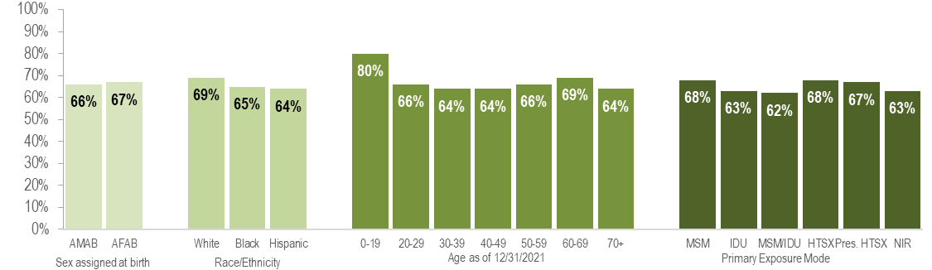
FIGURE 34. Viral suppression among persons living with HIV infection engaged in care by sex assigned at birth, race/ethnicity, age, and exposure mode, Massachusetts 2021 (N=15,936)
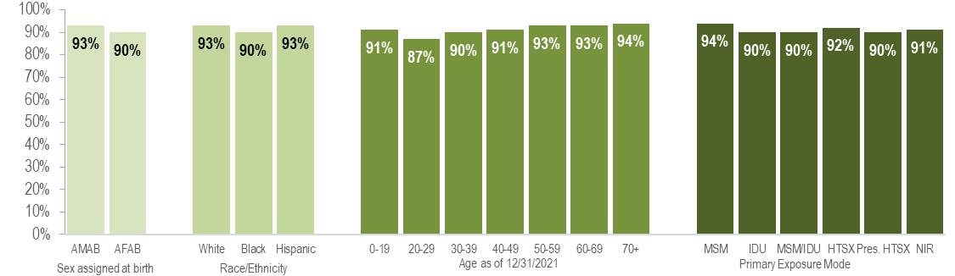
Among 15,936 persons living with HIV infection (PLWH) and engaged in care in Massachusetts at the end of 2021, viral suppression was lowest among individuals aged 20 to 29 years (87% versus 90%-94% for all other age groups). Viral suppression did not differ substantially by sex assigned at birth, race/ethnicity, or exposure mode among PLWH engaged in care.

SOCIAL VULNERABILITY INDEX
The social vulnerability index (SVI) is a tool to identify socially vulnerable communities that was created by CDC and the Agency for Toxic Substances and Disease Registry (ATSDR). The CDC/ATSDR SVI uses U.S. Census data to determine the social vulnerability of every census tract. The SVI ranks each tract on 16 social factors, including poverty, lack of vehicle access, and crowded housing, and groups them into four related themes: socioeconomic status, household characteristics, racial and ethnic minority status, and housing type/transportation. Each census tract receives a separate ranking for each of the four themes, as well as an overall ranking. Originally developed to incorporate social determinants of health into emergency response and recovery efforts for environmental and natural disasters, more recently, higher SVI has been linked to higher HIV diagnosis rates, COVID-19 mortality, and lower COVID-19 vaccination coverage.
FIGURE 35. HIV infection diagnoses by Social Vulnerability Index*, Massachusetts 2019–2021
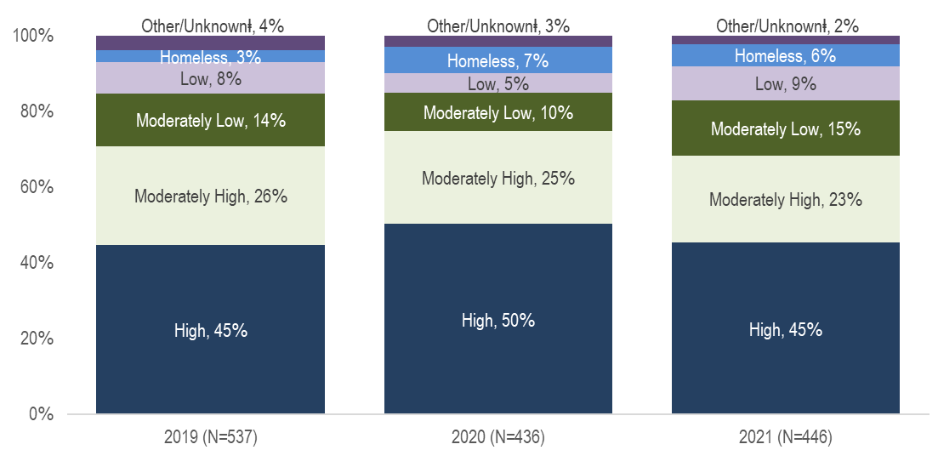
Figure 35 Notes: * Census tract level overall SVI values for 2020 were obtained from CDC/Agency for Toxic Substance and Disease Registry (CDC/ATSDR) and assigned to all cases based on their street address at diagnosis. Values range from 0 to 1, with higher values implying greater social vulnerability. SVI rankings were grouped into quartiles (low, <0.25; mid low, 0.25 - <0.5; mid high, 0.5 - <0.75; high >0.75).
ⱡ Other/Unknown includes correctional facility addresses, P.O. Box addresses, hospital addresses and addresses that could not be geocoded
Social Vulnerability Index
The majority of individuals recently diagnosed with HIV infection in Massachusetts were diagnosed in areas with high (45% in 2021) or moderately high (23% in 2021) social vulnerability.

TECHNICAL NOTES
I. Data source for all HIV case data:
Massachusetts Department of Public Health (MDPH) Bureau of Infectious Disease and Laboratory Sciences (BIDLS) HIV/AIDS Surveillance Program, data are current as of 01/01/2023 and may be subject to change.
II. Individuals living with HIV infection by current residence:
As of January 1, 2018, the MDPH BIDLS HIV fact sheets, epidemiologic reports, and other HIV data presentations include all persons living with HIV infection (PLWH) who are currently residing in Massachusetts. These prevalent cases include those who may have been first diagnosed in another state. Reports of incidence or new HIV infection diagnoses will continue to include only individuals who are first diagnosed in Massachusetts. Please note that HIV fact sheets, data reports, and presentations published from 2011 to 2017 include only cases that were first diagnosed in Massachusetts. BIDLS service planning continues to ensure responsive services to the entire population living with HIV infection in Massachusetts, regardless of place of diagnosis.
III. Configuration of Health Service Regions (HSR), Cities/Towns, and Counties
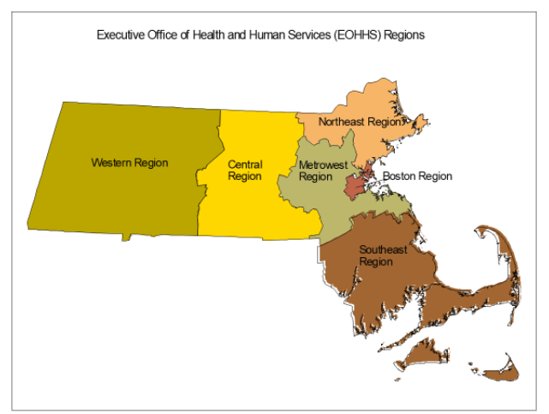
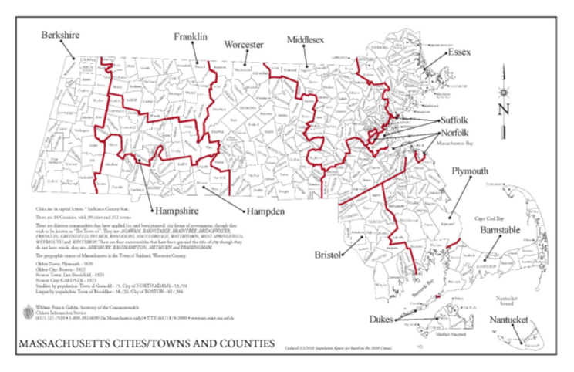
IV. Background on HIV reporting system
Massachusetts Department of Public Health (MDPH) regulations started requiring healthcare providers to submit case report forms, with demographic and risk information, on individuals diagnosed with AIDS in 1983, and with HIV infection in 1999. Existing cases of HIV infection diagnosed through 1998 were also to be reported by the end of 1999. When comparing HIV infection diagnosed before 1999 to HIV infection diagnosed after 1999, users should consider the differences in HIV reporting requirements for these two time periods. Since HIV was not reported at diagnosis prior to 1999 and clinical providers were given a relatively short time frame within which to report all prevalent HIV cases, the pre-1999 data may be less complete than data reported after 1999. Additionally, pre-1999 HIV infection diagnoses do not include individuals who were diagnosed with HIV infection and who died before 1999 without being reported with AIDS, nor do they include individuals who were no longer receiving HIV-related health care in Massachusetts at the point when HIV (non-AIDS) reporting became mandatory.
Beginning in 2019, all new diagnoses of HIV infection were assigned to field epidemiologists for partner services to ensure disease education/comprehension and assist with linkage to HIV care. As a part of this process, field epidemiologists helped to collect pertinent epidemiological, demographic, and risk information of the individual.
V. Data limitations
While trends in new HIV infection diagnoses are the best indicator of those who are most at risk of HIV infection, HIV surveillance reflects only incident diagnoses among individuals who are in care and not the actual incidence of new infections. Individuals may be living with HIV infection for many years prior to being tested and seeking care, at which point the case is considered a “diagnosis” and reported to the MDPH Bureau of Infectious Disease and Laboratory Sciences. In the most recent years of data presented, delays may occur in the reporting of a case to MDPH after it is diagnosed. Although Massachusetts regulations require providers to submit HIV case reports in a timely fashion, some 2021 HIV infection diagnoses will be reported to the surveillance program after the release of this report. Thus, the 2021 data presented in this report may change slightly. Previous analyses of Massachusetts HIV case data have suggested that the distribution of HIV infection diagnoses by race/ethnicity, sex assigned at birth and exposure mode for cases reported more than 6 months after diagnosis was not substantially different than the distribution of HIV infection diagnoses reported within 6 months. Caution should be exercised when considering changes in HIV infection diagnosis trends for 2021.
VI. Deaths among individuals reported with HIV
The death data presented in this report include all deaths among individuals diagnosed and reported with HIV in Massachusetts to present a full description of trends in mortality among this population. This includes deaths from non-HIV related causes such as drug overdoses, suicides, motor vehicle accidents and other causes. Therefore, the total number of annual deaths reported here will vary from the number of HIV-related deaths reported in Massachusetts Deaths by the Massachusetts Department of Public Health, Office of Population Health (available at https://www.mass.gov/lists/death-data). The death data reported here are considered complete through 2021. Data on deaths occurring in Massachusetts are from matches with the Massachusetts Registry of Vital Records and Statistics and from provider reports. Data on deaths occurring outside of Massachusetts are from matches with the Social Security Death Master File.
VII. HIV primary exposure mode definitions
The HIV primary exposure mode indicates the most probable risk behavior associated with HIV infection. Assignment of primary exposure mode is done in accordance with Centers for Disease Control and Prevention (CDC) guidelines when multiple exposure modes are reported. Although the reported primary exposure mode is the most likely mode of transmission, there is always the possibility that it is not the actual mode of transmission. Following is a description of the exposure mode categories:
- MSM (Male-to-Male Sex): Includes all individuals assigned male at birth who report any sexual contact with other individuals that identify as male. Please note that in accordance with CDC guidelines, this category is defined by an individual’s assigned sex at birth and not an individual’s current gender identity.
  - Sex with Men: This exposure mode category is used by the Bureau of Infectious Disease and Laboratory Sciences (BIDLS) to categorize sexual risk in transgender women reporting sex with men only. For the purposes of official reporting in the MA HIV/AIDS Surveillance System and to CDC, exposure mode for transgender women is based on sex assigned at birth, and therefore would be reported as male-to-male sex.
- IDU (Injection Drug Use): Cases among persons who report injection drug use.
- MSM/IDU: Includes all individuals assigned male at birth who report both sexual contact with other individuals that identify as male and injection drug use.
  - Sex with Men/IDU: This exposure mode category is used by BIDLS to categorize sexual risk in transgender women reporting both sex with men and injection drug use. For the purposes of official reporting in the MA HIV/AIDS Surveillance System and to CDC, exposure mode for transgender women is based on sex assigned at birth, and therefore would be reported as MSM/IDU.
- Heterosexual Sex: Cases among persons who report heterosexual sex with a person with, or at increased risk for, HIV infection (e.g., a PWID). The sub-categories for this mode of transmission are listed below.
  - Heterosexual Sex w/ a person who injects drugs
  - Heterosexual Sex w/ a person w/ HIV infection
  - Heterosexual Sex w/ bisexual male
  - Other Heterosexual Sex: includes all other sub-categories of heterosexual risk, such as heterosexual contact with a person infected through a blood transfusion.
- Other: Cases among persons with other known exposure modes, including receipt of clotting factor, receipt of transfusion or transplant, and mother-to-child transmission through pregnancy, childbirth, or breastfeeding (perinatal transmission).
- Presumed Heterosexual: The presumed heterosexual risk category is used by BIDLS exclusively for individuals assigned female at birth to identify HIV exposure mode when sex with individuals that identify as male was the only reported risk factor, there was no evidence of current or past injection drug use (IDU), and behavioral risk and HIV status information about sexual partners that identify as male was unknown. The rationale for the application of the presumed heterosexual risk category to individuals assigned female at birth only has been addressed in the MDPH Office of HIV/AIDS report “Intersecting Risks: HIV Infection among Heterosexual Women and Men in Massachusetts” (2010).
- NIR (No Identified Risk): Cases among persons with no reported history of exposure to HIV through any of the listed exposure categories. Follow-up is conducted to determine risk for those cases that are initially reported without a risk identified. Includes cases among individuals assigned male at birth who were previously categorized in Massachusetts as Presumed Heterosexual.
VIII. Cell suppression methodology:
Values less than five are suppressed for denominator populations less than 50,000 or for unknown size. Additional values may be suppressed to prevent back calculation. Values less than five are not suppressed for compound categories (categories containing two or more subcategories, such as other/undetermined or other exposure modes, which includes pediatric, blood, and blood products exposure modes), because the exact population value of each subcategory cannot be determined.
IX. Population estimates used for rate calculations
As of 1/1/2020, BIDLS calculates rates per 100,000 population using denominators estimated by the University of Massachusetts Donahue Institute using a modified Hamilton-Perry model. 2020 population estimates were used for single-year rates; for pooled year rates (i.e., 2019-2021), the 2020 population estimates were multiplied by three. For more information, see: Strate S, et al. Small Area Population Estimates for 2011 through 2020, report published Oct 2016, and http://www.donahue.umassp.edu/business-groups/economic-public-policy-research/massachusetts-population-estimates-program. Note that rates and trends calculated using previous methods cannot be compared to these.
X. Explanation of age-adjusted rates
A rate of a disease per 100,000 population is a useful way to compare groups with substantially different population sizes rather than relying on the raw number of cases. For example, the number of individuals living with HIV infection (PLWH) on December 31, 2021 who are Hispanic/Latinx is 6,346, whereas the number of individuals living with HIV infection who are white (non-Hispanic) is 9,140. Although the number of individuals living with HIV infection who are Hispanic/Latinx in Massachusetts is smaller than the number of individuals living with HIV infection who are white (non-Hispanic), we also need to consider that there are far fewer individuals of Hispanic/Latinx heritage living in Massachusetts than white (non-Hispanic) individuals. Hispanic/Latinx individuals represent 12% of the Massachusetts population compared to white (non-Hispanic) individuals who represent 71% of the population. If HIV had the same impact on the Hispanic/Latinx population of the state as on the white (non-Hispanic) population, then there should be six times as many cases in white (non-Hispanic) individuals, but there are less than twice as many. By calculating a rate which takes into consideration the differences in the population size, it is evident that the number of individuals living with HIV infection for every 100,000 Hispanic/Latinx individuals in Massachusetts is much higher than the rate for every 100,000 white (non-Hispanic) individuals. This is called a "crude rate" and is calculated by dividing the number of individuals living with HIV infection by the population of interest (the total number of Hispanic/Latinx individuals in Massachusetts, for example) and multiplying by 100,000. (See example below.)
Example: Calculation of crude HIV prevalence rate for white (non-Hispanic) individuals, Massachusetts (189.1 per 100,000)
Crude HIV prevalence rate for white (non-Hispanic) individuals | = [number of white (non-Hispanic) individuals living with HIV infection ÷ population size of white (non-Hispanic) individuals] ×100,000
 | = (9,140/4,832,394.52) ×100,000
 | = (0.0018914) ×100,000
 | = 189.1

However, sometimes, in addition to the population size being different, the age composition of the populations is different. In Massachusetts, the black (non-Hispanic) and Hispanic/Latinx populations are on average younger than white (non-Hispanic) population (medians: 29.7 years and 24.5 years vs. 38.8 years, respectively). Therefore, it is necessary to age-adjust the HIV prevalence rate to get a true comparison of the impact of the disease across racial/ethnic groups without an effect from the differences in age composition. Age-adjustment of rates minimizes the distortion created by differences in age composition. Age-adjusted rates are calculated by weighting the age-specific rates for a given population by the age distribution of a standard population. The weighted age-specific rates are then summed to produce the adjusted rate for all ages combined.
XI. HIV Care Continuum Indicator Definitions:
- HIV care continuum among individuals newly diagnosed with HIV infection in Massachusetts: “Newly Diagnosed” includes individuals diagnosed in 2020, alive through 12/31/2021, and living in Massachusetts based on last known address. “Linked to Care” is defined as having ≥1 viral load (VL) or CD4 test result within 3 months of diagnosis. “Retained in Care” is defined as having ≥2 VL or CD4 test results at least 3 months apart during the 12-month period after diagnosis. “Virally Suppressed” is defined as having a VL <200 copies/mL for the most recent VL test drawn during the 12-month period after diagnosis.
- HIV care continuum among persons living with HIV infection (PLWH) in Massachusetts: “PLWH” refers to individuals diagnosed through 2020, alive through 12/31/2021, and living in Massachusetts based on last known address. “Engaged in Care” is defined as having ≥1 VL or CD4 test result in 2020. “Retained in Care” is defined as having ≥2 VL or CD4 test results at least 3 months apart in 2021. “Virally Suppressed” is defined as having a VL <200 copies/mL for the most recent VL test drawn in 2021.

Source: Centers for Disease Control and Prevention and Health Resources and Services Administration. Integrated Guidance for Developing Epidemiologic Profiles: HIV Prevention and Ryan White HIV/AIDS Program Planning. Atlanta, Georgia: Centers for Disease Control and Prevention; 2022.
Please consider the impact of the COVID-19 pandemic on infectious disease screening, treatment, and surveillance in the interpretation of 2020 and 2021 data.
Please consider the impact of the COVID-19 pandemic on infectious disease screening, treatment, and surveillance in the interpretation of 2020 and 2021 data.
For more information, see: Charles Alpren et al. “Opioid Use Fueling HIV Transmission in an Urban Setting: An Outbreak of HIV Infection Among People Who Inject Drugs—Massachusetts, 2015–2018”, American Journal of Public Health 110, no. 1 (January 1, 2020): pp. 37-44. https://doi.org/10.2105/AJPH.2019.305366
For more information, see: Joint MDPH and BPHC Clinical Advisory: Increase in newly diagnosed HIV infections among persons who inject drugs in Boston, March 15, 2021, available at: https://www.mass.gov/doc/joint-mdph-and-bphc-clinical-advisory-hiv-transmission-through-injection-drug-use-in-boston-march-15-2021/download
Please consider the impact of the COVID-19 pandemic on infectious disease screening, treatment, and surveillance in the interpretation of 2020 and 2021 data.
External causes of injuries includes intentional injuries (e.g., homicide and suicide), unintentional injuries (e.g., motor vehicle and non-transport related accidents), and injuries of undetermined intent.
Please consider the impact of the COVID-19 pandemic on infectious disease screening, treatment, and surveillance in the interpretation of 2020 and 2021 data.
Among cities that reported at least 12 HIV infections during 2019-2021.
Virally Suppressed” is defined as having a VL <200 copies/mL for the most recent VL test drawn during the 12-month period after diagnosis.
“Linked to Care” is defined as having ≥1 viral load (VL) or CD4 test result within 3 months of diagnosis.
“Retained in Care” is defined as having ≥2 VL or CD4 test results at least 3 months apart during the 12-month period after diagnosis.
“Virally Suppressed” is defined as having a VL <200 copies/mL for the most recent VL test drawn in 2021.
“Engaged in Care” is defined as having ≥1 VL or CD4 test result in 2021.
“Retained in Care” is defined as having ≥2 VL or CD4 test results at least 3 months apart in 2021.
Please consider the impact of the COVID-19 pandemic on infectious disease screening, treatment, and surveillance in the interpretation of 2020 and 2021 data.
Please consider the impact of the COVID-19 pandemic on infectious disease screening, treatment, and surveillance in the interpretation of 2020 and 2021 data.
Please consider the impact of the COVID-19 pandemic on infectious disease screening, treatment, and surveillance in the interpretation of 2020 and 2021 data.
All individuals diagnosed with HIV infection from 2012-2021 with other exposure mode were perinatal exposures
99.7% of individuals diagnosed with HIV infection from 2012–2021 who were born in a US dependency were born in Puerto Rico
Please consider the impact of the COVID-19 pandemic on infectious disease screening, treatment, and surveillance in the interpretation of 2020 and 2021 data.
For more information, see: Charles Alpren et al. “Opioid Use Fueling HIV Transmission in an Urban Setting: An Outbreak of HIV Infection Among People Who Inject Drugs—Massachusetts, 2015–2018”, American Journal of Public Health 110, no. 1 (January 1, 2020): pp. 37-44. https://doi.org/10.2105/AJPH.2019.305366 and Joint MDPH and BPHC Clinical Advisory: Increase in newly diagnosed HIV infections among persons who inject drugs in Boston, March 15, 2021, available at: https://www.mass.gov/doc/joint-mdph-and-bphc-clinical-advisory-hiv-transmission-through-injection-drug-use-in-boston-march-15-2021/download
Please consider the impact of the COVID-19 pandemic on infectious disease screening, treatment, and surveillance in the interpretation of 2020 and 2021 data.
All individuals diagnosed with HIV infection from 2012-2021 with other exposure mode were perinatal exposures
99.7% of individuals diagnosed with HIV infection from 2012–2021 who were born in a US dependency (USD) were born in Puerto Rico (PR)
Please consider the impact of the COVID-19 pandemic on infectious disease screening, treatment, and surveillance in the interpretation of 2020 and 2021 data.
Please consider the impact of the COVID-19 pandemic on infectious disease screening, treatment, and surveillance in the interpretation of 2020 and 2021 data.
Please consider the impact of the COVID-19 pandemic on infectious disease screening, treatment, and surveillance in the interpretation of 2020 and 2021 data.
Please consider the impact of the COVID-19 pandemic on infectious disease screening, treatment, and surveillance in the interpretation of 2020 and 2021 data.
Please consider the impact of the COVID-19 pandemic on infectious disease screening, treatment, and surveillance in the interpretation of 2020 and 2021 data.
Please consider the impact of the COVID-19 pandemic on infectious disease screening, treatment, and surveillance in the interpretation of 2020 and 2021 data.
As of 1/1/2020, BIDLS calculates rates per 100,000 population using denominators estimated by the University of Massachusetts Donahue Institute using a modified Hamilton-Perry model (Strate S, et al. Small Area Population Estimates for 2011 through 2020, report published Oct 2016). Note that rates and trends calculated using previous methods cannot be compared to these. All rates are age-adjusted using the 2000 US standard population.
Please consider the impact of the COVID-19 pandemic on infectious disease screening, treatment, and surveillance in the interpretation of 2020 and 2021 data.
Please consider the impact of the COVID-19 pandemic on infectious disease screening, treatment, and surveillance in the interpretation of 2020 and 2021 data.
Please consider the impact of the COVID-19 pandemic on infectious disease screening, treatment, and surveillance in the interpretation of 2020 and 2021 data.
Please consider the impact of the COVID-19 pandemic on infectious disease screening, treatment, and surveillance in the interpretation of 2020 and 2021 data.
As of 1/1/2020, BIDLS calculates rates per 100,000 population using denominators estimated by the University of Massachusetts Donahue Institute using a modified Hamilton-Perry model (Strate S, et al. Small Area Population Estimates for 2011 through 2020, report published Oct 2016). Note that rates and trends calculated using previous methods cannot be compared to these. All rates are age-adjusted using the 2000 US standard population.
Please consider the impact of the COVID-19 pandemic on infectious disease screening, treatment, and surveillance in the interpretation of 2020 and 2021 data.
Please consider the impact of the COVID-19 pandemic on infectious disease screening, treatment, and surveillance in the interpretation of 2020 and 2021 data.
Data Source for Massachusetts death data: Office of Population Health, Massachusetts Department of Public Health. Note 2021 death data are preliminary.
As of 1/1/2020, BIDLS calculates rates per 100,000 population using denominators estimated by the University of Massachusetts Donahue Institute using a modified Hamilton-Perry model (Strate S, et al. Small Area Population Estimates for 2011 through 2020, report published Oct 2016). Note that rates and trends calculated using previous methods cannot be compared to these. All rates are age-adjusted using the 2000 US standard population.
Please consider the impact of the COVID-19 pandemic on infectious disease screening, treatment, and surveillance in the interpretation of 2020 and 2021 data.
Data Source for Massachusetts death data: Office of Population Health, Massachusetts Department of Public Health. Note 2021 death data are preliminary.
External causes of injuries includes intentional injuries (e.g., homicide and suicide), unintentional injuries (e.g., motor vehicle and non-transport related accidents), and injuries of undetermined intent.
Please consider the impact of the COVID-19 pandemic on infectious disease screening, treatment, and surveillance in the interpretation of 2020 and 2021 data.
As of 1/1/2020, BIDLS calculates rates per 100,000 population using denominators estimated by the University of Massachusetts Donahue Institute using a modified Hamilton-Perry model (Strate S, et al. Small Area Population Estimates for 2011 through 2020, report published Oct 2016). Note that rates and trends calculated using previous methods cannot be compared to these. All rates are age-adjusted using the 2000 US standard population.
Please consider the impact of the COVID-19 pandemic on infectious disease screening, treatment, and surveillance in the interpretation of 2020 and 2021 data.
Please consider the impact of the COVID-19 pandemic on infectious disease screening, treatment, and surveillance in the interpretation of 2020 and 2021 data.
External causes of injuries includes intentional injuries (e.g., homicide and suicide), unintentional injuries (e.g., motor vehicle and non-transport related accidents), and injuries of undetermined intent.
Other includes perinatal and clotting factor /transfusion/transplant-related exposures
Ninety-nine percent of individuals reported with HIV/AIDS who died from 2011–2020 who were born in a US dependency (USD) were born in Puerto Rico (PR)
Please consider the impact of the COVID-19 pandemic on infectious disease screening, treatment, and surveillance in the interpretation of 2020 and 2021 data.
Deaths among individuals reported with HIV infection with a missing cause of death are excluded from this analysis (2012–2020 N=385). Data are presented for the most recent ten-year period for which cause of death data was available.
Please consider the impact of the COVID-19 pandemic on infectious disease screening, treatment, and surveillance in the interpretation of 2020 and 2021 data
External causes of injuries includes intentional injuries (e.g., homicide and suicide), unintentional injuries (e.g., motor vehicle and non-transport related accidents), and injuries of undetermined intent.
Source: Massachusetts Department of Public Health, Office of Population Health. Massachusetts Deaths 2020; January 2023. available at: https://www.mass.gov/doc/2020-death-report/download
Please consider the impact of the COVID-19 pandemic on infectious disease screening, treatment, and surveillance in the interpretation of 2020 and 2021 data.
Please consider the impact of the COVID-19 pandemic on infectious disease screening, treatment, and surveillance in the interpretation of 2020 and 2021 data.
Please consider the impact of the COVID-19 pandemic on infectious disease screening, treatment, and surveillance in the interpretation of 2020 and 2021 data.
As of 1/1/2020, BIDLS calculates rates per 100,000 population using denominators estimated by the University of Massachusetts Donahue Institute using a modified Hamilton-Perry model.
Please consider the impact of the COVID-19 pandemic on infectious disease screening, treatment, and surveillance in the interpretation of 2020 and 2021 data.
Among cities that reported at least 12 HIV infections during 2019-2021.
For more information, see: Joint MDPH and BPHC Clinical Advisory: Increase in newly diagnosed HIV infections among persons who inject drugs in Boston, March 15, 2021, available at: https://www.mass.gov/doc/joint-mdph-and-bphc-clinical-advisory-hiv-transmission-through-injection-drug-use-in-boston-march-15-2021/download
Please consider the impact of the COVID-19 pandemic on infectious disease screening, treatment, and surveillance in the interpretation of 2020 and 2021 data.
Among cities that reported at least 50 PLWH as of 12/31/2021. Note: The rate of HIV prevalence for Provincetown is very high because of small population size (3,663), as opposed to the number of cases (419).
Please consider the impact of the COVID-19 pandemic on infectious disease screening, treatment, and surveillance in the interpretation of 2020 and 2021 data.
For definitions of the care continuum stages, see Technical note XI
Please consider the impact of the COVID-19 pandemic on infectious disease screening, treatment, and surveillance in the interpretation of 2020 and 2021 data.
Please consider the impact of the COVID-19 pandemic on infectious disease screening, treatment, and surveillance in the interpretation of 2020 and 2021 data.
For definitions of the care continuum stages, see technical note XI
Please consider the impact of the COVID-19 pandemic on infectious disease screening, treatment, and surveillance in the interpretation of 2020 and 2021 data.
For more information, see: https://www.atsdr.cdc.gov/placeandhealth/svi/index.html
Gant, Z., Dailey, A., Hu, X. et al. A Census Tract–Level Examination of Diagnosed HIV Infection and Social Vulnerability among Black/African American, Hispanic/Latinx, and White Adults, 2018: United States. J. Racial and Ethnic Health Disparities (2022). https://doi.org/10.1007/s40615-022-01456-7
Dasgupta S, Bowen VB, Leidner A, et al. Association Between Social Vulnerability and a County’s Risk for Becoming a COVID-19 Hotspot — United States, June 1–July 25, 2020. MMWR Morb Mortal Wkly Rep 2020;69:1535–1541. DOI: http://dx.doi.org/10.15585/mmwr.mm6942a3
Please consider the impact of the COVID-19 pandemic on infectious disease screening, treatment, and surveillance in the interpretation of 2020 and 2021 data.

