Massachusetts State Exposition Building
2024 Exhibit Opportunities/Application
September 13–September 29, 2024

OVERVIEW
Eastern States Exposition (The Big E) is an annual event that takes place in West Springfield, MA for 17 days (currently scheduled for September 13th through September 29, 2024) and draws over 1.6 million people. The Massachusetts Building (“Building”) located on the Avenue of States provides Massachusetts businesses, non-profits, and other entities an opportunity to showcase their products and services through an annual application process.

The following outlines the application process. Additional guideline information is available at the Massachusetts Department of Agricultural Resource’s (“MDAR”) website. Participating in the Big E in the Building is subject to compliance with all applicable federal, state, and local requirements in place at the time of the Big E. All requirements and any changes to the Big E will be communcated to applicants or selected applicants, depending on timing, as soon as they become available.
HOW TO APPLY
All exhibitors must submit the attached application to MDAR by 4:00 P.M. Friday, March 8, 2024 for consideration. The application should be submitted via email to Fran Pearson at Frances.Pearson@mass.gov and by mail to MDAR, Attn: Fran Pearson, 225 Turnpike Road, 3rd Floor, Southborough, MA 01772. A $100 application fee payable to “Commonwealth of Massachusetts, Massachusetts State Exposition Building Maintenance Fund” is due with the completed application.

First time applicants are asked to contact Fran Pearson, Building Manager at 617-655-3511 or Heather Labonte, Assistant Building Manager at 857-276-7385 prior to submitting an application to further discuss the available opportunities. First time applicants that qualify are required to participate in a New Applicant Presentation Day scheduled for Wednesday, March 27, 2024 (snow date: Tuesday, April 1, 2024). A new applicant that is unable to participate in New Applicant Presentation Day will not be considered and the application shall be deemed incomplete.

MA ENTITY REQUIREMENTS
MA Business/Non-profit: Applicants must demonstrate that they are a registered Massachusetts entity conducting business within the Commonwealth. Proof is required with the application and may include a current:
- Certificate of Good Standing from the Secretary of the Commonwealth of Massachusetts issued within the past sixty (60) days.
- Business certificate from the Massachusetts city/town in which business is conducted.
- Non-Profit 501(c)(3) documentation; or
- Supporting documentation that describes the structure of the non-profit organization.
DO NOT send copies of tax returns or other financial information that may include personal information, as all applications are subject to the Public Records law.

TERMS OF AGREEMENT
By applying, you are agreeing to the following fee structure:

EXHIBITOR FEE SCHEDULE
- Retail: $25 per square foot
- Food and beverage: 6.5% of gross sales (reported daily via electronic reporting system) or $30 per square foot, whichever is higher
- Beer/wine sales (on-premises consumption): 35% of gross sales (reported daily via electronic reporting system)
- Porch Space (Maximum of 10 days): $200 per day
- Government Agencies (Educational only): $500 flat fee
- Educational display $500 flat fee

“Gross Sales” shall be defined as total sales less Massachusetts Sales Tax. Failure to report and pay in a timely manner may cause temporary suspension or permanent revocation of the Exhibitor’s license and may prevent future participation in the Building at the Big E.

PAYMENT SCHEDULE

Vendor Type | **July 24th- submitted with completed license agreement | Sept. 25th | Sept. 30th
Retail- $25 per sq ft | $1,000 | Balance | N/A
Food/Beverage | $1,000 | N/A | Balance
Porch: $200 per day | 50% | Balance | N/A
Government Agency | $400 | N/A | N/A
Educational Display | $400 | N/A | N/A
** Unless otherwise agreed upon prior to due date by written consent with Building Manager

Rental fee (minus $100.00 deposit) should be made payable by certified or bank treasurer’s check to the Commonwealth of Massachusetts, Massachusetts State Exposition Building Maintenance Fund as outline above. Any payments made after the applicable due date will be assessed a $25.00 late fee each day past due. Exhibitors not in compliance may have their application denied in future years.

VENDOR SPACE
Each Exhibitor accepts responsibility for any changes needed (plumbing, electrical) to customize their space. Work must be done by a licensed and insured technician and approved in advance by Building Management. The Exhibitor booth space, product list and interior signage must be approved prior to signing the License Agreement. All exhibition space must look professional and encouraging to visitors to stop by, learn, interact, and purchase, where applicable.

SELECTION OF EXHIBITORS
MDAR, in coordination with the Massachusetts Building Advisory Committee, strives to avoid product and service competition among Exhibitors in its booth spaces. Please note: there is no assurance of exclusivity for any Exhibitor as to particular product or service offerings made during the Big E. Past Building Exhibitors are not guaranteed selection for the Big E or exclusivity of their product or service in current or successive years. All submitted applications will be reviewed and considered by MDAR, which retains sole discretion as to which applicants may be selected to participate. All applicants will be notified whether or not they have been selected in May, 2024.

All selected applicants will be required to enter into a license agreement by July 29, 2024. **Please note the $100 application fee is non-refundable once an applicant is selected.**

HOURS OF OPERATION/ STAFFING
The Building is open to fair-goers from 10:00 AM to 9:00 PM. Each exhibit MUST be staffed at all times during these hours. The building opens at 7:30 AM for exhibitors to begin daily preparation, which must be completed by 9:45 AM and remain in place until 9:00 PM.

INSURANCE REQUIREMENTS
See “Exhibitors Guideline” at MDAR website by clicking here for complete requirements. Proof of insurance must be provided to MDAR no later than Wednesday, July 26, 2024.

PUBLIC HEALTH PERMIT REQUIREMENTS
Exhibitors serving food and/or beverage must obtain a permit online from the West Springfield Board of Health. Fees are paid directly to the West Springfield Board of Health by its deadline (at least 30 days before the event or as otherwise provided by West Springfield). MDAR is not responsible for missed deadlines, which may result in the inability to participate.

Effective January 2019, the Town of West Springfield implemented a Single-Use Plastic ban. Additional information is available at the Department’s website.

Effective June 2019, the Town of West Springfield implemented a plastic bag ban where checkout bag to customers, the bag shall comply with the requirements of being either a recyclable paper bag, a compostable and marine-degradable plastic bag, or a reusable checkout bag. Additional information can be found here.

Effective June 2020, the Town of West Springfield implemented a polystyrene ban. As such, no Styrofoam food containers are allowed. Additional information can be found on their website by clicking here. Exhibitors are responsible for maintaining compliance with these bans.

All Exhibitors must comply with all applicable federal, state, and local regulations, ordinances, or other guidance issued that are in effect at the time any vendor is in the building and throughout the Big E.

MDAR reserves the right to:

Limit Building capacity as well as the number of Exhibitors, booth size and location, which could result in the loss of revenue and increased expenses.

Require Exhibitors to comply with all West Springfield Board of Health and Commonwealth of Massachusetts requirements, including but not limited to possible booth alterations at Exhibitors’ expense.

Require all Exhibitors to provide personal protective equipment for booth staff.

Comply with any other Exposition Event Guidelines.
Failure to comply with these requirements will result in the termination of any Agreement in effect at the time and immediate removal from the Building.

IMPORTANT REMINDERS
TIMELINE – Dates are subject to change:

- Application deadline and deposit Friday, March 8, 2024
- New Applicant Presentation Day Friday, March 27, 2024 (snow date Tuesday,
April 1, 2024)
- Application decision Friday, May 31, 2024
- Mandatory Exhibitors Meeting Wednesday, June 18, 2024
- Work Permit deadline Wednesday, June 26, 2024
- Health Certificate deadline Wednesday, July 24, 2024
- License Agreement & Certificate of
Insurance Wednesday, July 24, 2024
- Commitment fee- (see applicable Wednesday, July 24, 2024
fee schedule above)
- Admission/parking request Wednesday, July 24, 2024
- Basement storage form Wednesday, July 24, 2024
- Refrigeration/freezer request Wednesday, July 24, 2024
- Dead storage form Wednesday, July 24, 2024
- Booth payment deadline See payment schedule above

Special Days
- Massachusetts Day Thursday, September 19, 2024
- Harvest New England Day Friday, September 27, 2024

Exhibitors interested in participating in Massachusetts Day or Harvest New England Day are encouraged to review and complete the application available on our website by clicking here.

Statement of Understanding:

- All food and beverage products, hard goods, and other products or services must be local (i.e., grown, produced, or manufactured in Massachusetts). They must also be available commercially (other than commodity-related associations) on a regular basis in Massachusetts (e.g., year-round availability online or in-store, not only during the Big E). They must also be manufactured and sold in accordance with applcable state and federal law.
- Booths are a raw space and each Exhibitor is responsible for presenting plans for booth build out or changes to the Building Manager or Building Assistant Manager for review and approval. Exhibitors accept responsibility for any changes needed (e.g., plumbing, electrical, signage) to customize their space. The Ehibitor space, product inventory, and interior signage must be approved by the Building Manager or Building Assistant Manager prior to signing the license agreement.
- Participants are promoting their products in a Building owned and operated by the Commonwealth of Massachusetts and will be a professional, respectful, and positive representation of the state.
- Participants understand they are solely responsible for property, valuables, money, and personal items and should take care to protect such items.
- Participants shall fully comply with applicable health, fire and safety codes, rules, ordinances, regulations, and statutes, emergency safety protocols by Building Management and/or its designees.
- Compliance with the Commonwealth of Massachusetts Policy regarding, Non-Smoking, Drug and Alcohol Use, and Harassment and Civil Rights: The Avenue of States, including the Massachusetts Building, is a non-smoking facility. It is the policy of the Commonwealth of Massachusetts to maintain an alcohol and drug-free work environment and one that is free of intimidation and harassment. Participants and contractors, and their respective agents, employees, representatives, associates, and building staff are to comply with the Commonwealth of Massachusetts workplace policies for drug-free workplace and its policy against harassment during the event hours of operation.
- Whenever possible, the Department seeks to integrate Environmental Justice into its programs. Environmental justice is based on the principle that all people have a right to be protected from environmental hazards and to live in and enjoy a clean and healthful environment regardless of race, color, national origin, income, or English language proficiency. Environmental justice is the equal protection and meaningful involvement of all people and communities with respect to the development, implementation, and enforcement of energy, climate change, and environmental laws, regulations, and policies and the equitable distribution of energy and environmental benefits and burdens. It is the policy of the Executive Office of Energy and Environmental Affairs that environmental justice principles shall be an integral consideration, to the extent applicable and allowable by law, in making any policy, making any determination or other action related to a project review, in undertaking any project pursuant to M.G.L. c. 30 sections 61 through 62J, inclusive, and related regulations that are likely to affect environmental justice populations, and in the implementation of all EEA programs, including but not limited to, the grant of financial resources or technical assistance, the promulgation, implementation and enforcement of laws, regulations, and policies, the provision of access to both active and passive open space, and the diversification of energy sources, including energy efficiency and renewable energy generation. See, Attachment A
- Participants agree to abide by all applicable rules and laws governing the Massachusetts Building and Eastern States Exposition. For more info:
  - Massachusetts Building Guidelines
  - Big E/ESE: https://www.thebige.com

Massachusetts State Exposition Building
2024 Exhibitor Application
September 13th – September 29, 2024

Application Due Date: 4:00 P.M. Friday, March 8, 2024
Mission: The mission of the Massachusetts Building is to showcase Massachusetts agriculture, commerce, culture, and tourism through informational, educational, promotional, and retail exhibits. The Massachusetts Department of Agricultural Resources (“MDAR”) invites Massachusetts organizations and businesses (“Applicants”) to apply for the opportunity to exhibit in the Massachusetts Building (“Building”) at the Eastern States Exposition (“Exposition”) located in West Springfield, Massachusetts.

THIS APPLICATION MUST BE TYPED, NOT HANDWRITTEN. EVERY LINE MUST BE FILLED IN
(OR INDICATE N/A) FOR THIS FORM TO BE CONSIDERED COMPLETE

Business/ Association Name:__________________________________________________________
Contact Person:____________________________________________________________________
Address: __________________________________________________________________________
Telephone: _____________________________ Cell #: ______________________________________
Email: ____________________________________________________________________________
Website: _________________________________________________________________________
Facebook page: ____________________________________________________________________
Business Tax # or Tax Emempt # _______________________________________________________
Business Type (Corporation, Partnership, Sole Proprietor, etc.)________________________________

Note: All applicants must provide proof that they are a Massachusetts entity that is registered and operating in good standing within the Commonwealth of Massachusetts. See Exhibitor Guidelines for additional information/examples.

Booth /Site Manager name (if different) _________________________________________________

Email:_________________________________________________ Cell: ________________________

Are you a new applicant or retrurning exhibitor? __________________________________________

Preferred Booth space (Not Guaranteed):
Inside /Outside (rear/side) building - 17 days _____________________________________________
Porch Space- perferred dates (maximium of 10 days) _______________________________________

Preferred Booth Size (Not Guaranteed): 10x12 (standard)
Minimum square footage you are interested in: _____________________
Maxiumum square footage your are interested in: ___________________

Preferred Booth Location (Not Guaranteed unless previously agreed to in writing by both parties):
Preferred booth number (see attached diagram) 1st choice ___________2nd choice___________

Provide a list of ALL items individually you intend to sell, along with a description and price range
Item | Item Description | Product souce (ex. Farm name and location) | Item Price Range
**Note: only products listed above will be considered for sale in your booth. Please attach additional sheets if necessary.

**All food and beverage products, hard goods and other products or services must be local (i.e., grown, produced, or manufactured in Massachusetts). They must also be available commercially (other than comodity related associations) on a regular basis in Massachusetts (i.e. year-round availability online or in-store, not just during the 2024 Big E). They must also be maufactured and sold in accordance with applicable state and federal law. MDAR has the right to limit the Product/Service of any Exhibitor. MDAR strives to avoid competition amoung Exhibitors in the Massachusetts Building but does not guarantee exclusivity of products or services to any one Exhibitor.

If you have previously exhibited in the Massachusetts Building, which of the above are
new products?

Do you plan on offering food samples? Yes _______ No ________
If so, describe the items and method of sampling:
Are you ServSafe certified? Yes _______ No ________

Do you have a current MA Allergen Certificate? Yes _______ No ________

Support materials required: (NEW & RETURNING) please include photographs that fully describe your merchandise To assist the selection committee in evaluating your application.

What makes your product uniquely Massachusetts?

Describe how your booth would contribute to Massachusetts’ overall image of promoting agriculture, commerce, culture and tourism?

Building Hours: The Massachusetts Building is open 10:00 AM – 9:00 PM. Your booth must be staffed at all times from September 13 – September 29, 2024. Who will be staffing your exhibit? (Yourself, your employees, volunteers, etc.)? Please provide your staffing plan.

Booth space: Describe in detail your booth design, concept, layout, fabrication materials and any other relevant display features. (Please include a picture of all signs: you may include drawings, diagrams, and/or photographs of your exhibit with your application.)

Mission: Company/association/agency mission: Describe in detail the intended message of your exhibit and how you intend to convey that message. Highlight any educational opportunities you will provide fairgoers.

Utilities: All work will require an appoved Work Permit Plan- see Exhibitor Guidelines for details
Utility | Yes/ No | ampage/space size (if applicable)
Water (not available on porch)
Electricity
*Phone/internet
*Propane
*Refrigeration space
*Freezer space
Basement storage (limit 1 pallet per booth)
Other
*denotes an additional cost

Exhibitor Fee Schedule:
- Retail: $25 per square foot
- Food and beverage: 6.5 % of gross sales (reported daily via electronic reporting system) or $30 per square foot, whichever is higher
- Beer/wine sales (on-premises consumption): 35% of gross sales (reported daily via electronic reporting system)
- Porch Space (Maximum of 10 days): $200 per day
- Government Agencies (Educational only): $500 flat fee
- Educational Display $500 flat fee

“Gross Sales” shall be defined as total sales less Massachusetts Sales Tax. Failure to report and pay in a timely manner may cause temporary suspension or permanent revocation of the Exhibitor’s license and may prevent future participation in the Building at the Big E.

ALL APPLICANTS MUST SIGN AND COMPLETE THE FOLLOWING.

I believe the above to be an accurate and true description of my proposed exhibit area. I understand that the decision of the Massachusetts Building Advisory Committee and the MDAR will be based upon the content of this application. I understand any proposed changes to this application after submission to MDAR are subject to review before being approved.

I have read, understand, and agree to the above statements and to all provisions in the above “2024 Massachusetts Exposition Building Exhibitor Application Form”.

I have read, understand, and agree to the “2024 Exhibitor Guidelines” and “2024 Operating Rules for Exhibitors.”

Acknowledgement
Type your First and Last Name Date

I understand that checking this box constitutes a legal signature confirming that I acknowledge and warrant the truthfulness and accuracy of the information provided in this document and hereby agree to be bound by the terms and conditions set forth herein.

Signature:

Printed Name: Title:

Business/Association Name: Phone:

The application should be submitted via email to Fran Pearson at Frances.Pearson@mass.gov and mail the original to MDAR, Attn: Fran Pearson, 225 Turnpike Road, 3rd Floor, Southborough, MA 01772. A $100 application fee payable to “Commonwealth of Massachusetts, Massachusetts State Exposition Building Maintenance Fund” is due with the completed application.
*** Refer to separate Exhibitor Guidelines for additional selection criteria and resources.
Please direct questions to:
Fran Pearson: 617-655-3511/ Frances.Pearson@mass.gov or
Heather Labonte: 857.276.7385 / Heather.R.Labonte@mass.gov

COMPLETE APPLICATION CHECKLIST
Applications missing any of the following items will be deemed incomplete and will not be considered.

- Email a completed electronic application directly to Frances.Pearson@mass.gov or Heather.R.Labonte@mass.gov.
AND
- Mail a completed and signed original copy of the application to MDAR, 225 Turnpike Road, 3rd Floor, Southborough, MA 01772, Attn: Fran Pearson.
- Submit a $100.00 deposit, checks made out to Commonwealth of Massachusetts, Massachusetts State Exposition Building Maintenance Fund
- Submit current proof of Massachusetts business or non-profit
(copies of tax returns are not valid and should NOT be submitted)
  - Certificate of Good Standing;
  - Business certificate;
  - 501(c)(3) status; or
  - Other non-profit designation.
- Submit drawings, diagrams, and/or photographs of proposed exhibit
- Submit staffing plan

Floor plan is subject to change for 2024 fair.
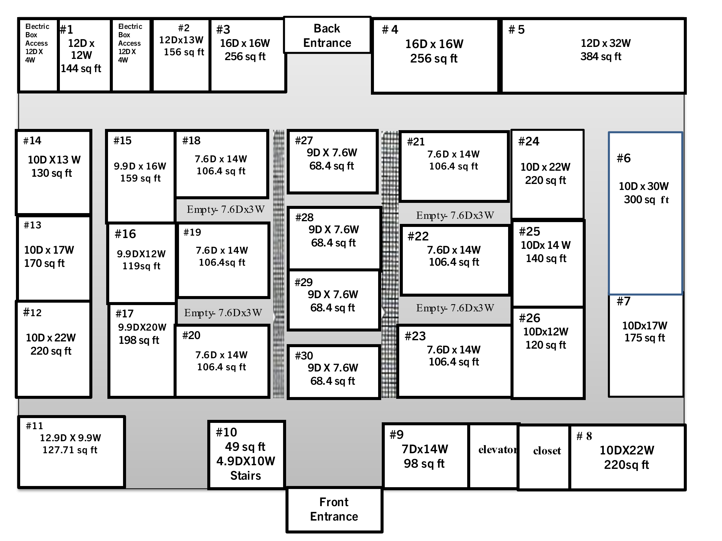
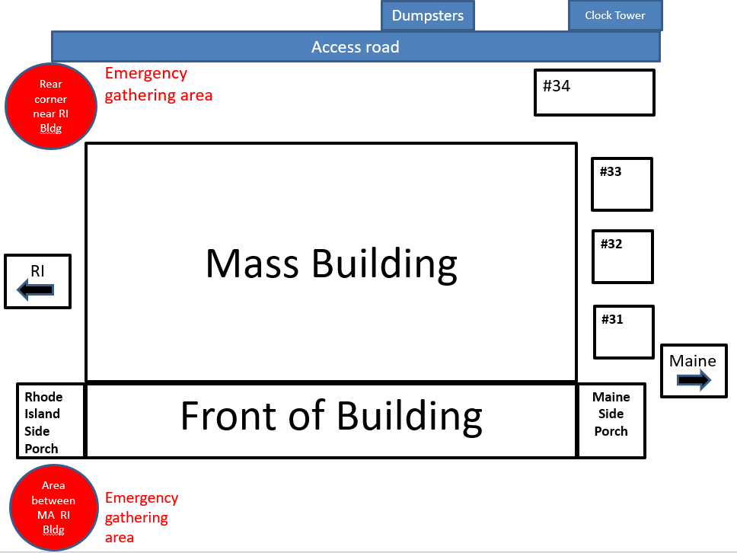
Backyard

Environmental Justice Policy
For the purposes of this RFR, “Environmental Justice” is based on the principle that all people have a right to be protected from environmental hazards and to live in and enjoy a clean and healthful environment regardless of race, color, national origin, income, or English language proficiency. Environmental justice is the equal protection and meaningful involvement of all people and communities with respect to the development, implementation, and enforcement of energy, climate change, and environmental laws, regulations, and policies and the equitable distribution of energy and environmental benefits and burdens.
While encouraged, the following questions are voluntary and will not impact eligibility. Answers to these questions help MDAR track progress towards the goals set forth in the 2021 Environmental Justice Policy, and the 2022 Environmental Justice Strategy, which require MDAR to a) report the amount of public funds used in Environmental Justice Communities, and b) track the number of new applicants for grant programs from Environmental Justice Communities and BIPOC Farmers. More information can be found in below. MDAR encourages stakeholders to provide feedback on the Environmental Justice Policy and Strategy, by visiting mass.gov/environmental- justice.
Environmental Justice Questions

- Has the applicant applied for MDAR funding programs before this current application? Yes No I don’t know

- Has the applicant received funding from any MDAR funding programs? Yes No I don’t know

z
- Select one or more of the racial categories below:

Answers to the following questions are optional. This information will not in any way aﬀect your eligibility for MDAR programs and is used for statistical purposes only.
American Indian/Alaskan Native/Indigenous Middle Eastern or North African

Asian/South Asian Native Hawaiian or other Pacific Islander

Black or African American White

Other:
Please state with the understanding that the races above may not be reflective of everyone.
- Select one or more of the ethnic categories below:
Answers to the following questions are optional. This information will not in any way aﬀect your eligibility for MDAR programs and is used for statistical purposes only.
Not Hispanic or Latino Hispanic or Latino
Other:
Please state with the understanding that the races above may not be reflective of everyone.
- Are any applicants a Historically Underserved Farmer?
Please check any of the following categories that apply based on these USDA definitions: https://www.nrcs.usda.gov/getting-assistance/underserved-farmers-ranchers
Limited Resource Farmer Socially Disadvantaged Farmer
Beginning Farmer Veteran Farmer
- If you feel that this application did not allow you to fully explain the diversity of the applicant for this grant (whether you are applying as an individual or on behalf of an entity), please explain here:

RFR - Further Information on MDAR's Environmental Justice Goals
Revision Date: January 15, 2023
MDAR strives to promote and integrate EJ considerations across their programs, policies, and activities to ensure the equal access and meaningful involvement of all people residing in the Commonwealth with respect to agricultural economic and environmental sustainability and the equitable development, implementation, and accessibility to information and resources.
Among the priorities and goals outlined in the 2021 Environmental Justice Policy, and the 2022 Environmental Justice Strategy, EEA agencies are tasked with ensuring that Environmental Justice neighborhoods benefit from positive impacts of environmental programs, grants and investments.
  - Environmental Justice Populations

EJ populations are those segments of the population that EEA has determined to be most at risk of being unaware of or unable to participate in environmental decision-making or to gain access to state environmental resources or are especially vulnerable.
"Environmental Justice Population" is defined by the Environmental Justice Policy, issued by the Massachusetts Executive Office of Energy and Environmental Affairs in 2017, and updated in June 2021, as
    - a neighborhood that meets 1 or more of the following criteria:
- the annual median household income is not more than 65 per cent of the statewide annual median household income;
- minorities comprise 40 per cent or more of the population;
- 25 per cent or more of households lack English language proficiency; or
- minorities comprise 25 per cent or more of the population and the annual median household income of the municipality in which the neighborhood is located does not exceed 150 per cent of the statewide annual median household income; or
    - a geographic portion of a neighborhood designated by the Secretary as an environmental justice population in accordance with law.
  - MA Environmental Justice Map Viewer
The MA Environmental Justice Map Viewer was designed to map Environmental Justice populations as census block groups in Massachusetts.
Please note - The data submitted in your application will be used to determine whether your project falls within an Environmental Justice block group, and will be used to design a map, available on the MDAR website, to show the positive impact of its grant awards, demonstrating the reach of its programs in EJ communities.
For more information on MDAR's Environmental Justice Program, or to provide feedback, please visit https:// www.mass.gov/info-details/mdars-environmental-justice-program.

