Determination of Need Application
Hampden & Franklin County Cardiovascular Associates, P.C. - 141 King Street, Northampton, MA

Exhibit Index
Massachusetts DPH Determination of Need Application - 105 CMR 100.210

Exhibit Description

- Newspaper Publication Record

- Corporate Documents

- Letters of Support

Exhibit set revised in response to the Department's Action steps to Achieve Completeness, dated May 5, 2026. A Word version of the Notice of Intent (with publication and web-posting detail) and a Word document linking to the Articles of Organization on the Secretary of the Commonwealth site are submitted separately.

Determination of Need Application
Hampden & Franklin County Cardiovascular Associates, P.C. - 141 King Street, Northampton, MA

Exhibit A

Newspaper Publication Record

Contents of This Exhibit
- The Republican - Newspaper Publication of the Notice of Intent (April 1, 2026)
Note: A Word version of the Notice of Intent - with the publication date, paper of publication, and the date the notice was posted to the Applicant's website - is submitted separately as required.
- The Practice Website - website publication of the Notice of Intent on March 27, 2026. It remains up today. The Notice can be found at HFCAA website under Legal Notices.

Massachusetts Department of Public Health Determination of Need Program 105 CMR 100.210 Exhibit A



Affidavit of Publication

I, Veronica Fiske, hereby certify that the advertisement as detailed below appeared in The Republican.

Public Announcement Concerning A Proposed Health Care
Project Notice of Intent to File an Application for Determination of Need Pursuant to 105 CMR 100.405(C)--- Massachusetts Department of Public Health

Published: 4/1/2026
Page: A7
Submitted by: Diane McClellan, Accounting Manager
Hampden & Franklin County Cardiovascular Associates, P.C.
Falls Farm LLC 50 Maple Street, Springfield MA 01103
(413) 342-5305 – Telephone

Commonwealth Of Massachusetts
County of Hampden
Springfield, MA 01103
On Date: April 1, 2026

Veronica Fiske personally appeared before me, who made oath that the foregoing is a true and correct statement.

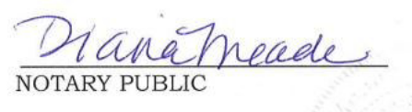
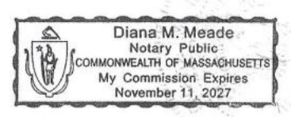

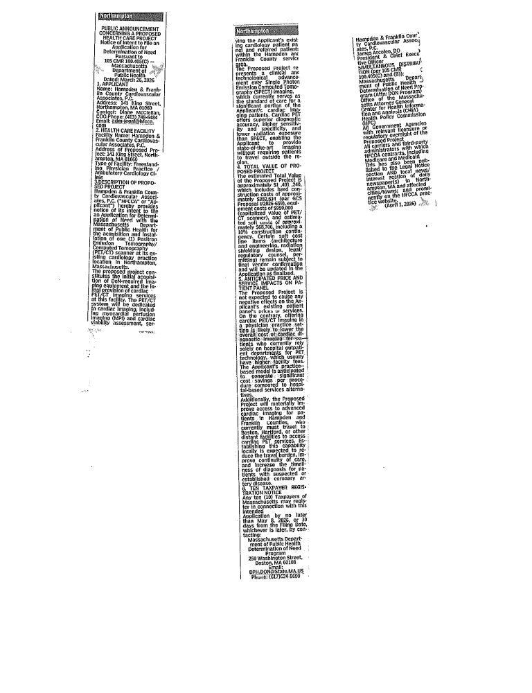
Determination of Need Application
Hampden & Franklin County Cardiovascular Associates, P.C. — 141 King Street, Northampton, MA

Exhibit B

Corporate Documents
Contents of This Exhibit

- Annual Report (FY2024) — filed February 17, 2025 (MA SOC Filing No. 202527701510);
- Entity ID 810555401;
- Sole Shareholder and President: Dr. James A. Arcoleo, D.O.
- The Articles of Organization are provided by hyperlink to the Secretary of the Commonwealth’s site in a separately submitted Word document.

The Commonwealth of Massachusetts
William Francis Galvin, Secretary of the Commonwealth
Corporations Division One Ashburton Place, 17th Floor, Boston, MA 02108-1512 (617) 727-9640

Annual Report — Professional
(General Laws, Chapter 156D, Section 16.22; 950 CMR 113.57) — Filing Fee: $100.00

Identification Number: 810555401
- Exact name of the corporation: HAMPDEN & FRANKLIN COUNTY CARDIOVASCULAR ASSOCIATES, P.C.
- 2, 3. Registered office & agent: James Arcoleo — 146 Federal St, Greenfield, MA 01301
- Principal office: 50 Maple Street, Springfield, MA 01103
- Directors and officers: Dr. James A. Arcoleo — President, Treasurer, Secretary, and Director — 108 Rivers Edge Drive, Conway, MA 01341 USA
- Business of the corporation: Medical Practice
- Capital stock: Class CNP; par value $0; 200 shares authorized; 0 shares issued and outstanding
- Report filed for fiscal year ending: 12/31/2024
- Shareholders: James A. Arcoleo — 108 Rivers Edge Drive, Conway, MA 01341 USA

Determination of Need Application
Hampden & Franklin County Cardiovascular Associates, P.C. — 141 King Street, Northampton, MA

Exhibit C

Letters of Support

Contents of This Exhibit
- Mayor Domenic J. Sarno, City of Springfield — Letter of Support
- State Representative Angelo J. Puppolo, Jr. (12th Hampden District) — Letter of Support
- Dean Singer, D.O., Bridge Primary — Referring Physician Support Letter (anticipated ~20 cardiac PET/CT studies/month)
[ Internal physician letters (Dr. Mohammed Ibrahim; Dr. Nitin Bhatnagar) and the Summary of Community Engagement to be inserted when finalized. ]

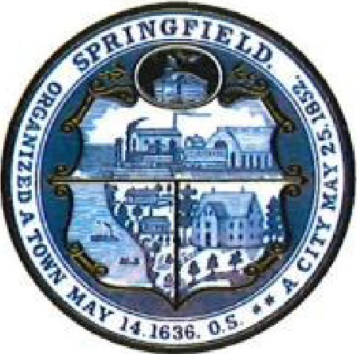
The City of Springfield, Massachusetts
Mayor Domenic J. Sarno
Home Of The Basketball Hall Of Fame

March 17, 2026

Dennis Renaud, Director
Determination of Need Program
Massachusetts Department of Public Health
67 Forest Street
Marlborough, MA 01752

RE: Support for Determination of Need Application- PET/CT and CT Imaging at Hampden & Franklin County Cardiovascular Associates P.C., 141 King Street, Northampton, MA

Dear Mr. Renaud:

I am writing in support of the Determination of Need Application filed by Hampden and Franklin County Cardiovascular Associates (HFCCA) to install and operate a cardiac PET/CT scanner at 141 King Street in Northampton, Massachusetts.

Springfield and the broader Western Massachusetts region carry a disproportionate burden of cardiovascular disease. Our residents - many of whom are lower-income, uninsured or underinsured, and without reliable transportation - face real and recurring barriers to accessing the kind of advanced cardiac diagnostic services that are routinely available in other parts of the Commonwealth. When those services require travel to hospital-based facilities, the associated cost and logistics often delay or prevent timely care.

Dr. Arcoleo and HFCCA are well known in our community. Their practice provides cardiovascular care to a substantial number of Springfield patients, including those served through Baystate Medical Center. Expanding their capacity to offer advanced cardiac imaging on an outpatient basis - at lower cost and closer to home - directly benefits those patients.

I strongly believe that this request would not only help to enhance our residents quality of life but would also strengthen the region's healthcare infrastructure, reduce costs for patients and payers, and help ensure that residents of Springfield and surrounding communities have access to medically appropriate, high-quality cardiac care without the barriers that hospital-based settings can impose.

Thank you for your time and attention on this important request and application filed by HFCCA.

Respectfully,

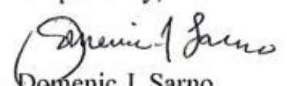
Domenic J. Sarno
Mayor

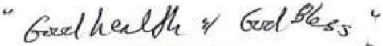

City of Springfield 36 Court Street Springfield, MA 01103-1687 (413) 787-6100

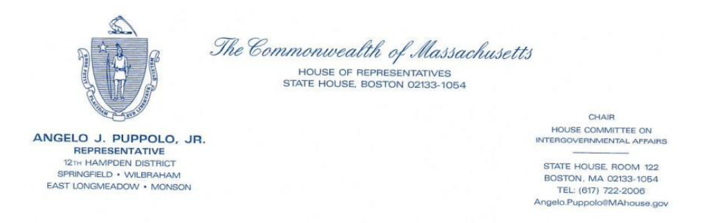
April 8 2026

Dennis Renaud, Director
Determination of Need Program
Massachusetts Department of Public Health
67 Forest Street
Marlborough, MA 01752

RE: Letter of Support - Determination of Need Application, Hampden & Franklin County Cardiovascular Associates P. C. Northampton, Massachusetts

Dear Director Renaud, 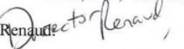

I am writing in strong support of the Determination of Need application filed by Hampden & Franklin County Cardiovascular Associates, P.C. for authorization to install a fixed cardiac PET/CT scanner at its Northampton practice location. As the State Representative for the 12th Hampden District, representing Springfield, Wilbraham, East Longmeadow, and Monson; l have spent over two decades advocating for health care access for the residents of western Massachusetts, with particular attention to the needs of seniors, lower-income families and underserved communities. This project speaks directly to those concerns and I offer full my support on those grounds. ln particular, the need is significant, now more than ever, in my area and region of the Commonwealth for access and availability to this advanced cardiac imaging machine.

My legislative record reflects a sustained focus on the health and well-being of vulnerable populations in our region. I authored Massachusetts' Silver Alert legislation to protect seniors living with Alzheimer’s and dementia, co-sponsored legislation mandating insurance coverage for Autism Spectrum Disorder treatment, and have championed measures to raise awareness of cardiovascular risk - including legislation designating November as Thrombosis Awareness Month in the Commonwealth. I have also co-sponsored legislation aimed at improving outcomes for patients who experience sudden cardiac arrest. I raise these not as credentials for the clinical merits of the application before you, but because they reflect the legislative priorities that animate my support; protecting the health of an aging population, closing gaps in insurance coverage, and addressing the cardiovascular disease burden that falls disproportionately on our communities.

Cardiovascular disease is the leading cause of death in Massachusetts, and its burden is not distributed equally. The residents of Springfield and the surrounding communities, that I represent, many of them elderly, many enrolled in Medicare or MassHealth, many facing economic hardship; are among those most at risk and historically least well served by the Commonwealth’s specialty health care infrastructure. Advanced cardiac imaging of the kind that this application contemplates has until now simply not been available to these residents in the western Massachusetts region. That is not a minor inconvenience. For a patient who has been told they need further evaluation for coronary artery disease, the difference between having that service available locally and being required to travel to Boston or Hartford for it, can be the difference between timely diagnosis and treatment and no diagnosis at all.

What strikes me about this application, from the perspective of community benefit, is that it proposes to deliver the current standard of care in cardiovascular imaging within an existing physician practice that is already deeply embedded in this community. A cardiology practice that has operated in western Massachusetts for over two decades is not an outside provider seeking to extract value from our communities. It is part of those communities. Approving this application means the residents I represent can access this service close to home, from providers who already know them, at cost that reflect a physician’s office setting rather than a hospital facility fee schedule.

I respectfully urge the Department to approve this application. The community benefit is real and immediate, the need is well documented, and the applicant is the right provider to deliver this service. Again, please know of my strong support of this application and I would welcome the opportunity to discuss further if that would be helpful. Feel free to contact me directly at my district office at (413) 596-4333 or at the State House at (617) 722-2006 or by email at Angelo.Puppolo@mahouse.gov.

Sincerely,

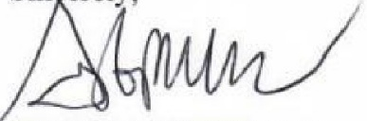

Angelo J. Puppolo, Jr.
State Representative


[55 Federal St. Ste 220] [Greenfield, MA 01301]
[413-225-2792] [dsinger@bridgeprimary.com]

March 13, 2026

Dennis Renaud, Director Determination of Need Program
Massachusetts Department of Public Health 67 Forest Street
Marlborough, MA 01752

RE: Support for Determination of Need Application - Cardiac PET/CT Imaging at Hampden & Franklin County Cardiovascular Associates, P.C., 141 King Street, Northampton, MA

Dear Mr. Renaud:

I am writing on behalf of Bridge Primary to express our support for the Determination of Need application submitted by Hampden & Franklin County Cardiovascular Associates, P.C. to install and operate a cardiac PET/CT scanner at 141 King Street, Northampton, Massachusetts 01060.

Bridge Primary serves patients throughout the Hampden and Franklin County service areas. Many of our patients require advanced cardiac imaging, and there is currently no facility in the region offering cardiac PET/CT imaging. Patients who require this level of functional cardiac assessment must travel to hospital-based facilities or specialized centers well outside this area - in some cases to other parts of Massachusetts or to Connecticut. These barriers cause meaningful delays in diagnosis and treatment and are particularly burdensome for patients who are elderly, have complex cardiac needs, or face transportation constraints.

If cardiac PET/CT imaging becomes available at Hampden & Franklin County Cardiovascular Associates, P.C., we anticipate referring a meaningful number of patients annually for outpatient cardiac PET/CT studies where a higher level of functional cardiac assessment is clinically appropriate.

Based on our current patient population and referral patterns, we estimate that we would refer approximately 20 cardiac PET/CT studies per month to Hampden & Franklin County Cardiovascular Associates, P.C. once this service is available at 141 King Street. Local access to this outpatient imaging service will reduce travel burdens, improve timely diagnosis, and support better coordinated cardiac care for the patients we serve.

For these reasons, we respectfully urge the Department to approve this Determination of Need application. Approval would provide a clear and documented benefit to public health and to the accessibility of appropriate cardiac imaging services throughout this region.

Respectfully submitted,
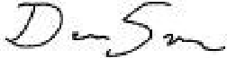

[Dean Singer, DO]
[Family Medicine/Addiction Medicine] [Bridge Primary]
[55 Federal St. Greenfield, MA 01301]

