BARRETT, HARRELL & FERRER LLC

Via Email - Read Receipt Requested and Overnight UPS - Signature Requested September 29, 2021
Via E-Mail

Lara Szent-Gyorgyi, Director Determination of Need Program Department of Public Health 250 Washington Street
Boston, MA 02108

RE: Ascentria Care Alliance, Inc. - Lutheran Home of Jamaica Plain, Inc. d/b/a Laurel Ridge Rehabilitation and Skilled Care Center Determination ofNeed Application# ACA-21092808- CL

Dear Ms. Szent-Gyorgyi:

We write to provide you with additional documentation for the above-captioned Determination of Need ("DoN") Application submitted to your office electronically on September 28, 2021. Please find enclosed the original Affidavit of Truthfulness (Exhibit I) and the filing fee (Exhibit 2) for the Ascentria Care Alliance, Inc. - Lutheran Home of Jamaica Plain, Inc. d/b/a Laurel Ridge Rehabilitation and Skilled Care Center DoN Application# ACA-21092808-CL.

We thank you for your assistance with this matter. Please do not hesitate to contact Amanda Beauregard, Esq. or me if you have any questions or require additional information.
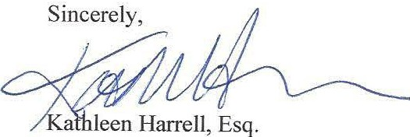

Enclosure

cc: R. Rodman, Esq. dph.don@state.ma.us

EXHIBIT 1

Massachusetts Department of Public Health Determination of Need
Affidavit of Truthfulness and Compliance
with Law and Disclosure Form 1OOAOS(B)

Version: 7-6-17

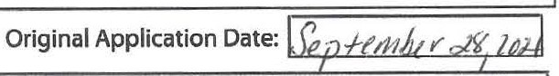
Instructions: Complete Information below. When complete check the box ''This document is ready to print:". This will date stamp and lock the form. Print Form. Each person must sign and date the form. When all signatures have been collected, scan the document and e-mail to: dph.don@state.ma.us Include all attachments as requested.
Application Number: ACA-21092080-CL
Applicant Name: Ascentria Care Alliance, Inc.(Laurel Ridge Rehabilitation and Skilled Care Center)

Application Type: conservation Long Term Care Project
Applicant's Business Type: Ci Corporation (' Limited Partnership (' Partnership (' Trust (' LLC ('Other IstheApplicant the sole member or sole shareholder of the Health Facility(ies) that are the subject of this Application? Ci Yes (' No
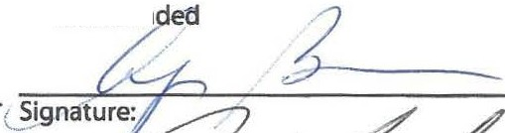
The undersigned certifies under the pains and penalties of perjury:
- The Applicant is the sole corporate member or sole shareholder of the Health Facility[ies] that are the subject of this Application;
- I have105 CMR 100.000, the Massachusetts Determination of Need Regulation;
- I understand and agree to the expected and appropriate conduct of the Applicant pursuant to 105 CMR 100.800;
* ,.
- I have '4iad this application for Determination of Need including all exhibits and attachments, and certify that** all of the information contained herein is accurate and true;
- I have submitted the correct Filing Fee and understand it is nonrefundable pursuant to 105 CMR 100.405(6);
- I have submitted the required copies of this application to the Determination of Need Program, and,as applicable, to all Parties of Record and other parties as required pursuant to 105 CMR 100.405(B);
- I have caused, as required, notices of intent to be published and duplicate copies to be submitted to all Parties of Record, and all carriers or third-party administrators, public and commercial, for the payment of health care services with which the Applicant contracts, and with Medicare and Medicaid, as required by 105 CMR 100.405(C), et seq.;
- I hau,i*ciu 11ied proper notification and submissions to the Secretary of Environmental Affairs pursuant to 105 CMR
100.405(E) and 301CMR 11.00; will be made if applicable.
- If subject to M.G.L. c. 6D, § 13 and 958 CMR 7.00,I have submitted such Notice of Material Change to the HPC - in accordance with 105 CMR 100.405(G);
- Pursuant to 105 CMR 100.210(A)(3), I certify that both the Applicant and the Proposed Project are in material and substantial compliance and good standing with relevant federal, state, and local laws and regulations, as well as with all
pr;auiously iss11ad Notices of Determination of Need and the terms a Tooditions attached therein·
- I have'4*iad and understand the limitations on solicitation of funding from the general public prior to' receiving a Notice of Determination of Need as established in 105 CMR 100.415;
- I understand that, if Approved, the Applicant, as Holder of the DoN, shall become obligated to all Standard Conditions pursuant to 105 CMR 100.310, as well as any applicable Other Conditions as outlined within 105 CMR 100.000 or that otherwise become a part of the Final Action pursuant to 105 CMR 100.360;
- Pursuant to 105 CMR 100.705(A), I certify that the Applicant has Sufficient Interest in the Site or facility; and
- Pursuant to 105 CMR 100.705(A), I certify that the Proposed Project is authorized under applicable zoning by-laws or ordinances, whether or not a special permit is required; or,
  - If the Proposed Project is not authorized under applicable zoning by-laws or ordinances, a variance has been received to permit such Proposed Project; or,
  - The Proposed Project is exempt from zoning by-laws or ordinances.
Corporation:
Attach a copy of Articles of Organization/Incorporation, as amen

Angela Bovill
CEO for Corporation Name:

_William Mayo

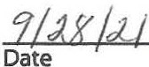
<signature on file>_. 28/9/21

Board Chair for Corporation Name: Date 1
- been informed of the contents of
** have been informed that
*** issued in compliance with 105 CMR I00.000, the Massachusetts Determination of Need rc:gulation effective January 27, 2017 and amended December 28.2018
llffin::2iuit nfTr11thf1alnacc 6crantri:a r:ara 6lli:anra lnr n ::1,1ral Rirlna Rah:ahil D:>na 1 nf')

EXHIBIT 2

••• : -
Laurel Ridge Rehabilitation & Skilled Care Center
174 Forest Hills Street Jamaica Plain, MA 02130

Berkshire Bank
530972'1} 21

3804

PAY TO THE ORDER OF
$25,479.80
Twenty Five Thousand Four Hundred Seventy Nine Dollars and 80 Cents

COMMONWEAL TH OF MASSACHUSETTS POST OFFICE BOX 3538
BOSTON, MA 02241-3538
DOLLARS

MEMO

Laurel Ridge Rehabilitation & Skilled Care Center Jamaica Plain, MA02130

COMMON COMMONWEALTH OF MASSACHUSETTS
Invoice Number | Invoice Date | Description | Gross Amount | Discount Taken | Net Amount Paid
DON | 09/24/2021 | DON (0.2% of MCE) | -$2-5,4-7-9 80 | $0.00 | $25,479.80
 |  |  | $25,479.80 | $0.00 | $25,479.80

3804
09/21/2021 3804

Laurel Ridge Rehabilitation & Skilled Care Center Jamaica Plain, MA02130

3804

COMMON
Invoice Number | Invoice Date | Description | Gross Amount | Discount Taken | Net Amount Paid
DON | 09/24/2021 | DON (0.2% of MCE) | $25,479.80 | $0.00 | $25,479.80
 |  |  | $25,479.80 | $0.00 | $25,479.80

COMMONWEALTH OF MASSACHUSETTS 09/21/2021 3804

