Sudbury Pines Extended Care, Inc.
Application #SPEC-23051912-AM

TABLE OF CONTENTS
- Notice of Intent
- Copy of Documents Related to Approved DoN
  - Copy of Original Decision Letter for Approved Emergency DoN
- Articles of Organization
  - Available at: https://corp.sec.state.ma.us/CorpWeb/CorpSearch/CorpSearchFormList.aspx?sysvalue=udpRRwFe838Z76AxHjag4w--
- Affidavit of Truthfulness & Compliance

1. Notice of Intent

LOCALiQ
PO Box 631210 Cincinnati, OH 45263-1210

NEW ENGLAND
PROOF OF PUBLICATION
Krokidas & Bluestein LIP
Krokidas & Bluestein LJp
600 Atlantic Avenue
Boston MA 02210
STATE OF MASSACHUSETTS, COUNTY OF MIDDLESEX
The MetroWest/Milford Daily News, a newspaper printed and published in the city of Framingham, and of general circulation in the County of Middlesex, Norfolk and Worcester, State of Massachusetts, and personal knowledge of the facts herein state and that the notice hereto annexed was Published in said newspapers in the issue:
05/12/2023
and that the fees charged are legal.
Sworn to and subscribed before on 05/12/2023
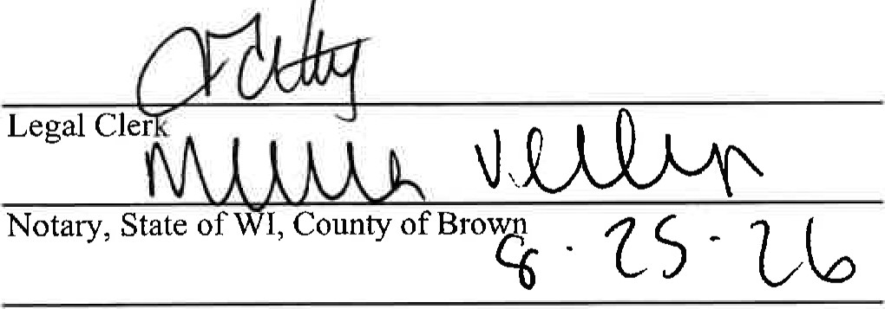
My commission expires
Publication Cost: $256.92
Order No: 8808461 # of Copies:
Customer No: 663911 1
PO
THIS IS NOT AN INVOICE!
MARIAH VERHAGEN
Notary Public
State of Wisconsin
Please do not use this form for payment remittance.
Page 1 of 2

LOCALiQ
PO Box 631210 Cincinnati, OH 45263-1210

NEW ENGLAND

PROOF OF PUBLICATION
Krokidas & Blucstcin LIP
600 Atlantic Avenue
Boston MA 02210
STATE OF MASSACHUSETTS, COUNTY OF MIDDLESEX
The MetroWest/Milford Daily News, a newspaper printed and published in the city of Framingham, and of general circulation in the County of Middlesex, Norfolk and Worcester, State of Massachusetts, and personal knowledge of the facts herein state and that the notice hereto annexed was Published in said newspapers in the issue:
05/12/2023
and that the fees charged are legal.
Sworn to and subscribed before on 05/12/2023
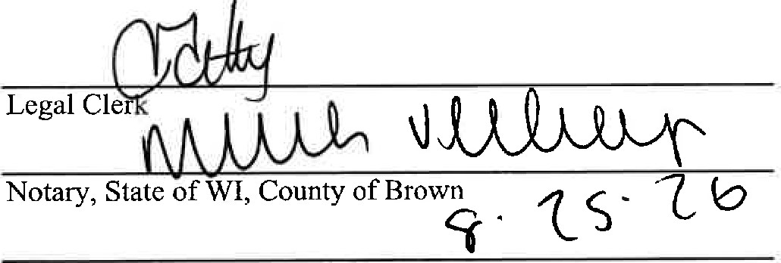
My
commission
expires
Publication Cost: $191.78
Order No: 8804419 # of Copies:
Customer No: 663911
THIS IS NOT AN INVOICE!
MARIAH VERHAGEN
Notary Public
State of Wisconsin
Please do not use this form for payment remittance

LONG TERM CARE
FACILITY PROJECT
LEGAL NOTICE
Sudbury Pines
Extended Care
Public Announcement
Concerning a Proposed
Long-Term Care Facility
Project
Sudbury Pines Extend Care Facility (the "Applicant") intends to file an application with the Massachusetts Department of Public Health for a Significant Change ("Application") to amend the Applicant's previously issued Determination of Need ("DON") Project No 4-1523 to increase in its approved Maximum Capital Expenditure of $2,750,000 (April 2010 dollars) adjusted to $7,037,407.03 (March 2023 dollars) to account for unforeseen costs associated with installing a waste water treatment plant that will service the Applicants 92-bed skilled nursing facility that the Applicant could not account for when the DON was originally approved during a state of emergency. The Applicant does not anticipate any price or service impacts on its patient panel as a result of the Applica-tion.
- 8804419
- DN: 5/12/2023

Page 1 of 1

Sudbury Pines Extended Care
Public Announcement Concerning a Proposed Long-Term
Care Facility Project

Sudbury Pines Extend Care Facility (the "Applicant") intends to file an application with the Massachusetts Department of Public Health for a Significant Change ("Application") to amend the Applicant's previously issued Determination of Need ("DON") Project No 4-1523 to increase in its approved Maximum Capital Expenditure of $2,750,000 (April 2010 dollars) adjusted to $7,037,407.03 (March 2023 dollars) to account for unforeseen costs associated with installing a waste water treatment plant that will service the Applicants 92-bed skilled nursing facility that the Applicant could not account for when the DoN was originally approved during a state of emergency. The Applicant does not anticipate any price
or service impacts on its patient panel as a result of the Application.
NW-35691191

2. Copy of Documents Related to Approved DoN

DEVALL. PATRICK

GOVERNOR
TIMOTHY P. MURRAY
LIEUTENANT GOVERNOR
JUDYANN BIGBY, MD
SECRETARY
JOHN AUERBACH
COMMISSIONER
The Commonwealth of Massachusetts Executive Office of Health and Human Services Department of Public Health
Determination of Need Program
99 Chauncy Street, 2nd Floor, Boston, MA 02111 (617) 753-7340
FAX (617) 753-7349

June 7, 2010

Roberta C. Henderson, Administrator Sudbury Pines Extended Care
642 Boston Post Road Sudbury, MA 01776

CERTIFIED MAIL
RETURN RECEIPT REQUESTED

NOTICE OF DETERMINATION OF NEED PROJECT NO. 4-1523
(Substantial Renovation of Existing Facility)

Dear Ms. Henderson:
This is to notify you that pursuant to M.G.L. c. 111, s.25C and the regulations adopted thereunder, including the provisions of I05 CMR I 00.504, I hereby approve the emergency Determination of Need application filed by Sudbury Pines Extended Care Facility, Inc. ("SPEC"). The application as approved provides for substantial renovation of the existing 92-bed long term care facility located at 642 Boston Post Road in Sudbury.

The project was filed as an emergency application on April 26, 20 I0, as the result of extensive flooding of the facility by torrential rains on March 23 and March 29, 2010. As a result, SPEC reports that the water reached up to eight inches on the entire ground floor, and the lower level containing the all the administrative offices, medical records, HVAC, electrical, food storage, nursing supply, housekeeping/laundry, alarms and other functions of the facility was completely evacuated on April 2, 20IO. SPEC further reports that because of the efforts of a crew of staff working around the clock, the facility did not lose heat or power and no actual patients had to be evacuated. However, given the potential for aerosolized mold to spread throughout the entire facility, SPEC reports that a contractor specializing in mold abatement started to immediately demolish the facility's lower level walls and remove the floor on April 3, 2010, while the space was still flooding and wet.

SPEC further reports that the project involves a number of activities necessary to return the facility's lower level to a habitable space and make the building and land compliant with regulatory concerns. SPEC engineers and contractors report that these activities include environmental remediation and substantial renovation to replace and repair the facility's existing mechanical and septic systems, including the HVAC, electrical service, telephone, water, landscaping, and repair the existing parking lot, outside resident areas and storage. The total

Sudbury Pines Extended Care Facility -2- Project No. 4-1523

gross square feet ("GSF") for the project is estimated to be 12,000 GSF. The preliminary estimated maximum capital expenditure ("MCE") is $2,750,000 (April 2010 dollars), which is anticipated to be financed through insurance proceeds and disaster assistance from federal and state sources, including FEMA and Small Business Administration funding. However, SPEC reports that it is currently unclear as to the final allocation of the project's financing, as estimates from the sources indicated above have not been finalized. SPEC also reports that the federal government has declared the area (Middlesex County) encompassing the facility to be a Federal Disaster Area.

The application satisfies the requirements as listed at 105 CMR 100.333-100.334 of the Determination of Need regulations. The application has identified the applicant, the nature of the emergency, and the nature, scope, location and cost of the project.

This Determination is effective upon receipt of this Notice.

Sincerely

John Auerbach
Commissioner

JA/JG/jp

cc: Michael Grenier, DHCFP
Teri Yannetti, OMA
Sherman Lohnes, DHCQ
Daniel Gent, DHCQ
Public File
Decision Letter File
MIS
3. Articles of Organization

Available at: https://corp.sec.state.ma.us/CorpWeb/CorpSearch/CorpSearchFormList.aspx?sysvalue=udpRRwFe838Z76AxHjag4w--

4. Affidavit of Truthfulness & Compliance

Version: 7-6-17

Massachusetts Department of Public Health

Determination of Need

Affidavit of Truthfulness and Compliance

with Law and Disclosure Form 100.405 (B)
Instructions: Complete Information below. When complete check the box "This document is ready to print:". This will date stamp and lock the form. Print Form. Each person must sign and date the form. When all signatures have been collected, scan the document and e-mail to: dph.don@state.ma.us Include all attachments as requested.
Application Number: SPEC-23051912-AM
Original Application Date: 04/26/2010
Applicant Name: Sudbury Pines Extended Care Facility
Application Type: Amendment Significant
Applicant's Business Type: Corporation
Is the Applicant the sole member or sole shareholder of the Health Facility(ies) that are the subject of this Application? [blank]

Corporation
Attach a copy of Articles of Organization/Incorporation, as amended

Roberta Henderson <Signature on File> 5/24/23
CEO for Corporation Name: Signature: Date:

Roberta Henderson <Signature on File> 5/24/23
Board Chair for Corporation Name: Signature: Date:

This document is ready to print: Yes Date/time Stamp: 05/24/2023 5:19 pm

