MVPMA NUMBER OF PATIENTS PANEL

TOWN | 2019 | 2020 | 2021 | 2022
Lawrence | 893 | 977 | 1044 | 1123
Methuen | 684 | 729 | 787 | 843
Haverhill | 312 | 301 | 293 | 319
North Andover | 188 | 196 | 211 | 217
Andover | 94 | 102 | 122 | 129
Lowell | 97 | 109 | 136 | 148
Salem, NH | 87 | 89 | 107 | 129
Chelmsford | 64 | 61 | 86 | 71
Reading | 37 | 24 | 22 | 14
Lynn | 38 | 44 | 68 | 84
Everett | 42 | 37 | 57 | 71
Boston area | 37 | 44 | 63 | 84
Londonderry, NH | 49 | 61 | 62 | 62
Worcester | 18 | 14 | 0 | 0
Dracut | 22 | 29 | 35 | 35
Windham, NH | 38 | 31 | 39 | 39
Stoneham/Melrose | 16 | 20 | 29 | 53
Others | 39 | 64 | 32 | 56
Total | 2755 | 2969 | 3193 | 3477

MVPMA Patients Breakdown by Towns

Gender, Age and Patients per town distribution for MVPMA

Gender | 2019 | 2020 | 2021 | 2022 | Total
F | 1492 | 1544 | 1714 | 1878 | 53%
M | 1263 | 1425 | 1478 | 1599 | 47 %
MVPMA | 2755 | 2969 | 3192 | 3477 | 100%

Age Cohort | 2019 | 2020 | 2021 | 2022 | Total
0-17 | 0 | 0 | 0 | 0 | 0%
18-64 | 1049 | 1290 | 1447 | 1488 | 42 %
65+ | 1705 | 1679 | 1745 | 1989 | 58 %
MVPMA | 2755 | 2969 | 3192 | 3477 | 100%

Please be advised that MVPMA doesn't collect data based on patients' race or ethnicity. However, and based on the geographical town service for our clinic, the following can be estimated:

White (non- Hispanic): 52% White (Hispanic): 20%
Black or African American (non- Hispanic): 20% Black or African American ( Hispanic): 5% Asian: 2%
Two or more races: 1%

Exhibit# 7
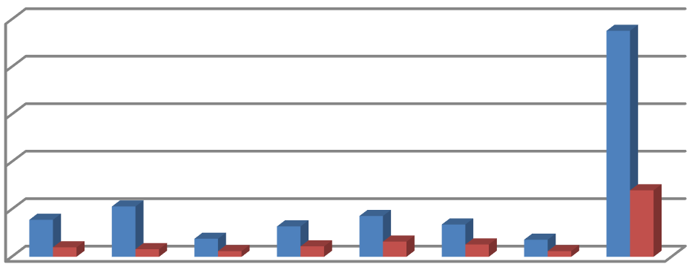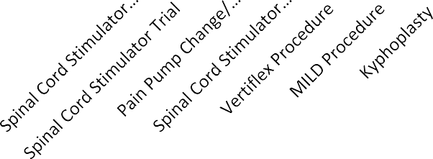
2021
250
200
150
100
50
0
Pain Surgical Procedures
Performed
Procedures delayed by Hospital >
6-8 weeks and/or changed scheduling

Exhibit # 8
Hanger
CL'INIC
Empowering Human Potential John Dieli, CPO
Certified Prosthetist, Orthotist Hanger Clinic

100 Milk Street, ste 120, Methuen, MA 01844, PH (978)683-5509 FAX(978)685-7264
jdieli@hanger.com

October 12, 2022
Rami R. Rustum, MD 280 Merrimack St,
Suite 103,
Lawrence, MA 01843
Dear Dr. Rustum,
Thank you for taking the time to meet with Rebekah Ray and I. Per our conversation, we look forward to collaborating with you to provide follow-up treatment for the local amputee population. We have many patients from the greater Lawrence area who travel to Boston for their amputations and then require post op care when they return home.
There is a real medical need for physiatry/pain management for this patient population as they require specialized attention from multiple disciplines as well as detailed medical note documentation. We would greatly appreciate being able to work with you to oversee and manage their continuity of care.
Hanger Clinic has been consistently providing custom orthotic and prosthetic care to the Merrimack Valley for over 40 years and we accept most insurances including MA Health.
Thank you,
John Dieli, CPO, Clinic Manager

Exhibit # 9A

CPT | Description |  |  | Transitional Payment Rate
CPT |  |  |  | 2007 |  | 2019 | 2020 | 2021 | 2022(P) | 2022 | % of Change 2022 FINAL  2022 P 2021 2020 2019 |  |  |  |  |  |  |  |  |  |  |  |  |  |  |  |  |  |  |  |  |  |  | 2007
0274T | Percutaneous Decompression Laminotomy |  |  | $0.0 |  | $0.00 | $2,803.36 | $2,944.24 | $3,039.30 | $3,000.95 | -1.3% |  |  |  | 1.9% |  |  |  |  |  |  | 7.0%
0275T | Percutaneous Decompression Laminotomy |  |  | $0.0 |  | $0.00 | $2,803.36 | $3,941.14 | $4,062.36 | $4,020.32 | -1.0% |  |  |  | 2.0% |  |  |  |  |  |  | 43.4%
20526 | Injection, therapeutic |  |  |  |  | $39.64 | $41.50 | $41.48 | $45.00 | $44.35 | -1.4% |  |  |  | 6.9% |  |  |  |  |  |  | 6.9% |  |  |  | 11.9%
20550 | tendon sheath, ligament injection |  |  |  |  | $24.14 | $25.98 | $26.25 | $28.21 | $28.56 | 1.2% |  |  |  | 8.8% |  |  |  |  |  |  | 9.9% |  |  |  | 18.3%
20551 | Tendon origin/insertion injection |  |  |  |  | $25.22 | $27.43 | $27.55 | $29.22 | $29.57 | 1.2% |  |  |  | 7.3% |  |  |  |  |  |  | 7.8% |  |  |  | 17.2%
20552 | Single or multiple trigger point(s), one or two muscle group(s) |  |  |  |  | $30.27 | $30.32 | $27.22 | $28.21 | $28.22 | 0.0% |  |  |  | 3.7% |  |  |  |  |  |  | -6.9% |  |  |  | -6.8%
20553 | Single or multiple trigger point(s), three or more muscle groups |  |  |  |  | $35.31 | $35.37 | $31.76 | $32.91 | $32.93 | 0.1% |  |  |  | 3.7% |  |  |  |  |  |  | -6.9% |  |  |  | -6.7%
20600 | Small joint injection |  |  |  |  | $23.06 | $24.90 | $25.28 | $27.54 | $27.55 | 0.0% |  |  |  | 9.0% |  |  |  |  |  |  | 10.6% |  |  |  | 19.5%
20605 | Intermediate joint injection |  |  |  |  | $24.50 | $25.98 | $26.57 | $28.55 | $28.56 | 0.0% |  |  |  | 7.5% |  |  |  |  |  |  | 9.9% |  |  |  | 16.6%
20610 | Major joint injection |  |  |  |  | $28.83 | $31.04 | $31.76 | $33.58 | $33.93 | 1.0% |  |  |  | 6.8% |  |  |  |  |  |  | 9.3% |  |  |  | 17.7%
22510 | Vertebroplasty (Cervicothoracic) |  |  | $1,339.0 |  | $1,256.16 | $1,286.26 | $1,335.09 | $1,376.57 | $1,361.61 | -1.1% |  |  |  | 2.0% |  |  |  |  |  |  | 5.9% |  |  |  | 8.4% |  |  |  |  | 2%
22511 | Vertebroplasty (Lumbosacral) |  |  | $1,339.0 |  | $1,256.16 | $1,286.26 | $1,335.09 | $1,376.57 | $1,361.61 | -1.1% |  |  |  | 2.0% |  |  |  |  |  |  | 5.9% |  |  |  | 8.4% |  |  |  |  |  |  |  | 2%
22513 | Kyphoplasty, thoracic |  |  |  |  | $2,742.94 | $2,803.36 | $2,944.24 | $3,039.30 | $3,000.95 | -1.3% |  |  |  | 1.9% |  |  |  |  |  |  | 7.0% |  |  |  | 9.4%
22514 | Kyphoplasty, lumbar |  |  |  |  | $2,742.94 | $2,803.36 | $2,944.24 | $3,039.30 | $3,000.95 | -1.3% |  |  |  | 1.9% |  |  |  |  |  |  | 7.0% |  |  |  | 9.4%
22869 | Insj stablj dev w/o dcmprn |  |  |  |  | $12,596.88 | $9,873.89 | $10,253.60 | $10,576.47 | $10,482.01 | -0.9% | 2.2% |  |  |  |  | 6.2% |  |  |  |  |  |  | -16.8%
27279 | Sacroiliac joint Fusion |  |  |  |  | $12,480.35 | $12,981.09 | $12,974.05 | $13,747.55 | $13,549.06 | -1.4% | 4.4% |  |  |  |  | 4.4% |  |  |  |  |  |  | 8.6%
61885 | Insrt/redo neurostim 1 array |  |  |  |  | $16,949.00 | $17,305.89 | $18,192.95 | $18,693.49 | $18,592.18 | -0.5% | 2.2% |  |  |  |  | 7.4% |  |  |  |  |  |  | 9.7%
62263 | Percutaneous epidural adhesiolysis - 2 or 3 days |  |  | $333.0 |  | $393.80 | $410.32 | $417.75 | $430.48 | $426.36 | -1.0% | 2.1% |  |  |  |  | 3.9% |  |  |  |  |  |  | 8.3% |  |  |  |  |  |  | 28%
62264 | Percutaneous epidural adhesiolysis – 1 day |  |  | $333.0 |  | $393.80 | $410.32 | $417.75 | $430.48 | $426.36 | -1.0% |  | 2.1% |  |  | 3.9% |  |  |  |  |  |  | 8.3% |  |  |  |  |  |  |  |  |  |  | 28%
62268 | Percutaneous aspiration, spinal cord cyst or syrinx |  |  | $183.8 |  | $393.80 | $410.32 | $417.75 | $430.48 | $426.36 | -1.0% |  |  |  | 2.1% |  |  |  |  | 3.9% |  |  |  |  |  |  |  | 8.3% |  |  |  |  | 132%
62269 | Biopsy of spinal cord, percutaneous needle |  |  | $333.0 |  | $546.90 | $576.39 | $597.23 | $614.82 | $608.63 | -1.0% |  |  |  | 1.9% |  |  |  |  | 5.6% |  |  |  |  |  |  |  | 11.3% |  |  |  |  | 83%
62270 | Spinal puncture, diagnostic |  |  | $139.0 |  | $308.32 | $315.83 | $322.32 | $332.13 | $328.88 | -1.0% |  |  |  | 2.0% |  |  |  |  | 4.1% |  |  |  |  |  |  |  | 6.7% |  |  |  |  | 137%
62272 | Spinal puncture, therapeutic |  |  | $139.0 |  | $308.32 | $315.83 | $322.32 | $332.13 | $328.88 | -1.0% |  |  |  | 2.0% |  |  |  |  | 4.1% |  |  |  |  |  |  |  | 6.7% |  |  |  |  | 137%
62273 | Epidural, blood patch |  |  | $333.0 |  | $308.32 | $315.83 | $322.32 | $332.13 | $328.88 | -1.0% |  |  |  | 2.0% |  |  |  |  | 4.1% |  |  |  |  |  |  |  | 6.7% |  |  |  |  | -1%
62280 | Subarachnoid neurolytic injection |  |  | $333.0 |  | $393.80 | $410.32 | $417.75 | $430.48 | $426.36 | -1.0% |  |  |  | 2.1% |  |  |  |  | 3.9% |  |  |  |  |  |  |  | 8.3% |  |  |  |  | 28%
62281 | Neurolytic epidural, C/T |  |  | $333.0 |  | $393.80 | $410.32 | $417.75 | $430.48 | $426.36 | -1.0% |  |  |  | 2.1% |  |  |  |  | 3.9% |  |  |  |  |  |  |  | 8.3% |  |  |  |  | 28%
62282 | Neurolytic epidural, L/S |  |  | $333.0 |  | $393.80 | $410.32 | $417.75 | $430.48 | $426.36 | -1.0% |  |  |  | 2.1% |  |  |  |  | 3.9% |  |  |  |  |  |  |  | 8.3% |  |  |  |  | 28%
62287 | Disc decompression |  |  | $1,339.0 |  | $1,919.87 | $796.79 | $808.87 | $834.04 | $825.71 | -1.0% |  |  |  | 2.1% |  |  |  |  | 3.6% |  |  |  |  |  |  |  | -57.0% |  |  |  |  | -38%
62292 | Chemonucleolysis |  |  |  |  | $781.32 | $796.79 | $808.87 | $834.04 | $825.71 | -1.0% |  |  |  | 2.1% |  |  |  |  | 3.6% |  |  |  |  |  |  |  | 5.7%
62320 | Cervical/Thoracic epidural without imaging guidance |  |  |  |  | $308.32 | $315.83 | $322.32 | $332.13 | $328.88 | -1.0% |  |  |  | 2.0% |  |  |  |  | 4.1% |  |  |  |  |  |  |  | 6.7%
62321 | Cervical/Thoracic epidural WITH imaging guidance |  |  |  |  | $308.32 | $315.83 | $322.32 | $332.13 | $328.88 | -1.0% |  |  |  | 2.0% |  |  |  |  | 4.1% |  |  |  |  |  |  |  | 6.7%
62322 | Lumbar/Caudal epidural without imaging guidance |  |  |  |  | $308.32 | $315.83 | $322.32 | $332.13 | $328.88 | -1.0% |  |  |  | 2.0% |  |  |  |  | 4.1% |  |  |  |  |  |  |  | 6.7%
62323 | Lumbar/Caudal epidural WITH imaging guidance |  |  |  |  | $308.32 | $315.83 | $322.32 | $332.13 | $328.88 | -1.0% |  |  |  | 2.0% |  |  |  |  | 4.1% |  |  |  |  |  |  |  | 6.7%
62324 | Epidural or subarachnoid, catheterization, C/T without imaging guidance |  |  |  |  | $393.80 | $410.32 | $417.75 | $430.48 | $426.36 | -1.0% |  |  |  | 2.1% |  |  |  |  | 3.9% |  |  |  |  |  |  |  | 8.3%
62325 | Epidural or subarachnoid, catheterization, C/T WITH imaging guidance |  |  |  |  | $393.80 | $410.32 | $417.75 | $430.48 | $426.36 | -1.0% |  |  |  | 2.1% |  |  |  |  | 3.9% |  |  |  |  |  |  |  | 8.3%
62326 | Epidural or subarachnoid, catheterization, L/S without imaging guidance |  |  |  |  | $393.80 | $410.32 | $417.75 | $430.48 | $426.36 | -1.0% |  |  |  | 2.1% |  |  |  |  | 3.9% |  |  |  |  |  |  |  | 8.3%
62327 | Epidural or subarachnoid, catheterization, L/S WITH imaging guidance |  |  |  |  | $393.80 | $410.32 | $417.75 | $430.48 | $426.36 | -1.0% |  |  |  | 2.1% |  |  |  |  | 3.9% |  |  |  |  |  |  |  | 8.3%
62350 | Tunneled intrathecal or epidural catheter |  |  | $446.0 |  | $2,480.08 | $2,897.82 | $3,539.92 | $3,644.92 | $3,614.41 | -0.8% |  |  |  | 2.1% |  |  |  |  | 24.7% |  |  |  |  |  |  |  | 45.7% |  |  |  |  | 710%
62355 | Removal or previously implanted intrathecal or epidural catheter |  |  | $446.0 |  | $781.32 | $796.79 | $808.87 | $834.04 | $825.71 | -1.0% |  |  | 2.1% |  |  |  | 3.6% |  |  |  |  |  |  |  |  |  | 5.7% |  |  |  | 85%
62360 | Implant or replacement of subcutaneous reservoir |  |  | $446.0 |  | $13,318.05 | $13,823.59 | $13,804.77 | $14,189.39 | $14,095.65 | -0.7% |  |  | 2.1% |  |  |  | 2.0% |  |  |  |  |  |  |  |  |  | 5.8% |  |  |  | 3060%
62361 | Implantation or replacement of non-programmable pump |  |  | $446.0 |  | $12,911.04 | $14,240.53 | $13,461.75 | $13,839.59 | $13,744.74 | -0.7% |  |  | 2.1% |  |  |  | -3.5% |  |  |  |  |  |  |  |  |  | 6.5% |  |  |  | 2982%
62362 | Implant spine infusion pump |  |  | $446.0 |  | $13,536.92 | $13,666.39 | $14,172.07 | $14,564.87 | $14,470.59 | -0.6% |  |  | 2.1% |  |  |  | 5.9% |  |  |  |  |  |  |  |  |  | 6.9% |  |  |  | 3145%
62365 | Remove spine infusion device |  |  | $446.0 |  | $1,919.87 | $2,170.24 | $2,449.00 | $2,526.89 | $2,498.07 | -1.1% |  |  | 2.0% |  |  |  | 15.1% |  |  |  |  |  |  |  |  |  | 30.1% |  |  |  | 460%
62367 | Electronic analysis of programmable pump |  |  |  |  | $21.98 | $13.71 | $13.29 | $14.44 | $13.10 | -9.3% |  |  | -1.4% |  |  |  | -4.4% |  |  |  |  |  |  |  |  |  | -40.4%
62368 | Electronic analysis of programmable pump with reprogramming |  |  |  |  | $29.91 | $19.13 | $18.47 | $20.15 | $18.48 | -8.3% |  |  | 0.1% |  |  |  | -3.4% |  |  |  |  |  |  |  |  |  | -38.2%
62369 | pump refills |  |  |  |  | $93.69 | $71.10 | $70.97 | $65.15 | $67.20 | 3.1% |  |  | -5.3% |  |  |  | -5.5% |  |  |  |  |  |  |  |  |  | -28.3%
62370 | Pump refills |  |  |  |  | $89.73 | $66.40 | $64.49 | $57.77 | $59.80 | 3.5% |  |  | -7.3% |  |  |  | -9.9% |  |  |  |  |  |  |  |  |  | -33.4%
62380 | Endoscopic Decompression of Lumbar Spine |  |  |  |  | $2,742.94 | $2,803.36 | $2,944.24 | $3,039.30 | $3,000.95 | -1.3% |  |  | 1.9% |  |  |  | 7.0% |  |  |  |  |  |  |  |  |  | 9.4%
63650 | Implant neuroelectrodes |  |  | $446.0 |  | $4,449.26 | $4,514.52 | $4,480.92 | $4,603.90 | $4,571.47 | -0.7% |  |  | 2.0% |  |  |  | 1.3% |  |  |  |  |  |  |  |  |  | 2.7% |  |  |  | 925%
63655 | Implant neuroelectrodes |  |  |  |  | $15,741.40 | $15,942.16 | $16,774.09 | $17,244.12 | $17,145.55 | -0.6% |  |  | 2.2% |  |  |  | 7.5% |  |  |  |  |  |  |  |  |  | 8.9%
63661 | Remove spine eltrd perq aray |  |  |  |  | $781.32 | $796.79 | $808.87 | $834.04 | $825.71 | -1.0% |  |  | 2.1% |  |  |  | 3.6% |  |  |  |  |  |  |  |  |  | 5.7%
63662 | Remove spine eltrd plate |  |  |  |  | $1,482.75 | $1,845.95 | $1,840.75 | $1,897.29 | $1,876.39 | -1.1% |  |  | 1.9% |  |  |  | 1.6% |  |  |  |  |  |  |  |  |  | 26.5%
63663 | Remove spine eltrd perq aray |  |  |  |  | $4,090.83 | $4,413.18 | $4,505.53 | $4,629.09 | $4,596.63 | -0.7% |  |  | 2.0% |  |  |  | 4.2% |  |  |  |  |  |  |  |  |  | 12.4%
63664 | Remove spine eltrd plate |  |  |  |  | $14,141.55 | $14,522.36 | $9,074.49 | $9,342.40 | $9,282.78 | -0.6% |  |  | 2.3% |  |  |  | -36.1% |  |  |  |  |  |  |  |  |  | -34.4%
63685 | Implant neuroreceiver |  |  | $446.0 |  | $22,580.27 | $23,465.83 | $23,904.12 | $24,554.44 | $24,424.28 | -0.5% |  |  | 2.2% |  |  |  | 4.1% |  |  |  |  |  |  |  |  |  | 8.2% |  |  |  | 5376%
63688 | Revise/remove neuroreceiver |  |  | $333.0 |  | $1,482.75 | $1,845.95 | $1,840.75 | $2,612.30 | $2,591.09 | -0.8% |  |  | 40.8% |  |  |  | 40.4% |  |  |  |  |  |  |  |  |  | 74.7% |  |  |  | 678%
64400 | Injection, Trigeminal nerve |  |  |  |  | $90.81 | $76.51 | $81.35 | $77.58 | $81.98 | 5.7% |  |  | 0.8% |  |  |  | 7.1% |  |  |  |  |  |  |  |  |  | -9.7%
64405 | Greater occipital nerve |  |  |  |  | $44.32 | $33.20 | $34.68 | $36.61 | $36.62 | 0.0% |  |  | 5.6% |  |  |  |  | 10.3% |  |  |  |  |  |  |  | -17.4%
64408 | Vagus nerve |  |  |  |  | $65.94 | $40.78 | $49.91 | $52.73 | $53.09 | 0.7% |  |  | 6.4% |  |  |  |  | 30.2% |  |  |  |  |  |  |  | -19.5%
64415 | Brachial plexus |  |  | $139.0 |  | $393.80 | $410.32 | $417.75 | $430.48 | $426.36 | -1.0% |  |  | 2.1% |  |  |  |  | 3.9% |  |  |  |  |  |  |  | 8.3% |  |  |  |  |  | 207%
64417 | Axillary nerve |  |  | $139.0 |  | $393.80 | $410.32 | $417.75 | $430.48 | $426.36 | -1.0% |  |  | 2.1% |  |  |  |  | 3.9% |  |  |  |  |  |  |  | 8.3% |  |  |  |  |  | 207%
64418 | Suprascapular nerve |  |  |  |  | $53.69 | $43.31 | $46.34 | $45.34 | $47.04 | 3.7% |  |  | 1.5% |  |  |  |  | 8.6% |  |  |  |  |  |  |  | -12.4%
64420 | Intercostal, single |  |  | $139.0 |  | $308.32 | $315.83 | $322.32 | $332.13 | $328.88 | -1.0% |  |  | 2.0% |  |  |  |  | 4.1% |  |  |  |  |  |  |  | 6.7% |  |  |  |  |  | 137%
64421 | Intercostal,additonal Levels |  |  | $333.0 |  | $393.80 |  | $417.75 | $430.48 | $426.36 | -1.0% |  |  | 2.1% |  |  |  |  |  |  |  |  |  |  |  |  | 8.3% |  |  |  |  |  | 28%
64425 | Ilioinguinal, Iliohypogastric |  |  |  |  | $72.43 | $75.07 | $76.48 | $73.89 | $74.92 | 1.4% |  |  | -2.0% |  |  |  |  | -0.2% |  |  |  |  |  |  |  | 3.4%
64445 | Sciatic nerve |  |  |  |  | $81.44 | $89.50 | $90.42 | $85.31 | $89.37 | 4.8% |  |  | -1.2% |  |  |  |  | -0.1% |  |  |  |  |  |  |  | 9.7%
64450 | Other peripheral nerve or branch |  |  |  |  | $49.37 | $48.36 | $48.61 | $47.69 | $47.71 | 0.0% |  |  | -1.9% |  |  |  |  | -1.3% |  |  |  |  |  |  |  | -3.4%
64451 | Sacroiliac joint nerves, with imaging |  |  |  |  |  | $315.83 | $322.32 | $332.13 | $328.88 | -1.0% |  |  | 2.0% |  |  |  |  | 4.1%
64454 | Genicular nerve branches, with imaging |  |  |  |  |  | $158.07 | $164.31 | $160.20 | $169.67 | 5.9% |  |  | 3.3% |  |  |  |  | 7.3%
64479 | Cervical transforaminal epidural injections |  |  | $333.0 |  | $393.80 | $410.32 | $417.75 | $430.48 | $426.36 | -1.0% |  |  | 2.1% |  |  |  |  | 3.9% |  |  |  |  |  |  |  | 8.3% |  |  |  |  |  | 28%
64483 | Lumbar/sacral transforaminal epidural injections |  |  | $333.0 |  | $393.80 | $410.32 | $417.75 | $430.48 | $426.36 | -1.0% |  |  | 2.1% |  |  |  |  | 3.9% |  |  |  |  |  |  |  | 8.3% |  |  |  |  |  | 28%
64490 | Cervical and thoracic facet joint injections, 1st Level |  |  | $333.0 |  | $393.80 | $410.32 | $417.75 | $430.48 | $426.36 | -1.0% |  |  | 2.1% |  |  |  |  | 3.9% |  |  |  |  |  |  |  | 8.3% |  |  |  |  |  | 28%
64493 | Paravertebral facet joint or facet joint nerve; lumbar/sacral, 1st Level |  |  | $333.0 |  | $393.80 | $410.32 | $417.75 | $430.48 | $426.36 | -1.0% |  |  | 2.1% |  |  |  |  | 3.9% |  |  |  |  |  |  |  | 8.3% |  |  |  |  |  | 28%
64505 | Injection, sphenopalatine ganglion |  |  |  |  | $63.06 | $71.46 | $79.40 | $85.31 | $85.68 | 0.4% |  |  | 7.9% |  |  |  |  | 19.9% |  |  |  |  |  |  |  | 35.9%
64510 | Injection, Stellate ganglion (cervical sympathetic) |  |  | $333.0 |  | $393.80 | $410.32 | $417.75 | $430.48 | $426.36 | -1.0% |  |  | 2.1% |  |  |  |  | 3.9% |  |  |  |  |  |  |  | 8.3% |  |  |  |  |  | 28%
64520 | Injection, lumbar or thoracic (paravertebral sympathetic) |  |  | $333.0 |  | $393.80 | $410.32 | $417.75 | $430.48 | $426.36 | -1.0% |  |  | 2.1% |  |  |  |  | 3.9% |  |  |  |  |  |  |  | 8.3% |  |  |  |  |  | 28%
64530 | Injection, celiac plexus, |  |  | $333.0 |  | $393.80 | $410.32 | $417.75 | $430.48 | $426.36 | -1.0% |  |  | 2.1% |  |  | 3.9% |  |  |  |  |  |  |  | 8.3% |  |  |  |  |  |  | 28%
64553 | Implant neuroelectrodes |  |  |  |  | $4,577.28 | $5,162.51 | $9,715.54 | $10,003.01 | $9,939.96 | -0.6% |  |  | 2.3% |  |  | 92.5% |  |  |  |  |  |  |  | 117.2%
64555 | Implant neuroelectrodes |  |  |  |  | $4,543.17 | $4,685.77 | $4,789.16 | $4,919.67 | $4,886.62 | -0.7% |  |  | 2.0% |  |  | 4.3% |  |  |  |  |  |  |  | 7.6%
64561 | Implant neuroelectrodes |  |  |  |  | $4,586.59 | $4,683.42 | $4,580.83 | $4,705.26 | $4,673.62 | -0.7% |  |  | 2.0% |  |  | -0.2% |  |  |  |  |  |  |  | 1.9%
64569 | Revise/repl vagus n eltrd |  |  |  |  | $5,272.14 | $5,464.77 | $11,037.76 | $11,359.34 | $11,295.43 | -0.6% |  |  | 2.3% |  |  | 106.7% |  |  |  |  |  |  |  | 114.2%
64570 | Remove vagus n eltrd |  |  |  |  | $1,919.87 | $2,170.24 | $2,449.00 | $2,526.89 | $2,498.07 | -1.1% |  |  | 2.0% |  |  | 15.1% |  |  |  |  |  |  |  | 30.1%
64575 | Implant neuroelectrodes |  |  |  |  | $14,827.33 | $15,671.06 | $10,003.93 | $10,298.84 | $10,235.60 | -0.6% |  |  | 2.3% |  |  | -34.7% |  |  |  |  |  |  |  | -31.0%
64581 | Implant neuroelectrodes |  |  |  |  | $4,822.35 | $4,843.80 | $4,847.76 | $4,979.04 | $4,946.53 | -0.7% |  |  | 2.0% |  |  | 2.1% |  |  |  |  |  |  |  | 2.6%
64600 | Destruction by neurolytic agent, trigeminal nerve |  |  | $333.0 |  | $393.80 | $410.32 | $417.75 | $430.48 | $426.36 | -1.0% |  |  | 2.1% |  |  | 3.9% |  |  |  |  |  |  |  | 8.3% |  |  |  |  |  |  | 28%
64605 | Destruction by neurolytic agent, trigeminal nerve; second and third division branches at foramen ovale |  |  | $333.0 |  | $781.32 | $796.79 | $808.87 | $834.04 | $825.71 | -1.0% |  |  | 2.1% |  |  | 3.6% |  |  |  |  |  |  |  | 5.7% |  |  |  |  |  |  | 148%
64610 | Destruction by neurolytic agent, trigeminal nerve; second and third division branches at foramen |  |  | $333.0 |  | $781.32 | $796.79 | $808.87 | $834.04 | $825.71 | -1.0% |  |  | 2.1% |  |  | 3.6% |  |  |  |  |  |  |  | 5.7% |  |  |  |  |  |  | 148%
64612 | Chemodenervation of muscle(s); muscle(s) innervated |  |  |  |  | $76.40 | $77.23 | $75.51 | $80.94 | $78.62 | -2.9% |  |  | 4.1% |  |  | 1.8% |  |  |  |  |  |  |  | 2.9%
64620 | Intercostal nerve - neurolysis |  |  | $333.0 |  | $393.80 | $410.32 | $417.75 | $430.48 | $426.36 | -1.0% |  |  | 2.1% |  |  | 3.9% |  |  |  |  |  |  |  | 8.3% |  |  |  |  |  |  | 28%
64624 | Genicular nerve branches, Radiofrequency |  |  |  |  |  | $318.67 | $808.87 | $834.04 | $825.71 | -1.0% |  |  | 2.1% |  |  | 159.1%
64625 | Sacroiliac joint nerves, Radiofrequency |  |  |  |  |  | $796.79 | $808.87 | $834.04 | $825.71 | -1.0% |  |  | 2.1% |  |  | 3.6%
64630 | Pudendal nerve - neurolysis |  |  | $351.9 |  | $393.80 | $410.32 | $417.75 | $430.48 | $426.36 | -1.0% |  |  | 2.1% |  |  | 3.9% |  |  |  |  |  |  |  | 8.3% |  |  |  |  |  |  | 21%
64633 | Paravertebral facet joint nerve; C/T, single level - - neurolysis |  |  | $333.0 |  | $781.32 | $796.79 | $808.87 | $834.04 | $825.71 | -1.0% |  |  | 2.1% |  |  | 3.6% |  |  |  |  |  |  |  | 5.7% |  |  |  |  |  |  | 148%
64635 | Paravertebral facet joint nerve; L/S, single level - - neurolysis |  |  | $333.0 |  | $781.32 | $796.79 | $808.87 | $834.04 | $825.71 | -1.0% |  |  | 2.1% |  |  | 3.6% |  |  |  |  |  |  |  | 5.7% |  |  |  |  |  |  | 148%
64640 | Other peripheral nerve or branch - - neurolysis |  |  |  |  | $91.17 | $176.48 | $180.19 | $166.24 | $176.39 | 6.1% |  |  | -2.1% |  |  | -0.1% |  |  |  |  |  |  |  | 93.5%
64680 |  | Celiac plexus - - neurolysis | $391.0 |  | $393.80 |  | $410.32 | $417.75 | $430.48 | $426.36 | -1.0% |  |  |  | 2.1% |  |  |  |  |  | 3.9% |  |  |  |  |  |  |  | 8.3% |  |  |  | 9%
G0260 |  | (27096) Sacroiliac joint, arthrography | $333.0 |  | $308.32 |  | $315.83 | $322.32 | $332.13 | $328.88 | -1.0% |  |  |  | 2.0% |  |  |  |  |  | 4.1% |  |  |  |  |  |  |  | 6.7% |  |  |  | -1%
No payments for all Add-on codes

Exhibit# 9B

CPT Description |  |  | Payment Rate
 |  |  | 2007 | 2019 | 2020 | 2021 | 2022 (P) | 2022 F |  | % of Change for 2022 FINAL
 |  |  |  |  |  |  |  |  |  | 2022 P | 2021 | 2020 | 2019 | 2007
C/T Percutaneous Decompression Laminotomy  0274T |  |  |  | $0.0 | $5,981.3 | $6,265.0 | $6,428.5 | $6,397.1 |  | -0.5% | 2.1%
Lumbar Percutaneous Decompression Laminotomy  0275T |  |  |  | $0.0 | $5,981.3 | $6,265.0 | $6,428.5 | $6,397.1 |  | -0.5% | 2.1%
Injection, therapeutic  20526 |  |  | $139 | $247.5 | $261.7 | $261.2 | $268.0 | $266.8 |  | -0.4% | 2.2% | 2% | 8% | 92%
tendon sheath, ligament injection  20550 |  |  | $139 | $247.5 | $261.7 | $261.2 | $268.0 | $266.8 |  | -0.4% | 2.2% | 2% | 8% | 92%
Tendon origin/insertion injection  20551 |  |  | $139 | $247.5 | $261.7 | $261.2 | $268.0 | $266.8 |  | -0.4% | 2.2% | 2% | 8% | 92%
Single or multiple trigger point(s), one or two muscle  20552 group(s) |  |  | $139 | $247.5 | $261.7 | $261.2 | $268.0 | $266.8 |  | -0.4% | 2.2% | 2% | 8% | 92%
Single or multiple trigger point(s), three or more  20553 muscle groups |  |  | $139 | $247.5 | $261.7 | $261.2 | $268.0 | $266.8 |  | -0.4% | 2.2% | 2% | 8% | 92%
Small joint injection  20600 |  |  | $139 | $247.5 | $261.7 | $261.2 | $268.0 | $266.8 |  | -0.4% | 2.2% | 2% | 8% | 92%
Intermediate joint injection  20605 |  |  | $139 | $247.5 | $261.7 | $261.2 | $268.0 | $266.8 |  | -0.4% | 2.2% | 2% | 8% | 92%
Major joint injection  20610 |  |  | $139 | $247.5 | $261.7 | $261.2 | $268.0 | $266.8 |  | -0.4% | 2.2% | 2% | 8% | 92%
Vertebroplasty (Cervicothoracic)  22510 |  |  | $1,545 | $2,623.3 | $2,737.2 | $2,830.4 | $2,906.7 | $2,892.3 |  | -0.5% | 2.2% | 6% | 10% | 87%
Vertebroplasty (Lumbosacral)  22511 |  |  | $1,545 | $2,623.3 | $2,737.2 | $2,830.4 | $2,906.7 | $2,892.3 |  | -0.5% | 2.2% | 6% | 10% | 87%
Kyphoplasty, thoracic  22513 |  |  | $4,093 | $5,699.6 | $5,981.3 | $6,265.0 | $6,428.5 | $6,397.1 |  | -0.5% | 2.1% | 7% | 12% | 56%
Kyphoplasty, lumbar  22514 |  |  | $4,093 | $5,699.6 | $5,981.3 | $6,265.0 | $6,428.5 | $6,397.1 |  | -0.5% | 2.1% | 7% | 12% | 56%
Insj stablj dev w/o dcmprn  22869 |  |  |  | $15,402.5 | $11,899.4 | $12,314.8 | $12,630.5 | $12,593.3 |  | -0.3% | 2.3% | 6%
Sacroiliac joint Fusion  27279 |  |  |  | $15,402.5 | $15,944.3 | $15,868.1 | $16,640.4 | $16,513.4 |  | -0.8% | 4.1% | 4%
Insrt/redo neurostim 1 array  61885 |  |  |  | $18,707.2 | $19,277.3 | $20,479.8 | $21,014.0 | $20,912.6 |  | -0.5% | 2.1% | 8%
Percutaneous epidural adhesiolysis - 2 or 3 days  62263 |  |  | $748 | $764.8 | $812.0 | $822.5 | $844.6 | $840.7 |  | -0.5% | 2.2% | 4% | 10% | 12%
Percutaneous epidural adhesiolysis – 1 day  62264 |  |  | $748 | $764.8 | $812.0 | $822.5 | $844.6 | $840.7 |  | -0.5% | 2.2% | 4% | 10% | 12%
Percutaneous aspiration, spinal cord cyst or syrinx  62268 |  |  | $184 | $764.8 | $812.0 | $822.5 | $844.6 | $840.7 |  | -0.5% | 2.2% | 4% | 10% | 357%
Biopsy of spinal cord, percutaneous needle  62269 |  |  | $377 | $1,375.5 | $1,372.5 | $1,407.0 | $1,443.9 | $1,437.0 |  | -0.5% | 2.1% | 5% | 4% | 281%
Spinal puncture, diagnostic  62270 |  |  | $139 | $598.8 | $625.0 | $634.6 | $651.6 | $648.5 |  | -0.5% | 2.2% | 4% | 8% | 367%
Spinal puncture, therapeutic  62272 |  |  | $139 | $598.8 | $625.0 | $634.6 | $651.6 | $648.5 |  | -0.5% | 2.2% | 4% | 8% | 367%
Epidural, blood patch  62273 |  |  | $352 | $598.8 | $625.0 | $634.6 | $651.6 | $648.5 |  | -0.5% | 2.2% | 4% | 8% | 84%
Subarachnoid neurolytic injection  62280 |  |  | $391 | $764.8 | $812.0 | $822.5 | $844.6 | $840.7 |  | -0.5% | 2.2% | 4% | 10% | 115%
Neurolytic epidural, C/T  62281 |  |  | $391 | $764.8 | $812.0 | $822.5 | $844.6 | $840.7 |  | -0.5% | 2.2% | 4% | 10% | 115%
Neurolytic epidural, L/S  62282 |  |  | $391 | $764.8 | $812.0 | $822.5 | $844.6 | $840.7 |  | -0.5% | 2.2% | 4% | 10% | 115%
Disc decompression  62287 |  |  | $2,038 | $4,566.1 | $1,719.2 | $1,754.4 | $1,802.1 | $1,793.3 |  | -0.5% | 2.2% | 4% | -61% | -12%
Chemonucleolysis  62292 |  |  | $184 | $1,631.5 | $1,719.2 | $1,754.4 | $1,802.1 | $1,793.3 |  | -0.5% | 2.2% | 4% | 10% | 876%
Cervical/Thoracic epidural without imaging guidance  62320 |  |  |  | $598.8 | $625.0 | $634.6 | $651.6 | $648.5 |  | -0.5% | 2.2% | 4%
Cervical/Thoracic epidural WITH imaging guidance  62321 |  |  |  | $598.8 | $625.0 | $634.6 | $651.6 | $648.5 |  | -0.5% | 2.2% | 4%
Lumbar/Caudal epidural without imaging guidance  62322 |  |  |  | $598.8 | $625.0 | $634.6 | $651.6 | $648.5 |  | -0.5% | 2.2% | 4%
Lumbar/Caudal epidural WITH imaging guidance  62323 |  |  |  | $598.8 | $625.0 | $634.6 | $651.6 | $648.5 |  | -0.5% | 2.2% | 4%
Epidural or subarachnoid, catheterization, C/T without 62324 imaging guidance |  |  |  | $764.8 | $812.0 | $822.5 | $844.6 | $840.7 |  | -0.5% | 2.2% | 4%
Epidural or subarachnoid, catheterization, C/T WITH  62325 imaging guidance |  |  |  | $764.8 | $812.0 | $822.5 | $844.6 | $840.7 |  | -0.5% | 2.2% | 4%
Epidural or subarachnoid, catheterization, L/S without  62326 imaging guidance |  |  |  | $764.8 | $812.0 | $822.5 | $844.6 | $840.7 |  | -0.5% | 2.2% | 4%
Epidural or subarachnoid, catheterization, L/S WITH  62327 imaging guidance |  |  |  | $764.8 | $812.0 | $822.5 | $844.6 | $840.7 |  | -0.5% | 2.2% | 4%
Tunneled intrathecal or epidural catheter  62350 |  |  | $1,896 | $4,566.1 | $5,508.4 | $5,700.3 | $5,851.4 | $5,824.0 |  | -0.5% | 2.2% | 6% | 28% | 207%
62355 | Removal or previously implanted intrathecal or epidural catheter |  | $748 | $1,631.5 | $1,719.2 | $1,754.4 | $1,802.1 | $1,793.3 |  | -0.5% | 2.2% | 4% | 10% | 140%
62360 | Implant or replacement of subcutaneous reservoir |  | $6,923 | $16,067.4 | $16,514.6 | $17,031.9 | $17,487.2 | $17,405.3 |  | -0.5% | 2.2% | 5% | 8% | 151%
62361 | Implantation or replacement of non-programmable pump |  | $10,720 | $16,067.4 | $16,514.6 | $17,031.9 | $17,487.2 | $17,405.3 |  | -0.5% | 2.2% | 5% | 8% | 62%
62362 | Implant spine infusion pump |  | $10,720 | $16,067.4 | $16,514.6 | $17,031.9 | $17,487.2 | $17,405.3 |  | -0.5% | 2.2% | 5% | 8% | 62%
62365 | Remove spine infusion device |  | $2,038 | $4,566.1 | $5,508.4 | $5,700.3 | $5,851.4 | $5,824.0 |  | -0.5% | 2.2% | 6% | 28% | 186%
62367 | Electronic analysis of programmable pump |  | $178 | $280.4 | $270.9 | $272.5 | $280.3 | $278.9 |  | -0.5% | 2.3% | 3% | -1% | 57%
62368 | Electronic analysis of programmable pump with reprogramming |  | $178 | $280.4 | $270.9 | $272.5 | $280.3 | $278.9 |  | -0.5% | 2.3% | 3% | -1% | 57%
62369 | Pump Refills |  |  | $280.4 | $270.9 | $272.5 | $280.3 | $278.9 |  | -0.5% | 2.3% | 3%
62370 | Pump Refills |  |  | $280.4 | $270.9 | $272.5 | $280.3 | $278.9 |  | -0.5% | 2.3% | 3%
62380 | Endoscopic Decompression of Lumbar Spine |  |  | $5,699.6 | $5,981.3 | $6,265.0 | $6,428.5 | $6,397.1 |  | -0.5% | 2.1% | 7%
63650 | Implant neuroelectrodes |  | $3,477 | $5,979.5 | $6,186.4 | $6,160.7 | $6,326.5 | $6,295.5 |  | -0.5% | 2.2% | 2% | 5% | 81%
63655 | Implant neuroelectrodes |  | $5,175 | $18,707.2 | $19,277.3 | $20,479.8 | $21,014.0 | $20,912.6 |  | -0.5% | 2.1% | 8% | 12% | 304%
63661 | Remove spine eltrd perq aray |  |  | $1,631.5 | $1,719.2 | $1,754.4 | $1,802.1 | $1,793.3 |  | -0.5% | 2.2% | 4% | 10%
63662 | Remove spine eltrd plate |  |  | $2,879.8 | $3,148.1 | $3,275.3 | $3,362.0 | $3,345.7 |  | -0.5% | 2.2% | 6% | 16%
63663 | Remove spine eltrd perq aray |  |  | $5,979.5 | $6,186.4 | $6,160.7 | $6,326.5 | $6,295.5 |  | -0.5% | 2.2% | 2% | 5%
63664 | Remove spine eltrd plate |  |  | $18,707.2 | $19,277.3 | $11,236.2 | $11,534.1 | $11,483.4 |  | -0.4% | 2.2% | -40%
63685 | Implant neuroreceiver |  | $11,164 | $27,697.9 | $29,115.5 | $29,444.5 | $30,208.5 |  |  | -0.5% | 2.1% | 3% | 9% | 169%
 |  |  |  |  |  |  |  | $30,063.5
63688 | Revise/remove neuroreceiver |  | $2,186 | $2,879.8 | $3,148.1 | $3,275.3 | $3,362.0 | $3,345.7 |  | -0.5% | 2.2% | 6% | 16% | 53%
64400 | Injection, Trigeminal nerve |  | $139 | $247.5 | $261.7 | $261.2 | $268.0 | $266.8 |  | -0.4% | 2.2% | 2% | 8% | 92%
64405 | Greater occipital nerve |  | $139 | $247.5 | $261.7 | $261.2 | $268.0 | $266.8 |  | -0.4% | 2.2% | 2% | 8% | 92%
64408 | Vagus nerve |  | $139 | $247.5 | $261.7 | $261.2 | $268.0 | $266.8 |  | -0.4% | 2.2% | 2% | 8% | 92%
64415 | Brachial plexus |  | $139 | $764.8 | $812.0 | $822.5 | $844.6 | $840.7 |  | -0.5% | 2.2% | 4% | 10% | 505%
64417 | Axillary nerve |  | $139 | $764.8 | $812.0 | $822.5 | $844.6 | $840.7 |  | -0.5% | 2.2% | 4% | 10% | 505%
64418 | Suprascapular nerve |  | $139 | $598.8 | $625.0 | $634.6 | $651.6 | $648.5 |  | -0.5% | 2.2% | 4% | 8% | 367%
64420 | Intercostal, single Level |  | $139 | $598.8 | $625.0 | $634.6 | $651.6 | $648.5 |  | -0.5% | 2.2% | 4% | 8% | 367%
64421 | Intercostal, Multiple levels |  | $352 | $764.8 |  | $822.5 | $844.6 | $840.7 |  | -0.5% |  |  | 10% | 139%
64425 | Ilioinguinal, Iliohypogastric |  | $139 | $598.8 | $625.0 | $634.6 | $651.6 | $648.5 |  | -0.5% | 2.2% | 4% | 8% | 367%
64445 | Sciatic nerve |  | $139 | $598.8 | $625.0 | $634.6 | $651.6 | $648.5 |  | -0.5% | 2.2% | 4% | 8% | 367%
64450 | Other peripheral nerve or branch |  | $139 | $598.8 | $625.0 | $634.6 | $651.6 | $648.5 |  | -0.5% | 2.2% | 4% | 8% | 367%
64451 | Sacroiliac joint nerves, with imaging |  |  |  | $625.0 | $634.6 | $651.6 | $648.5 |  | -0.5% | 2.2%
64454 | Genicular nerve branches, with imaging Destruction by neurolytic agent genicular nerve |  |  |  | $625.0 | $634.6 | $651.6 | $648.5 |  | -0.5% | 2.2%
64479 | Cervical transforaminal epidural injections |  | $391 | $764.8 | $812.0 | $822.5 | $844.6 | $840.7 |  | -0.5% | 2.2% | 4% | 10% | 115%
64483 | Lumbar/sacral transforaminal epidural injections |  | $391 | $764.8 | $812.0 | $822.5 | $844.6 | $840.7 |  | -0.5% | 2.2% | 4% | 10% | 115%
64490 | Cervical and thoracic facet joint injections, 1st Level |  | $391 | $764.8 | $812.0 | $822.5 | $844.6 | $840.7 |  | -0.5% | 2.2% | 4% | 10% | 115%
64493 | Paravertebral facet joint or facet joint nerve; lumbar/sacral, 1st Level |  | $391 | $764.8 | $812.0 | $822.5 | $844.6 | $840.7 |  | -0.5% | 2.2% | 4% | 10% | 115%
64505 | Injection, sphenopalatine ganglion |  | $139 | $247.5 | $261.7 | $261.2 | $268.0 | $266.8 |  | -0.4% | 2.2% | 2% | 8% | 92%
64510 | Injection, Stellate ganglion (cervical sympathetic) |  | $391 | $764.8 | $812.0 | $822.5 | $844.6 | $840.7 |  | -0.5% | 2.2% | 4% | 10% | 115%
64520 | Injection, lumbar or thoracic (paravertebral sympathetic) |  | $391 | $764.8 | $812.0 | $822.5 | $844.6 | $840.7 |  | -0.5% | 2.2% | 4% | 10% | 115%
64530 | Injection, celiac plexus, |  | $391 | $764.8 | $812.0 | $822.5 | $844.6 | $840.7 |  | -0.5% | 2.2% | 4% | 10% | 115%
64553 | Implant neuroelectrodes |  |  | $5,979.5 | $6,186.4 | $11,236.2 | $11,534.1 | $11,483.4 |  | -0.4% | 2.2% | 86%
64555 | Implant neuroelectrodes |  |  | $5,979.5 | $6,186.4 | $6,160.7 | $6,326.5 | $6,295.5 |  | -0.5% | 2.2% | 2%
64561 | Implant neuroelectrodes |  |  | $5,979.5 | $6,186.4 | $6,160.7 | $6,326.5 | $6,295.5 |  | -0.5% | 2.2% | 2%
64569 | Revise/repl vagus n eltrd |  |  | $5,979.5 | $6,186.4 | $11,236.2 | $11,534.1 | $11,483.4 |  | -0.4% | 2.2% | 86%
64570 | Remove vagus n eltrd |  |  | $4,566.1 | $5,508.4 | $5,700.3 | $5,851.4 | $5,824.0 |  | -0.5% | 2.2% | 6%
64575 | Implant neuroelectrodes |  |  | $18,707.2 | $19,277.3 | $11,236.2 | $11,534.1 | $11,483.4 |  | -0.4% | 2.2% | -40%
64581 | Implant neuroelectrodes |  |  | $5,979.5 | $6,186.4 | $6,160.7 | $6,326.5 | $6,295.5 |  | -0.5% | 2.2% | 2%
64585 | Revise/remove neuroelectrode |  |  |  | $3,148.1 | $3,275.3 | $3,362.0 | $3,345.7 |  | -0.5% | 2.2%
64600 | Destruction by neurolytic agent, trigeminal nerve |  | $748 | $764.8 | $812.0 | $822.5 | $844.6 | $840.7 |  | -0.5% | 2.2% | 4% | 10% | 12%
64605 | Destruction by neurolytic agent, trigeminal nerve; second and third division branches at foramen ovale |  | $748 | $1,631.5 | $1,719.2 | $1,754.4 | $1,802.1 | $1,793.3 |  | -0.5% | 2.2% | 4% | 10% | 140%
64610 | Destruction by neurolytic agent, trigeminal nerve; second and third division branches at foramen ovale |  | $748 | $1,631.5 | $1,719.2 | $1,754.4 | $1,802.1 | $1,793.3 |  | -0.5% | 2.2% | 4% | 10% | 140%
64612 | Chemodenervation of muscle(s); muscle(s) innervated |  | $139 | $247.5 | $261.7 | $261.2 | $268.0 | $266.8 |  | -0.4% | 2.2% | 2% | 8% | 92%
64620 | Intercostal nerve - neurolysis |  | $748 | $764.8 | $812.0 | $822.5 | $844.6 | $840.7 |  | -0.5% | 2.2% | 4% | 10% | 12%
64624 | Genicular nerve branches, Radiofrequency Destruction by neurolytic agent genicular nerve |  |  |  | $1,719.2 | $1,754.4 | $1,802.1 | $1,793.3 |  | -0.5% | 2.2%
64625 | Sacroiliac joint nerves, Radiofrequency |  |  |  | $1,719.2 | $1,754.4 | $1,802.1 | $1,793.3 |  | -0.5% | 2.2%
64630 | Pudendal nerve - neurolysis |  | $352 | $764.8 | $812.0 | $822.5 | $844.6 | $840.7 |  | -0.5% | 2.2% | 4% | 10% | 139%
64633 | Paravertebral facet joint nerve; C/T, single level - - neurolysis |  | $748 | $1,631.5 | $1,719.2 | $1,754.4 | $1,802.1 | $1,793.3 |  | -0.5% | 2.2% | 4% | 10% | 140%
64635 | Paravertebral facet joint nerve; L/S, single level - - neurolysis |  | $748 | $1,631.5 | $1,719.2 | $1,754.4 | $1,802.1 | $1,793.3 |  | -0.5% | 2.2% | 4% | 10% | 140%
64640 |  | Other peripheral nerve or branch - - neurolysis | $352 | $764.8 | $812.0 | $822.5 | $844.6 | $840.7 |  | -0.5% | 2.2% | 4% | 10% | 139%
64680 |  | Celiac plexus - - neurolysis | $391 | $764.8 | $812.0 | $822.5 | $844.6 | $840.7 |  | -0.5% | 2.2% | 4% | 10% | 115%
72265 |  | Contrast x-ray, lower spine | $157 | $691.8 | $680.7 | $715.2 | $733.8 | $730.7 |  | -0.4% | 2.2% | 7% | 6% | 365%
72270 |  | Contrast x-ray of spine | $157 | $691.8 | $680.7 | $715.2 | $733.8 | $730.7 |  | -0.4% | 2.2% | 7% | 6% | 365%
72285 |  | Discography C/T Radiological supervision and interpretation | $982 | $1,631.5 | $1,719.2 | $1,754.4 | $1,802.1 | $1,793.3 |  | -0.5% | 2.2% | 4% | 10% | 83%
72295 |  | Discography lumbar radiological supervision and interpretation | $982 | $1,631.5 | $1,719.2 | $1,754.4 | $1,802.1 | $1,793.3 |  | -0.5% | 2.2% | 4% | 10% | 83%
73525 |  | Radiological examination, hip, arthrography, radiological supervision and interpretation | $227 | $385.9 | $381.8 | $368.1 | $377.8 | $376.1 |  | -0.5% | 2.2% | -1% | -3% | 66%
76000 |  | Fluoroscopic examination | $79 | $230.6 | $233.0 | $230.1 | $236.1 | $235.0 |  | -0.5% | 2.1% | 1% | 2% | 196%
95970 |  | Electronic analysis of implanted neurostimulator pulse generator/transmitter |  | $106.5 | $109.0 | $112.0 | $115.7 | $115.2 |  | -0.5% | 2.9% | 6%
95971 |  | Electronic analysis of implanted neurostimulator pulse generator/transmitter |  | $117.5 | $113.4 | $100.3 | $103.0 | $102.5 |  | -0.4% | 2.2% | -10%
G0260 |  | (27096) Sacroiliac joint, arthrography | $352 | $598.8 | $625.0 | $634.6 | $651.6 | $648.5 |  | -0.5% | 2.2% | 4% | 8% | 84%
G0463 |  | Hospital outpatient clinic visit |  | $115.9 | $115.9 | $118.7 | $121.9 | $121.4 |  | -0.5% | 2.2% | 5% | 5%
Note: 77001, 77002, 77003 are Packaged service/item; no separate payment No payments for all Add-on codes

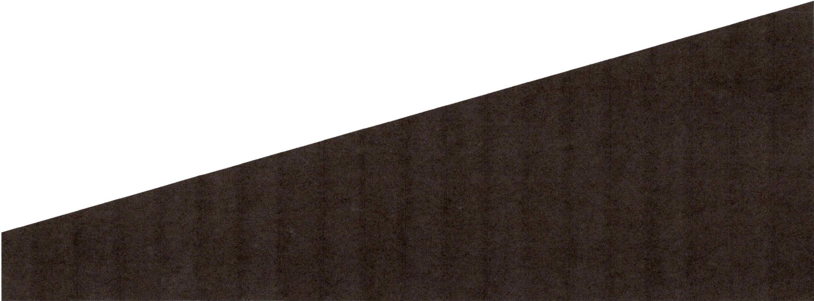
Exhibit# 11

Welcome to Excel Surgery Center
A presentation by Dr. Rami R. Rustum MD



- Thank you so much for your interest in our new establishment.

- We are so excited to share our plans to build a new ambulatory surgery center at 386 Merrimack Street Suite #D, Methuen, MA.

- Throughout the presentation, we will introduce some of the features and individuals involved in this project, and provide the opportunity for any questions and or feedback.

An Explanation: What is an ambulatory surgical center?

- An ambulatory surgical center (otherwise known as an ASC) is a medical facility that provides outpatient or "day-surgery" procedures.

- Patients will arrive, undergo surgery, and go home the same day.

- This provides patients with the advantage of having non-complex surgeries locally, near their homes and work spaces.

- ASCs have an excellent record of safety, quality and success. They provide patients with outcomes that are equal to or exceed the experience provided by every other site of outpatient surgical care - including hospitals.

- ASC performed surgeries are up to 40% less than hospital performed surgeries, translating to direct savings for patients in high deductible health plans.

- Patients have reported a 92% satisfaction rate for ASC performed surgeries!

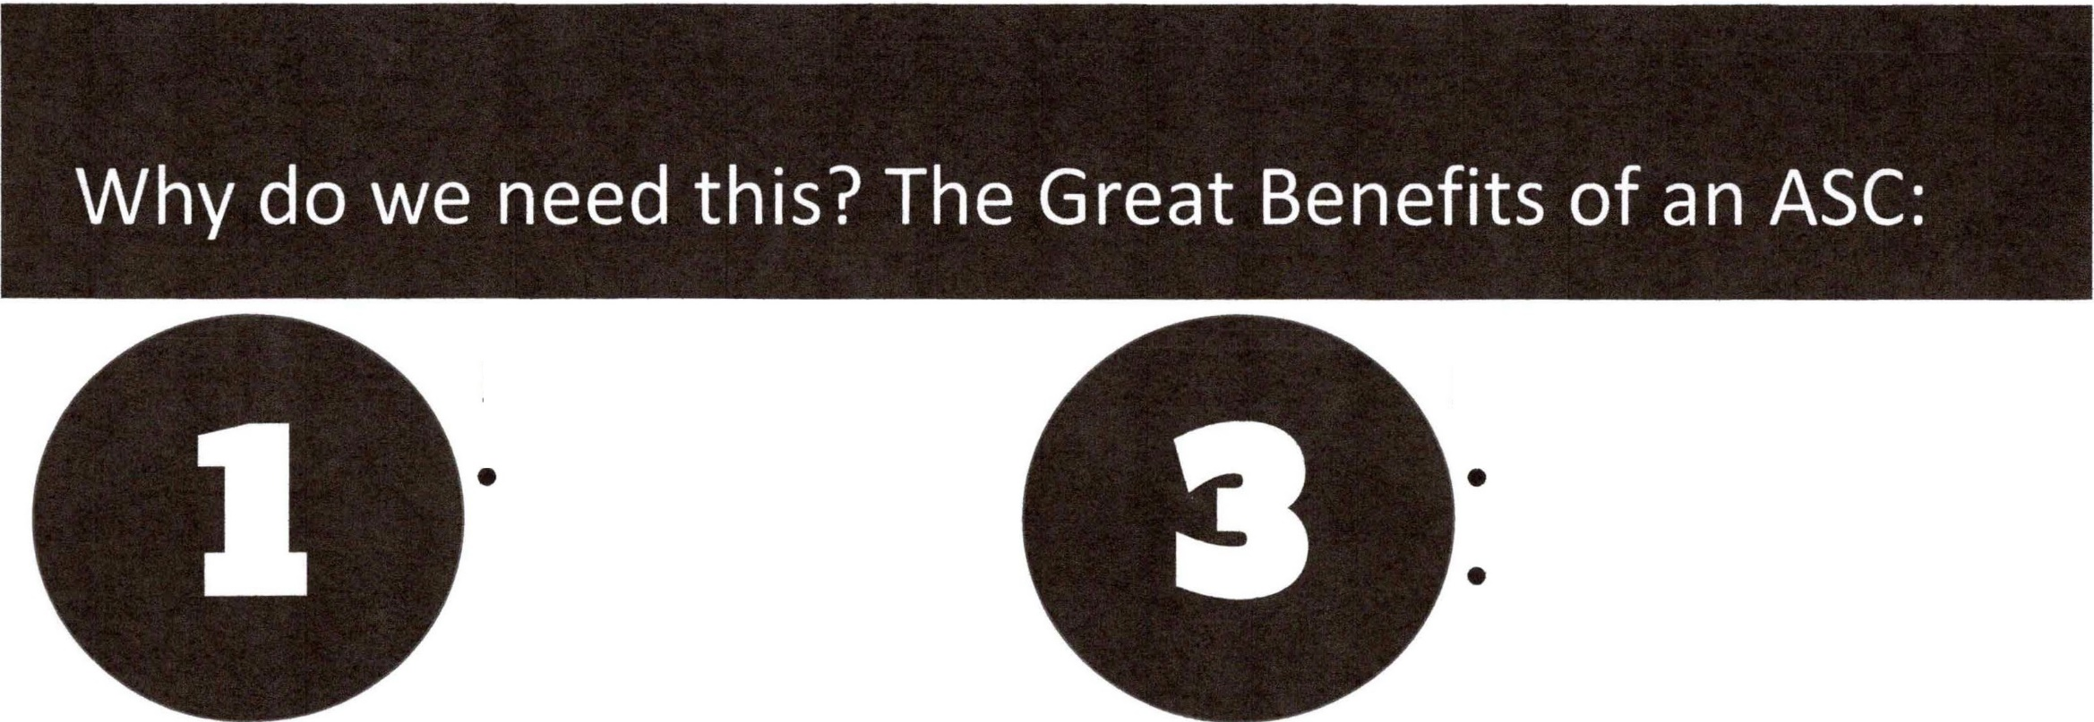
Lowering costs:

Procedures cost
25%-50% less in an ASC compared to an outpatient hospital procedure.

Bringing care to the community:

Shift of care from inpatient to outpatient.
Easy and convenient location.
  - Multispecialty care for families.

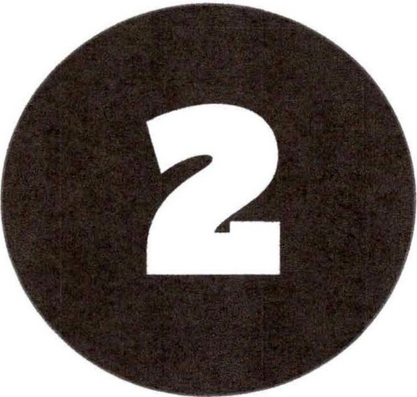
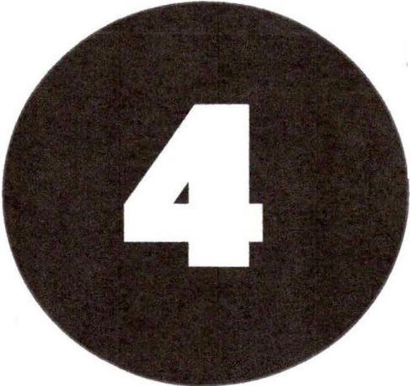
Providing more choices:
- High patient satisfaction
- Safe and high quality service.
- Ease of scheduling.
- Greater personal attention.

Increasing accessibility of care:

- Provides best access for both patients and physicians.
- Specialization in outpatient surgeries leads to greater efficiencies.


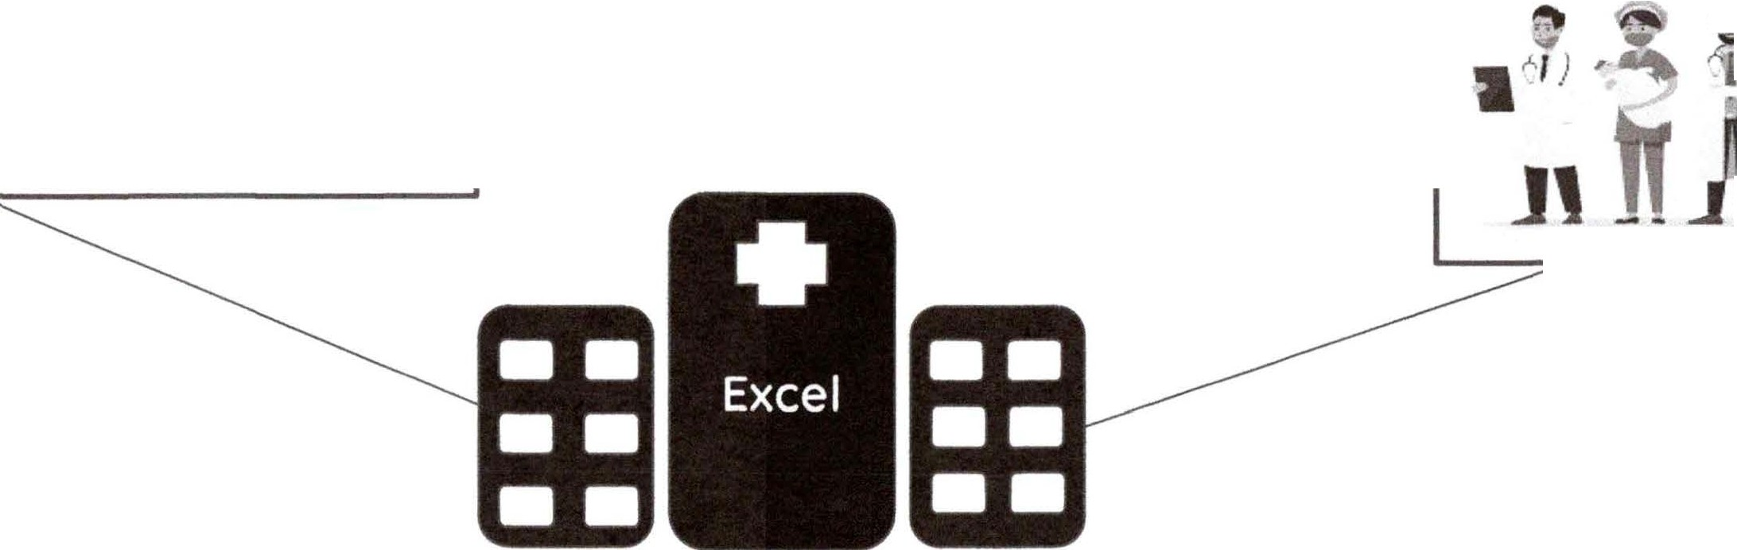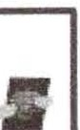
Merrimack Valley
Pain Management Associates, P.C.
_
�-
I ii-
L JlrL

Services
•
•
2 Operating Rooms
Future considerations for total joint program & complementary specialties.
•
•
5,000 square feet of newly renovated space
386 Merrimack Street Suite #D, Methuen, MA 01844

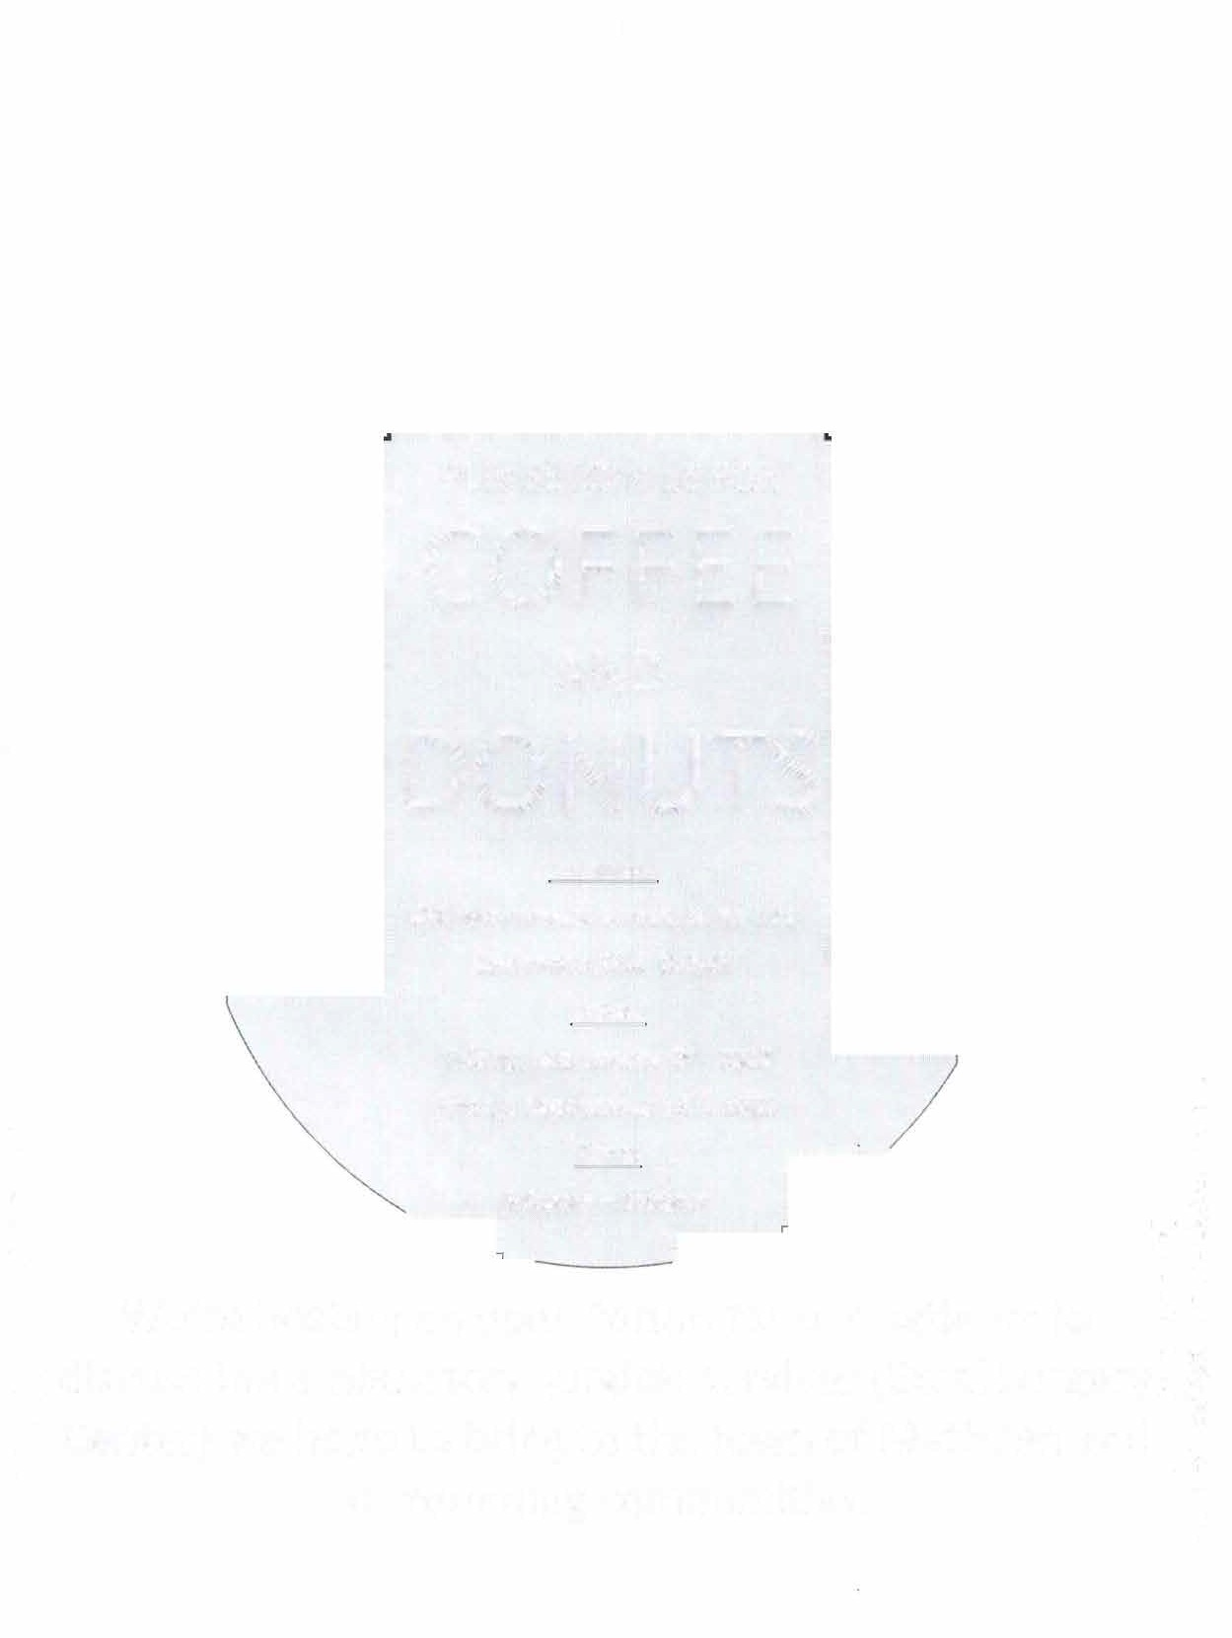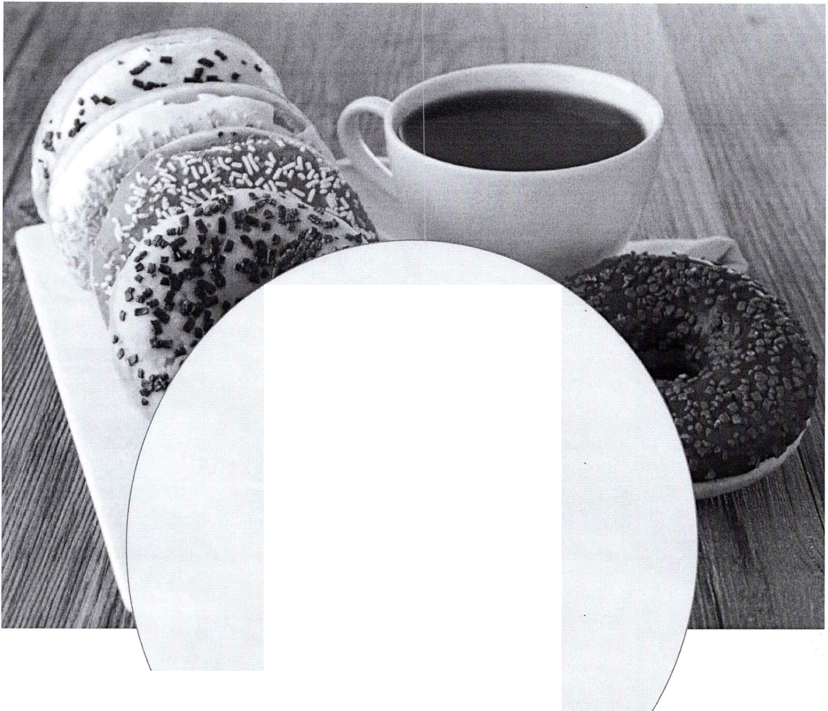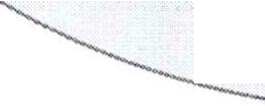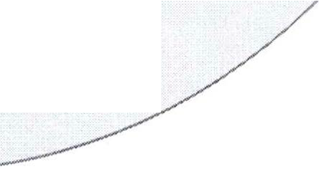Exhibit# 10

PLEASE JOIN US FOR

COFFEE
AND

DONUTS
Location:
280 Merrimack Street, Suite 103
Lawrence, MA 01843 Dates:
Friday, September 9th, 2022 Friday, September 16th, 2022 Time:
5:00pm - 6:00pm

We're hosting an open forum for our patients to discuss the ambulatory surgical services· (Excel Surgery Center) we hope to bring to the town of Methuen and surrounding communities.

