EXHIBIT 1

New tower is not closer than community hospitals to existing UMass EDs

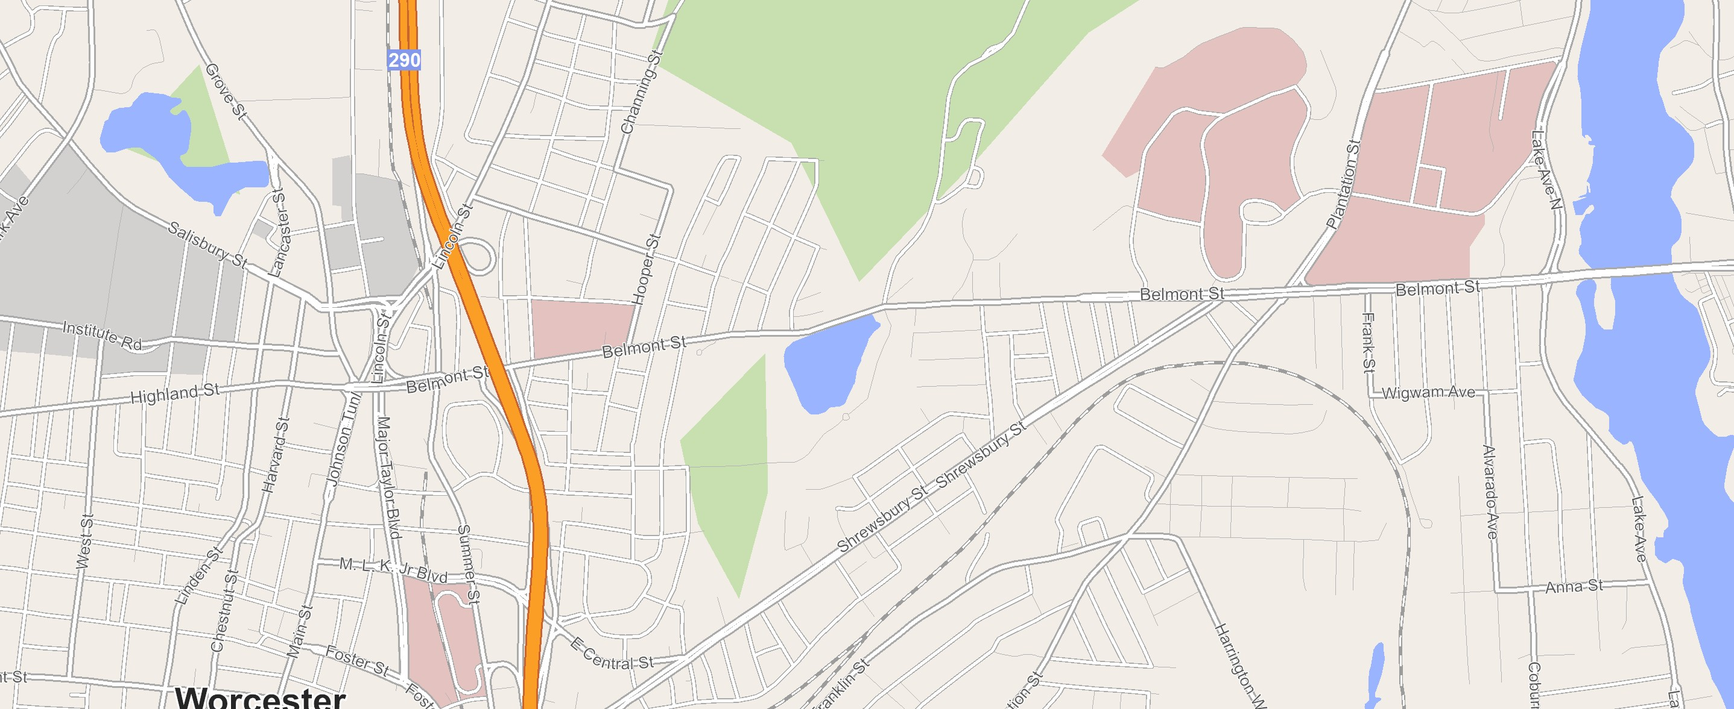UMass Memorial – Memorial Campus SVH UMass Memorial – University Campus New tower
New Tower
UMass Memorial Medical Center – Memorial Campus
UMass Memorial Medical Center – University Campus
Saint Vincent Hosptial (SVH)

Source: UMass filing, publicly available addresses and maps data

- UMass is expecting to outfit a new 72-bed tower for additional beds; the new tower will support ED to inpatient admissions and require ambulances for transferring patients
UMass ED | Distance to new UMass tower (mi) | Ambulance required? | Distance to SVH (mi) | Ambulance required?
UMass Memorial Medical Center – University Campus | ~0.6 | Yes | ~2.4 | Yes
UMass Memorial Medical Center – Memorial Campus | ~1.9 | Yes | ~1.0 | Yes
- The UMass ED sites serviced by the new facility are similarly distanced to SVH, which has capacity to accommodate transfers

EXHIBIT 2
Occupancy rate (licensed beds)
Source: AHA data, UMass licensed bed statistics, SVH Data by YR provided by Tenet Strategy Team
 | Inpatient Days (#) |  | Licensed Beds (#) |  | Occupancy Rates (%)
Healthcare System | 2019 | 2020 | 2019 | 2020 | 2019 | 2020
UMass Memorial Medical Center | 208,648 | 211,706 | 733 | 747 | 78% | 78%
UMass Memorial HealthAlliance-Clinton Hospital | 34,881 | 32,276 | 152 | 152 | 63% | 58%
Heywood Hospital | 21,772 | 21,220 | 134 | 134 | 45% | 43%
Harrington Hospital | 20,727 | 20,743 | 129 | 129 | 44% | 44%
UMass Memorial-Marlborough Hospital | 16,571 | 16,472 | 79 | 79 | 57% | 57%
Athol Hospital | 3,340 | 3,446 | 21 | 21 | 44% | 45%
SVH | 69,441 | 66,819 | 290 | 290 | 66% | 63%

EXHIBIT 3

Adding capacity may result in regional increases to cost of care

Commercial relative price at UMass Medical Center and SVH compared to market average

Relative price to market average
1.090
0.955
14%
1.000
9%

UMass SVH
Market average

Medicare FFS reimbursement at UMass Medical Center and SVH for DRGs representative of the service lines stated by UMass

Service type | DRGs | Differential (SVH compared to UMass)
Septicemia / severe sepsis | 870, 871, 872 | 14.1%
COPD | 190, 191, 192 | 17.4%
Heart failure | 291, 292, 293 | 16.9%
Pneumonia | 193, 194 | 15.9%
Pulmonary edema | 189, 208 | 16.2%
Respiratory infection | 177, 178, 179 | 16.2%

- For commercial payers, UMass is ~9% above Massachusetts market average and
~14% above SVH costs
- For DRGs of service lines in UMass’ filing, UMass is ~14-17% more expensive than SVH for Medicare FFS
- Due to their relatively high cost of care, introducing additional beds at UMass could potentially increase regional costs

Source: Statewide commercial payer RP data, CMS IPPS Web Pricer

EXHIBIT 4

Adding beds will likely further increase UMass market share, potentially further reducing competition in the region

2021 Market share based on inpatient surgery volume for SVH SSA, Medicare FFS only

UMass

SVH

Other

1.4%

32.7%
15.8%

51.5%

In 2021,
UMass acquired Harrington Hospital
  - Prior to its 2021 acquisition, UMass held the highest market share at 50.1% after acquiring Harrington Hospital, UMass’ market share increased by 1.4% to 51.5%
  - With the acquisition, other area hospitals lost market share while SVH’s remained at 15.8%
  - UMass’ proposal for additional beds may further decrease market share of other local health systems

2021 Pre-acquisition 2021 Post-acquisition

34.1%
15.8%

50.1%

EXHIBIT 5

Estimated operating costs for med/surg beds should be measured against national and Massachusetts average
x
x

Estimated
Inpatient admissions
Average length of
Average cost per IP

annual cost of inpatient bed
= stay day
# of staffed IP beds

    - National estimated operating cost for a med/surg bed is
Metric | National average | Massachusetts average
# of inpatient admissions | ~33.4M | ~809K
Average length of stay | ~5.5 | ~4.9
$ per inpatient day | ~$2,873 | ~$3,462
# of staffed inpatient beds | ~921K | ~15,000
Estimated annual cost per inpatient bed | ~$550-600K | ~$900-950K

~$600K annually
    - In Massachusetts, estimated operation costs for a med/surg bed is ~$900K annually

Source: American Hospital Association, Kaiser Family Foundation 2020, fully loaded costs, Average length of stay in community hospitals , Massachusetts government, Massachusetts Adult Care Hospital Inpatient Data, 2018 – 2021 CMS LDS data (Medicare FFS)

EXHIBIT 6

UMass’ CMI adjusted LOS for non-psych inpatients is 20% higher than SVH, and grew faster over 2018-2021

2018 – 2021 Medicare FFS CMI adjusted LOS, inpatient excluding psych
SVH
3.5 UMass Medical Center
3.5
3.3
3.1
5.6%
2.9
2.8
2.7
2.7
4.4%
CMI Adj LOS = Average LOS / case mix index (CMI)

3.5
3.4
3.3
3.2
3.1
3.0
2.9
2.8
2.7
2.6
0

- From 2018 – 2021 UMass CMI adjusted LOS increased by ~5.6%,
~1.3x the increase at SVH, indicating that increase in length of stay is likely disproportionately higher that increase in level of care
- This likely indicates that operational inefficiencies exist and could lead to longer stays

2018
2019
2020
2021

Source: 2018 – 2021 CMS LDS data (Medicare FFS) for UMass, SVH Data by YR provided by SVH Strategy Team

EXHIBIT 7
UMass is in the bottom third of teaching hospitals and AMCs in MA for O/E LOS ratio

Q1-Q2 2021 inpatient Medicare O/E length of stay (LOS) for teaching hospitals and AMCs in MA, excluding psych and newborn

Median O/E Top quartile O/E
45%
1.35
1.37
1.40
1.41
1.22
1.24 1.27
1.11
1.13
1.14
1.15
1.20
0.99
0.88
O/E = Observed LOS / expected LOS per discharge
UMass Memorial Medical Center
  - O/E ratio >1 indicates acute inpatient days are often longer than

Carney Hospital

St.
Vincent

Mount Auburn

Lahey Tufts Hospital & Medical

St. Brigham Cambridge Baystate UMass Mass Elizabeth and Health Medical Memorial General

Brigham and

Boston Beth Israel MedicalDeaconess
1.21
1.03
expected days2
- UMass O/E is 1.27, indicating average acute inpatient stays are 27% longer than expected
- UMass is outperformed by 9 peers in MA and has an O/E 45%

Hospital
Hospital
Medical Center Center,
Burlington
Medical Women’s Alliance Center Faulkner
Hospital
Center
Medical Center
Hospital
Women’s Hospital
Center Medical
Center
higher than top
performing Carney

- Average O/E performance across top 4 hospitals (Carney, St. Vincent. Mount Auburn, Lahey)
- Expected days assessed per reason for hospitalization and patient factors (e.g., age, comorbidities, etc) Source: 2021 CMS LDS data (Medicare FFS) for academic medical centers in Massachusetts
Hospital

EXHIBIT 8

UMass could potentially create additional capacity by improving O/E LOS performance compared to other comparable AMCs

Q1-Q2 2021 inpatient Medicare O/E length of stay (LOS) for comparable AMCs1

Top quartile

1.41
O/E = Observed LOS / expected LOS per discharge2

Second Quartile Third Quartile Bottom Quartile
1.26
1.06
1.16

UMass
UMass could potentially create additional bed capacity by matching Second Quartile or Top Quartile performance at comparable AMCs

O/E comparison | O/E ratio | Necessary inpatient beds | Potential capacity created
UMass - current state | 1.27 | 747 | N/A
Second Quartile Average | 1.16 | ~683 | ~64
Top Quartile | 1.06 | ~624 | ~123
average

- Comparable AMCs defined as CMI (>1.8), Teaching level (>25% residents per total beds), Bed size (>350)
- Expected days assessed per reason for hospitalization and patient factors (e.g., age, comorbidities, etc) Source: 2021 CMS LDS data (Medicare FFS) for academic medical centers

EXHIBIT 9
2021 O/E LOS (excluding psych and newborn)
Source: Medicare FFS LDS data & AHA licensed beds for UMass

O/E | Comparison | Inpatient beds | # reduced from current  state | Source
1.27 | UMass current state O/E | 747 | 0 | 2021 CMS LDS data (Medicare FFS) for academic medical  centers in MA, AHA licensed beds data for UMass
1.22 | National AMC average | 719 | 28 | 2021 CMS LDS data (Medicare FFS) for national academic  medical centers

EXHIBIT 10

Increasing medical costs may continue to disproportionally impact households under 4x FPL

2021 Massachusetts Health Policy Commission Annual Healthcare Cost Trends Report on affordability (% surveyed experiencing affordability issue)

Household income under 400% FPL
Household income at or more than 400% FPL
59.3%
36.1%
38.2%
26.0%
26.8%
21.0%
16.0%
17.8%
12.4%
3.5%
Medical bills being paid over time
Problems paying family medical bills
High share of family income on out-of-pocket
Any unmet
Any of the four
health care affordability issues needs for family

Source: 2021 Massachusetts Health Policy Commission Annual Healthcare Cost Trends Report

- Increasing regional costs will also impact patients; with 59.3% under 400% FPL and 38.2% above 400% FPL
with commercial insurance citing challenges to affordability of healthcare
- Increasing costs to healthcare greater impact on lower income adults across all affordability issues, and rises to regional costs may negatively impact affordability of care

EXHIBIT 11
Inpatient beds per 1,000
Source: AHA & CMS LDS data (Medicare FFS)

County | Med / surg staffed beds per 1,000
Plymouth, MA | 0.27
Essex, MA | 0.50
Norfolk, MA | 0.50
Hampshire, MA | 0.57
Franklin, MA | 0.67
Middlesex, MA | 0.80
Nantucket, MA | 0.89
Bristol, MA | 0.90
Dukes, MA | 1.03
Worcester, MA | 1.17
Barnstable, MA | 1.27
Hampden, MA | 1.54
Berkshire, MA | 1.55
Suffolk, MA | 3.47
Massachusetts avg | 1.13
National avg | 1.07

Harrington Hospital licensed beds not available in AHA data; licensed beds found in 2022 UMass statistics report on licensed beds (https://www.ummhealth.org/about-us/system-statistics)
SVH licensed beds provided by Tenet (Carolyn Jackson)
UMass acquired Harrington Hospital in June 2021 Source: Trilliant All-Payor Surgical Data Sample

