Commonwealth of Massachusetts
Executive Office of Health and Human Services

Virtual Gateway



CBHI Export/File Import to MS Excel
Reference Guide
February 2015 R3.0 v1


CBHI Export/File Import to MS Excel Reference Guide

Table of Contents
Logon to Virtual Gateway 3
Export CANS Files 3
Exporting Layout (Column Headings) 3
Export File (Data) 4
Using MS Excel to View Exported Report 5
Auditing 7
Performance Tip 7
Questions or Need Assistance? 8

Logon to Virtual Gateway
To log on to the Virtual Gateway (VG), go to www.mass.gov/vg and select the link “Logon to Virtual Gateway”. Select the Children’s Behavioral Health Initiative (CBHI) business service to enter CANS in the VG.
Note: See the Login Assistance page at www.mass.gov/eohhs/provider/training-and-edu/vg/login-help-for-providers-and-state-agency-staff.html for more information on setting up a Virtual Gateway (VG) account.
Important Note For MCE and Organization VG CBHI Roles:
Only users with MCE (Managed Care Entity) and CBHI Organization roles have access to export files from the CANS application.

Export CANS Files
Exporting CANS records is a two-step process.
- Exporting the layout (column headings)
- Exporting the file (data)

Exporting Layout (Column Headings)
- From the CANS Welcome page, select the [Export] tab.
Note: The Export tab is only available to users who have the designated organization role in CBHI.
- Select the [Export Layout] button.
- Select the [OK] button.
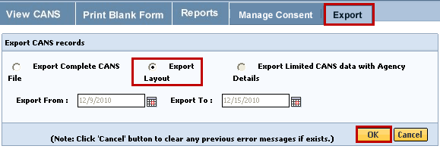
The File Download dialog box will appear on screen asking “Do you want to open or save this file?”
- Select the [Save] button.
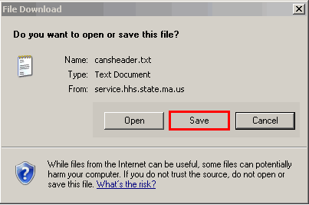

Note: Remember to rename and save file to the appropriate directory on your computer. This saves the column headings for later use.
Tip: The default name for the Export Layout is “cansheader.txt” and the file type is Text.

Export File (Data)
- From the Export page, select the [Export File] button.
- Enter [Export From:] date or select the Calendar () icon to select date. (Format: mm/dd/yyyy)
- Enter [Export To:] date or select the Calendar () icon to select date. (Format: mm/dd/yyyy)
Note: We recommend limiting date range to one week.
- Select the [OK] button.
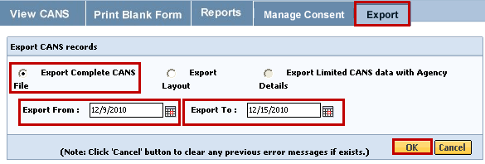
The File Download dialog box will appear on screen asking “Do you want to open or save this file?”
- Select the [Save] button.
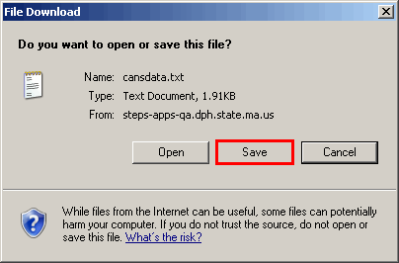
Things to Remember:
- Remember to rename and save file to the appropriate directory on your computer. This saves the CANS data for later use.
- The default name for the Export File is “cansdata.txt” and the file type is Text.
Once both files are saved to your computer, logout of the CANS application.

Using MS Excel to View Exported Report
Since the exported file has been saved in txt format, to view it in Excel follow these steps:
Open MS Excel
- Select the [Start] menu (located in lower left of computer monitor).
- Select the [Programs] link.
- Select the [Microsoft Office] link.
- Select the [Microsoft Office Excel 2003] (or similar version) link.
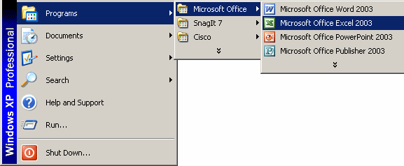
- Export File (CANS Data) from within MS Excel
- Select the [File] menu.
- Select the [Open] link.
- Locate the directory (specific drive/folder of the saved file) of saved file.
- Select drop-down arrow next to [Files of type:]; select [All Files].
- Highlight the file to open (example: cansdata).
- Select the [Open] button.
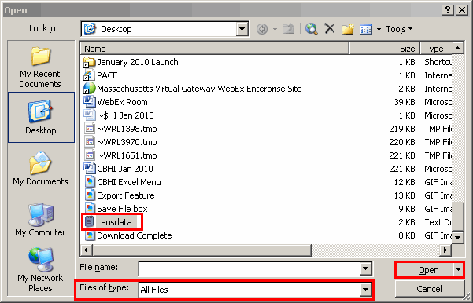
- Select the radio button next to Delimited.
- Select the [Next] button.
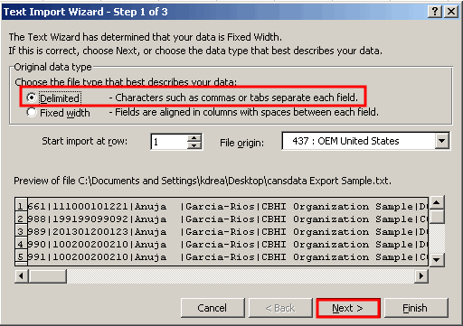
- Under the Delimited section,
  - Uncheck the [Tab] checkbox.
  - Check the [Other] checkbox.
  - Next to the Other checkbox, enter the [Pipe-delimiter] ( | ) symbol located above the Enter key on keyboard.
- Select the [Next] button.
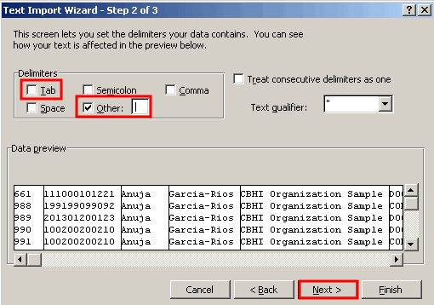
- Select all of the columns in the Data preview section,
- Select the first column, then using the bottom scroll bar and scroll to the last “General” column which will have the ^ character.
- Press and hold down the Shift-key and Select the last [General] column with the ^ character.
- From the Column data format,
- Select the radio button next to [Text].
Note: You can easily change number formats later in Excel, if needed.
- Select the [Finish] button.
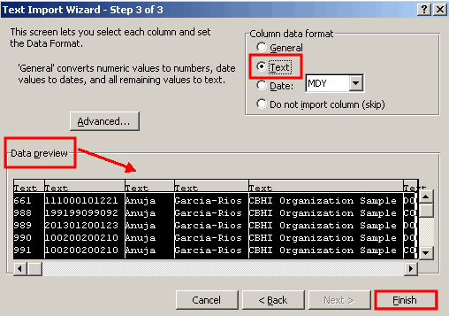

Auditing
All actions performed in the Massachusetts CANS system are logged including actions performed, user id, date and time. This enables administrators to have an audit trail of activities.

Performance Tip
If application performance appears to be slow, use browser options to clear cookies, history and/or cache. Please see individual browser instructions for specific steps.

Questions or Need Assistance?
Call Virtual Gateway Customer Service
1-800-421-0938
(617-847-6578 - TTY for those with complete or partial loss of hearing)
8:30 am to 5:00 pm Monday through Friday
Bookmark the Children's Behavioral Health Initiative Website:
www.mass.gov/masshealth/cans

