Program: | MBHV-QEIP
Performance Year: | 3
Measure: | Achievement of External Standards for Health Equity
Deliverable: | External Standards for Health Equity Report
Submission Portal: | OnBase
Submission Due Date: | January 31, 2026
File Naming Convention: | EntityAbbreviation_ExternalStandardsReport_YYYYMMDD
Suggested Page Limit: | 3 pages

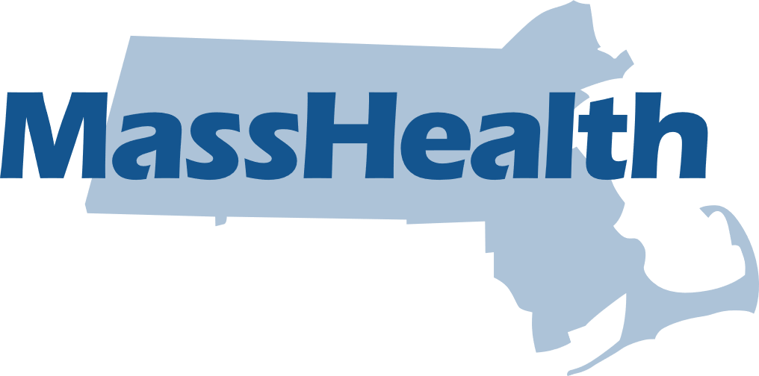

MassHealth Quality and Equity Incentive Program (QEIP)

Summary
This measure assesses the MBHV’s progress towards and/or achievement of external standards related to health equity established by the National Committee for Quality Assurance (NCQA).
NCQA’s Health Equity Standards are intended to serve as a foundation for the MBHV to address health care disparities. These Health Equity Standards build on the equity-focused Health Plan Accreditation standards to recognize organizations that go above and beyond to provide high quality and equitable care.
This measure incentivizes MBHV to demonstrate achievement of the NCQA Health Equity Accreditation by the end of Performance Year (PY) 3 (2025).

Reporting Template

Contact Information
Point of Contact Name: | Add text
Point of Contact Name: | Add text
Point of Contact Title: | Add text
Organization Name: | Add text

Introduction
By the end of PY3 of the MBHV-QEIP, the MBHV is required to achieve certification of NCQA’s Health Equity Accreditation, as demonstrated through this report.
There are two sections to this report:
- Section 1. Documentation of Achievement of NCQA Health Equity Accreditation by PY3
- Section 2. Progress Towards NCQA Health Equity Accreditation
Please complete EITHER Section 1 OR Section 2. Do not complete both.

Section 1. Documentation of Achievement of NCQA Health Equity Accreditation by PY3
If the MBHV has achieved NCQA Health Equity Accreditation by the end of Performance Year 3 (2025), complete this section 1.
- Please provide a screenshot of the formal/official certificate of achievement of the NCQA Health Equity Accreditation below. Alternatively, you may upload the certificate from NCQA alongside this reporting template in OnBase.

Section 2. Progress Towards NCQA Health Equity Accreditation
If the MBHV has not yet achieved NCQA’s Health Equity Accreditation, complete this section 2. The following questions are related to MBHV’s progress towards achieving accreditation.
- List the NCQA Health Equity Standards achieved to date (may be from the MBHV’s own assessment of standards achieved):
Response:

- List the NCQA Health Equity Standards in progress (may be from the MBHV’s own assessment of standards in progress):
Response:

- Describe any efforts undertaken in PY3 (CY2025) to make progress towards achieving NCQA Health Equity Accreditation.
Response:

- Describe any anticipated efforts, resources, etc. needed to achieve Accreditation by the end of PY4 (2026).
Response:

