
The Career Center Seminar
Facilitator’s Guide Version October 2015

This is to be used in conjunction with a Power Point presentation of the Career Center Seminar (CCS).

The Career Centers are the cornerstone of the Massachusetts workforce system and your CCS is the entry point. The Career Center Seminar facilitator is vital, as you are not only representing your Career Center but the entire One-Stop system.

• Before beginning the Seminar, facilitators should review the contents of the presentation to familiarize themselves with the services and resources available at the Career Center (CC) as they will need to “market” services and resources to the Seminar participants.

• The Seminar is now the entry point for the Re-employment Services Program. All customers attending the CCS should fill out the Individual Needs Assessment and be scheduled for an initial meeting with Career Center staff according to the procedures established at the local Career Center.

Materials
Be sure to have handout materials printed in a large font to meet ADA regulations (size 18 font). A few copies of the presentation in the larger font should be made available.

Welcome Packet (This will include all required handouts as well as any Career Center specific handouts which are discussed in the Seminar.)

Welcome Packet
Required
Labor Market Information Worksheet
Updated Work Search Activity Log
Individual Needs Assessment
Universal Access Flyer
Resources & Website lists
Trade & WOTC Handouts
Local Career Center Complaint Process with name & contact for the complaint officer
List of all Massachusetts Career Centers

Optional
Materials, continued
Career Center Hours and Contact Information
Career Center Calendar of Events
Employment Verification Form
Policy for use of CC Facilities (Resource Room guidelines, what to do if unable to attend workshop, how to inform CC when you get a job)
Any other Career Center Specific Flyers/Handouts
Appointments for Initial Assessments (according to local procedures)
Optional is CCS Power Point as a Handout


There are notes for the facilitator, which are highlighted by the notepad icon
General Information
throughout this guide. The icon will be an indication to the facilitator that he/she needs to give participants additional information on that particular topic/bulleted point.

Throughout the CCS, the Facilitator can continually remind participants that in order to ensure a successful job search they should take advantage of the services offered by the Career Center. Also emphasize that many of the activities offered by the Career Center can be completed on a self-directed basis.

There are cues that guide the facilitator in advancing the slide. The mouse icon highlights these cues.

The information in the CCS Power Point and the Facilitator’s Guide cannot be removed; however, slides can be added to meet your Career Center and customer needs. Slides that can be customized with additional Career Center- specific information are identified in the notes section(s).

BEGIN SEMINAR: Advance to SLIDE 1

SLIDE 1


NOTES:
Insert the name of your Career Center into the PowerPoint.


SAY:
Welcome to [INSERT THE NAME OF YOUR CAREER CENTER HERE] and introduce yourself.

Advance to SLIDE 2


SLIDE 2

NOTES:
You can substitute this quote for another quote of encouragement.
Please inform your audience that, during this presentation, you will
review all of the information that is contained in their packet.

You may choose to review those items at this time or at another point in this presentation.

Advance to SLIDE 3

SLIDE 3
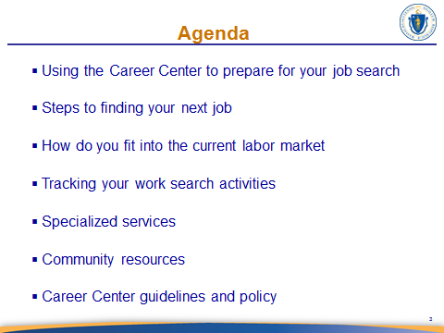

NOTES:
Discuss the bullet points.

Advance to SLIDE 4

Continued on next page

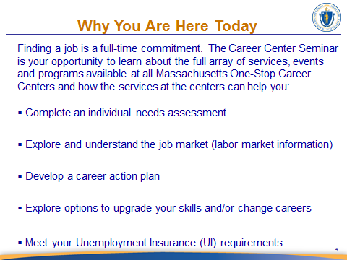
SLIDE 4

NOTES:
Introduce the slide as seen in the ‘SAY’ section and then discuss the agenda by bullet point as they relate to your career center.
Click to advance through each bulleted talking point.

SAY:
You are here today because you are trying to find a job. We are here to tell you that you are not alone because the Career Center is invaluable in assisting you with your job search preparation. Developing a career action plan can lead to many different avenues that may start with an assessment. The assessment may determine if remaining in the same occupation is beneficial or if you need additional training. The assessments will help provide a better understanding of labor market information as it relates to you. Attending this seminar will help you meet your UI eligibility requirements and some of you are required to be here.

Advance to SLIDE 5

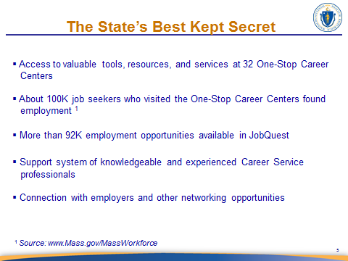
SLIDE 5

In going over these bullet points, mention the fact that finding a job is always difficult, but even more so in a challenging economy and that the Career Center’s resources and support will help them succeed in their endeavor.
NOTES:

Use this slide to market the Career Center outcomes, also take the opportunity to discuss your Career Center specific outcomes. Be sure to periodically update bullet three in your slides when the number of employment opportunities change significantly from the number that is on the slide.

SAY:
Let me tell you a little about our staff’s knowledge and experience. Most of the Career Center staff have been unemployed and understand the hardship and emotions you may be experiencing.

Advance to SLIDE 6

Continued on next page

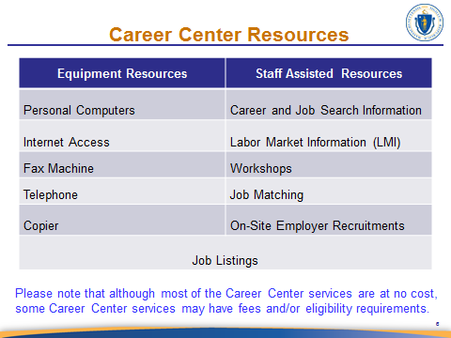
SLIDE 6

NOTES:
Please familiarize yourself where these resources are within your Career Center. Inform the participants that some Career Centers may charge a fee for some services (indicate whether or not your Career Center does). Point out that some services have eligibility requirements.

Inform participants that if they are interested in a particular service and are not sure if they are eligible, they can ask Career Center staff after the Seminar. Mention the availability of adaptive technology as well.

Give examples of how the resources could be used (i.e. personal computers could be used to prepare your résumé and cover letter, use the internet to email a résumé to an employer or research occupations). Review each resource and discuss the use of JobQuest.
SAY:
The Career Center offers many resources to assist you with your job search.
Think of it as your personal office while you search for your next job.
Career Center staff will assist or coach you along the way.

Advance to SLIDE 7

Continued on next page
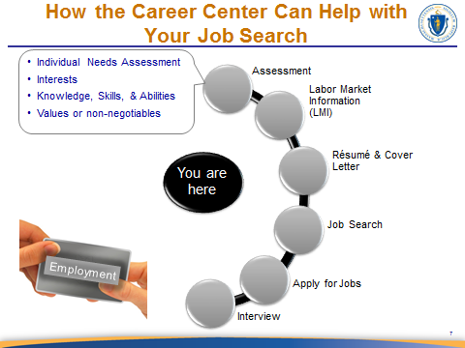
SLIDE 7
NOTES:
The next eight pages refer to slide 7 of the presentation. This slide includes multiple transitioning call-outs. For clarity, this guide presents a copy of this slide for each call-out transition. The actual presentation slide will only show this slide once.

This slide is your opportunity to market your services, so the dialog should reflect this. After the dialog seen in the ‘SAY’ section below, discuss the assessment tools available in your Career Center. Then to transition to the next call out.
SAY:
The available assessment tools allow you to do an Individual Needs Assessment (INA) that considers your interests, knowledge, skills, and abilities (KSA’s). It also addresses key features associated with a job that you require to be non-negotiable such as how far you are willing to travel. The assessment process also evaluates if you need additional training, certification, or licenses. The Career Center can provide or help you access an assessment that is useful to you. To get you started we will be completing an INA during this presentation.

Stay on SLIDE 7

Continued on next page
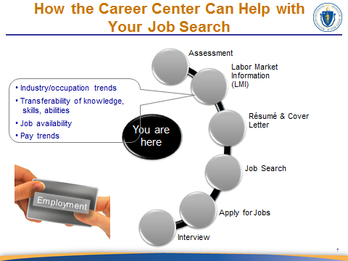
SLIDE 7

NOTES:
Briefly mention the sites (e.g., O’Net, MassCIS, BLS) available to find labor market information.


Use this slide to market the services/workshops that you offer that relate to
each aspect of the job search discussed here. After the dialog below to transition to the next call out.
SAY:
As we progress through this presentation we are going to show you available tools and how they are used to help you learn more about what is going on in the labor market for your occupation and how your Career Center helps you to access them.

Did you know that your job skills can transfer to alternative occupations? We will discuss this a little more shortly. What if there is growth or decline in your industry, wouldn’t you want to know that? If the current pay trends have shifted and your job now pays five dollars per hour more or less, wouldn’t that information be important to you?

Stay on SLIDE 7

Continued on next page

SAY:
Labor market information (LMI) is key to understanding the workplace and the dynamics that influence your job search and career choices. Taking your skills and interests into account helps to guide your job search.

Career Center staff can help you understand your labor market and how to start exploring it to help you strategize your job search. Our Career Center offers… [MENTION RELATED WORKSHOP(S) OR CAREER CENTER SERVICES THAT ADDRESS LMI COMPONENTS OF THE JOB SEARCH].

Stay on SLIDE 7

Continued on next page

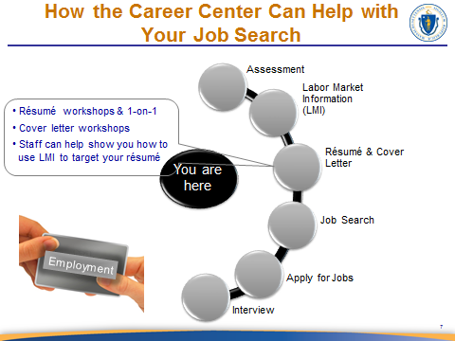
SLIDE 7

NOTES:
After the dialog below discuss available workshops then to transition to the next call out.

Emphasize the fact that the job search is a fluid process, meaning that one may go through the different steps and find that they need to revisit a previous step (e.g., LMI, assessment) in order to proceed.

SAY:
I’d like to briefly talk about the résumé and cover letter because everyone needs a résumé. Our Career Center offers résumé development and cover letter workshops, or [IF APPLICABLE] you can meet with one of our certified résumé writers to discuss your resume. Some of you may already have a résumé and some of you may need a résumé. Many of you may have worked in the same job for many years, and the market may look very different today than in years past. Résumés today focus more on your skills rather than just a job title.

Stay on SLIDE 7

Continued on next page

We can show you how to include a summary on your résumé and why it is important to tailor it to match the job for which you are applying. The more specific you are in your summary, the more likely you are of getting the job that you want. Your résumé should include the same keywords that appear in job descriptions. That way, you will increase your chances of your résumé matching available positions in a company posting.

Résumés should be adjusted to reflect your strengths as they relate to the job to which you are applying. So going forward after doing a job search and locating a job that meets your requirements you need to adjust your résumé to reflect your strengths and skills related to the job description. By taking this step, you will be showing the best of what you have to offer to the employer.

Cover letters summarize your qualifications and achievements as they relate to the job of interest. Your cover letter is best used as quick introductory to how you meet the qualifications for the job. To write a great cover letter you need to show the hiring managers that your KSA’s meet their hiring needs and plant a ‘seed’ in their minds that you are the special employee they've been looking for.

When you are submitting your résumé and cover letter, whether it be via email, U.S. mail, or uploading it to a company website, it is important to follow the employer's submission instructions. This will directly influence the employer’s opinion of how well you follow instructions and may even determine if your résumé is reviewed. So ask our Staff about signing up for our résumé services and/or workshops to help you navigate through these stages of your job search.

Stay on SLIDE 7

Continued on next page
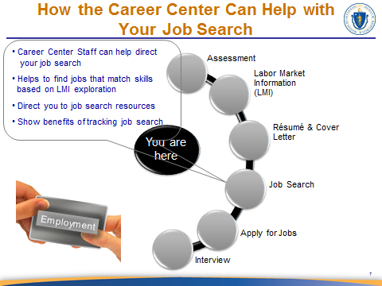
SLIDE 7

NOTES:
Briefly mention JobQuest and available job search sites (e.g., TORQ, MassCIS). After the dialog below discuss available workshops then to transition to the next call out.

SAY:
Now that you have done some research you can begin looking for jobs within or outside of your current occupation. Start exploring jobs that match your skills based on the information you gathered during the Labor Market phase of your job search process. This helps you to broaden your opportunities and look for jobs in related/alternative occupations or industries. The Career Center can help guide you on how to develop a targeted job search. And don’t forget that an important part of your job search will be to keep track of your job search using the Work Search Activity Log which we will discuss shortly.

Remember, looking for a job is a full time job and you will invest a lot of your time and effort in this process, let the Career Center help you make the most effective use of your time. [MENTION RELATED WORKSHOP(S) OR CAREER CENTER SERVICES THAT ADDRESS THE JOB SEARCH]

Stay on SLIDE 7

Continued on next page
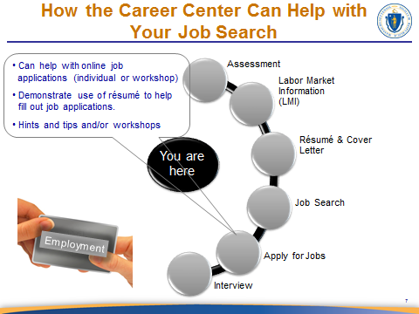
SLIDE 7

After the dialog below to transition to the next call out.
NOTES:
SAY:
Let the Career Center show you how to look for jobs using what you discovered during your labor market exploration. [MARKET YOUR JOB SEARCH WORKSHOPS AND/OR RESOURCES] This will open up opportunities in areas that you may not have considered to be part of your profile. For example, you may have been in a security guard for many years, but after your Labor Market research you realize you could apply to the Department of Corrections as a Corrections Officer. With this information you know now you will be making more than twice the weekly income with little or no training to meet the job requirements. Not too bad just for doing a little research.

CC staff can also help guide you through how to apply for jobs online. And remember that in most cases the application is also part of a screening process. So it is good to have useful hints and tips and to follow the application instructions. Also, think about how having a resume handy makes it easy to fill out an application and saves you time.

Stay on SLIDE 7

Continued on next page

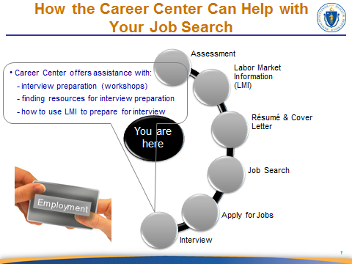
SLIDE 7

NOTES:
Discuss related workshops or Career Center services that address the interview process.

SAY:
Now you are able to start preparing for the interview. Our Career Center offers… [ENTER INTERVIEW RELATED WORKSHOPS AND SERVICES HERE]. You should research the company via Google, or career sites like www.glassdoor.com, that give you some insight into the company. This should include new and exciting events happening in a company. Investigating a company’s favorite charities allows you to express your interest in being part of their initiatives.

Sites like www.glassdoor.com offer information about the type of questions typically asked by specific companies during the interview. This will help you guide the conversation during the interview process. Now at the end of an interview you may be asked if you have any questions. Most people say “no, I think you have covered everything,” but not you.

Continued on next page

You can ask a question as simple as “when you hire me, what would a typical day look like,” or “if you hire me what would be the first three areas of importance you would like me to address,” (allow the employer to answer) then proceed with: “out of the three, which ones would be your first priority,” (allow the employer to answer). Now capitalize on the experience reflected in your résumé to resolve their priorities.

When the employer shares this priority with you they are potentially telling you the real reason you have been considered for this position. Capitalize on this information and now make yourself outshine the competition. Remember that our Career Center offers an interview workshop that covers some of this information.

Advance to SLIDE 8

Continued on next page

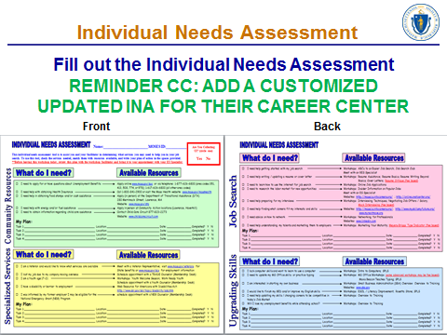
SLIDE 8

NOTES:
Stop and have the job seekers take out the INA form to complete during the next 10 minutes. All attendees must complete the INA prior to leaving CCS.

Career Centers can customize the Individual Needs Assessment designed by the CCS workgroup to optimize the services at your center. If your Career Center will use another tool for determining what services customers will need to become re-employed, go over the procedures for that tool at this time. Be sure to include the workshop calendar and encourage the job seeker to enroll.

In this discussion be sure to include segue to LMI.

Take a look at your Individual Needs Assessment Survey to determine what your next steps are. Please look at our workshop calendar and resources offered to see how we can help you reach your goal. Select activities or workshops to help meet the needs you identified on your INA. It is important to establish what services you need to become re-employed as soon as possible.

Continued on next page

Please also complete your membership form if you have not done so and ensure that any other required signatures are in place. [ENCOURAGE CUSTOMERS TO FILL OUT THE MEMBERSHIP FORM COMPLETELY INCLUDING WORK HISTORY AND EDUCATION.]

After this presentation you will be given an appointment with a Career Center staff member to continue your assessment and help you to develop your Career Action Plan. During this appointment, you will meet one-on-one with a job specialist to get your job search on the fast track. (Local procedures may differ).

Advance to SLIDE 9

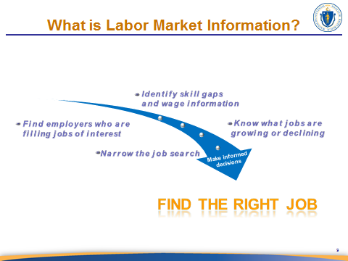
SLIDE 9

NOTES:
The three (3) main points of emphasis that should be addressed in this slide are:

- use the dialog questions in the ‘Say’ section below to discuss LMI in terms that are meaningful to job seekers

- the answers to these questions help job seekers to make informed decisions about their job search, and

- the goal in making these key decisions is to find a sustainable job that will be the right fit for the job seeker

For those who are just looking for a stepping stone/stop gap job, remind them that their job search for the ‘right job’ should continue and should include a continuous re-evaluation of their labor market.

Continued on next page

SAY:
- Do you know where to find answers to the following questions:
      - Am I able to find jobs in my occupation?
      - Are my skills still in demand?
      - How do I identify my transferrable skills?
      - Are my wage expectations realistic?
      - Where are the jobs?
      - How far am I willing to travel for the right job?
      - Do I need additional training/education?

Answers to these questions will provide you with valuable information about the labor market in your area and will guide you to a targeted job search while saving you time with the process.

Advance to SLIDE 10

SLIDE 10
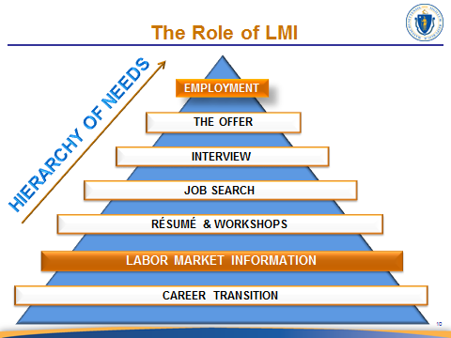

NOTES:
This slide borrows from Maslow’s Hierarchy of Needs Theory of Motivation. Thus, the emphasis of this slide is to illustrate how each step of the job search process relies on the need to know one’s labor market. The script below is very specific regarding how this emphasis is applied.

This slide lends itself to using sample stories about how customers found success through the use of LMI, so draw upon your customer experiences.

SAY:
We introduced you to labor market information; now let’s talk about why it is so important to your job search. Let’s see how LMI feeds into every step of your job search.

Each of us has the basic need for meaningful employment. In addition, we have a need to meet financial responsibilities that allow us to put food on the table and keep a roof over our head and changing a job or a career needs to meet these needs. This motivates you to search for a job.
CAREER TRANSITION

Your first step toward meeting the need to find meaningful employment is to explore your labor market. Every step or ‘need’ in your hierarchy of needs is a necessary part of your job search; however, fulfilling each of these needs should be based on what you learn about your labor market.
LABOR MARKET
INFORMATION

For example, in order to create or update your résumé you will need to list your prior skills and experiences and then compare them to the skills and knowledge required in similar jobs. This involves exploring your labor market. You may have different versions of your résumé based on the variety of different jobs to which you apply. Labor market information helps you understand what skills and knowledge employers expect and ensure that you include those that you have in your résumé(s).
SAY:
RÉSUMÉ &
WORKSHOPS

Labor market information also helps you determine which Career Center workshops are important to you such as interviewing techniques or how to network. Or perhaps you need to upgrade your job skills. Labor market information also helps you identify any training or education needs you may have prior to applying for a job. Does your LMI indicate that employers in your occupation/industry expect you to know how to use Microsoft Excel? Well the Career Center offers Excel classes so that you can fill that skill gap (the gap between the KSAs that you have and those that you don’t have which are required by employers).

And don’t forget that if you qualify for a training program the Career Center can help guide you through the application process. The point is that labor market information tells you which of your KSA’s are most relevant to employers so that you can include this in your résumé.
NOTES:
Discuss workshops that are relevant to this discussion and your Career Center and encourage customer enrollment. Résumé, interviewing, computer skills… [gear this section to your Career Center]. The point of this discussion is to reiterate how the LMI research provides insight into which workshops/training would benefit the job seeker and guides the résumé’s development.

After having explored your labor market information you may have a better idea of where to start your job search process. Perhaps you realized that you want to apply for jobs in another industry that uses your knowledge, skills, and abilities. This allows you to cast a wider net and increase your job opportunities.
SAY:
JOB SEARCH

Knowing your labor market also helps you to prepare for interviews. For example, it helps you identify the KSAs which employers commonly look for in a different industry where you could transfer your skills to. If you are called in for an interview you can discuss how the skills you used in your prior occupation/industry applies to the job they are hiring for. The LMI that you explored helps you by guiding your interview conversation and helps you to explain how your KSAs and experience can be used to meet their needs.
INTERVIEW
LABOR MARKET
INFORMATION
Continued on next page

SAY:
Be sure to explore the company’s website to better understand the company’s product/or service, the industry, and who their competitors are to better informed.
Are they in the news, any press releases, have they expanded their industry to include a new service, is there any related information about the key players in the company. Remember Glassdoor.com or news articles.

How does LMI help you prepare for a salary negotiation? Because of your labor market review you would know the going pay rate that helps you to effectively negotiate a job and salary offer. With this information you may also come to realize that many employers are paying less than what you are used to making for the same type job that you just left. This is the reality of this economy, but if you are open to transferring those skills into other industries or occupations you may find that in some cases the pay is better. If you know the salary range that employers in an occupation/industry then you will be able to identify when an employer is low-balling your salary and benefit offer. LMI also helps you identify if you are undervaluing or overvaluing your skills so that you can set realistic wage expectations.
THE OFFER

[THIS IS A GOOD PLACE TO INSERT A SAMPLE STORY TO ILLUSTRATE YOUR POINT ON THE ‘OFFER’ DISCUSSION]

Can you see how each step fulfills a need that culminates in realizing your need for relevant employment? Each step is influenced by what you learn from your LMI research.
EMPLOYMENT

And don’t forget that our Career Centers offer valuable workshops in résumé writing, job search tips, how to prepare for the interview and salary negotiations among other topics. [ADD CAREER CENTER SPECIFIC TOPICS HERE- OPTIONAL]

Advance to SLIDE 11

Continued on next page
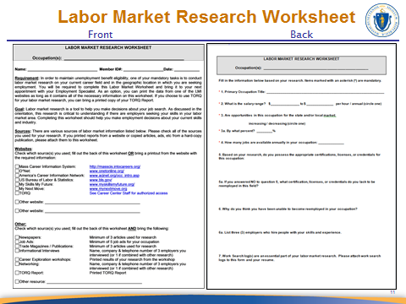
SLIDE 11

NOTES:
Use a question from the worksheet to discuss as example.
Discuss this worksheet as it is used in your Career Center. Be sure that if you use an alternate LMI worksheet that it includes links to LMI resources/websites as seen on the first page of the sample worksheet seen above.

We discussed what LMI is and how it is used in the job search process. Now we want to take a look at where you start your labor market exploration. This worksheet provides LMI resources and LMI-centered questions to help get you started on your LMI exploration.
SAY:

[FOCUS ON HOW TO USE THE LMI RESOURCES AND EXPLORE THE LMI QUESTIONS WHILE ENCOURAGING CUSTOMERS TO THINK OF ADDITIONAL QUESTIONS THAT CAN ENHANCE THEIR LMI EXPLORATION.]

Advance to SLIDE 12

Continued on next page
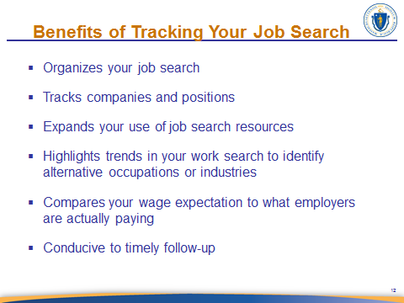
SLIDE 12

NOTES:
The focus of this slide is to segue into the benefits of using the Work Search Activity log as a tool to enhance your job search.

Discuss the bullet points on the slide first then address the dialog seen below.

In addition to the benefits discussed above, consider a self-assessment by continuously asking yourself the following questions:
SAY:

- What is working and not working with my approach to the job search?
- Am I getting a response? Why or why not?
- Do I know how to follow-up?
- Do I need to re-evaluate how I am presenting myself on paper (résumé and cover letter)?
- Have I reinforced that I have the KSAs required for the position?
- Is my focus too narrow?

Continued on next page

- Am I willing to broaden my industry and job title search?
SAY:
- Do I know if this industry/occupation is growing or declining in my geographic area?
- Do I need to rethink my methodology (i.e., on-line versus networking)?
- Do I have a balanced approach?
- Do I know what the prevailing wage is in my geographic area?
- Are my wage expectations realistic?
- What additional research/knowledge do I need to pursue?
- Do I need to seek assistance from the Career Center professionals? (i.e., workshops, résumé review, sponsored networking sessions)

Many of these questions can be answered by looking for patterns in your Work Search Activity log, which we will discuss next.

Advance to SLIDE 13

Continued on next page
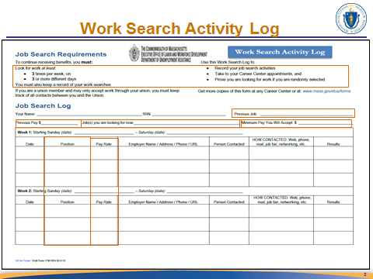
SLIDE 13
NOTES:
Review and explain all circled areas and then explain how to complete the Work Search Activity (WSA) log before beginning the discussion in the section below. Click to display the circles around nine (9) key items on this form.

When going over the Craig’s List discussion below, also explain that website names like this can be entered in the ‘How Contacted’ column.

[KEY POINTS TO DISCUSS IN CIRCLED ITEMS:]
SAY:
- Job search three (3) times per week on three (3) or more different days.
- When conducting your job search, compare previous occupations to…
Occupation(s) of interests.
- Compare previous pay, minimum acceptable pay, to what the
industry is paying for an occupation.

Continued on next page

Most of the information that is required on this log can be found by doing your labor market exploration and looking at the patterns of information with which you fill out your Work Search Activity log. So how do you identify these trends?
SAY:

For instance the question “Is my job search focus too narrow?” can be answered by looking at job title and location patterns in your log along with broadening your search to provide better job search results.

So the question “Do I need to re-think my methodology?” is answered by looking at patterns like repeatedly using the same method that yields little results (i.e., only used newspapers versus search engines), in which case you may need to consider other methods. So let’s say you use Craig’s List day after day, but are not getting any feedback you might include other search engines or looking directly at websites for companies that you researched.

Answers to familiarity with the prevailing wage can be determined by looking at the type of wages associated with the jobs that you are applying for. For example, you should at least know the median pay for an occupation and note that this amount may vary depending on the industry. You can compare this pattern with the minimum acceptable pay rate that you wrote on the top of the log.

As you can see, this log is truly a benefit to your work search as it tracks all the details associated with the jobs for which you applied facilitating a quick follow up with employers. It also allows you to continuously re-evaluate your job search approach, while helping you meet your work search requirements to maintain UI benefit eligibility.

You need to know that part of these requirements include keeping a WSA log for every week in which you are claiming benefits. Also know that even though you may not have to send in your completed WSA every week you may receive a call or letter to provide proof for specific weeks. If you do not have the logs completed you may jeopardize your benefit eligibility.

Also, if selected to participate in RESEA the Job Specialist will review your logs at each meeting. However, it is your responsibility as part of accepting UI benefits to keep a copy of your weekly Work Search Activity log.

Advance to SLIDE 14

Continued on next page

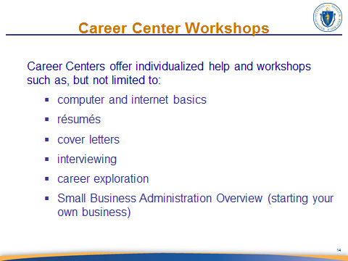
SLIDE 14

The focus on this slide is to market your best and/or career center-specific workshops. Please customize this slide accordingly.
NOTES:

Also mention resources for self-employment.

Advance to SLIDE 15

Continued on next page
SLIDE 15

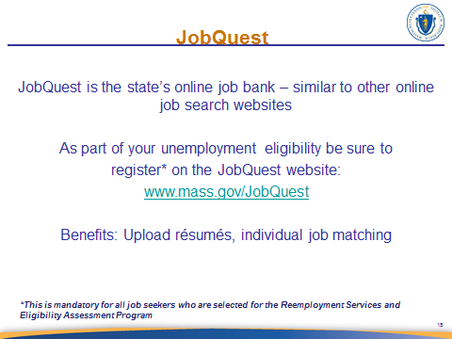

NOTES:
If you do not have access to the internet then use next 5 (JobQuest) slides; otherwise you may simply use the JobQuest link on this slide to demonstrate the site.

Mandatory RESEA Requirement: Must register in JobQuest before RESEA Review meeting.

SAY:
You may not know that the state maintains a job search website called JobQuest. In some respects, it is similar to other job search sites such as Monster.com, Career Builder, etc., but ours has a few additional tools available in it that we will discuss in another section.

Continued on next page
SAY:
While you are receiving unemployment benefits, you will be required to register in JobQuest before your RESEA Review, but it benefits each of you. Registration only takes a few minutes and is free. After your register you can upload your résumé, and you can build a customized job match even if you are not REA. Since our staff database system is tied to JobQuest, if you meet with a staff member after you register, they can help you refine your job match. Once you are registered and have customized your job match, each time you log in, there will be a list of jobs available that meet your match criteria available with hyperlinks to access the individual job order.

In the next few slides, I will briefly show you where to register in JobQuest, how to build your match, and how to access Job Orders.

Advance to SLIDE 16

Continued on next page
SLIDE 16

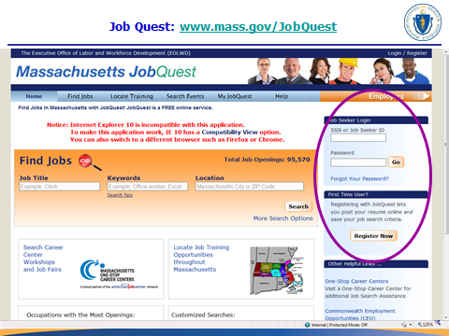

SAY:
The purple circle shows you where to register, and once registered where to log in to JobQuest. Near the bottom of the circle you see the “Register Now” link – this is where you click to gain access to the registration page. You will fill out some information and create a password – remember that password so you can log in later.

The top part of the circle is where you will log in once you return to the website. Your user name is your SSN or Career Center membership number – the number on your membership card. Please note that if you forget your JobQuest password, any staff member can reset it for you, or you can use the “Forgot Password” tool.

It is important that you register on the site – our database system will record your registration.

Advance to SLIDE 17

Continued on next page
SLIDE 17
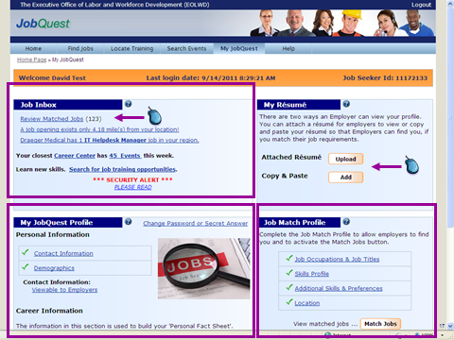

SAY:
I am going to show you the basic membership area in JobQuest and how to look up a job order. This is how the screen will look when you first log in.
First, here you can upload your résumé or copy-and-paste it. Please note, your résumé is converted to PDF format so once you upload it, you cannot change it, but you can always delete it and upload a new one.
This box shows where you can update your personal information.

This box shows where you would go to build your customized match. You can customize by job title, skills, and location.

Continued on next page
SAY:
Now that we have built our customized match we can see what jobs are available! This information will be in the Jobs Inbox.

This is the Jobs Inbox. Here you will see Matched Jobs as well as some notices about highlighted jobs, Career Center events, and other notices.

To review our customized job matches, we will click on the “Review Matched Jobs” link – notice there are 123 jobs available based on my customized match. So that is why it is very important to have an updated job match profile. It will help weed out jobs that don’t match your skills, which saves you time.

Advance to SLIDE 18

Continued on next page
SLIDE 18
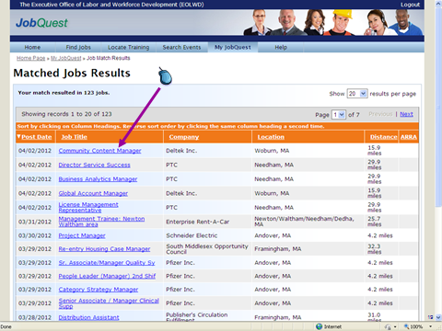

SAY:
Here are the jobs that match the criteria we specified in our custom match. Note that each job has information about the date posted, job title, company, location, and, distance from our address to the job site. Also note that I have multiple pages of jobs.

If we were interested in the first job on our list, the job title is conveniently hyper-linked to the job order. All we have to do is click on the link and it will take us to the job order. [CLICK ON THE RESULTS IF YOU ARE DEMONSTRATING THE WEBSITE INSTEAD OF USING THE JOBQUEST SLIDES] Once you click on the job order you can follow the instructions to apply for the job.

Advance to SLIDE 19

Continued on next page

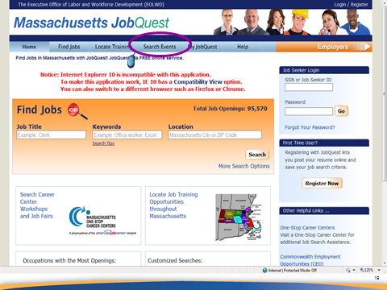
SLIDE 19

NOTES:
Career Centers may consider adding a slide or slides prior to this one that shows how to access their website to obtain information about local job fairs and recruitments.

When you visit our JobQuest website, you will see a tab called “Search Events” on the top menu bar. This tab will take you to an internal search engine that allows you to search for statewide job fairs, recruitments, and other events.
SAY:

Advance to SLIDE 20

Continued on next page
SLIDE 20
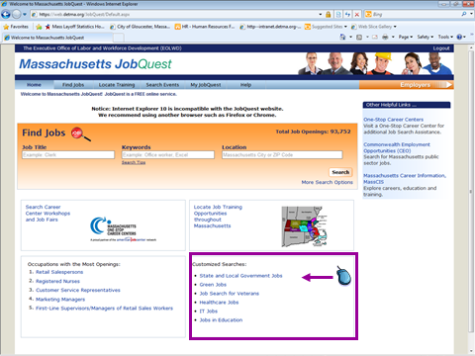

SAY:
There are seven (7) new micro sites added to JobQuest. These sites are located on the home page under Customized Searches allowing for a more targeted job search.

These sites pull in jobs which are also posted in JobQuest, Job Central, and One Stop Career Center, as well as employers.

These sites are compatible with Smart phones and tablets which allow the job seeker to apply right from these sites. Now you can apply on the fly.

Advance to SLIDE 21

Continued on next page

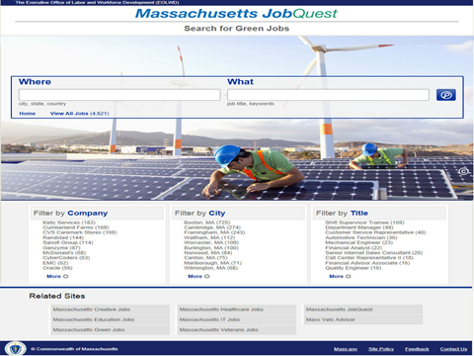
SLIDE 21

This slide transitions from the online website view to two separate smart phone/tablet compatible displays. The following two facilitator guide pages show the same slide at its different transition stages. To navigate through these transitions in the power point presentation simply click .
NOTES:

After clicking on the micro site you will see the web view of this site displayed. At the top of the page you can search for jobs by entering where you would like to work or what type of work you would like to do. Also, notice that you can filter your search by company, city, or title. Beneath the search filter you can see the number of jobs associated with the relevant filter. For instance, under the company filter, Kelly Services displays 183 job opportunities. If you click on that selection it will display all of those job announcements.
SAY:

At the bottom of the page, below the filter options, the screen also displays links to the seven (7) micro sites that were shown on the customized searches menu as was demonstrated on the JobQuest home page.

Stay on SLIDE 21

Continued on next page
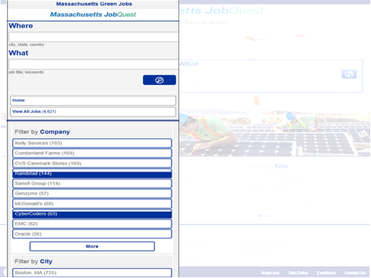
SLIDE 21
SAY:

Next, you can see the same information from the Smartphone and tablet view. Those of you who use these devices may be familiar with this different layout format. Here you can see the main page displayed.

Stay on SLIDE 21

Continued on next page
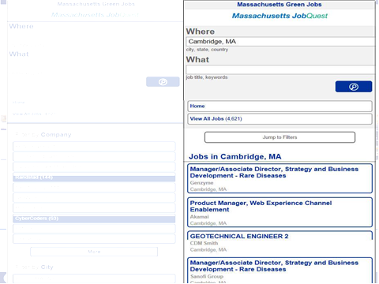
SLIDE 21

SAY:
And then if you search by location this is what the results will look like as displayed on a Smartphone/tablet. You will be able to apply for jobs right from your phone or tablet so that you can apply on the fly.

Advance to SLIDE 22

Continued on next page

SLIDE 22

NOTES:
You should encourage any Veteran to set up an appointment with the Career Center’s Veteran Employment Specialist. Another option is to offer to introduce them to the Veteran Employment Specialist after the seminar or have the Veteran Employment Specialist come into the seminar and introduce him/herself.

Give the name and contact information for any LVER’s and DVOP’s in your Career Center. Priority of Services to Veterans MUST be highlighted.

SAY:
Each Career Center has a Veteran Representative who can assist our Military Veterans and Eligible Spouses who meet program requirements with your employment and training needs. Our Career Centers recognize the sacrifices that our Veterans and their family members have made in service to our country. If there are any Veterans in this room, we would like to thank you for your service and welcome you home.

Continued on next page

It is important for you to know that Veterans and eligible Spouses also receive Priority of Services in all Career Centers. This means that Veterans will be serviced first in all federally funded programs in the Career Center.
SAY:

Advance to SLIDE 23

Continued on next page

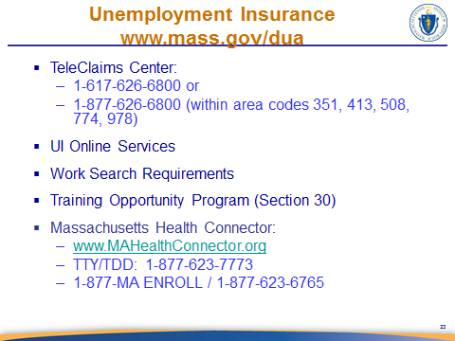
SLIDE 23

NOTES:
When discussing the UI online services emphasize the fact that the Career Center staff is available to help customers navigate the new system.

After discussing the first three bullets, explain the Section 30 Program.
Emphasize Section 30 requirements.

SAY:
For those of you who are receiving unemployment benefits the TeleClaims Center contact number is [READ INFORMATION FROM BULLET 1]. This service is available in English, Spanish, and Portuguese and will soon be available in Cantonese.

Unemployment applications and weekly benefit requests (certification) is now available online at www.mass.gov/DUA. The Career Centers have staff available to help you navigate the system.

Continued on next page

Section 30
SAY:
As discussed previously, for each and every week you request UI benefits, you must be able, available and actively seeking work and you must keep a record of your work search activity (refer to the work search activity log on page 29). The Department of Unemployment Assistance provides work search logs which you must complete each week and you must record at least one work search activity on at least three days.

You may have your work search requirement waived if you are attending DUA approved training. This is known as the Section 30 program and there are certain eligibility requirements that we will go into detail on the next slide.

Mass Health Connector

If your unemployment benefits will end soon and you still need health insurance, the state may offer other health insurance options for you. You can apply, find out which plans you qualify for, and learn about new ways to receive help paying for insurance when you visit the Massachusetts Health Connector website at www.MAhealthconnector.org. Apply now to avoid any gaps in coverage.

If you were previously enrolled in MassHealth and recently received a letter from MassHealth about renewing your benefits, you will need to submit a new application. MassHealth began sending out renewal letters on January 15, 2015. [UPDATE YOUR TALKING POINTS PERIODICALLY AS THIS INFORMATION CHANGES] You must submit a new application by the deadline on your letter to avoid a gap in coverage. More information about reapplying and renewing your coverage can be found at http://www.mass.gov/eohhs/provider/insurance/masshealth/aca.

For those of you who were not yet enrolled in a health plan just visit the MAhealthconnector.org website or call the number shown on this slide.

Advance to SLIDE 24

Continued on next page

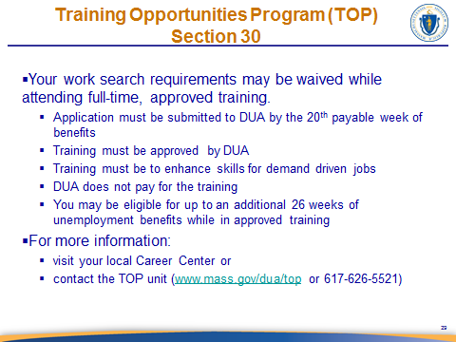
SLIDE 24

NOTES:
Discuss the bullet points.

Advance to SLIDE 25

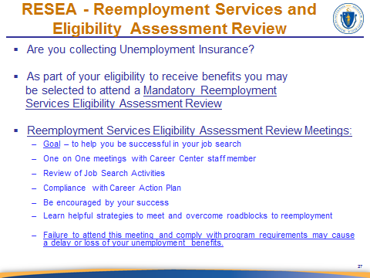
SLIDE 25

SAY:
The Reemployment Services Eligibility Assessment is a Program mandated by the Department of Labor for the Career Centers to provide reemployment services to our customers receiving UI benefits. Claimants are randomly selected for this program. If selected, you will meet one-on-one with a staff member to help you plan a successful job search. Our staff will help you navigate your way through labor market research, developing a résumé, meeting the UI requirement of work search and other helpful job search strategies. [REVIEW THE BULLETS ON THE SLIDE]. The Initial RESEA Review will take place today immediately following the CCS presentation. At that meeting, you will be scheduled for your Subsequent RESEA Review.

You will know before you leave today if you have been selected to be part of this program.

If you are selected, please remember it is mandatory to meet the program requirements or there may be an interruption or loss of your unemployment benefits.

Advance to SLIDE 26

Continued on next page

SLIDE 26
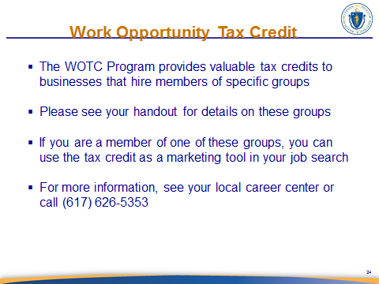

NOTES:
Speak to the bullet points on this slide.

Advance to SLIDE 27

Continued on next page
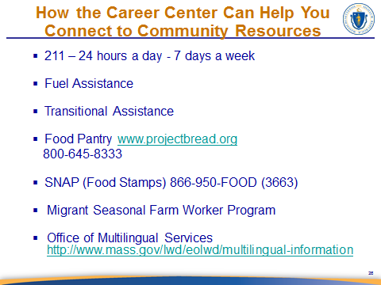
SLIDE 27

If you have a handout of local community resources, now would be a good time to call attention to it. Have the address and phone number of the local DTA office and any other local information you want to include here.
NOTES:

Please review the following two websites prior to facilitating a CCS Orientation in order to discuss these topics in a more informed manner. Please familiarize yourself with the Migrant and Seasonal Farmworker Program by visiting http://www.doleta.gov/MSFW.

Also familiarize yourself with MA Migrant Education Program by reviewing the information at http://www2.ed.gov/programs/mep/index.html.

Talk to the bullets on the slide and explain each program. If time allows show the Food Pantry and Multilingual Services websites.

[FOR DISCUSSION ON MULTILINGUAL SERVICES] You can access documents that are translated into 12 different languages by going to this link [SEE LINK ON SLIDE].
SAY:

Stay on SLIDE 27

Continued on next page

Most of these documents are also available here at the Career Center. The Office of Multilingual Services serves over 100 languages. So please let us know if you need an interpreter so that we can help you access this translation service.
SAY:

[MIGRANT SEASONAL FARM WORKER PROGRAM DISCUSSION] If you have worked in agriculture or food processing during the last 12 months and were required to relocate in order to perform your job, you may access all of the services available at our Career Center as well as assistance with applying to this program. The goal of this program follows a ‘teach a person how to fish for a lifetime’ model to empower its program participants. If eligible, your family may also benefit from services offered through the MA Migrant Education Program and referrals to MA Community Health Centers. If you fall into this worker category please inform our Staff prior to leaving today.

Advance to SLIDE 28

Continued on next page
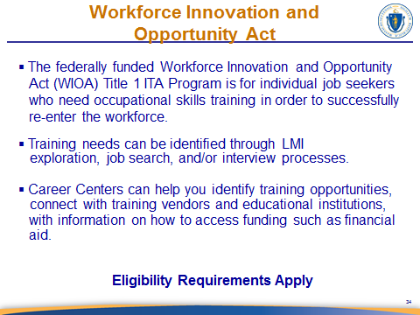
SLIDE 28
NOTES:
Mention how one may have learned through their LMI research job search and/or interviewing that they need additional training. Talk about what services Career Center offers in meeting those needs and point them out on the calendar.

SAY:
Some of you may need to access training services in order to become reemployed. This could be because you lack a particular license or certification, or that your job title no longer exists in this area, or for a variety of other reasons. Training opportunities are a potential service with which the Career Center system can assist. If you are interested in training and feel you have a need for training, please inquire about how to start the process.

There are eligibility requirements to attend training, and these will be discussed during the intake process.


Advance to SLIDE 29

Continued on next page

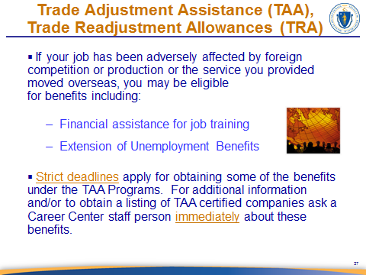
SLIDE 29

NOTES:
Take a few moments to touch upon all these bullet points. If there has been an affected company in your area, you may want to specify them as an example. Get feedback from the staff and management of your Career Center about what companies may qualify and who claimants should contact in your Career Center. Also highlight the newly developed TRADE handout in the Welcome Packet.

Advance to SLIDE 30

Continued on next page
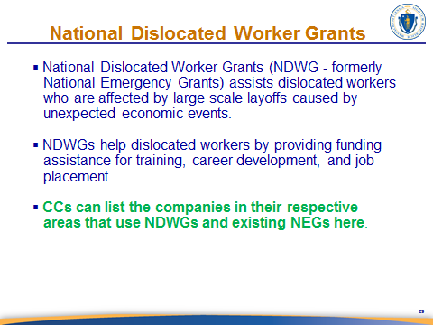
SLIDE 30

NOTES:
For bullet three add customized information that is relevant to your area.
Discuss each bullet. It is highly recommended that you provide a listing of all the current NDWGs and existing NEG’s for the benefit of the customers that attending the CCS.

Advance to SLIDE 31

Continued on next page
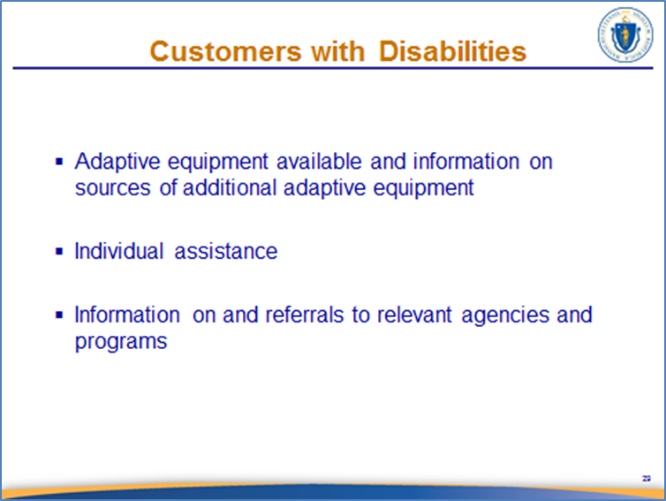
SLIDE 31

NOTES:
Handout: Universal Access Flyer. Customize if your Career Center has any specialized disability services.

Please note that our Career Centers are Universal Access Career Centers and have adaptive and assistive equipment available for those who may have a hearing or visual disability – please inquire about how to access this equipment.
SAY:

Advance to SLIDE 32

Continued on next page

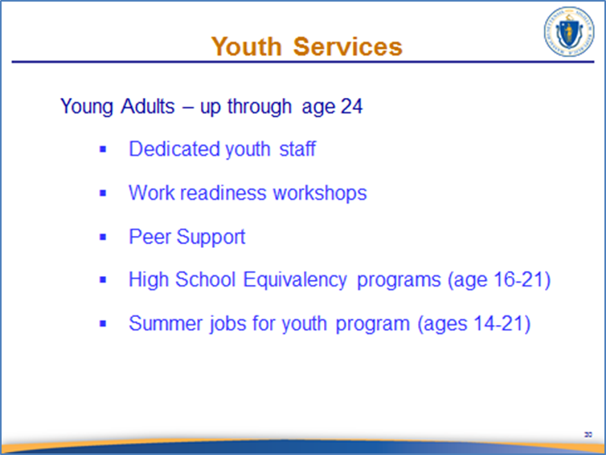
SLIDE 32

NOTES:
If you have any specialized services for the Youth Program you can customize this slide for your Career Center. Develop talking points for this slide to reflect your Career Center’s processes.

Advance to SLIDE 33

Continued on next page

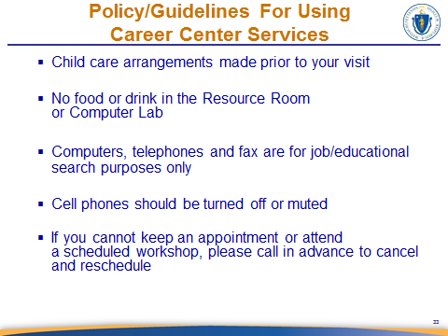
SLIDE 33

NOTES:
Career Centers may customize this slide to reflect local policies. Touch upon the points briefly. This is placed near the end of the presentation AFTER you have explained what the Career Center has to offer to be more user-friendly.

Handout: Career Center and Resource Room Policies.

We want your experience in our Career Centers to be a pleasant and productive one. In order to help you and other customers focus on your job search, we have policies in place to assist you in getting the most out of your visit.
SAY:

Please make arrangements for child care before visiting us; children are not allowed in the Career Center. No food or drinks are allowed in the Resource Room or Computer Labs.

All equipment in the Career Center is for job and education / training search purposes only.

Continued on next page

Cell phones should be set to mute or vibrate; if you must take a call, please move to a designated area to take your call.

If you cannot make an appointment or attend a scheduled workshop, please let us know as soon as possible so we can reschedule you. Some of your workshops or appointments will be mandatory and you have very strict time limits to meet your goals.

Advance to SLIDE 34

Continued on next page

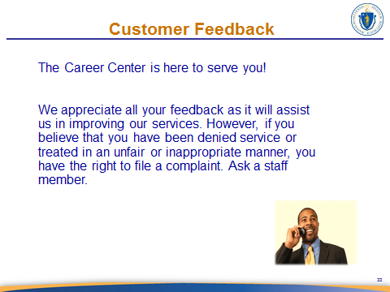
SLIDE 34

NOTES:
Go over local procedures for eliciting feedback from customers. Point out the complaint procedures and the name of the local complaint officer.

Handout: Local Career Center Complaint Process (with name & contact for the complaint officer); EO Policy.

SAY:
We are here to serve your needs and we value your feedback. In order to improve our services for you and other job seekers, please let us know if there is anything that you think we could update or improve, or if you have any suggestions for new services that we could offer. If you feel that you have been denied a service or have been treated inappropriately, you have the right to provide us with that feedback as well.

We have also provided you with a copy of our Equal Opportunity Policy.

Advance to SLIDE 35
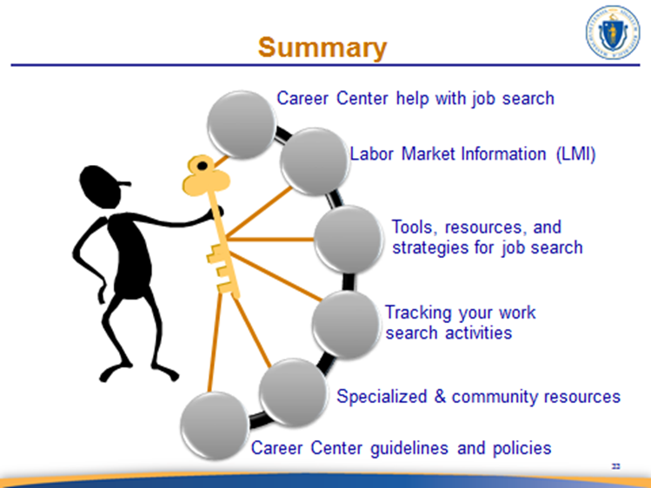
SLIDE 35

SAY:
Can you: [CLICK TO HIGHLIGHT EACH TALKING POINT ON SLIDE]
- recall two key facts about the discussion on job search? (Looking outside of your current occupation OR looking for jobs based on skills.)
- recall two or three things that Labor Market research can provide related to your job search? (Wages and market trends)
- identify two resources available to you through the Career Center? (Résumé workshops, TORQ) [MENTION YOUR TOP SELLER WORKSHOPS]
- remember three things about why the Work Search Activity log is important? (tracking, wage comparisons, expand job search, it is required to maintain benefit eligibility)

Remember that we are here to help you! [SUMMARIZE THE SECTIONS FOR THE NEXT TWO TALKING POINTS]

So, tell me what is the first thing you will do when you leave this room? [THEY SHOULD SIGN UP FOR A SERVICE/WORKSHOP]
Advance to SLIDE 36

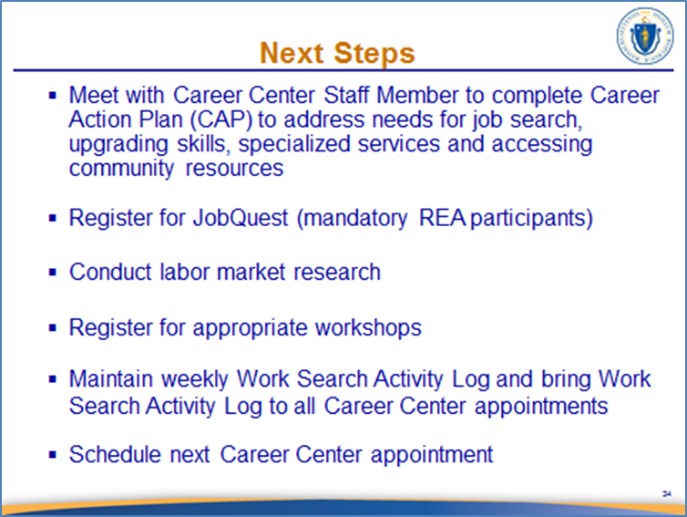
SLIDE 36

The focus of this slide is to provide actionable steps.
NOTES:
Click for each bullet to bring up the text, and then discuss each point.
Depending on individual Career Center procedures, you may want to customize this slide to include filling out membership forms, policy acknowledgments, etc. The order of the bullets can also be adjusted to reflect the processes used in your Career Center.

SAY:
If you are selected for REA, you need to set up a meeting with your local Re-employment specialist.

If you need assistance with registering for JobQuest visit the resource room.

And for everyone, consider signing up for a workshop to help your with your labor market exploration, résumé, and/or computer skills.

These are your next steps. Please make note of the items that you must bring to your RESEA Review meeting.

Advance to SLIDE 37


SLIDE 37

SAY:
Providing us your return to work information helps us keep current on local labor trends and is useful in planning Career Center services and the optimal use of our limited resources. This will also ensure that there are no issues on any future unemployment benefit claims if anyone who is on unemployment applies again in the future.

Remember, your job search is more than just sending out a résumé or looking through the want ads. You need to know how to conduct a successful job search. YOU are the key to your job search success! It’s natural to focus on the experience/skills you acquired in your last job, but maybe you need to take a look at yourself from another angle. We all have skills; many of these skills are transferable to different jobs and industries. These skills just need to be identified.
- Know what your needs and interests are
- Identify the work values that are important to YOU
- Know your skills and be able to effectively communicate those skills to others
- Learn about the job market
- And finally, keep a POSITIVE attitude

Thank you for attending the Career Center Seminar. Are there any questions?

