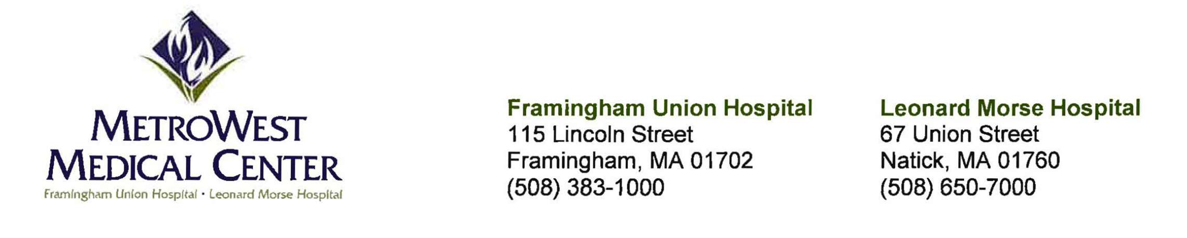

May 29, 2025

**VIA EMAIL**

Stephen Davis, Director

Division of Health Care Facility Licensure and Certification Massachusetts Department of Public Health

67 Forest Street

Marlborough, MA 01752

Re: VHS Acquisition Subsidiary Number 9, Inc. (d/b/a MetroWest Medical Center)-Closure of Level IIB Special Care Nursery Service at Framingham Union Campus - Response to Department Comments on Plan of Access

Dear Mr. Davis:

This letter is submitted on behalf of VHS Acquisition Subsidiary Number 9, Inc. (d/b/a MetroWest Medical Center ("MWMC")), which operates a licensed hospital (License No. VL8S) with a campus located at 115 Lincoln Street, Framingham, MA 01702 ("Framingham Union"). MWMC notified the Department of Public Health ("Department"), by letter dated February 10, 2025 and by letter dated March 12, 2025, ofMWMC's intent to discontinue operation of its Level IIB Special Care Nursery Service (the "Service") on or about June 10, 2025. In response to the Department's Essential Service Finding letter, dated April 24, 2025, MWMC submitted to the Department, by letter dated May 9, 2025, MWMC's plan to maintain access to Level IIB Special Care Nursery Services and provide the additional information requested by the Department. MWMC received the Department's letter, dated May 19, 2025, setting forth the Department's comments on MWMC's plan to maintain access. In compliance with the regulatory requirements at 105 CMR 130.122(G), MWMC offers the following responses to the Department's comments.

1. ***Transitioning from Level JIB to IB:*** *In your response dated May 9, 2025, you stated the Hospital is currently working toward a clinical affiliation model that would provide the required advanced neonatal practitioner coverage, enabling it to sustainably maintain a level IB designation. The Department requests additional information on the steps being taken to transition from Level JIB to IB. Specifically, what needs to happen to enable this transition and what is the timeline.*

MWMC currently has an agreement in place for the provision of 24/7 on-site advanced neonatal coverage, in connection with our Level IIB Special Care Nursery. That agreement will expire as of August 9, 2025. MWMC is in the final stages of establishing a formal agreement to provide the

advanced neonatal practitioner coverage required for Level IB designation. We fully anticipate that formal agreement to be finalized and to take effect in a timely manner to ensure continuous coverage in connection with the transition from Level IIB designation to Level IB designation. In the unlikely event that such formal agreement cannot be finalized, MWMC will implement a transition to Level IA designation.

1. ***Census at or Below 25%:*** *In your response dated May 9, 2025, you stated that the current census of the Level JIB Special Care Nursery is zero neonates, and the census is consistently at or below 25% capacity. Additionally, you stated the demand for the service has been low and is associated with high operating expenses. The Department requests information on what the Hospital has done to staff and market the Level IIB Special Care Nursery in order to evaluate the factors driving the decreased use.*

To evaluate and address the factors driving the decreased use of the Services, MWMC did the following:

* + **Staffing Flexibility and New Staffing:** We implemented cross-training of the labor and delivery nursing staff and the postpartum nursing staff. This enabled us to manage low volume in the Level IIB Special Care Nursery and simultaneously preserve neonatal skill sets. Additionally, MWMC is excited to welcome a new OB provider to the Framingham Union campus in the coming months, enhancing access to OB services.
  + **Marketing Efforts:** We initiated targeted outreach campaigns in 2022 and 2023, aimed at local OB/GYN practices, to highlight our neonatal services. These campaigns included direct provider engagement, digital content, and community events. Starting in 2024 and continuing through the present, we have significantly expanded these efforts as part of a comprehensive women's health marketing strategy that includes the following initiatives:
    - **Emails:** Sent emails to all MWMC newsletter subscribers and hospital contacts, including OB and General Surgery providers on staff and in the community, with qualified lead (QL)-focused messaging, driving newsletter sign-ups and awareness around Women's Health Month.
    - **Paid Social Ads:** Arranged for ongoing targeted Google ads to run throughout the year, aimed at women in geotargeted areas based on demographic and behavioral data.
    - **Social Media Posts:** On a monthly basis, posted photos of babies treated at Framingham Union in connection with the celebration of holidays and special events, and posted focused campaigns for Women's Health Month in May.
    - **Posters, Email Blasts, and Digital Banners:** Placed throughout May to coincide with Women's Health Month, to increase OB/GYN service line visibility.
    - **Website Updates:** Conducted in June and August 2024 to update services, remove outdated content, and verify providers' credentials, improving the user experience for expectant families.
    - **Brochures:** Created and printed in English, Portuguese, Spanish, and Haitian Creole to better serve our diverse patient population. These were distributed in clinical and community locations.
    - **Performance Analytics:** In October 2024, an email campaign to over 10,000 recipients yielded a 51.26% open rate, confirming strong community interest in

Framingham Union. Plans for provider-authored follow-up emails are in development to personalize outreach further, for purposes of communicating with recipients about the closure of the Service and the transition to a Level IB designation.

* + - **Provider Networking:** Ongoing provider participation in networking events to ensure continued visibility and relationship-building within the referring physician community.
  + **Referral Patterns:** We conducted a review of referral patterns and discovered a shift in high-acuity deliveries to tertiary centers due to regional provider preferences and maternal risk profiles. We are using this data to inform our revised service strategy under the Level IB model, while continuing to strengthen outreach to providers and patients through the initiatives described above.

1. ***Transfer Agreements:*** *In your response dated May 9, 2025, you noted the Hospital had entered into detailed clinical transfer agreements with Saint Vincent Hospital and St. Elizabeth's Medical Center (now Boston Medical Center Brighton) which clearly outline care continuity protocols. The Department requests the Hospital provide it with information on what these care continuity protocols are and how/when are they used. Additionally, the Department requests information on the dedicated transfer lines the Hospital has established with Saint Vincent Hospital and Boston Medical Center Brighton. Specifically, how do these transfer lines work and what are the mechanisms that drive the process.*
   * **Care Continuity Protocols:** The agreement between MWMC and Saint Vincent Hospital, and the agreement between MWMC and St. Elizabeth's Medical Center (now Boston Medical Center Brighton) each defines streamlined escalation pathways for continuity of care, including:
     + Rapid consultation access (within 15 minutes) via dedicated transfer lines (see below for additional information about dedicated transfer lines)
     + Transfer checklist with standard documentation, clinical hand-off protocols, and parental consent workflow
     + Standardized follow-up communication to ensure discharge coordination and patient family communication
   * **Dedicated Transfer Lines:** Saint Vincent Hospital and Boston Medical Center Brighton each utilize dedicated phone lines connected to their Special Care Nursery access points. The dedicated transfer lines are coordinated through Framingham Union's transfer center. When a neonate meets criteria for transfer, the Framingham Union attending or nursery provider activates the transfer line, provides a verbal hand-off to clinical staff at the receiving hospital, and coordinates EMS dispatch.
   * **Activation Mechanism:** Transfers are activated when neonates require intensive respiratory support, surgical evaluation, or subspecialty care unavailable on-site. Our nursery provider initiates transfer once criteria are met and clinical stability has been achieved.
2. ***Meetings with Public Officials:*** *In your response dated May 9, 2025, you stated the Hospital has enhanced its community engagement framework to include monthly meetings with Framingham and Natick public health officials. The Department requests information on when these meetings will take place, what the agenda will be, and for how many months will the meetings be held.*

# Meeting Schedules and Frequency (over the next six months)

* + MWMC's Associate Chief Nursing Officer, Associate Administrator, and EMS Medical Director met with EMS Officials most recently on 5/19/25 and 5/21/2025.
  + MWMC's CEO met with the Mayor of Framingham most recently on 5/6/2025.
  + MWMC's Board of Trustees meets on the fourth Tuesday of every month, and those meetings include community members and Mass Bay College Faculty.
  + MWMC's Associate Administrator meets with Natick 180 (a division of the Natick Health Department) on the first Wednesday of every month.
  + MWMC's Associate Administrator is arranging for regular meetings with a representative(s) from the Framingham Public Health Department.
  + MWMC's Associate Administrator met with Spark Kindness leadership most recently on March 20, 2025 to implement educational materials for parents of children referred to Framingham Union's pediatric clinic, and anticipates regular ongoing meetings.

# Meeting Agendas (past and future)

* + Neonatal service transitions and community impact
  + Feedback from community providers
  + Transfer trends and patient satisfaction
  + Additional matters as needed

1. ***Cultural*** *I* ***Linguistic Needs:*** *In your response dated May 9, 2025, you stated the Hospital has confirmed with the four primary alternative sites that they have established multilingual education materials and interpreter availability. Additionally, you stated that Hospital staff is undergoing additional cultural competency training. The Department requests additional information on what the four primary alternative sites are doing to accommodate the cultural needs of patients from the Hospital's service area. The Department also requests additional information on the curriculum for the cultural competency training Hospital staff is currently undergoing.*
   * **Interpreter Services:** Each of the four sites provides 24/7 medical interpreter services, including in-person, telephonic, and video modalities. Languages most frequently supported include Spanish, Portuguese, Haitian Creole, and Vietnamese, reflecting the demographics in Framingham Union's service area.
   * **Multilingual Education Materials:** Each of the four sites has made available patient education materials in at least five languages, including those listed above, covering neonatal care, breastfeeding, immunizations, and discharge planning.
   * **Cultural Competency Curriculum at MWMC:** We are developing a cultural competency curriculum for Framingham Union staff training that will focus on:
     + Bias reduction
     + Effective cross-cultural communication
     + Understanding health beliefs and practices
     + Language access rights and obligations
     + Case studies specific to maternal and neonatal care

We anticipate that the curriculum will be finalized by July 31, 2025, and staff will be fully trained by September 1, 2025.

Thank you for your attention to this matter. If you have any questions, please contact Lianne Anlmer, Esq., Anlmer & Levy, PC at 617-247-3104 [a@anknerlevy.c](mailto:a@anknerlevy.c)

Sincerely,

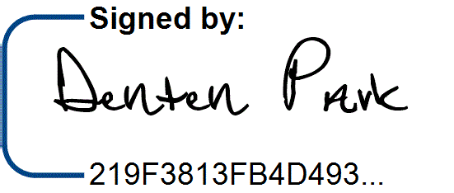5/29/2025 I 2:06 PM CDT

Denten Park

Market & Saint Vincent CEO

cc: T. Smith, DPH

A. Sousa, DPH

J. Bernice, DPH

K. Fillo, DPH

J. Gagne, DPH

M. Callahan, DPH

W. Mackie, DPH

C. Davison, MWMC

L. Domstead, MWMC

N. Wallis, MWMC

K. Lianne Ankner, Esq.