DMH Worcester Recovery Center and Hospital
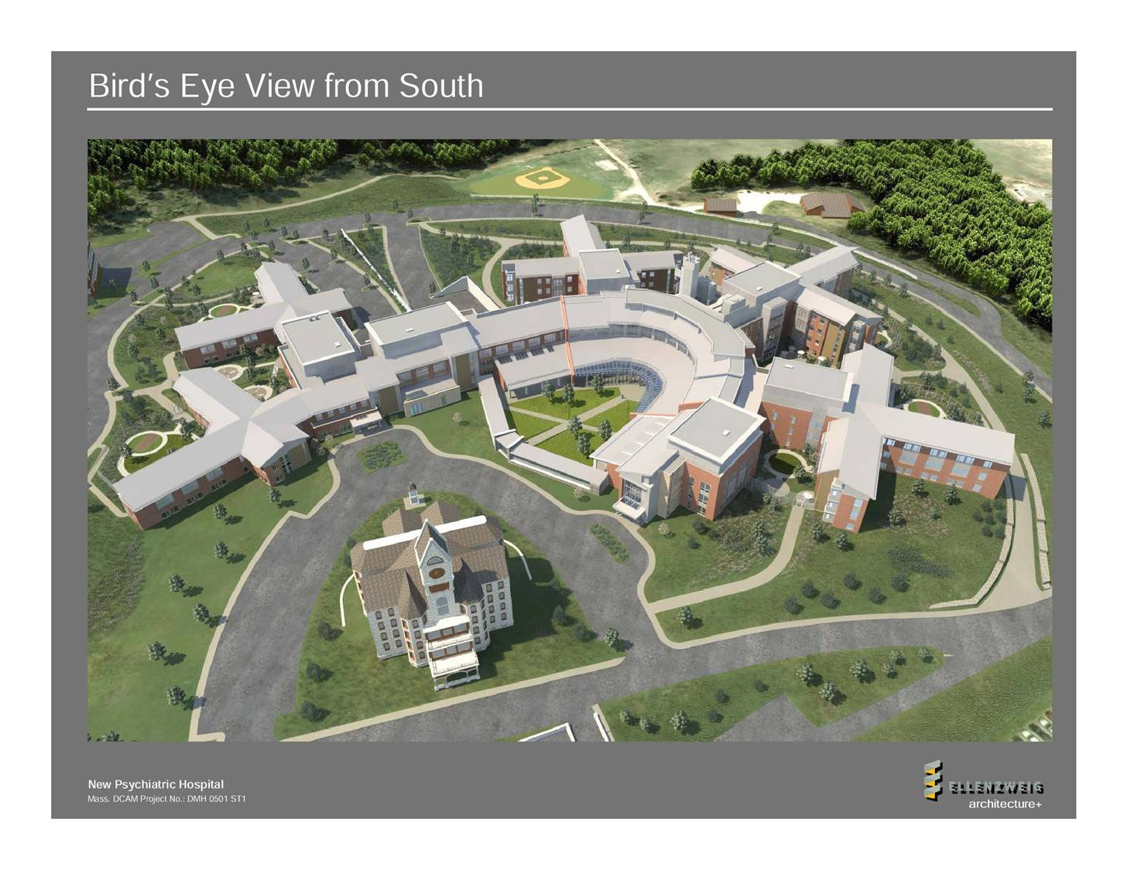

- The Massachusetts Department of Mental Health Worcester Recovery Center and Hospital (WRCH) opened October 2012. The 320-bed recovery center and hospital serves 260 adults and 60 adolescents through an innovative design and provides a state-of-the-art environment for patients and staff.

- Designed by Ellenzweig Associates, Inc., and constructed by Gilbane Building Company, the new DMH facility comprises 428,000 square feet and will be LEEDS Gold Certified.

- In 2004, in a report to the General Court, DMH recommended the consolidation of Worcester State Hospital and Westborough State Hospital (closed in 2010) and the construction of a new facility.

- In 2005, the Legislature convened the “DMH Facility Feasibility Commission,” comprised of legislators, consumers and family members of DMH clients. In 2006, the Commission recommended that the new hospital be sited on the existing Worcester State Hospital campus.

- Construction on the new hospital began in the spring of 2009.

- The anticipated cost of the hospital is $302 million, making it the largest non-road state-funded building project in state history. It has provided more than 500 construction jobs and resulted in more than 1,200 permanent jobs in the Commonwealth. The annual operating cost of WRCH is approximately $60M.

- The essential design reflects stages of recovery from serious mental illness by using familiar environments, ranging from “house” to “neighborhood” to “downtown.” Outdoor spaces relate to each living unit and the “downtown area” surrounds a central “village green” shared by all. The low-rise scale emphasizes the residential character of the new WRCH and strives to minimize the stigma often attached to psychiatric facilities. Other features include:

- A state-of-the-art, high quality, safe and respectful environment for patients, promoting active rehabilitation as a key component of therapeutic care and recovery

- Private bedrooms, soon to be required for accreditation, enhance the ability of staff to provide individualized care

- Joining of “neighborhoods” to serve multiple units permits a richer mix of professional skills in the staff, enhancing patient treatment and recovery

