

**Factors Contributing to Traumatic Brain and Spinal Cord Injury**

**in Massachusetts Motor Vehicle Crashes**

Massachusetts Crash-Related Injury Surveillance System, 2012 - 2015

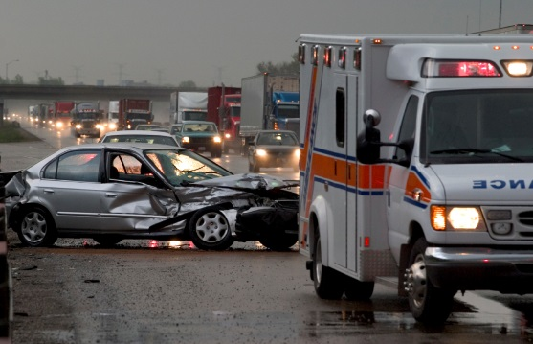

**Massachusetts Crash-Related Injury Surveillance System**

The Massachusetts Crash-Related Injury Surveillance System (MA CRISS) includes data for persons treated in MA acute care hospitals for motor vehicle crash injuries whose hospital record linked with a MA police crash report. These data do not include all crashes involving injuries in MA, as they do not include cases in which crash victims were transported to out-of-state hospitals, police were not involved, crash reports were not submitted to the Registry of Motor Vehicles, or missing or incorrect data prevented data linkage. Data may contain some duplicate records and/or linkages of some hospital records with the wrong crash records.

MA Hospital Discharge data are compiled by the Center for Health Information and Analysis. Crash data are compiled by the MA Registry of Motor Vehicles.

Acknowledgements: Data linkage and analyses were conducted by Catherine Rahilly-Tierney, MD, MPH and Arman Altincatal, MS, of Strategic Research Partners, LLC, on behalf of the MA Department of Public Health, Injury Surveillance Program.

a In this report, “drivers” refers to drivers of cars, vans, or trucks. Motorcycle operators are covered in a separate report.

b Spinal cord injury diagnoses are under-reported in death data, so were not included here.

Prior studies have identified not wearing a seatbelt, lateral impact, airbag non-deployment, and age under 40 as risk factors for sustaining a TBI in a crash.5,6,7 There are mixed results as to whether males or females are at higher risk of sustaining a TBI in a crash.5,6

**This study** used linked 2012 - 2015 MA Crash-Related Injury Surveillance System (MA CRISS) data to identify driver and crash-related factors associated with sustaining a TBI/SCI in a crash. Note that MA CRISS data differ from the hospitalization data presented above, in that MA CRISS data include only those hospital records that link to a police crash report. See box on left for further details.

This study focused on drivers only; passengers were excluded. A [separate report](https://www.mass.gov/lists/general-injury-data#2015-data-) examines factors associated with hospitalized motorcycle operators sustaining a TBI/SCI in a crash. We combined TBI and SCI because they are both neurological injuries associated with significant long-term disability.

***In 2015, over 40% of drivers killed and 30% of drivers hospitalized in Massachusetts sustained a traumatic brain injury in the crash.***

This report explores the circumstances surrounding motor vehicle crashes that result in traumatic brain and spinal cord injuries. Understanding those circumstances can inform prevention programs and policies so fewer people suffer these serious injuries and potential long-term disability.1

After falls, motor vehicle crashes are the second leading cause of death and hospitalization involving traumatic brain injury (TBI) in Massachusetts (MA).2 In 2015, of the 197 car/truck driversa killed in a crash in MA, approximately two out of five (41%) sustained a TBI in the crash.3,b

Of the 1,219 hospitalizations of drivers in MA for crash-related injuries in fiscal year (FY) 2015, 30% sustained a TBI and 3% sustained a spinal cord injury (SCI).4 DPH found no recent estimates of TBI or SCI (TBI/SCI) frequency among hospitalized drivers in other states, but a study of drivers in Maryland hospitalized for crash-related injuries between 1994-1996 found that 38% sustained a TBI in the crash.5

Based on FY 2015 data, hospitalized drivers who sustained a TBI/SCI in the crash had longer hospital stays (7 vs. 5 days) and higher mean hospital charges ($71,000 vs. $51,000) than drivers who did not sustain a TBI/SCI.4

Injury Surveillance Program, Massachusetts Department of Public Health October 2021



c 22 drivers sustained both a TBI and a SCI.

d ICD-9-CM codes in any field were used to identify TBI (800-801,

803-804, 850-854.19, 950(.1-.3) or 959.01) and SCI (806 or 952).

eNon-intersection crash in which a vehicle crosses an edge line, a centerline, or otherwise leaves the traveled way.

fDenominator changes based on missing data.

g Age was divided into two groups at the median age of 47.

h Excludes 164 cases where race/ethnicity was missing.

i Excludes 1,142 cases where seatbelt use was missing.

j Excludes 40 cases where point-of-impact was missing.

k Excludes 416 cases where airbag deployment status was missing.

**Characteristics of Drivers and Related Crashes in MA CRISS Data**

Of 4,060 hospitalized drivers in 2012-2015 MA CRISS data (Jan. 1, 2012 - Sep. 30, 2015), nearly one in three (30%) sustained a TBI or SCI in the crash (TBI - 29% and SCI - 2%).c These percentages are similar to those described in FY 2015 hospitalization data above.

TBI/SCI and demographic data were obtained from hospital discharge data.d  Seatbelt use, speeding, lane departuree, airbag deployment, and point-of-impact data were obtained from crash data. Data on alcohol/drug intoxication were obtained from both of these data sources. Table 1 describes these characteristics in hospitalized drivers who sustained a TBI/SCI in the crash and those who did not sustain a TBI/SCI in the crash.

When looked at individually, most factors studied were significantly associated with sustaining a TBI/SCI in the crash. Specifically, of hospitalized drivers who sustained a TBI/SCI the crash:

* 41% were identified as not wearing a seatbelt compared with 24% of those who did not sustain a TBI/SCI.i
* 17% were identified as speeding compared with 11% of those who did not sustain a TBI/SCI.
* 29% were identified as intoxicated on alcohol or drugs compared with 23% of those who did not sustain a TBI/SCI.
* 30% had documentation that airbags did not deploy in the crash compared with 25% of those who did not sustain a TBI/SCI.k
* A higher percentage of drivers who were male, ages 46 and under, and people of color sustained a TBI/SCI in the crash.

**Table 1. Driver and Crash-related Factors in Hospitalized Drivers who Sustained and did not Sustain a TBI/SCI in the Crash,**

**2012-2015 MA CRISS data (N = 4,060)**

|  |  |  |
| --- | --- | --- |
| **Factor** | **Sustained a TBI/SCI**  **n (%)f** | **Did not sustain a TBI/SCI**  **n (%)f** |
| Total | 1,213 (100%) | 2,847 (100%) |
| Ageg* |  |  |
| Ages 46 and under | 688 (57%) | 1,306 (46%) |
| Ages 47 and older | 525 (43%) | 1,541 (54%) |
| Sex* |  |  |
| Male | 765 (63%) | 1,577 (55%) |
| Female | 448 (37%) | 1,270 (45%) |
| Race/ethnicityh* |  |  |
| White, non-Hispanic | 943 (81%) | 2,359 (86%) |
| People of color | 217 (19%) | 377 (14%) |
| Alcohol/drug intoxication* |  |  |
| Yes | 354 (29%) | 665 (23%) |
| Not documented | 859 (71%) | 2,182 (77%) |
| Seatbelt usei* |  |  |
| Seatbelt worn | 505 (59%) | 1,561 (76%) |
| Seatbelt not worn | 352 (41%) | 500 (24%) |
| Speeding* |  |  |
| Yes | 206 (17%) | 327 (11%) |
| Not documented | 1,007 (83%) | 2,520 (89%) |
| Lane departure* |  |  |
| Yes | 785 (65%) | 1,677 (59%) |
| Not documented | 428 (35%) | 1,170 (41%) |
| Point-of-impactj |  |  |
| Lateral impact | 301 (25%) | 711 (25%) |
| Front/rear impact | 904 (75%) | 2,104 (75%) |
| Airbag deploymentk* |  |  |
| Airbag deployed | 758 (70%) | 1,921 (75%) |
| Airbag not deployed | 329 (30%) | 636 (25%) |

*Significantly associated at p < 0.05 based on Chi-Square test.

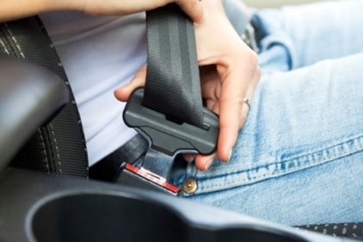

k Unadjusted odds ratios do not take other potential contributing factors into account.

l Lt. Timothy Dowd, personal communication, June 24, 2019.

In addition to these associations with sustaining a TBI/SCI, many factors were associated with one another. Among drivers who sustained a TBI/SCI, factors significantly associated with one another included: alcohol/drug intoxication, speeding, not wearing a seatbelt, and lane departures. Being male or age 46 or under were also significantly associated with these four risk factors in drivers who sustained a TBI/SCI, although being a person of color was not associated with these four factors (data not shown).

The increased risk of TBI/SCI in people of color may be related to vehicle characteristics that were not included in this study.  Prior studies have found that Hispanic motorists and communities with lower income are more likely to have older vehicles with fewer safety features than non-Hispanic, white motorists or communities with higher income.10

Airbag deployment was significantly associated with driver’s age. Of crashes in which drivers sustained a TBI/SCI, airbags were not deployed in nearly half of crashes involving drivers ages 75 and older, compared to one-quarter of crashes involving drivers under age 55 (data not shown). Prior studies have found that older drivers are more likely to be involved in low-speed crashes10, which may be one reason for airbag non-deployment.l

**Limitations:** TBI cases may be underestimated, as milder TBI cases may not get diagnosed until after patients are discharged from the hospital. Intoxication rates may also be underestimated, as healthcare providers and police may not always test drivers for alcohol/drugs, or test results may not be documented in the hospital or crash record. Missing crash data may limit the accuracy of several factors, including seatbelt use and airbag deployment. Speeding and driving under the influence of alcohol/drugs may also be underestimated due to incomplete violation codes in crash data.

**Figure 1. Odds Ratios for Factors Significantly Associated with Sustaining a TBI/SCI in a Crash, Hospitalized Drivers, 2012-2015 MA CRISS data (N = 4,060)**

**Driver and Crash-related Factors Associated with Sustaining a TBI/SCI in a Crash**

We calculated unadjusted odds ratios (OR)k to further understand factors that were significantly associated with sustaining a TBI/SCI in a crash. Figure 1 shows only the factors with ORs that were significantly associated with sustaining a TBI/SCI in a crash (p < 0.05).

In this sample of hospitalized drivers:

* Not wearing a seatbelt more than doubled the odds (OR = 2.18) of drivers sustaining a TBI/SCI in the crash, compared to drivers identified as wearing a seatbelt.
* Speeding increased the odds of sustaining a TBI/SCI in the crash by 58% (OR = 1.58), compared to drivers not identified as speeding.
* Alcohol/drug intoxication increased the odds of sustaining a TBI/SCI in the crash by 35% (OR = 1.35), compared to drivers not identified as intoxicated.
* Drivers who were age 46 or under, a person of color, or male had increased odds of sustaining a TBI/SCI in the crash of 56%, 44%, and 38% respectively (ORs = 1.56, 1.44, and 1.38), compared to drivers who were age 47 or older, White non-Hispanic, or female.
* Airbag non-deployment increased the odds of sustaining a TBI/SCI in the crash by 31% (OR = 1.31), compared to crashes in which airbags were documented as deployed.

**Strategies to Prevent Traumatic Brain and Spinal Cord Injuries in Motor Vehicle Crashes**

Preventing TBI and SCI that result from motor vehicle crashes requires increasing seatbelt use, preventing impaired driving, and preventing speeding crashes. This analysis/study identified that in Massachusetts, men, people of color, and drivers under 47 years of age are at higher risk of sustaining these injuries, and therefore prevention strategies must be developed or evaluated with those populations in mind. In addition, prevention strategies and policies should address and account for any potential consequences of racial bias and inequity. The following describes ways Massachusetts can better prevent such crashes.

**Support Primary Seatbelt Legislation**

Proposed in the [MA Strategic Highway Safety Plan (SHSP) 2018](https://www.mass.gov/doc/massachusetts-shsp-2018/download), primary seatbelt legislation is the most effective strategy for increasing seatbelt usage. Massachusetts is one of 15 states that have a secondary seatbelt law, meaning that a police officer cannot stop and ticket a driver for the sole offense of not wearing a seatbelt. Primary Seatbelt Legislation can increase seatbelt use by 8%, and seatbelt use during a crash is known to reduce fatalities by 45%.11 In states that strengthened laws from secondary to primary enforcement, driver death rates declined by 7% annually over a 15-year period (1989-2003).12 Implementation of this evidence-based approach should integrate considerations around equitable enforcement of such a law. Policymakers should engage communities of color throughout the process of developing, piloting, and evaluating primary seatbelt legislation. Furthermore, primary seatbelt legislation should provide for the collection of race and ethnicity data for cited drivers.

**Impaired Driving Prevention**

Proposed in the [MA Strategic Highway Safety Plan (SHSP) 2018](https://www.mass.gov/doc/massachusetts-shsp-2018/download), All-Offender Ignition Interlock legislation would permit judges to require ignition interlock devices for first time OUI offenders. Studies show that ignition interlock devices can reduce re-arrest rates for impaired driving by as much as 70% and reduce alcohol-involved crash deaths by 15%.11 All-offender Ignition Interlock Legislation should be coupled with the establishment of a fund for individuals who cannot afford the ignition interlock installation and maintenance fees, similar to the fund for Section 24D driver alcohol education program. First time offender ignition interlock legislation should include provisions for collection of demographic data of drivers sentenced under those policies.

Additionally, programs related to driving under the influence of alcohol programs are operated by the MA Department of Public Health Bureau of Substance Addiction Services. These programs serve as alternatives to loss of license or incarceration:

* + First Offender Driver Alcohol Education (DAE): 40-hour educational program to help drivers identify and understand alcohol addiction and drinking-and-driving behaviors.
  + Second Offender Driving Under the Influence of Liquor (DUIL) Program: 14-day residential program that includes medical evaluation, individual and group counseling, educational sessions, and assignment to a Second Offender Aftercare Program.
  + Second Offender Aftercare (SOA) Program: one-year program of individual, group, and family services individually designed to meet the needs of the client.

Improving access to alternative transportation programs is another strategy for preventing impaired driving. For more information about alternative transportation programs, see [Alternative Transportation Programs: A Countermeasure for Reducing Impaired Driving.](https://www.ems.gov/pdf/811188.pdf)

Additional strategies to prevent impaired driving are enumerated in the [Federal Fiscal Year 2020 MA Highway Safety Plan.](https://www.mass.gov/doc/ffy-2020-massachusetts-highway-safety-plan-0/download)

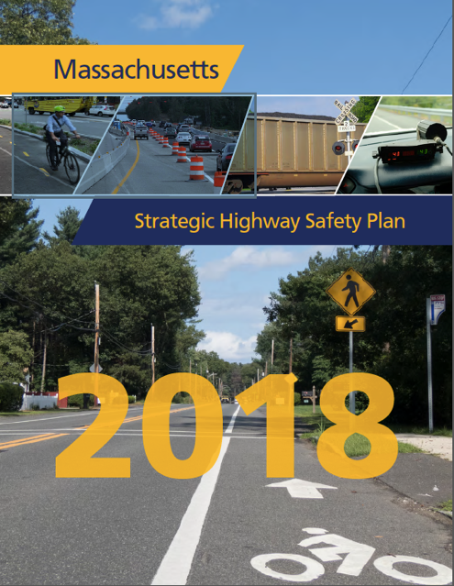

**Strategies to Prevent Traumatic Brain and Spinal Cord Injuries in Motor Vehicle Crashes (cont.)**

**Culturally and Linguistically Appropriate Education**

It must become common knowledge that not using a seatbelt, driving while intoxicated, or speeding may not only end in fatality, but can also result in life-altering disabilities such as paralysis and brain injury. Community-level, culturally and linguistically appropriate outreach and education geared towards populations at higher risk for sustaining such injuries is necessary to share that message, especially if the above legislative changes are implemented. Outreach and education materials should be developed with input (e.g., collecting qualitative data through focus groups and key informant interviews) from high-risk populations, and delivered through trusted sources, such as community coalitions, community leaders, employers, community support specialists, and others.

**Ongoing Research**

Preventing traumatic brain and spinal cord injuries that result from motor vehicle crashes requires in-depth understanding of driving behaviors and circumstances that contribute to crash risk, and evaluation of strategies to reduce crash risk. Efforts to support, sustain, analyze, and disseminate data from MA CRISS will continue to improve our ability to prevent crash-related injuries and deaths.

**MASSACHUSETTS DEPARTMENT OF PUBLIC HEALTH, HEALTH SURVEY PROGRAM**

**www.mass.gov/dph/hsp |** Released August 2014

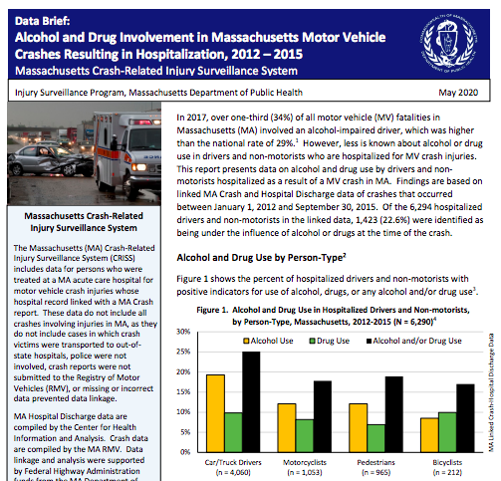

5

**Data Sources and References**

Data Sources in the MA Crash-Related Injury Surveillance System used in these analyses:

* Inpatient Hospital Discharge data (Jan. 2012 – Sep.2015), Center for Health Information and Analysis
* Crash Data System (Jan. 2012 – Sep. 2015), MA Registry of Motor Vehicles

1 Chia-Ying Kuo, et al. Functioning and Disability Analysis of Patients with Traumatic Brain Injury and Spinal Cord Injury by Using the World Health Organization Disability Assessment Schedule 2.0. *Int J Environ Res Public Health*. 2015 Apr 14;12(4):4116-27.

2 Massachusetts Department of Public Health, Injury Surveillance Program (June 2018). *Massachusetts Special Emphasis Report: Traumatic Brain Injury – 2015*. Retrieved from <https://archives.lib.state.ma.us/handle/2452/802168>

3 MA Department of Public Health. *Registry of Vital Records and Statistics*.

4 Center for Health Information and Analysis. MA Inpatient Hospital Discharge data. Fiscal year Oct. 1, 2014 – Sep. 31, 2015.

5 Dischinger PC, Ho SM, & Kufera JA (1999). The Epidemiology of Traumatic Brain Injury: A Statewide Study of Hospitalized Maryland Drivers. *Annu Proc Assoc Adv Automot Med*. 1999; 43: 71–88.

6Antona-Makoshi J, et al. Accident analysis to support the development of strategies for the prevention of brain injuries in car crashes. *Accid Anal Prev*. 2019; 117:98-105.

7 Siegel JH, et al. Factors influencing the patterns of injuries and outcomes in car versus car crashes compared to sport utility, van, or pick-up truck versus car crashes: Crash Injury Research Engineering Network Study. *J Trauma*. 2001 Nov;51(5):975-90.

8 Harper JS, et al. Motor vehicle crash fatalities: a comparison of Hispanic and non-Hispanic motorists in Colorado. *Ann Emerg Med.* 2000;36(6):589-596.

9 Girasek DC, Taylor B. An exploratory study of the relationship between socioeconomic status and motor vehicle safety features. *Traffic Inj Prev.* 2010;11(2):151-155.

10 Kent R, et al. On the fatal crash experience of older drivers. *Annu Proc Assoc Adv Automot Med.* 2005;49:371-91.

11 Massachusetts Department of Transportation (2018). *Massachusetts Strategic Highway Safety Plan*.Retrieved from <https://www.mass.gov/doc/massachusetts-shsp-2018/download>

12 Farmer CM, Williams AF. Effect on fatality risk of changing from secondary to primary seat belt enforcement. *J Safety Res.* 2005; 36(2): 189-94

This study and report were supported by MA Department of Transportation (MassDOT) funds and Centers for Disease Control and Prevention (CDC) grant #NU17CE924835-01-00. The content is solely the responsibility of the authors and does not necessarily represent the official views of MassDOT or the CDC.

**Massachusetts Department of Public Health,** [**Injury Surveillance Program**](http://www.mass.gov/injury-surveillance-program)