Municipal Vulnerability Preparedness Program Action Grant Case Study
Municipality: Town of Fairhaven
Project Title: Climate Change Vulnerability Assessment
Award Year (FY): FY22-23
Grant Award: $ 40,000
Match: $ 13,500
Match Source: $3,500 in-kind match, $10,000 cash match
One or Two Year Project: 1-year
Municipal Department Leading Project: Paul Foley and Bruce Webb
Project Website URL: https://www.fairhaven-ma.gov/
Community Overview:
- What is the population size of your community and where is it located?
15,924 as of 2020
- Do you have any Environmental Justice or other Climate Vulnerable communities? (Think about both those who live and work in your town.)
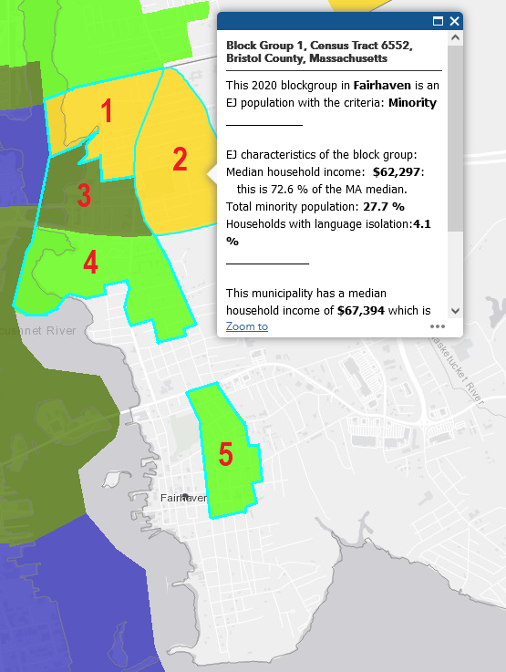
Currently, the Town of Fairhaven contains two environmental justice communities both qualifying as Income. At the inception of the MVP grant application for this project, Fairhaven had been identified to encompass 5 Environmental Justice (EJ) community block groups, including 1 Minority and Income, 2 Minority, and 2 Income designated block groups. These 5 blocks were classified by EEA, summarized in the below table, and pictured in the adjacent figure. The total population encompassed under these block groups as of 2019 is approximately 4,556, representing 29% of the total Town population (15,924 as of 2020). Climate change disproportionally impacts lower-income and other marginalized communities. A portion of Fairhaven’s EJ community falls within current mapped flood zones. All EJ communities utilize and rely on infrastructure along the coastline which may be vulnerable to sea level rise and coastal hazards. The proposed project will increase climate resiliency for these populations by helping the community plan and adapt to existing and projected impacts of climate change. As sea levels rises, flood zones will expand, and Fairhaven’s EJ community will be increasingly impacted.
# associated with Image Below | EEA EJ Block Group Heading | EEA EJ Description
1 | Block Group 5, Census Tract 6552, Bristol County, Massachusetts | This 2020 blockgroup in Fairhaven is an EJ population with the criteria: Minority  EJ characteristics of the block group:  Median household income: $64,675: this is 75.3 % of the MA median.  Total minority population: 31.2 %  Households with language isolation: 17.2 %  This municipality has a median household income of $67,394 which is 78.5 % of the Massachusetts MHHI.  In 2019 this block group had a population of 934 in 325 households.
2 | Block Group 1, Census Tract 6552, Bristol County, Massachusetts | This 2020 blockgroup in Fairhaven is an EJ population with the criteria: Minority  EJ characteristics of the block group:  Median household income: $62,297: this is 72.6 % of the MA median.  Total minority population: 27.7 %  Households with language isolation:4.1 %  This municipality has a median household income of $67,394 which is 78.5 % of the Massachusetts MHHI.  In 2019 this block group had a population of 1,103 in 437 households.
3 | Block Group 3, Census Tract 6552, Bristol County, Massachusetts | This 2020 blockgroup in Fairhaven is an EJ population with the criteria: Minority and income  EJ characteristics of the block group:  Median household income: $38,180: this is 44.5 % of the MA median.  Total minority population: 26.5 %  Households with language isolation:0.0 %  This municipality has a median household income of $67,394 which is 78.5 % of the Massachusetts MHHI.  In 2019 this block group had a population of 1,046 in 445 households.
4 | Block Group 4, Census Tract 6552, Bristol County, Massachusetts | This 2020 blockgroup in Fairhaven is an EJ population with the criteria: Income  EJ characteristics of the block group:  Median household income: $40,256: this is 46.9 % of the MA median.  Total minority population: 0.0 %  Households with language isolation:0.0 %  This municipality has a median household income of $67,394 which is 78.5 % of the Massachusetts MHHI.  In 2019 this block group had a population of 446 in 300 households.
5 | Block Group 3, Census Tract 6553, Bristol County, Massachusetts | EJ characteristics of the block group:  Median household income: $54,743: this is 63.8 % of the MA median.  Total minority population: 3.5 %  Households with language isolation:0.0 %  This municipality has a median household income of $67,394 which is 78.5 % of the Massachusetts MHHI.  In 2019 this block group had a population of 1,027 in 375 households.
- Other unique traits of your municipality like who the top employers are, geography, history, etc.
The Town of Fairhaven is located on the Massachusetts south coast, bordered by the Acushnet River and New Bedford Harbor to the west, and Buzzards Bay to the south. As such, the Town is exposed to the damaging effects of coastal storms, hurricanes, and the projected exacerbation of these hazards with climate change and sea level rise. Low-lying areas of the Town are especially prone to flooding and erosion. The New Bedford Hurricane Barrier is managed by the U.S. Army Corps of Engineers (USACE), providing storm protection to the developed downtown and working waterfront. However, seaward of the hurricane barrier, Sconticut Neck, West Island, and Shaw’s Cove residential areas experience unmitigated coastal storms. Here, salt marsh habitats and other brackish and freshwater marsh resources along the shoreline provide a measure of storm surge and wave attenuation.
Fairhaven’s coastal areas include residential and commercial districts, open space and conservation areas, and various municipal facilities. Coastal flooding has impacted the Fairhaven shoreline and infrastructure, most of which intersect the present-day FEMA 100-year floodplain. Notably, a recent unnamed storm on December 23, 2022, flooded low-lying areas outside of the hurricane barrier, especially Goulart Memorial Dr which is a causeway between Sconticut Neck and West Island. While high elevation limits coastal flood exposure for the interior core of the Town, rising sea levels and increased storm frequencies and intensities associated with climate change will increase the threat of flooding and storm damages in the low-lying and waterfront portions of Fairhaven.
Project Description and Goals:
- Where was the project located?
Town of Fairhaven
- What climate change impacts did the project address?
Sea level rise and coastal storm surge and the cascading impacts associated with these hazards.
- What were the specific goals and tasks of the project as stated in your application?
The project was the logical next step in the process of identifying Fairhaven’s top vulnerabilities in order to work towards adapting to future conditions under climate change. Prioritizing potential areas and projects for adaptations is a key outcome of this vulnerability assessment. Fairhaven is committed to maximizing its strengths, minimizing vulnerabilities, and becoming a more sustainable and resilient community in the face of a changing climate.
- Did your project meet the goals set forth in your application in terms of:
  - Employing nature-based solutions
Through the process of analyzing marsh migration, future adaptation prioritization has the information to look to areas which facilitate natural and nature-based features and green infrastructure.
  - Improving equitable outcomes for and fostering strong partnerships with EJ and other Climate Vulnerable Populations
Two community meetings were held in person, the second of which was recorded by the Town for public viewing.
  - Providing regional benefits
The project successfully evaluated Town-wide infrastructure and natural resources for climate change vulnerability. The results, although not directly applying to other parts of the region, build knowledge and momentum towards increasing coastal resilience in the region.
  - Implementing the public involvement and community engagement plan set forth in your application
Public involvement met the goal of two public meetings. The turnout was fairly large for public meeting #1, though less for #2. Outreach through the Town website, newspaper advertisement, project manager emails, and stakeholder committee emails reached new faces, however future efforts would benefit from more direct communication with neighborhood associations, community based organizations, and non-profits.
  - Finishing the project on time
The project was completed at the deadline. Some delays were seen due to a changeover in Town staff.
Results and Deliverables:
- Describe, and quantify (where possible) project results (e.g. square footage of habitat restored or created, increase in tree canopy coverage, etc.). Report out on the metrics outlined in your application.
The team successfully performed a detailed vulnerability and risk assessment of Town-wide potentially exposed infrastructure and natural resources to inform prioritization and adaptation planning. Working with Town staff, Woods Hole Group refined the existing GIS asset inventory with an in-field survey of infrastructure and critical elevations, and developed consequence scores for all potentially exposed assets to inform the risk assessment. Using MC- FRM water surface elevation projections (2030, 2050, and 2070), site specific documentation, and asset consequence scoring, Woods Hole Group conducted the vulnerability and risk assessment for Town infrastructure. In parallel, Woods Hole Group used projected tidal benchmarks to assess potential nuisance flooding impacts. Using MA CZM Sea Level Affecting Marshes Model (SLAMM) projections, Woods Hole Group calculated potential habitat change over time. Woods Hole Group developed Town-wide maps of MC-FRM projections, maps and tables of SLAMM analyses, and maps and tables of infrastructure risk. An outcome of this risk assessment was a comprehensive list of assets and their vulnerability. The final assessment highlighted the most vulnerable assets and areas, to assist the Town in choosing priority assets for adaptation planning.
- Provide a brief summary of project deliverables with web links, if available.
Project Task # and Description | Deliverables
Sub-task 1.1 Kick-off meeting with Town, EEA, and Consultant | Meeting notes
Sub-task 1.2 Monthly progress reports FY23 | Monthly progress reports
Sub-task 1.5 Project Case Study | Final Case Study Report
Sub-task 2.1 Community Progress Meeting 1 | PowerPoint Presentation, sign-in sheet, survey, and in-person workshop materials
Sub-task 2.2 Community Progress Meeting 2 | PowerPoint Presentation, sign-in sheet, and in-person workshop materials
Sub-task 2.3 Steering Committee Meetings | PowerPoint Presentations and field survey plan
Sub-task 3.1 Data Collection & Establishment of Study Parameters | Technical Memorandum evaluating data collected & Description/Map of Sea-Level Rise and Storm Scenarios
Sub-task 4.1 Perform Draft Vulnerability Assessment | See below.
Sub-task 4.2 Perform Final Vulnerability Assessment | Final Climate Change Vulnerability Assessment Report
Lessons Learned:
- What lessons were learned as a result of the project? Focus on both the technical matter of the project and process-oriented lessons learned.
Fairhaven’s location on Buzzards’ Bay and its topography means that the Town has, and will continue to experience significant coastal storms and storm damage. Flooding issues resulting from long-term shifts in tidal datums due to sea level rise and increasing risk of coastal storm surge will significantly impact infrastructure, roadways, and low-lying developed areas in the Town of Fairhaven.
The MC-FRM projections from Present Day, 2030, 2050, and 2070 were used to assess the vulnerability and total risks from storm surge impacts to Town infrastructure and roadways. A risk assessment of Town-wide municipal assets and low-lying roads found that by 2070, 48 assets and 31 miles of roads could be at risk to coastal storm flooding. Looking beyond municipal infrastructure, up to 2,227 buildings in the Town were found to be at-risk to a 100-year storm by 2070.
Vulnerability assessment results emphasized the risk to Town pump stations and low-lying open space areas, but notably found critical infrastructure such as Town Hall, the Public Works facility, schools, shelters, the Millicent Library, and Police and Fire headquarters to be outside of future coastal flood zones. An assessment of roadways found that many critical linkages and evacuation routes are at risk to storm flooding, and in some cases tidal flooding in the future. Of the vulnerable roadways, several serve as the shortest evacuation route from more distant parts of Town, including:
- Interstate-195
- Route 6
- Causeway Rd/Goulart Memorial Dr
- Sconticut Neck Rd
- Fort St
- Main St
- Washington St
- Spring St
- Bridge St
Overall, areas outside of the New Bedford Hurricane Barrier are anticipated to experience extreme water levels from future storms. Such flooding impacts pose a significant threat to primarily to residents and public/emergency access, but also encroaches on portions of developed commercial areas adjacent to Route 6. The downtown area of Fairhaven is currently protected by the Hurricane Barrier. Assuming that the barrier continues to function as intended, much of the downtown remains outside of future flood zones. However, fringe flooding of the commercial and industrial waterfront, Union Wharf for example, is anticipated. Analysis of the possibility of failure of the Hurricane Barrier to provide protection was beyond the scope of this project. However, overtopping of the harbor under extreme storm scenarios in 2050 and 2070 was included in this study.
The intersection of several Town assets and low-lying roadways with high vulnerability to storm surge inundation highlights the need for effective planning and adaptation strategies to reduce vulnerability and increase resilience in Fairhaven.
The next step is to develop a climate change adaptation plan for the identification of adaptation recommendations to increase community resilience to present and future coastal hazards. Any future work would benefit from continued public outreach to disseminate information on coastal flood risk to residents, local businesses, and organizations.
- What is the best way for other communities to learn from your project/process?
The Town will make the final report available at https://www.fairhaven-ma.gov/
Partners and Other Support:
- Include a list of all project partners and describe their role in supporting/assisting in the project.
The Project was led by Paul Foley until his departure in May 2023, when Bruce Webb, Conservation Agent for the Town of Fairhaven, took over. Woods Hole Group was hired as a consultant to the Town, and was led by Conor Ofsthun, Coastal Scientist, and supported by Justine Rooney, Brittany Hoffnagle, Joe Famely, Kirk Bosma, Linnea Laux, and Annie O’Connell, among others. A steering committee was assembled to help guide the Project, create efficient communication across municipal departments, and ensure the best available data and experience fed into this work. The Steering Committee was composed of the following members who volunteered their time:
Name | Department/Affiliation | Contact Information
Vincent Furtado  Rene Robillard  Jeffrey Furtado | Fairhaven Public Works Department | vfurtado@fairhaven-ma.gov  rrobillard@fairhaven-ma.gov  jfurtado@fairhaven-ma.gov
Jeff Osuch | Formerly of Fairhaven Public Works Department | osuch1@aol.com
Joshua Crabb | Fairhaven Highway | jcrabb@fairhaven-ma.gov
Gary Lavalette  Bruce Webb | Fairhaven Conservation Commission | conservation@fairhaven-ma.gov  garysplumbing@msn.com  conservation_agent@fairhaven-ma.gov
Scott Gordon  Todd Correia  Michael Myers | Fairhaven Emergency Services | scott.gordon@fairhavenpolice.org  tcorreia@fairhaven-ma.gov  michael.myers@fairhavenpolice.org
Paul Foley | Fairhaven Economic Development Committee;  Fairhaven Planning Board | pfoley@fairhaven-ma.gov
Timothy Cox | Harbormaster | tcox@fairhaven-ma.gov
Project Photos:
- In your electronic submission of this report, please attach (as .jpg or .png) a few high-resolution (at least 300 pixels per inch) representative photos of the project. Photos should not show persons who can be easily identified, and avoid inclusion of any copyrighted, trademarked, or branded logos in the images. MVP may use these images on its website or other promotional purposes, so please also let us know if there is someone who should receive credit for taking the photo.
Photo Credit: Woods Hole Group, 2022
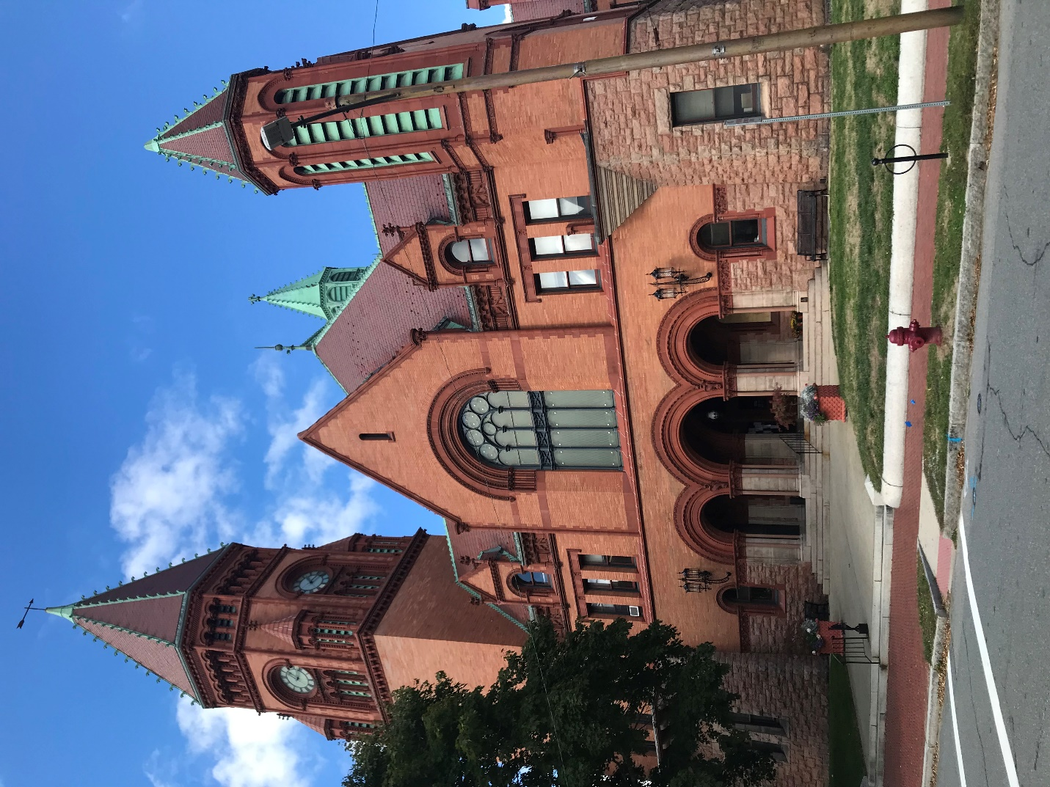
Town Hall
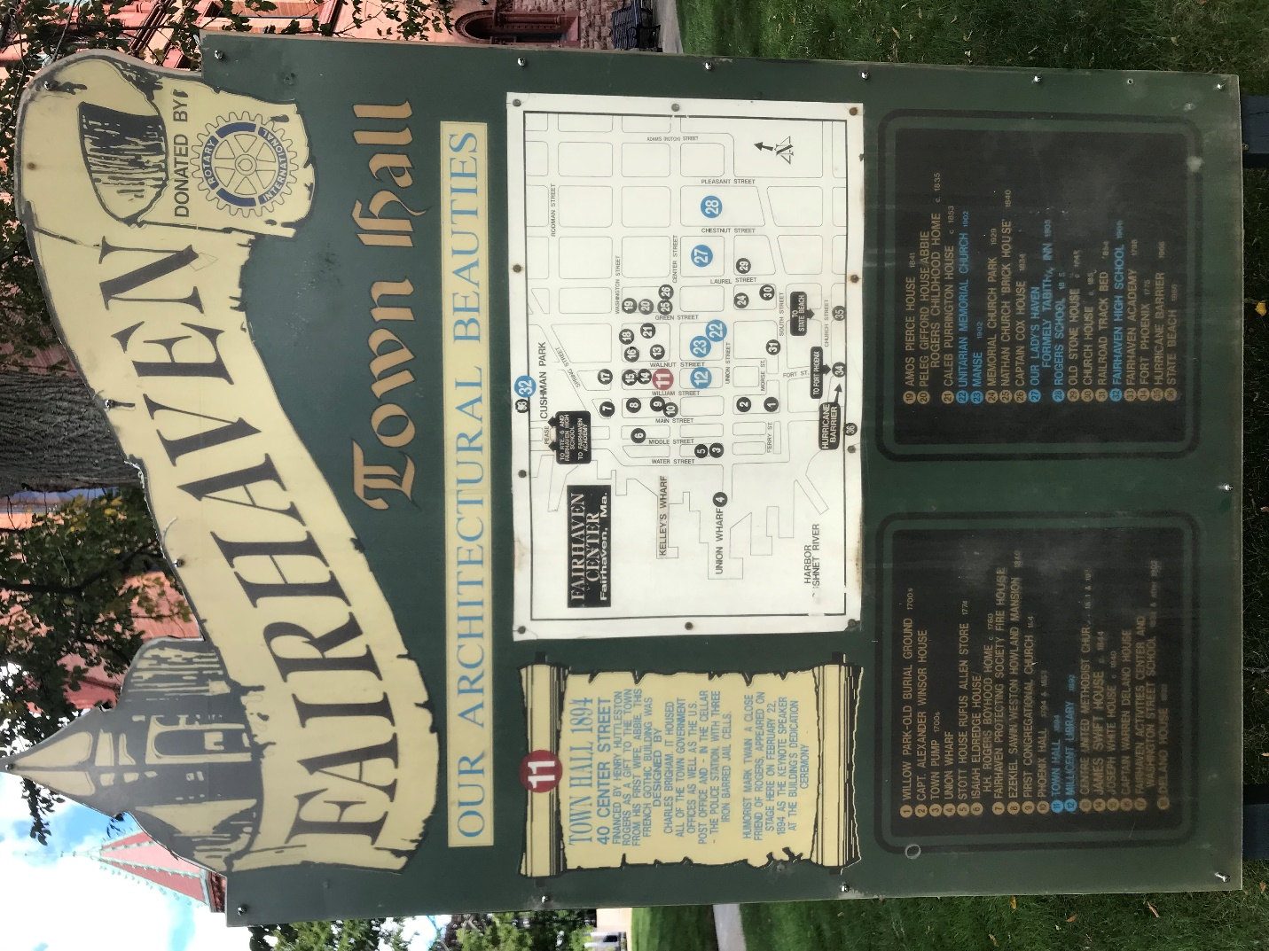
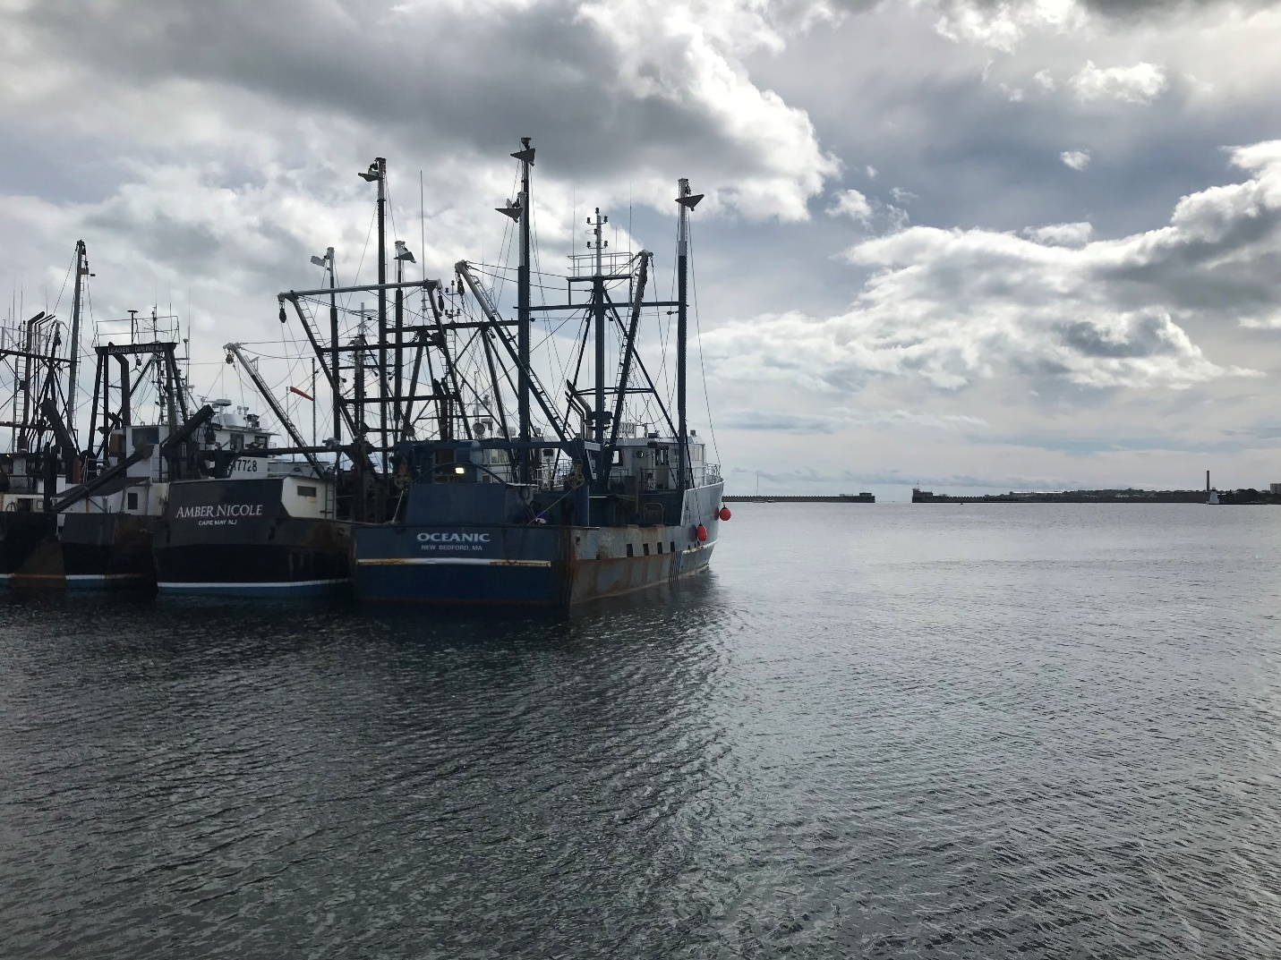
Union Wharf and the New Bedford Hurricane Barrier
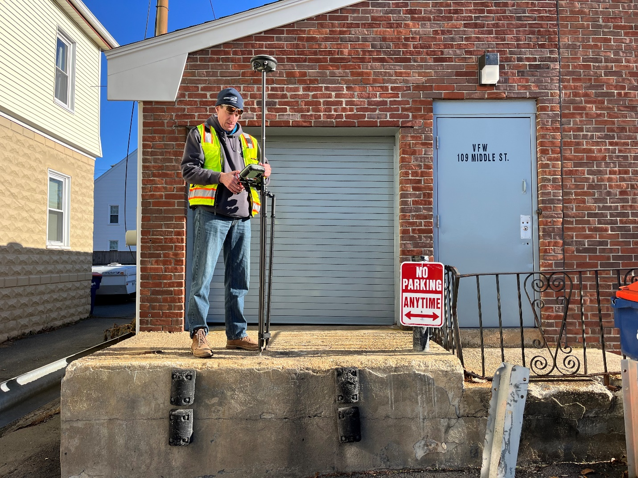
Critical elevation surveying of municipal assets.
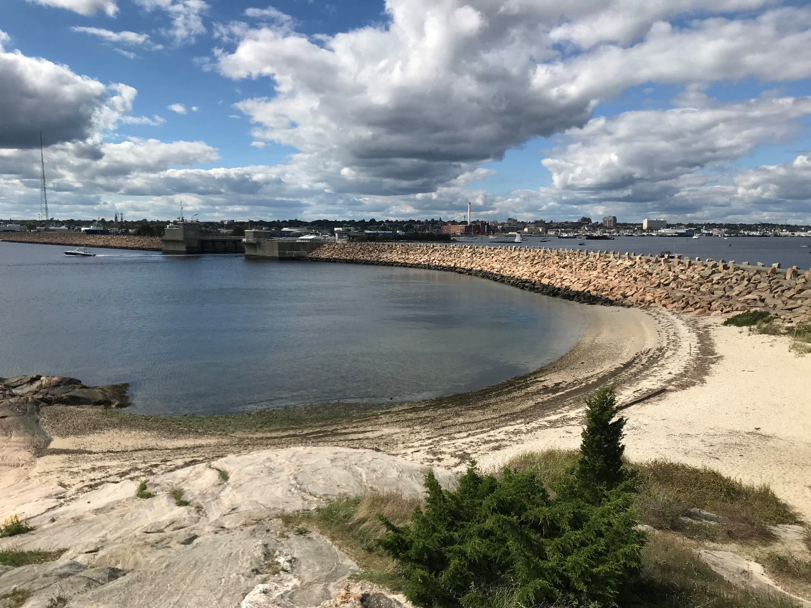
New Bedford Hurricane Barrier photographed from Phoenix Landing
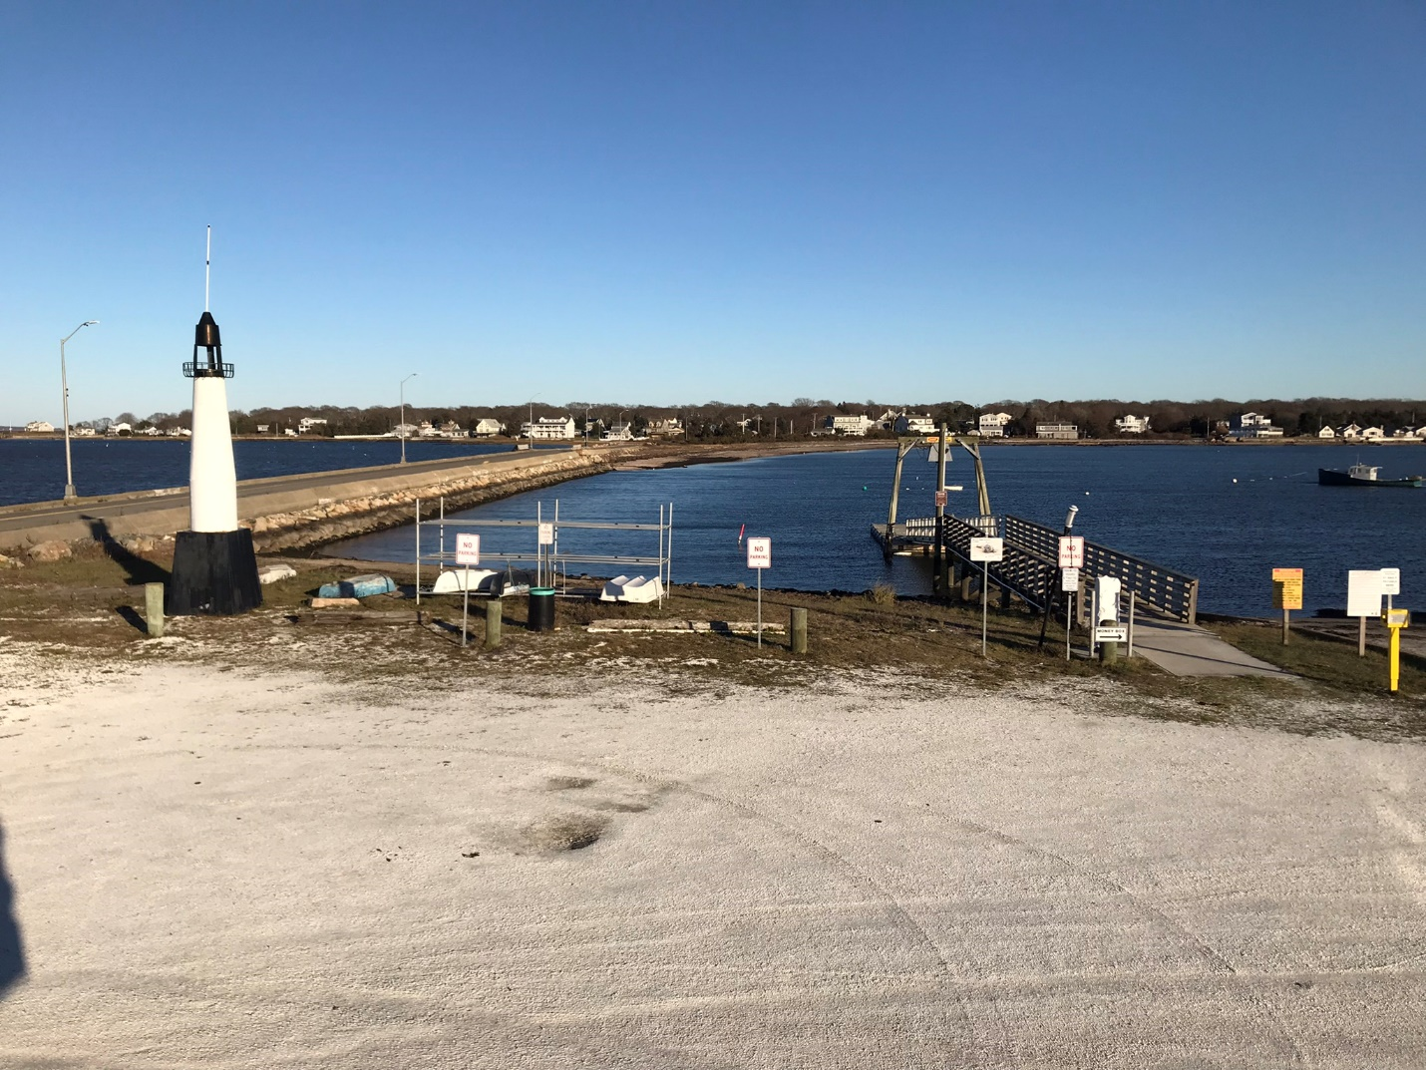
Hoppy’s Landing and Causeway Road

