INDOOR AIR QUALITY ASSESSMENT

**Fairhaven Police Department**

1 Bryant Lane

Fairhaven, MA

**October 2024**

Exterior view of Fairhaven Police Department
1 Bryant Lane
Fairhaven, MA


Prepared by:

Massachusetts Department of Public Health

Bureau of Climate and Environmental Health

Indoor Air Quality Program

Contents

EXECUTIVE SUMMARY 3

BACKGROUND 4

RESULTS AND DISCUSSION 5

Ventilation 5

Water Damage and Moisture Concerns 6

Water Damage Issues 7

Sources of Respiratory Irritants/Possible Asthma Triggers 9

CONCLUSIONS AND RECOMMENDATIONS 11

REFERENCES 15

PICTURES 16

Table 1 35

Table 2A 38

Table 2B 39

Table 2C 40

Table 3 41

Table 4 43

# R an EXECUTIVE SUMMARY

The Massachusetts Department of Public Health’s Indoor Air Quality Program (MDPH IAQ) conducted an IAQ assessment of the Fairhaven Police Department on September 20, 2024. This assessment was requested by Fairhaven Town Officials for the purpose of investigating mold concerns and general IAQ complaints reported in the building.

The building is reported to have chronic issues with water damage and mold growth. Water damage was occurring from both exterior/building envelope issues, as well as internal sources (leaks and condensation) which has resulted in visible mold growth on building materials. It is also important to note the heating, ventilation, and air conditioning (HVAC) system components are original to the construction of the building (1970s/1990s addition, > 30-50 years old), well past their service life. These conditions make it difficult to control outside airflow, temperature, and relative humidity, particularly during hot, humid, summer conditions that have led to widespread condensation and water damage issues. Further, other building materials (e.g., carpeting, asbestos floor tiles, roof, and windows) are mostly original to the building’s construction and are also past their service life and in need of replacement. As climate change and global warming intensifies, the urgent need for modern, energy-efficient solutions becomes clear, without significant upgrade of HVAC equipment and other interior components, building conditions and indoor air quality will continue to degrade.

In addition, several building envelope issues/leaks have led to temperature/comfort control issues and water damage as shown by rotted wood, stained ceiling tiles, and visible mold growth on the surface of building materials. As climate change and global warming intensifies, the urgent need for modern, energy-efficient solutions becomes clear, without significant repair of the building envelope and repair/upgrade of interior HVAC components, building conditions and indoor air quality will continue to degrade.

(Conclusions)

Based on the results of the assessment, the following primary recommendations are made:

* Work with a professional flooding/restoration firm to identify and remediate areas of water damage and mold growth.
* Remediate water-damaged/mold-colonized items and building materials using the US EPA’s “Mold Remediation in Schools and Commercial Buildings”. Available at: <http://www.epa.gov/mold/mold-remediation-schools-and-commercial-buildings-guide>
* Due to the age/condition of the HVAC system, consult with an HVAC engineering firm to evaluate the system for repair or replacement.
* Make repairs to the building exterior to prevent water damage and temperature/comfort control issues.
* Operate supply and exhaust ventilation equipment continuously for air exchange and filtration during occupied hours.
* Adjust air intakes as necessary to avoid uncontrolled outside air during periods of elevated relative humidity to avoid condensation/mold issues; and during extreme cold weather to avoid freezing of pipes, which can lead to flooding and mold issues.
* Utilize portable air purifiers equipped with high efficiency particulate air (HEPA) filters.

(Conclusions and Recommendations)

# R an BACKGROUND

|  |  |
| --- | --- |
| Building: | Fairhaven Police Department (FPD) |
| Address: | 1 Bryant Lane, Fairhaven, Massachusetts |
| Assessment Requested by: | Kevin Fournier, Facilities Manager, Town of Fairhaven |
| Reason for Request: | Mold concerns and general indoor air quality (IAQ) |
| Date of Assessment: | September 20, 2024 |
| Massachusetts Department of Public Health/Bureau of Climate and Environmental Health (MDPH/BCEH) Staff Conducting Assessment: | Cory Holmes, Assistant Director, IAQ Program |
| Building Description: | The FPD is a brick and concrete structure that is part of a complex, which also includes the Fairhaven Fire Department, that was originally built in the 1970s. An addition was constructed in the 1990s. Interior components consists of wall-to-wall carpet, carpet squares, laminate floors, and floor tiles, suspended ceilings, and painted gypsum wallboard walls. |
| Windows: | Windows are original and are openable throughout the building, however, many are difficult to open due to the condition of window frames. |

# R an RESULTS AND DISCUSSION

The following is a summary of indoor air testing results (Table 1)

|  |  |  |
| --- | --- | --- |
| * ***Carbon dioxide (CO2)*** | *a measure of the adequacy of ventilation* | Levels were below the MDPH guideline of 800 parts per million (ppm) in areas surveyed. However most areas were empty/sparsely populated at the time of inspection, which can reduce carbon dioxide levels. Carbon dioxide levels would be expected to increase with higher occupancy. |
| * ***Temperature*** | *a measure of comfort* | Was below the MDPH recommended range of 70°F to 78°F in several areas at the time of assessment. |
| * ***Relative humidity*** | *a measure of comfort and, when in excess for an extended period, a way to reflect the potential for mold and fungal growth* | Was above the MDPH recommended range of 40 to 60% in all areas tested, indicating the HVAC units may not be able to, or may not be operating to reduce moisture in indoor air. |
| * ***Carbon monoxide***   ***(CO)*** | *a product of combustion that can result in acute and long term cardiovascular, respiratory, and neurological symptoms* | Levels were non-detectable in all areas assessed. |
| * ***Particulate matter (PM2.5)*** | *a way to measure inhalable particle distribution in the air* | Concentrations were below the National Ambient Air Quality Standard (NAAQS) of 35 micrograms per cubic meter (μg/m3) in all areas tested. |

## Ventilation

Ventilation refers to both the supply of fresh air and the removal of stale air from a room. The introduction of fresh air into an occupied space will dilute normally occurring pollutants that are generated by occupancy and other activities. In addition, a heating, ventilation, and air conditioning (HVAC) system will remove pollutants from a building if operating appropriately.

The HVAC system consists of air handling units (AHUs) located on the roof or in mechanical rooms equipped with pleated air filters (Pictures 1 through 3). Conditioned outside air is provided through ducted wall or ceiling vents (Pictures 4 and 5) and is returned to the AHUs by ducted ceiling or wall-mounted return vents (Pictures 6 and 7).

The various types of ventilation components *as well as devices that can move/redirect airflow* are listed in Table 2A, Table 2B and Table 2C.

## HVAC System Maintenance

**Balancing**

To have proper ventilation with a mechanical supply and exhaust system, a system must be balanced to provide an adequate amount of fresh air to the interior of a room while also removing stale air from the room. It is recommended that HVAC systems be re-balanced every five years to ensure adequate air systems function (SMACNA, 1994).

Additional HVAC Conditions:

Please note, this equipment has exceeded its service life. According to the American Society of Heating, Refrigeration, and Air-Conditioning Engineers (ASHRAE), the service life of this type of unit is 15-20 years, assuming routine maintenance of the equipment (ASHRAE, 1991). In their current state, these units have shown they are not sufficient to provide proper temperature and humidity control as evidenced by historical/current issues with mold growth, visible water damage, and relative humidity measurements (Table 1).

* **Please note that with the age and condition of the HVAC components, balancing of fresh air supply and return/exhaust vents may not be possible.**
* **To maximize air exchange, the IAQ program recommends that both supply and exhaust ventilation operate *continuously* during periods of occupancy**. To have proper ventilation with a mechanical ventilation system, the systems must be balanced after installation to provide an adequate amount of fresh air to the interior of a room while removing stale air from the room. It is recommended that HVAC systems be re-balanced every five years to ensure adequate air systems function (SMACNA, 1994). The last date of balancing of the systems was not known at the time of assessment.

## Water Damage and Moisture Concerns

Please note that the IAQ Program does not recommend conducting mold testing in a typical water damage remediation. For details, please consult [Guidance Regarding Testing for Mold in Water-Damaged Public Buildings](https://www.mass.gov/info-details/guidance-regarding-testing-for-mold-in-water-damaged-public-buildings) | Mass.gov

The application of a mildewcide to moldy porous materials is not recommended.

Molds are found naturally in our environment both indoors and outdoors. Inside, mold growth may occur when items, particularly porous products such as paper or GW, are exposed to moisture. Typical water sources include leaks, floods, and condensation. To avoid mold growth, dry all water-damaged items and affected areas within 24-48 hours and reduce indoor humidity. Some people with chronic respiratory conditions, such as asthma, are more likely to experience health symptoms associated with molds, including allergic reactions and respiratory irritation. Controlling moisture is the key to preventing mold growth and potential health symptoms.

Hot humid summers are becoming more frequent due to climate change. Massachusetts has experienced hot, humid, and rainy summers in 2018, 2021, and 2023. July of 2021 was the wettest ever recorded in Massachusetts, and the three-month period from June through August, known as the meteorological summer, was the fourth wettest on record, according to the National Oceanic and Atmospheric Administration’s (NOAA) Centers for Environmental Information (NOAA, 2021). The summer of 2023 was also hot, and wet, being measured as the second rainiest on record (WBUR, 2023). The summer of 2024 has also had significant stretches of hot, humid weather.

During these hot and wet summers, extended periods of outdoor relative humidity above 70% occurred. Under these weather periods, public buildings experienced extended periods of water vapor exposure from high relative humidity. When exposed to these conditions, porous materials such as gypsum wallboard, cardboard, and other materials may become prone to developing mold colonization, particularly if located in areas that are prone to developing condensation on floors and walls (e.g., below grade space).

### Water Damage Issues

(see Water Damage and Moisture Concern Pictures)

* **Water damage from condensation was observed in the form of water-damaged/mold-colonized ceiling tiles** **in several areas typically below metal ductwork** (Table 1, Pictures 8 through 10).
* **Water infiltration and leaks were noted in the squad room,where the ceiling tiles were removed and water was being collected in a plastic garbage bag** (Pictures 11 and 12).
* **Visible mold was seen on gypsum wallboard in the conference room above the ceiling tile system** (Picture 13), **in the first-floor restroom** (Picture 14), **and underneath vinyl coving in the basement breakroom** (Pictures 15 and 16), which was under renovation at the time of assessment.
* **Visible mold was observed on the surface of fabric blinds that are installed in several areas throughout the building** (Picture 17). Not only is this fabric a porous material that can absorb moisture, but the design is prone to collect dust, that can serve as a food source for mold once it gets wet.
* **Visible mold was also observed on the ceiling of the Armory** (Picture 18); however, this was a non-porous concrete material that can be cleaned/wiped down.
* **Missing damaged caulking was noted along the Women’s Locker Room bathroom wall** (Picture 19).
* **Carpeting was observed in close proximity (several feet) from bathroom utilities/fixtures** (Picture 20). Due to the age of the building, floor tiles and mastics beneath carpeting may be asbestos containing materials (ACM). Intact ACM does not pose a health hazard. If damaged, ACM can be rendered friable and become aerosolized. Friable asbestos is a chronic (long-term) health hazard but will not produce acute (short-term) health effects (e.g., headaches) typically associated with buildings believed to have IAQ problems. Where asbestos-containing materials are found damaged, these materials should be removed or remediated in a manner consistent with Massachusetts asbestos remediation laws.
* **Gypsum wallboard ceiling in the locker room stairwell has been removed due to chronic leaks, exposing fiberglass insulation (an eye, skin, and respiratory irritant)** (Picture 21). It was reported that portions of the ceiling were removed to allow the leaks to pass through so they can be mopped up on the stairwell; this becomes a slip and fall hazard.
* **No shower vents are installed over/near showers.** There was a vent on a wall in the Men’s Locker Room, however this appeared to be part of the general HVAC system (Picture 22).
* **Chronic moisture/mold issues were reported on the ceiling of the ground floor Meeting Room** (Picture 23). The most likely source of moisture is from the loose exterior door that is in nearby (Picture 24).
* **In some cases, window frames were rotted, warped, and damaged creating gaps that allow for uncontrolled drafts, moisture, and pest entry** (Pictures 25 through 28). These conditions can make it difficult to control temperature leading to comfort complaints and condensation issues that can lead to mold growth.

Several other conditions on the outside of the building were identified that can contribute to water infiltration issues, which are specified in Table 3 and are listed below.

**Mold Growth**

Porous materials (e.g., gypsum wallboard, ceiling tiles and carpeting) can be dried with fans and heating within 24 to 48 hours of becoming wet (US EPA, 2008).

If porous materials are not dried within this time frame, mold growth may occur.

* **Rotted wood along the roof and delaminating paint along the roof eaves**, which can accelerate water damage and wood rot (Pictures 29 and 30).
* **Cracks/damage to the concrete foundation** (Picture 31).
* **Spaces between the handicapped access ramp and building** (Picture 32).
* **Holes and breaches around utilities were observed in some areas** (Picture 33). These breaches can provide a pathway for drafts, odors, particulates, and pests into the building.
* **Shrubbery/vegetation against exterior walls** (Pictures 34 and 35).
* **Trees were near the building** (Picture 36). The presence of large trees is likely enhancing water retention, preventing drying of the exterior, and affecting drainage as well as overhanging the roof. These trees pose several hazards:
  + *Leaves and other debris accumulate around gutters, and roof drains where present, which inhibits rainwater drainage.* Clogged gutters and/or ineffective drains can lead to water running off the roof to moisten exterior walls.
  + *Trees prevent sunlight from drying walls and soil.*
  + *The trees are a possible danger due to the distance from exterior walls.*

The recommended safe distance that any tree should be planted is the

minimum of the expected maximum growth height of the species from the

exterior of a building (BI, 2015).

* + *Soil subsidence may also be caused by tree roots, which can undermine the structure of a building to cause wall and floor cracking and related damage*. To prevent subsidence, a sufficient distance appropriate for the tree species is recommended (Williams, 2006).
  + *Severe weather may result in the tree falling onto the building or the tree roots damaging the foundation.* Due to the height of the trees, each is likely located closer than recommended distances.
  + *In general, a tree root system will spread out in all directions from its trunk*. In some cases, tree roots can extend for over 100 feet from its trunk. Any structure disrupting the root structure may make the tree unstable if subjected to high winds from a certain direction. Based on the location, the foundation walls likely disrupt the roots of several trees.
  + *The Federal Emergency Management Agency (FEMA) provides several recommendations to prepare for severe thunderstorms*. Of note FEMA recommends “Cut down or trim trees that may be in danger of falling on your [building]” (FEMA, 2018). Given the proximity to exterior walls, removal of trees near the building should be considered.

## 

## Sources of Respiratory Irritants/Possible Asthma Triggers

Asthma is a lung disease that can make breathing difficult. Without careful management of asthma, some people can have symptoms, like a tight feeling in the chest, shortness of breath, coughing, or wheezing. Although there is no cure for asthma, people with asthma can live healthy, active lives. A safe and healthy environment helps to reduce asthma symptoms.

Possible asthma triggers and/or airborne pollutants exist in the building. These are listed below as well as in (Table 4).

(see Sources of Respiratory Irritant Pictures)

* **Dust, a common respiratory and eye irritant, can collect on surfaces and items.** Although janitorial and maintenance staff perform routine cleaning, they may not be able to clean as effectively if items are not picked up or surfaces are cluttered. Even with a properly functioning ventilation system, it is necessary to either eliminate or reduce the use of materials that can be a source of respiratory irritants to prevent symptoms in individuals who have sensitivity to such pollutants.
* **In general, it is not recommended for police departments and other emergency response agencies to have carpeted floors due to the possible cross-contamination that may occur from footwear contact with automotive products, chemicals, or biological contamination.** In addition, the Institute of Inspection, Cleaning and Restoration Certification (IICRC) discusses floor covering in its guideline, “Standard for Professional Cleaning of Textile Floor Coverings” (IICRC, 2015). Based on this standard, the IICRC recommends twice-daily vacuuming and/or pile-lifting cleaning for commercial carpeting in heavy traffic areas. This frequency of cleaning of the building as well as the use of vacuum cleaners equipped with HEPA filters would remove respirable dust from the indoor air.
* **Some areas had carpeting that was beyond its service life of approximately 10-11 years (IICRC, 2002).** Carpeting that is beyond its service life becomes increasingly difficult to clean and may release fibers which can be irritating if airborne. Carpets should be vacuumed regularly with a HEPA filter-equipped vacuum cleaner and cleaned annually (or semi-annually in soiled/high traffic areas) in accordance with Institute of Inspection, Cleaning and Restoration Certification (IICRC) recommendations (IICRC, 2012).
* **In some areas ceiling/wall vents had accumulated dust and debris.** This dust/debris can be re-aerosolized when units are activated and be a source of eye and respiratory irritation.
* **Air purifiers were noted in some areas** (Picture 37). HEPA-filtered units are good choices for use in occupied areas. Air purifiers that may produce ozone should not be used (EPA, 2003) All air purifiers should be cleaned and maintained in accordance with manufacturer’s instructions.
* **Finally, a vintage thermostat was observed in the basement breakroom that contained a mercury ampoule** (Picture 38). When elemental mercury is spilled or a device containing mercury breaks, the spilled mercury can vaporize and become an invisible, odorless, toxic vapor. It is also expensive to clean up and can interfere with normal operations due to containment and cleanup efforts.

# R an CONCLUSIONS AND RECOMMENDATIONS

|  |  |  |
| --- | --- | --- |
| **Short-term Recommendations** | | |
| **HVAC System** | | |
|  |  | **Helpful links** |
|  | Consult with a ventilation engineer to determine if the HVAC system has the configuration and capacity to properly remove water vapor and excess humidity from the building. Make repairs and/or adjustments as necessary. |  |
|  | Due to the age/condition of the HVAC system, consult with an HVAC engineering firm to evaluate the system for repair or replacement. |  |
|  | Operate supply and exhaust ventilation equipment continuously for air exchange and filtration during occupied hours. |  |
|  | Use openable windows for additional fresh air during temperate weather. However, care should be taken to *avoid opening windows when air conditioning is in use* to prevent condensation and mold growth, and during extreme cold to prevent freezing of pipes. |  |
|  | Conduct regular filter changes (2-4 times per year) for HVAC equipment using minimum efficiency rating value (MERV rating) of 8 or the best quality/highest MERV rating the ventilation system can accommodate to improve air filtration as much as possible without significantly reducing airflow. |  |
|  | During filter cleaning examine cooling fins for dust/debris and clean/vacuum as needed to ensure efficient operation and to prevent mold growth and associated odors. |  |
|  | During filter changes vacuum out dust and debris from HVAC cabinets. |  |
|  | Remove obstruction from supply vent in Dispatch, replace with vent deflector. |  |
|  | Have the HVAC system balanced every 5 years in accordance with SMACNA recommendations (SMACNA, 1994). |  |
| **Water Damage Sources** | | |
|  | Work with a professional flooding/restoration firm to identify and remediate areas of water damage and mold growth.  Remove or clean water-damaged/mold-contaminated materials in accordance with US EPA Guidance “Mold Remediation in Schools and Commercial Buildings”. | US EPA. 2008. “Mold Remediation in Schools and Commercial Buildings”. EPA 402-K-01-001. United States Environmental Protection Agency, Office of Air and Radiation, Indoor Environments Division, Washington, DC. September 2008. <http://www.epa.gov/mold/mold-remediation-schools-and-commercial-buildings-guide> |
|  | During remediation, remove or cover items to prevent dust accumulation and conduct thorough cleaning after using HEPA vacuum and wet-wiping techniques of items, flat surfaces, floors, and walls. |  |
|  | Replace fabric window shades with a non-porous/cleanable alternative. |  |
|  | Clean ceiling of the Armory with a HEPA vacuum and an antimicrobial agent (or soap and water) and dry. |  |
|  | Conduct a thorough building envelope evaluation to make repairs/repointing efforts to eliminate leaks. Building occupants should ensure they report active leaks to building management for investigation and repairs. |  |
|  | Seal holes/breaches in exterior walls and spaces around utilities with a fire-rated insulation or foam. |  |
|  | Replace missing/damaged caulking along wall tile in Female Locker Room. |  |
|  | Remove trees and plants from away from exterior walls to allow for better drying of building materials and prevent pollen and odors from being drawn into the building. |  |
|  | Repair/refinish rotted wood/delaminated wooden roof eaves to prevent water damage and wood rot. |  |
|  | Seal/repair broken windows on top floor to prevent drafts, moisture, and pest entry. |  |
|  | Trim branches overhanging roof and clean out gutters. |  |
|  | Install/replace weather-stripping around exterior doors. |  |
|  | Until windows can be replaced, make repairs to prevent drafts and water infiltration. |  |
|  | Over the summer, conduct regular walkthroughs to observe conditions in the building, paying close attention to walls, ceiling tiles, and flat surfaces for signs of moisture and/or mold growth. |  |
|  | Monitor weather through extended forecasts to determine if hot, humid weather for more than two days is predicted. Many web-based weather services will provide a dew point listing. |  |
|  | Consider installing/using indoor air sensors. As indoor air sensors become more sophisticated and less expensive, they can be placed in municipal buildings to measure and provide accurate, real-time information via an application or web-based dashboard, eliminating the need for personnel to take measurements with hand-held equipment. |  |
|  | Avoid storing porous materials in contact with the floors, particularly during periods of high humidity. |  |
|  | Use dehumidifiers in combination with fans and ACs during summer months/periods of elevated relative humidity. Clean and maintain portable dehumidifying units in accordance with manufacturers’ recommendations or drain into sinks/floor drains to reduce daily maintenance. |  |
|  | Remove carpeting from close proximity to bathrooms and showers. Be sure to have any suspect floor tiles and mastic evaluated/remediated in accordance with state and Federal regulations for asbestos-containing materials. |  |
| **Respiratory Irritants/Possible Asthma Triggers** | | |
|  | Reduce clutter. Periodically remove unwanted items. Store remaining items neatly and off the floor. Where rooms have a history of moisture issues, consider storing items in waterproof totes. |  |
|  | Cover exposed fiberglass insulation to prevent exposure in the Locker Room stairwell. |  |
|  | To control for dusts, use a HEPA filter-equipped vacuum cleaner and wet wiping on all surfaces on a regular basis. |  |
|  | Until carpet can be replaced, clean in accordance with IICRC recommendations (IICRC, 2012); annually (or semi-annually in soiled/high traffic areas). Be sure to have any suspect floor tiles and mastic evaluated/remediated in accordance with state and federal regulations for asbestos-containing materials. |  |
|  | Clean/change filters and maintain portable air purifiers/HEPA units in accordance with manufacturers’ recommendations. Avoid the use of air purifiers that may product ozone. | <https://www.epa.gov/indoor-air-quality-iaq/ozone-generators-are-sold-air-cleaners> |
|  | Clean vents and portable fans regularly to remove accumulated dust/debris. |  |
| **Other Recommendations to Improve Air Quality Conditions** | | |
|  | Seal breaches/openings around utilities (e.g., radiator pipes) exterior doors, and the building envelope to keep out drafts, moisture and pests. Report any pest/rodent sightings to building management. | |
|  | Replace mercury-containing thermostats with modern digital ones. Ensure all mercury-containing devices are disposed of properly. | |
| **Long-term Recommendations** | | |
|  | Consult a HVAC engineering firm to conduct a building-wide ventilation systems assessment. Based on historical issues with air exchange/indoor air quality complaints, age, physical deterioration, and availability of parts for ventilation components, such an evaluation is necessary to determine the feasibility of repair or replacement of the equipment. In addition, have them determine whether the existing HVAC system can be balanced in its current condition should be considered. | |
|  | Replace carpeting beyond its service life. | |
|  | Remove trees from close proximity to the building. | |
|  | Replace warped/damaged windows. | |
|  | Evaluate exterior doors for proper closure, repair/replace as necessary. | |
|  | Install exhaust vents for showers that direct moisture to the outside. | |

## REFERENCES

BI. 2015. A List of Trees and the Recommended Safe Distance from Buildings. Bickers Insurance, Littlehampton, West Sussex, UK. <https://www.bickersinsurance.co.uk/about-us/latest-news/property-owners-news/a-list-of-trees-and-the-recommended-safe-distance-from-buildings/>

FEMA. 2018. How to Stay Safe When a Thunderstorm Threatens. Federal Emergency Management Agency, Washington, DC. FEMA V-1009/May 2018.

IICRC. 2002. Institute of Inspection, Cleaning and Restoration Certification. A Life-Cycle Cost Analysis for Floor Coverings in School Facilities.

IICRC. 2012. Institute of Inspection, Cleaning and Restoration Certification. Carpet Cleaning: FAQ.

IICRC. 2015. Institute of Inspection, Cleaning and Restoration Certification. Commercial Carpet Cleaning: FAQ.

MDPH. 2015. Massachusetts Department of Public Health. Indoor Air Quality Manual: Chapters I-III. Available at: [Indoor Air Quality Manual](https://www.mass.gov/lists/indoor-air-quality-manual-and-appendices#indoor-air-quality-manual-).

NOAA. 2021. Summer 2021 neck and neck with Dust Bowl summer for hottest on record. National Oceanic and Atmospheric Administration, 1401 Constitution Avenue NW, Room 5128, Washington, DC 20230 <https://www.noaa.gov/news/summer-2021-neck-and-neck-with-dust-bowl-summer-for-hottest-on-record>

SMACNA. 1994. HVAC Systems Commissioning Manual. 1st ed. Sheet Metal and Air Conditioning Contractors’ National Association, Inc., Chantilly, VA.

US EPA. 2003. “Ozone Generators that are Sold as Air Cleaners: An Assessment of Effectiveness and Health Consequences”. United States Environmental Protection Agency, Office of Air and Radiation, Indoor Environments Division, Washington, DC. Last updated September, 2018. <https://www.epa.gov/indoor-air-quality-iaq/ozone-generators-are-sold-air-cleaners>.

US EPA. 2008. Mold Remediation in Schools and Commercial Buildings. US Environmental Protection Agency, Office of Air and Radiation, Indoor Environments Division, Washington, D.C. EPA 402-K-01-001. <http://www.epa.gov/mold/mold-remediation-schools-and-commercial-buildings-guide>.

WBUR. 2023. “It's been a summer of rain and flooding misery in Mass.” WBUR local news. September 12, 2023. <https://www.wbur.org/news/2023/09/12/summer-flooding-rain-massachusetts>.

Williams. 2006. The Distance at Which Trees Can Affect a Building is Quite Significant. The Architects’ Journal. <https://www.architectsjournal.co.uk/home/the-distance-at-which-trees-can-affect-a-building-is-quite-significant/130858.article>

# R an PICTURES

(Click to link back to report)

HVAC pictures

**Picture 1**

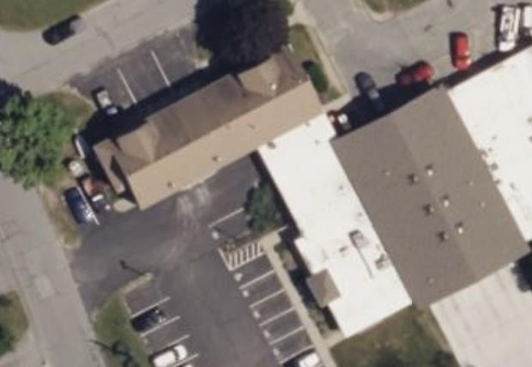

**Rooftop air handling units (arrows)**

**Picture 2**

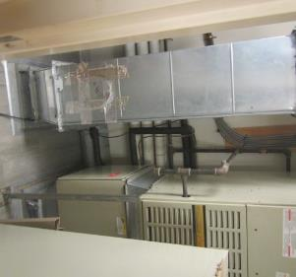

**Air handling unit in mechanical room**

**Picture 3**

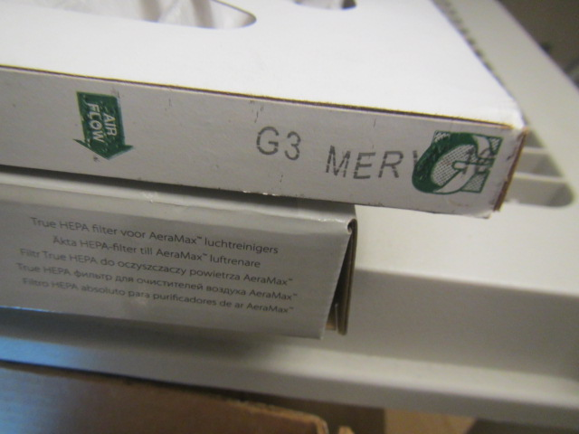

**Close-up of pleated MERV 10 filter for air handling units**

**Picture 4**

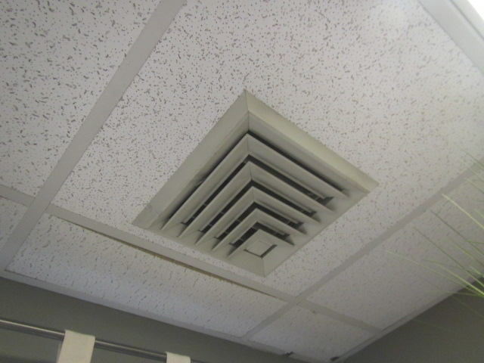

**Multi-directional supply diffuser**

**Picture 5**

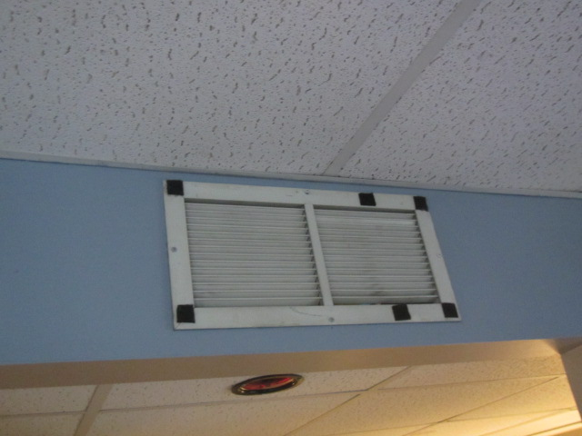

**Wall-mounted supply diffuser, note right side of vent was blocked to prevent airflow**

**Picture 6**

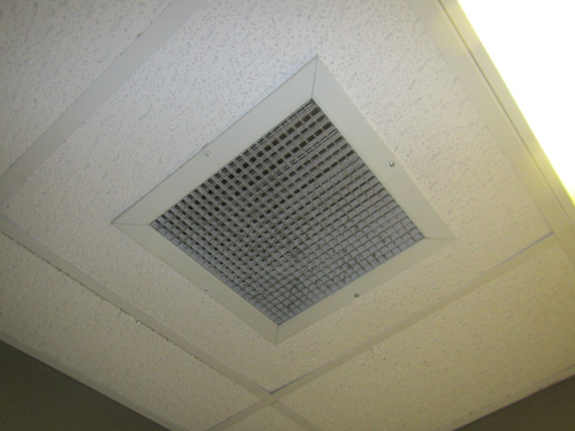

**Ceiling-mounted return/exhaust grill**

**Picture 7**

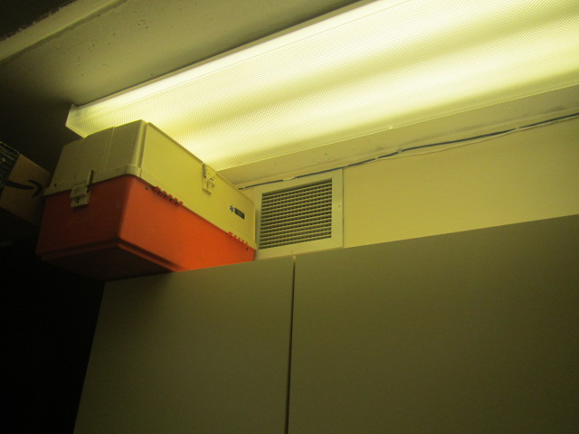

**Wall-mounted return/exhaust grill**

Water Damage and Moisture Concern Pictures

**(click to link back to report)**

**Picture 8**

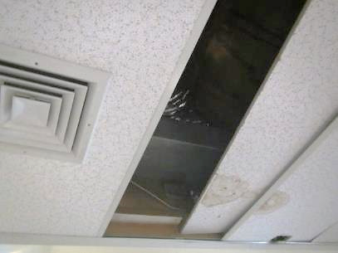

**Water-damaged ceiling tiles below metal ductwork**

**Picture 9**

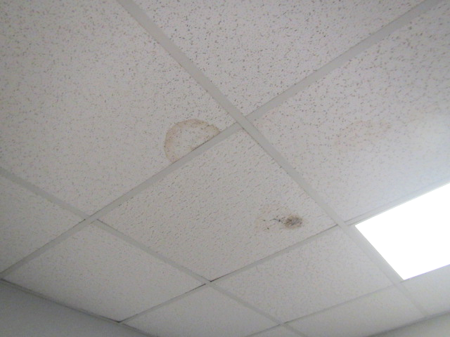

**Water-damaged ceiling tiles, dark staining indicates likely mold growth**

**Picture 10**

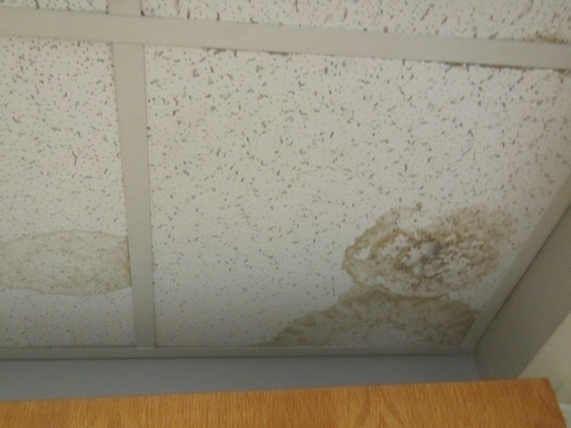

**Water-damaged ceiling tiles, dark staining indicates likely mold growth**

**Picture 11**

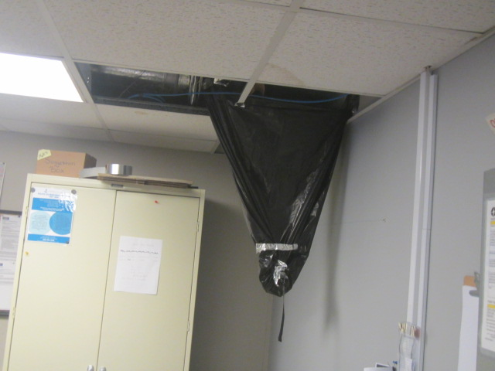

**Chronic leaks in the Squad Room are collected with a garbage bag suspended from the ceiling tile system**

**Picture 12**

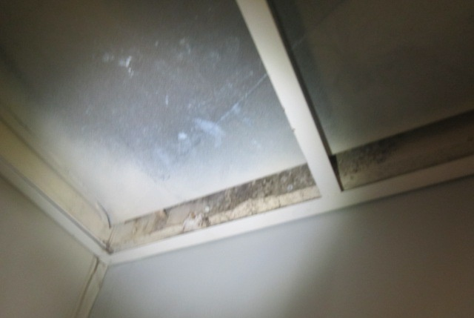

**Visible mold growth on gypsum wallboard above ceiling, in area of chronic leaks in the Squad Room**

**Picture 13**

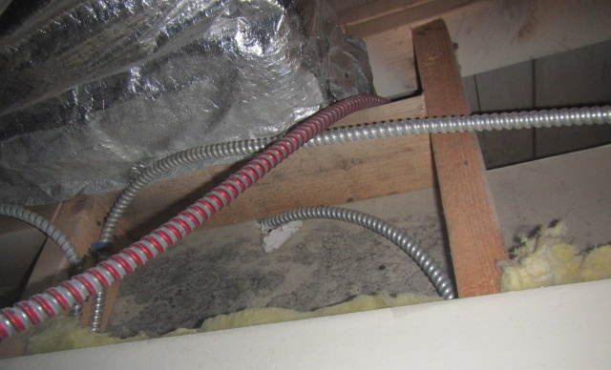

**Visible mold growth on gypsum wallboard above ceiling tiles in first floor Conference Room**

**Picture 14**

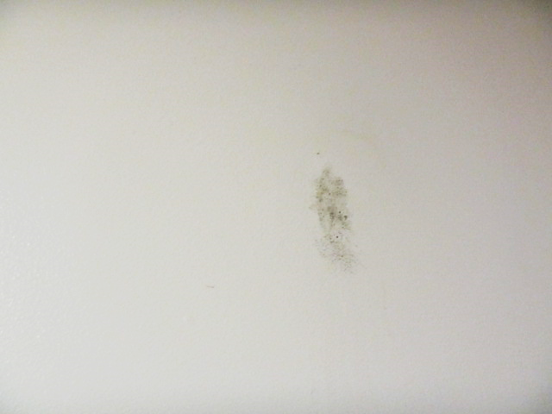

**Visible mold growth on gypsum wallboard in 1st floor bathroom**

**Picture 15**

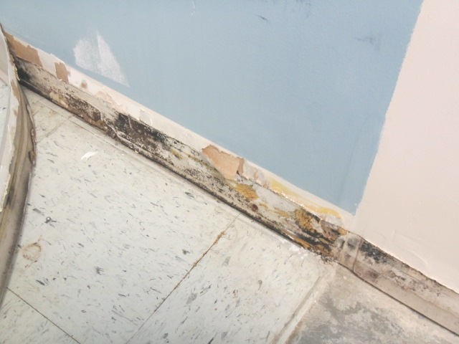

**Visible mold (dark staining) beneath coving in the basement breakroom**

**Picture 16**

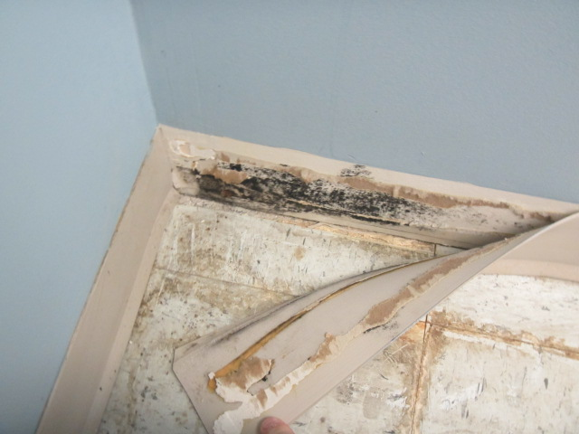

**Visible mold (dark staining) beneath coving in the basement breakroom**

**Picture 17**

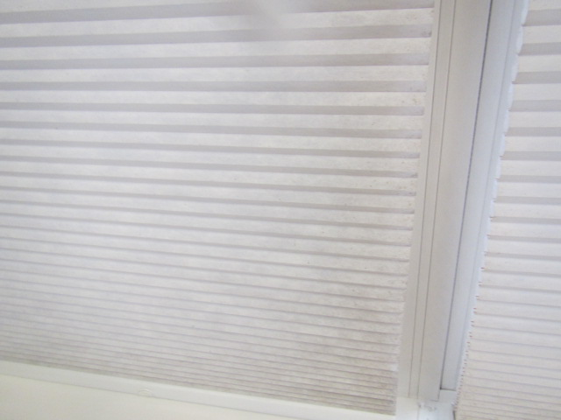

**Fabric blinds that are colonized with mold**

**Picture 18**

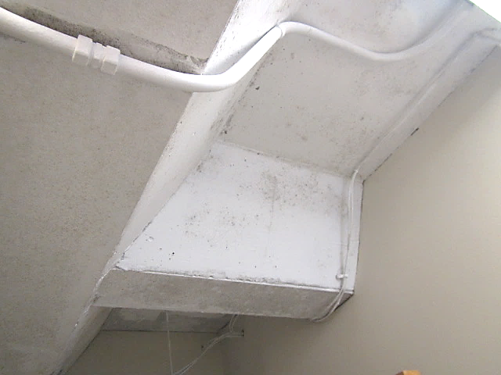

**Visible mold growth on concrete ceiling of the Armory**

**Picture 19**

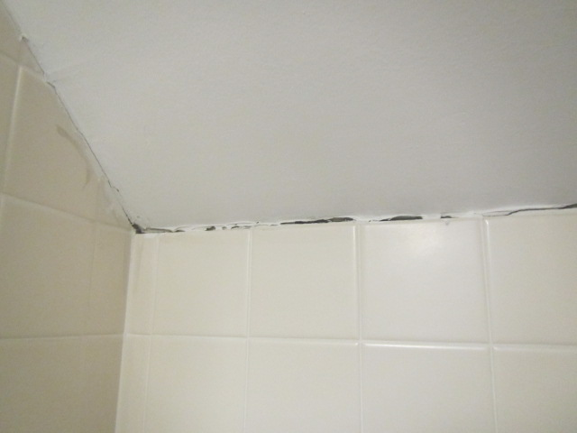

**Missing/damaged caulking along the women’s locker room/bathroom wall**

**Picture 20**

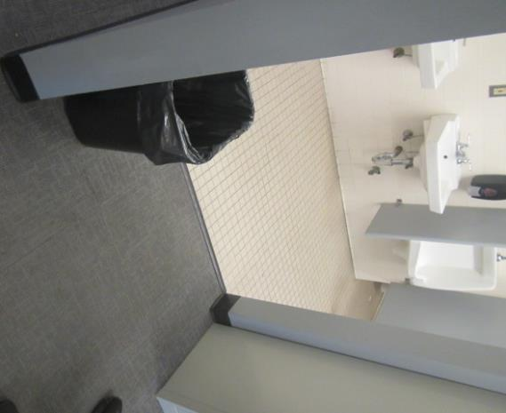

**Carpeting in close proximity to bathroom**

**Picture 21**

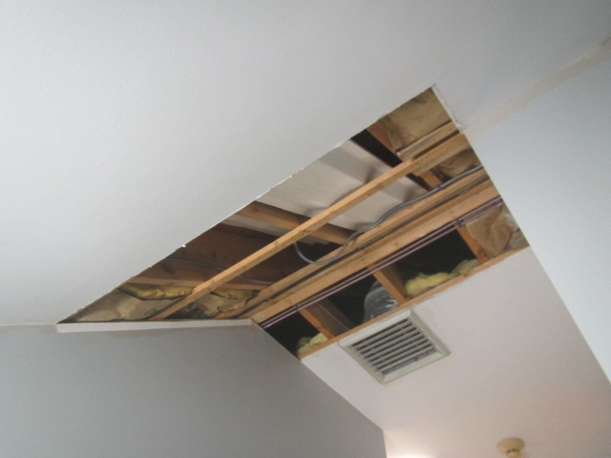

**Gypsum wallboard ceiling removed due to chronic leaks, note exposed fiberglass insulation**

**Picture 22**

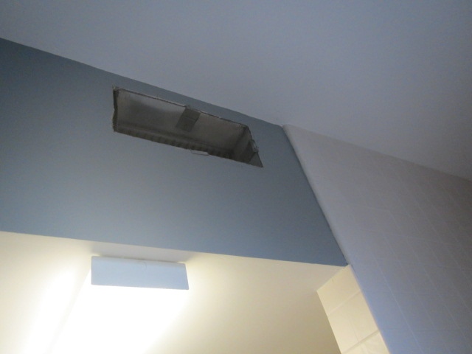

**Exhaust vent (missing a grill) in men’s locker room**

**Picture 23**

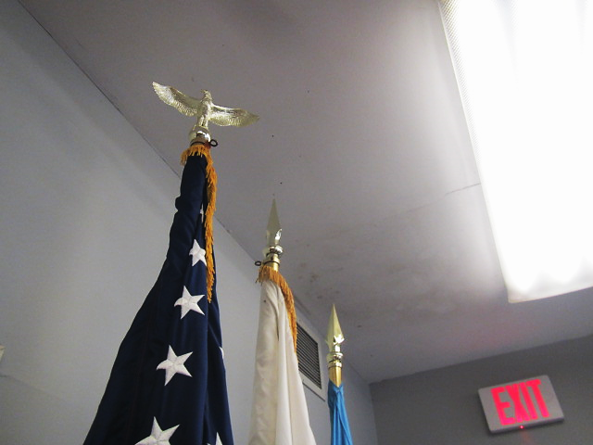

**Stained area of Meeting Room ceiling reported to have chronic moisture/mold issues**

**Picture 24**

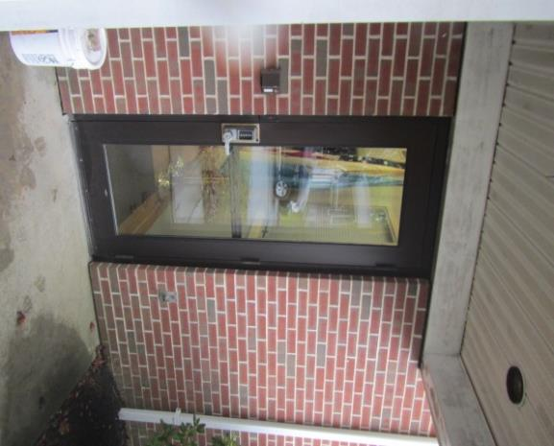

**Loose-fitting exterior door outside of Meeting Room**

**Picture 25**

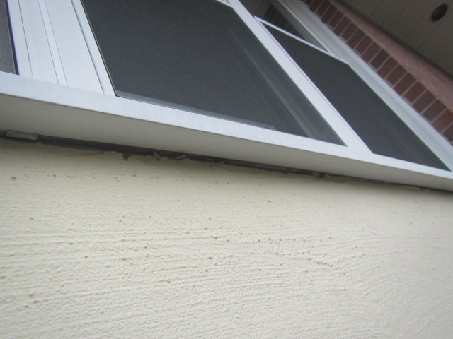

**Missing/damaged caulking around window frames**

**Picture 26**

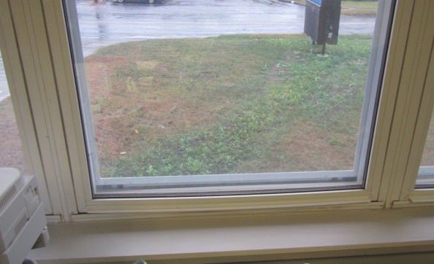

**Warped window frames, note curvature along bottom and gaps/spaces in the corners**

**Picture 27**

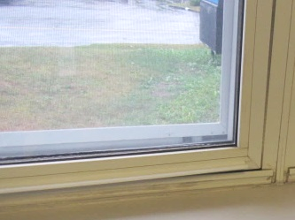

**Gaps in corner of windows (arrow) due to warped window frames**

**Picture 28**

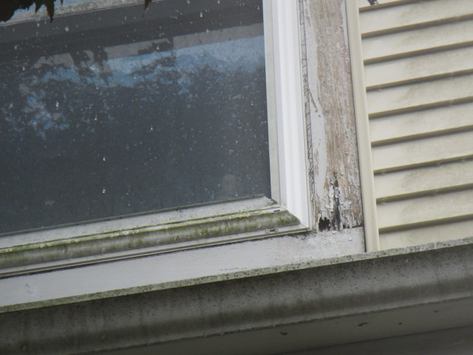

**Rotted exterior window frame**

**Picture 29**

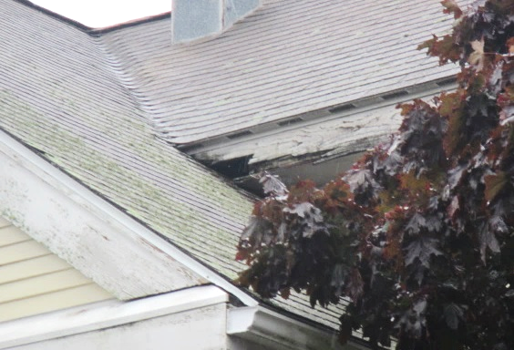

**Rotted/delaminating wood along roof**

**Picture 30**

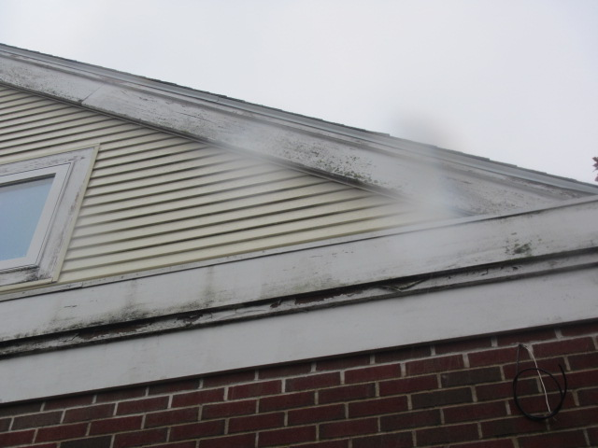

**Damaged/delaminating wood along roof**

**Picture 31**

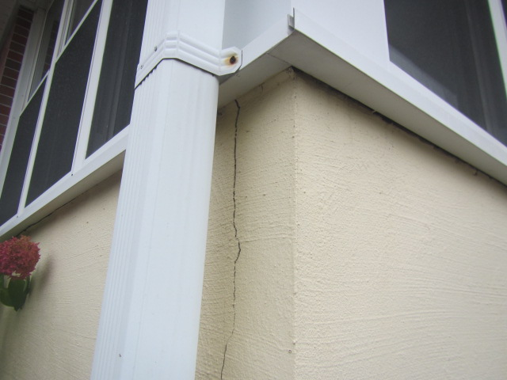

**Crack in concrete foundation**

**Picture 32**

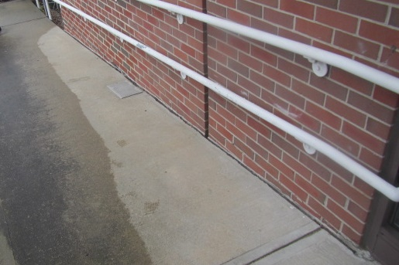

**Missing sealant/spaces between handicapped ramp and exterior wall**

**Picture 33**

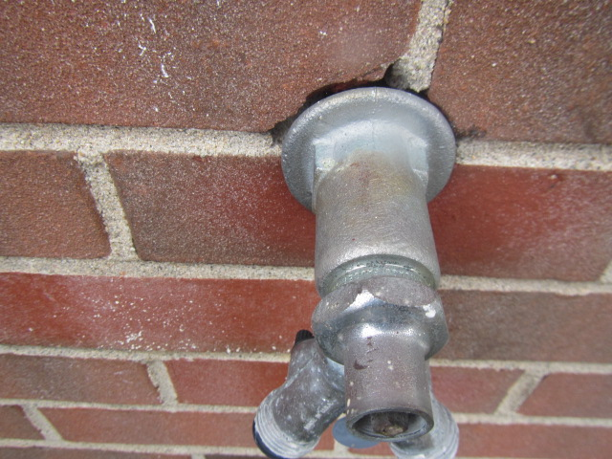

**Spaces around utility pipe**

**Picture 34**

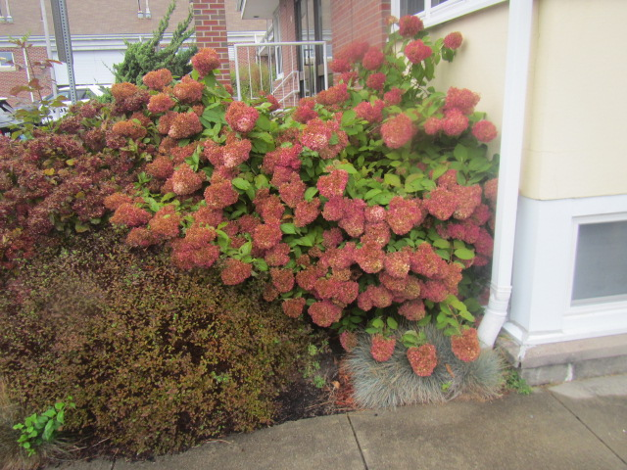

**Plants/shrubbery against exterior wall**

**Picture 35**

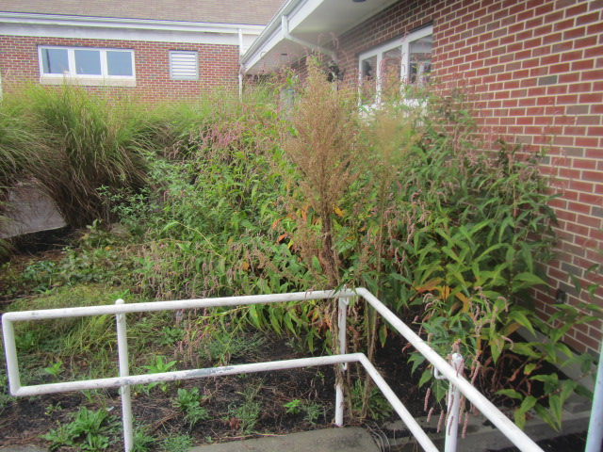

**Plants/shrubbery against exterior wall**

**Picture 36**

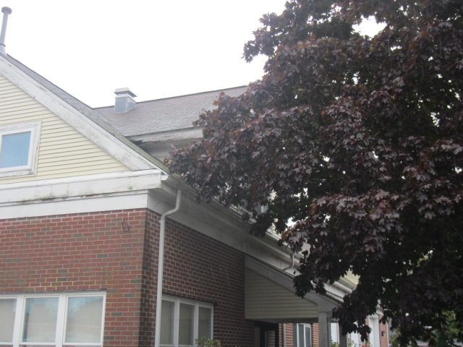

**Trees/branches overhanging roof**

Sources of Respiratory Irritant Pictures

(Click to link back to report)

**Picture 37**

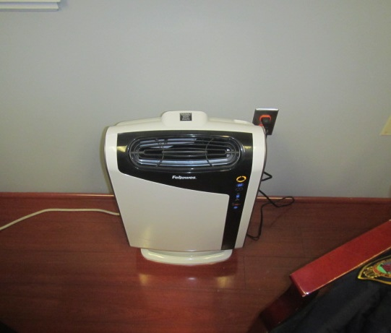

**Air purifier**

**Picture 38**

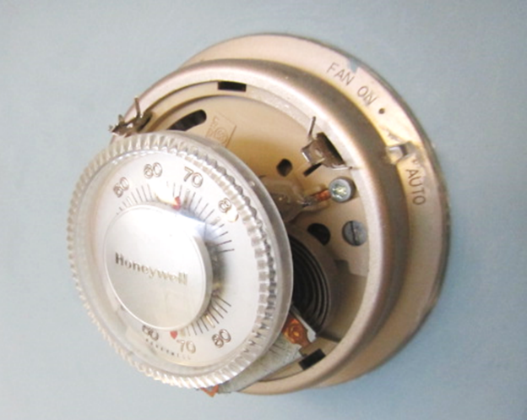

**Vintage thermostat containing mercury ampoule (arrow)**



| Table 1 **Location** | **Carbon**  **Dioxide**  **(ppm)** | **Carbon Monoxide**  **(ppm)** | **Temp**  **(°F)** | **Relative**  **Humidity**  **(%)** | **PM2.5**  **(µg/m3)** | **Occupants**  **in Room** | **Windows**  **Openable** | **Ventilation** | | **Remarks** |
| --- | --- | --- | --- | --- | --- | --- | --- | --- | --- | --- |
| **Supply** | **Exhaust** |
| Background (outside) | 420 | ND | 65 | 89 | 1 |  |  |  |  | Windy with intermittent rain |
| Armory | 739 | ND | 69 | 72 | 1 | 0 | N | N | Y  Off | Visible mold on surface of concrete ceiling, exhaust off and back drafting (cool moist air) into space |
| Property Evidence | 768 | ND | 71 | 64 | 1 | 0 | N | Y  Off | Y | Ventilation off, passive grill in door |
| Breakroom | 582 | ND | 70 | 66 | 1 | 0 | Y | Y |  | Vintage thermostat-mercury, visible mold growth on gypsum wallboard under vinyl coving, space under renovation |
| Detective Office | 635 | ND | 71 | 64 | 1 | 2 | Y | Y | Y | History of chronic water infiltration prior to repairs along exterior, peeling paint in corner along wall |
| 1st Floor Restroom |  | ND | 69 | 68 | 2 | 0 | N | N | Y | Visible mold on gypsum wallboard wall-wet |
| Conference Room | 599 | ND | 69 | 63 | 2 | 0 | N | Y | Y | 5 WD CTs, visible mold on gypsum wallboard above ceiling |
| Captain Office | 660 | ND | 67 | 66 | 1 | 1 | Y | Y | Y | Window frames warped/gaps in corners – uncontrolled drafts & moisture, 2 WD CTs (visible mold) |
| Lt. Sobral Office | 604 | ND | 66 | 66 | ND | 0 |  | Y | N | Thermostat Fan-auto, air purifier |
| Chief Office | 545 | ND | 68 | 67 | ND | 0 | Y | Y | Y | Air purifier, WD CT |
| Dispatch | 627 | ND | 69 | 64 | 1 | 1 | Y | Y | Y | Supply vent partially blocked, dusty vents, portable AC unit, condensation reported on vents |
| Chief Admin | 619 | ND | 71 | 63 | 2 | 0 | Y | Y | Y | Dusty vents |
| Squad Room | 610 | ND | 70 | 63 | 1 | 2 | N | Y | Y | Chronic leaks collected with garbage bag suspended from CT system, visible mold on gypsum wallboard above CTs/next to metal duct, missing and WD CTs – visible mold growth in corner |
| Meeting Room | 499 | ND | 66 | 83 | 2 | 0 | Y | Y | Y | Chronic issues with surface mold on ceiling near exterior door – loose/drafts, dehumidifier (full), wall reportedly repaired from previous water damage/mold growth |
| Stairwell Locker Room |  |  |  |  |  |  |  |  |  | Chronic leaks, gypsum wallboard ceiling removed to allow water to collect on floor to mop |
| Men’s Locker Room | 583 | ND | 68 | 73 | 1 | 0 | Y | Y | Y | Windows reportedly difficult to open/damaged, carpet squares near bathroom, no shower vent near shower |
| Female Locker Room | 513 | ND | 68 | 76 | 1 | 0 | N | Y | Y | Missing/damaged caulking along tile wall, no shower vent |
| Weight Room | 571 | ND | 62 | 61 | ND | 1 | N | Y | Y | 8 WD CTs, wall to wall carpet, thermostat set to 60⁰ |

(Click to link back to report)

# Table 2A

|  |  |  |  |  |  |
| --- | --- | --- | --- | --- | --- |
| **Equipment Present in Building**  **(X = Yes)** | **Type of Heating/Cooling Ventilation**  **Equipment** | **Fresh**  **Air**  **Supply**  **(X = Yes)** | **Type of Location(s)** | **Air Filters Installed**  **MERV Rating**  **(1-15, U*)**  **(X = Yes)** | **Comments** |
|  | Univents |  |  |  |  |
| X | Rooftop Air Handling Units | X |  |  |  |
|  | Outdoor, Ground-Installed Air Handling Units |  |  |  |  |
|  | Attic/Crawlspace Air Handling Units |  |  |  |  |
|  | Ceiling-Mounted Air Handling Units (including inside plenum) |  |  |  |  |
|  | Basement/Crawlspace-Installed Air Handling Units |  |  |  |  |
| X | Mechanical Room-installed Air Handling Units | X |  |  |  |
|  | Fan Coil Units |  |  |  |  |
|  | Window-Mounted Air Conditioners |  |  |  |  |
|  | Wall Louver-Controlled Gravity Air Supply |  |  |  |  |
| X | Windows |  |  |  |  |
|  | Fan in window (blowing in) |  |  |  |  |
|  | Built in wall fan (switched) |  |  |  |  |
|  | Heat recovery ventilator unit |  |  |  |  |
|  | Energy recovery ventilator unit |  |  |  |  |
|  | Chilled Beam |  |  |  |  |
|  | Passive combustion supply vent in basement/boiler room |  |  |  |  |

*U = Filter Rating underdetermined due to inaccessibility during building visit

(Click to link back to report)

# Table 2B

|  |  |  |  |  |
| --- | --- | --- | --- | --- |
| **Equipment Present in Building**  **(X = Yes)** | **Type of Exhaust Ventilation**  **Equipment** | **Ducted**  **To Outdoors**  **(X = Yes)** | **Type of Location(s)** | **Comments** |
|  | Rooftop Motors/Fans |  |  |  |
|  | Unit Exhaust |  |  |  |
| X | Ceiling Return Vent |  |  |  |
|  | Ceiling Return Vent, Plenum |  |  |  |
| X | Wall Return Vent |  |  |  |
|  | Kitchen Stove Hood |  |  |  |
| X | Restroom Exhaust Vent |  |  |  |
|  | Photocopier Exhaust Vent |  |  |  |
|  | Garage |  |  |  |
|  | Chemical Hood(s) |  |  |  |
|  | Locker Rooms |  |  |  |
|  | Showers |  |  |  |
|  | Lock up Cells |  |  |  |
|  | Clothes Dryers |  |  |  |
|  | Gas Water Heaters |  |  |  |
|  | Furnace-Flue to Chimney |  |  |  |
|  | Furnace/Boiler direct vent or power vent (no combustion air supply) |  |  |  |
|  | Kiln, Pottery |  |  |  |
|  | Dark Room |  |  |  |
|  | Generator Room |  |  |  |
|  | Wood Shop Dust Collector |  |  |  |
|  | Spray Paint Booths |  |  |  |
|  | Fan in window (blowing out) |  |  |  |

# Table 2C

|  |  |  |  |
| --- | --- | --- | --- |
| **Equipment Present in Building**  **(X = Yes)** | **Type of Equipment** | **Type of Location(s)** | **Comments** |
|  | Floor Fans, pedestal |  |  |
|  | Portable fans |  |  |
| X | Air Purifier (HEPA, other) | Various |  |
|  | Floor heaters, portable |  |  |
|  | Refrigerators, Cold Beverage Vending Machines |  |  |
|  | Radiator, wall-mounted |  |  |
|  | Radiator, floor-mounted |  |  |
| X | Passive vents (Wall/Door) | Property Evidence Room |  |

(Click to link back to report)

# Table 3

| **Found in Building**  **X = Yes** | **Water-Damaged Materials, Building Components or Stored Materials** | **Location** | **Visible Microbial Growth?**  **X = Yes** | **Musty odor detected?**  **X = Yes** | **Comments** |
| --- | --- | --- | --- | --- | --- |
|  | Books-other bound materials |  |  |  |  |
|  | Brick walls – broken, missing mortar |  |  |  |  |
|  | Brick walls – blocked weep holes |  |  |  |  |
|  | Cardboard boxes |  |  |  |  |
|  | Carpet tiles |  |  |  |  |
|  | Carpet - Area rugs |  |  |  |  |
| X | Carpet wall-to-wall | Locker rooms |  | X |  |
|  | Ceiling tiles - affixed directly to ceiling surface |  |  |  |  |
|  | Ceiling tiles - bowing-in suspended ceiling |  |  |  |  |
|  | Ceiling tiles - water-stained in splined ceiling |  |  |  |  |
| X | Ceiling tiles - water-stained in suspended ceiling | Various | X |  |  |
|  | Chairs - laminated |  |  |  |  |
|  | Cloth |  |  |  |  |
|  | Countertops (around sinks) |  |  |  |  |
| X | Curtains | Offices and Meeting Room | X |  |  |
| X | Dust/debris within AHU, uninvent, HVAC, chilled beam units, etc. (WD through condensation, humidity, or leaks) | Various |  |  |  |
|  | Efflorescence (i.e., mineral deposits) |  |  |  |  |
|  | Engineered woods - particleboard, plywood, Masonite |  |  |  |  |
|  | Flooring – loosened tiles |  |  |  |  |
|  | Flooring - wooden |  |  |  |  |
|  | Furniture - laminated |  |  |  |  |
|  | Furniture - upholstered |  |  |  |  |
| X | Gypsum wallboard - ceiling | Various |  |  |  |
| X | Gypsum wallboard - restroom wall | 1st Floor |  |  |  |
| X | Gypsum wallboard - interior wall | Conference and Breakroom | X |  |  |
| X | Gypsum wallboard – located on exterior wall | Breakroom |  |  |  |
|  | HVAC drain pan – lack of draining |  |  |  |  |
|  | HVAC filters |  |  |  |  |
|  | Insulation- attic (paper-backed) |  |  |  |  |
|  | Insulation - inside air handling unit |  |  |  |  |
|  | Insulation - on pipe(s) fiberglass |  |  |  |  |
|  | Insulation - on pipe(s) other/plaster-like material |  |  |  |  |
|  | Insulation - wall cavity |  |  |  |  |
|  | Insulation – ceiling plenum |  |  |  |  |
|  | Modular furniture – walls/cloth partitions |  |  |  |  |
|  | Musical instrument cases |  |  |  |  |
|  | Plaster ceilings |  |  |  |  |
|  | Plaster walls |  |  |  |  |
|  | Records/files |  |  |  |  |
|  | Refrigerator - door gasket |  |  |  |  |
|  | Refrigerator - drip pan |  |  |  |  |
|  | Refrigerator - Interior surfaces |  |  |  |  |
|  | Room divider - ceiling-mounted, sliding |  |  |  |  |
|  | Sink backsplash |  |  |  |  |
|  | Tables – laminated |  |  |  |  |
|  | Wallpaper |  |  |  |  |
| X | Wood - attic/roof materials | Exterior |  |  |  |
|  | Wood - floor joists in basement ceiling |  |  |  |  |
|  | Wood - wall framing |  |  |  |  |
| X | Wood - window sills | 2nd floor |  |  |  |
|  | Wood - window-mounted air conditioner framing |  |  |  |  |
|  | OTHER: Wooden baseboard |  |  |  |  |

WHAT ARE ENVIRONMENTAL ASTHMA TRIGGERS?

Asthma triggers are any chemical, pollutant, or allergen that can make your asthma worse. Asthma triggers can also be strong chemical smells, dust, or pets. Your asthma triggers may be different from those of other people. Not all asthma triggers affect people the same way. Environmental asthma triggers are found both indoors and outdoors. DPH link: [Asthma and Your Environment (mass.gov)](https://www.mass.gov/doc/asthma-and-your-environment-english/download)

(click to link back to report)

# Table 4

| **Condition Present**  **X = Yes** | **Possible asthma symptom-inducing environmental pollutant** | **Recommendation to reduce or eliminate the pollutant** |
| --- | --- | --- |
| X | Water Damage and/or Mold  (allergen) | Identify water source and repair to eliminate.  Clean non-porous materials.  Remove and replace porous materials susceptible to mold growth.  Perform regular water damage assessments as a tool to ensure timely mitigation as needed.  Use NIOSH water damage assessment protocol as a guide: [NIOSH water damage assessment guideline](https://www.cdc.gov/niosh/docs/2019-115/pdfs/2019-115.pdf?id=10.26616/NIOSHPUB2019115&inf_contact_key=241b5c2ed98c27d94b530dedc36f1623f651f238aa2edbb9c8b7cff03e0b16a0). |
| X | Moistening of building components during hot, humid weather (>2 days in length) (mold, allergen) | Remove materials not dried in <2 days in a manner consistent with [US EPA Mold Removal in Commercial Buildings guideline](https://www.epa.gov/mold/pdf-version-checklist-mold-remediation-mold-remediation-schools-and-commercial-buildings).  Use dehumidification in occupied basement areas and other areas with chronic dampness. |
| X | Vegetation against exterior of building (water damage-mold) | Remove all vegetation preventing building exterior drying.  Remove all vegetation capable of falling onto a building or depositing debris onto the roof. |
| X | Personal humidifiers (lack of proper maintenance)  (pollutant and allergen) | Clean and maintain properly.  Use distilled water to eliminate metal and water treatment odors.  Maintain hydration by increasing water consumption. |
|  | Drains: Floor drains, Sink drains (abandoned use)  Water bubblers (abandoned use) | If in use, pour water into drain at least twice a week.  If not in use, seal the drain with an appropriate material in accordance with Massachusetts Plumbing Code (248 CMR 10.00). |
|  | Live Animals (turtles, gerbils, birds, rabbits, etc.) | Ensure cleanliness or remove animals from the location. |
|  | Improperly maintained aquariums and terrariums (allergen) | Maintain such equipment properly to eliminate odor.  Discontinue use. |
|  | Plants and flowers  (allergen and mold) | Keep indoor plants well maintained and not overwatered. Monitor for signs of mold and pests.  Ensure water for cut flowers does not become stagnant.  Ensure dried plant material is free of odors, mold, and pests and handled carefully  If asthma risks are high, eliminate plants and flowers. |
| X | HVAC system moisture issues  (mold, allergen) | Consult ASHRAE’s minimum standards for HVAC maintenance and inspection of commercial HVAC systems (<https://www.ashrae.org/technical-resources/bookstore/standards-180-and-211>). |
|  | HVAC system contaminant issues (allergen) | Consult ASHRAE’s minimum standards for HVAC maintenance and inspection of commercial HVAC systems (<https://www.ashrae.org/technical-resources/bookstore/standards-180-and-211>). |
|  | Indoor swimming pool odors outside of swimming pool (mold, chemical) | Maintain and operate pool HVAC systems to vent odors from building.  Ensure locker room exhaust vents are operating during building hours.  All doors leading to pool should be rendered airtight and be closed. |
|  | Pollen (allergen) | Recommend installation of MERV 8 or better filters if HVAC engineer confirms HVAC system can be so equipped without adversely affecting function.  Cut grass after hours.  Cut grass in a pattern to direct clippings away from exterior wall.  Remove trees and shrubs from in front of windows and air intakes. |
|  | Dry air | Maintain hydration.  Avoid overheating of air. |
|  | Dust mites  (allergen) | Recommendation to remove non-official upholstered furniture, area rugs, pillows, cushions, etc.  Cleaning with use of HEPA-filtered vacuum cleaner.  Eliminating clutter, storing items in dust and moisture-proof containers, and regularly removing dust through wet wiping. |
|  | Pests, including rodents and cockroaches  (allergen) | Use of integrated pest management guidelines, including:   * Proper disposal of food containers * Proper storage of food products in airtight containers * Elimination of use of food as art projects * Remove pest harborages/clutter * Regular monitoring for pests   [EPA IPM guideline link](https://www.epa.gov/ipm/introduction-integrated-pest-management) |
|  | Latex-containing materials | Remove tennis balls from furniture legs. |
|  | Fragrances  (chemical) | Eliminate point sources, such as:   * Plug-in air fresheners * Aroma/oil reed diffusers * Scented sprays * Discontinue use of other scented materials * Consult DPH fragrance guideline: [*Clean air is odor-free*](https://www.mass.gov/doc/clean-air-is-odor-free-removing-fragrances-to-improve-indoor-air-quality-in-schools-and-0/download) |
|  | Strong smells from /use of Chemicals (such as cleaning products)  (chemical) | Use building-issued cleaning products.  Use products in accordance with manufacturer’s instructions including dilution, application, and ventilation.  Avoid using products that are stronger than needed for the situation. |
|  | Strong odors from new building materials (carpeting/furniture)  (chemical) | Use low VOC-emitting materials.  Air out materials (outside or in unoccupied area) prior to installation. |
|  | Tobacco smoke  Secondhand Smoke  (pollutant) | Eliminate tobacco smoking.  Seal all shared wall penetrations. |
|  | Products with a strong odor such as paint, perfume, hairspray, air fresheners, bug-spray, laminators, candles, wax melters, dry erase markers and other VOC-containing products  (chemical) | If essential:   * Provide proper exhaust ventilation to eject aerosolized product directly outdoors. * Avoid/reduce use during occupied hours.   If not necessary, remove and eliminate. |
|  | Vehicle exhaust  (pollutant) | Enforce anti-idling regulations and post signs to give notice.  Relocate vehicles away from fresh air intakes.  Require cars to park face-in at building walls.  [MA anti-idling law FAQs](https://www.mass.gov/files/documents/2018/02/20/idling-faq.pdf#:~:text=The%20Massachusetts%20Anti-Idling%20Law%20The%20goal%20of%20the,sometime%20wonder%20when%20idling%20might%20be%20considered%20necessary.) |
|  | Vapors and or fumes from gas, oil, or kerosene stoves  (pollutant) | Operate stove hood when stove in use.  Install stove hood if not present.  Ensure equipment is in good working order. |
|  | Ozone (pollutant) | Eliminate use of ozone generating equipment. |
|  | Window Air Conditioners (if not properly maintained) (allergen) | Equip with proper filter and clean periodically.  Clean drip pans.  Install in window with weathertight, non-mold-growth sustaining material. |
|  | Pottery (pollutant) | Do not operate kiln during occupied hours.  Operate kiln with exhaust system activated.  Seal all seams and holes in kiln vent.  Ensure kiln exhaust discharge terminates outdoors. |
| X | Carpeting (allergen) | Clean carpeting in a manner consistent with IICRC standards, including regular vacuuming with a high efficiency particulate air (HEPA) filtered vacuum in combination with annual cleaning or semi-annual cleaning in soiled high traffic areas. |
|  | Sweeping/dusting vs HEPA vacuuming/wet wiping  (allergen or pollutant) | Refrain from using feather dusters or brooms.  Utilize HEPA vacuums and wet wiping to minimize aerosolizing particulate matter. |
| X | Lack of adequate air exchange/mechanical ventilation | Make repairs as necessary and ensure all HVAC system components are operating continuously when building is occupied. |
|  | Lack of local exhaust at source of pollution (vocational shop activities, kitchen exhaust hood) (all) | Recommend installation of exhaust ventilation to direct pollutants directly outdoors. |
|  | Renovating buildings while occupied  (chemical) | Use all SMACNA guidelines for Renovation While Buildings Are Occupied. For information, visit <https://www.mass.gov/service-details/construction-and-renovation-generated-pollutants-in-occupied-buildings>. |
|  | Chemistry program chemical storage  (chemical) | Repair (if needed) and operate chemical storeroom vents appropriately.  Reduce or eliminate unneeded or overstocked chemicals.  Store all chemicals in a manner to separate incompatible chemicals.  Keep chemical storerooms clean. |
| X | Photocopiers/duplicating machines | All machines should have dedicated exhaust vents or be used in a well-ventilated area. |