Massachusetts Board of Registration in Medicine

Quality & Patient Safety Division

Fall 2024

*Spotlight on Quality & Patient Safety* is issued by the Massachusetts Board of Registration in Medicine Quality & Patient Safety Division (QPSD) to share aggregate Safety and Quality Review (SQR) report data and to share performance improvement initiatives being achieved by some of the hospitals, ambulatory surgery centers, and ambulatory clinics in the Commonwealth. The QPSD would like to thank Beth Israel Deaconess Medical Center and Cambridge Health Alliance for their contributions to this issue of *Spotlight*.

As part of regulatory reporting, healthcare organizations submit events of unexpected patient outcomes (SQR reports) to the QPSD. The first graph represents a breakdown of the major categories reported via SQR submissions. There were 391 SQR reports submitted in Q 1-3 CY 2024. Within those 391 SQR reports, 475 events were reported. This is because some reports included more than one event. Additional data related to the most common categories is also provided. Please note the alert on page three regarding trends observed related to central line insertion reported events.

Spotlight on Quality & Patient Safety

The Massachusetts Board of Registration in Medicine Quality & Patient Safety Committee hosted a Quality & Patient Safety Conference in September. The theme of the conference was peer review. Attendees of the conference represented over 100 healthcare organizations and represented 13 of the 14 counties of the Commonwealth. Please refer to pages seven and eight for photographs of the event. The QPSD thanks UMass Memorial Medical Center for providing a beautiful and centrally located venue. We also express our appreciation to the presenters and to the participants who attended the all-day conference.

# Events Reported via SQR Submissons by Major Category

**51**

**47**

**43**

Jan-Sept 2024

475 events submitted in 391 reports

Q1 Q2 Q3

**8**

**10 10**

**13**

**18**

**17**

**32**

**21**

**29**

**18**

**10**

Number of events

**7 3**

**9**

**12**

**51 6 3**

**10 12**

**10**

**22**

**6**

**9**

**2**

**5 5**

**4 5 1 2 0**

**00 1**

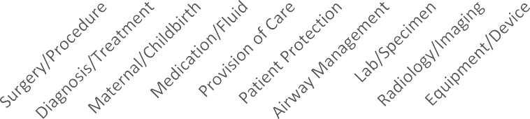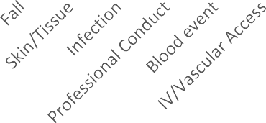

**QPSD Mission is to assist Massachusetts healthcare facilities in maintaining and improving systems for patient care that are evidence and team based, sustainable, safe, and inclusive. We achieve this by reviewing data, listening, collaborating, and educating teams in healthcare facilities throughout the state.**

# Surgery/Procedure Events

Jan-Sept 2024 n=141

Q1 Q2 Q3

15

5

11

5

3

5

4

9

10

10

3

5

9

Number of events

3

11

4

2

2

1

4

4

3 0 01 1 1

01 1 1 1 1 01

21

# Maternal/Childbirth Events

Jan- Sept 2024 n=50

**3 3**

**3**

**4**

**3**

**3**

## Q1 Q2 Q3

Number of events

**1**

**1**

|  |  |  |
| --- | --- | --- |
| **1** |  | |
| **1** | **1** | **1** |
| **1** | **1** | **1** |

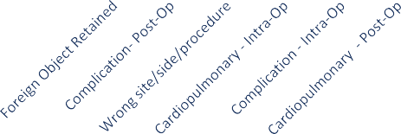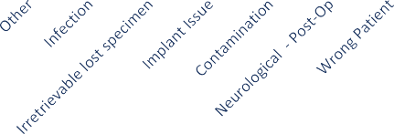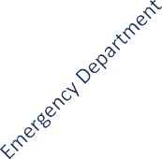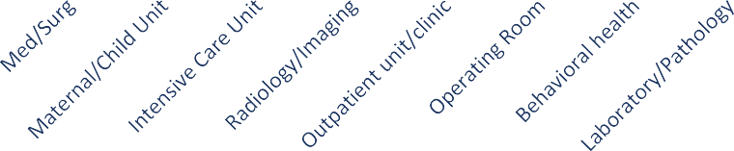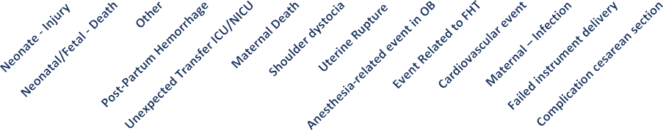

Location of Reported Delays in Diagnosis/Treatment

Jan-Sept 2024 n=64

**20**

**13**

**8**

**6**

**6**

**5**

**4**

Number of events

**2 |** P a g e

**1**

**1**

**2**

**2**

**1 1**

**2**

**2**

**3**

**2**

**2**

**1 1**

**0 1**

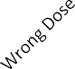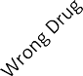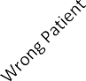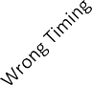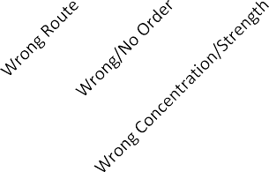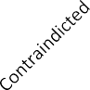

Medication/Fluid Events

Jan-Sept 2024 n=45

8

Q1 Q2 Q3

6

5

3

3

2

2

2

2

3

1

1

1

2

1

2

1

Provision of Care Events by Location

Jan-Sept 2024 n=31

These events include unexpected transfer to a higher level of care and unexpected death

**3% 3%**

**6%**

Outpatient unit/clinic

**39%**

**13%**

**16%**

**16%**

Med/Surg Unit

Behavioral Health Unit Emergency Department ICU

Operating Room Endoscopy

L&D

Number of Events

**3 |** P a g e

## Patient Safety Alert:

The QPSD has received several reports of events involving central line insertions. These events are occurring in interventional areas and at the bedside. The events include:

* Retained foreign objects: guidewires
* Wrong site procedure: lines inserted into an artery instead of a vein, when the error was not corrected before the line was utilized.
* Complications: neurologic injury, arterial injury, pneumothorax, tracheal injury, and perforation of adjacent structures.

Recommendations:

* Utilize line insertion checklist. Consider audit of checklists.
* Standardize the use of ultrasound for vessel localization and guiding the needle to its intended venous location.
* Reinforce maintaining hold of the guidewire while it is inside the patient.
* Announce ‘Guidewire is out” when it has been completely removed.
* Utilize a standardized equipment set for insertion and an appropriately stocked line cart.
* Select the smallest size catheter appropriate for the clinical situation.
* Ensure the post insertion CXR is completed, and the results are communicated and documented BEFORE use.
* Consider the implementation of central venous access line teams if possible. Resources:

Agency for Healthcare Research and Quality. Central Line Insertion Care Team Checklist. [Central Line Insertion Care Team Checklist |](https://www.ahrq.gov/hai/patient-safety-resources/cli-checklist/index.html) [Agency for Healthcare Research and Quality (ahrq.gov)](https://www.ahrq.gov/hai/patient-safety-resources/cli-checklist/index.html)

Kolikof J, Peterson K, Baker AM. Central Venous Catheter. [Updated 2023 Jul 26]. In: StatPearls [Internet]. Treasure Island (FL): StatPearls Publishing; 2024 Jan-. Available from: https://[www.ncbi.nlm.nih.gov/books/NBK557798/](http://www.ncbi.nlm.nih.gov/books/NBK557798/) [Central Venous Catheter - StatPearls -](https://www.ncbi.nlm.nih.gov/books/NBK557798/) [NCBI Bookshelf (nih.gov)](https://www.ncbi.nlm.nih.gov/books/NBK557798/)

Practice Guidelines for Central Venous Access 2020: An Updated Report by the American Society of Anesthesiologists Task Force on Central Venous Access. *Anesthesiology* 2020; 132:8–43 doi: <https://doi.org/10.1097/ALN.0000000000002864>

# SPOTLIGHT: Beth Israel Deaconess Medical Center

### Putting the Action in RCA2: An Analysis of Intervention Strength After Adverse Events

Jessica A. Zerillo MD, MPH, Senior Medical Director of Patient Safety Sarah A. Tardiff BSN, RN, Senior Project Manager of Patient Safety Dorothy Flood BSN, RN, Director, Patient Safety/Health Care Quality

Lauge Sokol-Hessner MD, CPPS, Associate Professor of Medicine, University of Washington Anthony Weiss MD, MBA, Chief Medical Officer

In the ongoing effort to improve patient safety, the article *"Putting the Action in RCA2: An Analysis of Intervention Strength After Adverse Events"* presents a critical examination of how hospitals respond to safety events through corrective actions. Conducted at Beth Israel Deaconess Medical Center (BIDMC) in Boston, MA, this study investigates the types and strengths of interventions that follow adverse events, highlighting the importance of strong, system-level changes to achieve lasting safety improvements.

Key Findings

### Strength and Completion of Corrective Actions:

* + We analyzed 67 adverse events resulting in 148 corrective actions.
  + A significant portion of these actions (56.8%) were classified as "weak" (e.g., policy changes, training), which are less likely to result in sustainable improvements. Intermediate actions (24.3%) included measures like checklists and standardized communication tools, while only 10.1% were strong interventions, such as forcing functions or standardized processes.
  + 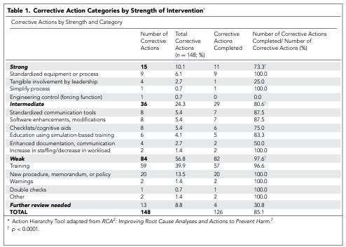There was an inverse relationship between the strength of the intervention and its completion: 97.6% of weak actions were completed, compared to 80.6% of intermediate and 73.3% of strong actions.

### Impact of Preventability:

We found that preventable events were more likely to lead to intermediate or strong corrective actions compared to non-preventable events. However, nearly half of the preventable events still did not have any intermediate or strong corrective action, indicating room for improvement in the implementation of robust solutions.

Recommendations for Providers and Hospitals

### Focus on Strong Interventions:

* + Healthcare organizations should prioritize strong interventions, such as engineering controls or system-wide changes, that are less dependent on individual compliance. These changes are more likely to prevent recurrence of adverse events.

**4 |** P a g e

### Integration of Action Strength in Follow-up:



**5 |** P a g e

* + Hospitals should incorporate the strength of corrective actions into their tracking systems. By monitoring not just the completion but also the effectiveness and strength of these actions, organizations can better address barriers to implementing robust safety solutions.

### Leadership Engagement and Resource Allocation:

* + Strong interventions often require significant resources and leadership involvement. To facilitate this, hospitals should ensure that senior leaders are aware of incomplete or weak corrective actions and are prepared to allocate the necessary resources to overcome these challenges.

Conclusions

This study highlights a critical gap in the current approach to patient safety: while hospitals are generally quick to implement corrective actions after adverse events, in part due to resource limitations and in part due to rapid timelines for external reporting, these actions are often weak and unlikely to result in long-term improvement. To make meaningful strides in patient safety, healthcare organizations must focus on stronger, more impactful interventions and ensure these are tracked and completed with the same urgency as weaker, more easily implemented solutions.

This call to action is particularly relevant for medical providers and hospital administrators in Massachusetts, where the findings of this study could serve as a model for other institutions seeking to improve their patient safety outcomes. By adopting the strategies outlined in this study, healthcare organizations can create safer environments for both patients and staff, ultimately advancing the quality of care across the state.

Spotlight on Quality & Patient Safety

Citation: Zerillo, J. A., Tardiff, S. A., Flood, D., Sokol-Hessner, L., & Weiss, A. (2024). Putting the "Action" in RCA2: An Analysis of Intervention Strength After Adverse Events. *The Joint Commission Journal on Quality and Patient Safety*, 50(7), 492–499. <https://doi.org/10.1016/j.jcjq.2024.03.012>

# SPOTLIGHT: Cambridge Health Alliance

### CHA Spotlight: Strengthening our culture of high reliability

Maren Batalden, MD MPH, Chief Quality Officer

Taruna Banerjee, MPH CPHQ CPPS, Associate Chief Quality and Patient Safety Officer

Brianne Goodwin, JD, RN, MPH, MSN, MSB, Senior Director of Risk Management and Patient Safety

The Joint Commission has long used a definition of high reliability as a three-legged stool – leaders that prioritize safety, a workforce that can and does speak up for safety, and problem-solving capacity that enables an institution to respond effectively when concerns are identified. The Cambridge Health Alliance has been working in partnership with Press Ganey Associates for the past two years with the intent of strengthening our culture of high reliability. The work began with an assessment of our culture of safety – reviewing data from staff and provider surveys, from patient safety events and patient complaints and from interviews with nearly 200 staff across the institution. Building on the literature of evidence-based high reliability institutional practices, we planned and implemented twelve hours of leader training for 350 leaders and four hours of “everybody behavior” training for our 5000 staff and providers. We stood up a tiered huddle system across the institution and introduced unit level learning boards which enable a disciplined team-based

“look back” and “look ahead,” permit regular review of key performance metrics, and invite team members to surface and commission solutions for operational and safety problems in their area. Sharing safety stories in meetings and regular leader rounding across the institution support the culture we endeavor to nurture and sustain.

Though we are still early in our journey, we are already beginning to see results:

* We have seen statistically significant improvements on staff and provider surveys in key indicators related to engagement and the culture of safety.
* The overall volume of safety event reports has remained constant this year, but near miss and good catch events are up by 12% and harm events have decreased by 33% from last year.
* Aggregate patient survey data from surveys across the enterprise show nine months of consistent improvement in patient perceptions of staff teamwork, with a 7-percentage point increase in top box scores over the previous year.

Critical to our high reliability journey and aligned with the aims of the BORIM Quality and Patient Safety Division, CHA has been working to improve our cause analysis program. CHA has had a robust reporting culture, with an average of about 8000 safety event reports filed annually. Prior to the advent of our intentional work with Press Ganey, we had developed a four-tiered system for event analysis :

* Adverse events that do not cause significant patient or staff harm are referred to clinical and operational managers for independent assessment and action.



* Adverse events that are well-described complications of hospital care such as pressure injuries, falls, and device-related infections for which formal best practice protocols have been developed are subject to a protocol-based review.

**Race**

* Adverse events resulting in intermediate level harm from processes that are not overly complex and largely contained within one clinical area are referred for apparent cause analysis; and
* Adverse events resulting in serious harm or the potential for serious harm, involving more complex process that cross boundaries between clinical areas are referred for root cause analysis and action (RCA2) by one of four dedicated multidisciplinary teams.

The different levels of analysis yield improvement action items with a clear completion date. Timely completion of action items is one of the key metrics followed by the Board Quality Committee, which serves as our Patient Care Assessment Committee.

High reliability organizations are characterized by leadership preoccupation with failure. One year ago, as a part of our high reliability journey, we began reviewing our weekly count of serious safety events at our daily huddle, giving clear leadership line of sight to safety concerns. We also convened a weekly serious safety event meeting of the senior leadership team including our Chief Medical Officer, our Chief Nursing Officer, our Chief Operating Officer, our Chief Information Officer, our Chief Human Resources Officer, and our Chief Quality Officer. All the serious safety events of the previous week are presented and assigned a level of analysis. All cases assigned to the highest level of analysis – RCA2 – also receive an executive sponsor from the senior leadership team. The executive sponsor partners with the designated patient safety/ risk manager to ensure full engagement from relevant stakeholders in the analysis and timely completion of robust action items.

Our adverse event analysis process uses a comprehensive typology of failure mechanisms to identify both systems level and individual level reasons for the failures that led to harm. Managers and leaders employ the Just Culture Algorithm to determine appropriate responses to cases in which individual errors are identified. Improvements and standardization in the processes that interrogate faulty systems have also inspired us to take action to standardize our approach to department-level provider peer review, which by design has a focus on individual provider judgements and behaviors. Our new system respects the importance of departmental physician leadership and acknowledges differences in provider practice between departments but introduces standardized processes and vocabulary across the system. A newly configured peer review form in our safety event reporting system:

* Prompts reviewers with key questions to determine when a known complication should be considered a safety event.
* Embeds the Just Culture Algorithm.
* Asks reviewers to identify the presence of systems dysfunctions that might have contributed to the outcome.
* Expects reviewers to make a formal determination as to whether the provider’s behavior was consistent

with community expectations.

* Invites reviewers to describe what actions, if any, were taken to support the provider and the provider’s

practice as a consequence of the event.

With biannual reporting to the Medical Executive Committee describing the aggregate outcomes of their departmental peer review processes, department chiefs have a new layer of peer accountability for their oversight of provider practice.

Our journey is strengthening all three legs of the Joint Commission’s high reliability stool – making it clear what leadership that puts safety first looks like, teaching staff how to speak up for safety and giving them multiple platforms for doing so, and strengthening our accountability for taking effective improvement action and solving the problems we identify.

**6 |** P a g e

**Massachusetts Board of Registration in Medicine Quality & Patient Safety Committee Fall Conference 2024**

*(l-r) Dr. Stephen Tosi, Janell Forget, Dr. Martin Reznek, and Dr. Kevin Kotkowski from UMass Memorial Health*

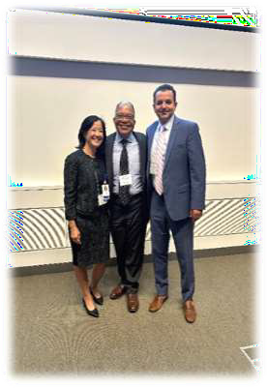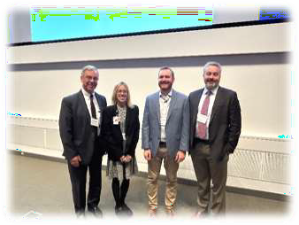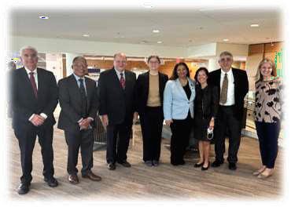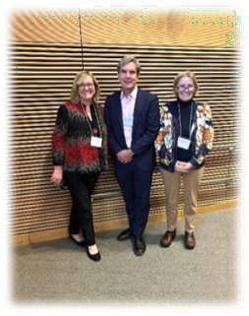

*(l-r) Dr. Yvonne Y. Cheung*, Dr. Booker T. Bush*, and BORIM Executive Director George Zachos*

*\*BORIM Quality & Patient Safety Committee member*

*(l-r)BORIM QPS Committee members Dr. Leslie Selbovitz*, Dr. Booker Bush*, Dr. Pardon Kenney*, Dr. Melissa Sundberg*, Dr. Meghna Trivedi*, Dr. Yvonne Y. Cheung*, Dr. Michael Henry*, Dr. Sarah Rae Easter\**

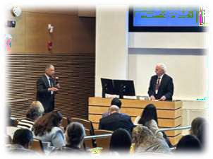

*(l-r) Dr. Booker T. Bush* and Dr. Leslie Selbovitz* as Dr. Selbovitz presents “The Teaching Principle for Medical Staff Peer Review Engagement”.*

The BORIM Quality & Patient Safety Committee held a conference on September 27, 2024 at UMass Memorial Medical Center for 250 registered participants. The theme of the conference was peer review. Participants were awarded CME credits and nursing contact hours.

**7 |** P a g e

*(l-r) Christi Barney, Dr. Barrett Kitch, and Gail Marlowe from Emerson Health*

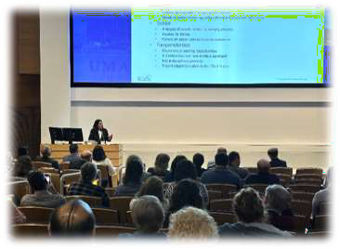

*Diane Hanley* presents “Nurse Peer Review: Principles & Practice at Boston Medical Center”*

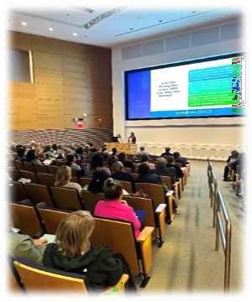*Lisa Mayo and* Jennifer Duquette present “*Enhancing Safety and Quality: Conducting an Effective Nursing Peer Review Program at Baystate Medical Center”.*

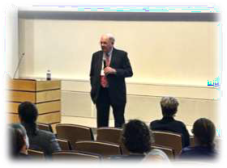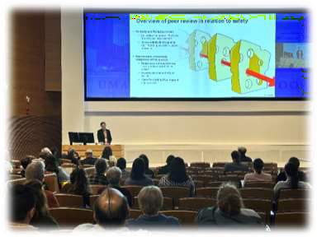

Dr. Melissa Sundberg* presents *“Pitfalls in Peer Review”.*

*Dr. Pardon R. Kenney* presents “Peer Review in Ambulatory Surgery”.*

Patient Care Assessment (PCA) program and online reporting guidance, including video tutorials, may be found at:

[Patient Care Assessment Program | Mass.gov](https://www.mass.gov/patient-care-assessment-program)

Questions and comments may be directed to

Trinh Ly-Lucas, MSN, AGNP-BC Quality Nurse Analyst

Quality & Patient Safety Division Massachusetts Board of Registration in Medicine

[trinh.ly-lucas@mass.gov](mailto:trinh.ly-lucas@mass.gov)

This issue is provided by the Board of Registration in Medicine (BORIM), Division of Quality and Patient Safety (QPSD). The issue allows BORIM to share the practices and experiences of the healthcare clinicians and facilities that report to the QPSD. It does not necessarily include a comprehensive review of literature. Publication of this issue does not constitute an endorsement by the BORIM of any practices described in the issue and none should be inferred.

**8 |** P a g e