
Massachusetts Board of Registration in Medicine
Quality & Patient Safety Division
Special Edition
2022

Fall 2025 2022

Spotlight on Quality & Patient Safety

Spotlight on Quality & Patient Safety is published by the Massachusetts Board of Registration in Medicine's Quality & Patient Safety Division (QPSD) to present aggregated data from Safety and Quality Review (SQR) reports. The QPSD and the Board’s Quality & Patient Safety (QPS) Committee are responsible for monitoring Patient Care Assessment programs at hospitals, ambulatory surgery centers, and certain ambulatory clinics throughout the Commonwealth.

Over the past two years, the Quality & Patient Safety Division (QPSD) has undergone a significant transition to online reporting. This shift has streamlined the process for healthcare organizations to submit reports, with Safety and Quality Review (SQR) reports becoming the most frequently submitted report type. SQR reports specifically focus on documenting patient safety events, allowing for a comprehensive understanding of trends and areas for improvement.

This issue of Spotlight will offer SQR aggregate data collected over the last two and a half years. This data provides insight into the patient safety events reported by healthcare organizations during this period, supporting ongoing efforts to enhance quality and safety across the Commonwealth.

Next, Spotlight will provide content from the recent Massachusetts Board of Registration in Medicine Quality & Patient Safety 2025 Conference held at UMass Memorial Medical Center (UMMMC). This event was designed to enhance education and foster transparency regarding the committee’s patient safety event review process. During the conference, the Board’s Quality & Patient Safety Committee engaged participants through role playing and active audience participation. The interactive conference provided valuable Patient Care Assessment education and allowed attendees to gain a deeper understanding of the committee’s approach to reviewing patient safety events.

The conference attracted significant interest, with over 230 physicians, nurses, and administrators from all 14 counties of the Commonwealth in attendance. It is important to note that the hospital, the SQR report, and the meeting depicted during the conference were entirely fictional. The scenario was intentionally designed with elements of humor to maintain audience engagement. In this issue, we will highlight some of the key learnings from the conference, as well as share photographs from the event.
QPSD – DATA CENTER UPDATE

Spotlight on Quality & Patient Safety

Spotlight on Quality & Patient Safety

Spotlight on Quality & Patient Safety

Spotlight on Quality & Patient Safety

Quality Patient Safety Committee - Fall Conference 2025

The audience reviewed a fictitious SQR report involving a delay in diagnosis. The audience (acting as the QPS Committee) deliberated and determined that the information provided in the SQR did not illustrate a comprehensive Patient Care Assessment Program, and therefore a meeting was in order. Using role-playing techniques, a meeting between the fictitious hospital’s leadership and the QPS Committee representatives was demonstrated. During this session, participants were asked to evaluate whether the hospital’s safety structure was sufficiently robust to identify and address both system-level and practitioner-specific issues. The audience expressed the concerns and suggestions noted on page six.
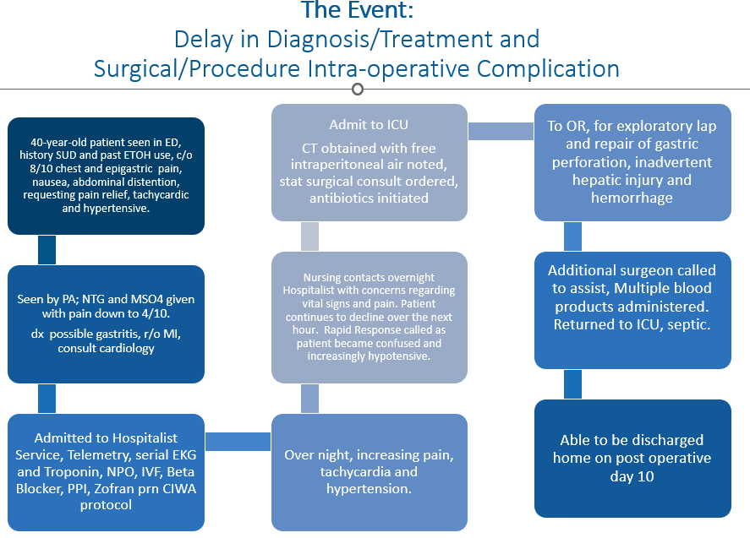

Patient Care Assessment Program Components

- Risk Management- Includes the ability to identify and respond to patient safety events.

- Quality Assurance- Includes the ability to create strong actions plans to mitigate risk of occurrence or recurrence of patient safety events and near misses. Ability to use internal incident reporting and complaint data to prioritize performance improvement activities.

- Peer Review- Demonstrates the implementation of ongoing processes to assess provider performance, skill, and judgement that utilizes provider performance/outcome metrics.

- Credentialing- Compliance with biannual requirement that incorporates peer review findings, performance metrics, and ongoing/focused professional practice evaluations.

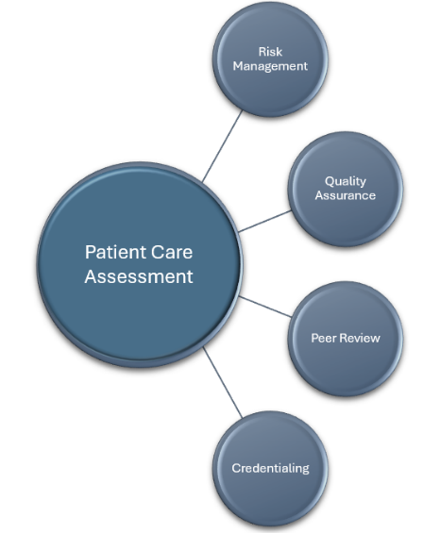

Spotlight on Quality & Patient Safety

Quality Patient Safety Committee - Fall Conference 2025
Audience concerns and suggestions:

Organizational Quality Structure of the fictitious hospital
- Flow of information throughout organization appeared siloed.
- Suggested that organization consider rebuilding the reporting structure so that information and reporting flows horizontally in addition to vertically.
- The Board did not appear to be engaged. Unclear if the organization’s board understands quality.
- Unclear if leaders understood the need for adequate resources for quality, risk, patient safety work.
Peer Review
- Inconsistent among departments. Some areas did have a process, but they were not explained.
- Nursing peer review absent in report.
- Impact on “third victim”….not included in any information submitted in SQR nor in the discussions at the site visit. No supports or resources for providers discussed.
- No system of monitoring and tracking of skills, knowledge, judgement of providers.
- No provider performance metrics were considered in review.
- Surgical complication was accepted as a “known complication” without a review of provider performance or a review for possible trends.
Systems
- There was a missed opportunity to improve systems like early warning systems, sepsis, etc.
- Physicians did not participate in the root cause analysis (RCA).
- How does this organization decide who the participants of RCA should include? Some organizations include the staff involved; others do not. It is worthwhile to ask the staff proximal to the event to participate as there is a potential wealth of information to share.
- Was the internal review process thorough? Were they asking “why”? Were the delays addressed?
- Concern re: culture of safety and communication in this organization.
- Can they do more than just education as an action plan to prevent recurrence of the event?

In considering the strength of an action plan in response to a Patient Safety event, the QPSD suggests referring to the Veterans Affairs Root Cause Analysis System: An Analysis of Adverse Events in the Rehabilitation Department: Using the Veterans Affairs Root Cause Analysis System, 2018. An Analysis of Adverse Events in the Rehabilitation Department: Using the Veterans Affairs Root Cause Analysis System - PubMed. By combining several actions of different strengths, the action plan to prevent a recurrence of a patient safety event is stronger. Some examples of action items in response to the fictitious event presented at the conference are listed below.
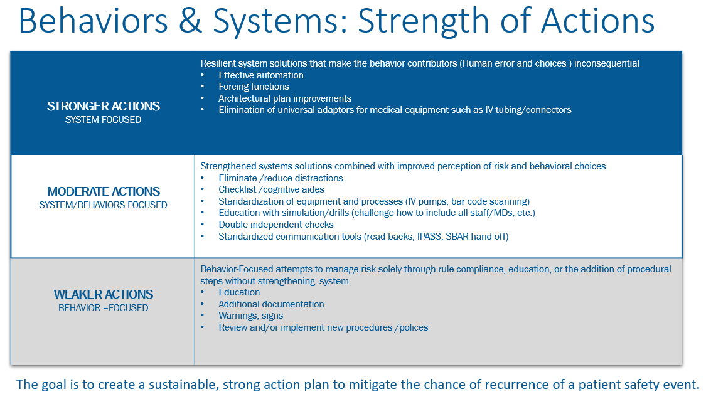

Spotlight on Quality & Patient Safety

Possible Actions:
Behavior focused (weak): Ongoing implicit bias training. Consider incorporating an “awareness pause” in decision making.
Behavior focused (weak): Educate nurses on recognition and response to changes in patient status.

Combination behavior and system focused (moderate): Create a formal orientation and ongoing learning quality assurance and Patient Care Assessment educational program for Board members.
Combination behavior and system focused (moderate): Implement a didactic and experiential learning experience by pairing diagnostic error CMEs with case studies, simulation, and collaborative learning with group discussions.
Combination behavior and system focused (moderate): Consider creating a Chairs and Chiefs Committee to support Chairs and Chiefs in the peer review process and assist with creating a process within the system for external peer review.
Combination behavior and system focused (moderate): Education and implementation of communication tool (SBAR, IPASS).
Combination behavior and system focused (moderate): Implement a fair and consistent approach/process to
peer review (see below).
Combination behavior and system focused (moderate): Create a resource program during off hours whereby the resource nurse rounds on novice nurses and reviews patient assignments and concerns OR develop a program whereby a resource nurse can identify patients in the EMR with abnormal vital signs or changes in vital signs to be able round on those patients.

System-focused (strong): Explore addition of (IT) early warning systems for sepsis and changes in vital signs to alert nurses for need for urgent further assessment and action
System-focused (strong): Force function which limits or regulates copy/paste function in EMR (electronic medical record).
System-focused (strong): Create a quality organizational structure that flows laterally as well as upward. Improve transparency by sharing information regarding patient safety events with the Board, Departments, Nursing, and Ancillary departments to promote a non-punitive culture of learning.
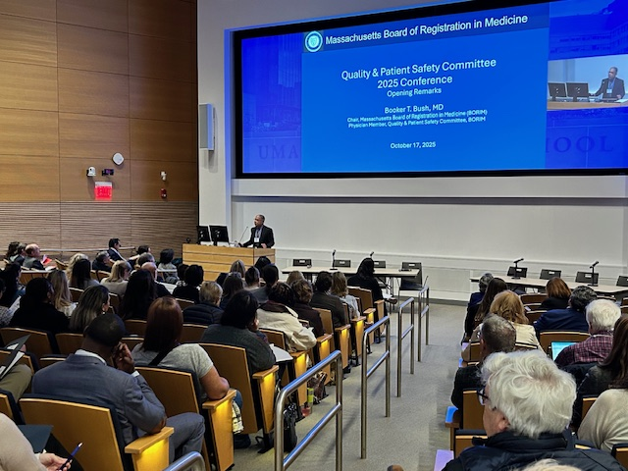
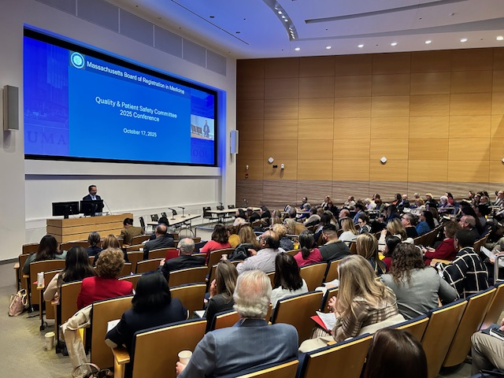
Adopt a fair and consistent approach to peer review

Peer review: A review of performance, skill, and judgement.
- Establish and document standard workflows for peer review.
- Create a fair and consistent process by
  - Standardizing the process and frequency so it is the same for all
  - Define clinical performance measures and benchmarks.
  - Include performance metrics that are outcome-based and not just fiscal-based.
  - Using internal and/or external benchmarks to compare providers to peer groups.
  - Define the methods used for collecting information (e.g., chart review, direct observation, etc.).
  - Ensure feedback to credentialed providers is consistent and respectful.
- Determine when external review would be indicated.
- Ensure tools, education, and supports are available.
- Document guidelines for how peer review is used for re-credentialing.
Spotlight on Quality & Patient Safety

Quality Patient Safety Committee - Fall Conference 2025

①

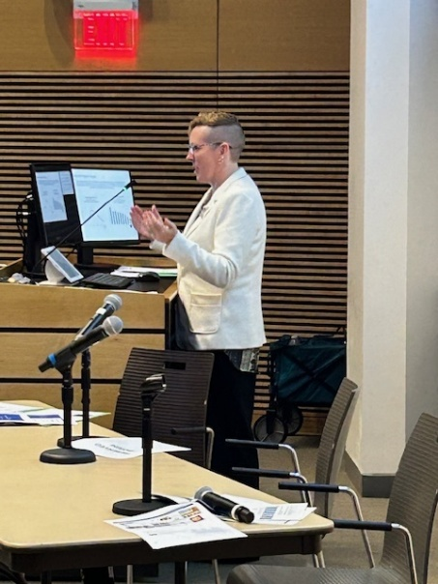
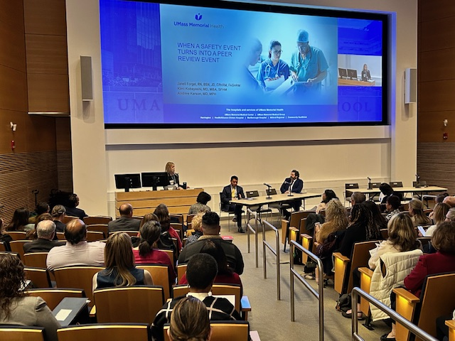
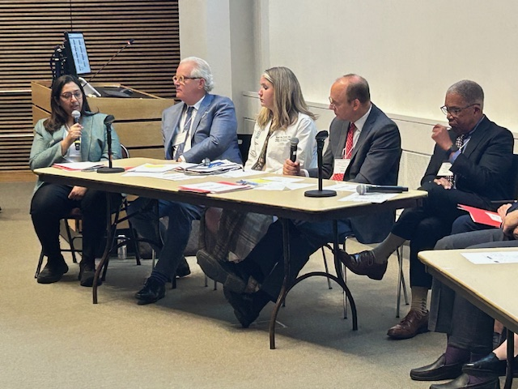

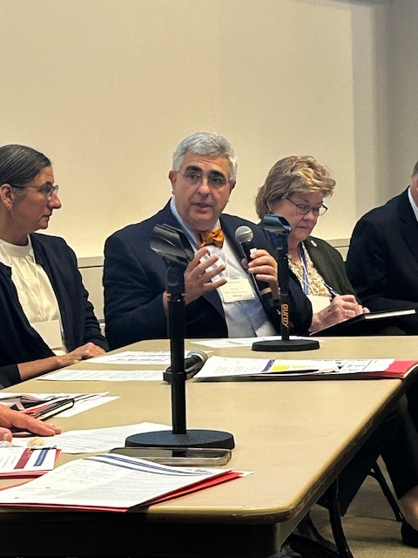

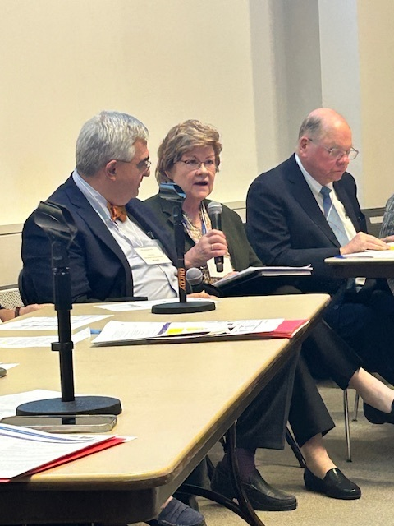
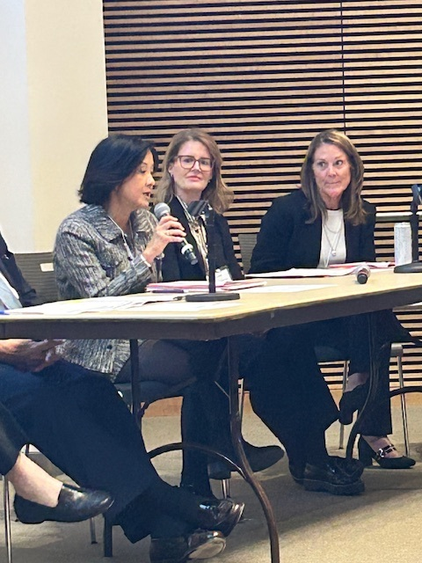
Spotlight on Quality & Patient Safety

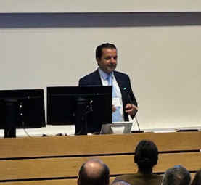
Many thanks to the following individuals that participated in the conference:

- *Booker T. Bush, MD, Chair, Massachusetts Board of Registration in Medicine (BORIM)
- *Yvonne Y. Cheung, MD, MPH, MBA, CPHQ, Chief Medical Officer, Baystate Health; Physician Member, BORIM; Chair, BORIM Quality & Patient Safety Committee
- *Carrie Arrieta, MSHM, CPHRM, Vice President, Patient and Family Relations, Mass General Brigham
- *Sarah Rae Easter, MD, Maternal Fetal Medicine & Critical Care Medicine, Brigham and Women Hospital
- Janell Forget RN, BSN, JD, CPHRM, FASHRM, Associate Vice President of Risk Management, UMass Memorial Health
- *William H. Goodman, MD, MPH, VP Medical Affairs & Ambulatory Practices, Merrimack Health
- *Diane Hanley, MSN, RN-BC, EJD, Associate Chief Nursing Officer, Nursing Education, Quality & Professional Practice, Boston Medical Center
- *Michael E. Henry, MD, Medical Director, Dauten Family Center for Bipolar Treatment Innovation, Director of Electroconvulsive Therapy (ECT), Massachusetts General Hospital
- Beth Jackson, MS, Senior Risk Manager, Tufts Medical Center
- Andrew Karson, MD, MPH, President, UMass Memorial Medical Group, and Chief Physician Executive, UMass Memorial Health
- *Pardon R. Kenney, MD, MMSc, FACS, Staff Surgeon, Brigham and Women’s Faulkner Hospital, Senior Lecturer in Surgery, Harvard Medical School
- Kimi Kobayashi, MD, MBA, SFHM, VP, Chief Medical Officer, UMass Memorial Medical Center
- Erica Ravenelle, Project Coordinator, UMass Memorial Health
- *Julian N. Robinson, MD, MBA, Obstetrics and Gynecology-Maternal-Fetal Medicine, Beth Israel Deaconess Medical Center and Winchester Hospital
- *Marc S. Rubin, MD, Chair of Surgery, Colon and Rectal Surgery, General and Gastrointestinal Surgery, Salem Hospital
- *Melissa J. Sundberg, MD, MPH, Associate Physician in Pediatrics, Division of Emergency Medicine, Boston Children’s Hospital; Physician Member, Board of Registration in Physician Assistants
- *Meghna C. Trivedi, MD, FACP, FHM, Hospital Medicine, UMass Memorial Medical Center
- George Zachos, Esq., Executive Director, Massachusetts Board of Registration in Medicine
*Member, BORIM Quality & Patient Safety Committee

Spotlight on Quality & Patient Safety

SPOTLIGHT: UMass Memorial Health
When a safety event turns into a peer review event
Janell Forget RN, BSN, JD, CPHRM, FASHRM, Associate Vice President of Risk Management
Andrew Karson, MD, MPH, President, UMass Memorial Medical Group, and Chief Physician Executive
Kimi Kobayashi, MD, MBA, SFHM, VP, Chief Medical Officer, UMass Memorial Medical Center

UMass Memorial Health provided a presentation during the conference describing their patient safety event report life cycle and peer review process. After a patient safety event is entered and reviewed by a Risk Manager, it may be presented at a safety huddle. During these safety huddles, factors such as reportability, potential review needs, and potential disclosure are discussed. The event may be referred for further leadership review.

Center for Quality and Safety Leadership Huddles
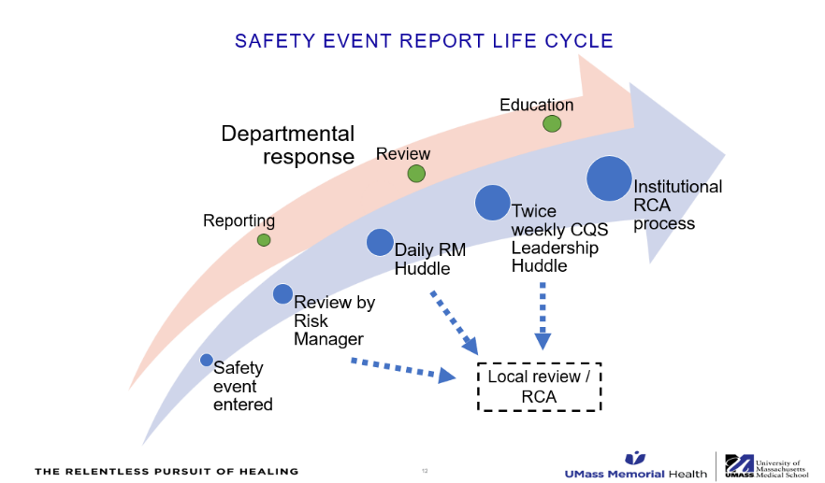

Review of a case may lead to one or more of the following:
- Continued investigation
- Decision to report case as a Serious Reportable Event (SRE) to DPH or a Safety Quality Review (SQR) report to BORIM
- Schedule Root Cause Analysis or Multi-disciplinary Review
- Send to Morbidity & Mortality (M&M) conference or Grand Rounds
- Requires potential Peer Review. This would be a decision reviewed by the Chief Medical Officer and Chair
Triggers of Peer Review
The current bylaws of UMass Memorial Medical Center define the following as triggers for a Peer Review:
- Failure to fulfill applicable standards of clinical practice, including conduct which is disruptive to the delivery of patient care, or disruptive behavior which negatively impacts the work environment for other members
- Unprofessional conduct
- Failure to comply with the bylaws, policies, procedures
- Failure to comply with regulatory standards, including BORIM
- Probation of a professional license
- Conviction of a misdemeanor indicative of poor moral or ethical behavior
- Question of performance by quality assessment

Spotlight on Quality & Patient Safety

Peer Review Goal and Process

The Peer Review findings and any Corrective Action Plan (CAP) that is developed go to our:

- Medical Executive Committee for potential approval and/or modification
- Board of Trustee’s Patient Care Assessment Committee (PCAC) for potential approval and/or modification
- At all times, patient safety is paramount, and modifications and/or restrictions to the physician’s practice will stay in effect during the process based on the Chief Medical Officer’s determination and as allowed by the institutional bylaws.

Corrective Action Plans and Follow-ups
Effective Correction Action Plans:

- Aim to address the specific quality, safety, behavioral, compliance, and/or other concerns raised through the Peer Review processes
- Are clear, actionable, and measurable
- Are well-documented with specific tracking and follow-up milestones, and with loop closure

An important consideration is that Peer Review Committee outcomes, and their associated Corrective Action Plans need to be well cataloged, stored and tracked within the institution’s infrastructure. Over time, patterns may develop, and knowledge of previous events can be instrumental in ensuring the full assessment and actions related to future events.

Medical Staff Peer Review Vs. Human Resource Pathway
Often the behaviors and actions that lead to Peer Reviews are the very same actions that lead to a physician being disruptive from a human resources point of view.
- Poor and/or disruptive communication with others
- Creating non-productive working environment
- Being non-truthful
- Being non-compliance with policies, etc.

We have deliberate discussions regarding when to go down either or both the Peer Review versus the Human Resources pathways. Considerations include:
- Is there potential risk to patient safety that can be best understood and addressed through a Peer Review Process? This consideration is especially important when there is a real chance that the physician may end up being separated from the organization, because we do not want to “kick the can” down the road to future organizations.
- Which process will get us to the most expeditious outcome? Especially when considering the appeals processes embedded in our Peer Review processes.

Human Resource investigations, deliberations, and actions are not inherently peer protected.

SAVE THE DATE
Virtual Patient Care Assessment Bootcamp
February 6th, 2026
9am-12pm

More information to come in December for users of the online reporting portal.
Spotlight on Quality & Patient Safety

Reporting Reminders

Ambulatory Surgery Centers and Ambulatory Clinics
PCA-QA Reports
(or Annual & Semi-Annual Reports)
Due by March 30, 2026

Hospitals
PCA-QA Reports
(or Annual & Semi-Annual Reports)
Due by April 30, 2026

Patient Care Assessment (PCA) program and online reporting guidance including video tutorials, examples of fictitious SQR reports, and an overview of Patient Care Assessment may be found at:
Patient Care Assessment Program | Mass.gov

Questions and comments may be directed to
Trinh Ly-Lucas, MSN, AGNP-BC
Quality Nurse Analyst

trinh.ly-lucas@mass.gov

This issue is provided by the Board of Registration in Medicine (BORIM), Division of Quality and Patient Safety (QPSD). This issue allows BORIM to share the practices and experiences of the healthcare clinicians and facilities that report to the QPSD. It does not necessarily include a comprehensive review of literature. Publication of this issue does not constitute an endorsement by the BORIM of any practices described in this issue and none should be inferred.

