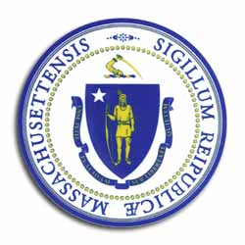
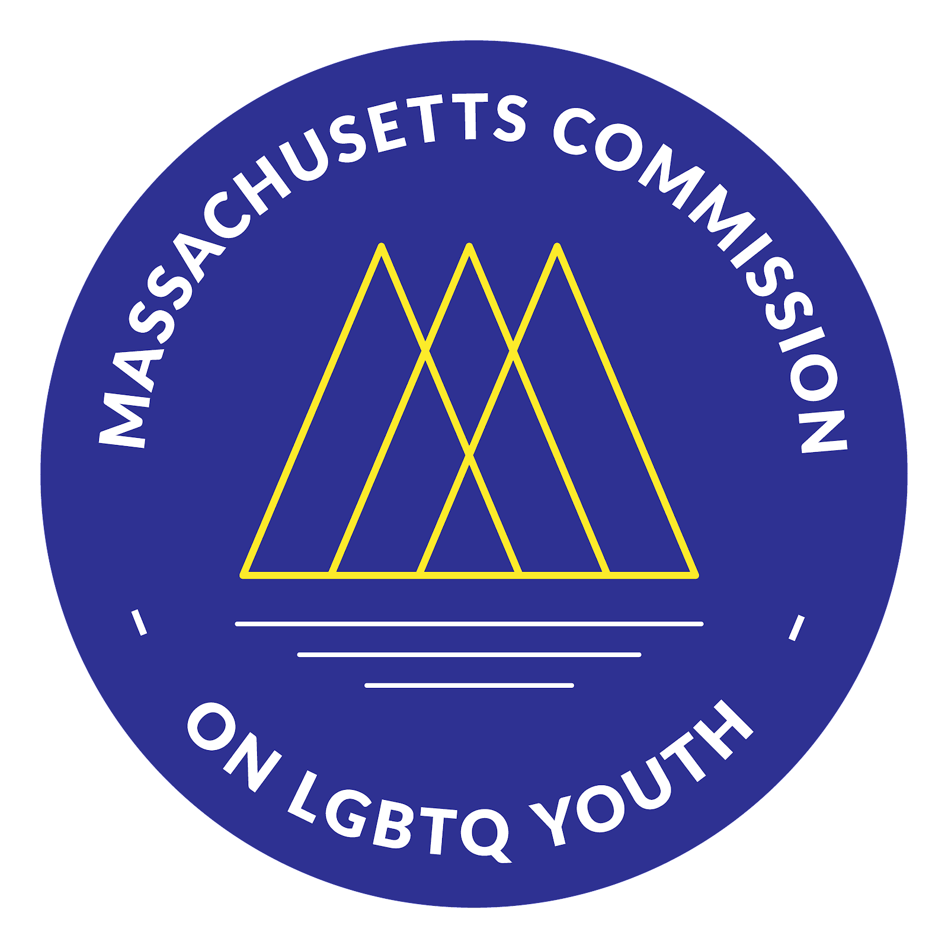
Massachusetts Commission

on LGBTQ Youth

“Working for a Commonwealth where all youth thrive”

AGENDA
2022 Fall Quarterly Full Commission Meeting
Monday, September 19, 2022 @ 6:00 pm
https://www.mass.gov/orgs/massachusetts-commission-on-lgbtq-youth

Pursuant to Chapter 20 of the Acts of 2021, this meeting will be conducted via remote participation.
https://us02web.zoom.us/meeting/register/tZ0vduuqqzwtGN2CZ-GwASOwJsmW4De9Nqos

6:00 - 6:10 pm: Welcome and Approval of Minutes Craig, Chair
- Land Acknowledgement
- Public Comment
- Approval of the Minutes (May/June)

6:10 - 6:20 pm: Introductions & Connection Time
- Icebreaker by Craig

6:20 - 7:00 pm: Executive Director Update Shaplaie, Executive Director
- GSA Summit 2022 (20 minutes)
- Strategic Planning Update (10 minutes)
- Gayla Update (10 minutes)

7:00 - 7:30 pm Committee Time Craig, Chair
- Team & Committee Activities List
- Membership (Lead: Chris)
- Safe Schools (Leads: Ashley Waterberg)
- Racial Justice Committee (Lead: Fahmina)
- Legislative Team (Lead: Braxton)
- Info Session for Members of the Public

7:30-7:50 pm Membership Conversation on Michael Cox & Charlese Horton
- Black & Pink Media Post
- https://linktr.ee/ChangeBNPMA

7:50-8:00 pm: Closing & Next Steps Craig
- Scheduling Commission Meetings for Winter & 2023 (Vote)

Members: Please share feedback on this meeting here!

All meetings, with the exception of Special Meetings for Executive Session, are open to the public.
The items listed are those reasonably anticipated by the Chair to be discussed at the meeting. Not all items may in fact be discussed and other items not listed may also be brought up for discussion to the extent permitted by law. Meetings may be recorded for live stream and/or future posting to our website.

