Background/Introduction

INDOOR AIR QUALITY ASSESSMENT

Commonwealth of Massachusetts
Department of Children and Families
1561 North Main Street
Fall River, Massachusetts

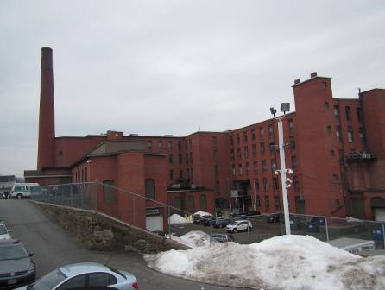

Prepared by:
Massachusetts Department of Public Health
Bureau of Environmental Health
Indoor Air Quality Program
May 2015

In response to a request by Rhett Cavicchi, Director of Labor Relations, Office of Children, Youth and Families (CYF), the Massachusetts Department of Public Health (MDPH), Bureau of Environmental Health (BEH) provided assistance and consultation regarding indoor air quality (IAQ) at the Department of Children and Families (DCF) located 1561 North Main Street, Fall River, Massachusetts. The request was prompted by general IAQ concerns among staff. On March 17, 2015 the DCF was visited by Cory Holmes and Jason Dustin, Environmental Analysts/Inspectors in BEH’s IAQ Program to conduct an IAQ assessment.
The DCF is located on the first floor of the former Narragansett Mill facility, which has been converted into multiple-unit office space in downtown Fall River. DCF has reportedly occupied the space since 1998. Ceilings consist of suspended ceiling tiles. Floors in the majority of areas are covered with wall-to-wall carpeting. Windows are openable in the building; however, staff have been instructed to keep them closed to maintain temperature/comfort conditions.

Methods
Air tests for carbon monoxide, carbon dioxide, temperature and relative humidity were conducted with the TSI, Q-Trak, IAQ Monitor, Model 7565. Air tests for airborne particle matter with a diameter less than 2.5 micrometers were taken with the TSI, DUSTTRAK™ Aerosol Monitor Model 8520. BEH/IAQ staff also performed a visual inspection of building materials for water damage and/or microbial growth.

Results
Approximately 125 employees work in the DCF portion of the building and up to 40 members of the public may visit the space on a daily basis. The tests were taken during normal operations and appear in Table 1.

Discussion

Ventilation
It can be seen from Table 1 that carbon dioxide levels were above 800 parts per million (ppm) in 45 of 69 areas, indicating a lack of air exchange in approximately two-thirds of the areas tested on the day of the assessment. It is possible that due to low outside temperatures on the day of the assessment and over the previous several weeks, fresh air supplies may have been automatically or manually restricted in order to protect piping from freezing and enable comfortable temperatures to be maintained.
Fresh air is provided by air handling units (AHUs) located around the exterior of the building (Pictures 1 and 2). The AHUs draw in fresh air, heat/cool it and duct it to ceiling-mounted supply diffusers (Picture 3). Air is drawn back into ceiling vents (Picture 4) and returned to AHUs. Additional exhaust ventilation in restrooms is provided by exhaust vents ducted directly to fans on the roof. Office ‘S’ did not have a means of supply ventilation (nor a window or ceiling vent), however it did have a return vent, which would place the office under negative pressure conditions. In order to provide a source of make-up air, the door can be undercut or a passive vent/grill can be installed.
To maximize air exchange, the MDPH recommends that both supply and exhaust ventilation operate continuously during periods of occupancy. In order to have proper ventilation with a mechanical supply and exhaust system, the systems must be balanced to provide an adequate amount of fresh air to the interior of a room while removing stale air from the room. It is recommended that HVAC systems be re-balanced every five years to ensure adequate air systems function (SMACNA, 1994). The date of the last balancing of these systems was not available at the time of the assessment.
Minimum design ventilation rates are mandated by the Massachusetts State Building Code (MSBC). Until 2011, the minimum ventilation rate in Massachusetts was higher for both occupied office spaces and general classrooms, with similar requirements for other occupied spaces (BOCA, 1993). The current version of the MSBC, promulgated in 2011 by the State Board of Building Regulations and Standards (SBBRS), adopted the 2009 International Mechanical Code (IMC) to set minimum ventilation rates. Please note that the MSBC is a minimum standard that is not health-based. At lower rates of cubic feet per minute (cfm) per occupant of fresh air, carbon dioxide levels would be expected to rise significantly. A ventilation rate of 20 cfm per occupant of fresh air provides optimal air exchange resulting in carbon dioxide levels at or below 800 ppm in the indoor environment in each area measured. MDPH recommends that carbon dioxide levels be maintained at 800 ppm or below. This is because most environmental and occupational health scientists involved with research on IAQ and health effects have documented significant increases in indoor air quality complaints and/or health effects when carbon dioxide levels rise above the MDPH guidelines of 800 ppm for schools, office buildings and other occupied spaces (Sundell et al., 2011). The ventilation must be on at all times that the room is occupied. Providing adequate fresh air ventilation with open windows and maintaining the temperature in the comfort range during the cold weather season is impractical. Mechanical ventilation is usually required to provide adequate fresh air ventilation.
Carbon dioxide is not a problem in and of itself. It is used as an indicator of the adequacy of the fresh air ventilation. As carbon dioxide levels rise, it indicates that the ventilating system is malfunctioning or the design occupancy of the room is being exceeded. When this happens, a buildup of common indoor air pollutants can occur, leading to discomfort or health complaints. The Occupational Safety and Health Administration (OSHA) standard for carbon dioxide is 5,000 parts per million parts of air (ppm). Workers may be exposed to this level for 40 hours/week, based on a time-weighted average (OSHA, 1997).
The MDPH uses a guideline of 800 ppm for publicly occupied buildings. A guideline of 600 ppm or less is preferred in schools due to the fact that the majority of occupants are young and considered to be a more sensitive population in the evaluation of environmental health status. Inadequate ventilation and/or elevated temperatures are major causes of complaints such as respiratory, eye, nose and throat irritation, lethargy and headaches. For more information concerning carbon dioxide, please see Appendix A.
Temperature readings during the assessment ranged from 70ºF to 74ºF (Table 1), which were within the MDPH recommended comfort guidelines. The MDPH recommends that indoor air temperatures be maintained in a range of 70ºF to 78ºF in order to provide for the comfort of building occupants. A number of temperature control complaints were expressed at the time of the assessment. The HVAC system is controlled by sensors located throughout the space that feed back to digital thermostats centrally-located in the computer network room (Picture 5). In order to adjust temperature, DCF management must contact the landlord/building management to adjust the system. In many cases concerning indoor air quality, fluctuations of temperature in occupied spaces are typically experienced, even in a building with an adequate fresh air supply.
The relative humidity measured during the assessment ranged from 26 to 35 percent, which was below the MDPH recommended comfort range. The MDPH recommends a comfort range of 40 to 60 percent for indoor air relative humidity. Relative humidity levels in the building would be expected to drop during the winter months due to heating. The sensation of dryness and irritation is common in a low relative humidity environment. Low relative humidity is a very common problem during the heating season in the northeast part of the United States.

Microbial/Moisture Concerns
Water-damaged ceiling tiles were observed in a few areas (Picture 6, Table 1), indicating current/historic roof leaks, plumbing leaks or other water infiltration. Water-damaged ceiling tiles can provide a source of mold and should be replaced after a water leak is discovered and repaired.
Gaps between the sink countertop and backsplash were noted in the ladies restroom and kitchen/break area (Picture 7, Table 1). Improper drainage or sink overflow can lead to water penetration of countertop wood, the cabinet interior and areas behind cabinets. Like other porous materials, if these materials become wet repeatedly they can provide a medium for mold growth.
Plants were observed in several areas (Table 1). Plants, soil and drip pans can serve as sources of mold/bacterial growth. Plants should be properly maintained, over-watering of plants should be avoided and drip pans should be inspected periodically for mold growth.
Water coolers were observed on carpet. Spills or leaks from these appliances can moisten carpeting. They should be located in a non-carpeted area or on waterproof mats.
The computer network room was equipped with a ductless air conditioning unit. These units have condensation drains that are typically pumped to the outside of the building. These units should be regularly inspected to insure that the condensation drains and pumps are working properly and are not clogged or leaking.

Other IAQ Evaluations
Indoor air quality can be negatively influenced by the presence of respiratory irritants, such as products of combustion. The process of combustion produces a number of pollutants. Common combustion emissions include carbon monoxide, carbon dioxide, water vapor, and smoke (fine airborne particle material). Of these materials, exposure to carbon monoxide and particulate matter with a diameter of 2.5 micrometers (μm) or less (PM2.5) can produce immediate, acute health effects upon exposure. To determine whether combustion products were present in the indoor environment, BEH/IAQ staff obtained measurements for carbon monoxide and PM2.5.

Carbon Monoxide
Carbon monoxide is a by-product of incomplete combustion of organic matter (e.g., gasoline, wood and tobacco). Exposure to carbon monoxide can produce immediate and acute health effects. Several air quality standards have been established to address carbon monoxide and prevent symptoms from exposure to these substances. The MDPH established a corrective action level concerning carbon monoxide in ice skating rinks that use fossil-fueled ice resurfacing equipment. If an operator of an indoor ice rink measures a carbon monoxide level over 30 ppm, taken 20 minutes after resurfacing within a rink, that operator must take actions to reduce carbon monoxide levels (MDPH, 1997).
The American Society of Heating Refrigeration and Air-Conditioning Engineers (ASHRAE) has adopted the National Ambient Air Quality Standards (NAAQS) as one set of criteria for assessing indoor air quality and monitoring of fresh air introduced by HVAC systems (ASHRAE, 1989). The NAAQS are standards established by the US EPA to protect the public health from six criteria pollutants, including carbon monoxide and particulate matter (US EPA, 2006). As recommended by ASHRAE, pollutant levels of fresh air introduced to a building should not exceed the NAAQS levels (ASHRAE, 1989). The NAAQS were adopted by reference in the Building Officials & Code Administrators (BOCA) National Mechanical Code of 1993 (BOCA, 1993), which is now an HVAC standard included in the Massachusetts State Building Code (SBBRS, 2011). According to the NAAQS, carbon monoxide levels in outdoor air should not exceed 9 ppm in an eight-hour average (US EPA, 2006).
Carbon monoxide should not be present in a typical, indoor environment. If it is present, indoor carbon monoxide levels should be less than or equal to outdoor levels. The day of the assessment, outdoor carbon monoxide concentrations were non-detect (ND) (Table 1). No measurable levels of carbon monoxide were detected in the building during the assessment (Table 1).

Particulate Matter
The US EPA has established NAAQS limits for exposure to particulate matter. Particulate matter includes airborne solids that can be irritating to the eyes, nose and throat. The NAAQS originally established exposure limits to PM with a diameter of 10 μm or less (PM10). In 1997, US EPA established a more protective standard for fine airborne particulate matter with a diameter of 2.5 μm or less (PM2.5). This more stringent PM2.5 standard requires outdoor air particle levels be maintained below 35 μg/m³ over a 24-hour average (US EPA, 2006). Although both the ASHRAE standard and BOCA Code adopted the PM10 standard for evaluating air quality, MDPH uses the more protective PM2.5 standard for evaluating airborne PM concentrations in the indoor environment.
Outdoor PM2.5 concentrations were measured at 12 μg/m³ (Table 1). PM2.5 levels indoors ranged from 7 to 15 μg/m³, which were below the NAAQS PM2.5 level of 35 μg/m³. Frequently, indoor air levels of particulate matter (including PM2.5) can be at higher levels than those measured outdoors. A number of activities that occur indoors and/or mechanical devices can generate particulate matter during normal operations. Sources of indoor airborne particulate matter may include but are not limited to particles generated during the operation of fan belts in the HVAC system, use of stoves and/or microwave ovens in kitchen areas, use of photocopiers, fax machines and computer printing devices; operation of an ordinary vacuum cleaner and heavy foot traffic indoors.

Volatile Organic Compounds
Indoor air concentrations can be greatly impacted by the use of products containing volatile organic compounds (VOCs). VOCs are carbon-containing substances that have the ability to evaporate at room temperature. Total volatile organic compounds (TVOCs) can result in eye and respiratory irritation if exposure occurs. For example chemicals evaporating from a paint can stored at room temperature would most likely contain VOCs.
Sources of TVOCs in the office area include dry erase boards and related materials (Table 1). Materials such as dry erase markers and dry erase board cleaners may contain VOCs, such as methyl isobutyl ketone, n-butyl acetate and butyl-cellusolve (Sanford, 1999), which can be irritating to the eyes, nose and throat.
Hand sanitizer and air fresheners were also observed in the space (Table 1); these products may contain ethyl alcohol and/or isopropyl alcohol, which are highly volatile and may be irritating to the eyes and nose. Sanitizing products may also contain fragrances to which some people may be sensitive. Air deodorizers contain chemicals that can be irritating to the eyes, nose and throat of sensitive individuals. Many air fresheners contain 1,4-dichlorobenzene, a VOC which may cause reductions in lung function (NIH, 2006). Furthermore, deodorizing agents do not remove materials causing odors, but rather mask odors that may be present in the area.

Other Conditions
Other conditions that can affect IAQ were observed during the assessment. In some office areas, accumulations of items were seen on floors, windowsills, tabletops, counters, bookcases and desks, which provide a source for dusts to accumulate (Picture 8). These items (e.g., papers, folders, boxes) make it difficult for custodial staff to clean. Items should be relocated and/or be cleaned periodically to avoid excessive dust build up.
Personal fans, supply and exhaust vents were found to be dusty in some areas (Picture 3, Table 1). Regular cleaning of supply diffusers, exhaust vents and personal fans will reduce aerosolizing any accumulated particulate matter on these surfaces.
Most areas of the office space were carpeted. The Institute of Inspection, Cleaning and Restoration Certification (IICRC) recommends that carpeting be cleaned annually (or semi-annually in soiled high traffic areas) (IICRC, 2012). Regular cleaning with a high efficiency particulate arrestance (HEPA) filtered vacuum in combination with an annual cleaning will help to reduce accumulation and potential aerosolization of materials from the carpeting.
Finally, food and empty soda cans were seen in some areas, crumbs/food debris was observed in appliances. Food and recycling items (i.e., cans and bottles) should be kept in tightly-sealed bags/containers to prevent attracting pests. Food preparation equipment should also be kept clean and free of debris.

Conclusions/Recommendations
In view of the findings at the time of the visit, the following recommendations are made:
- Continue to operate all ventilation systems throughout the building continuously during periods of occupancy to maximize air exchange. This would include leaving thermostat fan settings in the “on” mode (not auto) for continuous airflow.
- Work with building management/HVAC engineer to adjust/increase fresh air intake within the space and control temperatures.
- To provide a source of make-up for office ‘S’, undercut the door (~2-3 inches) or install a passive vent/grill in the door.
- Consider adopting a balancing schedule of every 5 years for all mechanical ventilation systems, as recommended by ventilation industrial standards (SMACNA, 1994).
- For buildings in New England, periods of low relative humidity during the winter are often unavoidable. Therefore, scrupulous cleaning practices should be adopted to minimize common indoor air contaminants whose irritant effects can be enhanced when the relative humidity is low. To control for dusts, a high efficiency particulate arrestance (HEPA) filter equipped vacuum cleaner in conjunction with wet wiping of all surfaces is recommended. Avoid the use of feather dusters. Drinking water during the day can help ease some symptoms associated with a dry environment (throat and sinus irritations).
- Ensure building/plumbing leaks are repaired and replace any remaining water-damaged ceiling tiles and other building materials. Disinfect areas of water leaks with an appropriate antimicrobial, as needed.
- Seal areas around sinks (e.g., restrooms, kitchen/breakrooms) to prevent water damage to the interior of cabinets and adjacent wallboard.
- Indoor plants should be properly maintained and equipped with drip pans to prevent water damage to porous building materials and be located away from ventilation sources to prevent the aerosolization of dirt, pollen or mold.
- Place water coolers/dispensers in areas without carpeting or place on a waterproof mat.
- Regularly inspect the ductless air conditioning units for proper condensation drainage.
- Use dry erase markers only in well ventilated areas. Clean dry erase boards and trays to prevent accumulation of materials.
- Reduce the use of hand sanitizing products especially those containing fragrances.
- Avoid the use of air freshener sprays, solids and diffuser reeds to avoid exposure to VOCs and fragrance compounds.
- Move items in offices periodically to allow for regular cleaning. Consider reducing the amount of items stored in offices.
- Regularly clean supply diffusers, exhaust vents and personal fans to avoid re-aerosolizing any accumulated debris.
- Continue to clean carpeting annually or semi-annually in soiled high traffic areas as per the recommendations of the Institute of Inspection, Cleaning and Restoration Certification (IICRC, 2012). Consider a schedule for replacing any worn carpeting that is beyond its service life.
- Ensure that food and recycling items (i.e., cans/bottles) are kept tightly sealed and food-preparation equipment is cleaned regularly.
- Refer to resource manuals and other related indoor air quality documents for further building-wide evaluations and advice on maintaining public buildings. Copies of these materials are located on the MDPH’s website: http://mass.gov/dph/iaq.

References
ASHRAE. 1989. Ventilation for Acceptable Indoor Air Quality. American Society of Heating, Refrigeration and Air Conditioning Engineers. ANSI/ASHRAE 62-1989.
BOCA. 1993. The BOCA National Mechanical Code/1993. 8th ed. Building Officials & Code Administrators International, Inc., Country Club Hills, IL.
IICRC. 2012. Carpet Cleaning FAQ 4 Institute of Inspection, Cleaning and Restoration Certification. Institute of Inspection Cleaning and Restoration, Vancouver, WA.
MDPH. 1997. Requirements to Maintain Air Quality in Indoor Skating Rinks (State Sanitary Code, Chapter XI). 105 CMR 675.000. Massachusetts Department of Public Health, Boston, MA.
NIH. 2006. Chemical in Many Air Fresheners May Reduce Lung Function. NIH News. National Institute of Health. July 27, 2006. http://www.nih.gov/news/pr/jul2006/niehs-27.htm
OSHA. 1997. Limits for Air Contaminants. Occupational Safety and Health Administration. Code of Federal Regulations. 29 C.F.R 1910.1000 Table Z-1-A.
Sanford. 1999. Material Safety Data Sheet (MSDS No: 198-17). Expo® Dry Erase Markers Bullet, Chisel, and Ultra Fine Tip. Sanford Corporation. Bellwood, IL.
SBBRS. 2011. Mechanical Ventilation. State Board of Building Regulations and Standards. Code of Massachusetts Regulations, 8th edition. 780 CMR 1209.0.
SMACNA. 1994. HVAC Systems Commissioning Manual. 1st ed. Sheet Metal and Air Conditioning Contractors’ National Association, Inc., Chantilly, VA.
Sundell. 2011. Sundell, J., H. Levin, W. W. Nazaroff, W. S. Cain, W. J. Fisk, D. T. Grimsrud, F. Gyntelberg, Y. Li, A. K. Persily, A. C. Pickering, J. M. Samet, J. D. Spengler, S. T. Taylor, and C. J. Weschler. Ventilation rates and health: multidisciplinary review of the scientific literature. Indoor Air, Volume 21: pp 191–204.
US EPA. 2006. National Ambient Air Quality Standards (NAAQS). US Environmental Protection Agency, Office of Air Quality Planning and Standards, Washington, DC. http://www.epa.gov/air/criteria.html.
Picture 1
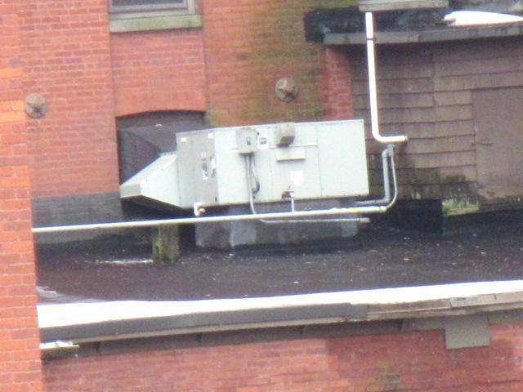
Air-handling unit
Picture 2
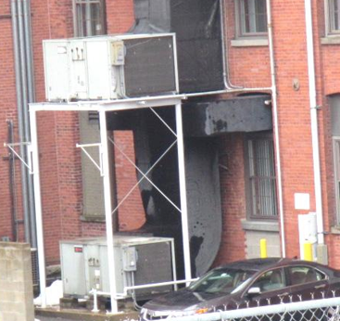
Air-handling units
Picture 3
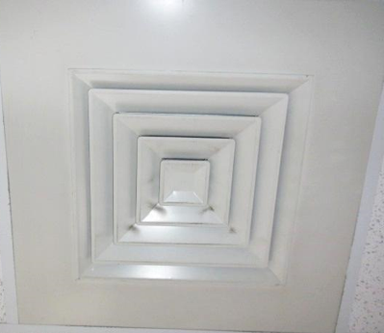
Ceiling-mounted supply diffuser, note dust/debris accumulation on vent
Picture 4
Ceiling-mounted return vent
Picture 5
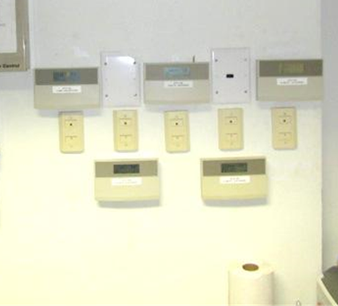
Digital thermostats for HVAC system in computer network room
Picture 6
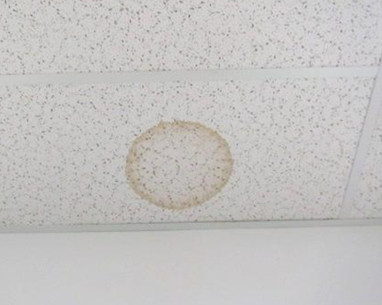
Water-damaged ceiling tile
Picture 7
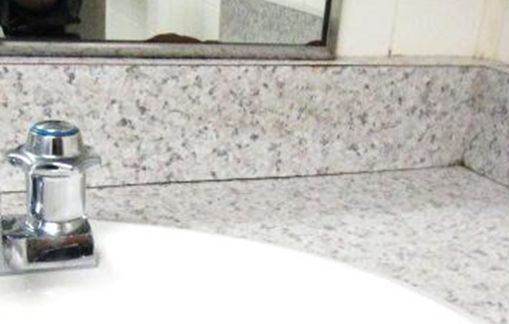
Space between sink countertop and backsplash in ladies restroom
Picture 8
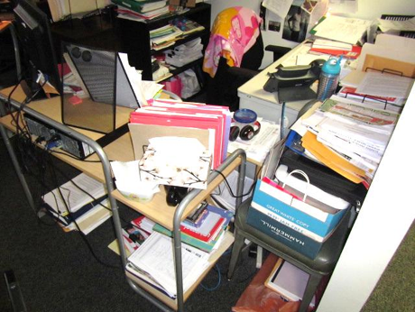
Accumulated items in work space
Location | Carbon  Dioxide  (ppm) | Carbon Monoxide  (ppm) | Temp  (°F) | Relative  Humidity  (%) | PM2.5  (µg/m³) | Occupants  in Room | Windows  Openable | Ventilation |  | Remarks
 |  |  |  |  |  |  |  | Supply | Exhaust
Background | 374 | ND | 39 | 100 | 12 |  |  |  |  | Moderate to heavy rain; winds WSW 6 to 24 mph, gusts up to 41 mph
Lobby/waiting area | 773 | ND | 72 | 30 | 10 | 1 | N | Y | Y | NC
Reception | 806 | ND | 72 | 33 | 13 | 1 | N | Y | Y | 1 WD CT
M1 | 887 | ND | 70 | 35 | 9 | 2 | Y | Y | Y
M2 | 870 | ND | 73 | 28 | 8 | 1 | Y | Y | Y | DO, HS, plants
1 | 827 | ND | 70 | 33 | 13 | 2 | Y | Y | N
2 | 860 | ND | 71 | 33 | 13 | 4 | Y | Y | Y | 1 WD CT, plant
3 | 837 | ND | 71 | 33 | 12 | 1 | Y | Y | Y | 1 WD CT (small stain)
4 | 851 | ND | 71 | 33 | 13 | 3 | Y | Y | Y | WD CT in hallway
5 | 840 | ND | 71 | 33 | 13 | 3 | Y | Y | Y | Dust/debris build up on vents
6 | 831 | ND | 71 | 32 | 13 | 3 | Y | Y | N
7 | 825 | ND | 72 | 34 | 11 | 2 | Y | Y | N | Plants
8 | 858 | ND | 73 | 33 | 11 | 2 | Y | Y | Y
9 | 866 | ND | 73 | 33 | 13 | 3 | Y | Y | Y
10 | 847 | ND | 73 | 32 | 12 | 4 | Y | Y | Y
11 | 791 | ND | 74 | 31 | 13 | 0 | Y | Y | Y
12 | 815 | ND | 74 | 32 | 13 | 3 | Y | Y | Y
13 | 790 | ND | 74 | 31 | 12 | 2 | Y | Y | N
14 | 791 | ND | 72 | 31 | 12 | 3 | Y | Y | Y | Dust and debris on vents
15 | 781 | ND | 73 | 32 | 13 | 3 | Y | Y | Y
16 | 850 | ND | 73 | 32 | 15 | 4 | Y | Y | N
17 | 859 | ND | 73 | 32 | 11 | 3 | Y | Y | Y | Dust and debris on vents
18 | 883 | ND | 73 | 32 | 11 | 3 | Y | Y | Y | Plant
19 | 861 | ND | 73 | 31 | 10 | 2 | Y | Y | Y
20 | 862 | ND | 73 | 32 | 11 | 4 | Y | Y | Y | Dust and debris on vents
C1 (conf.) | 764 | ND | 73 | 29 | 11 | 0 | N | Y | Y | DO
C2 (conf.) | 703 | ND | 73 | 30 | 10 | 0 | N | Y | Y
Clinical Family Resource | 831 | ND | 73 | 29 | 9 | 0 | Y | Y | Y
Women’s rest room (near lobby) |  |  |  |  |  |  | N | Y | Y | 1 WD CT, space between sink countertop and backsplash
Ex 1 | 820 | ND | 74 | 28 | 9 | 0 | N | Y | Y | AI
Ex 2 | 818 | ND | 73 | 28 | 8 | 0 | N | Y | Y | DEM, cut flowers
Ex 3 | 853 | ND | 73 | 28 | 7 | 0 | Y | Y | Y | HS, AF
Ex 4 | 840 | ND | 73 | 29 | 11 | 0 | Y | Y | Y | Plant
Ex 5 | 861 | ND | 73 | 30 | 10 | 4 | Y | Y | Y | DO
Ex 7 | 876 | ND | 73 | 30 | 9 | 1 | Y | Y | Y | DO
Ex 8 | 840 | ND | 73 | 30 | 10 | 0 | Y | Y | Y
Ex 9 | 844 | ND | 73 | 31 | 10 | 2 | Y | Y | Y | Dust and debris on vents, 2 WD CT
Ex 10 | 993 | ND | 74 | 32 | 9 | 2 | N | Y | Y
Ex 11 | 835 | ND | 74 | 30 | 10 | 1 | N | Y | Y
EX 12 (File) | 749 | ND | 73 | 30 | 12 | 0 | Y | Y | N | Dust and debris on vents
K1 (kitchen) | 880 | ND | 73 | 30 | 9 | 1 | N | Y | Y | DO, NC, counter seal, crumbs in appliances
Conf. room C | 904 | ND | 70 | 32 | 7 | 2 | N | Y | Y
S | 843 | ND | 71 | 31 | 9 | 0 | N | N | Y | AI, NC, PF, DO, no fresh air supply-recommend door vent or undercut
S1 | 884 | ND | 72 | 33 | 9 | 0 | N | Y | Y | UF, PF
S2 | 908 | ND | 72 | 32 | 9 | 0 | N | Y | Y | UF, AI, HS
S4 | 872 | ND | 71 | 31 | 9 | 1 | N | Y | Y | DEM, 3 WD CT
S5 | 989 | ND | 73 | 29 | 10 | 2 | N | Y | Y | Plants, HS
S6 | 886 | ND | 73 | 29 | 10 | 0 | N | Y | Y | UF, DO
S7 | 824 | ND | 73 | 28 | 7 | 0 | N | Y | Y | AF, DO, plants
S8 | 820 | ND | 73 | 30 | 10 | 1 | N | Y | N | DO, area rug
S11 | 715 | ND | 72 | 33 | 12 | 0 | N | Y | N | DO, dust and debris on vents
S12 | 772 | ND | 72 | 30 | 9 | 0 | N | Y | N
S13 | 750 | ND | 72 | 30 | 10 | 0 | N | Y | N | DO, food, empty soda cans
S14 | 728 | ND | 72 | 30 | 10 | 0 | N | Y | N | DO, plant
S15 | 710 | ND | 72 | 30 | 10 | 0 | N | Y | N | DO, UF
S16 | 834 | ND | 73 | 31 | 10 | 1 | N | Y | N | DO
S17 | 911 | ND | 73 | 32 | 9 | 2 | N | Y | N | DO
S18 | 783 | ND | 73 | 31 | 9 | 0 | N | Y | N | DO, AI, PF
S19 | 875 | ND | 73 | 33 | 12 | 0 | N | Y | N | DO, dust and debris on vents
S20 | 818 | ND | 73 | 33 | 12 | 1 | N | Y | N | DO
Interview 1 | 733 | ND | 71 | 33 | 13 | 0 | N | Y | N
Interview 2 | 721 | ND | 71 | 33 | 13 | 0 | N | Y | Y
Interview 3 | 736 | ND | 71 | 31 | 10 | 0 | N | Y | Y
Interview 4 | 743 | ND | 71 | 31 | 10 | 0 | N | Y | Y | 2 WD CT, plush toys
Interview 5 | 720 | ND | 71 | 33 | 13 | 0 | N | Y | Y
Interview 6 | 784 | ND | 72 | 32 | 9 | 0 | N | Y | Y
Interview 7 | 763 | ND | 72 | 31 | 10 | 0 | N | Y | Y
Interview 8 | 771 | ND | 72 | 31 | 11 | 0 | N | Y | N | Area play rug
Interview 9 ( play room) | 733 | ND | 71 | 32 | 13 | 0 | N | Y | Y | Dust and debris on vents
Copy/Inbox area | 839 | ND | 74 | 27 | 8 | 0 | N | Y | Y | NC
File Room | 799 | ND | 74 | 26 | 8 | 0 | N | Y | Y | NC, DO

