INDOOR AIR QUALITY WALKTHROUGH

**John J. Doran Community School**

101 Fountain Street

Fall River, MA

**June 2025**

Aerial view of the John J. Doran Community School
101 Fountain Street
Fall River, MA


Prepared by:

Massachusetts Department of Public Health

Bureau of Climate and Environmental Health

Division of Environmental Health Regulations and Standards

Contents

EXECUTIVE SUMMARY 3

BACKGROUND 5

RESULTS AND DISCUSSION 5

Ventilation 5

Water Damage and Moisture Concerns 7

Sources of Respiratory Irritants/Possible Asthma Triggers 9

Other IAQ Issues 11

CONCLUSIONS AND RECOMMENDATIONS 12

REFERENCES 18

FIGURES 20

PICTURES 21

Ventilation Pictures 21

Water Damage Pictures 27

Respiratory Irritants Pictures 33

Table 1 39

Table 2A 42

Table 2B 43

Table 2C 44

Table 3 45

Table 4 47

# EXECUTIVE SUMMARY

Massachusetts Department of Public Health’s (MDPH), Division of Environmental Health Regulations and Standards (EHRS) conducted an Indoor Air Quality (IAQ) walkthrough of the John J. Doran Community School located at 101 Fountain Street, Fall River on June 2, 2025. This walkthrough was in conjunction with the “Asthma in Schools: Data to Action Project”- a collaboration between Massachusetts Department of Public Health (MDPH) programs, local health departments, and local school health and administration officials to support asthma prevention and intervention efforts in school settings <https://www.mass.gov/asthma-in-schools-data-to-action-project>.

Any building can have IAQ issues. These issues can be made worse through conditions common to marginalized communities (Environmental Justice communities or EJ) such as inequitable exposure to outdoor air pollution and a greater likelihood of poor building conditions leading to deterioration of IAQ resulting in higher asthma rates. The John J. Doran Community School is within an EJ community. In addition, the pediatric asthma rate for this school as of 2023-2024 is 19.4%, which is statistically significantly higher than the statewide pediatric prevalence rate of 9.6% (MAEPHT, 2025).

The assessment was conducted by evaluating several key elements within the school; a visual inspection of the heating, cooling, and ventilating (HVAC) systems, water/microbial damage, exterior building envelope evaluation, cleanliness, and point sources of respiratory irritants such as chemicals. Data is collected in this manner to identify potential asthma triggers, allergens, and other environmental factors that can cause indoor air quality symptoms.

As a result of this walkthrough, there are several findings: conditions in this school are typical of elementary schools of this age and type, the roof, windows, and HVAC components are approaching or exceeding their lifespan, some leaks/water-stained ceiling tiles were observed, and there are occupant induced issues including storage/clutter and blockage of HVAC units. (Results and Discussion)

During the assessment some supply and exhaust components of the mechanical ventilation system were not operating to full capacity. This limits its ability to dilute and remove typical indoor pollutants as well as outdoor pollutants, such as vehicle exhaust, pollen, mold spores, and wildfire smoke. In addition, excess water vapor during hot, humid weather may also build up in the building and lead to water damage/mold growth to building materials over summer months.

Upon review of these findings, a number of recommendations are made to optimize existing HVAC systems and improve air exchange. Issues regarding the presence of point sources of irritation such as clutter can be addressed to reduce dust and odors. (Conclusions)

Based on the results of the assessment, the following primary recommendations are made:

* Operate supply and exhaust ventilation *continuously* when the building is occupied. Check univents and exhaust vents during occupied periods to ensure they are on and operating to their full capacity.
* Educate teachers and staff on the operation of univents and exhaust vents so they can avoid blocking units and can report off or inoperable units to facility staff. If not already in use, consider using a tracking program to collect and administer work orders for mechanical systems.
* Replace water-damaged ceiling tiles and clean/replace other water-damaged materials.
* Consider reducing the number of items stored in rooms and storage areas. To control dust, a high efficiency particulate arrestance (HEPA) filter equipped vacuum cleaner in conjunction with wet wiping of all surfaces is recommended. Avoid the use of brooms and feather dusters.
* Examine long-term plans to replace HVAC units, roof, and windows.

Please note: this report contains a series of recommendations that should serve as Best Practices that apply to most public-school buildings across the Commonwealth and should be shared amongst other buildings in the school district.

# BACKGROUND

|  |  |
| --- | --- |
| Building: | John J. Doran Community School (DCS) |
| Address: | 101 Fountain Street,  Fall River, Massachusetts |
| Coordinated Via: | Dr. Tracy Curley, Superintendent, Fall River Public Schools |
| Reason for Request: | Pediatric Asthma Project and General IAQ |
| Date of Assessment: | June 2, 2025 |
| Massachusetts Department of Public Health/Bureau of Climate and Environmental Health/Division of Environmental Health Regulations and Standards (MDPH/BCEH/EHRS) Staff and Bureau of Community Health and Prevention (BCHAP) | Cory Holmes, Thomas Murphy, and Hannah LeBeau, IAQ Outreach and Education Unit, EHRS |
| Building Description: | The DCS is a three-story brick and concrete building built in the 1920s. An addition was built, and the original building was renovated, in the late 90’s/early 2000s. The building is located downtown and directly adjacent to the Western Fall River Expressway. The roof is flat with a black rubber membrane. The school contains general classrooms, offices, and accessory rooms including a gym and cafeteria. |
| Windows: | Most windows in the school are openable. |

# RESULTS AND DISCUSSION

A summary of conditions observed during the indoor air quality walkthrough can be found in (Table 1).

## Ventilation

Ventilation refers to both the supply of fresh air and the removal of stale air from a room. The introduction of fresh air into an occupied space will dilute normally occurring pollutants that are generated by occupancy and other activities. In addition, an HVAC system will remove pollutants from a building if operating appropriately. All ventilation systems throughout the building should operate continuously during periods of occupancy.

The DCS has a combination of unit ventilators (univents, Picture 1), and air handling units (AHUs) located on rooftops (AHUs, Picture 2). Univents and the AHUs provide both heating and cooling in the school. Univents bring in fresh air from a vent on the outside of the building (Picture 3), filter it, heat cool it, and supply the air through a vent on the top. Some room air is recirculated along with the fresh air through a vent at the bottom (Figure 1). The air handling units bring in fresh air from the roof, filter it, heat or cool it, and bring it into the occupied areas through ceiling-mounted supply vents (Pictures 4 and 5). Classrooms and other rooms are also equipped with exhaust vents located along walls or on the ceiling that remove stale air from rooms. It was noted that classroom exhaust vents appeared to use the same diffusers as the supply vents (Picture 6).

The various types of ventilation components as well as devices that can move/redirect airflow are listed in Table 2A, Table 2B and Table 2C.

### HVAC System Maintenance

* **Univents, AHUs, and other HVAC components may be beyond their service life.** According to the American Society of Heating, Refrigeration, and Air-Conditioning Engineering (ASHRAE), the service life of this type of unit is 15-20 years, assuming routine maintenance of the equipment (ASHRAE, 1991).

**Balancing**

To have proper ventilation with a mechanical supply and exhaust system, a system must be balanced to provide an adequate amount of fresh air to the interior of a room while also removing stale air from the room.

It is recommended that HVAC systems be re-balanced every five years to ensure adequate air systems function (SMACNA, 1994).

### HVAC Types and Specific Conditions

(see Ventilation Pictures)

**Classroom Unit ventilators**:

* **Some univents were blocked** along the top or front with furniture or other classroom items (Picture 7; Table 1).
* **Some AHUs and univents were deactivated** (Picture 8; Table 1), so no fresh air was being provided during the walkthrough.
* **The MDPH IAQ Outreach and Education Unit recommends that filters of at least minimum efficiency reporting value (MERV) 8 or better be used**, if an HVAC engineer confirms system can be so equipped without adversely affecting function, as these are adequate to filter out pollen, mold, and similar particulates (ASHRAE, 2012).
  + The Rooftop AHUs were examined and found to have clean MERV 10 filters installed (Picture 9).
  + A univent was opened and the filter examined (Picture 10). The rating could not be determined, and this filter appeared to be of middling quality, likely not more than MERV 8 and potentially less.
  + This filter had a date of 3/25 marked on it (Picture 11), indicating that it had been changed two or three months prior. Changing filters 2-4 times a year is recommended, and dating filters is good practice to ensure this occurs.
  + It should be noted that although efforts are made to maintain equipment and change filters, the filters have to be *lodged in place* by a wooden block (Pictures 10 and 12). This is time-consuming and not ideal, as the blocks could be dislodged, or removed, resulting in displacement of the filter. If filters are not secured in place, it can cause filter bypass, providing a source of unfiltered air/airborne pollutants.

**Classroom Exhaust vents**:

* **Some of the exhaust vents were not operating to full capacity, as noted by a lack of or minimal air draw (Table 1).** This could be due to not being turned on, or a problem with the fan. However, most exhaust vents that were tested were operating correctly.

**Additional HVAC Conditions:**

* **Most classrooms have openable windows (Table 1)**. These can be used for additional fresh air during temperate weather. Windows should be kept closed during wet weather to prevent water infiltration. They should also be kept closed during air conditioning operation to prevent condensation and mold growth during elevated relative humidity, and at the end of the school day to prevent frozen pipes during the winter. Several classrooms reported that windows were broken or inoperable (classrooms 215, G-21).
* **Both univents and rooftop AHUs are beyond their service life.** According to the American Society of Heating, Refrigeration, and Air-Conditioning Engineering (ASHRAE), the service life of this type of unit is 15-20 years, assuming routine maintenance of the equipment (ASHRAE, 1991).
* **Severe corrosion was noted on rooftop AHUs**, which can compromise air quality if the metal housing of the unit is breached (Picture 13).

## Water Damage and Moisture Concerns

Please note that the IAQ Outreach and Education Unit does not recommend conducting mold testing in a typical water damage remediation. For details, please consult [Guidance Regarding Testing for Mold in Water-Damaged Public Buildings](https://www.mass.gov/info-details/guidance-regarding-testing-for-mold-in-water-damaged-public-buildings) | Mass.gov

The application of a mildewcide to moldy porous materials is not recommended.

Molds are found naturally in our environment both indoors and outdoors. Inside, mold growth may occur when items, particularly porous products such as paper or gypsum wallboard, are exposed to moisture. Typical water sources include leaks, floods, and condensation. To avoid mold growth, dry all water-damaged items and affected areas within 24-48 hours and reduce indoor humidity. Some people with chronic respiratory conditions, such as asthma, are more likely to experience health symptoms associated with molds, including allergic reactions and respiratory irritation. Controlling moisture is the key to preventing mold growth and potential health symptoms.

Hot humid summers are becoming more frequent due to climate change. Massachusetts has experienced hot, humid, and rainy summers in 2018, 2021, and 2023. July of 2021 was the wettest ever recorded in Massachusetts, and the three-month period from June through August, known as the meteorological summer, was the fourth wettest on record, according to the National Oceanic and Atmospheric Administration’s (NOAA) Centers for Environmental Information (NOAA, 2021). The summer of 2023 was measured as the second rainiest on record (WBUR, 2023). The summer of 2024 also had significant stretches of hot, humid weather. These conditions are challenging for buildings, particularly those without central air conditioning.

During these hot and wet summers, extended periods of outdoor relative humidity above 70% occurred. Public buildings experienced extended periods of water vapor exposure from high relative humidity. When exposed to these conditions, porous materials such as gypsum wallboard, cardboard, and other materials may become mold colonized, particularly if located in areas that are prone to developing condensation (e.g., floors and walls in below grade space). (see Water Damage and Moisture Concern Pictures)

* **Water-damaged ceiling tiles were found in some locations (Pictures 14; Table 1),** which indicate current/historic roof/plumbing leaks or other water infiltration. Water-damaged ceiling tiles can provide a source of mold and should be replaced after a water leak is discovered and repaired. The roof was likely installed during the 2000 addition/renovation project, which likely makes it towards the end of its lifespan. Therefore, the school should continue to patch and make repairs as needed. Staff are encouraged to report any active leaks to the Facilities Department for prompt remediation and to avoid storing porous items in areas with active leaks.
* **Leaks during wind-driven rain were reported in the library area where buckets were stationed to catch water (Picture 15).** Although the placement of buckets is necessary to prevent the wetting of building components (to prevent mold), the cloth material, which is porous and can grow mold if wetted repeatedly, should be removed.
* **Visible mold was observed on the gaskets of refrigerators and freezers in room 143 and the Teacher’s Lounge (Pictures 16 through 18).**
* **Window Gaskets were damaged/failing in a few areas (Picture 19; Table 1).**
* **Plants were noted in some classrooms and offices (Picture 20).** Plants can be a source of pollen or mold especially if overwatered or not well maintained. Plants without drip pans can damage porous surfaces they are placed on.
* **Dehumidifiers were noted in some rooms (Picture 21; Table 1), particularly on the lower level.** Some were operating at the time of the walkthrough. Dehumidifiers are a good tool to lower humidity in the absence or lack of need for air conditioning. Dehumidifiers either need to be emptied daily when in use or have the accumulated water directed to a drain such as in a sink. They need to be cleaned periodically to remove stagnant water that can produce odors. Dehumidifiers should not be used when humidity is low as this can further increase irritating effects of excessively dry air.
* **The gym was reported to be an area of chronic humidity and condensation that has resulted in water damage and mold growth.** At the time of assessment all water-damaged ceiling tiles had been removed with many of them replaced with plastic grids to allow airflow to help prevent issues with condensation. MDPH would also recommend the use of dehumidifiers, and stand-up/pedestal fans to provide air circulation and facilitate drying (assuming it is safe to do so/plugs & cords being trip hazards).

An exterior evaluation was also conducted to identify potential pathways for water penetration and pest entry. The following issues were noted:

* **Plants, trees, and shrubbery were noted near the building (Pictures 3, 22, and 23),** which can prevent the exterior of the building from drying, and may damage walls and foundations. In addition, moisture, mold spores, and pollen may be drawn through air intakes on exterior walls.
* **Trees/branches were noted overhanging the roof (Picture 23).** Trees shade the building, preventing walls from drying, can drop debris that can clog gutters and drains, and provide transportation for pests to access windows and the building roof.
* **A missing drain cover was noted on the roof (Picture 24).**

These conditions represent potential water penetration sources. Over time, these conditions can undermine the integrity of the building envelope and provide a means of water entry into the building via capillary action through foundation concrete and masonry (Lstiburek & Brennan, 2005).

**Mold Growth**

Porous materials (e.g., gypsum wallboard, ceiling tiles and carpeting) can be dried with fans and heating within 24 to 48 hours of becoming wet (US EPA, 2008).

If porous materials are not dried within this time frame, mold growth may occur.

A list of water damage issues identified inside and outside the building were identified which can contribute to water issues, is included as Table 3.

## Sources of Respiratory Irritants/Possible Asthma Triggers

Asthma is a lung disease that can make breathing difficult. Without careful management of asthma, some individuals can have symptoms, like a tight feeling in the chest, shortness of breath, coughing, or wheezing. Although there is no cure for asthma, individuals with asthma can live healthy, active lives. A safe and healthy environment helps to reduce asthma symptoms.

**Comparison of Local and State-wide Asthma Rates (2023-2024 school year/MAEPHT, 2025)**

15.5% of children

have asthma

**Fall River**

9.6% of children

have asthma

**Massachusetts**

19.4% of children

have asthma

**Doran Community School**

* **Sometimes, learning tools and personal items in a classroom can be a source of irritants.** For example, a bird or insect nest is a great learning tool for students but may harbor microbes and allergens. Similarly, food-based projects can attract pests that carry disease or trigger allergies.
* **Personal products, particularly those with volatile organic compounds (VOCs) including scents, can also be a source of respiratory irritation.** VOCs are carbon-containing substances that have the ability to evaporate at room temperature. Frequently, exposure to low levels of total VOCs (TVOCs) may produce eye, nose, throat and/or respiratory irritation in some sensitive individuals. **Products noted were dry erase markers, air fresheners, essential oils, sanitizers, and cleaning products (Pictures 25 through 27; Table 1).** Consult “[Clean Air Is Odor Free](https://www.mass.gov/doc/clean-air-is-odor-free-removing-fragrances-to-improve-indoor-air-quality-in-schools-and-offices-0/download)” for more information on fragrances in schools and other building.
* **Dust, a common respiratory and eye irritant, can collect on surfaces and items.** Although janitorial and maintenance staff perform routine cleaning in classrooms, they may not be able to clean as effectively if classroom items are not picked up or surfaces are cluttered. **Some classrooms had an excess of items such as books, craft materials, papers, and other miscellaneous materials**.

Even with a properly functioning ventilation system, it is necessary to either eliminate or reduce the use of materials that can be a source of respiratory irritants to prevent symptoms in individuals who have sensitivity to such pollutants.

For guidance on maintaining an asthma-friendly healthy school environment, please consult the MDPH Asthma Prevention and Control Program’s [Clearing the Air: An Asthma Toolkit for Healthy Schools](https://www.maasthma.org/schooltoolkit).

Possible asthma triggers and/or airborne pollutants exist in the building. These are listed below as well as in (Table 4).

(see Sources of Respiratory Irritant Pictures)

* **Tennis balls had been sliced open and placed on table/chair footings to reduce noise in a few areas** **(Picture 28; Table 1).** Tennis balls are made of a number of materials that are a source of respiratory irritants. Constant wearing of tennis balls can produce fibers and lead to off-gassing of VOCs. Tennis balls are made with a natural rubber latex bladder, which becomes abraded when used as a chair leg pad. Use of tennis balls in this manner may introduce latex dust into the school environment. Some individuals are highly allergic to latex (e.g., spina bifida patients) (SBAA, 2001). It is recommended that the use of materials containing latex be limited in buildings to reduce the likelihood of symptoms in sensitive individuals (NIOSH, 1997).
* **Many classrooms had area rugs, pillow cushions, and upholstered chairs (Pictures 29 through 31; Table 1).** Area rugs need to be cleaned regularly to remove dust, debris, and odors. Area rugs should also be stored off the floor in a climate-controlled area during the summer to prevent moistening by condensation. Used area rugs should not be brought into the school as they may harbor allergens such as pet dander.
* **Wall-to-wall carpeting is present in a few areas of the school, notably in the ground-level library area.** This carpeting is original to the 2000 building and is therefore beyond its service life (IICRC, 2002).
* **Break rooms around the school and some classrooms and offices have food storage and preparation equipment such as refrigerators, microwaves, and toasters. Some of this equipment was dirty (Picture 32).** Food spills and crumbs can be a source of odors, especially when heated, and can attract pests.
* **In some areas supply/exhaust vents and personal fans were dusty (Picture 33; Table 1).** This dust can be aerosolized under certain conditions and can also be a medium for mold growth.
* **Damage to walls in the K-foyer was noted (Picture 34).** Holes/breaches in walls, floors, or missing ceiling tiles can create pathways for dust, debris, and odors into occupied areas.
* **Of note was the close proximity of the school to major roadways and train tracks (Pictures 35 and 36).** Exhaust emissions, including particulate matter and carbon monoxide from cars, trucks, other motor vehicles, and trains are found in higher concentrations near major roads and train tracks. Therefore, care should be taken when opening classroom windows during periods of heavy traffic conditions and trains operations outside.
* **During the Covid-19 pandemic many schools and public buildings supplemented fresh air and filtration by using high-efficiency particulate arrestance (HEPA) air purifiers.** HEPA units remove up to 99% of airborne contaminants as small as 0.1 microns including airborne mold/mushroom spores. These are good choices for use in occupied areas, particularly in rooms adjacent to major roadways.
* **Finally, odors were reported in room 215, that were believed to be associated with mechanical equipment above the ceiling.** Over the summer, it is recommended to investigate and remove ceiling tiles to determine if the equipment itself may be the source of odors. It is possible the mechanical equipment may also need replacement parts, or the equipment may need to be tuned or adjusted (e.g., tight belts creating burning odors).

## Other IAQ Issues

*Radon*

Radon is a naturally occurring radioactive gas that seeps into buildings from the surrounding soil and can increase the risk of lung cancer at elevated levels.

The Environmental Protection Agency (EPA) conducted a National School Radon Survey “in which it discovered nearly one in five schools has at least one schoolroom with a short-term radon level above the action level of 4pCi/L (picocuries per liter) – the level at which the EPA recommends that schools take action to reduce the level” (US EPA, 1993).

**The MDPH therefore recommends that every school be tested for radon, and that this testing be conducted during the heating season while school is in session in a manner consistent with US EPA radon testing guidelines**. Radon measurement specialists and other information can be found at [www.nrsb.org](http://www.nrsb.org) and <http://aarst-nrpp.com/wp>, with additional information at: <https://www.mass.gov/radon>

# CONCLUSIONS AND RECOMMENDATIONS

Please note: this report contains a series of recommendations that should serve as *Best Practices* that apply to most public-school buildings across the Commonwealth and should be shared amongst other buildings in the School District.

Issues typical to many schools were found in this building. The age of the HVAC equipment will make controlling temperature and airflow more difficult as time goes on. Other issues described can be mitigated with repairs to the building, and changes to occupant behaviors to reduce blockages of univents/exhaust vents and clutter.

**Short-term recommendations** can be implemented as soon as practicable, however **long-term measures** are more complex and will require planning and resources to adequately address overall indoor air quality issues within the building.

|  |  |  |
| --- | --- | --- |
| **Short-term Recommendations** | | |
| **HVAC System** | | **Helpful Links** |
| 1. 1. | Ensure all AHUs and univents are on and operating *continuously* during occupied periods if operable. If univent fan operation is linked to thermostat, work with HVAC vendor to operate independently as to not “cycle” off/on during the school day. |  |
| 1. 2. | Remove blockages from exhaust vents, and the top/front of univents, including furniture and items. |  |
| 1. 3. | Periodically check the function of all classroom and restroom exhaust vents. Repair as needed. |  |
| 1. 5. | Continue with regular filter changes for HVAC equipment using a minimum efficiency rating value (MERV) 8 or the best quality/highest MERV-rated filter that can be used without effecting airflow.  Ensure filters fit flush within their racks to prevent filter bypass. Contact the manufacturer (if still in business) to determine if retrofit is available to secure filters in place. | [ANSI/ASHRAE Standard 52.2-2017](https://www.ashrae.org/File%20Library/Technical%20Resources/COVID-19/52_2_2017_COVID-19_20200401.pdf) |
| 1. 6. | During filter changes, clean dust and debris from the inside of univent and AHU cabinets. |  |
| 1. 7. | Use openable windows for additional fresh air during temperate weather. Tightly close windows at the end of the day and avoid opening windows during extreme cold to prevent freezing of pipes. Keep windows closed when outdoor air quality is unhealthy, during heavy traffic conditions, or trains operating outside. | <https://www.airnow.gov/> |
| **Water Damage Sources** | | |
| 1. 9. | Replace water-damaged ceiling tiles. Repeated water damage to ceiling tiles indicates leaks from the roof or plumbing/HVAC system which should be repaired. | <http://www.epa.gov/mold/mold-remediation-schools-and-commercial-buildings-guide> |
|  | Investigate leak in library area and make repairs to the building envelope. Remove cloth material from underneath buckets to prevent mold growth. |  |
| 1. 10. | Properly maintain plants to avoid mold and odors. Keep plants away from airflow of HVAC equipment. |  |
| 1. 16. | If relative humidity cannot be controlled with the HVAC system, consider using dehumidifiers in combination with fans and AC during summer months/periods of elevated relative humidity. Clean and maintain portable dehumidifying units in accordance with manufacturers’ recommendations. Drain units into sinks/floor drains where possible to reduce daily maintenance. |  |
|  | Inspect and clean refrigerator/freezer gaskets periodically, if they cannot be adequately cleaned, replace. |  |
|  | Make repairs to missing/damaged window caulking. |  |
|  | Trim trees, branches and shrubbery at least 5 feet away from the building. |  |
|  | Replace missing roof drain covers. Inspect periodically to ensure proper drainage/operation. |  |
| 1. 19. | Do not store cardboard, backpacks, clothing items or other porous items directly on floors to prevent mold growth due to condensation on cool surfaces, Elevate items with pallets or store on shelving. |  |
| 1. 20. | During summer months, pull furniture away (1 to 2 inches) from walls to prevent mold growth due to lack of airflow and remove impermeable wall coverings that can trap moisture such as laminated posters. |  |
|  | If chronic moisture issues recur over the summer consider the use of dehumidifiers, and stand-up/pedestal fans to provide air circulation and facilitate drying (assuming it is safe to do so/plugs & cords being trip hazards). |  |
| **Respiratory Irritants/Possible Asthma Triggers** | | |
| 1. 22. | Learning tools, such as food-based projects and classroom animals, can be a source of irritants that attract pests and can trigger allergies. Continuously clear these areas of dust and debris. |  |
|  | Avoid using latex-containing tennis balls as chair or table glides. Replace with latex-free glides or other materials. | <https://www.cdc.gov/niosh/docs/97-135/default.html>  <https://www.spinabifidaassociation.org/wp-content/uploads/latex-in-the-home-and-community-eng.pdf> |
| 1. 23. | Reduce use of products and equipment that create irritating volatile organic compounds (VOCs) and only use in well-ventilated areas. Minimize the use of air fresheners (e.g., plug-ins), deodorizers and scented products. | <https://www.mass.gov/cleaner-greener-healthier-schools> |
| 1. 33. | Use only District-approved cleaning products. Keep spray bottles properly labeled and out of the reach of children. |  |
| 1. 34. | Provide exhaust ventilation or move copiers and laminators to a well-ventilated area with an exhaust vent. |  |
| 1. 26. | Clean area rugs, upholstered furniture, cushions/pillows frequently using a HEPA-equipped vacuum cleaner. Avoid bringing used area rugs into the school. |  |
|  | Clean carpeting regularly in accordance with IICRC recommendations (IICRC, 2012). |  |
| 1. 27. | Periodically, sort classroom and storage rooms for removal of unwanted items. Store the remaining items neatly and off the floor. |  |
| 1. 28. | Clean personal fans, ACs, supply, and exhaust/return vents periodically to remove dust and debris. |  |
| 1. 30. | Supplement mechanical ventilation with portable air purifiers equipped with high efficiency particulate arrestance (HEPA) filters. While these do not supply fresh air, they can remove particles including mold spores and microbes.  Units that may produce ozone should not be used. Maintain all in accordance with the manufacturer’s instructions.  Place them so the filtered airstream is in the breathing zone of occupants and away from open doors and exhaust vents. | <https://www.epa.gov/indoor-air-quality-iaq/ozone-generators-are-sold-air-cleaners> |
| 1. 31. | Ensure the principles of integrated pest management (IPM) are followed in accordance with state regulations. Continue with district-wide plans to work with a professional pest contractor to address rodent infestation issues, including:   * reducing harborages inside and outside the building, * sealing breaches and pathways of entry, * centralizing food prep appliances to central location, * reducing/eliminating eating in classrooms, and   improving cleaning protocols | <https://massnrc.org/ipm/docs/ipmkitforbuildingmanagers.pdf> |
|  | Make repairs to damaged walls in the K-Foyer. |  |
| 1. 32. | Continue to investigate source of odors in classroom 215. Consult with HVAC engineer/staff to determine if mechanical equipment is source and if parts can be replaced or adjusted to reduce or eliminate odors. |  |
| **Other Recommendations to Improve Air Quality Conditions** | | |
| 1. 35. | Test the school for radon by a certified radon measurement specialist during the heating season when school is in session. | Radon measurement specialists and other information can be found at: [www.nrsb.org](http://www.nrsb.org), and <http://aarst-nrpp.com/wp> |
| 1. 36. | To learn more about radon, review the MDPH’s Radon in Schools and Child Care Programs factsheet. | <https://www.mass.gov/radon>. |
| 1. 37. | Utilize the US EPA’s (2000), “Tools for Schools” as an instrument for maintaining a good IAQ environment in the building. | <https://www.epa.gov/iaq-schools>. |
| 1. 38. | For guidance on maintaining an asthma-friendly healthy school environment, please consult the MDPH Asthma Prevention and Control Program’s *Clearing the Air: An Asthma Toolkit for Healthy Schools*. | <https://www.maasthma.org/schooltoolkit> |
| 1. 39. | Include an IAQ component in the school’s Wellness Advisory Committee program. An IAQ plan should have an IAQ liaison/teacher representative, a member of maintenance/facilities and administration that conduct regular walk-throughs to identify on-going and/or potential environmental issues. |  |
| **Long-term Recommendations** | | |
| 1. 40. | Since the HVAC system is likely beyond its service life contact an HVAC engineering firm for advice regarding conditions noted, including a building-wide HVAC equipment assessment to determine:   * Whether the existing HVAC system can be balanced as recommended. * The operability and feasibility repairing the existing equipment. * If the equipment should be replaced due to age, physical deterioration, and availability of parts for ventilation components. |  |
| 1. 41. | Consider installing sensor technology in classrooms to provide continuous monitoring of the following indoor air parameters (particularly temperature and relative humidity). Sensors should be re-calibrated quarterly or according to manufacturer’s specifications and building management software updated as per manufacturers’ instructions, industrial standards, and/or change in operating systems. As an example, the link to the right illustrates how this technology is serving Boston Public Schools to improve air quality (i.e., carbon dioxide, temperature, relative humidity, carbon monoxide, and particulate matter). | [COVID-19 Health & Safety Information / Indoor Air Quality Sensor Dashboard (bostonpublicschools.org)](https://www.bostonpublicschools.org/Page/8810) |
| 1. 42. | Replace carpeting that is beyond its lifespan, with nonporous material. |  |
|  | Replace windows with modern energy-efficient ones. |  |
|  | Evaluate roof for condition and develop a timetable for replacement if needed. |  |
|  | Add exhaust ventilation to areas without (e.g., G-22, 143) |  |

# REFERENCES

# REFERENCES

ASHRAE. 1991. ASHRAE Applications Handbook, Chapter 33 “Owning and Operating Costs”. American Society of Heating, Refrigeration and Air Conditioning Engineers, Atlanta, GA.

ASHRAE. 2012. American Society of Heating, Refrigeration and Air Conditioning Engineers (ASHRAE) Standard 52.2-2012 -- Method of Testing General Ventilation Air-Cleaning Devices for Removal Efficiency by Particle Size (ANSI Approved).

IICRC. 2002. Institute of Inspection, Cleaning and Restoration Certification. A Life-Cycle Cost Analysis for Floor Coverings in School Facilities.

Lstiburek, J. & Brennan, T. 2005. Read This Before You Design, Build or Renovate. Building Science Corporation, Westford, MA. U.S. Department of Housing and Urban Development, Region I, Boston, MA. <https://www.buildingscience.com/documents/guides-and-manuals/gm-read-this-before-you-design-build-renovate/view>

MAEPHT. 2025. Massachusetts Environmental Public Health Tracking. Massachusetts Department of Public Health – Bureau of Climate and Environmental Health. <https://matracking.ehs.state.ma.us/>

NIOSH. 1997. NIOSH Alert Preventing Allergic Reactions to Natural Rubber latex in the Workplace. National Institute for Occupational Safety and Health, Atlanta, GA.

NOAA. 2021. Summer 2021 neck and neck with Dust Bowl summer for hottest on record. National Oceanic and Atmospheric Administration, 1401 Constitution Avenue NW, Room 5128, Washington, DC 20230 <https://www.noaa.gov/news/summer-2021-neck-and-neck-with-dust-bowl-summer-for-hottest-on-record>

SBAA. 2001. Latex In the Home And Community Updated Spring 2001. Spina Bifida Association of America, Washington, DC.

SMACNA. 1994. HVAC Systems Commissioning Manual. 1st ed. Sheet Metal and Air Conditioning Contractors’ National Association, Inc., Chantilly, VA.

US EPA. 1993. Radon Measurement in Schools, Revised Edition. Office of Air and Radiation, Office of Radiation and Indoor Air, Indoor Environments Division (6609J). EPA 402-R-92-014.

US EPA. 2000. Tools for Schools. Office of Air and Radiation, Office of Radiation and Indoor Air, Indoor Environments Division (6609J). EPA 402-K-95-001, Second Edition. <https://www.epa.gov/iaq-schools>.

US EPA. 2008. Mold Remediation in Schools and Commercial Buildings. US Environmental Protection Agency, Office of Air and Radiation, Indoor Environments Division, Washington, D.C. EPA 402-K-01-001. <http://www.epa.gov/mold/mold-remediation-schools-and-commercial-buildings-guide>.

WBUR. 2023. “It's been a summer of rain and flooding misery in Mass.” WBUR local news. September 12, 2023. <https://www.wbur.org/news/2023/09/12/summer-flooding-rain-massachusetts>.

# FIGURES

**Figure 1**

**Unit Ventilator (Univent)**

Mixed Air

Air Diffuser

**Outdoors Indoors**

Fan

Heating/Cooling Coil

Air Mixing Plenum

Filter

Outdoor Return

Air Air

Air

Flow

Control

Louvers

**Air Flow**

= Fresh Air/Return Air

= Mixed Air

# 

# PICTURES

(Click to link back to report)

## Ventilation Pictures

**Picture 1**

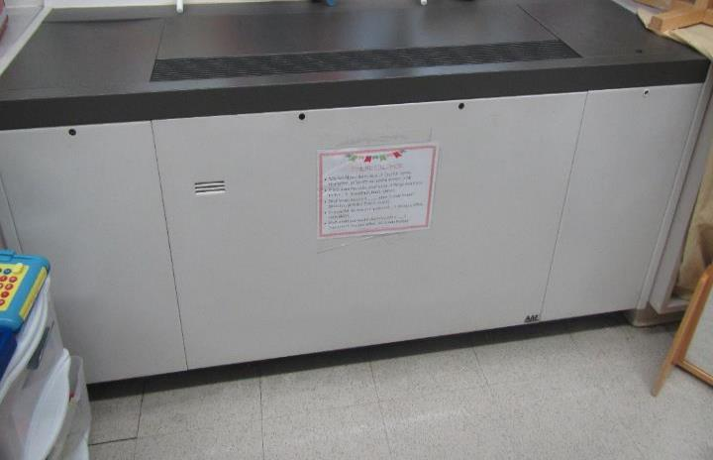

**Classroom unit ventilator (univent)**

**Picture 2**

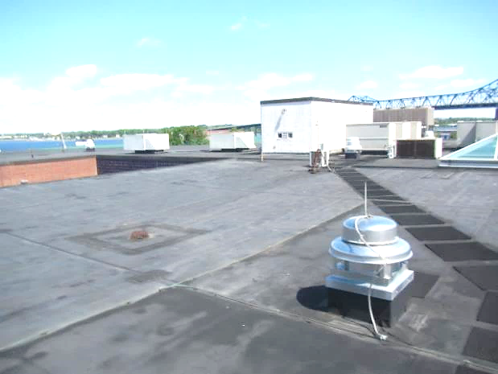

**Rooftop AHUs (white arrows) and exhaust vents (black arrows)**

**Picture 3**

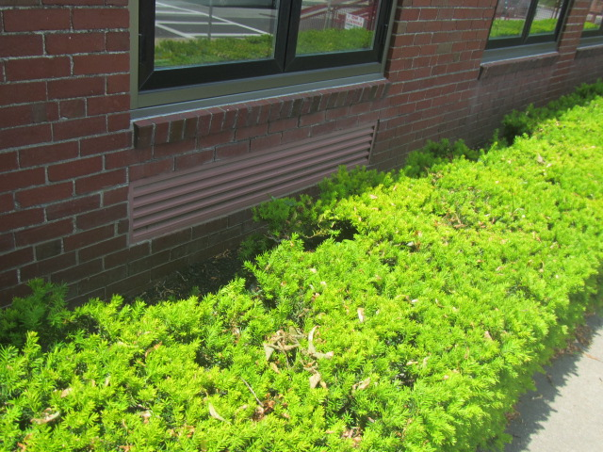

**Univent air intakes along exterior wall, note shrubbery in close proximity**

**Picture 4**

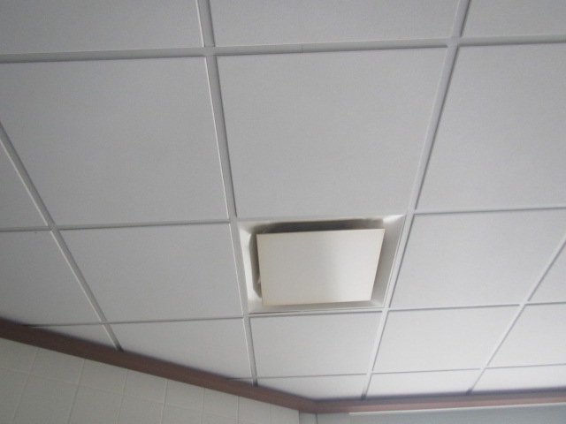

**Typical ceiling-mounted supply vent**

**Picture 5**

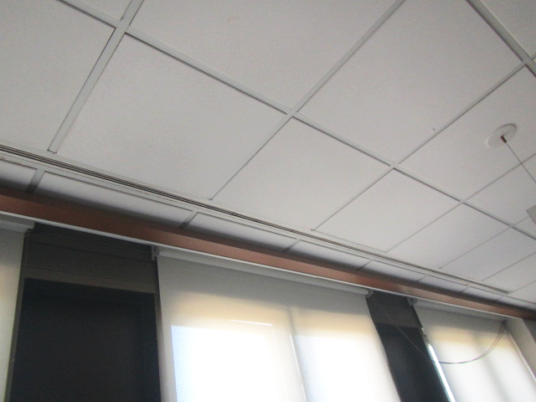

**Slotted air diffuser along exterior wall (arrow)**

**Picture 6**

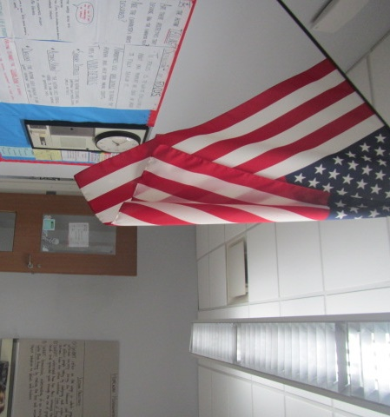

**Ceiling-mounted exhaust vent**

**Picture 7**

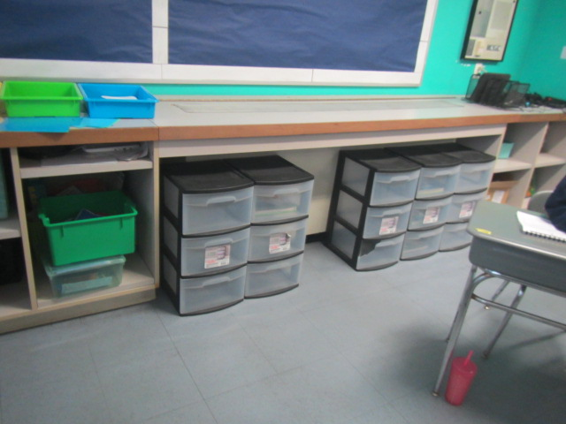

**Univent return vent (along front bottom) obstructed by classroom items**

**Picture 8**

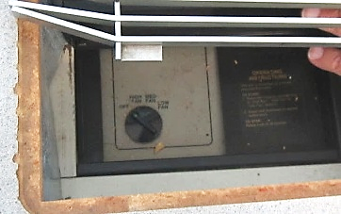

**Classroom univent deactivated due to noise**

**Picture 9**

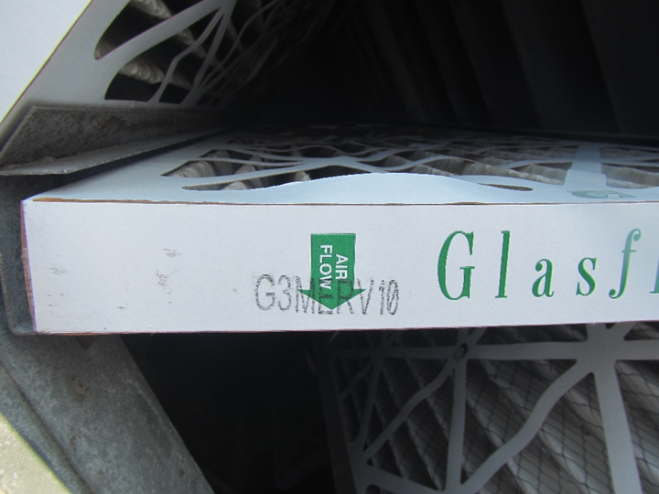

**MERV 10 filters installed in rooftop AHU**

**Picture 10**

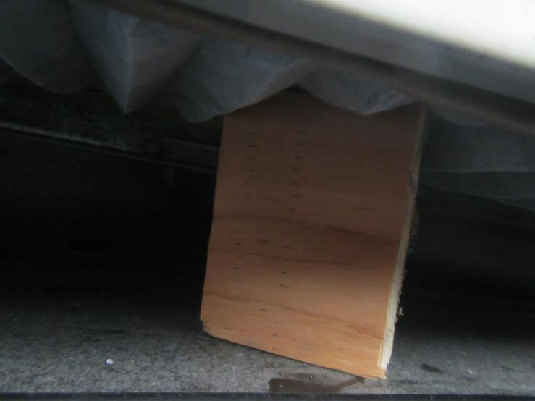

**Underside of classroom univent filter held up by wooden block**

**Picture 11**

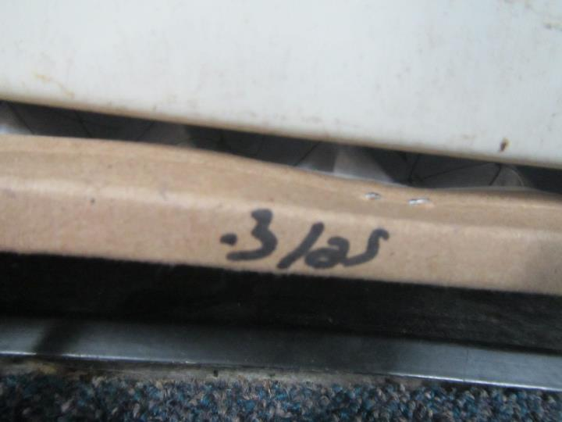

**Classroom univent filter marked 3/25 (March 2025)**

**Picture 12**

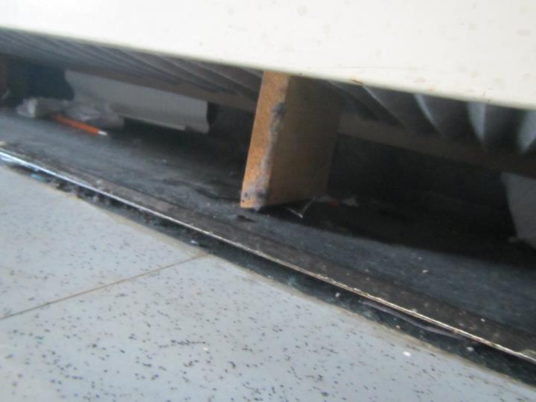

**Underside of classroom univent filter held up by wooden block**

**Picture 13**

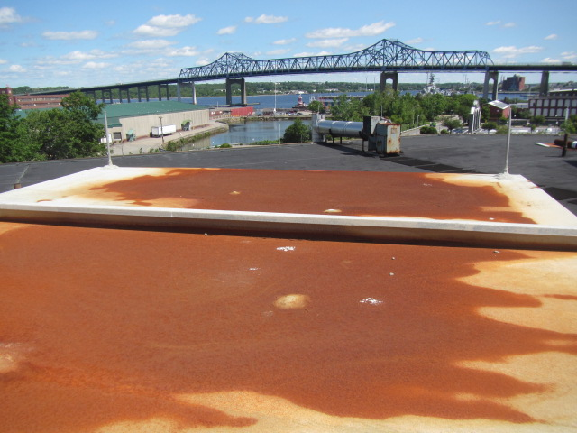

**Severely corroded metal housing for rooftop AHU**

## Water Damage Pictures

**Picture 14**

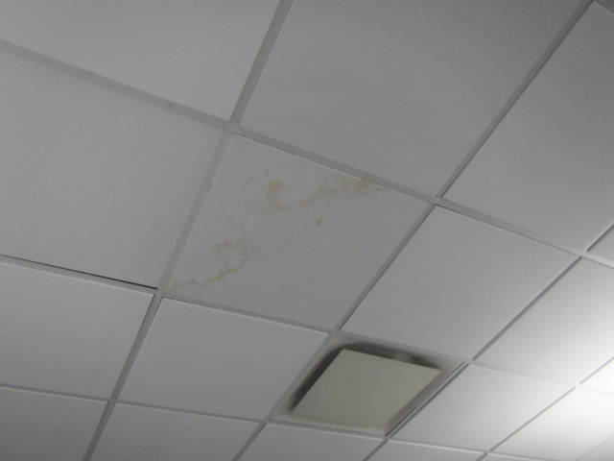

**Water-damaged ceiling tile**

**Picture 15**

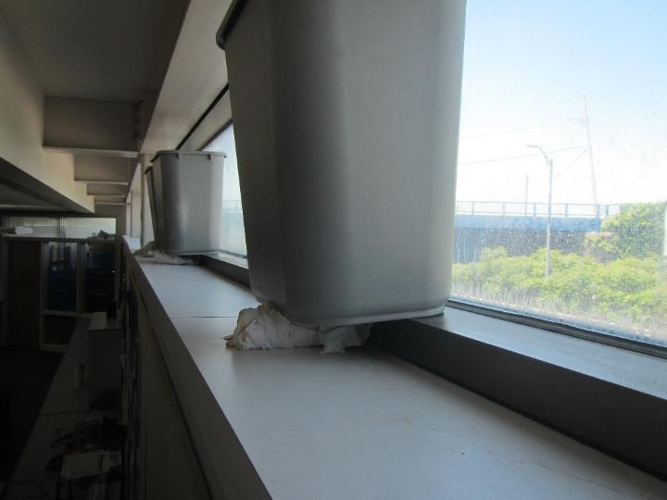

**Buckets stationed along windowsill in library area to catch leaks, note cloth underneath buckets**

**Picture 16**

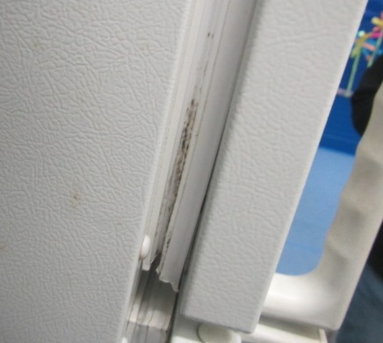

**Visible mold growth (dark staining) on freezer gasket in room 143**

**Picture 17**

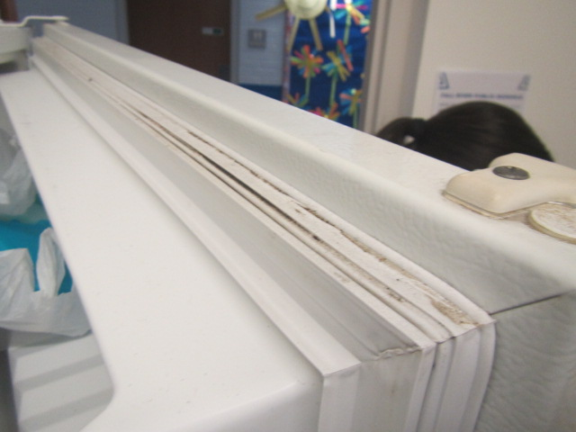

**Visible mold growth (dark staining) on freezer gasket in room 143**

**Picture 18**

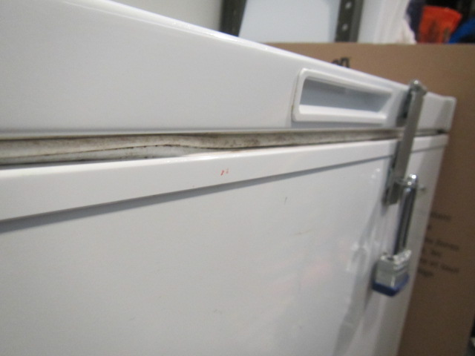

**Visible mold growth (dark staining) on freezer gasket in Teacher’s Lounge**

**Picture 19**

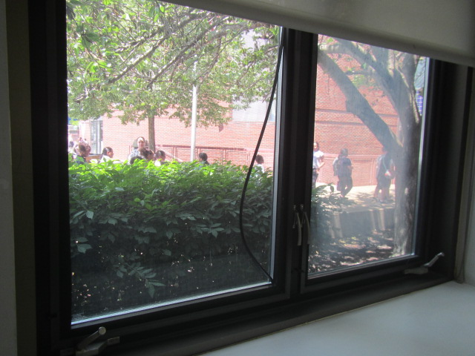

**Failing window caulking in classroom (gray boxes added to obscure students faces)**

**Picture 20**

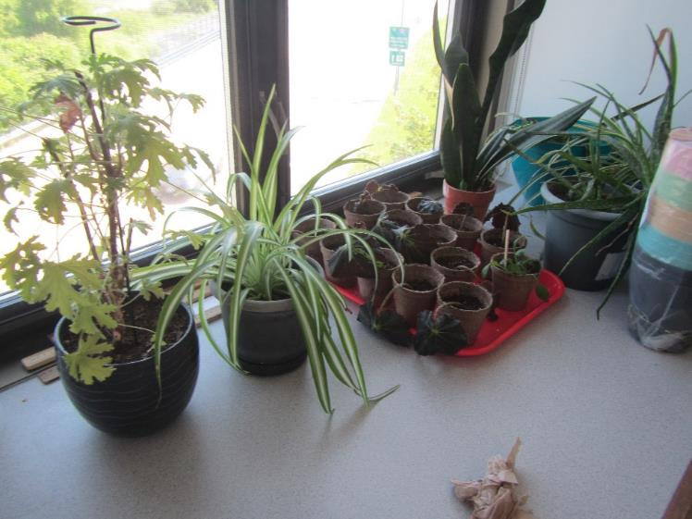

**Plants on a classroom windowsill**

**Picture 21**

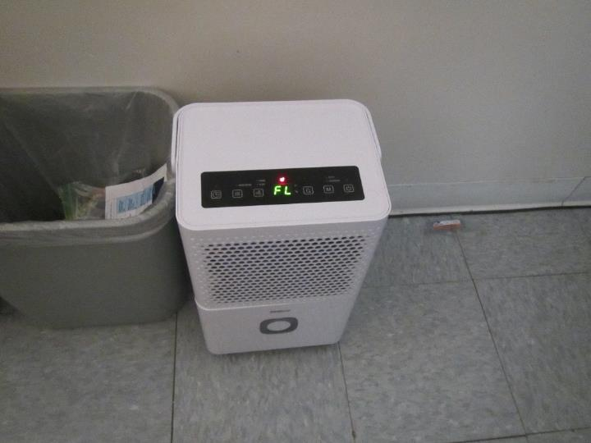

**Dehumidifier with red light and message indicating that it is full**

**Picture 22**

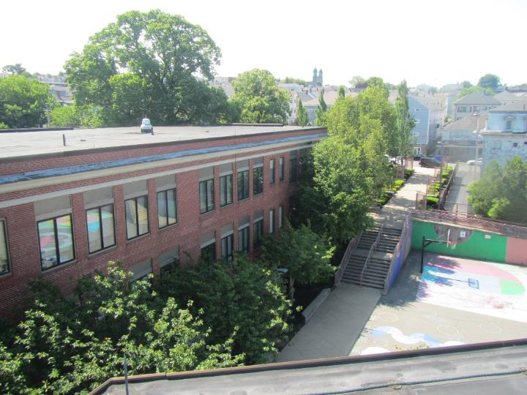

**Large plants and trees next to and overhanging the building**

**Picture 23**

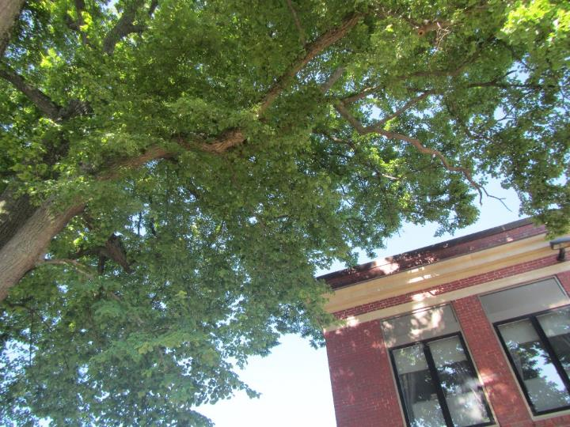

**Trees next to and branches overhanging the building**

**Picture 24**

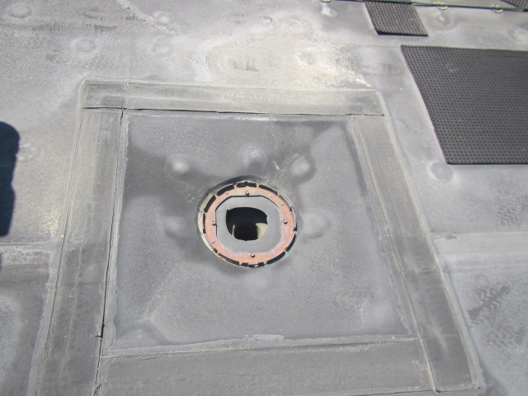

**Missing roof drain cover**

## Respiratory Irritants Pictures

**Picture 25**

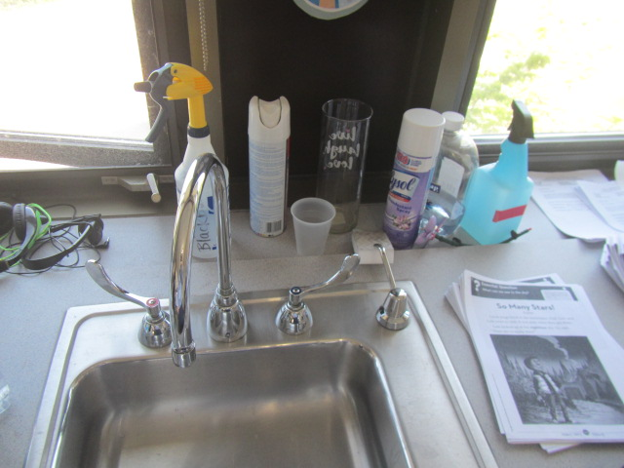

**Spray bottles and deodorizers on sink countertop**

**Picture 26**

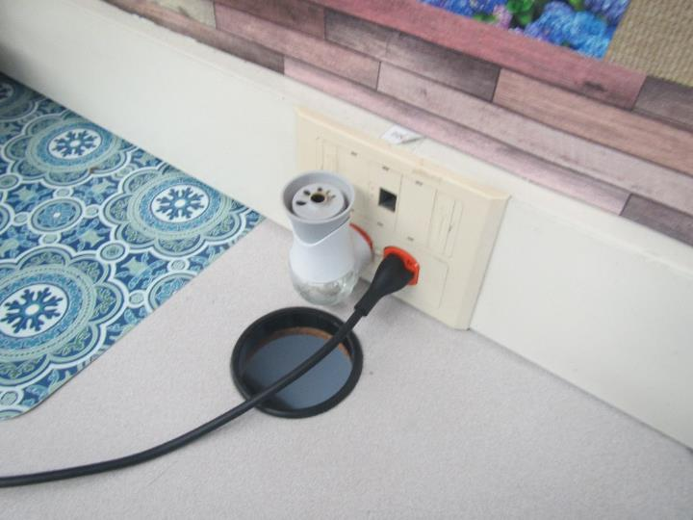

**Plug-in air freshener**

**Picture 27**

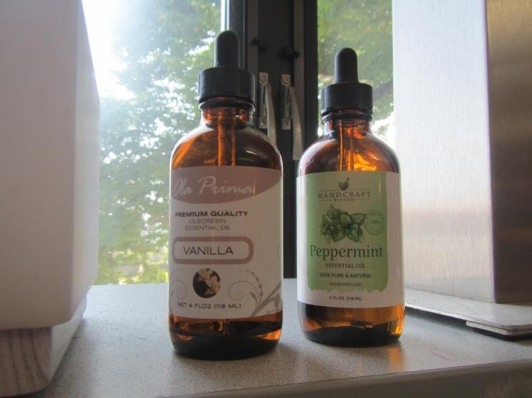

**Scented essential oils in classroom**

**Picture 28**

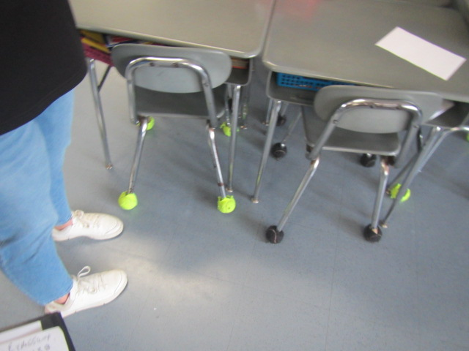

**Tennis balls on chair legs in classroom**

**Picture 29**

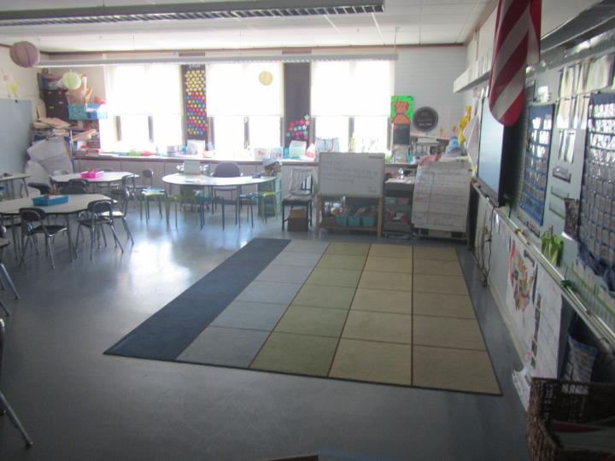

**Classroom area rug**

**Picture 30**

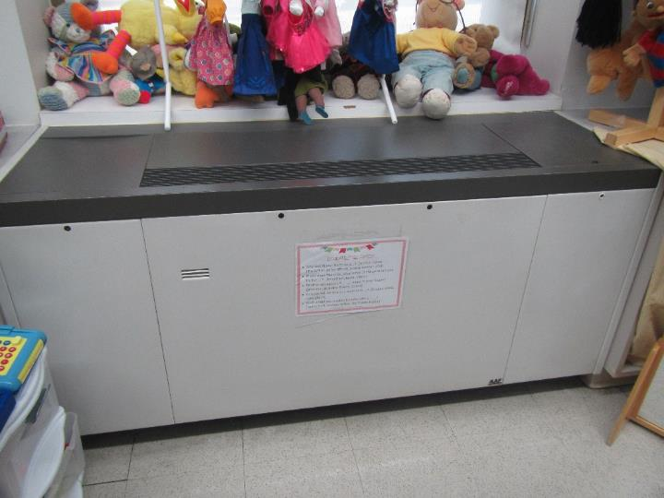

**Stuffed animals above univent air diffuser**

**Picture 31**

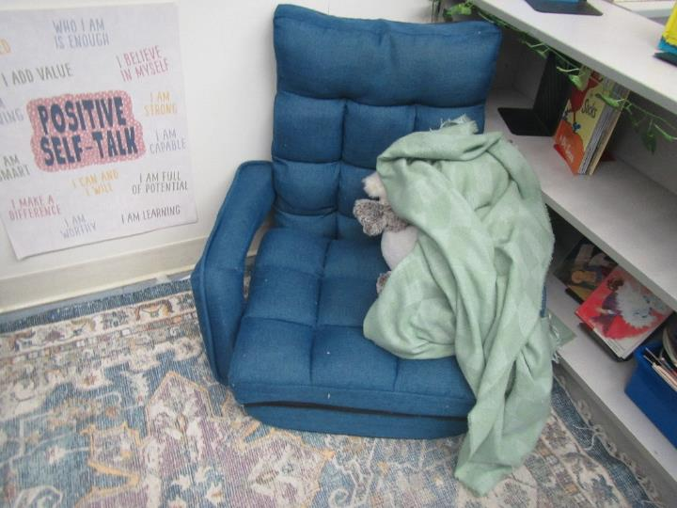

**Upholstered furniture, stuffed animal, and area rug**

**Picture 32**

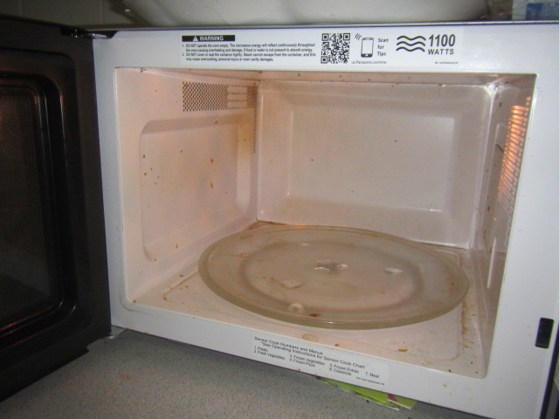

**Dirty microwave**

**Picture 33**

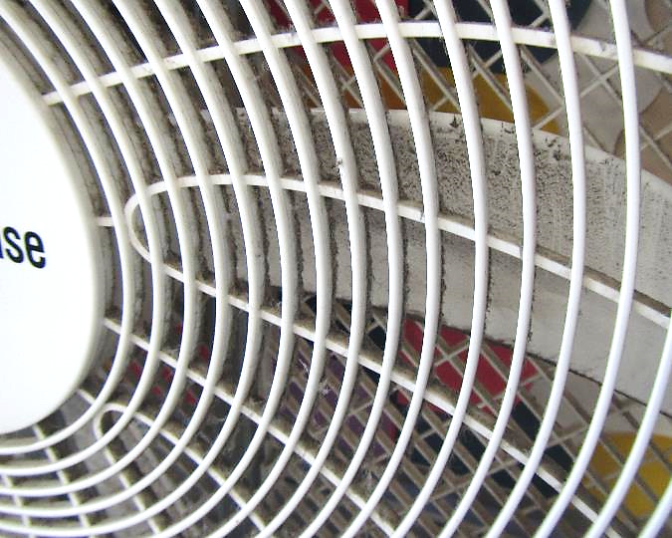

**Dust/debris accumulation on fan screen and blades**

**Picture 34**

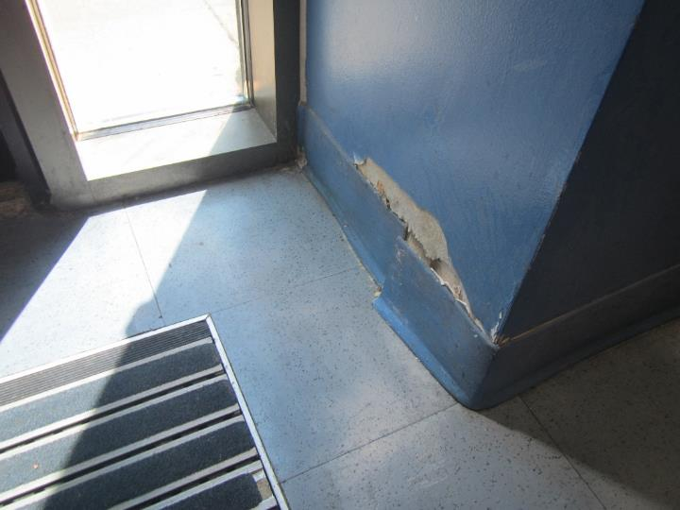

**Damage to walls in the K-foyer**

**Picture 35**

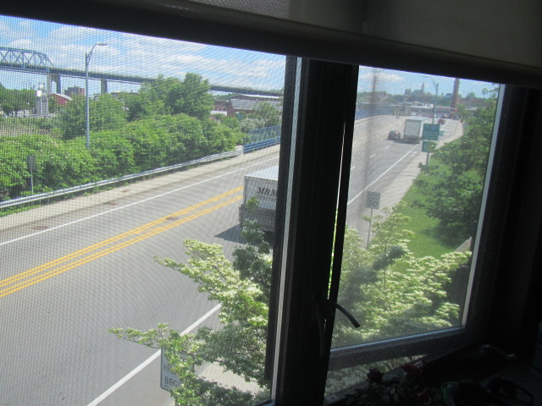

**Proximity to traffic/major roadway Western Fall River Expressway**

**Picture 36**



**Proximity to train tracks (left) and traffic/major roadway (right)**

Click to link back to report

# Table 1

| **Room** | **Openable Windows** | **HVAC** | **Ventilation** | | **Ceiling Tiles/Staining (Y or N)**  **B = Bowed** | **Comments** |
| --- | --- | --- | --- | --- | --- | --- |
| **Supply** | **Exhaust** |
| 111 | N | Y | Y | Y | N | CP |
| 112 | N | Y | Y | Y | N | HS |
| 114 | Y | Y | Y | Y | N | Area rug, HS, CP |
| 116 | Y | Y | Y | Y | N | Plants |
| 121 | Y open | Y | Y off | Y | N | Area rug, PF dusty, furniture |
| 123 | Y | Y | Y | Y | N | Plants, area rug, aquarium |
| 131 | Y | Y | Y | Y | N | Area rug |
| K-Foyer | N | Y | Y | Y | N | Area rug, damaged wall near exterior door |
| 137 | Y | Y | Y | Y | N | UV return vent obstructed, area rugs, PF, spray CP on sink countertop |
| 140 | Y | Y | Y | Y | N | Area rug, plant |
| 143 | N | N | N | N |  | Mold on refrigerator gaskets, recommend exhaust vent |
| 146 | Y open | Y | Y | Y | N | Failing window gasket, PF |
| 113 | Y | Y | Y | Y | N | Chronic heat reported/solar glare (recommend window tint), TB, PF, spray CP on countertop, pillows/cushions, area rug |
| 120 | Y open | Y | Y off | Y | N | Plants, room adjacent to major roadway, area rug, UV -off |
| 122 | Y | Y | Y | Y | N | Area rug, TB, PF dusty, pillows/cushions |
| Library | Y | Y | Y | Y | N | Wall to wall carpet, buckets on windowsills to catch periodic, wind-driven rain leaks – no visible water damage or mold growth observed, water-stained wooden cabinets from previous flooding event |
| G-21 | Y | Y | Y |  |  | Exhaust could not be identified, broken window |
| G-22 | Y | Y | Y | N | N | Did not locate exhaust vent, recommend connecting into closest room/area with HVAC exhaust |
| G-44 | N | Y | Y | Y | N | Refrigerator, microwave, dehumidifier |
| G-43 | Y | Y | Y | Y | N | Dehumidifier “full” display on, indicating it needs to be emptied |
| G-36 | Y | Y | Y | Y | Y | Area rug, WD CT |
| Nurse Suite | Y | Y | Y | Y off | Y | Failing window caulking, plant, no draw from exhaust vent |
| Cafeteria | Y | Y | Y | Y |  |  |
| Gym | N | Y | Y | Y |  | General ventilation off, relative humidity/moisture issues reported, ceiling grids inserted for airflow – to prevent condensation/mold growth on ceiling tiles, recommend dehumidifiers and stand up fans to move air |
| Teacher’s lounge | N | Y | Y | Y | N | Dirty microwave, mold on freezer gasket |
| 211 | N | Y | Y | Y | N | DEM |
| 212 | N | Y | Y | Y | N | PF |
| 213 | Y | Y | Y | Y | N | DEM |
| 214 | Y | Y | Y | Y | N | PF dusty |
| 215 | Y | Y | Y | Y | N | Odors reported – possible source machinery above CTs (reported), 2 windows reported broken, PF |
| 216 | Y | Y | Y | Y | N | Refrigerator, scanner/copier |
| 217 | Y | Y | Y | Y | Y | WD CT |
| 220 | Y open | Y | Y | Y | N | PF, plants, CP, wood holding up filter |
| 222 | Y | Y | Y | Y | N | UV return blocked, no draw from exhaust vent |
| 223 | Y | Y | Y | Y | N | Filter is being up by piece of wood to prevent from falling |
| 224 | Y | Y | Y | Y | N | UV deactivated due to noise, PF, plants |
| 231 | Y | Y | Y | Y | N | PF (2) |
| 232 | Y | Y | Y | Y | N | Mini refrigerator, PF |
| 233 | Y | Y | Y | Y | N |  |
| 234 | Y | Y | Y | Y | N | Dust/debris on vents |
| 235 | Y | Y | Y | Y | N | PF |
| 240 | Y | Y | Y | Y | N | CP |
| 241 | Y | Y | Y | Y | N | PF dusty |
| 242 | Y | Y | Y | Y | N | PF |
| 243 | Y | Y | Y | Y | N | CP, PF |

(Click to link back to report)

# Table 2A

|  |  |  |  |  |  |
| --- | --- | --- | --- | --- | --- |
| **Equipment Present in Building**  **(X = Yes)** | **Type of Heating/Cooling Ventilation**  **Equipment** | **Fresh**  **Air**  **Supply**  **(X = Yes)** | **Type of Location(s)** | **Air Filters Installed**  **MERV Rating**  **(1-15, U*)**  **(X = Yes)** | **Comments** |
| X | Univents | X | Classrooms | X, U |  |
| X | Rooftop Air Handling Units | X | Modular classrooms | X, 10 |  |
|  | Outdoor, Ground-Installed Air Handling Units |  |  |  |  |
|  | Attic/Crawlspace Air Handling Units |  |  |  |  |
| X | Ceiling-Mounted Air Handling Units (including inside plenum) | X | Some classrooms |  |  |
|  | Basement/Crawlspace-Installed Air Handling Units |  |  |  |  |
|  | Mechanical Room-installed Air Handling Units |  |  |  |  |
|  | Fan Coil Units |  |  |  |  |
|  | Window-Mounted Air Conditioners |  |  |  |  |
|  | Wall Louver-Controlled Gravity Air Supply |  |  |  |  |
| X | Windows |  | Classrooms, offices |  |  |
|  | Fan in window (blowing in) |  |  |  |  |
|  | Built in wall fan (switched) |  |  |  |  |
|  | Heat recovery ventilator unit |  |  |  |  |
|  | Energy recovery ventilator unit |  |  |  |  |
|  | Chilled Beam |  |  |  |  |
|  | Passive combustion supply vent in basement/boiler room |  |  |  |  |

*U = Filter Rating underdetermined due to inaccessibility during building visit

(Click to link back to report)

# Table 2B

|  |  |  |  |  |
| --- | --- | --- | --- | --- |
| **Equipment Present in Building**  **(X = Yes)** | **Type of Exhaust Ventilation**  **Equipment** | **Ducted**  **To Outdoors**  **(X = Yes)** | **Type of Location(s)** | **Comments** |
| X | Rooftop Motors/Fans | X | Classrooms and offices |  |
|  | Unit Exhaust |  |  |  |
|  | Ceiling Return Vent |  |  |  |
|  | Ceiling Return Vent, Plenum |  |  |  |
| X | Wall Return Vent | X | Cafeteria/Auditorium |  |
|  | Kitchen Stove Hood |  |  |  |
| X | Restroom Exhaust Vent | X |  |  |
|  | Photocopier Exhaust Vent |  |  |  |
|  | Garage |  |  |  |
|  | Chemical Hood(s) |  |  |  |
|  | Locker Rooms |  |  |  |
|  | Showers |  |  |  |
|  | Clothes Dryers |  |  |  |
|  | Gas Water Heaters |  |  |  |
|  | Furnace-Flue to Chimney |  |  |  |
|  | Furnace/Boiler direct vent or power vent (no combustion air supply) |  |  |  |
|  | Kiln, Pottery |  |  |  |
|  | Dark Room |  |  |  |
|  | Generator Room |  |  |  |
|  | Wood Shop Dust Collector |  |  |  |
|  | Spray Paint Booths |  |  |  |
|  | Fan in window (blowing out) |  |  |  |

# Table 2C

|  |  |  |  |
| --- | --- | --- | --- |
| **Equipment Present in Building**  **(X = Yes)** | **Type of Equipment** | **Type of Location(s)** | **Comments** |
|  | Floor Fans, pedestal |  |  |
| X | Floor Fans, portable | Classrooms |  |
| X | Air Purifier (HEPA, other) | Classrooms, offices |  |
|  | Floor heaters, portable |  |  |
| X | Refrigerators, Cold Beverage Vending Machines |  |  |
| X | Radiator, wall-mounted | All rooms with exterior walls |  |
|  | Radiator, floor-mounted |  |  |
|  | Passive Vents (Wall/Door) |  |  |

(Click to link back to report)

# Table 3

| **Found in Building**  **X = Yes** | **Water-Damaged Materials, Building Components or Stored Materials** | **Location** | **Visible Microbial Growth?**  **X = Yes** | **Musty odor detected?**  **X = Yes** | **Comments** |
| --- | --- | --- | --- | --- | --- |
|  | Books-other bound materials |  |  |  |  |
|  | Brick walls – broken, missing mortar |  |  |  |  |
|  | Brick walls – blocked weep holes |  |  |  |  |
|  | Cardboard boxes |  |  |  |  |
|  | Carpet tiles |  |  |  |  |
|  | Carpet - Area rugs |  |  |  |  |
|  | Carpet wall-to-wall |  |  |  |  |
|  | Ceiling tiles - affixed directly to ceiling surface |  |  |  |  |
|  | Ceiling tiles - bowing-in suspended ceiling |  |  |  |  |
|  | Ceiling tiles - water-stained in splined ceiling |  |  |  |  |
| X | Ceiling tiles - water-stained in suspended ceiling | Classrooms, offices |  |  |  |
|  | Chairs - laminated |  |  |  |  |
|  | Cloth |  |  |  |  |
|  | Countertops (around sinks) |  |  |  |  |
|  | Curtains |  |  |  |  |
|  | Dust/debris within AHU, uninvent, HVAC, chilled beam units, etc. (WD through condensation, humidity, or leaks) |  |  |  |  |
|  | Efflorescence (i.e., mineral deposits) |  |  |  |  |
|  | Engineered woods - particleboard, plywood, Masonite |  |  |  |  |
|  | Flooring – loosened tiles |  |  |  |  |
|  | Flooring - wooden |  |  |  |  |
|  | Furniture - laminated |  |  |  |  |
|  | Furniture - upholstered |  |  |  |  |
|  | Gypsum wallboard - ceiling |  |  |  |  |
|  | Gypsum wallboard - restroom wall |  |  |  |  |
|  | Gypsum wallboard - interior wall |  |  |  |  |
|  | Gypsum wallboard – located on exterior wall |  |  |  |  |
|  | HVAC drain pan – lack of draining |  |  |  |  |
|  | HVAC filters |  |  |  |  |
|  | Insulation- attic (paper-backed) |  |  |  |  |
|  | Insulation - inside air handling unit |  |  |  |  |
|  | Insulation - on pipe(s) fiberglass |  |  |  |  |
|  | Insulation - on pipe(s) other/plaster-like material |  |  |  |  |
|  | Insulation - wall cavity |  |  |  |  |
|  | Insulation – ceiling plenum |  |  |  |  |
|  | Modular furniture – walls/cloth partitions |  |  |  |  |
|  | Musical instrument cases |  |  |  |  |
|  | Plaster ceilings |  |  |  |  |
|  | Records/files |  |  |  |  |
| X | Refrigerator - door gasket | Teachers lounge, 143 | X |  |  |
|  | Refrigerator - drip pan |  |  |  |  |
|  | Refrigerator - Interior surfaces |  |  |  |  |
|  | Room divider - ceiling-mounted, sliding |  |  |  |  |
|  | Sink backsplash |  |  |  |  |
|  | Sink under cabinet |  |  |  |  |
|  | Tables – laminated |  |  |  |  |
|  | Wallpaper |  |  |  |  |
|  | Wood - attic/roof materials |  |  |  |  |
|  | Wood - floor joists in basement ceiling |  |  |  |  |
|  | Wood - wall framing |  |  |  |  |
|  | Wood – windowsills |  |  |  |  |
|  | Wood - window-mounted air conditioner framing |  |  |  |  |
|  | OTHER |  |  |  |  |

WHAT ARE ENVIRONMENTAL ASTHMA TRIGGERS?

Asthma triggers are any chemical, pollutant, or allergen that can make your asthma worse. Asthma triggers can also be strong chemical smells, dust, or pets. Your asthma triggers may be different from those of other people. Not all asthma triggers affect people the same way. Environmental asthma triggers are found both indoors and outdoors. MDPH link: [Asthma and Your Environment (mass.gov)](https://www.mass.gov/doc/asthma-and-your-environment-english/download)

(click to link back to report)

# Table 4

| **Condition Present**  **X = Yes** | **Possible asthma symptom-inducing environmental pollutant** | **Recommendation to reduce or eliminate the pollutant** |
| --- | --- | --- |
| X | Water Damage and/or Mold  (allergen) | Identify water source and repair to eliminate.  Clean non-porous materials.  Remove and replace porous materials susceptible to mold growth.  Perform regular water damage assessments as a tool to ensure timely mitigation as needed.  Use NIOSH water damage assessment protocol as a guide: [NIOSH water damage assessment guideline](https://www.cdc.gov/niosh/docs/2019-115/pdfs/2019-115.pdf?id=10.26616/NIOSHPUB2019115&inf_contact_key=241b5c2ed98c27d94b530dedc36f1623f651f238aa2edbb9c8b7cff03e0b16a0). |
| X | Moistening of building components during hot, humid weather (>2 days in length) (mold, allergen) | Remove materials not dried in <2 days in a manner consistent with [US EPA Mold Removal in Commercial Buildings guideline](https://www.epa.gov/mold/pdf-version-checklist-mold-remediation-mold-remediation-schools-and-commercial-buildings).  Use dehumidification in occupied basement areas and other areas with chronic dampness. |
| X | Vegetation against exterior of building (water damage-mold) | Remove all vegetation preventing building exterior drying.  Remove all vegetation capable of falling onto a building or depositing debris onto the roof. |
|  | Personal humidifiers (lack of proper maintenance)  (pollutant and allergen) | Clean and maintain properly.  Use distilled water to eliminate metal and water treatment odors.  Maintain hydration by increasing water consumption. |
| X | Drains: Floor drains, Sink drains (abandoned use)  Water bubblers (abandoned use) | If in use, pour water into drain at least twice a week.  If not in use, seal the drain with an appropriate material in accordance with Massachusetts Plumbing Code (248 CMR 10.00). |
|  | Live Animals (turtles, gerbils, birds, rabbits, etc.) | Ensure cleanliness or remove animals from the location. |
|  | Improperly maintained aquariums and terrariums (allergen) | Maintain such equipment properly to eliminate odor.  Discontinue use. |
| X | Plants and flowers  (allergen and mold) | Keep indoor plants well maintained and not overwatered. Monitor for signs of mold and pests.  Ensure water for cut flowers does not become stagnant.  Ensure dried plant material is free of odors, mold, and pests and handled carefully  If asthma risks are high, eliminate plants and flowers. |
|  | HVAC system moisture issues  (mold, allergen) | Consult ASHRAE’s minimum standards for HVAC maintenance and inspection of commercial HVAC systems (<https://www.ashrae.org/technical-resources/bookstore/standards-180-and-211>). |
|  | HVAC system contaminant issues (allergen) | Consult ASHRAE’s minimum standards for HVAC maintenance and inspection of commercial HVAC systems (<https://www.ashrae.org/technical-resources/bookstore/standards-180-and-211>). |
|  | Indoor swimming pool odors outside of swimming pool (mold, chemical) | Maintain and operate pool HVAC systems to vent odors from building.  Ensure locker room exhaust vents are operating during building hours.  All doors leading to pool should be rendered airtight and be closed. |
| X | Pollen (allergen) | Recommend installation of MERV 8 or better filters if HVAC engineer confirms HVAC system can be so equipped without adversely affecting function.  Cut grass after hours.  Cut grass in a pattern to direct clippings away from exterior wall.  Remove trees and shrubs from in front of windows and air intakes. |
|  | Dry air | Maintain hydration.  Avoid overheating of air. |
| X | Dust mites  (allergen) | Recommendation to remove non-official upholstered furniture, area rugs, pillows, cushions, etc.  Cleaning with use of HEPA-filtered vacuum cleaner.  Eliminating clutter, storing items in dust and moisture-proof containers, and regularly removing dust through wet wiping. |
|  | Pests, including rodents and cockroaches  (allergen) | Use of integrated pest management guidelines, including:   * Proper disposal of food containers * Proper storage of food products in airtight containers * Elimination of use of food as art projects * Remove pest harborages/clutter * Regular monitoring for pests   [EPA IPM guideline link](https://www.epa.gov/ipm/introduction-integrated-pest-management) |
| X | Latex-containing materials | Remove tennis balls from furniture legs or replace with latex free ones. |
| X | Fragrances  (chemical) | Eliminate point sources, such as:   * Plug-in air fresheners * Aroma/oil reed diffusers * Scented sprays * Discontinue use of other scented materials * Consult MDPH fragrance guideline: [*Clean air is odor-free*](https://www.mass.gov/doc/clean-air-is-odor-free-removing-fragrances-to-improve-indoor-air-quality-in-schools-and-0/download) |
| X | Strong smells from /use of Chemicals (such as cleaning products)  (chemical) | Use building-issued cleaning products.  Use products in accordance with manufacturer’s instructions including dilution, application, and ventilation.  Avoid using products that are stronger than needed for the situation. |
|  | Strong odors from new building materials (carpeting/furniture)  (chemical) | Use low VOC-emitting materials.  Air out materials (outside or in unoccupied area) prior to installation. |
|  | Tobacco smoke  Secondhand Smoke  (pollutant) | Eliminate tobacco smoking.  Seal all shared wall penetrations. |
| X | Products with strong odor such as paint, perfume, hairspray, air fresheners, bug-spray, laminators, candles, wax melters, dry erase markers and other VOC-containing products  (chemical) | If essential:   * Provide proper exhaust ventilation to eject aerosolized product directly outdoors. * Avoid/reduce use during occupied hours.   If not necessary, remove and eliminate. |
|  | Vehicle exhaust  (pollutant) | Enforce anti-idling regulations and post signs to give notice.  Relocate vehicles away from fresh air intakes.  Require cars to park face-in at building walls.  [MA anti-idling law FAQs](https://www.mass.gov/files/documents/2018/02/20/idling-faq.pdf#:~:text=The%20Massachusetts%20Anti-Idling%20Law%20The%20goal%20of%20the,sometime%20wonder%20when%20idling%20might%20be%20considered%20necessary.) |
|  | Vapors and or fumes from gas, oil, or kerosene stoves  (pollutant) | Operate stove hood when stove in use.  Install stove hood if not present.  Ensure equipment is in good working order. |
|  | Ozone (pollutant) | Eliminate use of ozone generating equipment. |
|  | Window Air Conditioners (if not properly maintained) (allergen) | Equip with proper filter and clean periodically.  Clean drip pans.  Install in window with weathertight, non-mold-growth sustaining material. |
|  | Pottery (pollutant) | Do not operate kiln during occupied hours.  Operate kiln with exhaust system activated.  Seal all seams and holes in kiln vent.  Ensure kiln exhaust discharge terminates outdoors. |
| X | Carpeting (allergen) | Clean carpeting in a manner consistent with IICRC standards, including regular vacuuming with a high efficiency particulate air (HEPA) filtered vacuum in combination with annual cleaning or semi-annual cleaning in soiled high traffic areas. |
| X | Sweeping/dusting vs HEPA vacuuming/wet wiping  (allergen or pollutant) | Refrain from using feather dusters or brooms.  Utilize HEPA vacuums and wet wiping to minimize aerosolizing particulate matter. |
| X | Lack of adequate air exchange/mechanical ventilation | Make repairs as necessary and ensure all HVAC system components are operating continuously when building is occupied. |
|  | Lack of local exhaust at source of pollution (vocational shop activities, kitchen exhaust hood) (all) | Recommend installation of exhaust ventilation to direct pollutants directly outdoors. |
|  | Renovating buildings while occupied  (chemical) | Use all SMACNA guidelines for Renovation While Buildings Are Occupied. For information, visit <https://www.mass.gov/service-details/construction-and-renovation-generated-pollutants-in-occupied-buildings>. |
|  | Chemistry program chemical storage  (chemical) | Repair (if needed) and operate chemical storeroom vents appropriately.  Reduce or eliminate unneeded or overstocked chemicals.  Store all chemicals in a manner to separate incompatible chemicals.  Keep chemical storerooms clean. |
| X | Photocopiers/duplicating machines | All machines should have dedicated exhaust vents. |