INDOOR AIR QUALITY WALKTHROUGH

James Madison Morton Middle School
1135 N Main Street
Fall River, MA

October 2025

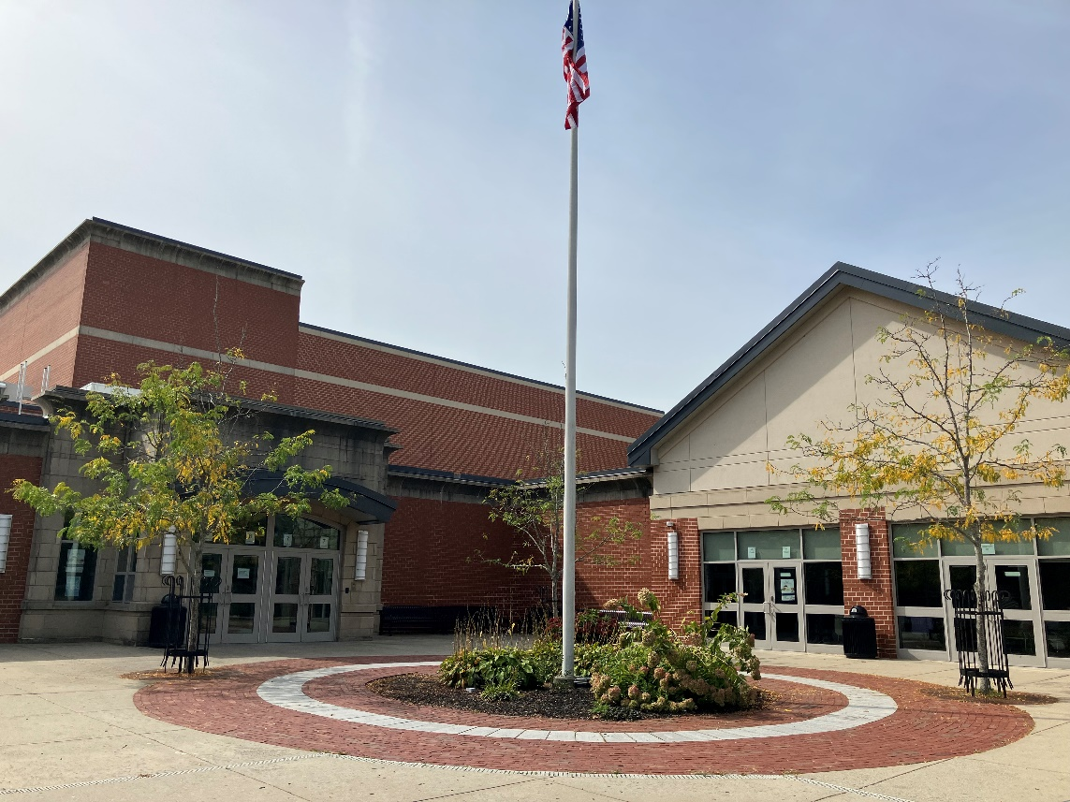

Prepared by:
Massachusetts Department of Public Health
Bureau of Climate and Environmental Health
Division of Environmental Health Regulations and Standards
Contents

EXECUTIVE SUMMARY 3
BACKGROUND 5
RESULTS AND DISCUSSION 5
Ventilation 5
Water Damage and Moisture Concerns 7
Sources of Respiratory Irritants/Possible Asthma Triggers 9
Other IAQ Issues 11
CONCLUSIONS AND RECOMMENDATIONS 12
REFERENCES 17
FIGURES 18
PICTURES 19
Ventilation Pictures 19
Water Damage Pictures 25
Respiratory Irritants Pictures 30
Table 1 34
Table 2A 40
Table 2B 41
Table 2C 42
Table 3 43
Table 4 45

EXECUTIVE SUMMARY
Massachusetts Department of Public Health’s (MDPH), Division of Environmental Health Regulations and Standards (EHRS) conducted an Indoor Air Quality (IAQ) walkthrough of the James Madison Morton Middle School located at 1135 N Main Street Fall River, MA, on September 30, 2025. This walkthrough was in conjunction with the “Asthma in Schools: Data to Action Project” - a collaboration between Massachusetts Department of Public Health programs, local health departments, and local school health and administration officials to support asthma prevention and intervention efforts in school settings, see https://www.mass.gov/asthma-in-schools-data-to-action-project.
Any building can have IAQ issues. These issues can be made worse through conditions common to marginalized communities (Environmental Justice communities or EJ) such as inequitable exposure to outdoor air pollution and a greater likelihood of poor building conditions leading to deterioration of IAQ resulting in higher asthma rates. The Morton Middle School is within an EJ community. In addition, the pediatric asthma rate for this school as of 2023-2024 is 20%, which is statistically significantly higher than the statewide pediatric prevalence rate of 9.6% (MAEPHT, 2025).
The assessment was conducted by evaluating several key elements within the school; a visual inspection of the heating, cooling, and ventilating (HVAC) systems, water/microbial damage, exterior building envelope evaluation, cleanliness, and point sources of respiratory irritants such as chemicals. Data is collected in this manner to identify potential asthma triggers, allergens, and other environmental factors that can cause indoor air quality symptoms.
As a result of this walkthrough, there are several findings: at ten years old, this school is generally in excellent condition. As building systems age, appropriate preventive and regular maintenance will help to keep school systems operating well into the future. Note that some water-stained ceilings were found, and there are occupant-induced issues including storage/clutter and use of scented products. The location of the school near major roadways and train lines provides additional challenges for maintaining good IAQ. (Results and Discussion), (Conclusions)
Based on the results of the assessment, the following primary recommendations are made:
- Operate supply and exhaust ventilation continuously when the building is occupied. Check fan coil units, air handling units, and exhaust vents during occupied periods to ensure they are on and operating to their full capacity.
- Educate teachers and staff on the operation of fan coil units and exhaust vents so they can avoid blocking units and can report off or inoperable units to facility staff. If not already in use, consider using a tracking program to collect and administer work orders for mechanical systems.
- Replace water-damaged ceiling tiles and clean/repair other water-damaged materials.
- Sort stored materials regularly to remove items that are outdated or no longer needed. Store items neatly and off the floor.

Please note: this report contains a series of recommendations that should serve as Best Practices that apply to most public-school buildings across the Commonwealth and should be shared amongst other buildings in the school district.

BACKGROUND
Building: | James Madison Morton Middle School (MMS)
Address: | 1135 N Main St, Fall River, Massachusetts
Coordinated Via: | Dr. Tracy Curley, Superintendent, Fall River Public Schools
Reason for Request: | Pediatric Asthma Project and General IAQ
Date of Assessment: | September 30, 2025
Massachusetts Department of Public Health/Bureau of Climate and Environmental Health/Division of Environmental Health Regulations and Standards (MDPH/BCEH/EHRS) staff | Ruth Alfasso and Bharathi Patimalla-Dipali, IAQ Outreach and Education Unit, EHRS
Building Description: | The MMS is a three-story building completed in 2013 that replaced the former Morton Middle School at the same location. The building has several flat roof segments and several peaked roof segments. It contains classrooms, offices, a gym, an auditorium, a cafeteria and other spaces. The building has “green building” features including rooftop solar and daylighting through use of courtyards and skylights.
Windows: | Most windows in the school are openable.

RESULTS AND DISCUSSION
A summary of conditions observed during the indoor air quality walkthrough can be found in (Table 1).

Ventilation
Ventilation refers to both the supply of fresh air and the removal of stale air from a room. The introduction of fresh air into an occupied space will dilute normally occurring pollutants that are generated by occupancy and other activities. In addition, an HVAC system will remove pollutants from a building if operating appropriately. All ventilation systems throughout the building should operate continuously during periods of occupancy.
Fresh air ventilation for the MMS comes from rooftop air handling units (AHUs, Picture 1). This air is filtered and heated/cooled and supplied to rooms via ceiling-mounted vents (Pictures 2 and 3). Units are present in many classrooms that provide air circulation, filtration, and heating/cooling (Picture 4). These units look like unit ventilators (univents), but they do not have a corresponding vent on the outside to supply fresh air. Like a univent, they should not be blocked by furniture or items, because this will impede the flow of air to and from the unit (Figure 1). During the walkthrough, cool air was noted from the white panels at the end of these units (Picture 5). Some of these were blocked by furniture and items.
Classrooms and other rooms are also equipped with exhaust vents located on the ceiling or walls that remove stale air from rooms (Pictures 6 and 7).
Additional HVAC equipment to provide cooling and air circulation is present in some central areas and offices (Picture 8). Many exterior walls in classrooms and hallways are equipped with radiators to provide heating.
The HVAC equipment in the building is controlled by a centralized energy management system. There are thermostats in each room (Picture 9) which feed into this system. It appears as though temperatures can be adjusted to a few degrees, but the thermostats have no indication of whether the systems are on during occupied periods. The IAQ Outreach and Education unit recommends that occupied rooms be supplied with continuous fresh air.

The various types of ventilation components as well as devices that can move/redirect airflow are listed in Table 2A, Table 2B and Table 2C.

HVAC System Maintenance
- According to the American Society of Heating, Refrigeration, and Air-Conditioning Engineering (ASHRAE), the service life of the types of HVAC equipment is 15-20 years, assuming routine maintenance of the equipment (ASHRAE, 1991). While the equipment in this school is not yet at its service life, ensuring that routine maintenance is conducted as recommended by the manufacturer will keep the systems running well for as long as possible.
Balancing
To have proper ventilation with a mechanical supply and exhaust system, a system must be balanced to provide an adequate amount of fresh air to the interior of a room while also removing stale air from the room.
It is recommended that HVAC systems be re-balanced every five years to ensure adequate air systems function (SMACNA, 1994).

HVAC Types and Specific Conditions
(see Ventilation Pictures)

Fresh Air Ventilation:
- Some fan coil units did not appear to be on, so no circulation/filtration was provided during the walkthrough. This may be because temperatures outside were mild, and no heating was called for.
- The IAQ Outreach and Education Unit recommends that filters of at least a minimum efficiency reporting value (MERV) 8 or better be used, if an HVAC engineer confirms the system can be so equipped without adversely affecting function, as these are adequate to filter out pollen, mold, and similar particulates (ASHRAE, 2012).
  - Filters in a rooftop AHU were noted to be well-fitted (Picture 10). These filters appeared to be rated MERV 8.
  - Some filters for rooftop units were stored in water-damaged boxes (Picture 11). Filters should be kept in clean, dry areas.
  - Filters were not viewed for fan coil units, but facility staff report they are MERV 8 and changed 2-4 times a year.
Exhaust vents:
- Ceiling-mounted and wall-mounted exhaust vents appeared to be on whenever examined. Some of them were dusty, which happens more quickly when the vents are drawing air in. Dusty vents should be cleaned periodically.
Additional HVAC Conditions:
- Most classrooms have openable windows (Table 1). Facility staff report that these are not typically used, however windows were found to be open in one classroom (Table 1). Windows can potentially be used for additional fresh air during temperate weather.
  - Windows should be kept closed during wet weather to prevent water infiltration.
  - They should also be kept closed when air conditioning is operating to prevent condensation and mold growth during elevated relative humidity.
  - Occupants should be aware of outdoor air quality and avoid opening windows during days with poor air quality, high pollen, outdoor noise, or when the generator is operating.
  - When not in use, windows should be closed tightly and locked. Some window locking handles appeared to be in the “open” configuration (Picture 12).
- A few air purifiers were noted in classrooms (Picture 13). Air purifiers with HEPA filters are good choices to remove particulates from the air that may include dust, pollen, mold spores, and microbes. Air purifiers that may produce ozone should not be used. Air purifiers should be maintained in accordance with manufacturers’ instructions, including cleaning and filter changes.
- Science rooms had originally been connected to a vent system for science hoods, but these are not in use. If science hoods are added or activated, they need to be calibrated periodically to ensure adequate drawing of air for operation.

Water Damage and Moisture Concerns

Molds are found naturally in our environment both indoors and outdoors. Inside, mold growth may occur when items, particularly porous products such as paper or gypsum wallboard, are exposed to moisture. Typical water sources include leaks, floods, and condensation. To avoid mold growth, dry all water-damaged items and affected areas within 24-48 hours and reduce indoor humidity. Some people with chronic respiratory conditions, such as asthma, are more likely to experience health symptoms associated with molds, including allergic reactions and respiratory irritation. Controlling moisture is the key to preventing mold growth and potential health symptoms.

Hot humid summers are becoming more frequent due to climate change. Massachusetts has experienced hot, humid, and rainy summers in 2018, 2021, and 2023. July of 2021 was the wettest ever recorded in Massachusetts, and the three-month period from June through August, known as the meteorological summer, was the fourth wettest on record, according to the National Oceanic and Atmospheric Administration’s (NOAA) Centers for Environmental Information (NOAA, 2021). The summer of 2023 was measured as the second rainiest on record (WBUR, 2023). The summers of 2024 and 2025 also had significant stretches of hot, humid weather. These conditions are challenging for buildings, even those with central air conditioning.
Mold Growth
Porous materials (e.g., gypsum wallboard, ceiling tiles and carpeting) can be dried with fans and heating within 24 to 48 hours of becoming wet (US EPA, 2008).
If porous materials are not dried within this time frame, mold growth may occur.

During these hot and wet summers, extended periods of outdoor relative humidity above 70% occurred. Public buildings experienced extended periods of water vapor exposure from high relative humidity. When exposed to these conditions, porous materials such as gypsum wallboard, cardboard, and other materials may become mold colonized, particularly if located in areas that are prone to developing condensation (e.g., floors and walls in below grade space).
Please note that the IAQ Outreach and Education Unit does not recommend conducting mold testing in a typical water damage remediation. For details, please consult Guidance Regarding Testing for Mold in Water-Damaged Public Buildings | Mass.gov
The application of a mildewcide to moldy porous materials is not recommended.
(see Water Damage and Moisture Concern Pictures)
- Water-damaged ceiling tiles and ceiling plaster were found in a few locations (Pictures 14 and 15; Table 1), which indicate plumbing, HVAC, or building envelope leaks or spills. Water-damaged ceiling tiles can provide a source of mold and should be replaced after a water leak is discovered and repaired. Staff are encouraged to report any active leaks to the Facilities Department for prompt remediation.
- Signs of water infiltration were noted in the stairwell leading to the roof, including water-damaged filter boxes (Picture 11) and water stains on stairway tiles (Picture 16). This appears to be due to rain infiltration underneath the door to the roof.
- Plants were noted in some classrooms and offices (Table 1). Plants can be a source of pollen or mold especially if overwatered or not well maintained. Plants without drip pans can damage porous surfaces they are placed on.
- Water-damaged pipe wrap was noted in some utility spaces (Picture 17). While none of the pipe wrap appeared to be mold-colonized, insulation that had been wet in the past may not insulate as well as designed, leading to issues with condensation.
- There are sinks in some classrooms, offices, and other areas (Table 1).
  - Some of the sinks had gaps between the countertop and the backsplash (Table 1). Without a continuous smooth surface, dirt and debris can become trapped, and the material behind the backsplash can become water-damaged.
  - Some sinks may not be used often, such as sinks in science classrooms. Sinks and floor drains that are not used can have the plumbing trap dry out, which allows sewer gases into occupied areas. Pouring water down seldom-used sinks every few weeks will keep the trap seal intact.
- Dehumidifiers were in use in some of the music rooms on the lower level. (Picture 18; Table 1). Dehumidifiers are a good tool to lower humidity in the absence of, or in addition to, air conditioning. Dehumidifiers either need to be emptied daily when in use or have the accumulated water directed to a drain such as in a sink or a floor drain. They need to be cleaned periodically to remove stagnant water that can produce odors. Keeping humidity below 60% is especially important in areas where instruments and instrument cases are stored as these materials are susceptible to water damage and can become a mold growth medium.
An exterior evaluation was also conducted to identify potential pathways for water penetration and pest entry. The following issues were noted:
- Gaps between and underneath exterior doors were observed in many areas (Picture 19). These gaps can allow moisture, unconditioned air, and pests into the building. Replacing worn or missing weather-stripping can help render these doors airtight. Gaps under the door to the roof have allowed water to flow into the building as shown in Pictures 11 and 16.
- While most of the building exterior is in good condition, areas of dampness (Picture 20), moss, small plant growth (Picture 21), and efflorescence (precipitated brick and mortar salts, Picture 22) were noted in some areas. These conditions represent potential water penetration. Over time, these conditions can undermine the integrity of the building envelope and provide a means of water entry into the building via capillary action through foundation concrete and masonry (Lstiburek & Brennan, 2005).
- The building has a complex shape including a courtyard and skylights. Any area where two parts of the building meet, or where there are penetrations through the building envelope, can start to leak over time as the building settles and wear occurs. Periodic checks of the condition of exterior seals, flashing, caulking, gutters, downspouts, and other materials should be conducted to discover and repair damage early.
A list of water damage issues identified inside and outside the building were identified which can contribute to water issues, is included as Table 3.

Sources of Respiratory Irritants/Possible Asthma Triggers

Asthma is a lung disease that can make breathing difficult. Without careful management of asthma, some individuals can have symptoms, like a tight feeling in the chest, shortness of breath, coughing, or wheezing. Although there is no cure for asthma, individuals with asthma can live healthy, active lives. A safe and healthy environment helps to reduce asthma symptoms.

Comparison of Local and State-wide Asthma Rates (2023-2024 school year/MAEPHT, 2025)
15.5% of children
have asthma
Fall River
9.6% of children
have asthma
Massachusetts
20.0% of children
have asthma
Morton Middle School

- Sometimes, learning tools and personal items in a classroom can be a source of irritation. For example, a bird or insect nest is a great learning tool for students but may harbor microbes and allergens. Similarly, food-based projects can attract pests that carry disease or trigger allergies.
- Personal products, particularly those with volatile organic compounds (VOCs) including scents, can also be a source of respiratory irritation. VOCs are carbon-containing substances that have the ability to evaporate at room temperature. Frequently, exposure to low levels of total VOCs (TVOCs) may produce eye, nose, throat and/or respiratory irritation in some sensitive individuals. Products noted were dry erase markers, air fresheners, reed diffusers, scented candles (Picture 23), sanitizers, and cleaning products (Table 1). Consult “Clean Air Is Odor Free” for more information on fragrances in schools and other building.
- Dust, a common respiratory and eye irritant, can collect on surfaces and items. Although janitorial and maintenance staff perform routine cleaning in classrooms, they may not be able to clean as effectively if classroom items are not picked up or surfaces are cluttered. A few classrooms and storage areas had an excess of items such as books, craft materials, papers, boxes, and miscellaneous materials (Pictures 24 and 25).
Even with a properly functioning ventilation system, it is necessary to either eliminate or reduce the use of materials that can be a source of respiratory irritants to prevent symptoms in individuals who have sensitivity to such pollutants.

For guidance on maintaining an asthma-friendly healthy school environment, please consult the MDPH Asthma Prevention and Control Program’s Clearing the Air: An Asthma Toolkit for Healthy Schools.
Possible asthma triggers and/or airborne pollutants exist in the building. These are listed below as well as in (Table 4).
(see Sources of Respiratory Irritant Pictures)

- A large laminator was found in a teachers’ workroom (Picture 26). Laminators melt plastic and produce fumes and odors. They should be used with good ventilation.
- There is a kiln in an art room storage area (Picture 27). This kiln is reportedly not used. However, if it were to be used again, items should be removed from the storage area to create a wide clear space around the unit. During any use of the kiln, the unit’s exhaust vent should be used, and the room door should be closed to prevent access by students until the unit is cooled down.
- Wall-to-wall carpeting is present in a few areas of the school, Carpeting was mostly in good condition, however some stained carpeting was found in the library (Picture 28).
- Break rooms around the school and some classrooms and offices have food storage and preparation equipment such as refrigerators, microwaves, and toasters. Some of this equipment was dirty (Picture 29; Table 1). Food spills and crumbs can be a source of odors, especially when heated, and can attract pests.
  - While these refrigerators are not covered by the food code, it is good practice to have a thermometer in each refrigerator that is visible to ensure refrigerated food temperatures are kept at 5ºC (41ºF) or less (USFDA 2022).
- In some areas supply/exhaust vents were dusty (Table 1). This dust can be aerosolized under certain conditions and can also be a medium for mold growth.
- Of note was the proximity of the school to major roadways and train tracks. Exhaust emissions, including particulate matter and carbon monoxide from cars, buses, trucks, other motor vehicles, and trains are found in higher concentrations near major roads and train tracks. Therefore, care should be taken when opening classroom windows during periods of heavy traffic.

Other IAQ Issues

Radon

Radon is a naturally occurring radioactive gas that seeps into buildings from the surrounding soil and can increase the risk of lung cancer at elevated levels.

The Environmental Protection Agency (EPA) conducted a National School Radon Survey “in which it discovered nearly one in five schools has at least one schoolroom with a short-term radon level above the action level of 4pCi/L (picocuries per liter) – the level at which the EPA recommends that schools take action to reduce the level” (US EPA, 1993).

The MDPH therefore recommends that every school be tested for radon, and that this testing be conducted during the heating season while school is in session in a manner consistent with US EPA radon testing guidelines. Radon measurement specialists and other information can be found at www.nrsb.org and http://aarst-nrpp.com/wp, with additional information at: https://www.mass.gov/radon and fact sheet on radon in schools and child care programs.

Note that if the school was tested for radon when it was initially commissioned, retesting may be warranted after ten years.

CONCLUSIONS AND RECOMMENDATIONS

Please note: this report contains a series of recommendations that should serve as Best Practices that apply to most public-school buildings across the Commonwealth and should be shared amongst other buildings in the School District.

As this is a relatively new school and in very good condition, fewer issues, compared to older schools, were noted. The goal for this school should be to maintain good air quality by maintaining the systems that exist, performing routine maintenance and cleaning, and controlling storage and clutter.

Recommendations

HVAC System Helpful Links
- 1. | Ensure all AHUs, fan coil units, and other HVAC systems. If fan-coil fan operation is linked to thermostat, work with HVAC vendor to operate independently as to not “cycle” off/on during the school day.
- 2. | Remove blockages from the top/front of fan coil units and radiators. including furniture and items.
- 3. | Periodically check the function of all classroom and restroom exhaust vents. Repair as needed.
- 5. | Continue with regular filter changes for HVAC equipment using a minimum efficiency rating value (MERV) 8 or the best quality/highest MERV-rated filter that can be used without effecting airflow.  Ensure filters fit flush within their racks to prevent filter bypass. | ANSI/ASHRAE Standard 52.2-2017
 | Store unused filters in closed boxes in clean, dry areas to prevent water damage or dust accumulation before use.
- 6. | During filter changes, clean dust and debris from the inside of fan coil and AHU cabinets.
- 7. | Develop and communicate a policy on when openable windows can be used. Tightly close windows at the end of the day and avoid opening windows during extreme cold to prevent freezing of pipes. Keep windows closed when it is hot and humid, outdoor air quality unhealthy, during heavy traffic conditions, or when the generator is operating. | https://www.airnow.gov/
- 30. | Supplement mechanical ventilation with portable air purifiers equipped with high efficiency particulate arrestance (HEPA) filters. While these do not supply fresh air, they can remove particles including mold spores and microbes.  Units that may produce ozone should not be used. Maintain all in accordance with the manufacturer’s instructions.  Place them so the filtered airstream is in the breathing zone of occupants and away from open doors and exhaust vents. | https://www.epa.gov/indoor-air-quality-iaq/ozone-generators-are-sold-air-cleaners
 | If science hoods are to be re-activated, ensure they are properly calibrated for adequate operation

Water Damage Sources
- 9. | Replace water-damaged ceiling tiles. Repeated water damage to ceiling tiles indicates leaks from the roof or plumbing/HVAC system which should be repaired. | http://www.epa.gov/mold/mold-remediation-schools-and-commercial-buildings-guide
 | Repair water-damaged ceiling plaster such as in the girls’ restrooms. Water damage in restrooms may come from plumbing on the floor above so these areas should be examined for leaks.
 | Reduce the potential for infiltration on the rooftop stairwell by ensuring doors are equipped with weather-stripping and making sure the roof is sloped towards roof drains rather than the stairwell. Increasing the berm on the door may also help keep water from entering.
 | If HVAC filters are kept in the stairwell to the roof, elevate them on pallets or furniture to avoid moistening if water enters the stairwell from the door to the roof.
- 10. | Properly maintain plants to avoid mold and odors. Keep plants away from airflow of HVAC equipment.
 | Replace water-damaged pipe wrap in utility rooms if this insulation is needed to prevent loss of heat, or ongoing condensation.
 | Ensure sink backsplashes are water-tight using appropriate caulking.
 | Pour water periodically (every week or two) down sinks and floor drains that are not often used to maintain the trap seal and prevent sewer gases from entering occupied areas.
- 16. | Continue using dehumidifiers in ground-level rooms with significant porous materials stored inside, such as the music storage rooms. Consider using dehumidifiers in combination with fans and AC during summer months in these and similar areas. Clean and maintain portable dehumidifying units in accordance with manufacturers’ recommendations. Drain units into sinks/floor drains where possible to reduce daily maintenance.
 | Replace worn or missing weather-stripping from all exterior doors so that no light can be seen around or underneath them.
 | Monitor areas of dampness along the exterior of the building. Consider methods to move condensation/drainage away from the building.
 | Remove moss and plant growth from the exterior of the building and repoint, regrout, or otherwise seal gaps where plants grow.
 | Periodically check the condition of flashing, building joints, roof drains, gutters and other building envelope systems so that issues can be repaired before significant leaks occur. This is particularly important after cycles of freezing and thawing during the winter.
- 19. | Periodically remove debris from roofs, roof drains, and exterior drains of the building to prevent clogs.
- 20. | During summer months, pull furniture away (1 to 2 inches) from walls to prevent mold growth due to lack of airflow and remove impermeable wall coverings that can trap moisture such as laminated posters.

Respiratory Irritants/Possible Asthma Triggers
- 23. | Reduce use of products and equipment that create irritating volatile organic compounds (VOCs) and only use in well-ventilated areas. Minimize the use of air fresheners (e.g., plug-ins), deodorizers and scented products. | https://www.mass.gov/cleaner-greener-healthier-schools
- 33. | Use only District-approved cleaning products. Keep spray bottles properly labeled and out of the reach of children.
- 34. | Provide exhaust ventilation or move copiers and laminators to a well-ventilated area with an exhaust vent.
- 26. | Clean area rugs, upholstered furniture, cushions/pillows frequently using a HEPA-equipped vacuum cleaner. Avoid bringing used area rugs into the school.
 | Clean carpeting regularly in accordance with IICRC recommendations (IICRC, 2012).
- 27. | Periodically, sort classroom and other storage areas for removal of unwanted items. Store the remaining items neatly and off the floor.
- 28. | Clean personal fans, ACs, supply, and exhaust/return vents periodically to remove dust and debris.
- 31. | Ensure the principles of integrated pest management (IPM) are followed in accordance with state regulations. | https://massnrc.org/ipm/docs/ipmkitforbuildingmanagers.pdf

Other Recommendations to Improve Air Quality Conditions
- 35. | Test the school for radon by a certified radon measurement specialist during the heating season when school is in session. | Radon measurement specialists and other information can be found at: www.nrsb.org, and http://aarst-nrpp.com/wp
- 36. | To learn more about radon, review the MDPH’s Radon in Schools and Child Care Programs factsheet. | https://www.mass.gov/info-details/radon-in-schools.
- 37. | Utilize the US EPA’s (2000), “Tools for Schools” as an instrument for maintaining a good IAQ environment in the building. | https://www.epa.gov/iaq-schools.
- 38. | For guidance on maintaining an asthma-friendly healthy school environment, please consult the MDPH Asthma Prevention and Control Program’s Clearing the Air: An Asthma Toolkit for Healthy Schools. | https://www.maasthma.org/schooltoolkit
- 39. | Include an IAQ component in the school’s Wellness Advisory Committee program. An IAQ plan should have an IAQ liaison/teacher representative, a member of maintenance/facilities and administration that conduct regular walk-throughs to identify on-going and/or potential environmental issues.
 | Consider installing sensor technology in classrooms to provide continuous monitoring of the following indoor air parameters (particularly temperature and relative humidity). Sensors should be re-calibrated quarterly or according to manufacturers’ specifications and building management software updated as per manufacturers’ instructions, industrial standards, and/or change in operating systems. As an example, the link to the right illustrates how this technology is serving Boston Public Schools to improve air quality (i.e., carbon dioxide, temperature, relative humidity, carbon monoxide, and particulate matter). | COVID-19 Health & Safety Information / Indoor Air Quality Sensor Dashboard (bostonpublicschools.org)

REFERENCES

REFERENCES
ASHRAE. 1991. ASHRAE Applications Handbook, Chapter 33 “Owning and Operating Costs”. American Society of Heating, Refrigeration and Air Conditioning Engineers, Atlanta, GA.
ASHRAE. 2012. American Society of Heating, Refrigeration and Air Conditioning Engineers (ASHRAE) Standard 52.2-2012 -- Method of Testing General Ventilation Air-Cleaning Devices for Removal Efficiency by Particle Size (ANSI Approved).
Lstiburek, J. & Brennan, T. 2005. Read This Before You Design, Build or Renovate. Building Science Corporation, Westford, MA. U.S. Department of Housing and Urban Development, Region I, Boston, MA. https://www.buildingscience.com/documents/guides-and-manuals/gm-read-this-before-you-design-build-renovate/view
MAEPHT. 2025. Massachusetts Environmental Public Health Tracking. Massachusetts Department of Public Health – Bureau of Climate and Environmental Health. https://matracking.ehs.state.ma.us/
NOAA. 2021. Summer 2021 neck and neck with Dust Bowl summer for hottest on record. National Oceanic and Atmospheric Administration, 1401 Constitution Avenue NW, Room 5128, Washington, DC 20230 https://www.noaa.gov/news/summer-2021-neck-and-neck-with-dust-bowl-summer-for-hottest-on-record
SMACNA. 1994. HVAC Systems Commissioning Manual. 1st ed. Sheet Metal and Air Conditioning Contractors’ National Association, Inc., Chantilly, VA.
US EPA. 1993. Radon Measurement in Schools, Revised Edition. Office of Air and Radiation, Office of Radiation and Indoor Air, Indoor Environments Division (6609J). EPA 402-R-92-014.
US EPA. 2000. Tools for Schools. Office of Air and Radiation, Office of Radiation and Indoor Air, Indoor Environments Division (6609J). EPA 402-K-95-001, Second Edition. https://www.epa.gov/iaq-schools.
US EPA. 2008. Mold Remediation in Schools and Commercial Buildings. US Environmental Protection Agency, Office of Air and Radiation, Indoor Environments Division, Washington, D.C. EPA 402-K-01-001. http://www.epa.gov/mold/mold-remediation-schools-and-commercial-buildings-guide.
US FDA. 2022. 2022 Food Code. U.S. Department of Health and Human Services. U.S. Food and Drug Administration. College Park, MD January 18, 2023 Version. https://www.fda.gov/media/164194/download
WBUR. 2023. “It's been a summer of rain and flooding misery in Mass.” WBUR local news. September 12, 2023. https://www.wbur.org/news/2023/09/12/summer-flooding-rain-massachusetts.

FIGURES
Figure 1

Fan Coil Unit (FCU)

Air Diffuser

Outdoors Indoors

Fan

Heating/Cooling Coil

Air Mixing Plenum

Filter

Return
Air

PICTURES
(Click to link back to report)

Ventilation Pictures

Picture 1
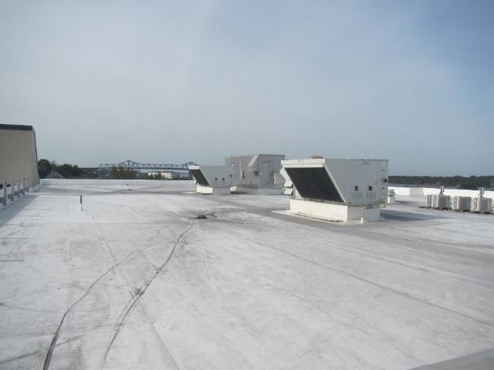
Air Handling Units (AHU) on the roof of the building
Picture 2
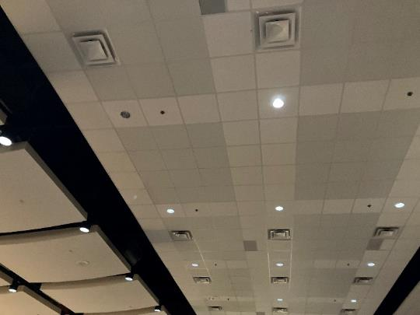
Supply vents in the ceiling of the auditorium

Picture 3
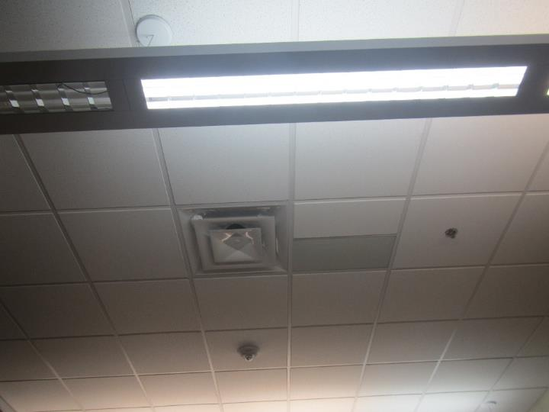
Typical supply vent
Picture 4
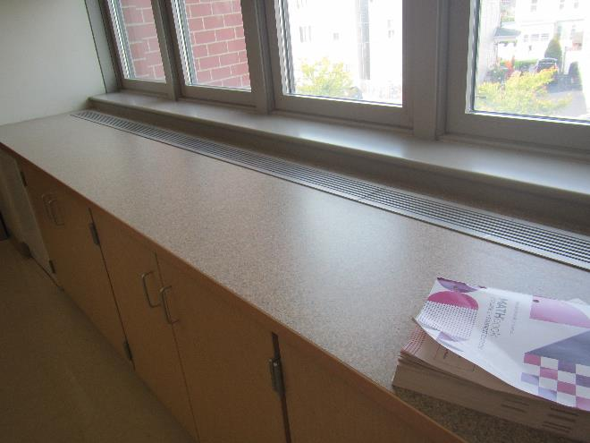
Fan Coil Unit (FCU) in a classroom

Picture 5
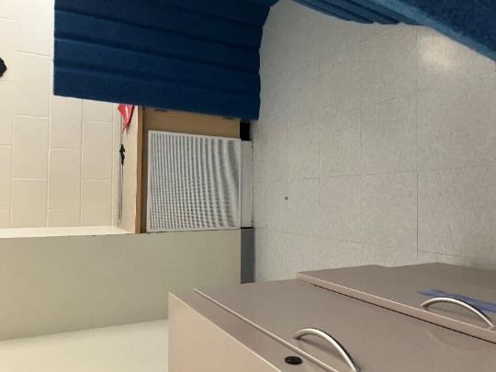
White panel that was providing cooling, note barrier in front of the fan coil unit
Picture 6
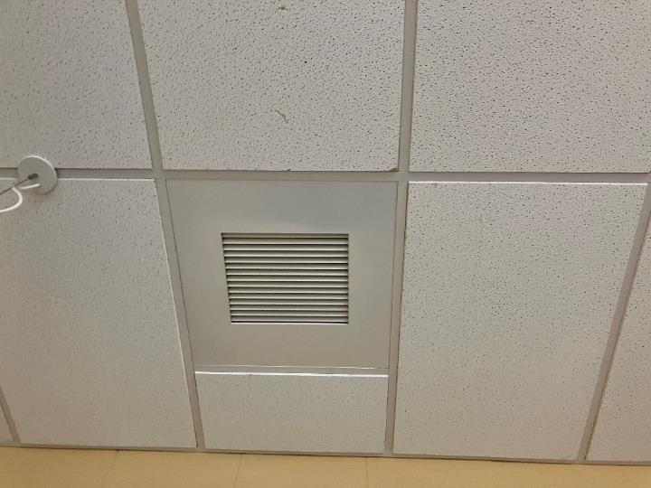
Typical exhaust vent in the ceiling

Picture 7
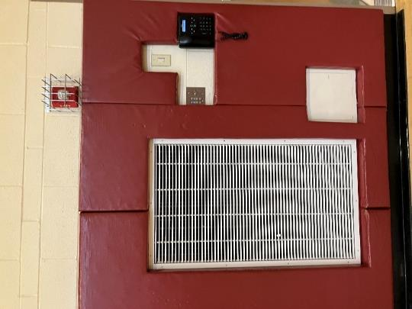
Wall-mounted exhaust vent in the gymnasium
Picture 8
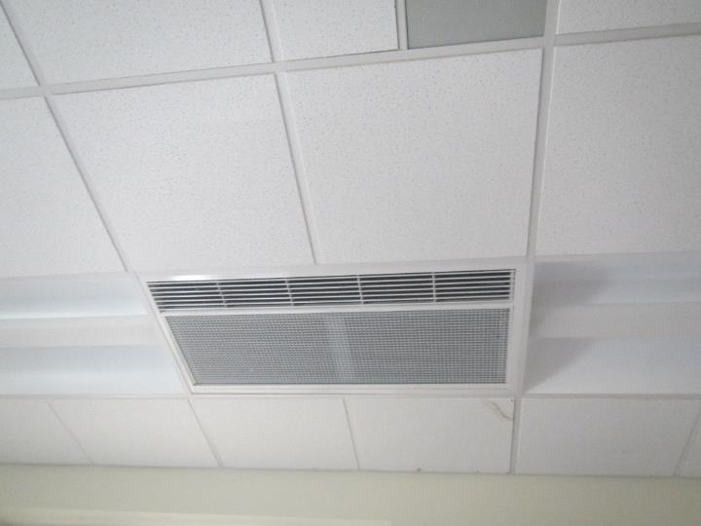
Ceiling-mounted HVAC unit

Picture 9
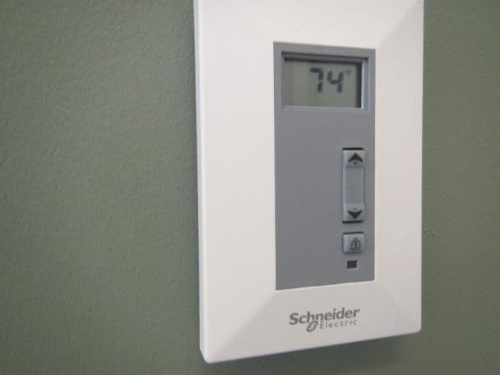
Thermostat in a classroom, note adjustment bar but no indication of system status
Picture 10
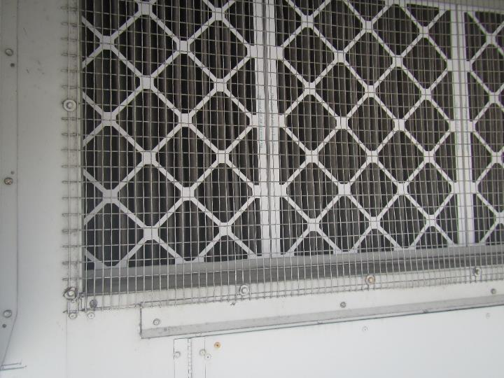
Filters in an AHU on the roof
Picture 11
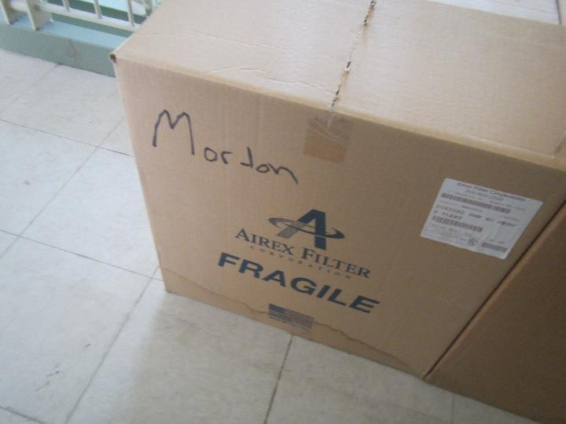
Water-damaged filter boxes near door to the roof
Picture 12
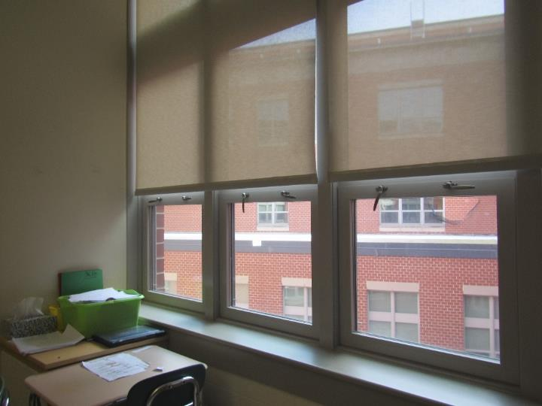
Windows with some handles in the unlocked position

Picture 13
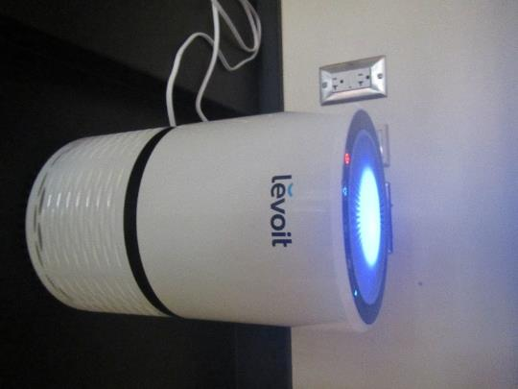
Air purifier

Water Damage Pictures

Picture 14
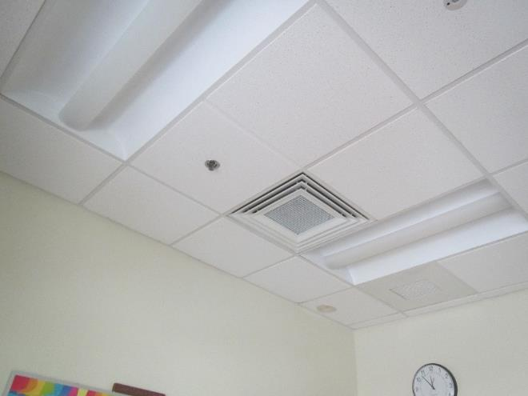
Water-damaged ceiling tile in the corner of the room

Picture 15
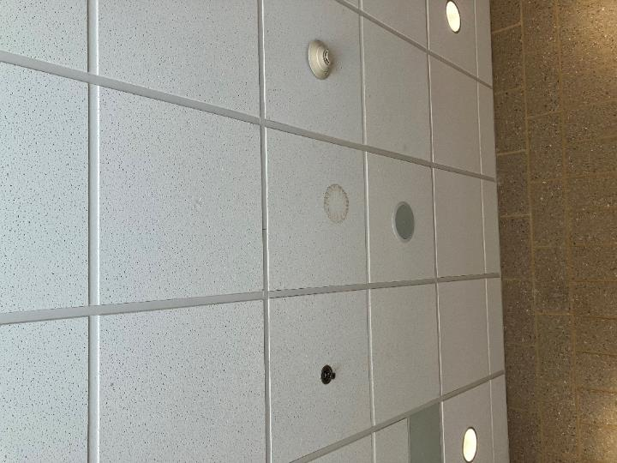
Water-damaged ceiling tile
Picture 16
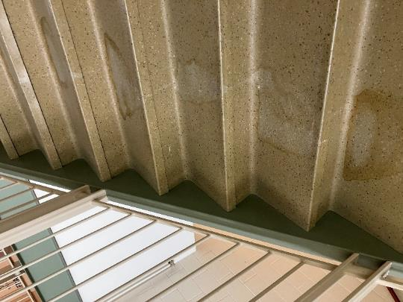
Water stains on stairs leading to the roof access

Picture 17
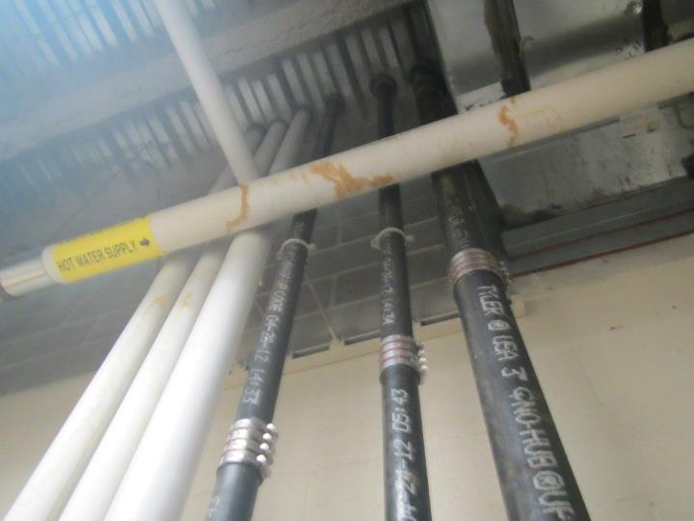
Water-damaged pipe wrap
Picture 18
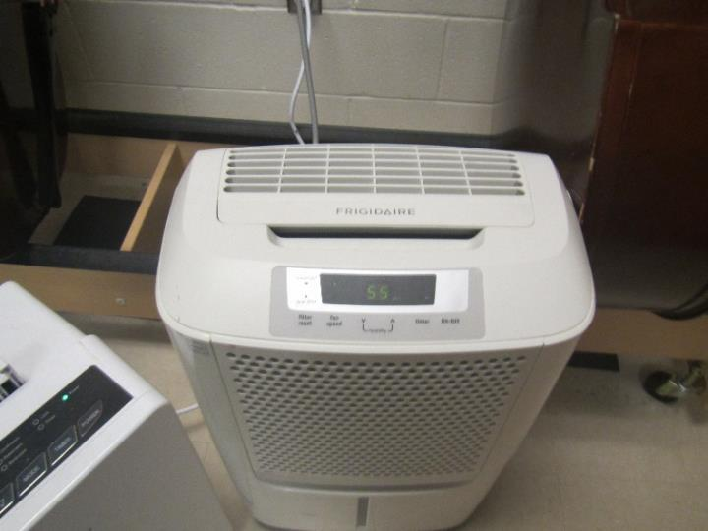
One of the dehumidifiers in the music storage area

Picture 19
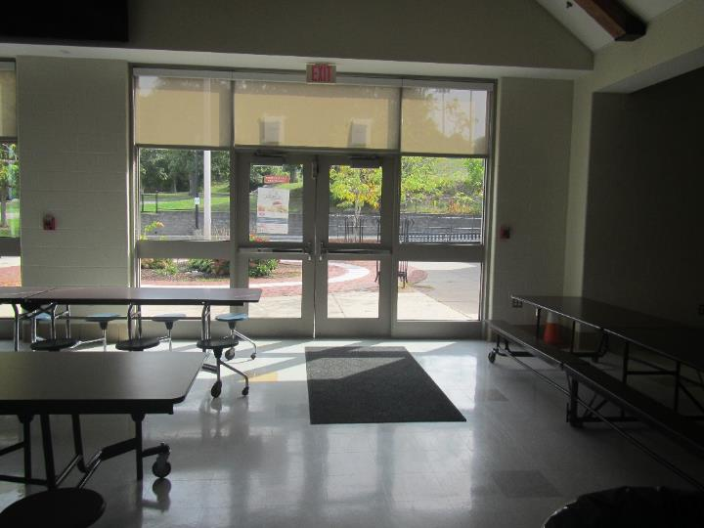
Light visible between doors from the cafeteria
Picture 20
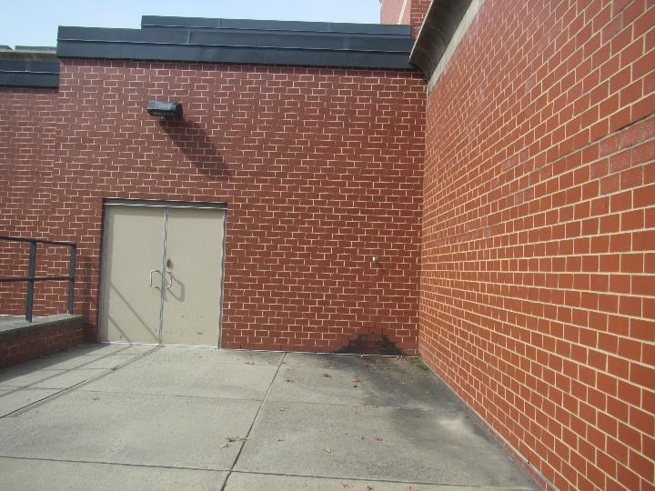
Damp area in corner of the building, possibly from equipment condensation drain

Picture 21
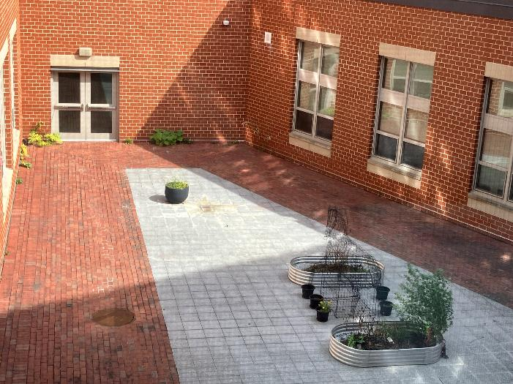
Plants growing out of seam between building and courtyard (arrows)
Picture 22
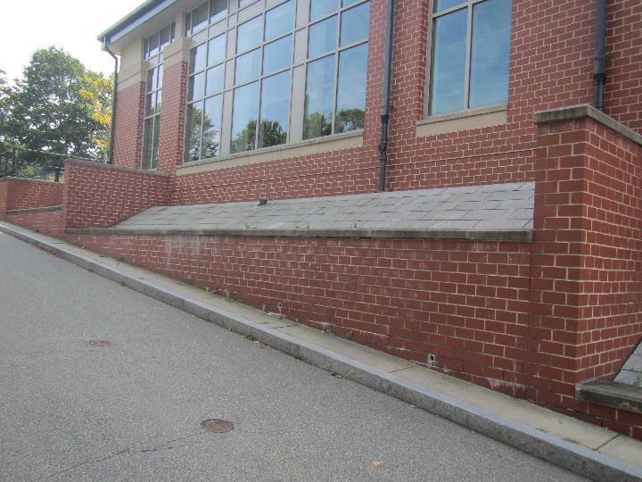
Efflorescence on brick

Respiratory Irritants Pictures

Picture 23
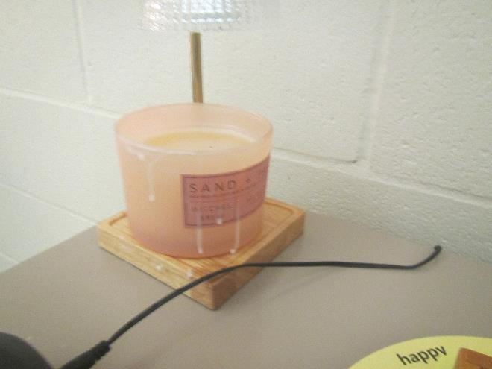
Scented candle
Picture 24
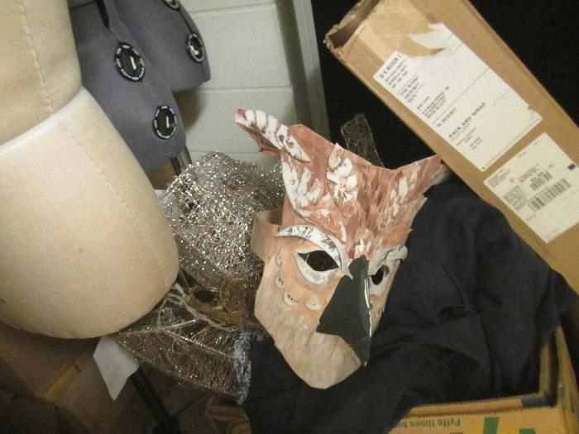
Cluttered storage area for theater materials

Picture 25
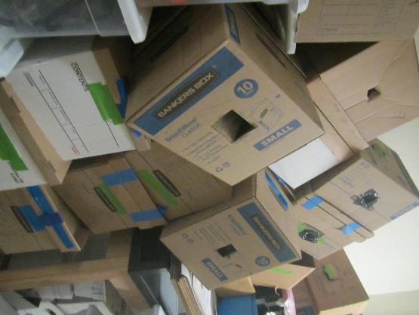
Disorganized storage of boxes
Picture 26
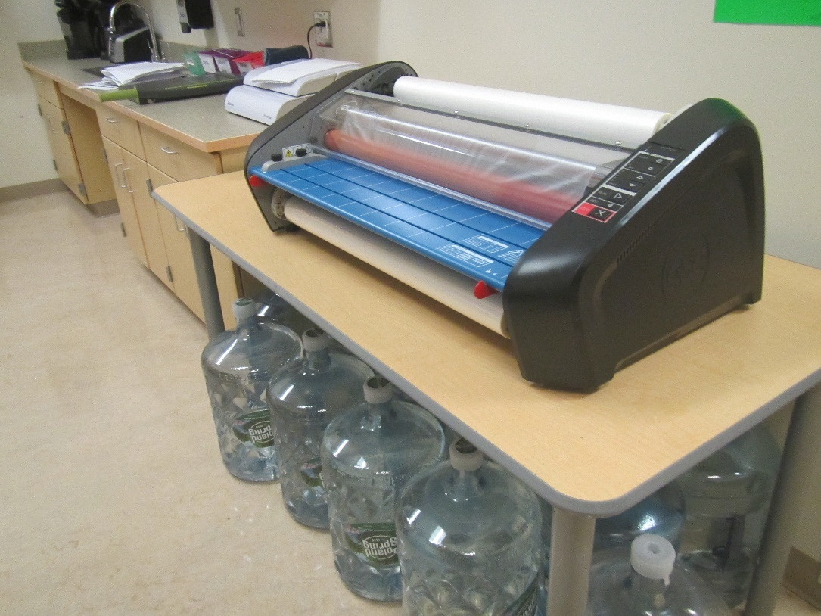
Laminator

Picture 27
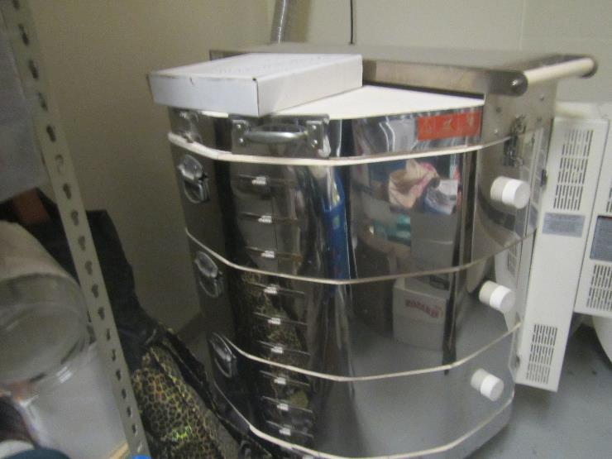
Kiln in an art storage room
Picture 28
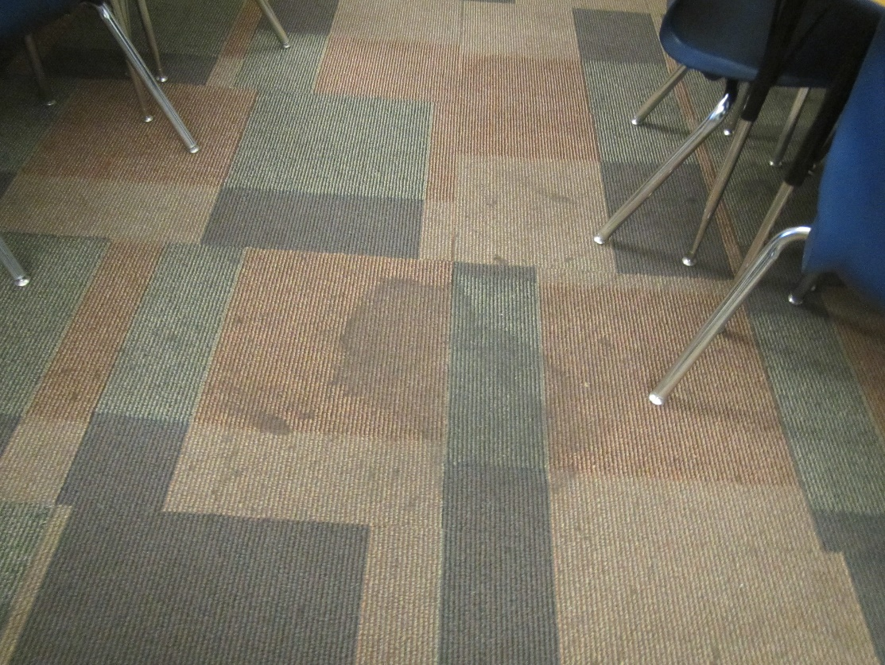
Stained carpeting in the library

Picture 29
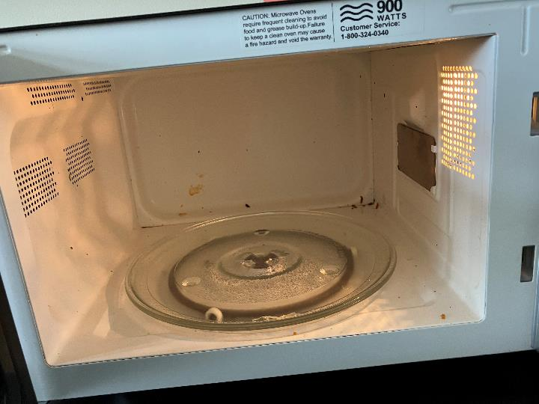
Dirty microwave

Click to link back to report

Table 1
Room | Openable Windows | HVAC | Ventilation |  | Ceiling Tiles/Staining (Y or N)  B = Bowed | Comments
Room | Openable Windows | HVAC | Supply | Exhaust | Ceiling Tiles/Staining (Y or N)  B = Bowed | Comments
A212 | Y | Y | Y | Y | N | DEM, plush chairs,
A209 | Y | Y | Y | Y | N | Univent, DEM, dusty exhaust
A202 science | Y | Y | Y | Y | N | 4 sinks, emergency shower
Teacher’s workroom | Y | Y | Y | Y | N | Refrigerator, microwave dirty, sink, PC
A217 | Y | Y | Y | Y | N | Sink, DEM, sink backsplash needs sealant
A218 | Y | Y | Y | Y | N | DEM
Boys’ restroom | N | Y |  | Y | N | One missing ceiling tile
A226 | Y | Y | Y | Y | N | Sinks, DEM, emergency shower
A224 | Y | Y | Y | Y | N | DEM, HS
A222 | Y | Y | Y | Y | N | DEM
A219 | Y | Y | Y | Y | N | DEM
A210 | Y | Y | Y | Y | 1 | DEM, Hole in window screen
A208 | Y | Y | Y | Y | N | DEM
A207 | Y | Y | Y | Y | N | DEM
A202 | Y | Y | Y | Y | 2
Custodial Closet |  |  |  |  |  | Mop/bucket, cleaning supplies and tools
A216 | Y | Y | Y | Y | N
Girls’ restroom | N | Y |  | Y | Y
Special needs restroom | N | Y |  | Y |  | Exhaust vent dirty
A225 | Y | Y | Y | Y | N | DEM
A223 | Y | Y | Y | Y | N | DEM
A221 Counselor’s Room | N | Y | Y | Y | N
C203 art classroom | Y | Y | Y | Y | N | DEM, teacher said that the room feels ‘stuffy’ sometimes and warmer than what is noted on the thermostat
C206 |  |  |  |  |  | Information Technology storage room
C201 art | Y | Y | Y | Y | N | Kiln in back has not been used in a long time, and room is used for storage.
Top of Auditorium | N | Y | Y | Y | N | Carpet
B219 |  | Y | Y | Y | N | Carpet
Boys’ restroom near cafeteria
Girls’ restroom near cafteria | N | Y | Y | Y | N | Exhaust dusty
Cafeteria | Door to outside | Y | Y | Y | N
B114 Janitor’s closet |  |  |  |  |  | Floor wax odor
B117 |  |  |  |  |  | Information Technology room
Hallway outside B121 |  | Y | Y | Y | 1
B116 | N | Y | Y | Y | N
B121 | Y | Y | Y | Y | N | DEM
Gym | N | Y | Y | Y | N
C119 | N | Y | Y | Y | N
C123 | N | Y | Y | Y | N
Girls’ gym restroom | N | Y | Y | Y | Y | Some water stains on ceiling
C103 | Y 3 open and door to outside | Y | Y | Y | N | Sink, HS
C108 | N | Y | Y | Y | N | Carpet, interior offices have art supplies, and stained carpet
C112 | N | Y | Y | Y | N | Special Education office in library, sink, refrigerator, microwave with crumbs
C109 | N | Y | Y | Y | N | Carpet, food, reed air fresheners
C110 | N | Y | Y | Y | N | HS, carpet
Music | N | Y | Y | Y | N | Cloth baffles on wall, sink, storage, dehumidifiers operating in music instrument storage
Custodial closet behind Auditorium
Stage | N | Y | Y | Y | N | DEM
B 102 Teachers lunch | Door to outside | Y | Y | Y | N | PC, DEM, stove, oven (not used), microwave (dirty), no kitchen exhaust
A110 | Y | Y | Y | Y | N | DEM
A108 | Y | Y | Y | Y | N | Some paint damage noted at a corner where ceiling meets wall
A117 | Y | Y | Y | Y | N | DEM
A125 | Y | Y | Y | Y | N | DEM
A123 | Y | Y | Y | Y | N | DEM
A121 Sensory room | N | Y | Y | Y | N | DEM, Bean bag chairs, padded swing in the center of the room floor mats
TV Station Room | Y | Y | Y | Y | N | DEM, trash on the floor
A109 | Y | Y | Y | Y | N | DEM, fake plant
A107 | Y | Y | Y | Y | N | Perfume odor, DEM, DO
Workroom |  |  | Y | Y | N | Refrigerator, sink, PC, microwave (dirty)
A115 janitor’s closet |  |  |  |  |  | WD pipe wrap
A117 | Y | Y | Y | Y | N | DEM, sink
A118 | Y | Y | Y | Y | N | Plush items
Boys’ restroom | N | Y | Y | Y | N | Missing ceiling tile, tissue on ceiling
A126 | Y | Y | Y | Y | N | DEM
A124 | Y | Y | Y | Y | N | DEM,
A122 | Y | Y | Y | Y | N | DEM
A119 | Y | Y | Y | Y | N | DEM, HS
C floor Boys restroom | N | Y | Y | Y | 2
C002 | N | Y | Y | Y | N | Carpet, food
B020 Storage Room
B104 | N | Y | Y | Y | N
B105 Counseling Room | Y | Y | Y | Y | N | DEM, Carpeted
Kitchen Storage
A025 | Y | Y | Y | Y | N | DEM
B026 | Y | Y | Y | Y | N | Sinks, broken ceiling tile
Girls’ restroom | N | Y | Y | Y | Y | a few WD CT
B002 | Y | Y | Y | Y | N | Science sinks, DEM, air purifier
A030 | Y | Y | Y | Y | N | DEM
A024 | Y | Y | Y | Y | N | DEM
Office | Y | Y | Y | Y | N | Heater – occupant reports room is cold
A022 | Y | Y | Y | Y | N
A012 | N | Y | Y | Y | N | Personal fan, refrigerator, microwave
A014 | Y | Y | Y | Y | N | Many offices through this space used for OT/Speech therapy
A003 | N | Y | Y | Y | N | Nurse’s office, not carpeted, sink, and refrigerator
Main office | Y | Y | Y | Y | Y | 1 WD CT
A050 | Y | Y | Y | Y | N | Carpet, food
A049 conference | Y | Y | Y | Y | N | Carpet, DEM
Office breakroom | Y | Y | Y | Y | N | Laminator, not carpeted, photocopier, sink
Office restroom | N | Y | Y | Y | N | Scented products
A048 | Y | Y | Y | Y | N | Carpet, food, plants, refrigerator
Welcome Center Room | Y | Y | Y | Y | N | Ceiling bubble by the sprinkler
A035 Acid Waste Room | N | N | N | N | N | Sump pump
A041 | Y | Y | Y | Y | N | DEM, fake plants, stuffed toys
A040 | Y | Y | Y | Y | N
A039 Social Workers Room | N | Y | Y | Y | N | Lots of fake plants and mood lighting
A037 | Y | Y | Y | Y | 2

(Click to link back to report)

Table 2A
Equipment Present in Building  (X = Yes) | Type of Heating/Cooling Ventilation  Equipment | Fresh  Air  Supply  (X = Yes) | Type of Location(s) | Air Filters Installed  MERV Rating  (1-15, U*)  (X = Yes) | Comments
 | Univents
X | Rooftop Air Handling Units | X | Most areas | X, 8
 | Outdoor, Ground-Installed Air Handling Units
 | Attic/Crawlspace Air Handling Units
X | Ceiling-Mounted Air Handling Units (including inside plenum) | Not known | Some areas
 | Basement/Crawlspace-Installed Air Handling Units
 | Mechanical Room-installed Air Handling Units
X | Fan Coil Units | no | Many classrooms and other rooms | X, 8
 | Window-Mounted Air Conditioners
 | Wall Louver-Controlled Gravity Air Supply
X | Windows |  | Classrooms, offices |  | Facility staff indicate these aren’t to be used
 | Fan in window (blowing in)
 | Built in wall fan (switched)
 | Heat recovery ventilator unit
 | Energy recovery ventilator unit
 | Chilled Beam
 | Passive combustion supply vent in basement/boiler room

*U = Filter Rating underdetermined due to inaccessibility during building visit

(Click to link back to report)

Table 2B
Equipment Present in Building  (X = Yes) | Type of Exhaust Ventilation  Equipment | Ducted  To Outdoors  (X = Yes) | Type of Location(s) | Comments
X | Rooftop Motors/Fans | X | Classrooms and offices
 | Unit Exhaust
X | Ceiling Return Vent | X | Most classrooms/offices
 | Ceiling Return Vent, Plenum
X | Wall Return Vent | X | Cafeteria/Auditorium
 | Kitchen Stove Hood
X | Restroom Exhaust Vent | X
 | Photocopier Exhaust Vent
 | Garage
X | Chemical Hood(s) | X | Science classrooms | Units are not connected or used, but rooftop equipment is present
X | Locker Rooms | X
 | Showers
 | Clothes Dryers
 | Gas Water Heaters
 | Furnace-Flue to Chimney
 | Furnace/Boiler direct vent or power vent (no combustion air supply)
X | Kiln, Pottery | X | Art storage area | Not currently used
 | Dark Room
 | Generator Room
 | Wood Shop Dust Collector
 | Spray Paint Booths
 | Fan in window (blowing out)

Table 2C
Equipment Present in Building  (X = Yes) | Type of Equipment | Type of Location(s) | Comments
 | Floor Fans, pedestal
X | Floor Fans, portable | Classrooms
X | Air Purifier (HEPA, other) | Classrooms, offices
 | Floor heaters, portable
X | Refrigerators, Cold Beverage Vending Machines
X | Radiator, wall-mounted | Exterior walls in many areas
 | Radiator, floor-mounted
 | Passive Vents (Wall/Door)

(Click to link back to report)

Table 3
Found in Building  X = Yes | Water-Damaged Materials, Building Components or Stored Materials | Location | Visible Microbial Growth?  X = Yes | Musty odor detected?  X = Yes | Comments
 | Books-other bound materials
 | Brick walls – broken, missing mortar
 | Brick walls – blocked weep holes
 | Cardboard boxes
X | Carpet tiles | Library |  |  | Dark staining on carpet, but not moldy
 | Carpet - Area rugs
 | Carpet wall-to-wall
 | Ceiling tiles - affixed directly to ceiling surface
 | Ceiling tiles - bowing-in suspended ceiling
 | Ceiling tiles - water-stained in splined ceiling
X | Ceiling tiles - water-stained in suspended ceiling | Classrooms, offices
 | Chairs - laminated
 | Cloth
 | Countertops (around sinks)
 | Curtains
 | Dust/debris within AHU, uninvent, HVAC, chilled beam units, etc. (WD through condensation, humidity, or leaks)
X | Efflorescence (i.e., mineral deposits) | One exterior wall
 | Engineered woods - particleboard, plywood, Masonite
 | Flooring – loosened tiles
 | Flooring - wooden
 | Furniture - laminated
 | Furniture - upholstered
 | Gypsum wallboard - ceiling
 | Gypsum wallboard - restroom wall
 | Gypsum wallboard - interior wall
 | Gypsum wallboard – located on exterior wall
 | HVAC drain pan – lack of draining
 | HVAC filters
 | Insulation- attic (paper-backed)
 | Insulation - inside air handling unit
X | Insulation - on pipe(s) fiberglass | Utility spaces | N | N
 | Insulation - on pipe(s) other/plaster-like material
 | Insulation - wall cavity
 | Insulation – ceiling plenum
 | Modular furniture – walls/cloth partitions
 | Musical instrument cases
 | Plaster ceilings
 | Records/files
 | Refrigerator - door gasket
 | Refrigerator - drip pan
 | Refrigerator - Interior surfaces
 | Room divider - ceiling-mounted, sliding
 | Sink backsplash
 | Sink under cabinet
 | Tables – laminated
 | Wallpaper
 | Wood - attic/roof materials
 | Wood - floor joists in basement ceiling
 | Wood - wall framing
 | Wood – windowsills
 | Wood - window-mounted air conditioner framing
 | OTHER

WHAT ARE ENVIRONMENTAL ASTHMA TRIGGERS?
Asthma triggers are any chemical, pollutant, or allergen that can make your asthma worse. Asthma triggers can also be strong chemical smells, dust, or pets. Your asthma triggers may be different from those of other people. Not all asthma triggers affect people the same way. Environmental asthma triggers are found both indoors and outdoors. MDPH link: Asthma and Your Environment (mass.gov)

(click to link back to report)

Table 4
Condition Present  X = Yes | Possible asthma symptom-inducing environmental pollutant | Recommendation to reduce or eliminate the pollutant
X | Water Damage and/or Mold  (allergen) | Identify water source and repair to eliminate.  Clean non-porous materials.  Remove and replace porous materials susceptible to mold growth.  Perform regular water damage assessments as a tool to ensure timely mitigation as needed.  Use NIOSH water damage assessment protocol as a guide: NIOSH water damage assessment guideline.
X | Moistening of building components during hot, humid weather (>2 days in length) (mold, allergen) | Remove materials not dried in <2 days in a manner consistent with US EPA Mold Removal in Commercial Buildings guideline.  Use dehumidification in occupied basement areas and other areas with chronic dampness.
 | Vegetation against exterior of building (water damage-mold) | Remove all vegetation preventing building exterior drying.  Remove all vegetation capable of falling onto a building or depositing debris onto the roof.
 | Personal humidifiers (lack of proper maintenance)  (pollutant and allergen) | Clean and maintain properly.  Use distilled water to eliminate metal and water treatment odors.  Maintain hydration by increasing water consumption.
X | Drains: Floor drains, Sink drains (abandoned use)  Water bubblers (abandoned use) | If in use, pour water into drain at least twice a week.  If not in use, seal the drain with an appropriate material in accordance with Massachusetts Plumbing Code (248 CMR 10.00).
 | Live Animals (turtles, gerbils, birds, rabbits, etc.) | Ensure cleanliness or remove animals from the location.
 | Improperly maintained aquariums and terrariums (allergen) | Maintain such equipment properly to eliminate odor.  Discontinue use.
X | Plants and flowers  (allergen and mold) | Keep indoor plants well maintained and not overwatered. Monitor for signs of mold and pests.  Ensure water for cut flowers does not become stagnant.  Ensure dried plant material is free of odors, mold, and pests and handled carefully  If asthma risks are high, eliminate plants and flowers.
 | HVAC system moisture issues  (mold, allergen) | Consult ASHRAE’s minimum standards for HVAC maintenance and inspection of commercial HVAC systems (https://www.ashrae.org/technical-resources/bookstore/standards-180-and-211).
 | HVAC system contaminant issues (allergen) | Consult ASHRAE’s minimum standards for HVAC maintenance and inspection of commercial HVAC systems (https://www.ashrae.org/technical-resources/bookstore/standards-180-and-211).
 | Indoor swimming pool odors outside of swimming pool (mold, chemical) | Maintain and operate pool HVAC systems to vent odors from building.  Ensure locker room exhaust vents are operating during building hours.  All doors leading to pool should be rendered airtight and be closed.
X | Pollen (allergen) | Recommend installation of MERV 8 or better filters if HVAC engineer confirms HVAC system can be so equipped without adversely affecting function.  Cut grass after hours.  Cut grass in a pattern to direct clippings away from exterior wall.  Remove trees and shrubs from in front of windows and air intakes.
 | Dry air | Maintain hydration.  Avoid overheating of air.
X | Dust mites  (allergen) | Recommendation to remove non-official upholstered furniture, area rugs, pillows, cushions, etc.  Cleaning with use of HEPA-filtered vacuum cleaner.  Eliminating clutter, storing items in dust and moisture-proof containers, and regularly removing dust through wet wiping.
 | Pests, including rodents and cockroaches  (allergen) | Use of integrated pest management guidelines, including:  - Proper disposal of food containers  - Proper storage of food products in airtight containers  - Elimination of use of food as art projects  - Remove pest harborages/clutter  - Regular monitoring for pests  EPA IPM guideline link
 | Latex-containing materials | Remove tennis balls from furniture legs or replace with latex free ones.
X | Fragrances  (chemical) | Eliminate point sources, such as:  - Plug-in air fresheners  - Aroma/oil reed diffusers  - Scented sprays  - Discontinue use of other scented materials  - Consult MDPH fragrance guideline: Clean air is odor-free
 | Strong smells from /use of Chemicals (such as cleaning products)  (chemical) | Use building-issued cleaning products.  Use products in accordance with manufacturer’s instructions including dilution, application, and ventilation.  Avoid using products that are stronger than needed for the situation.
 | Strong odors from new building materials (carpeting/furniture)  (chemical) | Use low VOC-emitting materials.  Air out materials (outside or in unoccupied area) prior to installation.
 | Tobacco smoke  Secondhand Smoke  (pollutant) | Eliminate tobacco smoking.  Seal all shared wall penetrations.
X | Products with strong odor such as paint, perfume, hairspray, air fresheners, bug-spray, laminators, candles, wax melters, dry erase markers and other VOC-containing products  (chemical) | If essential:  - Provide proper exhaust ventilation to eject aerosolized product directly outdoors.  - Avoid/reduce use during occupied hours.  If not necessary, remove and eliminate.
 | Vehicle exhaust  (pollutant) | Enforce anti-idling regulations and post signs to give notice.  Relocate vehicles away from fresh air intakes.  Require cars to park face-in at building walls.  idling-faq
 | Vapors and or fumes from gas, oil, or kerosene stoves  (pollutant) | Operate stove hood when stove in use.  Install stove hood if not present.  Ensure equipment is in good working order.
 | Ozone (pollutant) | Eliminate use of ozone generating equipment.
 | Window Air Conditioners (if not properly maintained) (allergen) | Equip with proper filter and clean periodically.  Clean drip pans.  Install in window with weathertight, non-mold-growth sustaining material.
 | Pottery (pollutant) | Do not operate kiln during occupied hours.  Operate kiln with exhaust system activated.  Seal all seams and holes in kiln vent.  Ensure kiln exhaust discharge terminates outdoors.
X | Carpeting (allergen) | Clean carpeting in a manner consistent with IICRC standards, including regular vacuuming with a high efficiency particulate air (HEPA) filtered vacuum in combination with annual cleaning or semi-annual cleaning in soiled high traffic areas.
X | Sweeping/dusting vs HEPA vacuuming/wet wiping  (allergen or pollutant) | Refrain from using feather dusters or brooms.  Utilize HEPA vacuums and wet wiping to minimize aerosolizing particulate matter.
 | Lack of adequate air exchange/mechanical ventilation | Make repairs as necessary and ensure all HVAC system components are operating continuously when building is occupied.
 | Lack of local exhaust at source of pollution (vocational shop activities, kitchen exhaust hood) (all) | Recommend installation of exhaust ventilation to direct pollutants directly outdoors.
 | Renovating buildings while occupied  (chemical) | Use all SMACNA guidelines for Renovation While Buildings Are Occupied. For information, visit https://www.mass.gov/service-details/construction-and-renovation-generated-pollutants-in-occupied-buildings.
 | Chemistry program chemical storage  (chemical) | Repair (if needed) and operate chemical storeroom vents appropriately. Reduce or eliminate unneeded or overstocked chemicals. Store all chemicals in a manner to separate incompatible chemicals.  Keep chemical storerooms clean.
X | Photocopiers/duplicating machines | All machines should have dedicated exhaust vents.

