INDOOR AIR QUALITY WALKTHROUGH

**Spencer Borden Elementary School**

1400 President Avenue

Fall River, MA

**June 2025**

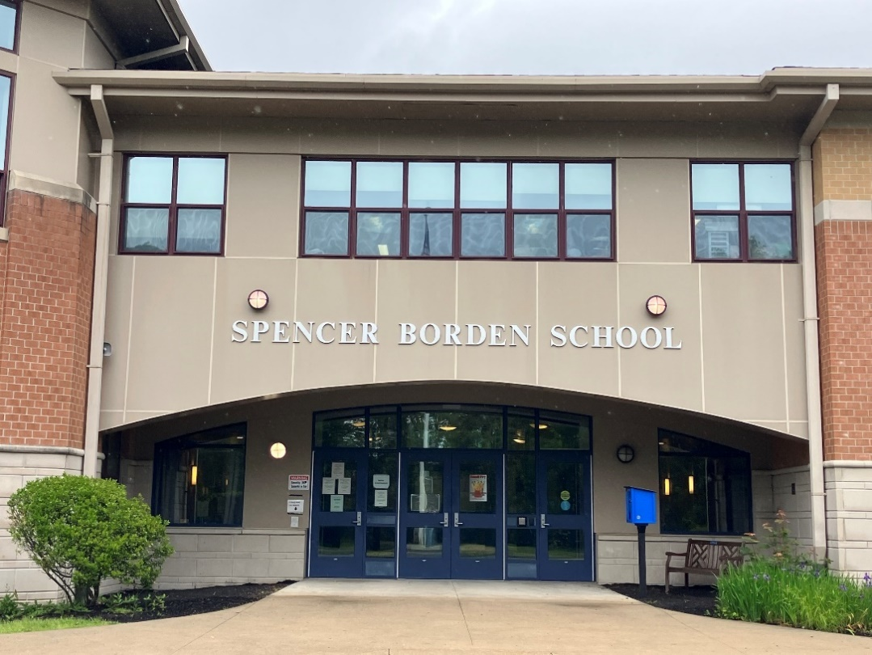

Prepared by:

Massachusetts Department of Public Health

Bureau of Climate and Environmental Health

Division of Environmental Health Regulations and Standards

Contents

EXECUTIVE SUMMARY 3

BACKGROUND 5

RESULTS AND DISCUSSION 5

Ventilation 5

Water Damage and Moisture Concerns 7

Sources of Respiratory Irritants/Possible Asthma Triggers 10

Other IAQ Issues 12

CONCLUSIONS AND RECOMMENDATIONS 12

REFERENCES 19

FIGURES 21

PICTURES 22

Ventilation Pictures 22

Water Damage Pictures 29

Respiratory Irritants Pictures 35

Table 1 39

Table 2A 44

Table 2B 45

Table 2C 46

Table 3 47

Table 4 49

# EXECUTIVE SUMMARY

Massachusetts Department of Public Health’s (MDPH), Division of Environmental Health Regulations and Standards (EHRS) conducted an Indoor Air Quality (IAQ) walkthrough of the Spencer Borden Elementary School located at 1400 President Avenue

Fall River on May 29, 2025. This walkthrough was in conjunction with the “Asthma in Schools: Data to Action Project”- a collaboration between Massachusetts Department of Public Health (MDPH) programs, local health departments, and local school health and administration officials to support asthma prevention and intervention efforts in school settings.

Any building can have IAQ issues. These issues can be made worse through conditions common to marginalized communities (Environmental Justice communities or EJ) such as inequitable exposure to outdoor air pollution and a greater likelihood of poor building conditions leading to deterioration of IAQ resulting in higher asthma rates. The Spencer Borden Elementary School is within an EJ community. In addition, the pediatric asthma rate for this school as of 2023-2024 is 11.0%, which, while higher, is not statistically different than the statewide pediatric prevalence rate of 9.6% (MAEPHT, 2025).

The assessment was conducted by evaluating several key elements within the school; a visual inspection of the heating, cooling, and ventilating (HVAC) systems, water/microbial damage, exterior building envelope evaluation, cleanliness, and point sources of respiratory irritants such as chemicals. Data is collected in this manner to identify potential asthma triggers, allergens, and other environmental factors that can cause indoor air quality symptoms.

As a result of this walkthrough, there are several findings: conditions in this school are typical of elementary schools of this age and type, univents and other HVAC components are approaching or exceeding their lifespan, some water-stained ceiling tiles were observed, and there are occupant induced issues including storage/clutter and blockage of HVAC units. (Results and Discussion)

During the assessment some supply and exhaust components of the mechanical ventilation system were not operating to full capacity. This limits its ability to dilute and remove typical indoor pollutants as well as outdoor pollutants, such as vehicle exhaust, pollen, mold spores, and wildfire smoke. In addition, excess water vapor during hot, humid weather may also build up in the building and lead to water damage/mold growth to building materials over summer months. Several areas with visible water damage were noted during the assessment.

Upon review of these findings, a number of recommendations are made to optimize existing HVAC systems and improve air exchange. Issues regarding the presence of point sources of irritation such as clutter can be addressed to reduce dust and odors. (Conclusions)

Based on the results of the assessment, the following primary recommendations are made:

* Operate supply and exhaust ventilation *continuously* when the building is occupied. Check univents and exhaust vents during occupied periods to ensure they are on and operating to their full capacity.
* Educate teachers and staff on the operation of univents and exhaust vents so they can avoid blocking units and can report off or inoperable units to facility staff. If not already in use, consider using a tracking program to collect and administer work orders for mechanical systems.
* Continue with plans for roof repair/replacement, and continue with plans to remove old worn carpeting from remaining areas of the school.
* Replace water-damaged ceiling tiles and clean/replace other water-damaged materials.
* Consider reducing the number of items stored in rooms and storage areas. Particular care should be taken with the Art storage room, and storage rooms 1A and 1B. The latter contains filters used in HVAC equipment which need to be kept clean and dry before use. To control dust, a high efficiency particulate arrestance (HEPA) filter equipped vacuum cleaner in conjunction with wet wiping of all surfaces is recommended. Avoid the use of brooms and feather dusters.

Please note: this report contains a series of recommendations that should serve as Best Practices that apply to most public-school buildings across the Commonwealth and should be shared amongst other buildings in the school district.

# R an BACKGROUND

|  |  |
| --- | --- |
| Building: | Spencer Borden Elementary School (SBES) |
| Address: | 1400 President Avenue  Fall River, Massachusetts |
| Coordinated Via: | Dr. Tracy Curley, Superintendent, Fall River Public Schools |
| Reason for Request: | Pediatric Asthma Project and General IAQ |
| Date of Assessment: | May 29, 2025 |
| Massachusetts Department of Public Health/Bureau of Climate and Environmental Health/Division of Environmental Health Regulations and Standards (MDPH/BCEH/EHRS) Staff and Bureau of Community Health and Prevention (BCHAP) | Bharathi Patimalla-Dipali and Ruth Alfasso, IAQ Outreach and Education Unit, EHRS |
| Building Description: | The SBES is a two-story brick and concrete building originally built in the early 2000s. The building has a triangular shape around a courtyard. The roof is peaked and shingled in most areas, but is flat with a rubber membrane in one section. The roof is original to the building. The school contains general classrooms, offices, and accessory rooms including a gym and combination cafeteria/auditorium. |
| Windows: | Most windows in the school are openable. |

# RESULTS AND DISCUSSION

A summary of conditions observed during the indoor air quality walkthrough can be found in (Table 1).

## Ventilation

Ventilation refers to both the supply of fresh air and the removal of stale air from a room. The introduction of fresh air into an occupied space will dilute normally occurring pollutants that are generated by occupancy and other activities. In addition, an HVAC system will remove pollutants from a building if operating appropriately. All ventilation systems throughout the building should operate continuously during periods of occupancy.

The SBES has a combination of unit ventilators (univents, Picture 1), and air handling units (AHUs) located on rooftops and in mechanical rooms (AHUs). Univents and the AHUs provide both heating and cooling in the school. A chiller was installed in late 2024 that is not currently active, so no cooling can be provided to most areas. Univents bring in fresh air from a vent on the outside of the building (Picture 2), filter it, heat it, and supply the air through a vent on the top. Some room air is recirculated along with the fresh air through a vent at the bottom (Figure 1). The air handling units bring in fresh air from the roof, filter it, heat it or cool it, and bring it into the occupied areas through ceiling-mounted supply vents (Picture 4). Classrooms and other rooms are also equipped with exhaust vents located along walls or on the ceiling (Pictures 5 and 6) that remove stale air from rooms.

Additional ceiling-mounted units were found in some rooms (Picture 7). It was not known at the time of the assessment whether these are ceiling-mounted univents with a fresh air supply, or fan coil units. Fan coil units operate similarly to univents, but they have no fresh air intake, and therefore only recirculate and heat/cool the air.

Radiators were present along exterior classroom walls to provide additional heat (Picture 8). In one section of the school, radiators were built into carpeted seats next to windows (Picture 9).

The various types of ventilation components as well as devices that can move/redirect airflow are listed in Table 2A, Table 2B and Table 2C.

### HVAC System Maintenance

* **Univents, AHUs, and other HVAC components may be beyond their service life.** According to the American Society of Heating, Refrigeration, and Air-Conditioning Engineering (ASHRAE), the service life of this type of unit is 15-20 years, assuming routine maintenance of the equipment (ASHRAE, 1991).
* As mentioned above, a new chiller was acquired in late 2024 but is not currently working. This unit would supply cooling for most HVAC units in the building, so no means of cooling is currently available.

**Balancing**

To have proper ventilation with a mechanical supply and exhaust system, a system must be balanced to provide an adequate amount of fresh air to the interior of a room while also removing stale air from the room.

It is recommended that HVAC systems be re-balanced every five years to ensure adequate air systems function (SMACNA, 1994).

### HVAC Types and Specific Conditions

(see Ventilation Pictures)

**Classroom Unit ventilators**:

* **Some univents were blocked** with items or furniture (Picture 10; Table 1).
* **Some univents were off or not operational** (Table 1), so no fresh air was being provided during the walkthrough.
* The MDPH IAQ Outreach and Education Unit recommends that filters of at least minimum efficiency reporting value (MERV) 8 or better be used, if an HVAC engineer confirms system can be so equipped without adversely affecting function, as these are adequate to filter out pollen, mold, and similar particulates (ASHRAE, 2012).
  + A univent was opened and the filter examined (Picture 11). The rating could not be determined, and this filter appeared to be of middling quality, likely not more than MERV 8 and potentially less.
  + This filter had a date of 3/25 marked on it, indicating that it had been changed two or three months prior. Changing filters 2-4 times a year is recommended, and dating filters is good practice to ensure this occurs.
  + Filters were found in a storage area stored in a disorganized manner, with dirty and clean filters stored in the same area, and filter boxes open (Pictures 12 and 13). Filters need to be stored in an organized manner so the correct filters can be used, and should be protected from moisture, dust, and pests. Dirty filters should be discarded or at least stored in a separate location until disposal.

**Classroom Exhaust vents**:

* **Some of the exhaust vents were not operating to full capacity, as noted by a lack of or minimal air draw (Table 1).** This could be due to not being turned on, or a problem with the fan. However, most exhaust vents that were tested were operating correctly.
* **Several wall-mounted exhaust vents were found obstructed by items or furniture (Picture 14).** Without proper supply and exhaust ventilation, normally occurring environmental pollutants can build up and lead to IAQ or comfort complaints. In addition, without proper exhaust ventilation, excess moisture cannot be removed from the building, which can lead to mold growth conditions over the summer.

**Additional HVAC Conditions:**

* **Most classrooms have openable windows (Table 1)**. These can be used for additional fresh air during temperate weather. Windows should be kept closed during wet weather to prevent water infiltration. They should also be kept closed during air conditioning operation, to prevent condensation and mold growth during elevated relative humidity, and at the end of the school day to prevent frozen pipes during the winter.

## Water Damage and Moisture Concerns

Please note that the IAQ Outreach and Education Unit does not recommend conducting mold testing in a typical water damage remediation. For details, please consult [Guidance Regarding Testing for Mold in Water-Damaged Public Buildings](https://www.mass.gov/info-details/guidance-regarding-testing-for-mold-in-water-damaged-public-buildings) | Mass.gov

The application of a mildewcide to moldy porous materials is not recommended.

Molds are found naturally in our environment both indoors and outdoors. Inside, mold growth may occur when items, particularly porous products such as paper or gypsum wallboard, are exposed to moisture. Typical water sources include leaks, floods, and condensation. To avoid mold growth, dry all water-damaged items and affected areas within 24-48 hours and reduce indoor humidity. Some people with chronic respiratory conditions, such as asthma, are more likely to experience health symptoms associated with molds, including allergic reactions and respiratory irritation. Controlling moisture is the key to preventing mold growth and potential health symptoms.

Hot humid summers are becoming more frequent due to climate change. Massachusetts has experienced hot, humid, and rainy summers in 2018, 2021, and 2023. July of 2021 was the wettest ever recorded in Massachusetts, and the three-month period from June through August, known as the meteorological summer, was the fourth wettest on record, according to the National Oceanic and Atmospheric Administration’s (NOAA) Centers for Environmental Information (NOAA, 2021). The summer of 2023 was measured as the second rainiest on record (WBUR, 2023). The summer of 2024 also had significant stretches of hot, humid weather. These conditions are challenging for buildings, particularly those without central air conditioning.

During these hot and wet summers, extended periods of outdoor relative humidity above 70% occurred. Public buildings experienced extended periods of water vapor exposure from high relative humidity. When exposed to these conditions, porous materials such as gypsum wallboard, cardboard, and other materials may become mold colonized, particularly if located in areas that are prone to developing condensation (e.g., floors and walls in below grade space). (see Water Damage and Moisture Concern Pictures)

* **Water-damaged ceiling tiles were found in many locations (Pictures 15 and 16; Table 1),** which indicate current/historic roof/plumbing leaks or other water infiltration. Water-damaged ceiling tiles can provide a source of mold and should be replaced after a water leak is discovered and repaired. Other signs of water infiltration were noted including water stains on walls (Picture 17). Plans to replace the roof are in progress. Therefore, the **school should continue to patch and make repairs as needed. Staff are encouraged to report any active leaks to the Facilities Department for prompt remediation and to avoid storing porous items in areas with active leaks.**
* **Plants were noted in some classrooms and offices (Picture 18).** Plants can be a source of pollen or mold especially if overwatered or not well maintained. Plants without drip pans can damage porous surfaces they are placed on.
* **Bowed or sagging ceiling tiles were noted in some areas (Picture 19; Table 1).** This is an indication that these rooms have been subjected to an extended period of high humidity. While bowing tiles are not a direct IAQ issue, it is a reminder that long periods of high relative humidity may lead to water damage to other materials, particularly those stored in contact with cooler temperatures such as uninsulated floors, and in the airstream of air conditioning.
* **Rust was noted on a few supply vents (Picture 20; Table 1).** This is another sign of high humidity. It is likely that during hot, humid weather when the air conditioning is operating, condensation forms on chilled surfaces such as supply vents.
* **School staff reported that during hot, humid weather when the power had gone out leading to no ventilation or air conditioning, condensation was noted on the floor.** With the chiller currently inoperable, these conditions are likely to recur.
* **Many classrooms had sinks. A few of them had porous items underneath (Picture 21).** Storing porous items underneath the sink can allow them to become wet with condensation or if there is a leak. In addition, some sinks were dripping and could not be turned all the way off (Table 1).
* **The original water fountains in the building were turned off during the COVID-19 pandemic and most remained off.** Bottle filling stations are now present in some areas of the school, but the disused water fountains are still present. This can lead the drain trap to dry out, which may allow sewer gases into occupied spaces.
* **Spaces were noted beneath/around exterior doors,** which can allow drafts, moisture, and pests into the building (Picture 22; Table 1).
* **Dehumidifiers were noted in some classrooms, particularly on the lower level.** Some were operating at the time of the walkthrough. Dehumidifiers are a good tool to lower humidity in the absence or lack of need for air conditioning. Dehumidifers either need to be emptied daily when in use or have the accumulated water directed to a drain such as in a sink. They need to be cleaned periodically to remove stagnant water that can produce odors. Dehumidifiers should not be used when humidity is low as this can further increase irritating effects of excessively dry air.

An exterior evaluation was also conducted to identify potential pathways for water penetration and pest entry. The following issues were noted:

* **Plants/shrubbery was noted near the building (Pictures 23 and 24),** which can prevent the exterior of the building from drying, and may damage walls and foundations. In addition, moisture, mold spores, and pollen may be drawn through air intakes on exterior walls.
* **Trees were noted overhanging the roof (Pictures 24 and 25).** Trees shade the building, preventing walls from drying, can drop debris that can clog gutters and drains, and provide transportation for pests to access windows and the building roof.
* **Some gutters appeared damaged and leaking (Pictures 26 and 27).** This can lead to damage to walls and water infiltration inside.

These conditions represent potential water penetration sources. Over time, these conditions can undermine the integrity of the building envelope and provide a means of water entry into the building via capillary action through foundation concrete and masonry (Lstiburek & Brennan, 2005).

**Mold Growth**

Porous materials (e.g., gypsum wallboard, ceiling tiles and carpeting) can be dried with fans and heating within 24 to 48 hours of becoming wet (US EPA, 2008).

If porous materials are not dried within this time frame, mold growth may occur.

A list of water damage issues identified inside and outside the building were identified which can contribute to water issues, is included as Table 3.

## Sources of Respiratory Irritants/Possible Asthma Triggers

Asthma is a lung disease that can make breathing difficult. Without careful management of asthma, some individuals can have symptoms, like a tight feeling in the chest, shortness of breath, coughing, or wheezing. Although there is no cure for asthma, individuals with asthma can live healthy, active lives. A safe and healthy environment helps to reduce asthma symptoms.

**Comparison of Local and State-wide Asthma Rates (2023-2024 school year/MAEPHT, 2025)**

15.5% of children

have asthma

**Fall River**

9.6% of children

have asthma

**Massachusetts**

11.0% of children

have asthma

**Spencer Borden Elementary**

* **Sometimes, learning tools and personal items in a classroom can be a source of irritants.** For example, a bird or insect nest is a great learning tool for students but may harbor microbes and allergens. Similarly, food-based projects can attract pests that carry disease or trigger allergies.
* **Personal products, particularly those with volatile organic compounds (VOCs) including scents, can also be a source of respiratory irritation.** VOCs are carbon-containing substances that have the ability to evaporate at room temperature. Frequently, exposure to low levels of total VOCs (TVOCs) may produce eye, nose, throat and/or respiratory irritation in some sensitive individuals. **Products noted were dry erase markers, air fresheners, sanitizers, and cleaning products (Picture 28; Table 1).** Consult “[Clean Air Is Odor Free](https://www.mass.gov/doc/clean-air-is-odor-free-removing-fragrances-to-improve-indoor-air-quality-in-schools-and-offices-0/download)” for more information on fragrances in schools and other building.
* **Dust, a common respiratory and eye irritant, can collect on surfaces and items.** Although janitorial and maintenance staff perform routine cleaning in classrooms, they may not be able to clean as effectively if classroom items are not picked up or surfaces are cluttered. **Many classrooms had clutter (Picture 29).**

Even with a properly functioning ventilation system, it is necessary to either eliminate or reduce the use of materials that can be a source of respiratory irritants to prevent symptoms in individuals who have sensitivity to such pollutants.

For guidance on maintaining an asthma-friendly healthy school environment, please consult the MDPH Asthma Prevention and Control Program’s [Clearing the Air: An Asthma Toolkit for Healthy Schools](https://www.maasthma.org/schooltoolkit).

Possible asthma triggers and/or airborne pollutants exist in the building. These are listed below as well as in (Table 4).

(see Sources of Respiratory Irritant Pictures)

* **Tennis balls had been sliced open and placed on table/chair footings to reduce noise in a few areas** **(Table 1).** Tennis balls are made of a number of materials that are a source of respiratory irritants. Constant wearing of tennis balls can produce fibers and lead to off-gassing of VOCs. Tennis balls are made with a natural rubber latex bladder, which becomes abraded when used as a chair leg pad. Use of tennis balls in this manner may introduce latex dust into the school environment. Some individuals are highly allergic to latex (e.g., spina bifida patients) (SBAA, 2001). It is recommended that the use of materials containing latex be limited in buildings to reduce the likelihood of symptoms in sensitive individuals (NIOSH, 1997).
* **Many classrooms had area rugs, pillow cushions, and upholstered chairs (Picture 30; Table 1).** Area rugs need to be cleaned regularly to remove dust, debris, and odors. Area rugs should also be stored off the floor in a climate-controlled area during the summer to prevent moistening by condensation. Used area rugs should not be brought into the school as they may harbor allergens such as pet dander.
* **Wall-to-wall carpeting is present in a few areas of the school.** This carpeting is original to the building and is therefore beyond its service life (IICRC, 2002). Much of this carpeting was reportedly replaced with non-porous flooring, and there are plans to replace the rest.
* **Photocopiers and laminators were found in the school (Table 1).** Photocopiers produce heat and ozone, and laminators melt plastic and produce odors when in use. Local exhaust should be provided for these areas or they should be placed near an openable window.
* **Some classrooms and storage rooms had an excess of items such as books, craft materials, papers, and other miscellaneous materials**. This was particularly prominent in the Art storage room (Picture 31) and the 1A storage room (Picture 32) as well as storage room 1B which contains filters as described above.
* **In some areas supply vents, exhaust vents, and personal fans had accumulated dust and debris** (Table 1). The univent cabinet that was opened for inspection also was dusty. This dust can be aerosolized under certain conditions and can also be a medium for mold growth. Univent and AHU cabinets should be cleaned out during filter changes.
* **Hanging items were noted in some classrooms.** Items hanging from the ceiling can collect dust and become water-damaged due to leaks. In addition installing such items can disrupt the ceiling tile grid and allow dust and debris from tiles and above tiles to enter occupied space. **In a few classrooms, cloth was placed over lights.** These need to be appropriately fire-retardant and cleaned periodically (e.g. every year) to remove dust.
* **Air purifiers were noted in a few classrooms.** These need to be kept clean and maintained, including filter changes.
* **Break rooms around the school and some classrooms and offices have food storage and preparation equipment such as refrigerators, microwaves, and toasters. Some of this equipment was dirty (Picture 33).** Food spills and crumbs can be a source of odors, especially when heated, and can attract pests.
* **Pallets were stored in stacks in contact with the building exterior (Picture 34)** which can provide harborage for pests.
* **The elevator mechanical room on both the upper and lower level had a strong odor** that could be described as “burning rubber” or “electrical”. School staff reported that the elevator company did not think this was due to any malfunction. The elevator rooms lack any ventilation apart from passive vents on the wall to the elevator shaft.

## Other IAQ Issues

*Radon*

Radon is a naturally occurring radioactive gas that seeps into buildings from the surrounding soil and can increase the risk of lung cancer at elevated levels.

The Environmental Protection Agency (EPA) conducted a National School Radon Survey “in which it discovered nearly one in five schools has at least one schoolroom with a short-term radon level above the action level of 4pCi/L (picocuries per liter) – the level at which the EPA recommends that schools take action to reduce the level” (US EPA, 1993).

**The MDPH therefore recommends that every school be tested for radon, and that this testing be conducted during the heating season while school is in session in a manner consistent with US EPA radon testing guidelines**. Radon measurement specialists and other information can be found at [www.nrsb.org](http://www.nrsb.org) and <http://aarst-nrpp.com/wp>, with additional information at: <https://www.mass.gov/radon>

# CONCLUSIONS AND RECOMMENDATIONS

Please note: this report contains a series of recommendations that should serve as *Best Practices* that apply to most public-school buildings across the Commonwealth and should be shared amongst other buildings in the School District.

Issues typical to many schools were found in this building. The age of the HVAC equipment will make controlling temperature and airflow more difficult as time goes on. Other issues described can be mitigated with repairs to the building, and changes to occupant behaviors to reduce blockages of univents/exhaust vents and clutter.

**Short-term recommendations** can be implemented as soon as practicable, however **long-term measures** are more complex and will require planning and resources to adequately address overall indoor air quality issues within the building.

|  |  |  |
| --- | --- | --- |
| **Short-term Recommendations** | | |
| **HVAC System** | | **Helpful Links** |
| 1. 1. | Ensure all AHUs and univents are on and operating *continuously* during occupied periods if operable. If univent fan operation is linked to thermostat, work with HVAC vendor to operate independently as to not “cycle” off/on during the school day. |  |
| 1. 2. | Remove blockages from exhaust vents, and the top/front of univents, including furniture and items. |  |
| 1. 3. | Periodically check the function of all classroom and restroom exhaust vents. Repair as needed. |  |
| 1. 5. | Continue with regular filter changes for HVAC equipment using a minimum efficiency rating value (MERV) 8 or the best quality/highest MERV-rated filter that can be used without effecting airflow.  Ensure filters fit flush within their racks to prevent filter bypass. | [ANSI/ASHRAE Standard 52.2-2017](https://www.ashrae.org/File%20Library/Technical%20Resources/COVID-19/52_2_2017_COVID-19_20200401.pdf) |
| 1. 6. | During filter changes, clean dust and debris from the inside of univent and AHU cabinets. Clean radiators periodically. |  |
|  | Store unused filters in an organized manner in boxes to protect them from dust and moisture. |  |
| 1. 7. | Use openable windows for additional fresh air during temperate weather. Tightly close windows at the end of the day and avoid opening windows during extreme cold to prevent freezing of pipes. Keep windows closed when outdoor air quality is unhealthy. | <https://www.airnow.gov/> |
| 1. 8. | Continue with plans to repair the chiller and bring it online. Until chilling capacity is available, use these guidelines to control moisture and increase comfort in a non-air-conditioned school especially during heatwaves. | * Mold Growth Prevention During Hot, Humid Weather <https://www.mass.gov/service-details/preventing-mold-growth-in-massachusetts-schools-during-hot-humid-weather> * Remediation and Prevention of Mold Growth and Water Damage in Public Schools <https://www.mass.gov/service-details/remediation-and-prevention-of-mold-growth-and-water-damage-in-public-schools-and> * Methods for Increasing Comfort in Non-air-conditioned Schools <https://www.mass.gov/doc/methods-for-increasing-comfort-in-non-air-conditioned-schools/download> |
| **Water Damage Sources** | | |
| 1. 9. | Replace water-damaged ceiling tiles. Repeated water damage to ceiling tiles indicates leaks from the roof or plumbing/HVAC system which should be repaired. | <http://www.epa.gov/mold/mold-remediation-schools-and-commercial-buildings-guide> |
| 1. 10. | Properly maintain plants to avoid mold and odors. Keep plants away from airflow of HVAC equipment. |  |
| 1. 11. | While bowed/sagging ceiling tiles are not a source of mold, this indicates extended exposure to high humidity. Therefore, care should be taken with storage of materials in these areas during hot, humid weather and over the summer. |  |
| 1. 12. | Clean rust from supply and exhaust vents. Rust on vents may be a sign that chilled air is too cold, or excess moisture occurs in that room. |  |
| 1. 13. | Ensure sinks are in good repair without leaks. Avoid storing large amounts of materials or porous materials under sinks. |  |
| 1. 14. | Ensure disused water fountain drains are wetted periodically. If these units are never to be used again, have them properly cut and capped off. |  |
| 1. 15. | Seal spaces around exterior doors with weatherstripping, to prevent drafts, moisture, and pest entry. Make repairs as needed. |  |
| 1. 16. | Continue to use dehumidifiers during periods of elevated relative humidity. Clean and maintain units in accordance with manufacturers’ instructions. In cases where there are outlets available and *it is safe to do so*, dehumidifiers should be stationed on countertops to allow them to drain directly into sinks/floor drains to reduce daily maintenance. |  |
| 1. 17. | Trim trees, branches and shrubbery at least 5 feet away from the building. |  |
| 1. 18. | Repair leaking gutters and ensure that all drain lines are flowing properly to direct rain away from the building. |  |
| 1. 19. | Do not store cardboard, backpacks, clothing items or other porous items directly on floors to prevent mold growth due to condensation on cool surfaces, Elevate items with pallets or store on shelving. |  |
| 1. 20. | During summer months, pull furniture away (1 to 2 inches) from walls to prevent mold growth due to lack of airflow and remove impermeable wall coverings that can trap moisture such as laminated posters. |  |
| 1. 21. | Remove pallets from the exterior of the building on a regular basis to prevent rodent harborage. |  |
| **Respiratory Irritants/Possible Asthma Triggers** | | |
| 1. 22. | Learning tools, such as food-based projects and classroom animals, can be a source of irritants that attract pests and can trigger allergies. Continuously clear these areas of dust and debris. |  |
| 1. 23. | Reduce use of products and equipment that create irritating volatile organic compounds (VOCs) and only use in well-ventilated areas. Minimize the use of air fresheners (e.g., plug-ins), deodorizers and scented products. | <https://www.mass.gov/cleaner-greener-healthier-schools> |
| 1. 33. | Use only District-approved cleaning products. Keep spray bottles properly labeled and out of the reach of children. |  |
| 1. 34. | Provide exhaust ventilation or move copiers and laminators to a well-ventilated area with an exhaust vent. |  |
| 1. 26. | Clean area rugs frequently using a HEPA-equipped vacuum cleaner. Avoid bringing used area rugs into the school. |  |
|  | Clean carpeting regularly in accordance with IICRC recommendations (IICRC, 2012). |  |
| 1. 27. | Periodically, sort classroom and storage rooms for removal of unwanted items. Store the remaining items neatly and off the floor. |  |
| 1. 28. | Clean personal fans, ACs, supply, and exhaust/return vents periodically to remove dust and debris. |  |
| 1. 29. | Avoid hanging items from the ceiling tile grid. These items collect dust and debris and are in head to reach places. |  |
| 1. 30. | Supplement mechanical ventilation with portable air purifiers equipped with high efficiency particulate arrestance (HEPA) filters. While these do not supply fresh air, they can remove particles including mold spores and microbes.  Units that may produce ozone should not be used. Maintain all in accordance with the manufacturer’s instructions.  Place them so the filtered airstream is in the breathing zone of occupants and away from open doors and exhaust vents. | <https://www.epa.gov/indoor-air-quality-iaq/ozone-generators-are-sold-air-cleaners> |
| 1. 31. | Ensure the principles of integrated pest management (IPM) are followed in accordance with state regulations. Continue with district-wide plans to work with a professional pest contractor to address rodent infestation issues, including:   * reducing harborages inside and outside the building, * sealing breaches and pathways of entry, * centralizing food prep appliances to central location, * reducing/eliminating eating in classrooms, and   improving cleaning protocols | <https://massnrc.org/ipm/docs/ipmkitforbuildingmanagers.pdf> |
| 1. 32. | Consider providing ventilation to the elevator mechanical rooms with a strong odor. Consult with the elevator maintenance company regarding safe and effective means of ventilation and odor reduction. Keep doors to these rooms tightly closed. |  |
| **Other Recommendations to Improve Air Quality Conditions** | | |
| 1. 35. | Test the school for radon by a certified radon measurement specialist during the heating season when school is in session. | Radon measurement specialists and other information can be found at: [www.nrsb.org](http://www.nrsb.org), and <http://aarst-nrpp.com/wp> |
| 1. 36. | To learn more about radon, review the MDPH’s Radon in Schools and Child Care Programs factsheet. | <https://www.mass.gov/radon>. |
| 1. 37. | Utilize the US EPA’s (2000), “Tools for Schools” as an instrument for maintaining a good IAQ environment in the building. | <https://www.epa.gov/iaq-schools>. |
| 1. 38. | For guidance on maintaining an asthma-friendly healthy school environment, please consult the MDPH Asthma Prevention and Control Program’s *Clearing the Air: An Asthma Toolkit for Healthy Schools*. | <https://www.maasthma.org/schooltoolkit> |
| 1. 39. | Include an IAQ component in the school’s Wellness Advisory Committee program. An IAQ plan should have an IAQ liaison/teacher representative, a member of maintenance/facilities and administration that conduct regular walk-throughs to identify on-going and/or potential environmental issues. |  |
| **Long-term Recommendations** | | |
| 1. 40. | Since the HVAC system is likely beyond its service life contact an HVAC engineering firm for advice regarding conditions noted, including a building-wide HVAC equipment assessment to determine:   * Whether the existing HVAC system can be balanced as recommended. * The operability and feasibility repairing the existing equipment. * If the equipment should be replaced due to age, physical deterioration, and availability of parts for ventilation components. |  |
| 1. 41. | Consider installing sensor technology in classrooms to provide continuous monitoring of the following indoor air parameters (particularly temperature and relative humidity). Sensors should be re-calibrated quarterly or according to manufacturer’s specifications and building management software updated as per manufacturers’ instructions, industrial standards, and/or change in operating systems. As an example, the link to the right illustrates how this technology is serving Boston Public Schools to improve air quality (i.e., carbon dioxide, temperature, relative humidity, carbon monoxide, and particulate matter). | [COVID-19 Health & Safety Information / Indoor Air Quality Sensor Dashboard (bostonpublicschools.org)](https://www.bostonpublicschools.org/Page/8810) |
| 1. 42. | Continue to replace the carpet, that is beyond its lifespan, with nonporous material. |  |

# REFERENCES

# REFERENCES

ASHRAE. 1991. ASHRAE Applications Handbook, Chapter 33 “Owning and Operating Costs”. American Society of Heating, Refrigeration and Air Conditioning Engineers, Atlanta, GA.

ASHRAE. 2012. American Society of Heating, Refrigeration and Air Conditioning Engineers (ASHRAE) Standard 52.2-2012 -- Method of Testing General Ventilation Air-Cleaning Devices for Removal Efficiency by Particle Size (ANSI Approved).

IICRC. 2002. Institute of Inspection, Cleaning and Restoration Certification. A Life-Cycle Cost Analysis for Floor Coverings in School Facilities.

Lstiburek, J. & Brennan, T. 2005. Read This Before You Design, Build or Renovate. Building Science Corporation, Westford, MA. U.S. Department of Housing and Urban Development, Region I, Boston, MA. <https://www.buildingscience.com/documents/guides-and-manuals/gm-read-this-before-you-design-build-renovate/view>

MAEPHT. 2025. Massachusetts Environmental Public Health Tracking. Massachusetts Department of Public Health – Bureau of Climate and Environmental Health. <https://matracking.ehs.state.ma.us/>

NIOSH. 1997. NIOSH Alert Preventing Allergic Reactions to Natural Rubber latex in the Workplace. National Institute for Occupational Safety and Health, Atlanta, GA.

NOAA. 2021. Summer 2021 neck and neck with Dust Bowl summer for hottest on record. National Oceanic and Atmospheric Administration, 1401 Constitution Avenue NW, Room 5128, Washington, DC 20230 <https://www.noaa.gov/news/summer-2021-neck-and-neck-with-dust-bowl-summer-for-hottest-on-record>

SBAA. 2001. Latex In the Home And Community Updated Spring 2001. Spina Bifida Association of America, Washington, DC.

SMACNA. 1994. HVAC Systems Commissioning Manual. 1st ed. Sheet Metal and Air Conditioning Contractors’ National Association, Inc., Chantilly, VA.

US EPA. 1993. Radon Measurement in Schools, Revised Edition. Office of Air and Radiation, Office of Radiation and Indoor Air, Indoor Environments Division (6609J). EPA 402-R-92-014.

US EPA. 2000. Tools for Schools. Office of Air and Radiation, Office of Radiation and Indoor Air, Indoor Environments Division (6609J). EPA 402-K-95-001, Second Edition. <https://www.epa.gov/iaq-schools>.

US EPA. 2008. Mold Remediation in Schools and Commercial Buildings. US Environmental Protection Agency, Office of Air and Radiation, Indoor Environments Division, Washington, D.C. EPA 402-K-01-001. <http://www.epa.gov/mold/mold-remediation-schools-and-commercial-buildings-guide>.

WBUR. 2023. “It's been a summer of rain and flooding misery in Mass.” WBUR local news. September 12, 2023. <https://www.wbur.org/news/2023/09/12/summer-flooding-rain-massachusetts>.

# FIGURES

**Figure 1**

**Unit Ventilator (Univent)**

Mixed Air

Air Diffuser

**Outdoors Indoors**

Fan

Heating/Cooling Coil

Air Mixing Plenum

Filter

Outdoor Return

Air Air

Air

Flow

Control

Louvers

**Air Flow**

= Fresh Air/Return Air

= Mixed Air

# 

# PICTURES

(Click to link back to report)

## Ventilation Pictures

**Picture 1**

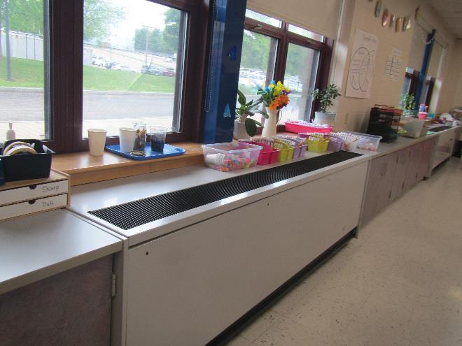

**Classroom unit ventilator (univent)**

**Picture 2**

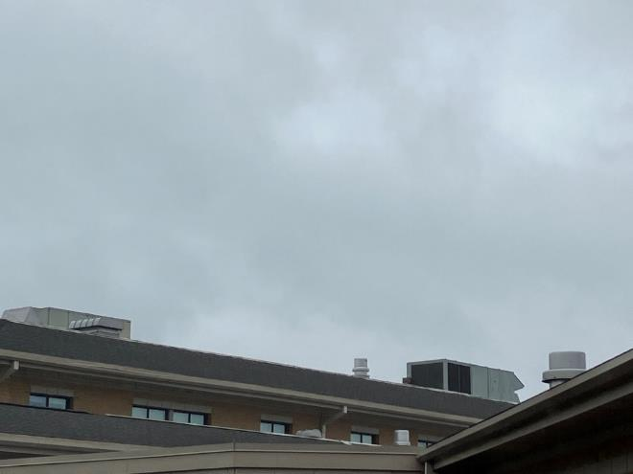

**Rooftop AHUs on the flat section of the roof**

**Picture 3**

**Univent air intakes along exterior wall
arrows point to univent air intakes**

**Univent air intakes along exterior wall (arrows)**

**Picture 4**

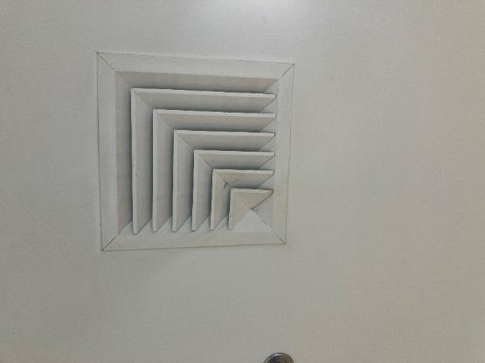

**Typical supply vent in the ceiling**

**Picture 5**

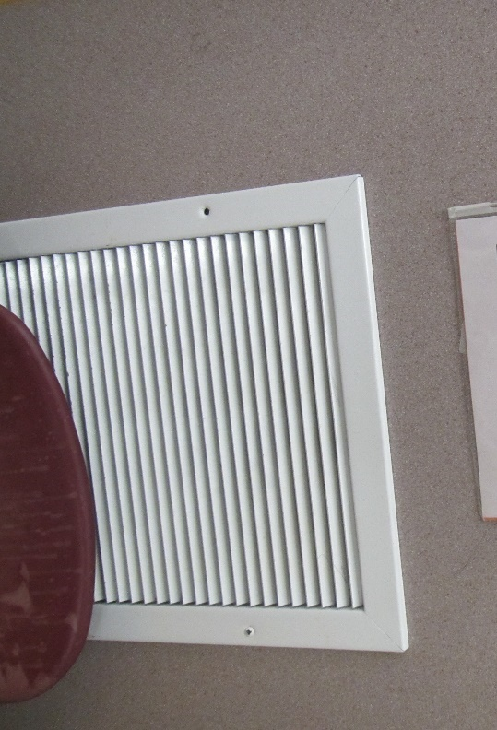

**Wall-mounted exhaust vent**

**Picture 6**

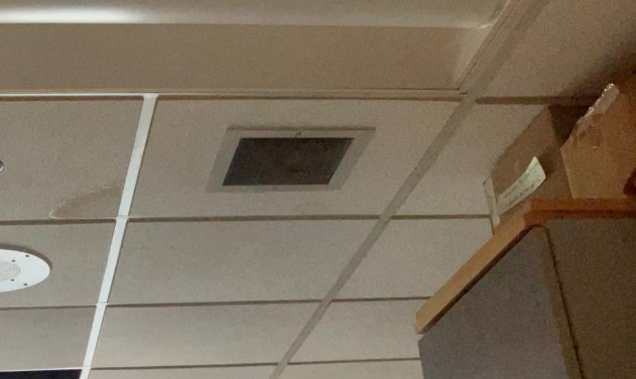

**Ceiling-mounted exhaust vent, note water-damaged ceiling tile**

**Picture 7**

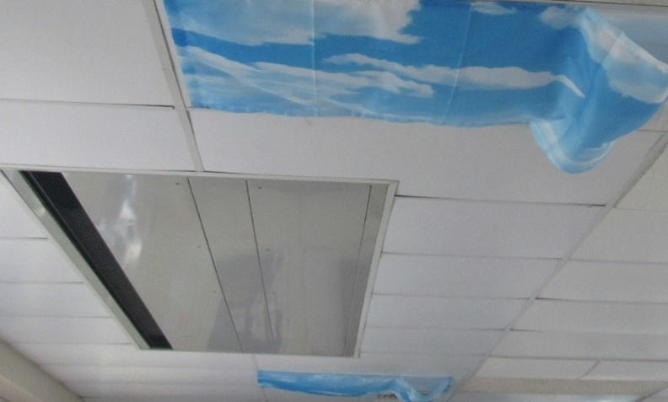

**Ceiling-mounted HVAC unit (univent or fan coil unit)**

**Picture 8**

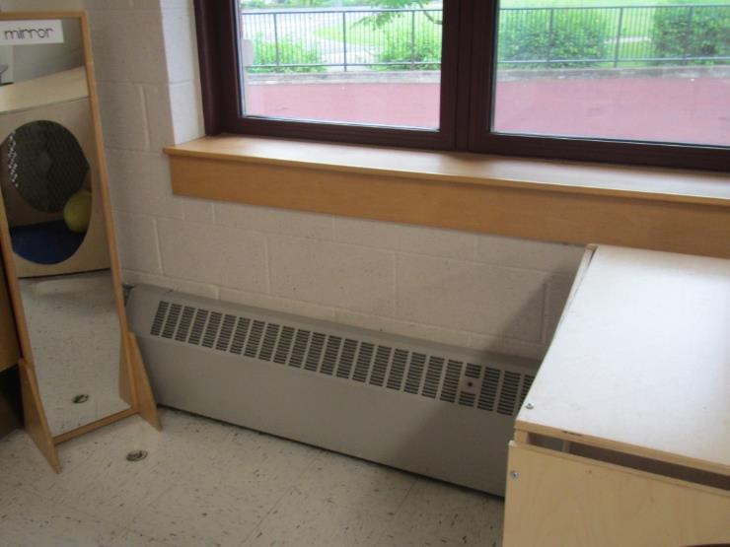

**Typical radiator in a classroom**

**Picture 9**

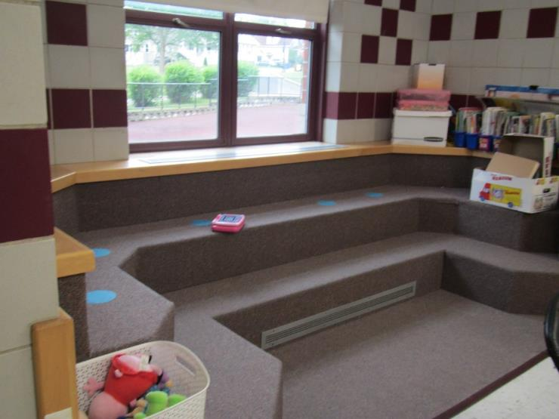

**Carpeted seating unit built around a radiator**

**Picture 10**

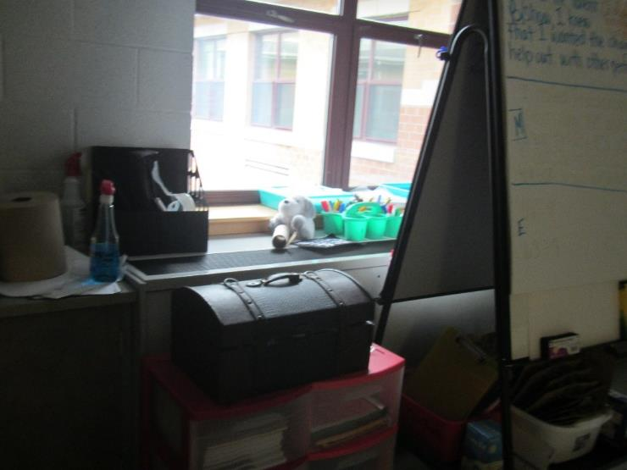

**Univent blocked by classroom items**

**Picture 11**

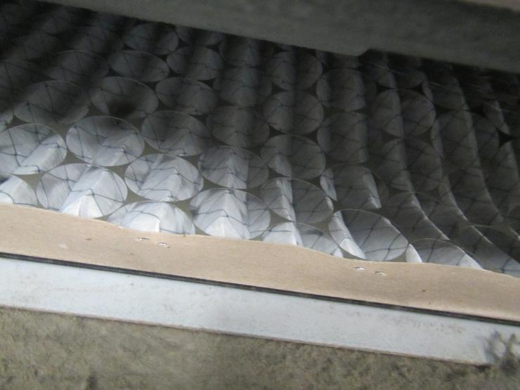

**Filter in a classroom univent, note somewhat low quality**

**Picture 12**

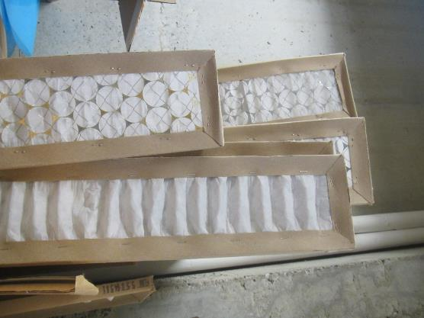

**Filters stored sticking out of boxes; these do not even appear to all be the same kind**

**Picture 13**

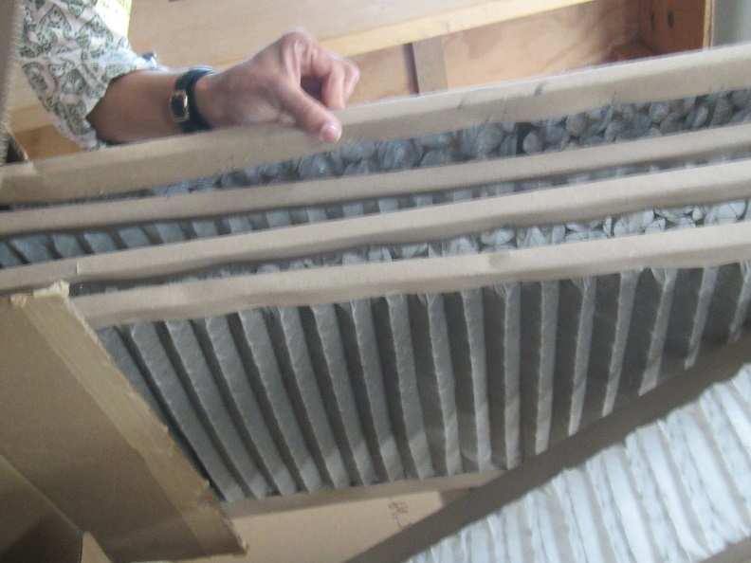

**Used, dusty filter in the same box as clean-looking filters**

**Picture 14**

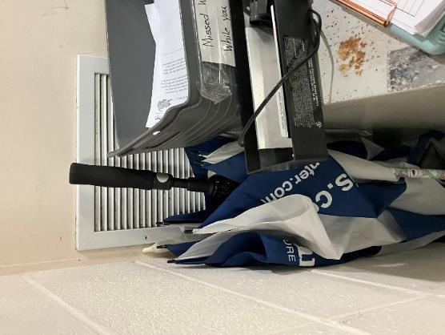

**Exhaust vent blocked by items**

## Water Damage Pictures

**Picture 15**

** 
Water-damaged ceiling tile
**

**Water-damaged ceiling tile**

**Picture 16**

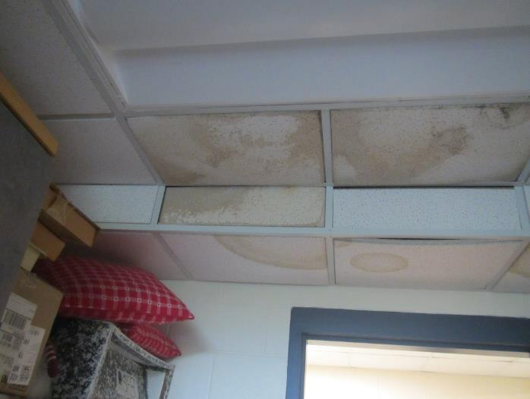

**Water-damaged ceiling tiles in a storage area**

**Picture 17**

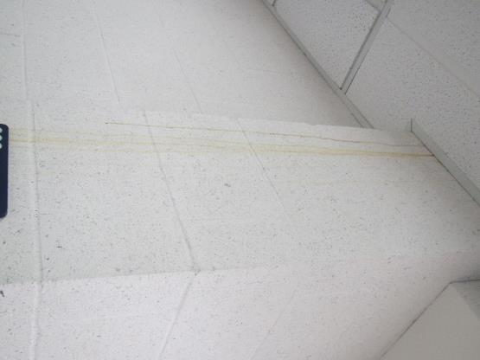

**Water stains on a wall**

**Picture 18**

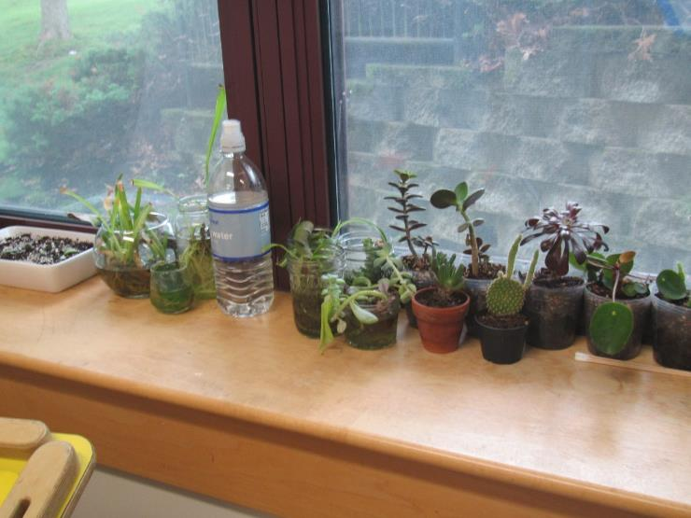

**Plants on a windowsill; note slight staining indicating past water damage to the wood of the sill**

**Picture 19**

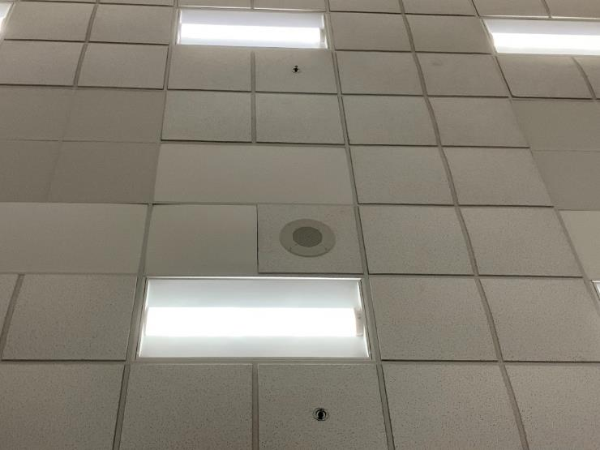

**Ceiling tiles that are sagging/bowed in the ceiling tile grid**

**Picture 20**

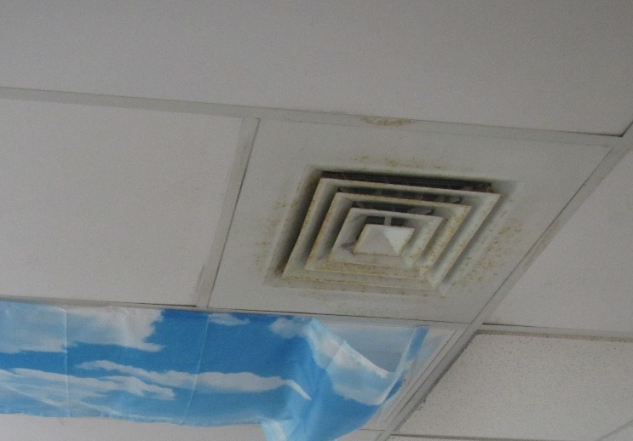

**Rust on a supply vent**

**Picture 21**

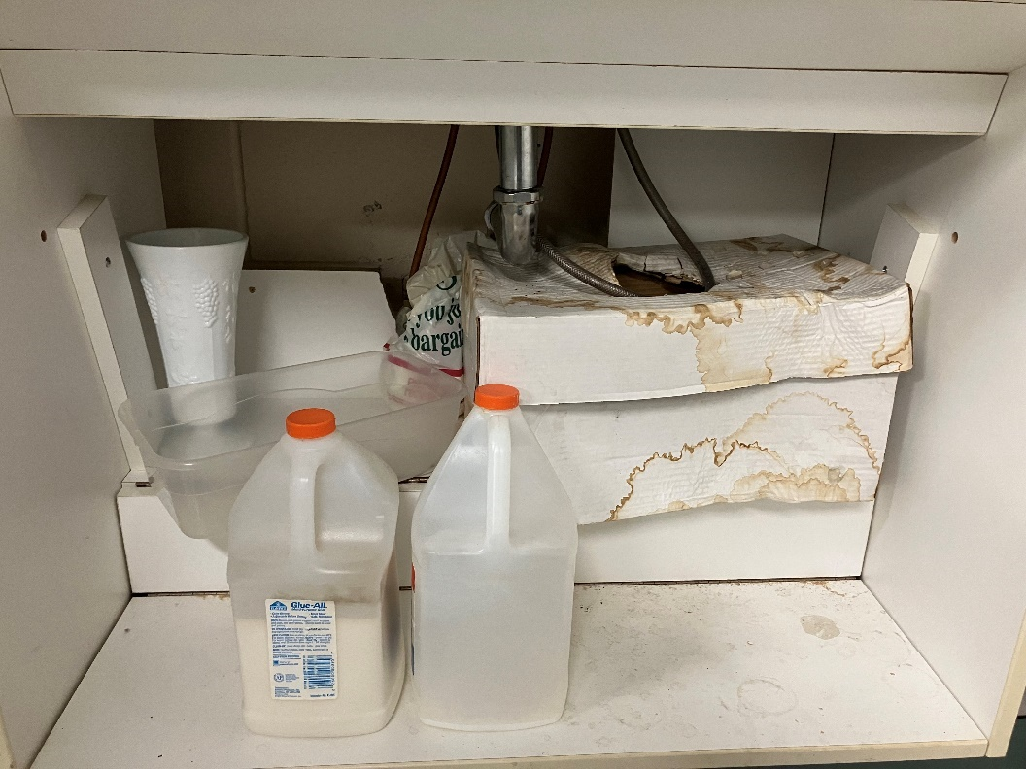

**Water-damaged cardboard box under a sink**

**Picture 22**

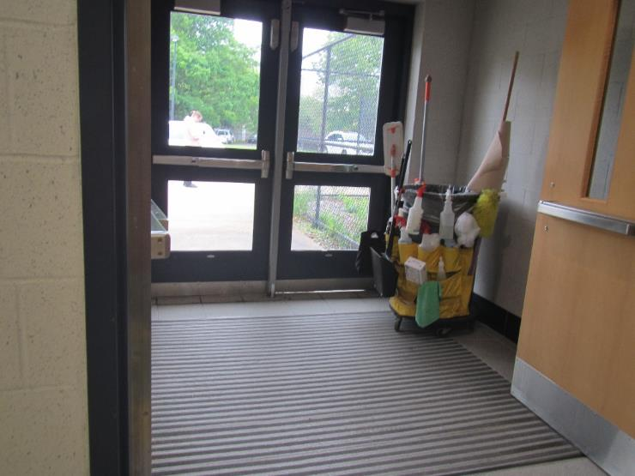

**Visible light underneath exterior door indicating worn or missing weather stripping**

**Picture 23**

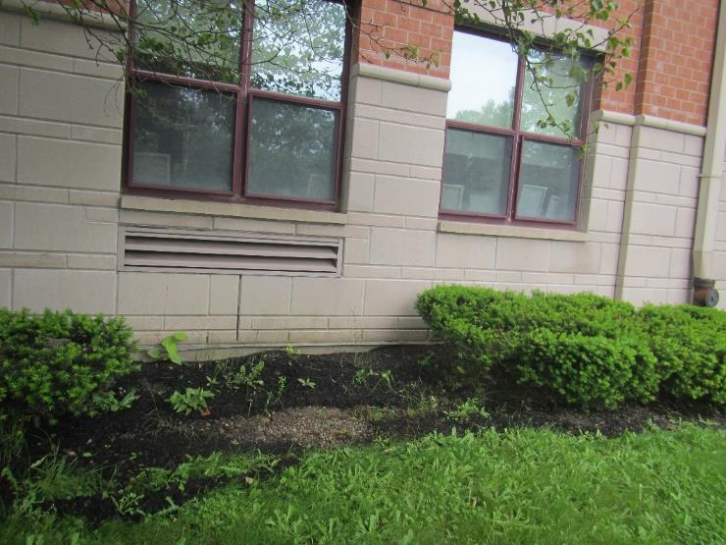

**Shrubs next to the building and univent air intake**

**Picture 24**

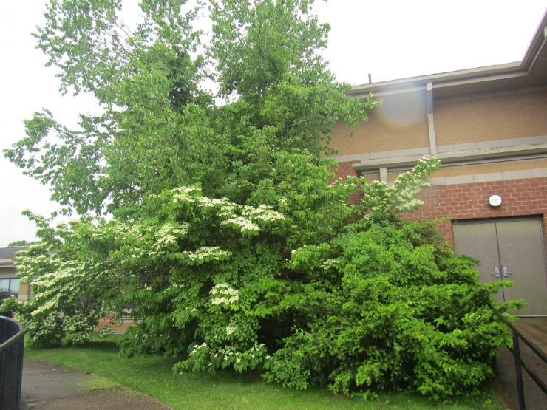

**Large plants and trees next to and overhanging rear of building**

**Picture 25**

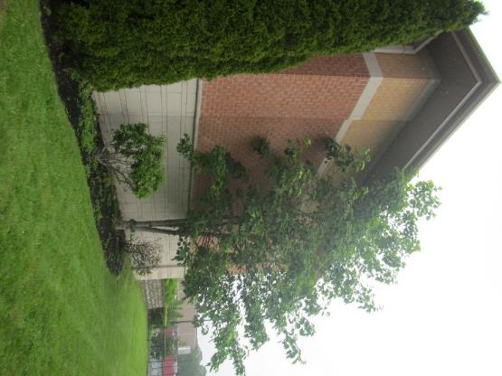

**Trees next to and overhanging the building**

**Picture 26**

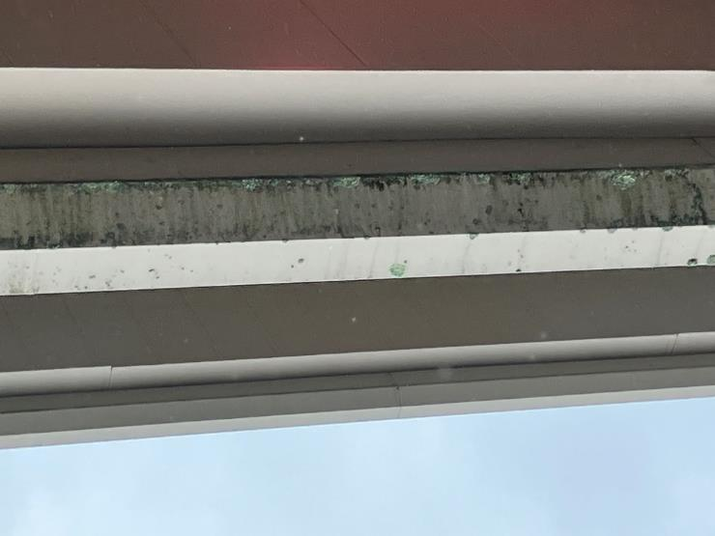

**Stains and damage to gutter which appeared to be leaking**

**Picture 27**

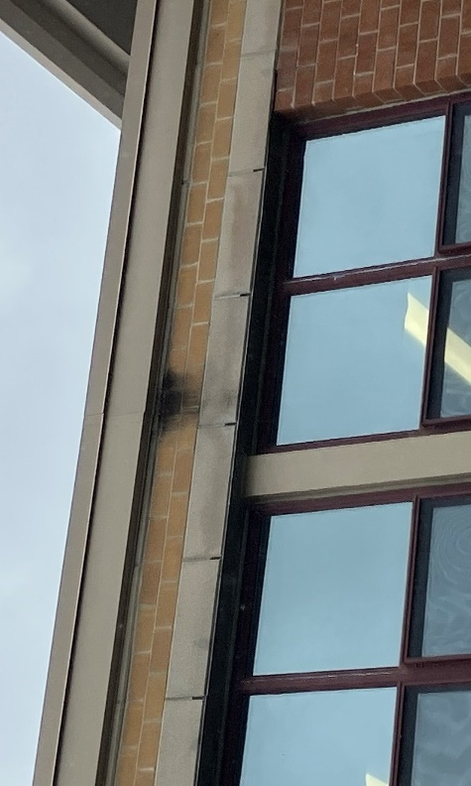

**Water stains on exterior wall at seam in gutter**

## Respiratory Irritants Pictures

**Picture 28**

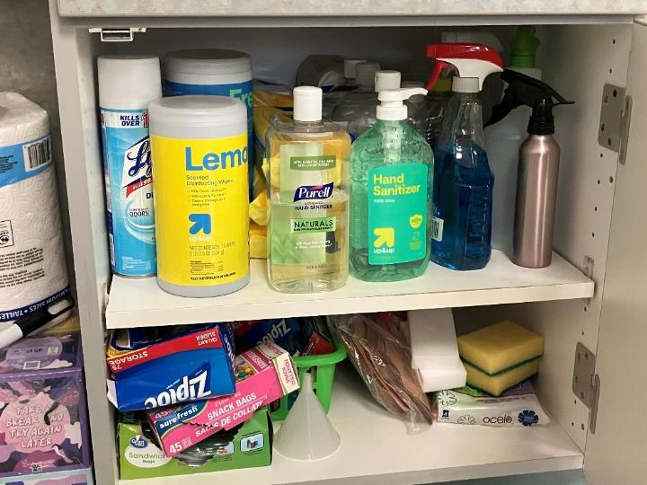

**Cabinet containing a variety of cleaning and sanitizing products**

**Picture 29**

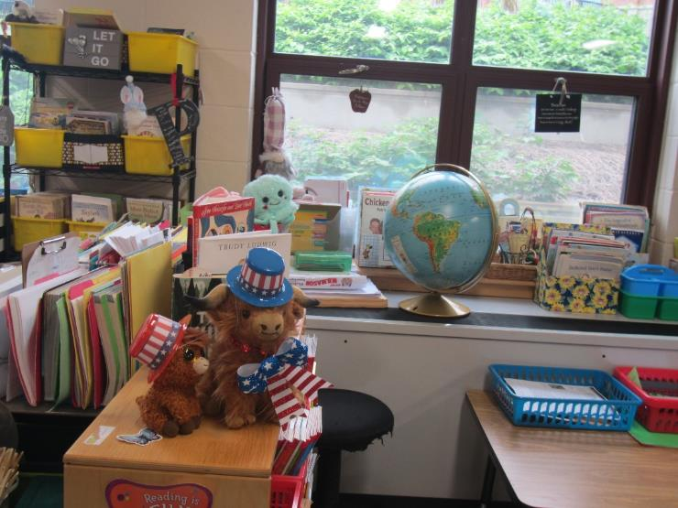

**Items/clutter in a classroom**

**Picture 30**

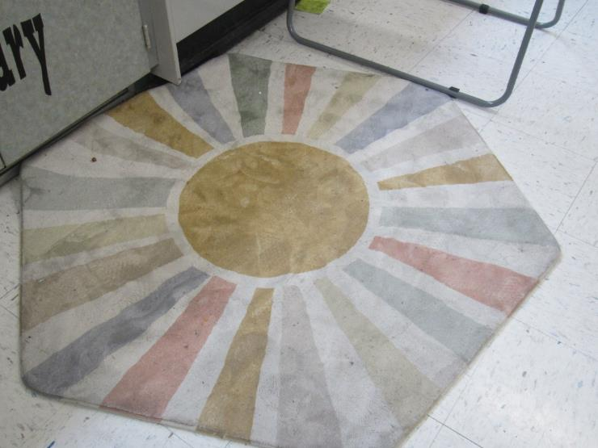

**Classroom area rug**

**Picture 31**

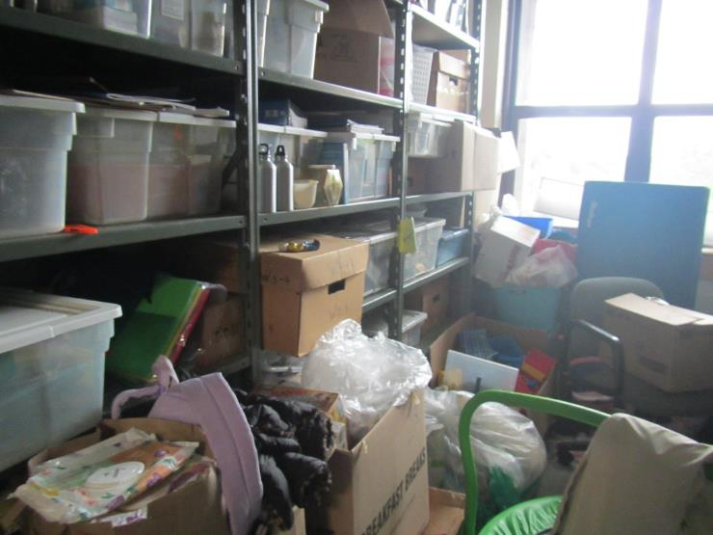

**Clutter in the art storage room**

**Picture 32**

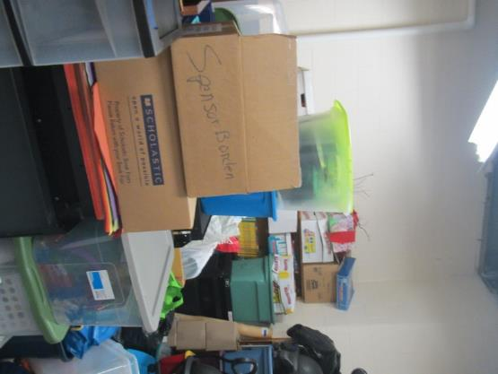

**Items stored in room 1A**

**Picture 33**

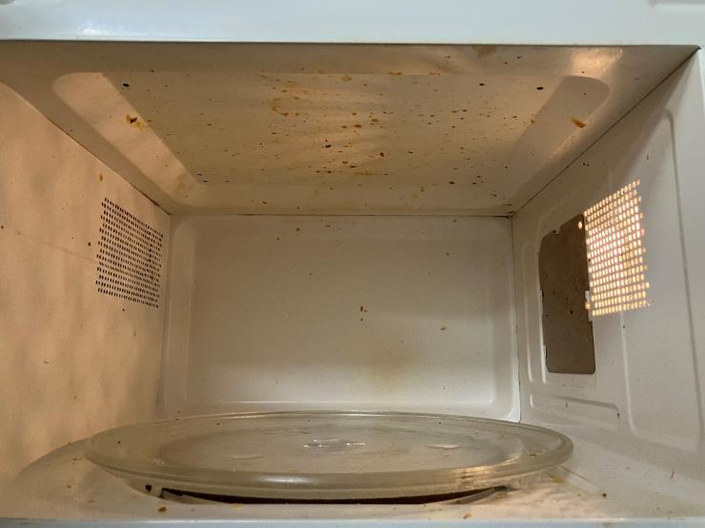

**Dirty microwave**

**Picture 34**

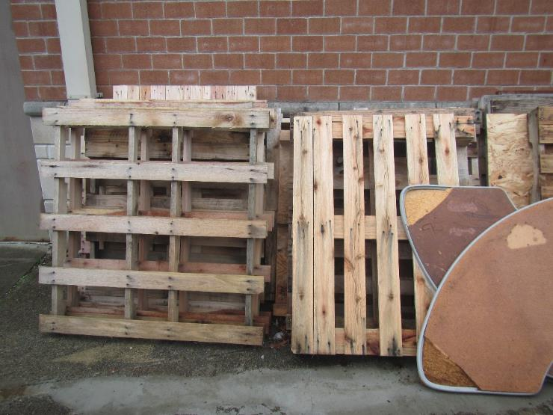

**Wooden pallets stored in contact with the building**

Click to link back to report

# Table 1

| **Room** | **Openable Windows** | **HVAC** | **Ventilation** | | **Ceiling Tiles/Staining (Y or N)**  **B = Bowed** | **Comments** |
| --- | --- | --- | --- | --- | --- | --- |
| **Supply** | **Exhaust** |
| Boiler room | N | N |  |  |  | This was the area where a fire broke out last year on a water heater, leading to smoke damage to the adjacent corner of the school. WD pipe wrap |
| Gym | N | Y | Y | Y |  | Water fountains turned off, some areas have bottle filler stations |
| Gym office | N | Y | Y | Y | Y, B | HS, exhaust off and dirty/dusty in restroom |
| Gym girl’s restroom | N | Y | N | Y dusty |  |  |
| Janitor’s office near gym | N | Y | Y |  | Y | PF on, fridge, freezer needs defrosting, aquarium, WD ceiling tiles |
| OT room | Y | Y | Y | Y on |  | Sink, chalk, DEM |
| 228 | Y | Y | Y 1 blocked | Y on |  | Sink – water staining under the pipes, kitchen-style stove without hood, area rug, plants |
| Specials office | Y | Y | Y | N |  | NC, DEM |
| Cafeteria | N | Y | Y | Y |  |  |
| Stage | N | Y | Y | Y |  | Wood floor, flaking paint up near the ceiling |
| 216 Music | N |  | Y | Y | Y, B | Area rug, WD ceiling tiles |
| Music classroom – left | N | Y | Y on | Y on dusty | Y |  |
| Art classroom | Y | Y | Y | Y | Y | PF, eyewash/safety shower station, items under sinks |
| Art closet | N | Y |  |  | Y | Clutter, old flammable cabinet (no flammables inside), WD ceiling tiles |
| Teacher’s lounge | Y | Y | Y | Y |  | Fridge is a little dirty, microwave dirty, Photocopier, DEM |
| 218 SPED | Y | Y | Y | Y | B | Items under sink, sink drips, area rug |
| 218 storage | N |  | Y | Y | Y | Clutter, missing ceiling tile, is sink used in this room? WD ceiling tiles |
| 219 | Y | Y | Y | Y | B | Area rug, sink with “Britta” filter |
| 220 | Y | Y | Y | Y |  | Exhaust blocked by furniture, area rug, sink |
| 221 | Y 6 open | Y on | Y | Y | Y | Occupant reported poor temperature/humidity control, area rug, sink |
| 222 | Y | Y | Y | Y weak |  | Area rug |
| 223 | Y | Y | Y | Y | B | Exhaust partly blocked, plush chairs, area rug, DEM, HS |
| Adult restrooms near 223 | N | Y |  | Y |  | Exhaust vents dusty |
| 225 | Y | Y | Y | Y |  | Area rug, beanbag chairs |
| 226 | Y | Y | Y | Y |  | Carpeted (old), rusty supply vent, pencil sharpener shavings |
| Former library   * Right room | Y | Y | Y | Y |  | Radiator, carpeted |
| * Middle room | Y | Y | Y | Y |  | Area around vent water damaged |
| Classroom next to former library | Y | Y | Y | Y on |  | No carpet |
| Mainframe room | N |  |  |  | Y | Ductless air conditioning unit |
| 208 | Y | Y | Y | Y | B | Dehumidifier, fridge (odor when opened), microwave, carpeted seating unit next to window |
| 202 | Y | Y | Y | Y | B | Loud ceiling unit, carpeted seating unit next to window |
| 206 | Y | Y | Y | Y | Y | Area rug, carpeted seating unit next to window, PF on |
| 204 | Y | Y | y | y | Y | Area rug, items on ceiling, dehumidifier off, carpeted seating unit next to window |
| 214 | Y | Y | Y | Y | N | Area rug, cleaning products, dusty exhaust vent, DEM, carpeted area with bean bag seating, stuffed toys |
| 213 | Y | Y | Y | Y | N | Area rug, exhaust blocked by bean bag |
| 212 | Y | Y | Y | Y weak | N | Area rug, univent partially open, DEM, clutter |
| 211 | Y | Y | Y | Y weak | Y | Area rug, WD ceiling tiles, DEM |
| 210 | Y | Y | Y | Y weak | Y | Area rug, WD ceiling tiles, DEM |
| Unisex adult and student bathroom |  |  |  | Y off | N |  |
| 209 | Y | Y | Y | Y | B | Area rug, ceiling tiles do not fit the channel, DEM |
| 201 | Y | Y | Y | Y off |  | Area rug, cleaning products, dusty exhaust vent, DEM, clutter |
| 207 | Y | Y | Y | Y |  |  |
| 203 | Y | Y | Y | Y weak |  | Area rug, cleaning products, dusty exhaust vent, DEM |
| 205 | Y | Y | Y | Y |  | Area rug, cleaning products, mostly textured ceiling tiles |
| 2B storage |  |  |  |  |  | Insulation leaks, cardboard boxes stored on the floor |
| 114 | Y | Y | Y | Y |  | DEM, sink drips, coffee maker, exhaust vent rusty |
| 1st floor teacher’s workroom | Y | Y |  | Y |  | Laminator, sink, fridge, microwave, area rug under sink |
| Elevator mechanical room | N | N | N | N |  | Rubber odor, electric heater |
| Nurse’s office | N | Y |  | Y |  | Plants |
| * Restroom | N | Y | N | Y |  | Exhaust vent dusty |
| Main office conference | Y | Y | Y | Y |  | Carpet, fake plant |
| Guidance | Y | Y | Y | Y |  | Carpet |
| Main office restroom | N | Y | Y | Y |  | Cleaning products, dusty exhaust vent |
| Main office break | Y | Y | Y | Y |  | Fridge and microwave, photocopier, items under sink, exhaust vent dusty |
| Main office | Y | Y | Y | Y |  | Carpet, HS |
| 112 | Y | Y | Y | Y |  | Area rug, plants |
| Girls’ restroom next to office | N | Y | Y | Y |  |  |
| 101 | Y | Y | Y | Y | B | Tennis balls used as glides, DEM, sink, dehumidifier |
| 102 | Y | Y | Y | Y |  | Area rug, univent blocked |
| 103 | Y | Y | Y | Y |  | Clutter, sink, univent blocked, area rug |
| 104 | Y | Y | Y | Y |  | Exhaust vent blocked, Area rug, dehumidifier on, DEM, HS |
| 105 | Y | Y | Y | Y |  | Univent blocked (on purpose?), area rugs, beanbag chairs, exhaust slightly blocked |
| 113 | Y | Y | Y | Y |  |  |
| 1C storage |  |  |  |  |  |  |
| 111 | Y | Y | Y | Y |  | Area rug, clutter |
| Unisex adult and student bathroom |  |  |  | Y off |  |  |
| 110 | Y | Y | Y | Y |  | Area rug, cleaning products, DEM, dehumidifier |
| 109 | Y | Y | Y | Y |  | Area rug, cleaning products, DEM, dehumidifier with dirty filter |
| 108 | Y | Y | Y | Y |  | Area rug, cleaning products, DEM |
| 107 | Y | Y | Y | Y |  | Area rug, cleaning products, DEM, dehumidifier, exhaust completely blocked |
| 106 | Y | Y | Y | Y |  | Area rug, cleaning products, DEM |
| Elevator mechanical room | N |  |  |  |  | Same rubber/electrical smell as other elevator room |
| Electrical room | N |  |  |  |  | Dead bug on floor |
| 1A storage | N |  |  |  |  | Clutter |
| 1B storage | N |  |  |  |  | Filters stored here, some are used, some stored outside boxes, used paint cans |

(Click to link back to report)

# Table 2A

|  |  |  |  |  |  |
| --- | --- | --- | --- | --- | --- |
| **Equipment Present in Building**  **(X = Yes)** | **Type of Heating/Cooling Ventilation**  **Equipment** | **Fresh**  **Air**  **Supply**  **(X = Yes)** | **Type of Location(s)** | **Air Filters Installed**  **MERV Rating**  **(1-15, U*)**  **(X = Yes)** | **Comments** |
| X | Univents | X | Classrooms | X, U |  |
| X | Rooftop Air Handling Units | X | Modular classrooms | X, U |  |
|  | Outdoor, Ground-Installed Air Handling Units |  |  |  |  |
|  | Attic/Crawlspace Air Handling Units |  |  |  |  |
| X | Ceiling-Mounted Air Handling Units (including inside plenum) | X | Some classrooms |  |  |
|  | Basement/Crawlspace-Installed Air Handling Units |  |  |  |  |
|  | Mechanical Room-installed Air Handling Units |  |  |  |  |
|  | Fan Coil Units |  |  |  |  |
|  | Window-Mounted Air Conditioners |  |  |  |  |
|  | Wall Louver-Controlled Gravity Air Supply |  |  |  |  |
| X | Windows |  | Classrooms, offices |  |  |
|  | Fan in window (blowing in) |  |  |  |  |
|  | Built in wall fan (switched) |  |  |  |  |
|  | Heat recovery ventilator unit |  |  |  |  |
|  | Energy recovery ventilator unit |  |  |  |  |
|  | Chilled Beam |  |  |  |  |
|  | Passive combustion supply vent in basement/boiler room |  |  |  |  |

*U = Filter Rating underdetermined due to inaccessibility during building visit

(Click to link back to report)

# Table 2B

|  |  |  |  |  |
| --- | --- | --- | --- | --- |
| **Equipment Present in Building**  **(X = Yes)** | **Type of Exhaust Ventilation**  **Equipment** | **Ducted**  **To Outdoors**  **(X = Yes)** | **Type of Location(s)** | **Comments** |
| X | Rooftop Motors/Fans | X | Classrooms and offices |  |
|  | Unit Exhaust |  |  |  |
|  | Ceiling Return Vent |  |  |  |
|  | Ceiling Return Vent, Plenum |  |  |  |
| X | Wall Return Vent | X | Cafeteria/Auditorium |  |
|  | Kitchen Stove Hood |  |  |  |
| X | Restroom Exhaust Vent | X |  |  |
|  | Photocopier Exhaust Vent |  |  |  |
|  | Garage |  |  |  |
|  | Chemical Hood(s) |  |  |  |
|  | Locker Rooms |  |  |  |
|  | Showers |  |  |  |
|  | Clothes Dryers |  |  |  |
|  | Gas Water Heaters |  |  |  |
|  | Furnace-Flue to Chimney |  |  |  |
|  | Furnace/Boiler direct vent or power vent (no combustion air supply) |  |  |  |
|  | Kiln, Pottery |  |  |  |
|  | Dark Room |  |  |  |
|  | Generator Room |  |  |  |
|  | Wood Shop Dust Collector |  |  |  |
|  | Spray Paint Booths |  |  |  |
|  | Fan in window (blowing out) |  |  |  |

# Table 2C

|  |  |  |  |
| --- | --- | --- | --- |
| **Equipment Present in Building**  **(X = Yes)** | **Type of Equipment** | **Type of Location(s)** | **Comments** |
|  | Floor Fans, pedestal |  |  |
| X | Floor Fans, portable | Classrooms |  |
| X | Air Purifier (HEPA, other) | Classrooms, offices |  |
|  | Floor heaters, portable |  |  |
| X | Refrigerators, Cold Beverage Vending Machines |  |  |
| X | Radiator, wall-mounted | All rooms with exterior walls |  |
|  | Radiator, floor-mounted |  |  |
|  | Passive Vents (Wall/Door) |  |  |

(Click to link back to report)

# Table 3

| **Found in Building**  **X = Yes** | **Water-Damaged Materials, Building Components or Stored Materials** | **Location** | **Visible Microbial Growth?**  **X = Yes** | **Musty odor detected?**  **X = Yes** | **Comments** |
| --- | --- | --- | --- | --- | --- |
|  | Books-other bound materials |  |  |  |  |
|  | Brick walls – broken, missing mortar |  |  |  |  |
|  | Brick walls – blocked weep holes |  |  |  |  |
|  | Cardboard boxes |  |  |  |  |
|  | Carpet tiles |  |  |  |  |
|  | Carpet - Area rugs |  |  |  |  |
|  | Carpet wall-to-wall |  |  |  |  |
|  | Ceiling tiles - affixed directly to ceiling surface |  |  |  |  |
| X | Ceiling tiles - bowing-in suspended ceiling | Classrooms, offices |  |  |  |
|  | Ceiling tiles - water-stained in splined ceiling |  |  |  |  |
| X | Ceiling tiles - water-stained in suspended ceiling | Classrooms, offices |  |  |  |
|  | Chairs - laminated |  |  |  |  |
|  | Cloth |  |  |  |  |
|  | Countertops (around sinks) |  |  |  |  |
|  | Curtains |  |  |  |  |
|  | Dust/debris within AHU, uninvent, HVAC, chilled beam units, etc. (WD through condensation, humidity, or leaks) |  |  |  |  |
|  | Efflorescence (i.e., mineral deposits) |  |  |  |  |
|  | Engineered woods - particleboard, plywood, Masonite |  |  |  |  |
|  | Flooring – loosened tiles |  |  |  |  |
|  | Flooring - wooden |  |  |  |  |
|  | Furniture - laminated |  |  |  |  |
|  | Furniture - upholstered |  |  |  |  |
|  | Gypsum wallboard - ceiling |  |  |  |  |
|  | Gypsum wallboard - restroom wall |  |  |  |  |
|  | Gypsum wallboard - interior wall |  |  |  |  |
|  | Gypsum wallboard – located on exterior wall |  |  |  |  |
|  | HVAC drain pan – lack of draining |  |  |  |  |
|  | HVAC filters |  |  |  |  |
|  | Insulation- attic (paper-backed) |  |  |  |  |
|  | Insulation - inside air handling unit |  |  |  |  |
|  | Insulation - on pipe(s) fiberglass |  |  |  |  |
|  | Insulation - on pipe(s) other/plaster-like material |  |  |  |  |
|  | Insulation - wall cavity |  |  |  |  |
|  | Insulation – ceiling plenum |  |  |  |  |
|  | Modular furniture – walls/cloth partitions |  |  |  |  |
|  | Musical instrument cases |  |  |  |  |
|  | Plaster ceilings |  |  |  |  |
|  | Records/files |  |  |  |  |
|  | Refrigerator - door gasket |  |  |  |  |
|  | Refrigerator - drip pan |  |  |  |  |
|  | Refrigerator - Interior surfaces |  |  |  |  |
|  | Room divider - ceiling-mounted, sliding |  |  |  |  |
|  | Sink backsplash |  |  |  |  |
| X | Sink under cabinet | A few classrooms |  |  |  |
|  | Tables – laminated |  |  |  |  |
|  | Wallpaper |  |  |  |  |
|  | Wood - attic/roof materials |  |  |  |  |
|  | Wood - floor joists in basement ceiling |  |  |  |  |
|  | Wood - wall framing |  |  |  |  |
|  | Wood - window sills |  |  |  |  |
|  | Wood - window-mounted air conditioner framing |  |  |  |  |
|  | OTHER |  |  |  |  |

WHAT ARE ENVIRONMENTAL ASTHMA TRIGGERS?

Asthma triggers are any chemical, pollutant, or allergen that can make your asthma worse. Asthma triggers can also be strong chemical smells, dust, or pets. Your asthma triggers may be different from those of other people. Not all asthma triggers affect people the same way. Environmental asthma triggers are found both indoors and outdoors. MDPH link: [Asthma and Your Environment (mass.gov)](https://www.mass.gov/doc/asthma-and-your-environment-english/download)

(click to link back to report)

# Table 4

| **Condition Present**  **X = Yes** | **Possible asthma symptom-inducing environmental pollutant** | **Recommendation to reduce or eliminate the pollutant** |
| --- | --- | --- |
| X | Water Damage and/or Mold  (allergen) | Identify water source and repair to eliminate.  Clean non-porous materials.  Remove and replace porous materials susceptible to mold growth.  Perform regular water damage assessments as a tool to ensure timely mitigation as needed.  Use NIOSH water damage assessment protocol as a guide: [NIOSH water damage assessment guideline](https://www.cdc.gov/niosh/docs/2019-115/pdfs/2019-115.pdf?id=10.26616/NIOSHPUB2019115&inf_contact_key=241b5c2ed98c27d94b530dedc36f1623f651f238aa2edbb9c8b7cff03e0b16a0). |
| X | Moistening of building components during hot, humid weather (>2 days in length) (mold, allergen) | Remove materials not dried in <2 days in a manner consistent with [US EPA Mold Removal in Commercial Buildings guideline](https://www.epa.gov/mold/pdf-version-checklist-mold-remediation-mold-remediation-schools-and-commercial-buildings).  Use dehumidification in occupied basement areas and other areas with chronic dampness. |
| X | Vegetation against exterior of building (water damage-mold) | Remove all vegetation preventing building exterior drying.  Remove all vegetation capable of falling onto a building or depositing debris onto the roof. |
|  | Personal humidifiers (lack of proper maintenance)  (pollutant and allergen) | Clean and maintain properly.  Use distilled water to eliminate metal and water treatment odors.  Maintain hydration by increasing water consumption. |
| X | Drains: Floor drains, Sink drains (abandoned use)  Water bubblers (abandoned use) | If in use, pour water into drain at least twice a week.  If not in use, seal the drain with an appropriate material in accordance with Massachusetts Plumbing Code (248 CMR 10.00). |
|  | Live Animals (turtles, gerbils, birds, rabbits, etc.) | Ensure cleanliness or remove animals from the location. |
|  | Improperly maintained aquariums and terrariums (allergen) | Maintain such equipment properly to eliminate odor.  Discontinue use. |
| X | Plants and flowers  (allergen and mold) | Keep indoor plants well maintained and not overwatered. Monitor for signs of mold and pests.  Ensure water for cut flowers does not become stagnant.  Ensure dried plant material is free of odors, mold, and pests and handled carefully  If asthma risks are high, eliminate plants and flowers. |
|  | HVAC system moisture issues  (mold, allergen) | Consult ASHRAE’s minimum standards for HVAC maintenance and inspection of commercial HVAC systems (<https://www.ashrae.org/technical-resources/bookstore/standards-180-and-211>). |
|  | HVAC system contaminant issues (allergen) | Consult ASHRAE’s minimum standards for HVAC maintenance and inspection of commercial HVAC systems (<https://www.ashrae.org/technical-resources/bookstore/standards-180-and-211>). |
|  | Indoor swimming pool odors outside of swimming pool (mold, chemical) | Maintain and operate pool HVAC systems to vent odors from building.  Ensure locker room exhaust vents are operating during building hours.  All doors leading to pool should be rendered airtight and be closed. |
| X | Pollen (allergen) | Recommend installation of MERV 8 or better filters if HVAC engineer confirms HVAC system can be so equipped without adversely affecting function.  Cut grass after hours.  Cut grass in a pattern to direct clippings away from exterior wall.  Remove trees and shrubs from in front of windows and air intakes. |
|  | Dry air | Maintain hydration.  Avoid overheating of air. |
| X | Dust mites  (allergen) | Recommendation to remove non-official upholstered furniture, area rugs, pillows, cushions, etc.  Cleaning with use of HEPA-filtered vacuum cleaner.  Eliminating clutter, storing items in dust and moisture-proof containers, and regularly removing dust through wet wiping. |
|  | Pests, including rodents and cockroaches  (allergen) | Use of integrated pest management guidelines, including:   * Proper disposal of food containers * Proper storage of food products in airtight containers * Elimination of use of food as art projects * Remove pest harborages/clutter * Regular monitoring for pests   [EPA IPM guideline link](https://www.epa.gov/ipm/introduction-integrated-pest-management) |
| X | Latex-containing materials | Remove tennis balls from furniture legs or replace with latex free ones. |
| X | Fragrances  (chemical) | Eliminate point sources, such as:   * Plug-in air fresheners * Aroma/oil reed diffusers * Scented sprays * Discontinue use of other scented materials * Consult MDPH fragrance guideline: [*Clean air is odor-free*](https://www.mass.gov/doc/clean-air-is-odor-free-removing-fragrances-to-improve-indoor-air-quality-in-schools-and-0/download) |
| X | Strong smells from /use of Chemicals (such as cleaning products)  (chemical) | Use building-issued cleaning products.  Use products in accordance with manufacturer’s instructions including dilution, application, and ventilation.  Avoid using products that are stronger than needed for the situation. |
|  | Strong odors from new building materials (carpeting/furniture)  (chemical) | Use low VOC-emitting materials.  Air out materials (outside or in unoccupied area) prior to installation. |
|  | Tobacco smoke  Secondhand Smoke  (pollutant) | Eliminate tobacco smoking.  Seal all shared wall penetrations. |
| X | Products with strong odor such as paint, perfume, hairspray, air fresheners, bug-spray, laminators, candles, wax melters, dry erase markers and other VOC-containing products  (chemical) | If essential:   * Provide proper exhaust ventilation to eject aerosolized product directly outdoors. * Avoid/reduce use during occupied hours.   If not necessary, remove and eliminate. |
|  | Vehicle exhaust  (pollutant) | Enforce anti-idling regulations and post signs to give notice.  Relocate vehicles away from fresh air intakes.  Require cars to park face-in at building walls.  [MA anti-idling law FAQs](https://www.mass.gov/files/documents/2018/02/20/idling-faq.pdf#:~:text=The%20Massachusetts%20Anti-Idling%20Law%20The%20goal%20of%20the,sometime%20wonder%20when%20idling%20might%20be%20considered%20necessary.) |
|  | Vapors and or fumes from gas, oil, or kerosene stoves  (pollutant) | Operate stove hood when stove in use.  Install stove hood if not present.  Ensure equipment is in good working order. |
|  | Ozone (pollutant) | Eliminate use of ozone generating equipment. |
|  | Window Air Conditioners (if not properly maintained) (allergen) | Equip with proper filter and clean periodically.  Clean drip pans.  Install in window with weathertight, non-mold-growth sustaining material. |
|  | Pottery (pollutant) | Do not operate kiln during occupied hours.  Operate kiln with exhaust system activated.  Seal all seams and holes in kiln vent.  Ensure kiln exhaust discharge terminates outdoors. |
| X | Carpeting (allergen) | Clean carpeting in a manner consistent with IICRC standards, including regular vacuuming with a high efficiency particulate air (HEPA) filtered vacuum in combination with annual cleaning or semi-annual cleaning in soiled high traffic areas. |
| X | Sweeping/dusting vs HEPA vacuuming/wet wiping  (allergen or pollutant) | Refrain from using feather dusters or brooms.  Utilize HEPA vacuums and wet wiping to minimize aerosolizing particulate matter. |
| X | Lack of adequate air exchange/mechanical ventilation | Make repairs as necessary and ensure all HVAC system components are operating continuously when building is occupied. |
|  | Lack of local exhaust at source of pollution (vocational shop activities, kitchen exhaust hood) (all) | Recommend installation of exhaust ventilation to direct pollutants directly outdoors. |
|  | Renovating buildings while occupied  (chemical) | Use all SMACNA guidelines for Renovation While Buildings Are Occupied. For information, visit <https://www.mass.gov/service-details/construction-and-renovation-generated-pollutants-in-occupied-buildings>. |
|  | Chemistry program chemical storage  (chemical) | Repair (if needed) and operate chemical storeroom vents appropriately.  Reduce or eliminate unneeded or overstocked chemicals.  Store all chemicals in a manner to separate incompatible chemicals.  Keep chemical storerooms clean. |
| X | Photocopiers/duplicating machines | All machines should have dedicated exhaust vents. |